Capstone Project: Pre-Submission Document
Project Residence: rental portfolio performance analytics for UrbanNest Property Services
Team: Group 16 Programme: IITM-JARO, Batch 03
1. Business Problem Understanding and Objective Formulation
UrbanNest manages about 500 residential apartments for individual owners and institutional investors. Its income depends on four things that move together: how quickly a vacant unit is let, the rent at which it is let, whether the tenant pays on time and renews, and what it costs to keep the unit in repair. These are reviewed today in separate occupancy, collection, renewal and maintenance reports, so management cannot see how they interact and cannot tell owners why two similar flats earn different amounts.
A first pass over the five extracts (500 properties, 1,029 listings, 1,841 leases, 6,621 maintenance requests and 18,000 property-months from January 2023 to December 2025) shows where the money is going. Collected rent is about 93% of reference rent. Setting aside the start-up quarter of 2023, when over half the units were still vacant, uncollected rent (about INR 34.5 million) is roughly twice the rent lost to vacancy (about INR 15.8 million). In 13% of occupied months the tenant pays less than was charged, and when the first payment arrives after day 7, about half of those months close with a balance outstanding. Only 59% of completed leases are renewed, and the rate drops from about 76% at no proposed increase to 52% at an increase of 8 to 10%. Repair requests rise sharply with building age (correlation 0.72), and net yield ranges from 74% of reference rent for the weakest decile of properties to 102% for the strongest.
We therefore treat the problem as revenue leakage along the whole tenancy cycle, and set the objectives below. These are working objectives and will be refined after exploratory analysis.
Business objective | Analytical objective | Approach
Reduce late and unpaid rent | Flag tenancy-months likely to end with an outstanding balance, using early payment delay and tenancy history | Classification (logistic regression, gradient boosting)
Keep good tenants and shorten gaps between lets | Explain and predict renewal on completed leases; relate days-to-lease to ask premium and property attributes | Logit and boosting; Cox model for tenure; hedonic regression
Control avoidable maintenance cost | Forecast request volume and repair cost per property and relate them to building age and priority mix | Count and cost regression
Explain why similar units earn differently | Group properties by net yield, occupancy, repair burden and collection behaviour | Clustering with profile comparison
2. Challenges and Constraints
Several fields are administrative leftovers: Migration_Remarks is entirely empty, Old_Inspection_Reference is 92% empty, and archive, batch and legacy codes carry no business meaning. A few columns duplicate others (billed and collected amounts, agreement and ticket references), and furnishing status and repair priority contain case and spacing variants. Amenity score (13 properties), transit distance (17) and tenant satisfaction (30% of occupied months) have gaps, and 108 of the 626 non-renewals and early exits carry the reason "Not recorded".
The harder issues are analytical. Of the 1,841 leases, 388 are still running and 64 start in the future, so they have no outcome and must not be counted as non-renewals; only 1,389 completed leases can be used for renewal. Same-month outstanding balance and net cash are consequences of the outcome and would leak into any collection model. Half of all properties begin the period vacant, which inflates the apparent occupancy gain from 91% in 2023 to 97% in 2025. Rent cuts appear only on listings that had already sat unlet (about 54 days on average against nearly zero for uncut listings), so a naive comparison would wrongly suggest that cuts slow leasing. The data are observational, so we report associations and mark anything causal as needing validation, for example through a controlled pilot. Stated exit reasons are also weak evidence: tenants who cite service concerns had the same satisfaction and repair times as the rest.
On the practical side, the extracts cover three years and one operator, with no market rent, competitor or macroeconomic data, and rents are nominal. Leasing teams currently rely on local judgement, so outputs must be explainable, and a few segments have few events. We assume the identifiers are consistent across systems (checked: no orphan keys), that same-day lets explain the many zero-day listings, and that the 2023 reference rent is a fair baseline for comparing units.
3. Background Study and Literature Review
Rent differences between units are conventionally explained with hedonic models, which value a dwelling as a bundle of attributes such as size, age, location and amenities [1]. Sirmans et al. review which variables such models use in real estate and how stable their effects are [2], which guides our feature set for rent premium and days-to-lease. Pricing a perishable inventory against time on the market is the core of revenue management [3]; the lesson we take is that rent and vacancy must be judged jointly, not one at a time.
Renewal is a close cousin of customer churn. Neslin et al. compared a large set of churn models and found that both the method and the data supplied to it affect predictive accuracy [4], so we compare simple and flexible models on the same split. Because active leases are unfinished observations, survival analysis with a Cox proportional hazards model [5] lets us use them without treating them as losses. For late and unpaid rent, credit-scoring research is the nearest analogue: a benchmark of 41 classifiers found that ensemble methods generally outperformed single classifiers [6], and gradient-boosted trees remain a standard, scalable choice for tabular data of this kind [7]. To keep such models usable by non-specialists, SHAP values attribute each prediction to its inputs [8]. Finally, random cross-validation overstates accuracy when rows are ordered in time, so blocked or time-based validation is preferred [9].
4. Proposed Methodology and Solution Approach
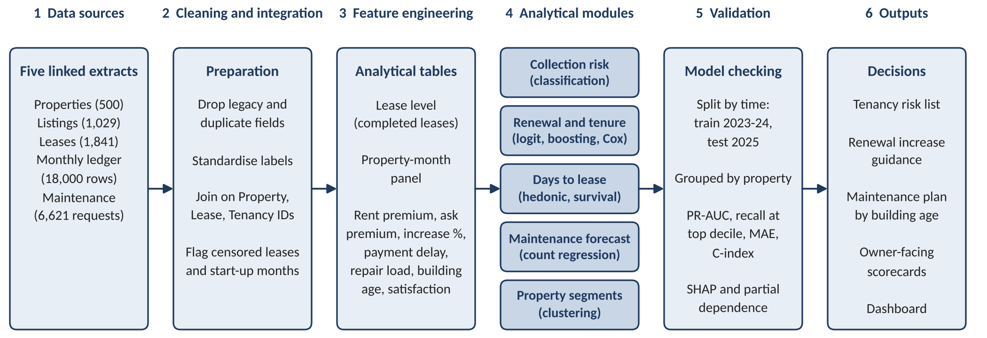
Figure 1. Proposed analytical workflow.
We will join the five tables on property, lease and tenancy identifiers, remove the non-informative fields, standardise labels and flag censored leases and the start-up months. Two analytical tables follow: a lease-level table of completed leases, with features such as rent premium over reference, proposed increase, term, lease sequence, average payment delay, repair requests and resolution days during the lease, building age, amenity score and transit distance; and a property-month panel for payments, maintenance and yield. After exploratory checks, each module starts with an interpretable baseline (logistic or hedonic regression) and is compared with gradient boosting, with Cox models for tenure and listing duration and clustering for property segments.
Models are trained on 2023 to 2024 and tested on 2025, with groups kept together by property, and judged on precision-recall AUC and recall in the top risk decile for the classifiers, MAE for forecasts and the concordance index for survival models, plus calibration and sensitivity checks. SHAP and partial dependence plots then show which factors move the outcome. This addresses the problem by turning separate reports into one linked view: tenancies likely to pay late can be followed up early, renewal increases can be set with the retention cost in view, repair budgets can follow building age, and owners receive a consistent explanation of each property’s result.
5. Proposed Timeline
Activity (weeks) | W1 | W2 | W3 | W4 | W5 | W6 | W7 | W8 | W9 | W10
Data understanding and quality audit
Cleaning, integration, feature building
Exploratory analysis, objective refinement
Model development
Evaluation and interpretation
Dashboard and recommendations
Final report and presentation
Milestones: quality audit and data dictionary (week 2), analytical tables (week 4), baseline models (week 6), final models and interpretation (week 8), final report and presentation (week 10).
6. Expected Deliverables and Outputs
- Data analysis report with the cleaned, joined dataset and a data dictionary.
- Collection-risk, renewal, days-to-lease and maintenance models, with evaluation results and the property segmentation.
- Interactive dashboard covering portfolio, property and tenancy-risk views.
- Business recommendations on collections follow-up, renewal increases, listing strategy and maintenance planning.
- Final presentation and technical documentation (reproducible code and modelling notes).
- Deployment proposal: monthly scoring run, alert thresholds and a monitoring plan.
References
[1] Rosen, S. (1974). Hedonic prices and implicit markets: product differentiation in pure competition. Journal of Political Economy, 82(1), 34-55.
[2] Sirmans, G. S., Macpherson, D. A., & Zietz, E. N. (2005). The composition of hedonic pricing models. Journal of Real Estate Literature, 13(1), 3-43.
[3] Phillips, R. L. (2005). Pricing and Revenue Optimization. Stanford University Press.
[4] Neslin, S. A., Gupta, S., Kamakura, W., Lu, J., & Mason, C. H. (2006). Defection detection: measuring and understanding the predictive accuracy of customer churn models. Journal of Marketing Research, 43(2), 204-211.
[5] Cox, D. R. (1972). Regression models and life-tables. Journal of the Royal Statistical Society: Series B, 34(2), 187-220.
[6] Lessmann, S., Baesens, B., Seow, H.-V., & Thomas, L. C. (2015). Benchmarking state-of-the-art classification algorithms for credit scoring. European Journal of Operational Research, 247(1), 124-136.
[7] Chen, T., & Guestrin, C. (2016). XGBoost: a scalable tree boosting system. Proceedings of KDD 2016, 785-794.
[8] Lundberg, S. M., & Lee, S.-I. (2017). A unified approach to interpreting model predictions. Advances in Neural Information Processing Systems 30.
[9] Bergmeir, C., & Benitez, J. M. (2012). On the use of cross-validation for time series predictor evaluation. Information Sciences, 191, 192-213.

