Create product table with field (pid, prodname, original_price, selling_date)

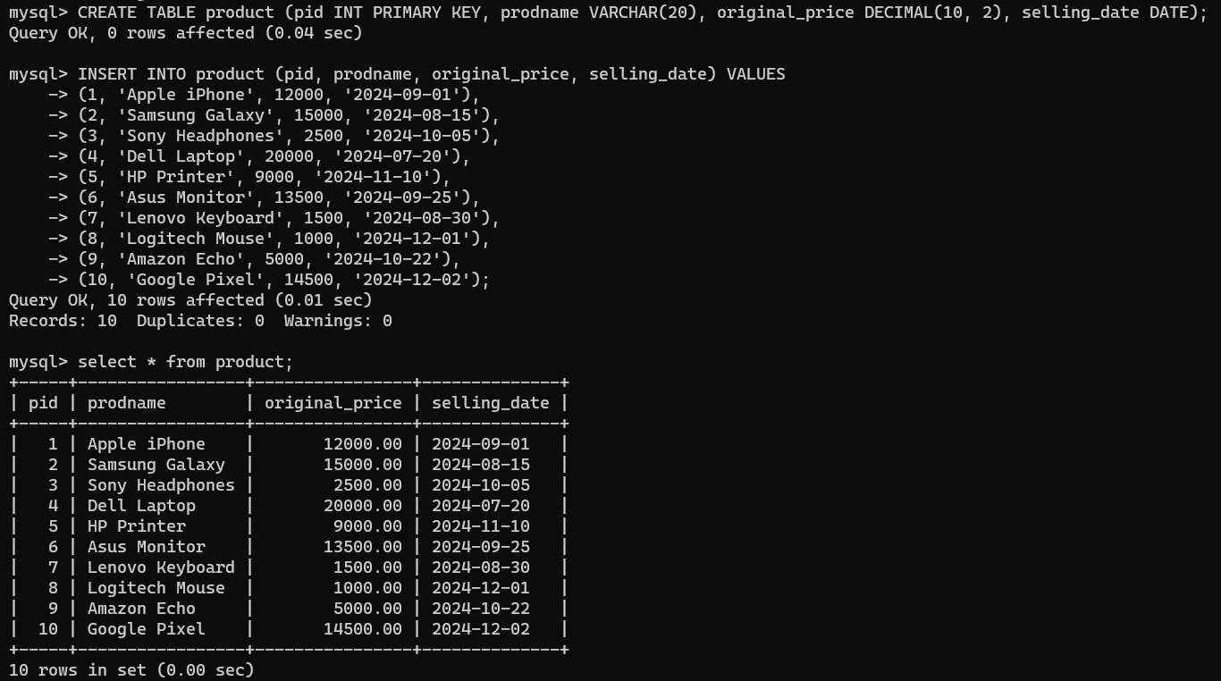

1)Write a query to list down all the products whose cost is between 2000 to 15000

Query:



Output:

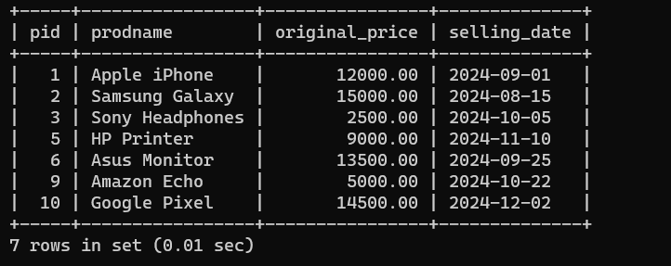

2)Write a query to list down all the products whose prodname is between 'a' and ' j'

Query:



Output:

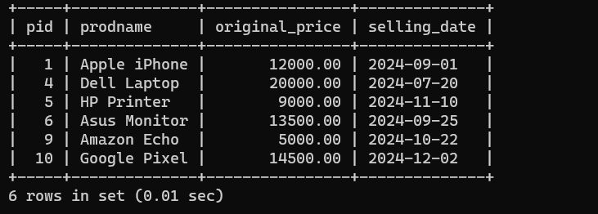

3)Write a query to list down product selling between 2024-08-12 and 2024-12-03

Query:



Output:

