**SMART WATER MANAGEMENT**

IOT PHASE_4

Regno:610821106023

Name: R.Gayathri

Designing the platform to display water consumption data from IoT sensors and promote water conservation efforts (using html, CSS and JS).

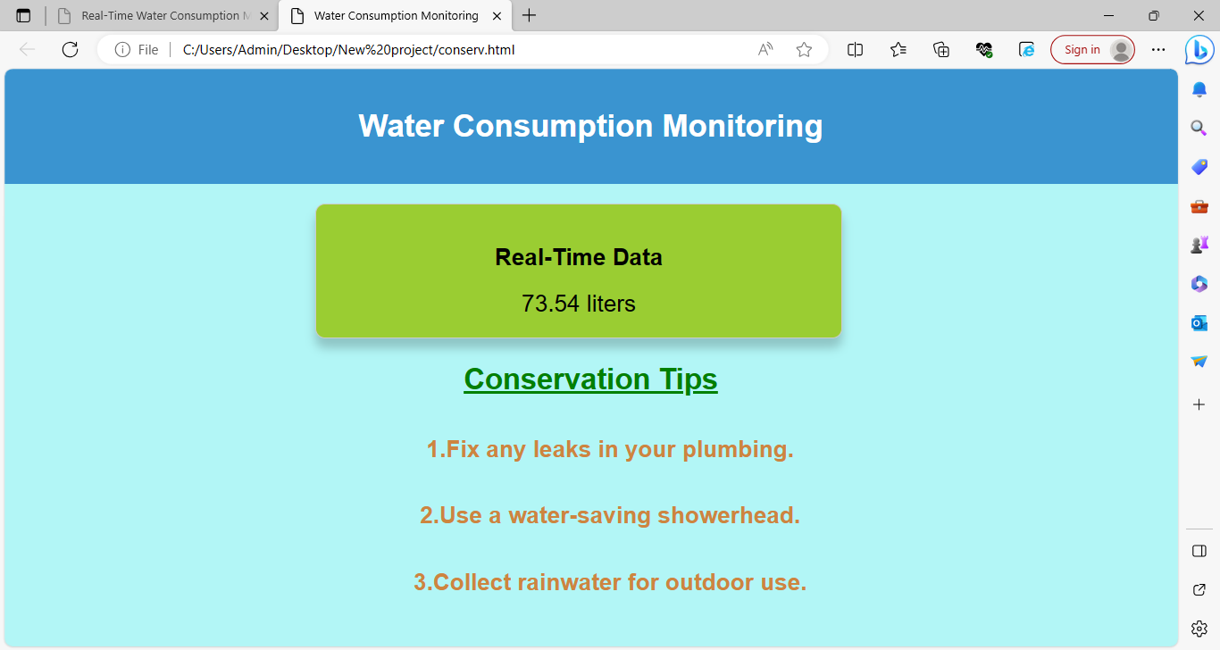

The webpage displays the real time data of water level based on the information given by the sensors.

**HTML:**

<!DOCTYPE html>

<html>

<head>

<title>Water Consumption Monitoring</title>

<link rel="stylesheet" type="text/css" href="style.css">

</head>

<body>

<header>

<h1>Water Consumption Monitoring</h1>

</header>

<main>

<div class="data-container">

<h2>Real-Time Data</h2>

<div class="water-consumption" id="water-consumption">

Loading...

</div>

</div>

<div class="conservation-tips">

<h2>Conservation Tips</h2>

<ul>

<li>Fix any leaks in your plumbing.</li>

<li>Use a water-saving showerhead.</li>

<li>Collect rainwater for outdoor use.</li>

</ul>

</div>

</main>

<script src="script.js"></script>

</body>

</html>

**CSS:**

body {

font-family: Arial, sans-serif;

margin: 0;

padding: 0;

}

header {

background-color: #3498db;

color: #fff;

text-align: center;

padding: 20px;

}

main {

text-align: center;

padding: 20px;

}

.data-container {

border: 1px solid #ccc;

padding: 20px;

border-radius: 5px;

box-shadow: 0 0 10px rgba(0, 0, 0, 0.2);

}

.water-consumption {

font-size: 24px;

}

.conservation-tips {

margin-top: 20px;

}

ul {

list-style-type: disc;

}

ul li {

margin: 10px 0;

}

JavaScript:

document.addEventListener("DOMContentLoaded", function () {

const consumptionElement = document.getElementById("water-consumption");

function updateWaterConsumption() {

const randomConsumption = (Math.random() * 100).toFixed(2);

consumptionElement.textContent = randomConsumption + " liters";

}

setInterval(updateWaterConsumption, 5000);

// Initial data load.

updateWaterConsumption();

});

Using the above frontend code I built the basic prototype of the data sharing platform.