Aerial Guardian: Person Detection and Tracking from Moving Drone Footage
Submission by Gayathri Rangu, PhD Student, Indian Institute of Technology Guwahati, Guwahati, India
Final submission: Fine-tuned YOLO26n with BoT-SORT and sparse optical-flow global motion compensation. The selected configuration achieves MOTA 0.283, IDF1 0.388, and 40.68 FPS on an NVIDIA Tesla P100-PCIE-16GB, using an approximately 5.16 MB checkpoint.

1. Project Overview
This project implements a lightweight aerial multi-object tracking (MOT) pipeline for detecting and tracking persons in moving drone footage (as shown in Figure 1). The main challenges are small target size, frequent camera motion, cluttered backgrounds, and temporary occlusion.
The system produces processed videos with bounding boxes, unique track IDs, and short trajectory tails, along with MOT-format tracker output files. The work is intentionally lightweight: the detector remains far below the 300 MB model-size limit and the final pipeline runs at approximately 40 FPS on the test GPU.
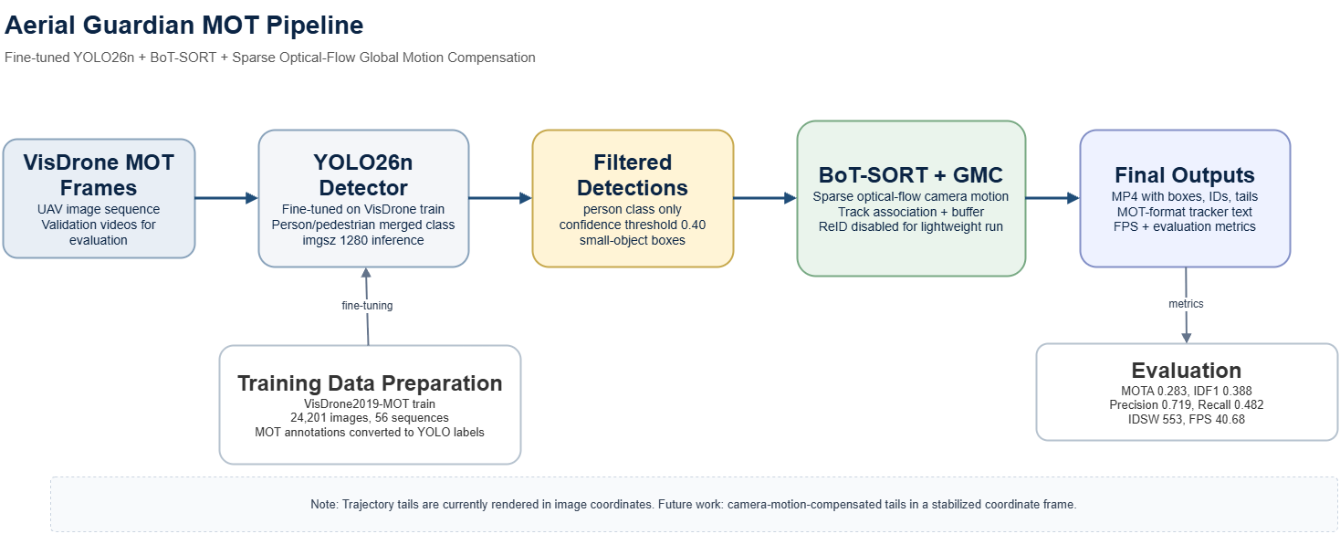
Figure 1: Aerial Guardian Multi-Person Tracking Pipeline for Aerial Imagery.

2. Dataset Preparation and Conversion
Fine-tuning was performed on the VisDrone2019-MOT train split, which contains 24,201 images across 56 video sequences. The training dataset is large and was prepared in a separate working repository/folder, so it is not committed inside this lightweight submission repository (current one).
The assignment evaluation and output videos use the VisDrone2019-MOT validation set. In the locally available validation annotations, the merged person target contains 50,312 boxes from the pedestrian and person categories. The median annotated target size is approximately 33 x 66 pixels, which supports the small-object detection focus of the design.
The original VisDrone MOT labels are tracking annotations: each row contains frame ID, object ID, bounding box, score, class, truncation, and occlusion information. YOLO detector training requires a different format: one label text file per image, with class ID and normalized box center/width/height. Therefore, the conversion script was used to transform MOT annotations into YOLO labels.
Item | Value
Training split | VisDrone2019-MOT train: 24,201 images across 56 video sequences
Evaluation split | VisDrone2019-MOT validation set
Class mapping and Format Conversion | VisDrone pedestrian and person categories merged into one person class. YOLO training requires per-image normalized detector labels rather than MOT tracking rows (refer to scripts/convert_visdronemot_to_yolo.py)

3. Detector Choice and Fine-Tuning
YOLO26n was selected because it is fast, small, and suitable for later edge deployment. A generic pretrained detector is not ideal for high-altitude drone imagery because persons are often tiny, partially occluded, and visually different from ground-level training examples. Fine-tuning on VisDrone person labels was the main adaptation step.
- Training used image size 1024, batch size 16, AdamW optimizer, and 50 epochs.
- Training ran for roughly 15 hours on the GPU setup used for experimentation.
- Mosaic and mixup augmentations were used to improve robustness to scale, density, and scene variation.
- Inference used image size 1280 to preserve more detail for small persons during tracking.
- The fine-tuning curves and validation prediction examples are included in the results folder.

4. Tracking Rationale and ID Stability
Both ByteTrack and BoT-SORT were evaluated. ByteTrack is attractive because it is lightweight and uses both high-confidence and low-confidence detections during association. However, its motion model relies on a Kalman filter that assumes most coordinate changes come from object motion. In drone footage, the entire scene can shift when the drone tilts, translates, or rotates, so image-space predictions can miss the new object positions even when the target itself moved smoothly.
To reduce this failure mode, global motion compensation (GMC) was introduced. Sparse optical flow estimates how stable background structures such as roads, buildings, and trees move between frames. The tracker can then account for camera-induced motion before associating detections. BoT-SORT was also tested because it provides stronger association behavior than the baseline ByteTrack setup, while ReID was kept disabled to preserve the lightweight deployment path.
- GMC addresses drone camera motion before track association.
- The 0.40 confidence threshold suppresses noisy detections that create unstable short tracks.
- A longer track buffer helps recover identities after brief disappearance or occlusion.
- ReID was not enabled because the assignment emphasized a lightweight solution and model-size efficiency.

5. Experiments and Results
The experiments were structured as ablations as shown in Table 1. E01 and E02 establish the baselines, E03 shows the effect of fine-tuning with ByteTrack, E04 tests ByteTrack with GMC, and E05 tests BoT-SORT with GMC as the final balanced setting.
Experiment | Detector | Tracker | Key setting | MOTA | IDF1 | Prec. | Recall | IDSW | FPS
E01 | YOLO26n | ByteTrack | Baseline | 0.242 | 0.282 | 0.807 | 0.334 | 581 | 41.06
E02 | Fine-tuned YOLO26n | BoT-SORT | conf=0.40 | 0.245 | 0.292 | 0.804 | 0.339 | 570 | 42.01
E03 | Fine-tuned YOLO26n | ByteTrack | conf=0.40 | 0.275 | 0.369 | 0.722 | 0.469 | 684 | 42.07
E04 | Fine-tuned YOLO26n | ByteTrack + GMC | tuned thresholds | 0.280 | 0.381 | 0.719 | 0.478 | 531 | 40.11
E05 | Fine-tuned YOLO26n | BoT-SORT + GMC | final setting | 0.283 | 0.388 | 0.719 | 0.482 | 553 | 40.68
Table 1: Ablation Study of Detector Fine-Tuning, GMC, and Tracker Variants on the VisDrone MOT Validation-Set
The final E05 configuration achieved the best overall MOTA and IDF1 while maintaining 40.68 FPS. E04 produced fewer ID switches, which confirms that GMC helps with identity stability, but E05 provided the best balanced setting across MOTA, IDF1, recall, and runtime.
Output videos are generated in outputs/E05_botsort_conf40_person_ft_gmc/videos/. The submission video is deliverables/baseline_vs_final_all_validation_youtube.mp4, a side-by-side compilation of all validation videos.
YouTube submission video: https://youtu.be/mpWsv7NLktM

6. Key Engineering Takeaways
- Fine-tuning was the largest improvement because the baseline detector missed many small aerial persons.
- Higher recall alone was not sufficient for MOT; noisy detections increased false positives and unstable track creation.
- Global motion compensation helped reduce camera-motion-related association errors.
- BoT-SORT + GMC gave the strongest balanced result while remaining lightweight enough for edge-oriented optimization.

7. Edge Deployment Plan
For NVIDIA Jetson, Qualcomm RB5 Robotics Board, or similar edge platforms, the detector can be exported to ONNX/TensorRT or another supported runtime. The nano detector should remain the default because it offers a practical size-speed trade-off.
- Export YOLO26n to ONNX or TensorRT for accelerated inference.
- Use FP16 inference where supported by the hardware.
- Keep batch size at 1 for streaming drone video.
- Tune input size between 960 and 1280 depending on altitude and FPS requirements.
- Keep ReID disabled initially; add lightweight ReID only if occlusion-heavy scenes require it.

8. Limitations and Future Work
The current trajectory tails are drawn in raw image coordinates. When the drone camera moves sharply, old tail points move with the camera view, so the tail can look unstable even when the tracked ID is mostly correct. This is a visualization limitation and can be improved by transforming historical tail points using the estimated camera motion or by rendering tails in a stabilized coordinate frame.
- Camera-motion-compensated trajectory tails.
- Selective SAHI/tiled inference for extremely small targets, with care because tiling is computationally expensive.
- TensorRT or ONNX benchmarking on Jetson/RB5 hardware.
- Adaptive confidence thresholding for dense versus sparse scenes.

9. Deliverables
- Code repository with setup, training/fine-tuning, tracking, and evaluation instructions.
- Processed output video with bounding boxes, unique IDs, and trajectory tails.
- Summary report explaining architecture choices, small-object handling, ID-switch mitigation, FPS, hardware, and edge deployment plan.

Additional Information: Fine-Tuning Results and Visual Evidence
The detector was fine-tuned from the YOLO26n base checkpoint on the VisDrone2019-MOT train split after converting the original MOT annotations into YOLO detector labels. This step was important because generic pretrained weights are not optimized for high-altitude UAV views where persons often occupy only a few dozen pixels.
Epoch | Precision | Recall | mAP50 | mAP50-95
50 | 0.901 | 0.840 | 0.912 | 0.546
By the final epoch, the fine-tuned detector reached approximately 0.901 precision, 0.840 recall, 0.912 mAP50, and 0.546 mAP50-95 on the detector validation run. The improvement trend in the training curves shows that the model adapted well to the aerial-person domain while remaining very small: the final checkpoint is approximately 5.16 MB. The detector was trained as a person-focused model by merging VisDrone pedestrian and person categories. The fine-tuned detector improved small-person sensitivity, which was the main driver behind the MOT recall and IDF1 gains which can be observed from Figures 2,3 and 4.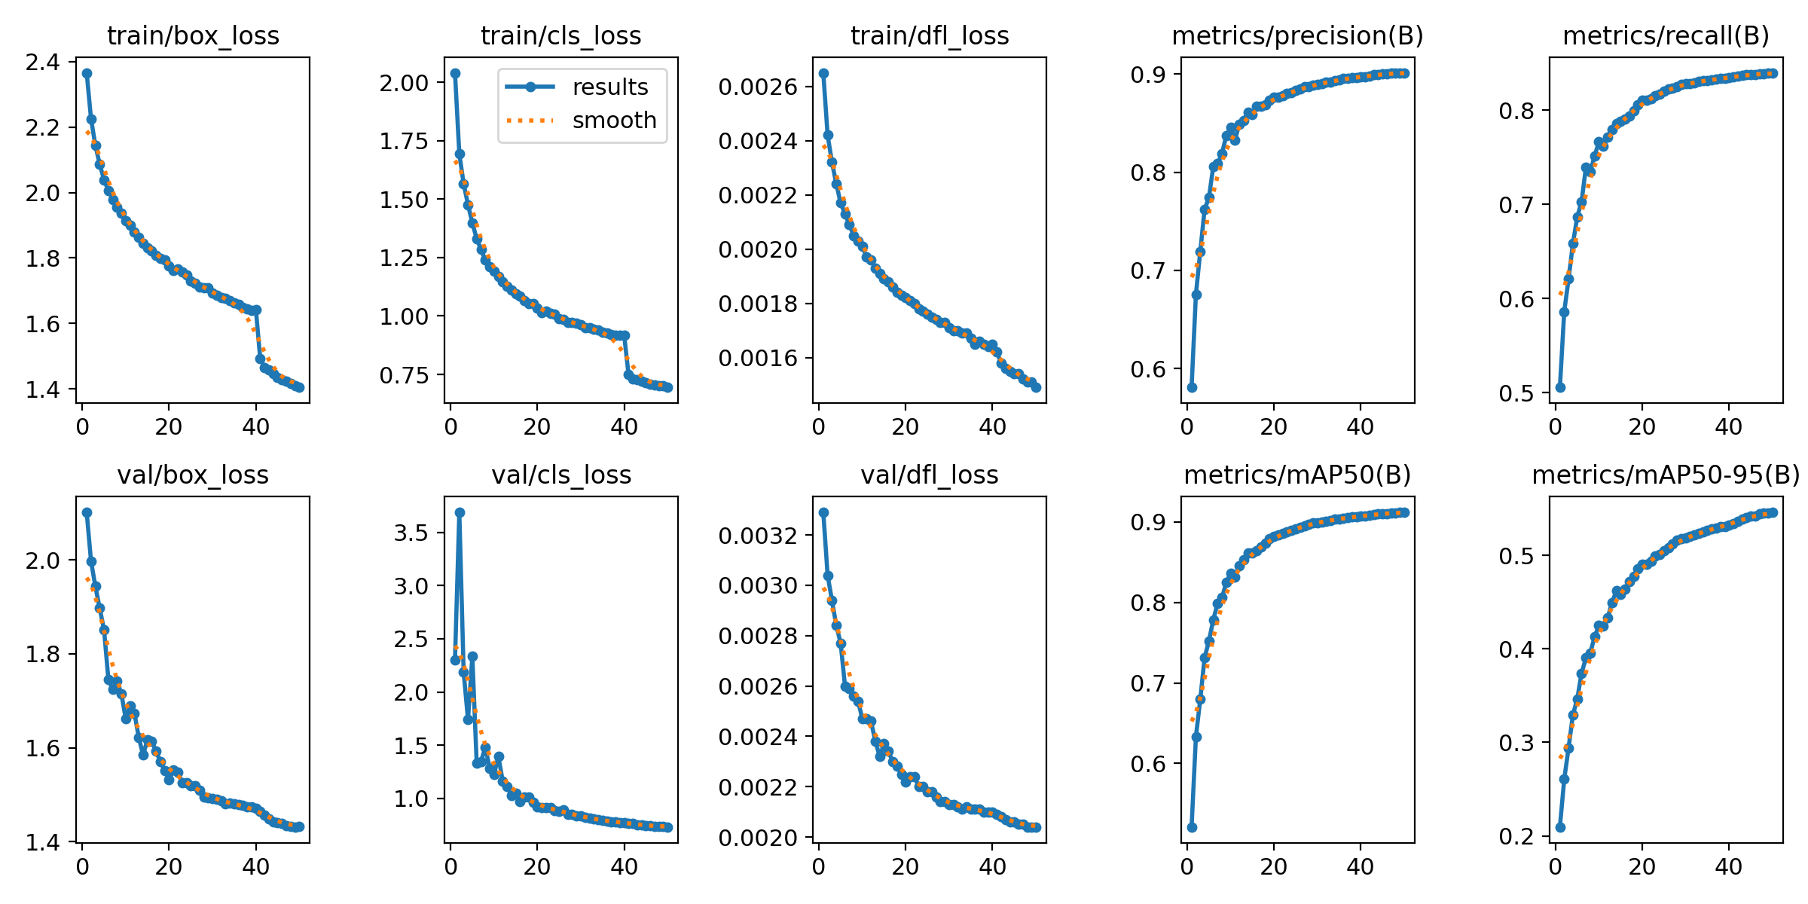
Figure 2. Fine-tuning losses and validation metrics across 50 epochs.
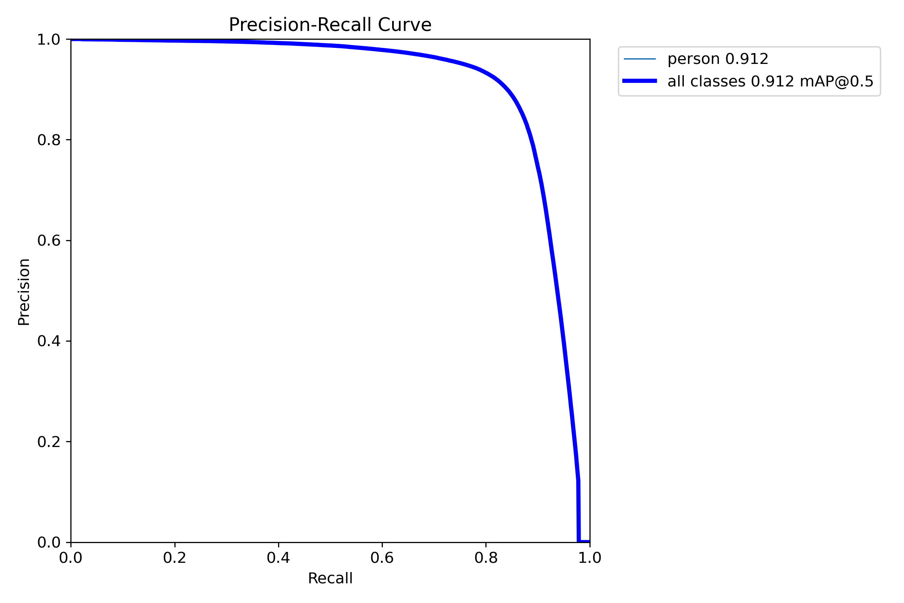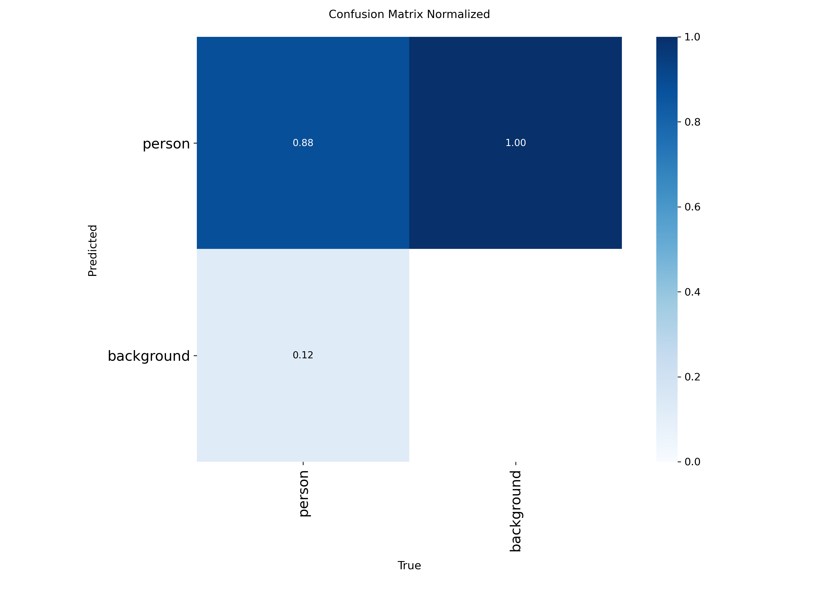
Figure 3. Precision-recall curve for the fine-tuned person detector and Normalized confusion matrix for the fine-tuned detector.

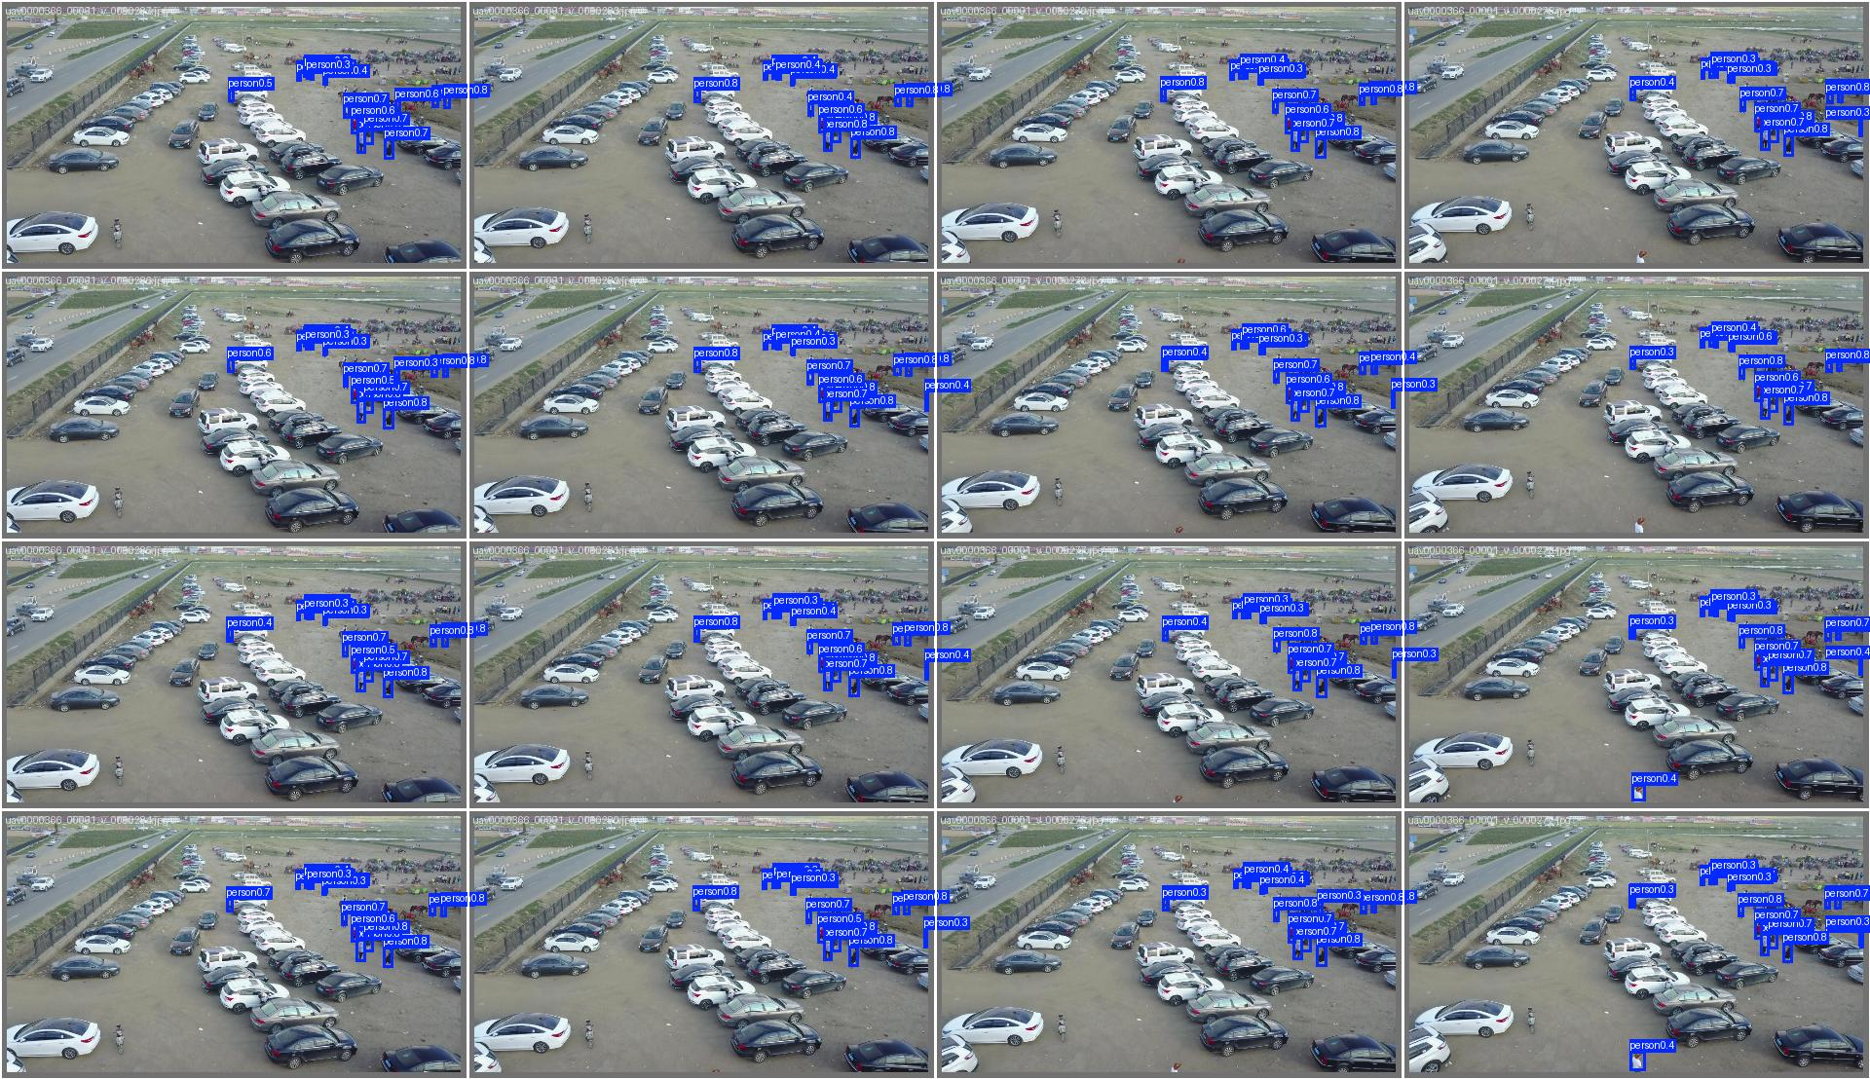
Figure 5. Example validation predictions from the fine-tuned detector.

------------------------------------------------- Thank You! Happy Learning! -----------------------------------------------

Chakrabarty, S., 2026. Yolo26: An analysis of NMS-free end to end framework for real-time object detection. arXiv preprint arXiv:2601.12882.
Zhang, Y., Sun, P., Jiang, Y., Yu, D., Weng, F., Yuan, Z., Luo, P., Liu, W. and Wang, X., 2022, October. Bytetrack: Multi-object tracking by associating every detection box. In European conference on computer vision (pp. 1-21). Cham: Springer Nature Switzerland.
Aharon, N., Orfaig, R. and Bobrovsky, B.Z., 2022. BoT-SORT: Robust associations multi-pedestrian tracking. arXiv preprint arXiv:2206.14651.
Cagatay Akyon, F., Cengiz, C., Onur Altinuc, S., Cavusoglu, D., Sahin, K. and Eryuksel, O., SAHI: A lightweight vision library for performing large scale object detection and instance segmentation. Zenodo.

