EXPERIMENT – 5

NAME: GAYATHRI JAYAM S ROLLNO: 240701142
Consider task analysis for an app and document user flows. Create corresponding wireframes using Lucid chart.
Task Analysis:
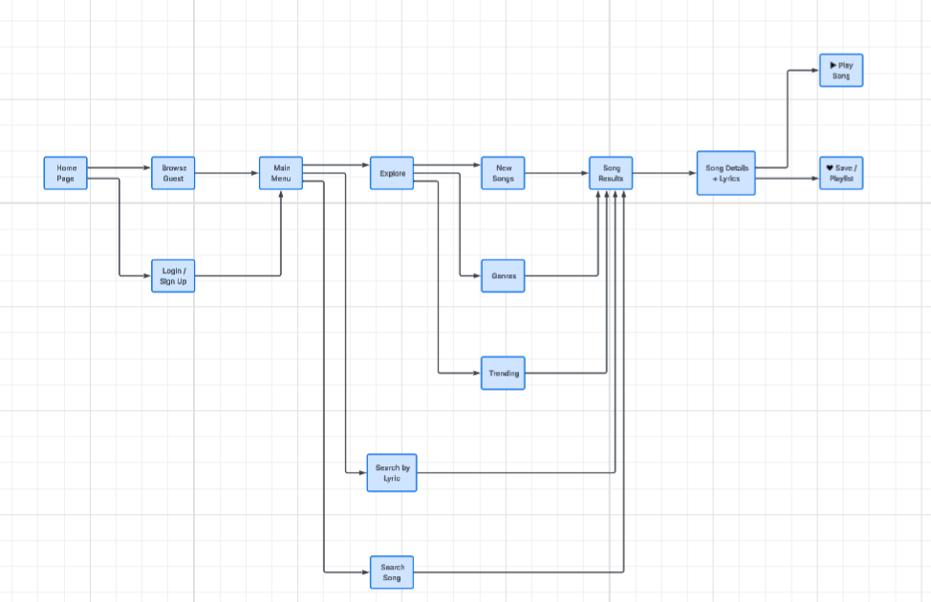
Task analysis is the process of breaking down a user's goal into smaller, actionable steps to understand how they interact with an application. It helps designers identify user needs, pain points, and areas for improvement.
Application considered: Find My Song Website (Song identification and discovery platform)
User Goal: Find a song by searching, filtering, or identifying it
Task Breakdown:
- Open the website
- Login or Sign up (optional for basic search)
- Choose a method to find a song:
  - Search by song name, artist, or lyrics
  - Upload an audio clip or hum a tune
  - Browse by genre, mood, or playlist
- View search results
- Select the correct song from results
- Listen to a preview or full song
- View song details (artist, album, lyrics, release year)
- Save song to playlist or favorites
- Share the song link with others
User Flow:
Homepage → Search/Upload/Identify → Results → Song Details → Save/Play/Share

Wireframe
Wireframes are low-fidelity layouts showing the structure of each webpage. Below are the wireframes created using Lucid chart for the Find Your Song website.

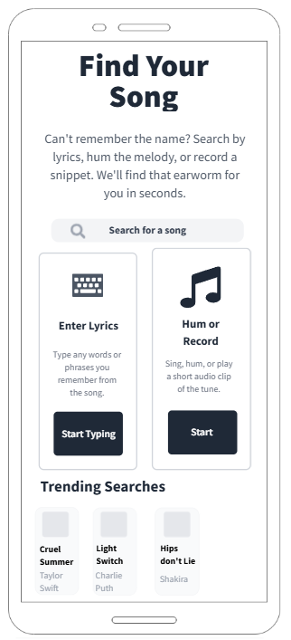

Wireframe 1: Splash Screen / Homepage
- Website logo/name: "Find My Song"
- Search bar (main feature)
- Options: Search by name, lyrics, or upload audio
- Login/Signup buttons
- Browse by genre/mood section

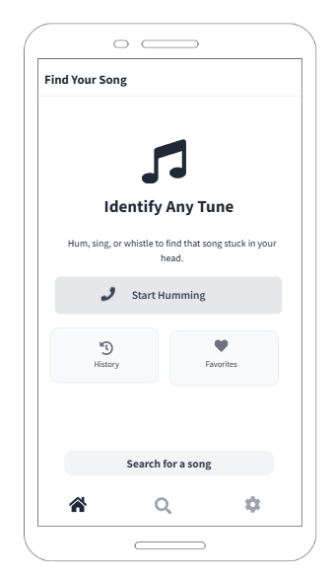
Wireframe 2: Login / Sign Up Page
- Email input field
- Password input field
- "Login" button
- "Sign Up" link for new users
- "Forgot Password" option
- Google/Facebook login options

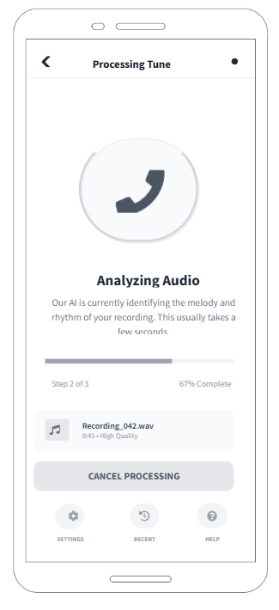
Wireframe 3: Search Results Page
- List of matching songs
- Each result shows: Song name, Artist name, Album art
- "Play Preview" button for each song
- "View Details" button
- Filter options (by artist, album, year)
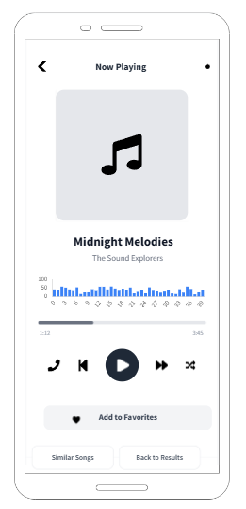
Wireframe 4: Song Details Page
- Song name and artist
- Album cover image
- Release year and genre
- Lyrics section
- "Play Full Song" button
- "Add to Playlist" button
- "Share" button
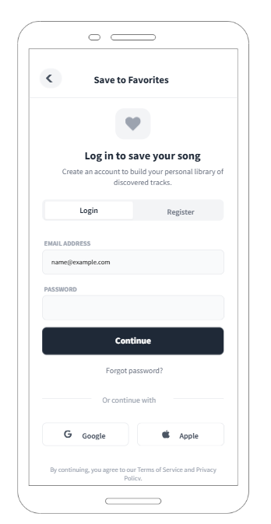
Wireframe 5: Audio Upload / Hum to Find Page
- "Upload Audio File" button
- "Click to Hum / Sing" button (mic access)
- Progress indicator while analyzing
- "Search Similar Song" button
- Status message: "Analyzing..."
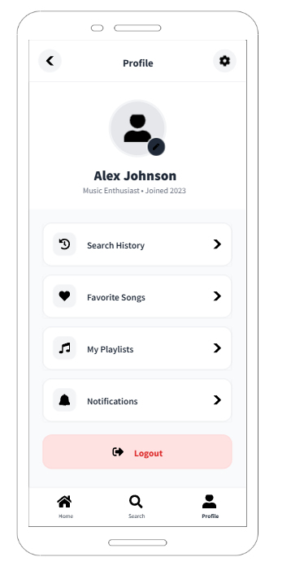

Wireframe 6: My Playlists / Favorites Page
- List of user's saved playlists
- Each playlist shows: Name, number of songs, cover art
- "Create New Playlist" button
- "Recently Added" section
- Option to remove songs

