EXPERIMENT-6

NAME: GAYATHRI JAYAM S ROLLNO:240701142
Simulate the life cycle states for UI design using the RAD model and develop a small interactive interface (azure.rp,open proj)
RAD MODEL work flow diagram:
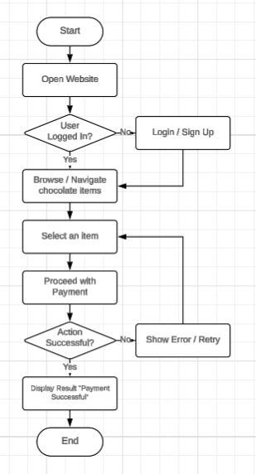

PROCEDURE:
Phase 1: Requirement Analysis
- Defined Application Objective:
Developed a web-based employee management prototype named HR Portal to streamline employee data handling and leave requests.
- Collected Functional Requirements:
  - Login Screen: Secure access using employee ID and password.
  - Dashboard Module: Displays key metrics — total employees, pending leaves, attendance summary.
  - Employee List Screen: Shows all employee records with search and filter options.
  - Employee Details Screen: View/edit individual employee information (name, department, role).
  - Leave Request Module: Form to submit new leave requests with date and reason.
  - Leave Status Module: Displays submitted requests and approval status.
  - Admin Panel: For approving/rejecting leave requests (admin only).
  - Logout Module: Ends session and returns to login screen.
- Prepared Workflow:
Mapped the process from login → dashboard → leave request → admin approval → status update → logout.
Phase 2: Interface Design
- Started Axure RP Project:
Created a prototype project titled HR Portal System.
- Screen Design Activities:
  - Designed all screens in desktop web format.
  - Applied a clean blue-and-white corporate color palette for professional branding.
  - Used table layouts for employee lists and leave records.
  - Positioned navigation menu on the left sidebar for easy access.
  - Used clear buttons and form fields for data entry.
- Usability Notes Added:
Added labels, placeholder text, and tooltips for smooth user interaction.
Phase 3: Prototype Development
- Built Interactive Navigation:
  - Login button redirects to Dashboard.
  - Clicking an employee name opens Employee Details screen.
  - Submit Leave button moves to Leave Request page.
  - Admin login shows additional Admin Panel menu.
  - Approve/Reject buttons update leave status dynamically.
  - Logout button returns to Login screen.
- Improved User Experience:
  - Tested all clickable links and screen transitions.
  - Adjusted spacing, font size, and alignment for readability.
  - Ensured smooth web-based simulation.
Phase 4: Implementation & Delivery
- Final Review:
Verified complete employee management flow, admin approval process, and logout functionality.
- Prototype Export:
Published the final clickable prototype via browser preview / Axure share link for presentation.
