EXPERIMENT 1
ROLL NO: 240701142 NAME: GAYATHRI JAYAM S

USER INTERFACE AND DESIGN

COMPARISON OF UI DESIGN BETWEEN TWO FIGMA CREATION

BAD WEBSITE :

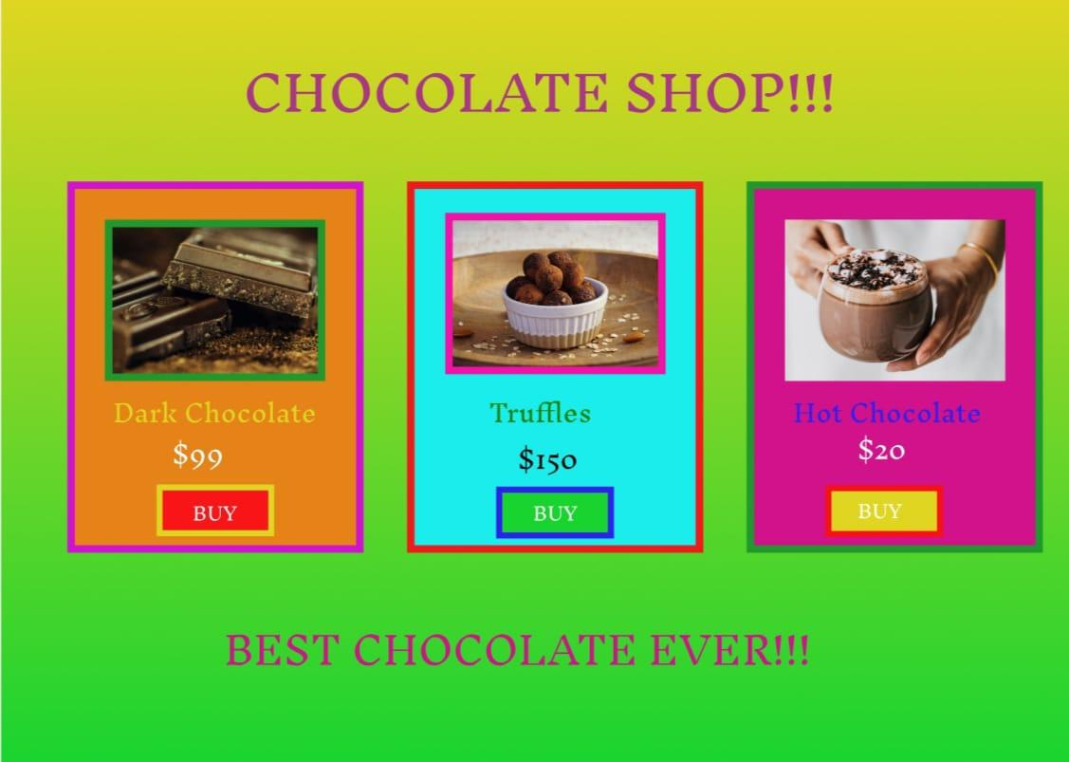

GOOD WEBSITE :

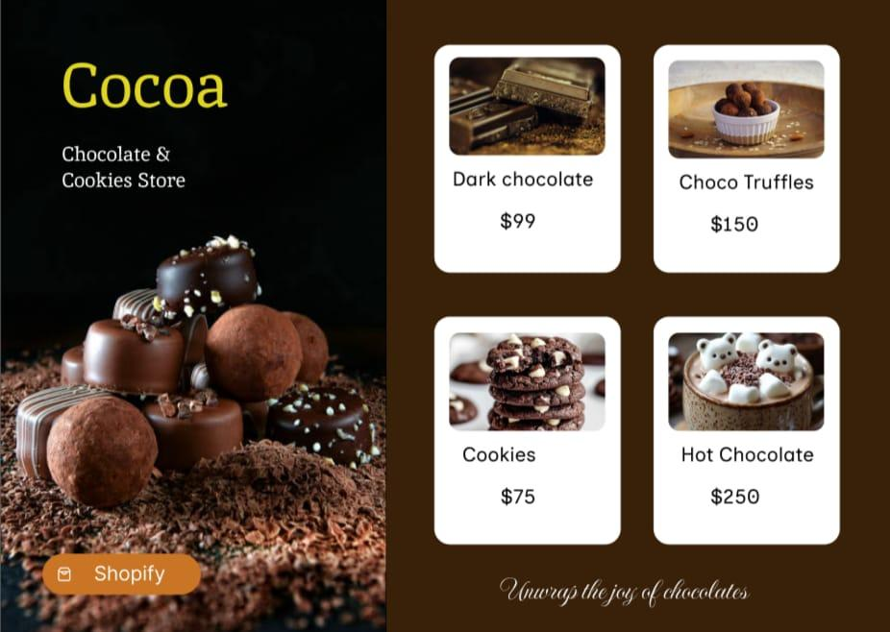

PROTOTYPE LINK:

https://www.figma.com/design/Xc8D78suF3dbIY83wp6M12/UID-EXP1?node-id=0-1&t=5RlUYTbiRXUWM1Yl-1

The two websites have distinct designs and approaches. Here’s comparison:

BAD WEBSITE (Chocolate Shop)

1. Design Style
- Uses too many bright and clashing colors.
- Heavy borders make the design look crowded and outdated

2. Color & Typography
- Poor color contrast reduces text readability.
- Inconsistent fonts and excessive capital letters look unprofessional.

3. Layout & Alignment
- Uneven spacing between product cards.
- Boxed layout makes the page feel cluttered and heavy.

4. Visual Hierarchy
- No clear priority between images, prices, and buttons.
- User attention is not guided properly.

5. Navigation & Interaction
- Inconsistent “BUY” button styles confuse users.
- Buttons do not stand out clearly as call-to-actions.

6. Purpose & Branding
- No clear brand theme or identity.
- Overall design fails to build trust with users.

GOOD WEBSITE (Chocolate & Cookies Store)

1. Design Style
- Uses a clean, minimal, and modern layout.
- Dark chocolate-themed background creates a premium and appetizing feel.

2. Color & Typography
- Consistent color palette (brown, white, cocoa tones) improves visual harmony.
- Simple, readable fonts enhance clarity and professionalism.

3. Layout & Alignment
- Well-structured grid layout with evenly spaced product cards.
- Balanced left image section and right product section improve readability.

4. Visual Hierarchy
- Clear hierarchy: brand name → product images → product names → prices.
- Users can easily scan and understand the content at a glance.

5. Navigation & Interaction
- Clear call-to-action button (“Shopify”) stands out without being distracting.
- Product cards are simple and easy to interact with.

6. Purpose & Branding
- Strong brand identity with a clear chocolate & cookies theme.
- Design builds trust and clearly communicates the purpose of selling products.

KEY DIFFERENCES: BAD vs GOOD Chocolate Website

1. Design Style
- Bad Website: Uses excessive bright colors and heavy borders, creating a cluttered look.
- Good Website: Uses a clean, minimal design with a consistent chocolate-themed style.

2. Color & Typography
- Bad Website: Poor color contrast and inconsistent fonts reduce readability.
- Good Website: Harmonious color palette and readable fonts improve clarity.

3. Layout & Alignment
- Bad Website: Uneven spacing and boxed cards make the layout look messy.
- Good Website: Proper grid alignment and balanced spacing create a clean structure.

4. Visual Hierarchy
- Bad Website: No clear hierarchy; all elements compete for attention.
- Good Website: Clear hierarchy guides users from brand name to products and prices.

5. Navigation & Interaction
- Bad Website: Inconsistent button styles confuse users.
- Good Website: Clear and consistent call-to-action improves user interaction.

6. Purpose & Branding
- Bad Website: Lacks a clear brand identity and purpose.
- Good Website: Strong branding clearly communicates the chocolate & cookies theme.

