EXPERIMENT-3
Name: Gayathri Jayam S
Roll No :230701142

OPERATION: File Copy
1.COMMAND LINE INTERFACE:
import os
import shutil

def copy_file(source, destination):
if not os.path.exists(source):
print("Error: Source file does not exist.")
return

if os.path.exists(destination):
print("Error: Destination file already exists.")
return

shutil.copy(source, destination)
print(f"File copied successfully from '{source}' to '{destination}'.")

while True:
command = input("➜ ").strip()

if command.lower() == "exit":
print("Exiting program.")
break

parts = command.split()

if len(parts) == 3 and parts[0].lower() == "copy":
source = parts[1]
destination = parts[2]
copy_file(source, destination)
else:
print("Invalid command format.")
print("Use: copy source_file destination_file")

OUTPUT:
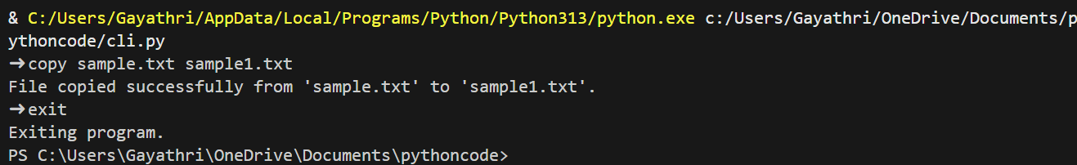

2.GRAPHICAL USER INTERFACE:
import os
import shutil
import tkinter as tk
from tkinter import messagebox

# -------- Placeholder Logic --------
def add_placeholder(entry, text):
entry.insert(0, text)
entry.config(fg="gray")

def on_focus_in(event):
if entry.get() == text:
entry.delete(0, tk.END)
entry.config(fg="black")

def on_focus_out(event):
if entry.get() == "":
entry.insert(0, text)
entry.config(fg="gray")

entry.bind("<FocusIn>", on_focus_in)
entry.bind("<FocusOut>", on_focus_out)

# -------- Duplicate Function --------
def duplicate_file():
source = source_entry.get().strip()
destination = dest_entry.get().strip()

source_entry.config(highlightbackground="#cccccc")
dest_entry.config(highlightbackground="#cccccc")

if source == "Source file path" or source == "":
source_entry.config(highlightbackground="red")
messagebox.showerror("Error", "Please enter source file path.")
return

if destination == "Destination file path" or destination == "":
dest_entry.config(highlightbackground="red")
messagebox.showerror("Error", "Please enter destination file path.")
return

if not os.path.isfile(source):
source_entry.config(highlightbackground="red")
messagebox.showerror("Error", "Source file does not exist.")
return

if os.path.exists(destination):
dest_entry.config(highlightbackground="red")
messagebox.showerror("Error", "Destination file already exists.")
return

try:
shutil.copy(source, destination)
root.destroy()
messagebox.showinfo("Success", "File duplicated successfully!")
except Exception as e:
messagebox.showerror("Error", str(e))

# -------- Main Window --------
root = tk.Tk()
root.title("📄 File Duplicator")
root.geometry("650x400")
root.configure(bg="#f4f6f9")

# Shadow Frame
shadow = tk.Frame(root, bg="#d9dde3")
shadow.place(relx=0.5, rely=0.5, anchor="center", width=480, height=360)

card = tk.Frame(root, bg="white")
card.place(relx=0.5, rely=0.5, anchor="center", width=480, height=340)

# Title
tk.Label(card, text="📄 Duplicate Your File",
font=("Segoe UI", 18, "bold"),
bg="white").pack(pady=20)

# Source Label
tk.Label(card, text="📂 Source File",
font=("Segoe UI", 11),
bg="white").pack()

# Source Entry
source_entry = tk.Entry(card,
font=("Segoe UI", 12),
relief="flat",
highlightthickness=2,
highlightbackground="#cccccc")
source_entry.pack(pady=8, ipadx=8, ipady=8)

# Destination Label
tk.Label(card, text="📝 Destination File",
font=("Segoe UI", 11),
bg="white").pack()

# Destination Entry
dest_entry = tk.Entry(card,
font=("Segoe UI", 12),
relief="flat",
highlightthickness=2,
highlightbackground="#cccccc")
dest_entry.pack(pady=8, ipadx=8, ipady=8)

add_placeholder(source_entry, "Source file path")
add_placeholder(dest_entry, "Destination file path")

# Duplicate Button
duplicate_btn = tk.Button(card,
text="✔ Duplicate",
font=("Segoe UI", 14, "bold"),
bg="#4CAF50",
fg="white",
activebackground="#43a047",
relief="flat",
padx=30,
pady=14,
command=duplicate_file)
duplicate_btn.pack(pady=25)

# Hover effect
def on_enter(e):
duplicate_btn.config(bg="#43a047")

def on_leave(e):
duplicate_btn.config(bg="#4CAF50")

duplicate_btn.bind("<Enter>", on_enter)
duplicate_btn.bind("<Leave>", on_leave)
root.mainloop()

OUTPUT:

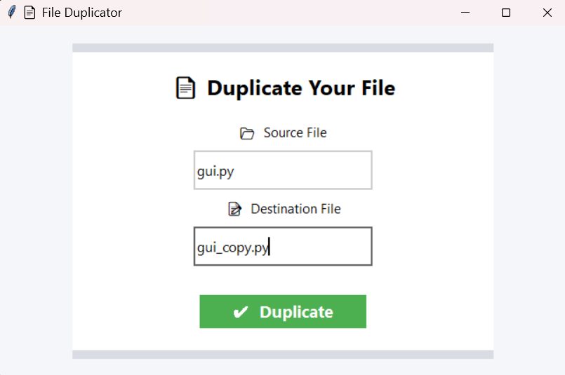
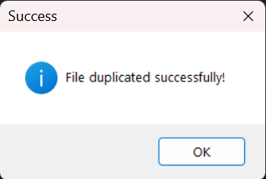

3.VOICE USER INTERFACE:
import os
import shutil
import speech_recognition as sr

recognizer = sr.Recognizer()
print("🎤 Listening for command to copy a file...")

with sr.Microphone() as source:
recognizer.adjust_for_ambient_noise(source)
audio = recognizer.listen(source,timeout=5,phrase_time_limit=10)
try:
command = recognizer.recognize_google(audio).lower()
print("Command received:", command)

# Expected format: copy oldfile.txt to newfile.txt
if "copy" in command and "to" in command:
parts = command.split()
old_file = parts[parts.index("copy") + 1]
new_file = parts[parts.index("to") + 1]

if not os.path.isfile(old_file):
print("❌ Source file does not exist.")
elif os.path.exists(new_file):
print("❌ Destination file already exists.")
else:
shutil.copy(old_file, new_file)
print(f"✅ File copied from {old_file} to {new_file}")

else:
print("❌ Invalid command format. Say: 'Copy oldfile.txt to newfile.txt'")

except Exception:
print("❌ Sorry, I couldn't understand the command.")
OUTPUT:

