Experiment -5
Name: Gayathri Jayam S Roll No: 240701142

Problem Statement:
Design a Task Flow for a website and a simple wireframe to illustrate the framework of the website flow
Task Flow Chart:
Topic: Find your song

Chunking is a cognitive strategy that breaks complex information into smaller,
manageable units, making it easier for users to process, understand, and remember instructions. The Sequence Builder instruction page effectively applies chunking in the following ways:
1. Clear and Sequential Numbering
- The instructions are presented in a numbered format, guiding users through the task step by step.
- Each step focuses on a single action, reducing cognitive overload and improving clarity.
2. Logical Grouping of Task Phases
- Observation Phase (Steps 1–2) → Users are informed about viewing and observing the sequence.
- Transition Phase (Step 3) → Users are prepared for the random rearrangement of items.
- Reconstruction Phase (Steps 4–5) → Users actively recreate the sequence and understand scoring.
- Completion Phase (Step 6) → Users submit their sequence to finish the round.

3. Visual Hierarchy and Design Support
- The bold title “SEQUENCE BUILDER” clearly communicates the game’s
objective.
- Proper spacing and alignment improve readability and visual flow.
- The “Let’s go!!” button is visually distinct, signaling the start of gameplay.
- Tom and Jerry visuals enhance engagement while keeping focus on instructions.
4. Time Constraint Communication
- The mention of a fixed 5-second viewing period sets clear expectations.
- This encourages focused attention during the observation phase.
5. Language Simplicity and Instruction Clarity
- Instructions are written using short, direct sentences for quick comprehension. I
- The active voice keeps the content engaging and action-oriented.
- 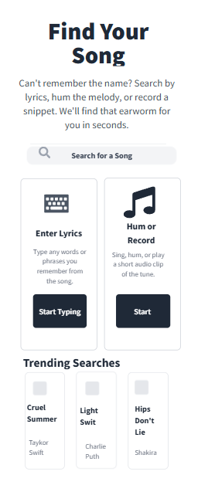
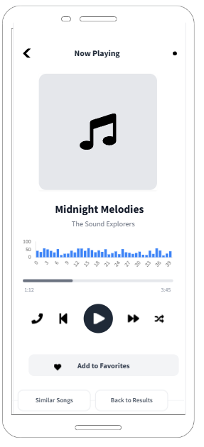
FRAME 2 : CHUNKING PHASE
Analysis of the Sequence Builder – Chunking & Memory Encoding Screen
This screen represents the Chunking Phase of the Sequence Builder game, where users briefly observe and mentally organize multiple visual elements before the task begins.
1. Purpose of the Screen
- This is the visual encoding stage, where users scan and memorize the displayed characters within a limited time.
- The screen encourages chunking, allowing users to group items mentally (by character type, familiarity, or visual traits) to improve recall accuracy in later stages.
2. Key UI Elements and Visual Components
⏳ Timer & Progress Indicator (Top Section)
- The horizontal progress bar visually represents the remaining observation time.
- The countdown duration reinforces urgency, prompting focused attention and rapid visual processing.
- A partially filled bar subtly communicates that time is already passing, increasing engagement.
🧩Grid of Character Cards
- A structured grid displays familiar animated characters, each placed inside uniform tiles.
- The consistent layout reduces visual noise and supports faster scanning.
- Users can naturally apply chunking strategies such as:
- Grouping by animation style or franchise
- Categorizing by color palettes
- Remembering characters by facial expressions or poses
🎮 Title: “SEQUENCE BUILDER”
- Clearly establishes the game’s objective and context.
- Positioned prominently to anchor user attention before interaction begins.
🐭 Mascot Presence (Jerry – Right Side)
- Adds a playful and familiar visual anchor without interfering with the task.
- Enhances emotional engagement while maintaining focus on the core grid area.
3. How the Chunking Phase Works
- Users quickly scan the character grid and identify patterns or familiar groupings.
- The limited time frame forces users to rely on efficient memory strategies rather than individual memorization.
- Once the timer completes, users transition into the sequence construction phase, using their encoded memory.
4. Cognitive and UX Benefits
- Supports short-term memory optimization by encouraging grouped recall instead of isolated elements.
- Reduces cognitive load through consistent spacing, alignment, and visual balance.
- Enhances pattern recognition and improves user confidence before active gameplay begins.

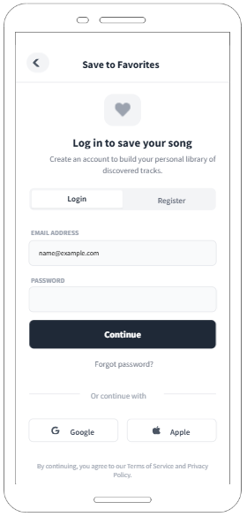

FRAME 3: RECALL PHASE:
Analysis of the Sequence Builder – Recall & Ordering Phase
This screen represents the Recall Phase of the Sequence Builder task, where users actively reconstruct the order of items they observed earlier. It evaluates both memory accuracy and sequence understanding.

1. Purpose of the Screen
- This phase focuses on memory retrieval and sequencing, requiring users to recall not just the items, but the correct order in which they appeared.
- The objective is to assess how effectively users encoded the sequence during the observation (chunking) phase.
2. Key Elements and UI Components
🎯 Title & Instruction Prompt
- “SEQUENCE BUILDER” (Bold Header) clearly reinforces the task objective.
- “Tap the items one by one to form the sequence” provides a direct, action-oriented instruction, reducing ambiguity.
🧩 Grid of Character Cards
- A set of character images is displayed in a clean, evenly spaced grid layout.
- All items appear visually equal, preventing visual bias and encouraging fair recall.
- Users select items sequentially, and number indicators appear on selected cards, showing their chosen order.
- This visual numbering acts as real-time feedback, helping users track and correct their sequence.
🐭 Jerry Character (Bottom Left)
- Acts as a playful visual anchor, enhancing engagement without distracting from the task.
- The familiar character adds a light, gamified tone, reducing performance anxiety.
✅ Submit Button (Bottom Center)
- Clearly separated from the grid, signaling task completion.
- Encourages users to review their sequence before final submission, promoting thoughtful interaction.
3. How the Recall Phase Works
- Users mentally recall the original order from the chunking phase.
- They tap items one by one, building the sequence visually.
- If unsure, users can adjust their selections by rethinking the order before submission.
- Pressing “Submit” finalizes the sequence and transitions to feedback or scoring.
4. Cognitive and UX Benefits
- Tests sequential memory, not just recognition.
- Reinforces active recall, which strengthens memory retention.
- Visual numbering reduces cognitive load by externalizing sequence tracking.
- Familiar characters and bright colors maintain motivation and engagement.
- The interaction design balances challenge and clarity, making the task intuitive yet mentally stimulating.

∙ 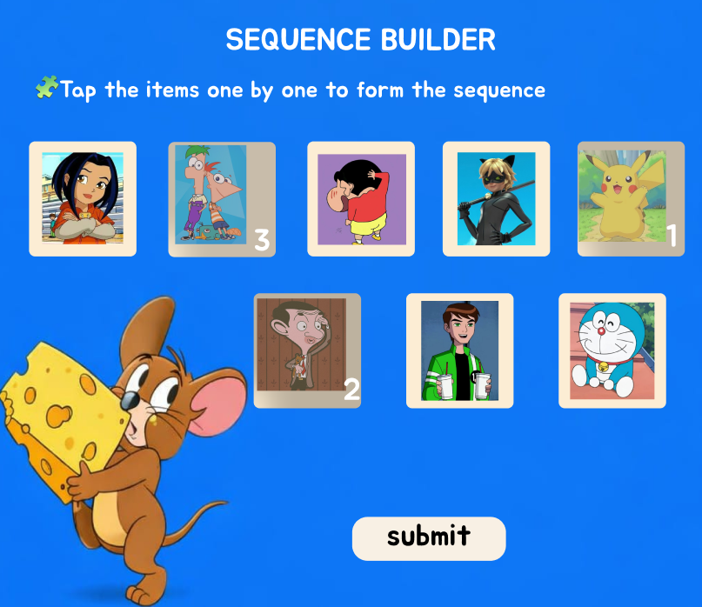

PROTOTYPE LINK:

https://www.figma.com/design/a8RGGrsES01O9efaED8eG7/Untitled?node-id=48-120&t=I2q9gl6DeBUvLmdw-1

FRAME 4: SCORE & FEEDBACK PAGE
Analysis of the Sequence Builder – Score & Feedback Screen

This screen represents the Score & Feedback Phase of the Sequence Builder task, where users receive performance feedback based on how accurately they reconstructed the sequence in the previous Recall Phase.
1. Purpose of the Screen
- This phase provides immediate performance feedback, helping users understand how close they were to the correct sequence.
- It reinforces learning by highlighting minor errors rather than framing the attempt as a failure.
- Encourages users to reflect, improve, and stay motivated to retry.
2. Key Elements & UI Components
🏆 Title & Score Display
- “SEQUENCE BUILDER” (Bold Header) reinforces the identity of the game.
- “Your Score: 32 points / 50” clearly communicates the achieved score relative to the maximum possible score.
- The rounded score container visually separates performance data from the rest of the screen, improving readability.
📝 Performance Feedback Message
- The line “Close run – two steps went off track” provides qualitative feedback instead of a simple right/wrong response.
- This phrasing acknowledges effort while gently indicating where improvement is needed, maintaining a positive user experience.
🧩 Highlighted Incorrect Sequence Items
- Specific items from the sequence are visually displayed with position indicators (e.g., 3, 5).
- This helps users identify exactly where the sequence order deviated, supporting learning through error recognition.
🐭 Tom & Jerry Characters (Bottom Corners)
- Jerry and Tom act as playful visual anchors, framing the feedback screen.
- Their familiar presence reduces stress and reinforces the game’s friendly, non-punitive tone.
3. How the Score & Feedback Phase Works
- The system evaluates the user’s submitted sequence against the correct order.
- A cumulative score is calculated based on correct placements and partial accuracy.
- Qualitative feedback highlights how close the user came to the correct solution.
- Visual cues indicate misplaced steps, allowing users to learn from mistakes.
4. Cognitive & UX Benefits
- Immediate feedback strengthens memory correction and learning retention.
- Partial success messaging prevents frustration and encourages retry behavior.
- Visual identification of incorrect steps supports metacognitive awareness.
- Gamified characters and soft color tones keep the experience engaging and user-friendly.

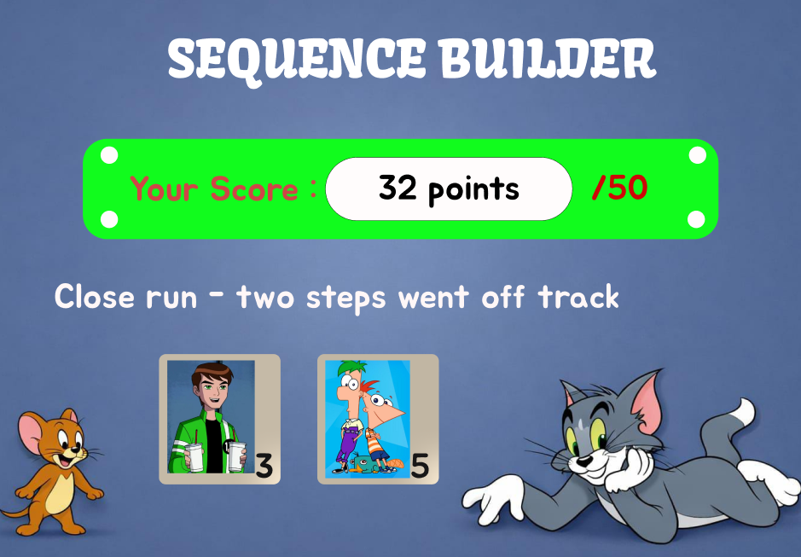

PROTOTYPE LINK:
https://www.figma.com/design/a8RGGrsES01O9efaED8eG7/Untitled?node-id=62-34&t=I2q9gl6DeBUvLmdw-1

