**Practical 1**

**CIFAR10 dataset**

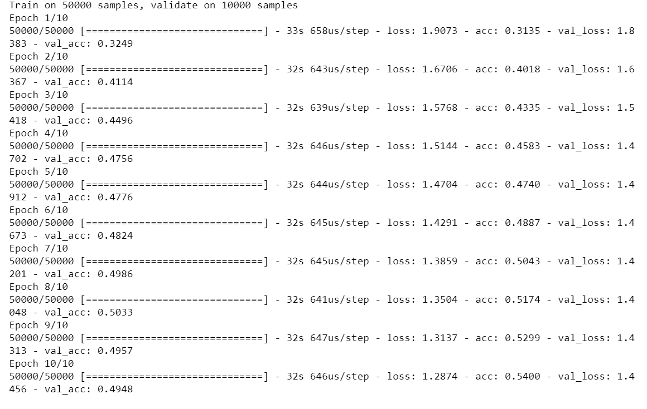

The test loss is 1.287 and the test accuracy is 54% at the end of 10 epochs.

# Iris dataset

Epoch 196/200

- 0s - loss: 0.2014 - acc: 0.9662

Epoch 197/200

- 0s - loss: 0.1976 - acc: 0.9662

Epoch 198/200

- 0s - loss: 0.1969 - acc: 0.9595

Epoch 199/200

- 0s - loss: 0.1955 - acc: 0.9662

Epoch 200/200

- 0s - loss: 0.1968 - acc: 0.9662

2/2 [==============================] - 0s 13ms/step

Final test set loss: 0.146893

Final test set accuracy: 1.000000

The final test set accuracy is 100% with a loss of 0.14 at the end of 200 epochs.