ZENSE PROJECT

SIMULATION OF DOUBLE PENDULUM

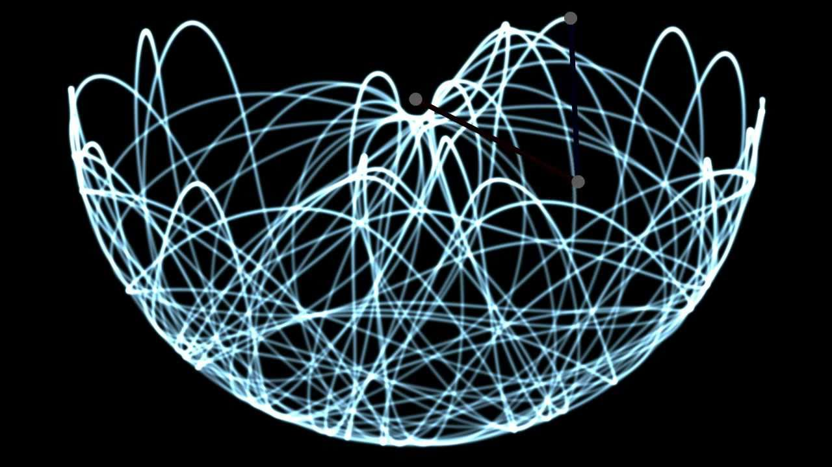

By:
Gayathri Venkatesh
IMT2018026

INTRODUCTION

A double pendulum consists of one pendulum attached to another. It is a simple mechanical system that shows chaos for some initial conditions.
Here’s a diagrammatic representation of such a system:

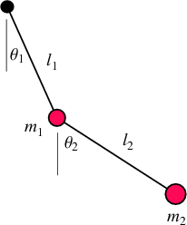

The equations revolving around this concept are as follows:

1. Determining the position

x₁ = l₁* sin(₁)

x₂ = l₂* sin(₂) + l₁* sin(₁)

y₁ = l₁* cos(₁)

y₂ = l₂* cos(₂) + l₁* cos(₁)

2. Determining the energies

Potential energy U = m₁*g* y₁ + m₂*g*y₂

Kinetic energy K = 0.5*(m₁*v1² + m₂*v2²) + 0.5*(I₁ *₁² + I₂*₂²)
where I andare moment of inertia and angular velocities respectively.

Total Energy = U + K (remains a constant as energy is conserved)

From the given values ofand , we can determine the path of the pendulum.

SIMULATION

The movement of the pendulum depends on the medium in which it is present. In order to demonstrate this, two graphs have been plotted – one for the pendulum in air and the other, in water. The upthrust of the medium causes a decrease in acceleration due to gravity (g), and hence changes the total energy.
Friction and viscosity of the mediums haven’t been considered.

The entire code is written in Python 2.7. The graphs have been plotted using matplotlib. Certain functions of numpy and scipy have also been used.

A snapshot of the simulation after 21.7 seconds :

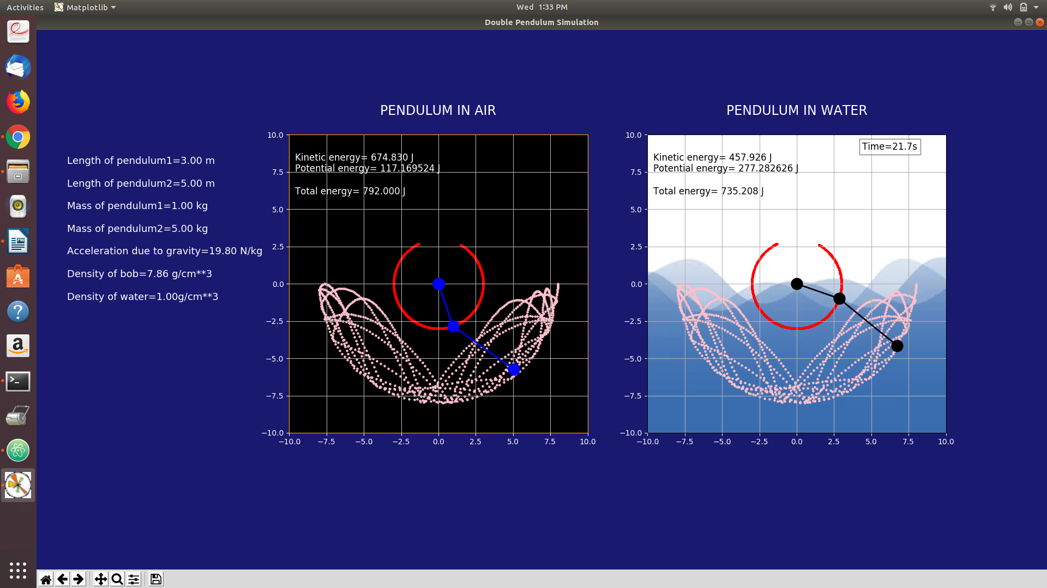

Link to the video : https://www.youtube.com/watch?v=zKYwVgVeevM

After changing the values of parameters (l,m,g, density) : https://www.youtube.com/watch?v=S6F527yu9Dg

MY EXPERIENCE

The idea occurred to me when I read an article on how pendulums are being used to dampen the effects of earthquake on tall buildings. This invention can help a great deal in minimizing destruction, but first, a sound understanding of the concept is required. Hence I decided to work on a simulation of a double pendulum.

This project provided me with an opportunity to test and improve my skills at coding. It got me acquainted with a lot of libraries within Python, like matplotlib. I got to explore a lot of features and functionalities within the language. The video lectures and websites that I referred to while adding different properties were extremely helpful.

Besides the coding aspect, I also got to brush up my knowledge in Physics. The underlying concept of double pendulum is basic mechanics, and deriving these equations proved to be a lot of fun. Being my favorite subject, I thoroughly enjoyed creating a project based on Physics.

CONCLUSION

Simulations are a cost-effective way of demonstrating how different systems behave when subject to various conditions. On varying these conditions, we can study the change in its behavior, and thus more robust solutions can be designed.

Simulations can be extremely useful in the academic sector. They allow concepts to be more easily communicated and understood. They can provide clear insights into complex systems by facilitating better visualization.

The project clearly represents the working of a double pendulum. With modified parameters, the change in its behavior is evident. With a clear comparison between the two plots (air and water), it exhibits the effect of the density of the medium. Energy values for both cases are continually updated and displayed, to give the viewer a clearer picture.

This simulation can thus be used to strengthen one’s understanding of the double pendulum.

SCOPE FOR IMPROVEMENT

A couple of features can be added to improve the existing project:

- The program can be made more interactive. Softwares like tkinter can help make it more user-friendly. This will allow the user to directly change the parameters, without having to refer to the code.
- Minor factors like friction in air and viscosity in water haven’t been accounted for. These attributes can be added to increase the accuracy and get it closer to reality.

REFERENCES

The following sites have been extremely helpful for the completion of this project:

1. For equations of motion
http://scienceworld.wolfram.com/physics/DoublePendulum.html

2. To create subplots on matplotlib
https://www.youtube.com/watch?v=Ql8QPcp8818&t=174s

3. To learn the basic methods of matplotlib
https://matplotlib.org/tutorials/introductory/pyplot.html
https://matplotlib.org/examples/animation/double_pendulum_animated.html
https://matplotlib.org/api/_as_gen/matplotlib.pyplot.sca.html

