Exercise 2: E-commerce Platform Search Function

import java.util.\*;

class Product {

int id;

String name;

String category;

double price;

Product(int id, String name, String category, double price) {

this.id = id;

this.name = name;

this.category = category;

this.price = price;

}

void display() {

System.out.println(id + " - " + name + " (" + category + ") - ₹" + price);

}

}

public class Main{

public static void main(String[] args) {

Scanner sc = new Scanner(System.in);

ArrayList<Product> products = new ArrayList<>();

products.add(new Product(1, "Laptop", "Electronics", 50000));

products.add(new Product(2, "Smartphone", "Electronics", 30000));

products.add(new Product(3, "Shoes", "Fashion", 2000));

products.add(new Product(4, "Book", "Education", 500));

products.add(new Product(5, "T-Shirt", "Fashion", 800));

System.out.println("Search by: 1. Name 2. Category 3. Price Range");

int choice = sc.nextInt();

sc.nextLine();

if (choice == 1) {

System.out.print("Enter product name keyword: ");

String keyword = sc.nextLine().toLowerCase();

for (Product p : products) {

if (p.name.toLowerCase().contains(keyword)) {

p.display();

}

}

} else if (choice == 2) {

System.out.print("Enter category: ");

String cat = sc.nextLine().toLowerCase();

for (Product p : products) {

if (p.category.toLowerCase().equals(cat)) {

p.display();

}

}

} else if (choice == 3) {

System.out.print("Enter min price: ");

double min = sc.nextDouble();

System.out.print("Enter max price: ");

double max = sc.nextDouble();

for (Product p : products) {

if (p.price >= min && p.price <= max) {

p.display();

}

}

} else {

System.out.println("Invalid choice.");

}

sc.close();

}

}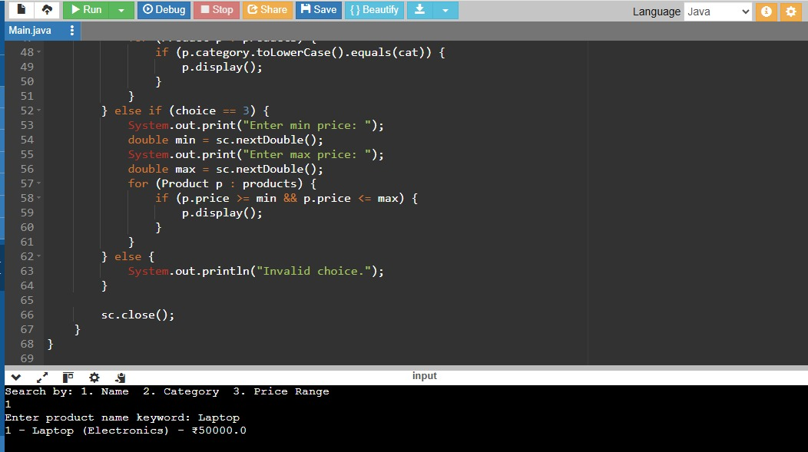

Exercise 7: Financial Forecasting

import java.util.Scanner;

public class Main {

public static void main(String[] args) {

Scanner sc = new Scanner(System.in);

System.out.print("Enter initial investment amount (Rs): ");

double principal = sc.nextDouble();

System.out.print("Enter annual interest rate (%): ");

double rate = sc.nextDouble();

System.out.print("Enter number of years: ");

int years = sc.nextInt();

System.out.println("\nYear\tFuture Value (Rs)");

for (int i = 1; i <= years; i++) {

double futureValue = principal \* Math.pow(1 + rate / 100, i);

System.out.printf("%d\t%.2f\n", i, futureValue);

}

sc.close();

}

}