**CLASSROOM BOOKING AND AVAILABILITY MANAGEMENT**

**PROBLEM STATEMENT**

A college has a number of classes. For exams, classrooms must be alloted.

Suppose there is an exam in the morning, the classroom is free in the afternoon.

In the program, show the date, duration time, and subject.

Retrieve data in tabular format.

If someone wants to book a classroom to conduct an exam or seminar or for any other reason, allow them to enter details of classroom number, date, duration time, and reason.

If the classroom is already allotted, display error message. The entered details should be saved into the database.

**Implementation Steps:**

-Database Creation

-Table Creation

-Values Insertion into Table

-Retrieve values in tabular format

-Query to display details of selected date/classroom

-Create form and accept details (Classroom number,Date, time,subject)

-Display error if classroom/time clash.

-Otherwise, save entered details into database.

* 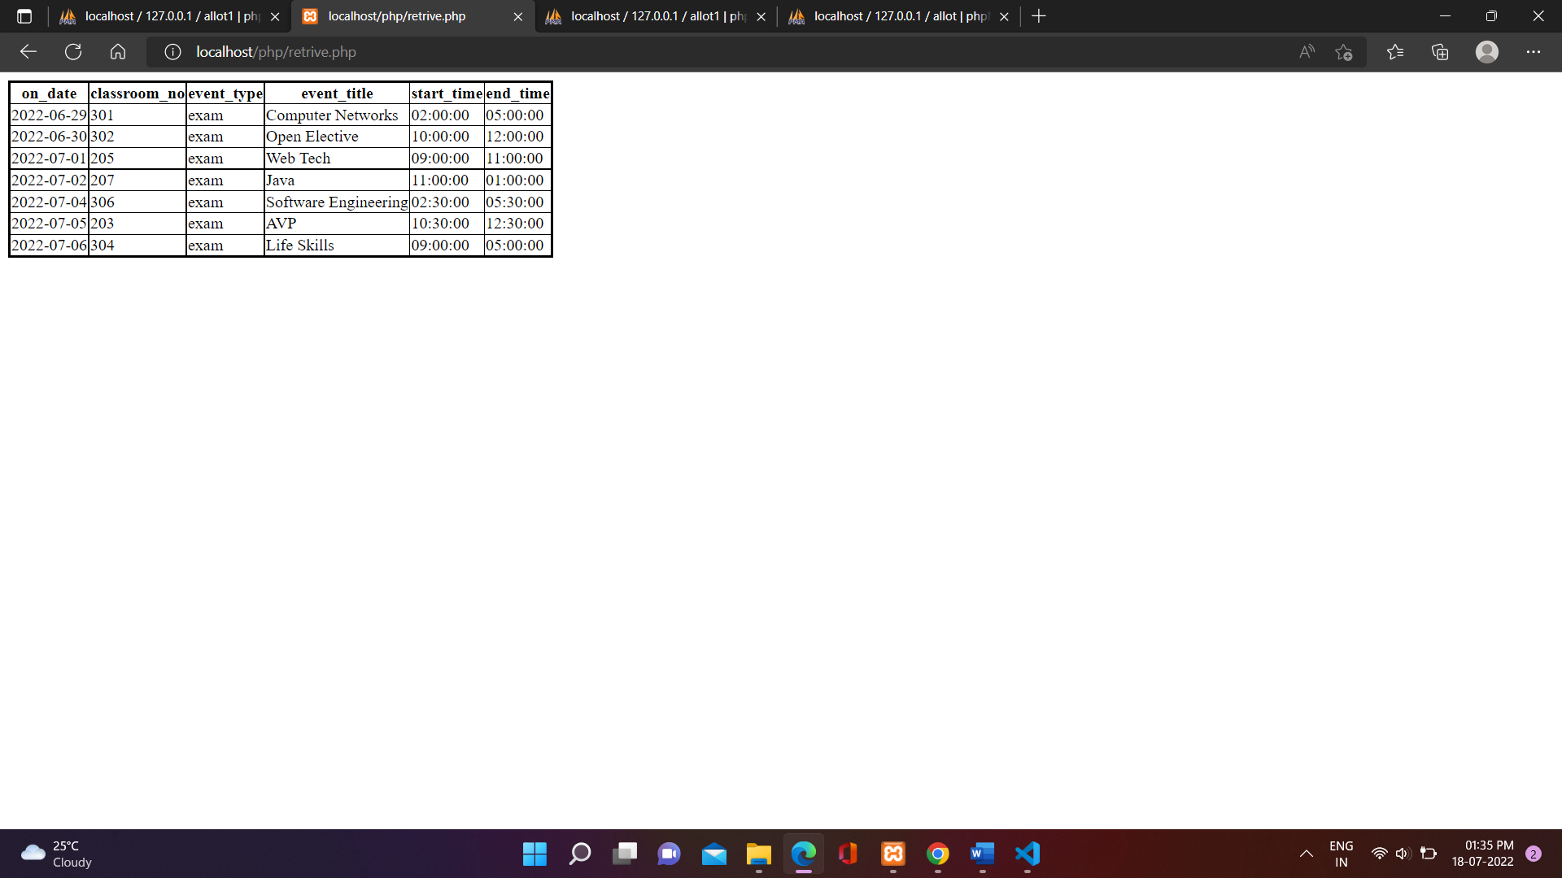Table before user fills form
* User fills form to allot classroom on a specific date.

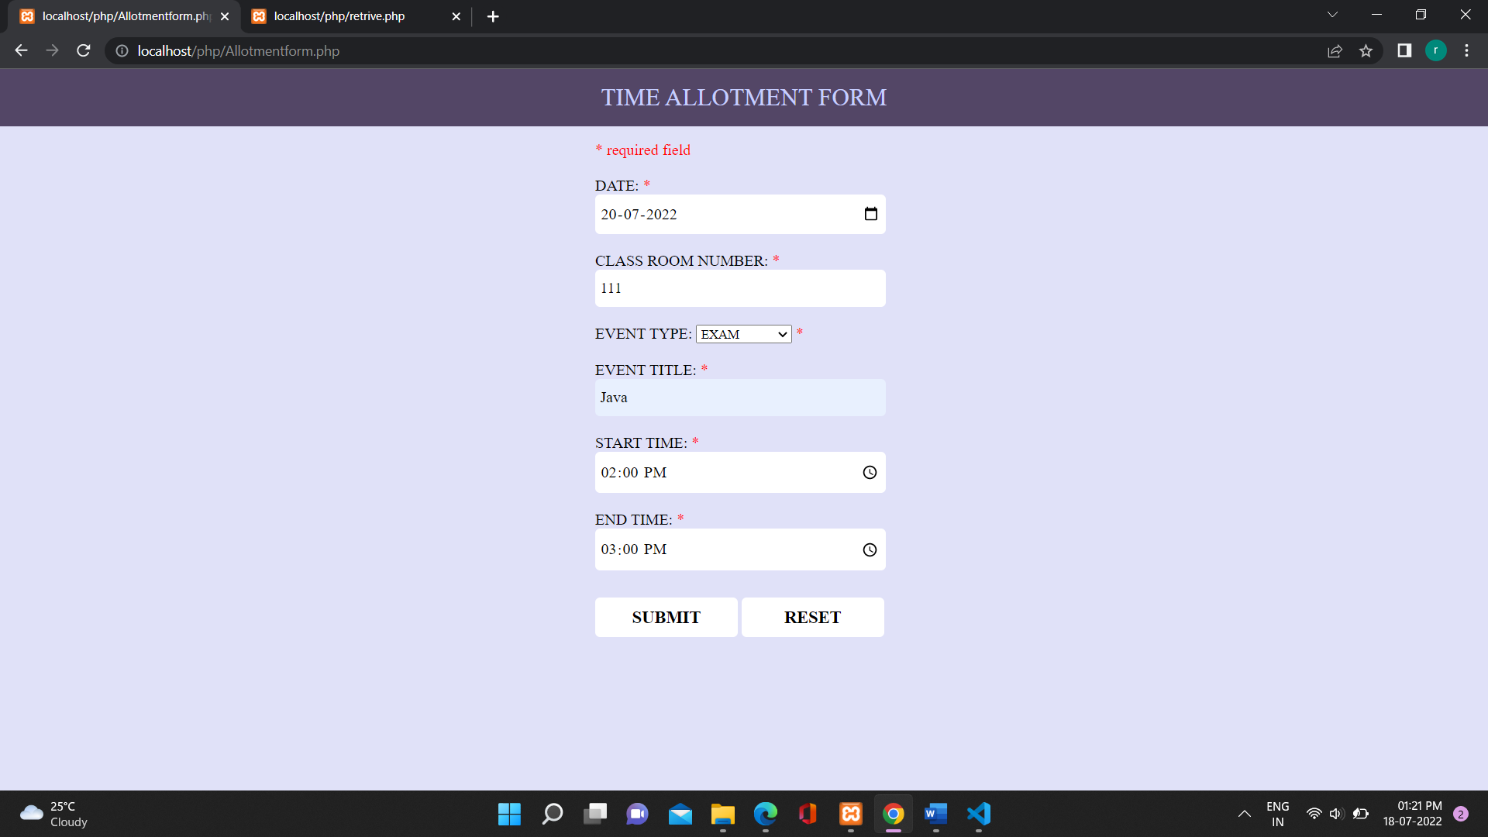

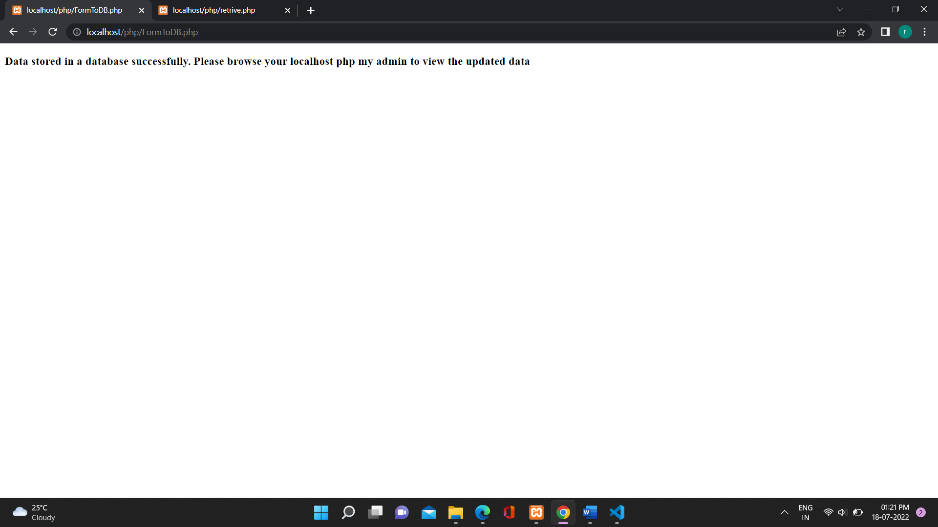

* User fills form on the same date at a different time.

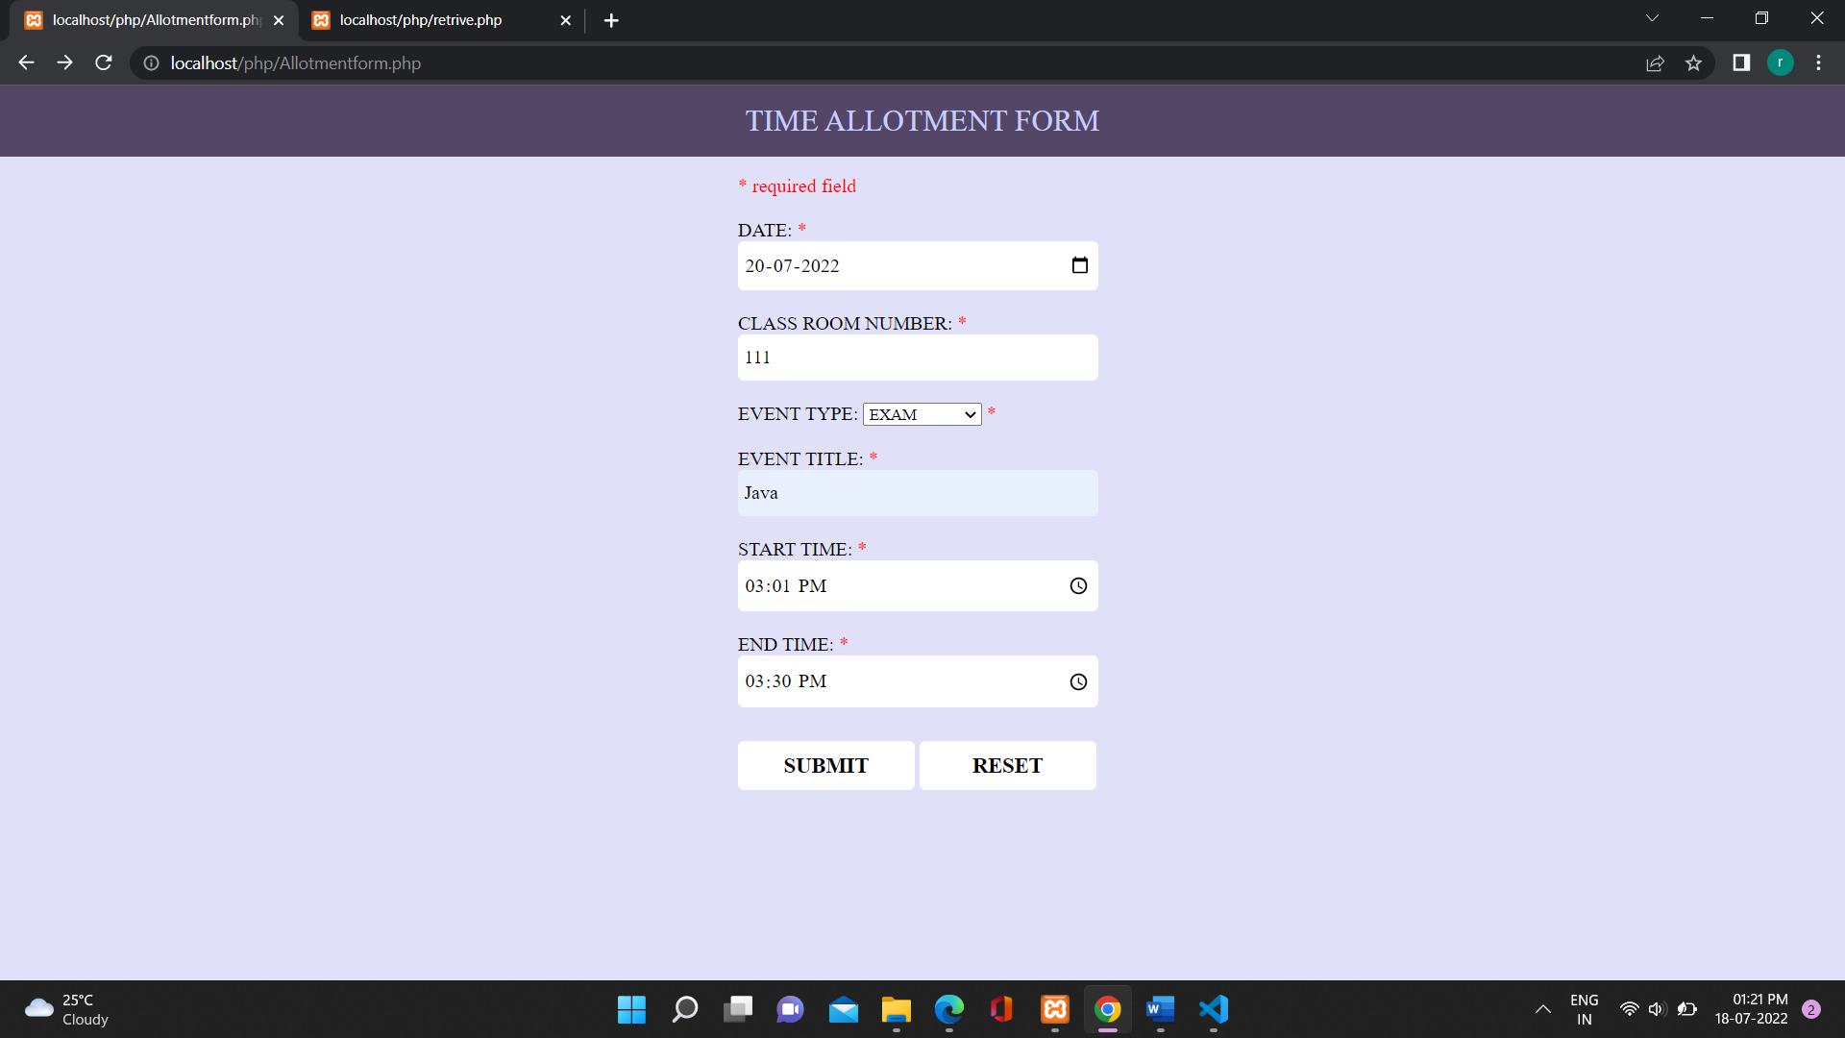



* User fills form on the same date between an already existing time.

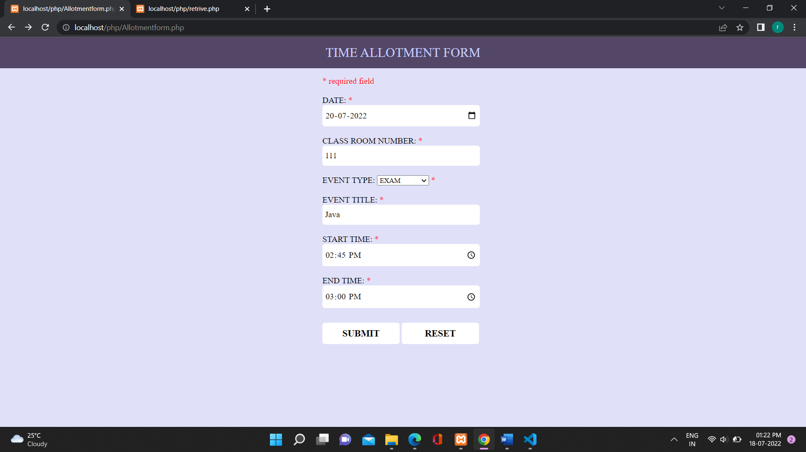

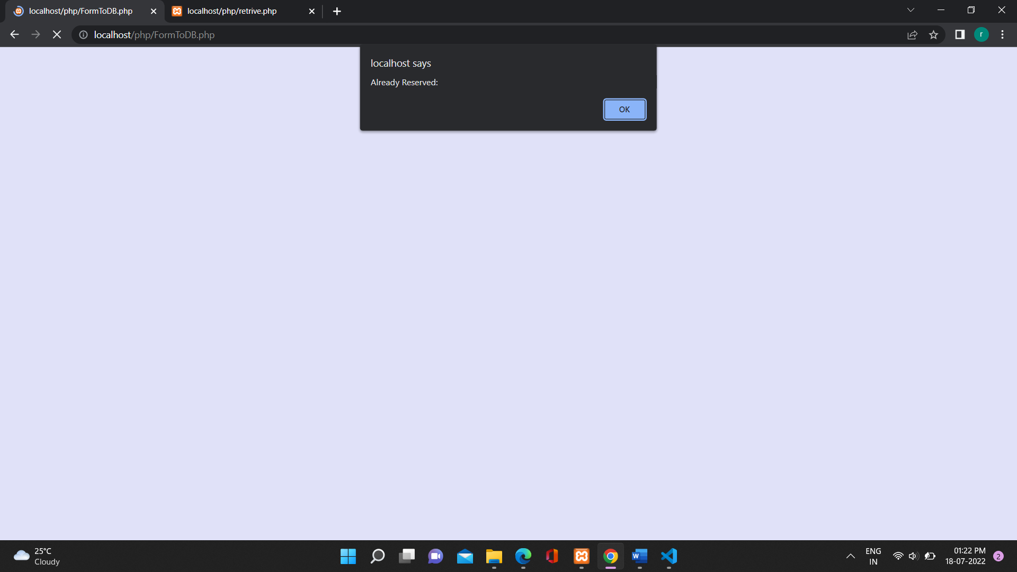

* 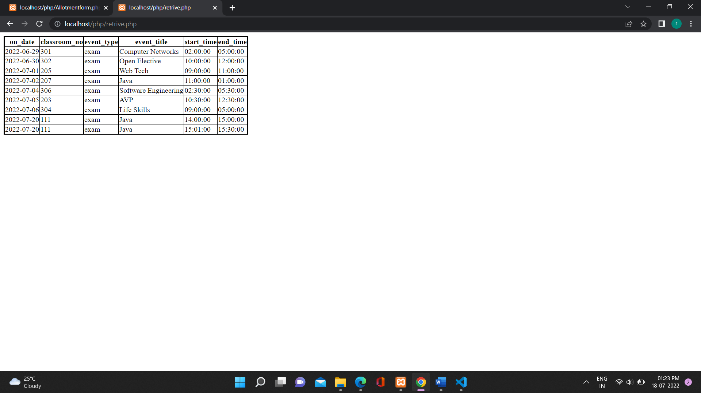Table after user fills form.