OUTPUT: XGBoost_Regressor.py
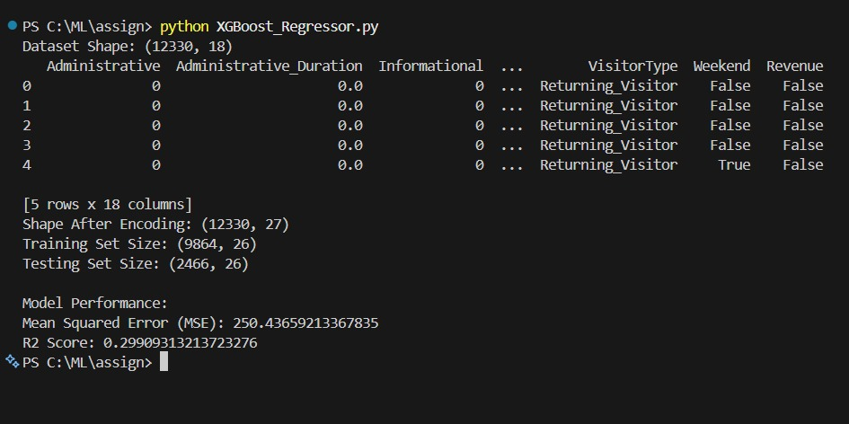
OUTPUT: Logistic_Regression.py
