**Appium (Android)**

**Step1:** Download the android sdk the different tools not the android studio from the link

<https://developer.android.com/studio>

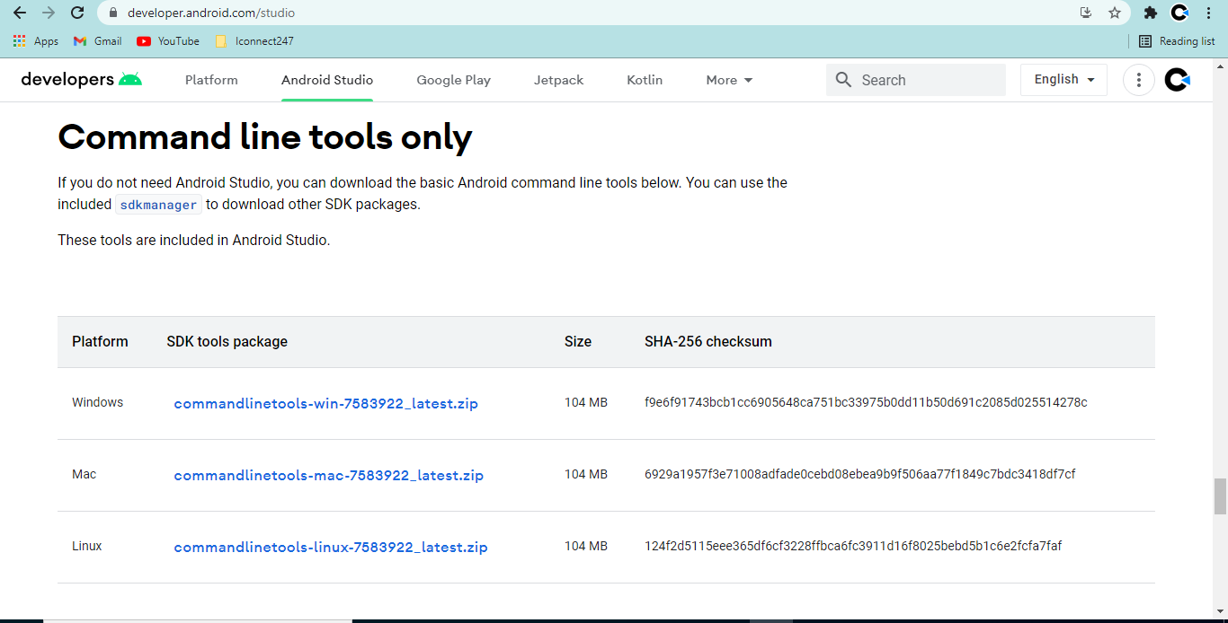

**Step2:** You can see the downloaded files and create the android sdk folder if not created

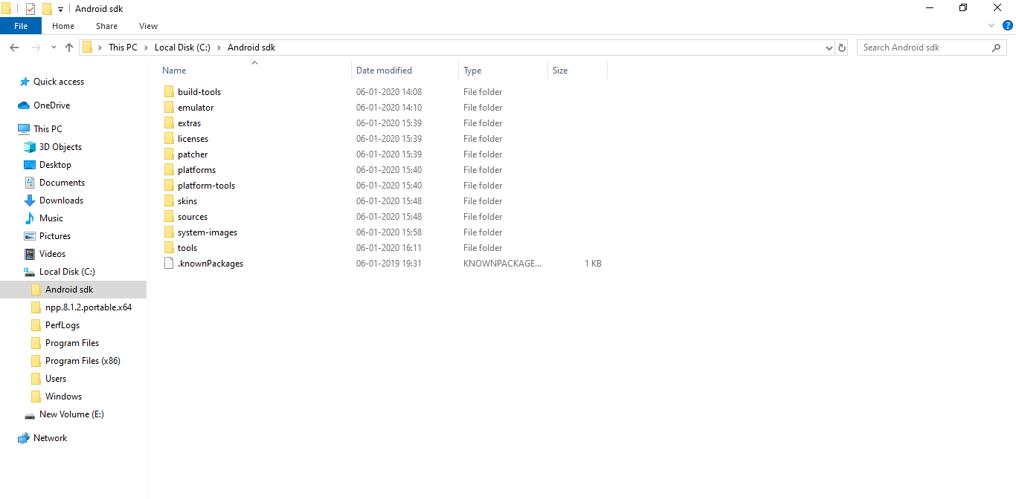

**Step3:** Copy the path of the Android sdk and create a new System variable ANDROID_HOME

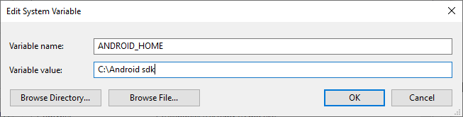

**Step4:** Edit the path in the System Variable

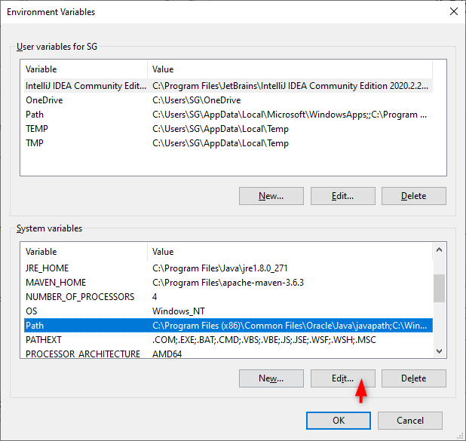

**Step5:** Add the path of the android sdk folders

* 1. C:\Android sdk\tools
  2. C:\Android sdk\platform-tools
  3. C:\Android sdk\tools\bin

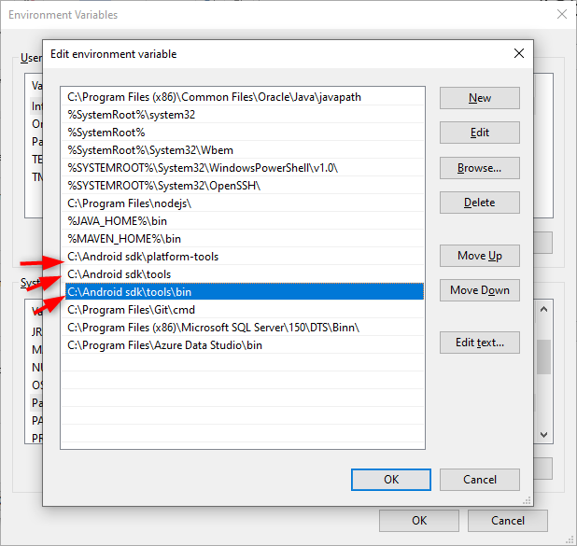

**Step6:** Save the Changes.

**Step7:** platform-tools->you can see adb here -> ctrl+L ->Type "cmd"

**Step8:** cmd prompt is opend. type "adb devices"

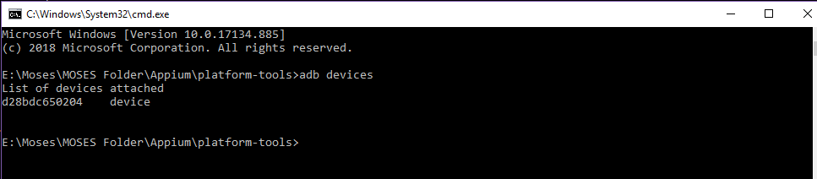

**Step9:** Download and Install Appium Desktop Client

<https://github.com/appium/appium-desktop/releases/download/v1.10.0/appium-desktop-setup-1.10.0.exe>

- Start server

- click search icon

- Refer the below image and add the Desired capabilities in your Appium

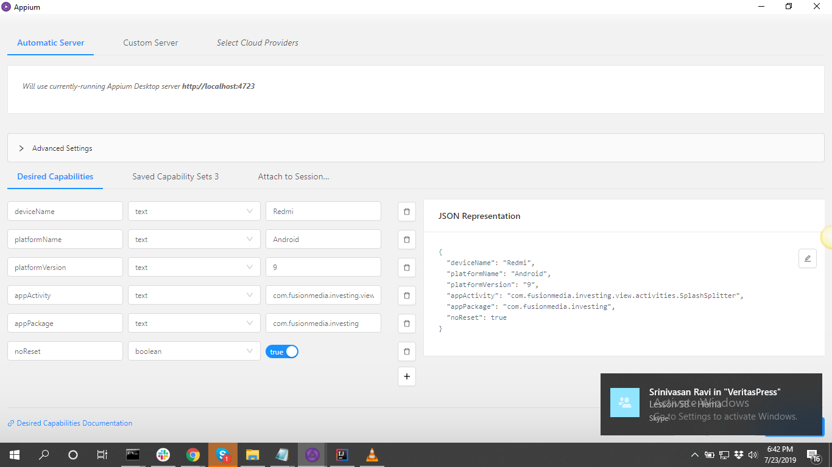c

**Step 10:** Enabling Developer Mode Options on Android Phone or Tablet

This is two step process, first step is to Enabling Developer Mode Options on Android Phone or Tablet and second is to Switch On the USB Debugging of the device.

**a) Enabling developer option**

Go to the Settings> Scroll down to ‘About phone‘ and tap on it > Scroll down to the bottom again, where you see ‘Build number’ (Tap On Build number Seven (7) times). Developer mode will enable.

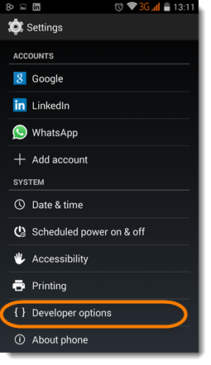

**b) Switch On USB Debugging**

Go to the Developer Options > Tick the USB Debugging check box or radio button

-Toggle on ->Stay awake, USB debugging, Install vis USB, USB debugging (Security settings),.

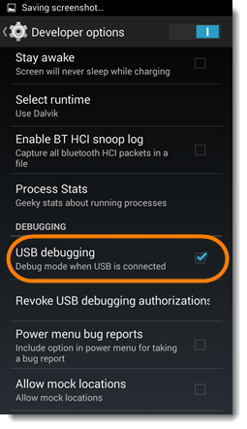

**Step 11: Continue on step 4 where the cmd prompt opened**

* Type “adb shell”

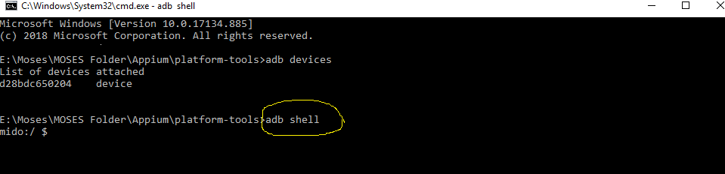

* Open the desired App in your mobile and your mobile shoud be connected to the CPU through Data Cable (Which you need to Test) Eg : Instagram, Whatsapp, Facebook…
* Now type the below command to get Activity and package

**dumpsys window displays | grep -E "mCurrentFocus|mFocusedApp"**

**or**

**dumpsys activity activities | grep ResumedActivity**

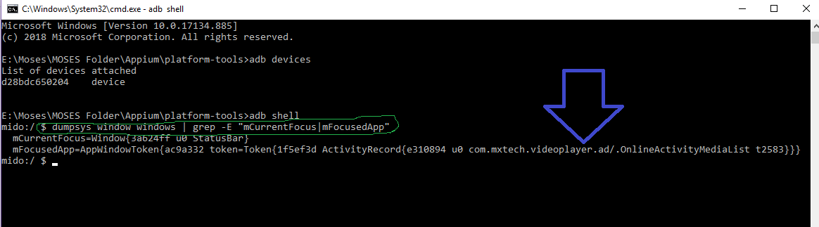

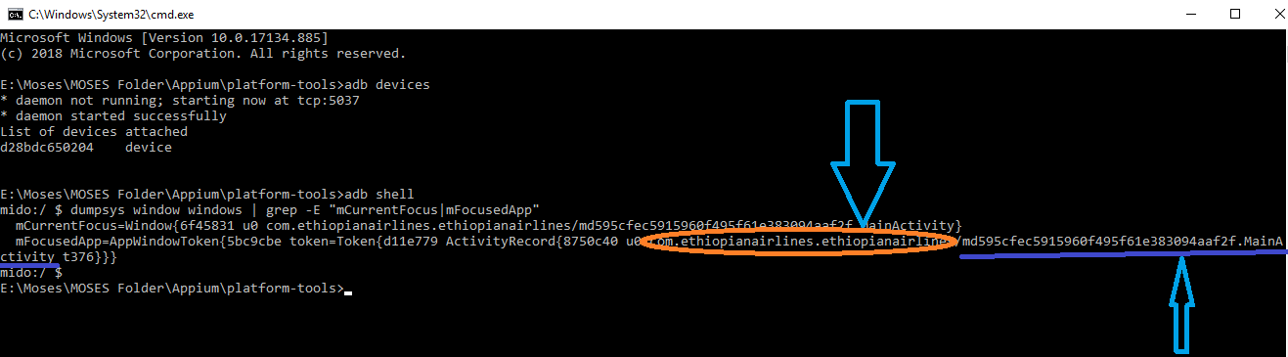

**Step 12:** Continue on **Step9** where Appium desired capabilities page

* Take the appPackage and appActivity as marked in the previous image and past it in the desired capabilities.
* Click “Save”.
* Click “Start Session”.
* If the App is not launched then change the “appActivity” MainActivity into LaunchActivity. (See the below image)

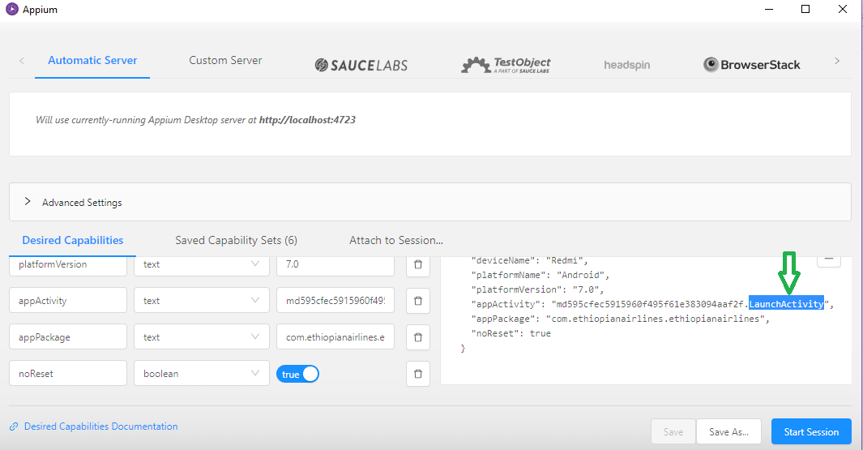**IntelliJ:**

* Create a New JAVA project
* 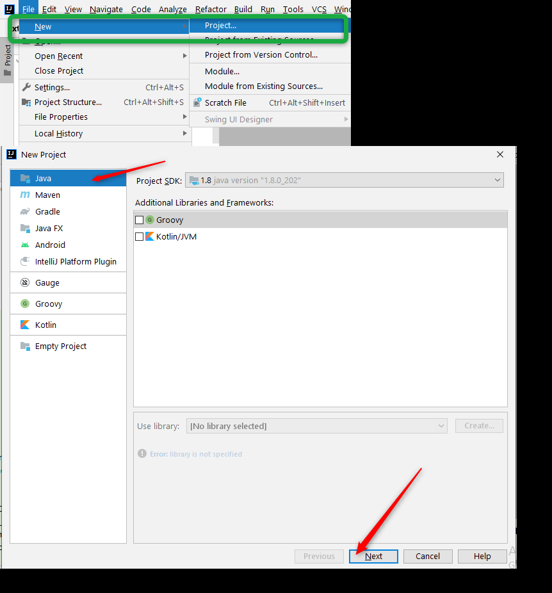

Enter Project Name and Project location:

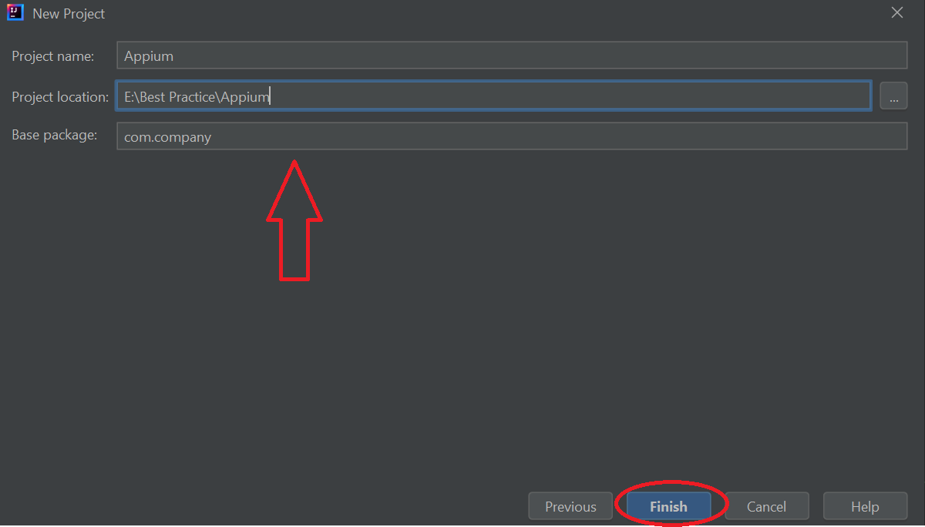

Go to File -> Project Structure -> in a project setting tab look for Libraries -> Click on ‘+’ Sign -> Select for JARs or directories.

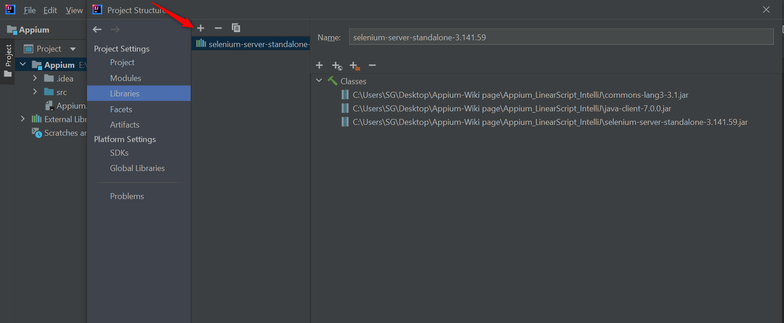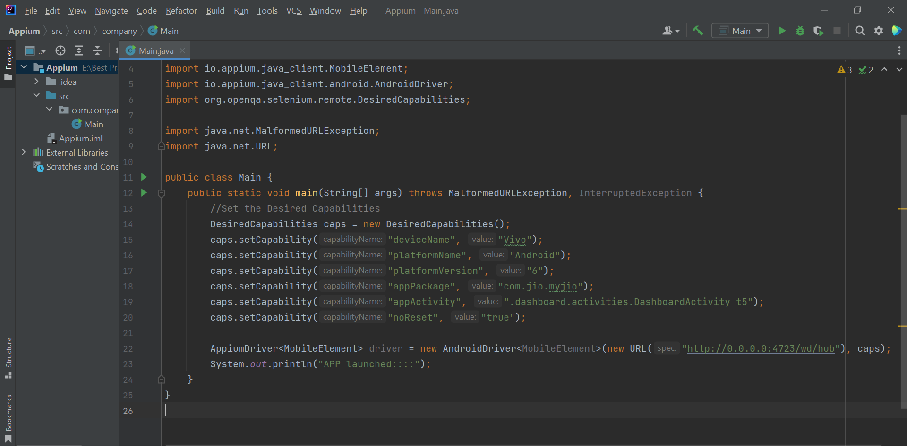

* **To know about Appium:**
* What is Appium?
* Features of Appium
* Appium Architecture
* Advantages of Appium
* Disadvantages of Appium
* How Appium work?
* Types of Mobile Application
* Prerequisite to use Appium
* Installation of Appium on Windows OS
* Reference link<< <https://www.javatpoint.com/appium> >>
* How to Connect your real device
* Sample GitHub Project << [https://github.com/swtestacademy/appium-sample-test](https://github.com/swtestacademy/appium-sample-test%20) >>
* Appium Parallel Testing For Real Devices | Wireless Mobile Device Lab << <https://www.swtestacademy.com/appium-paralllel-testing/> >>

**Reference Links:**

* Appium Tutorial Step by Step Appium Automation:

<< <https://www.swtestacademy.com/appium-tutorial/> >>

* APPIUM Tutorial for Android & iOS Mobile Apps Testing:

<< <https://www.guru99.com/introduction-to-appium.html> >>

* Appium codoid blog for Appium desired capabilities-🡪 <https://codoid.com/appium-commands/>
* The Complete Appium Guide to Run Tests on Real Device: << [Appium Codoid Blog](https://codoid.com/the-complete-appium-guide-to-run-tests-on-real-device/) >>
* <https://codoid.com/browserstack-tutorial-find-out-how-to-use-it-as-a-ui-inspector/>
* <https://codoid.com/browserstack-tutorial/>