**PYTHON DAY 22/05**

**Qn: TIME-DELTA(hacker-rank)**

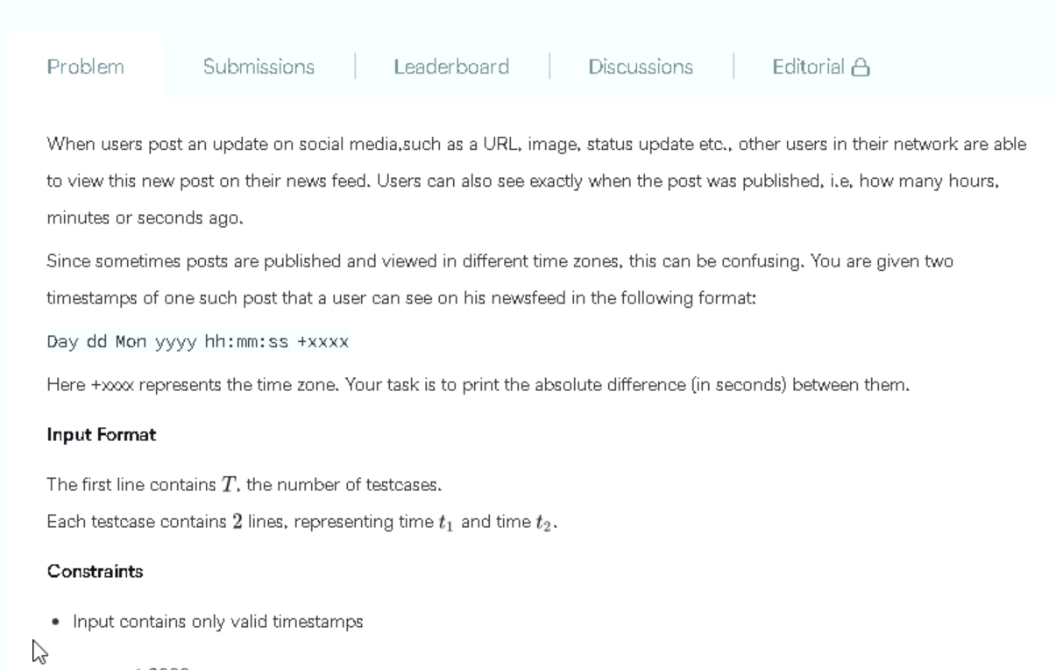

**CODE:**

**OUTPUT**

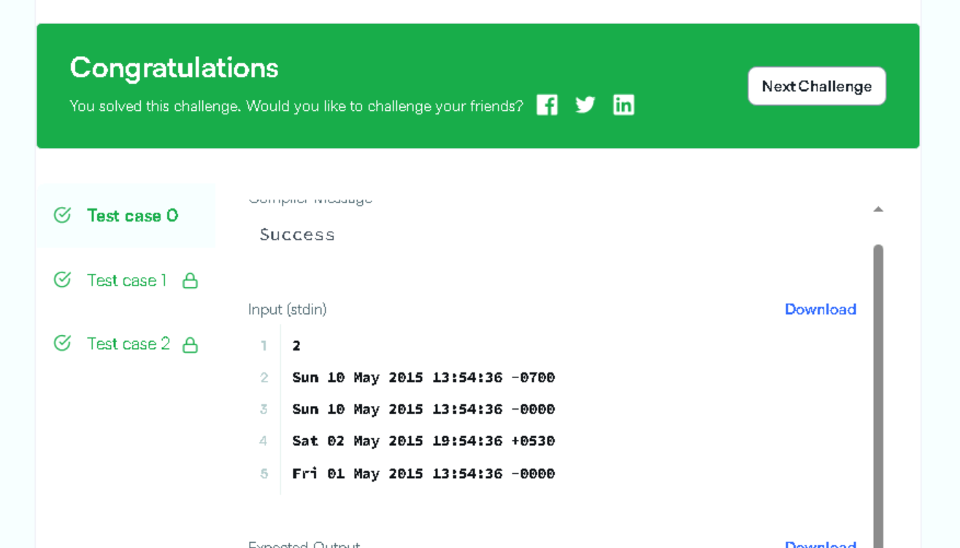

**QN:**

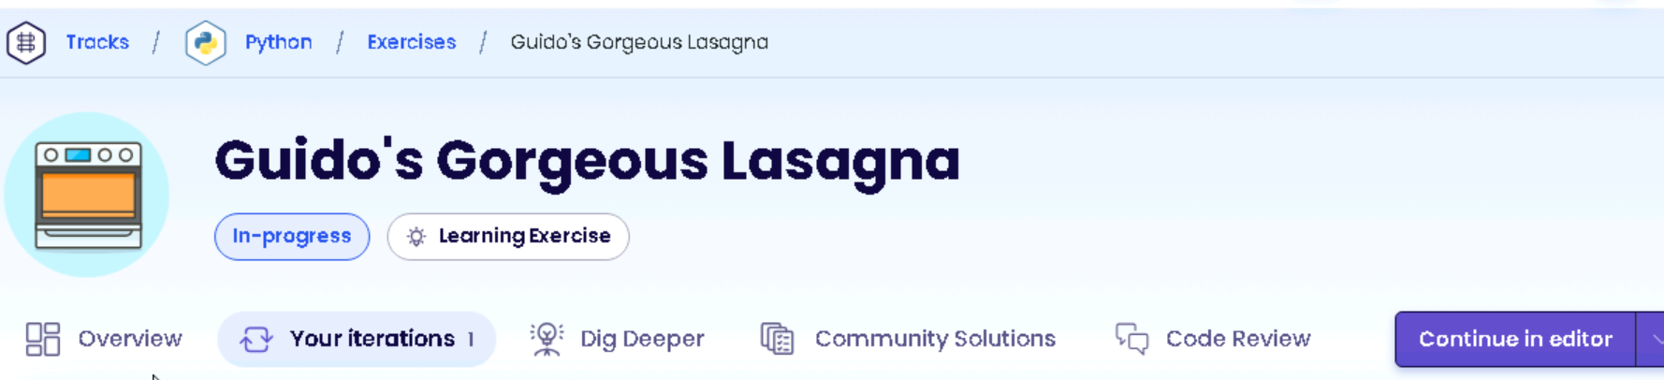

**CODE:**

**OUTPUT**

