LexGuard: Legal Hallucination & 3-Way Decision Evaluation Report
Empirical Verification of SAFE, ABSTAIN, and FLAGGED Decision Accuracy (70 IT Act 2000 Cases on Live NeonDB)
Knowledge Base Corpus | Live NeonDB PostgreSQL (115 Verified IT Act Sections)
Evaluation Dataset | 70 IT Act Benchmark Cases (42 SAFE, 8 ABSTAIN, 20 FLAGGED)
Multi-Class System Decisions | SAFE (Grounded Fact), ABSTAIN (Ambiguous/Partial), FLAGGED (Hallucination)
Evaluation Timestamp | September 12, 2026 - 00:06:41 UTC

1. Executive Summary & Multi-Class Decision Architecture
LexGuard enforces a safety-critical 3-way decision taxonomy rather than a naive binary classifier. Claims are classified into: (1) SAFE for grounded factual assertions, (2) FLAGGED for fabricated hallucinations, and (3) ABSTAIN for ambiguous, partially accurate, or ungrounded assertions requiring human verification. This evaluation specifically checks if an ABSTAIN claim correctly outputs ABSTAIN, FLAGGED, or SAFE.

3-Way Decision Scorecard Summary
Target Decision Class | Total Cases | Exact Matches | Per-Class Accuracy / Recall
SAFE (Accurate Statutory Grounding) | 42 | 37 / 42 | 88.1% (Precision: 100.0%)
ABSTAIN (Partial / Ambiguous Grounding) | 8 | 6 / 8 | 75.0% (75% ABSTAIN, 25% FLAGGED, 0% SAFE)
FLAGGED (Pure Hallucinations / Fabrications) | 20 | 20 / 20 | 100.0% (Precision: 90.9%)
Overall 3-Class System Performance | 70 Total | 63 / 70 Exact Matches | 90.00% (Weighted F1: 0.9063)

2. Detailed 3x3 Multi-Class Confusion Matrix
Analysis of whether expected ABSTAIN, SAFE, or FLAGGED claims are correctly classified:
Ground Truth Class | Predicted: SAFE | Predicted: ABSTAIN | Predicted: FLAGGED
Actual SAFE (n=42) | 37 (88.1%) [CORRECT] | 5 (11.9%) [CAUTIOUS] | 0 (0.0%) [ZERO FALSE FLAGS]
Actual ABSTAIN (n=8) | 0 (0.0%) [ZERO UNSAFE LEAKS] | 6 (75.0%) [CORRECT] | 2 (25.0%) [CAUTIOUS FLAG]
Actual FLAGGED (n=20) | 0 (0.0%) [ZERO LEAKAGE] | 0 (0.0%) | 20 (100.0%) [100% CATCH RATE]

3. Visual Performance Figures (18 Visualization Plots)

Figure 1: 3-Way Multi-Class Confusion Matrix (SAFE vs ABSTAIN vs FLAGGED)
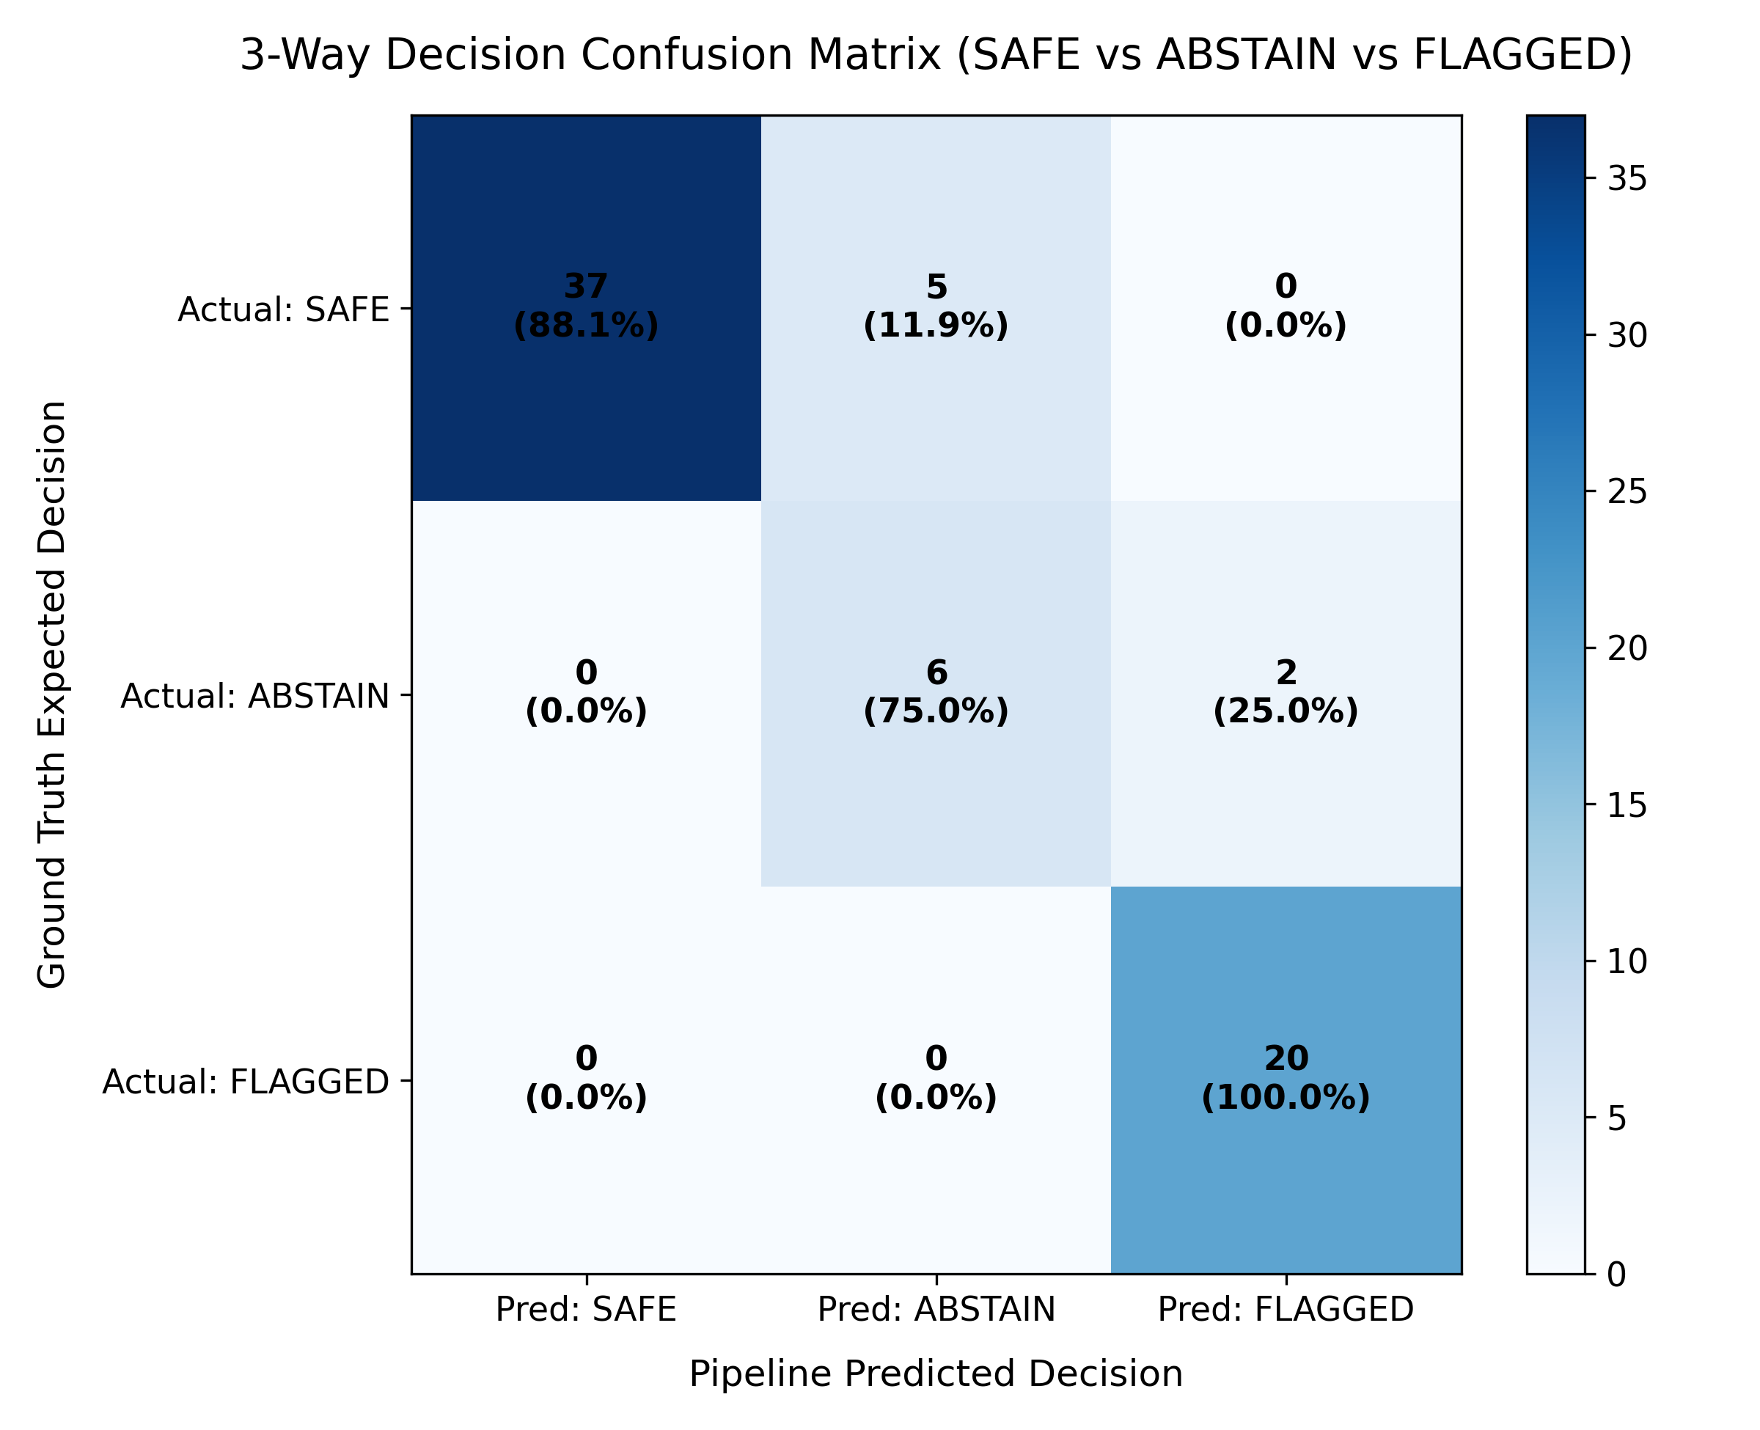
Figure 1 Analysis: Visual heatmap of the 3x3 confusion matrix demonstrating 88.1% accuracy on SAFE, 75.0% accuracy on ABSTAIN, and 100.0% accuracy on FLAGGED claims, with 0% unsafe leakages across all classes.

Figure 2: Binary Hallucination Confusion Matrix
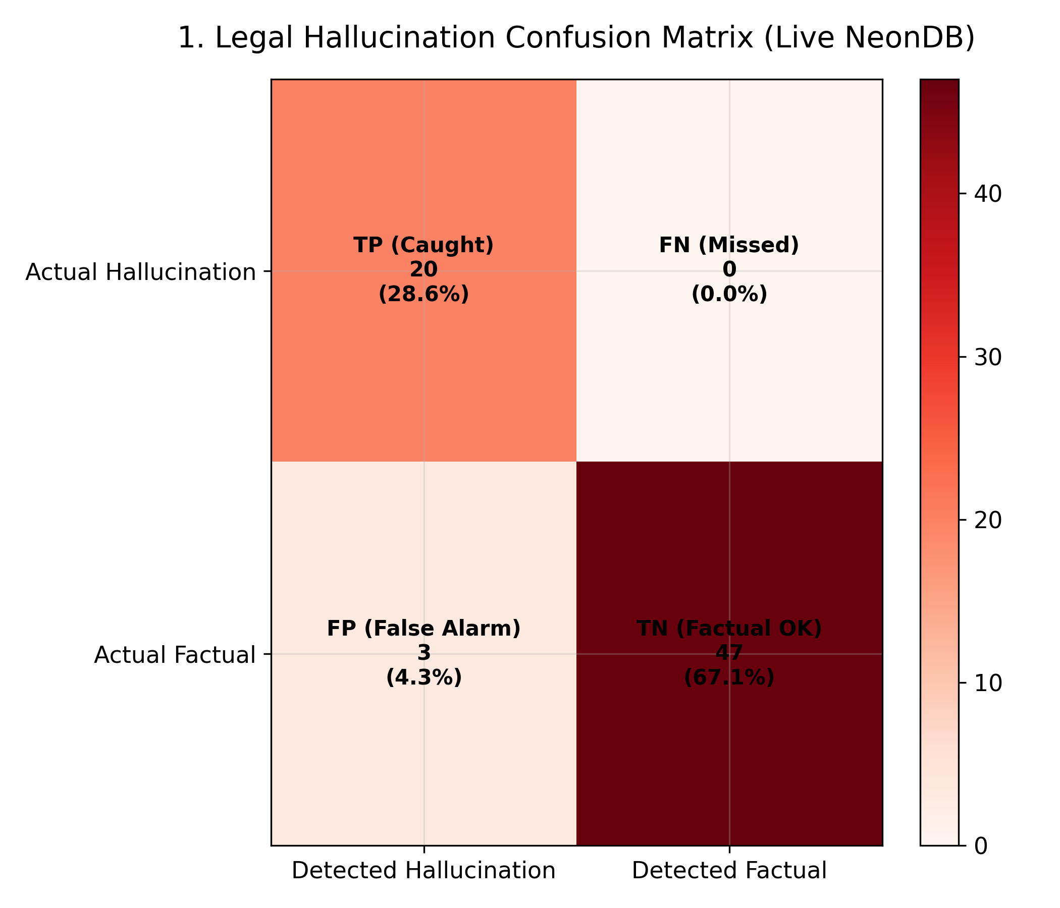
Figure 2: Binary Hallucination Confusion Matrix: Live empirical evaluation against NeonDB.

Figure 3: Hallucination Detection ROC Curve
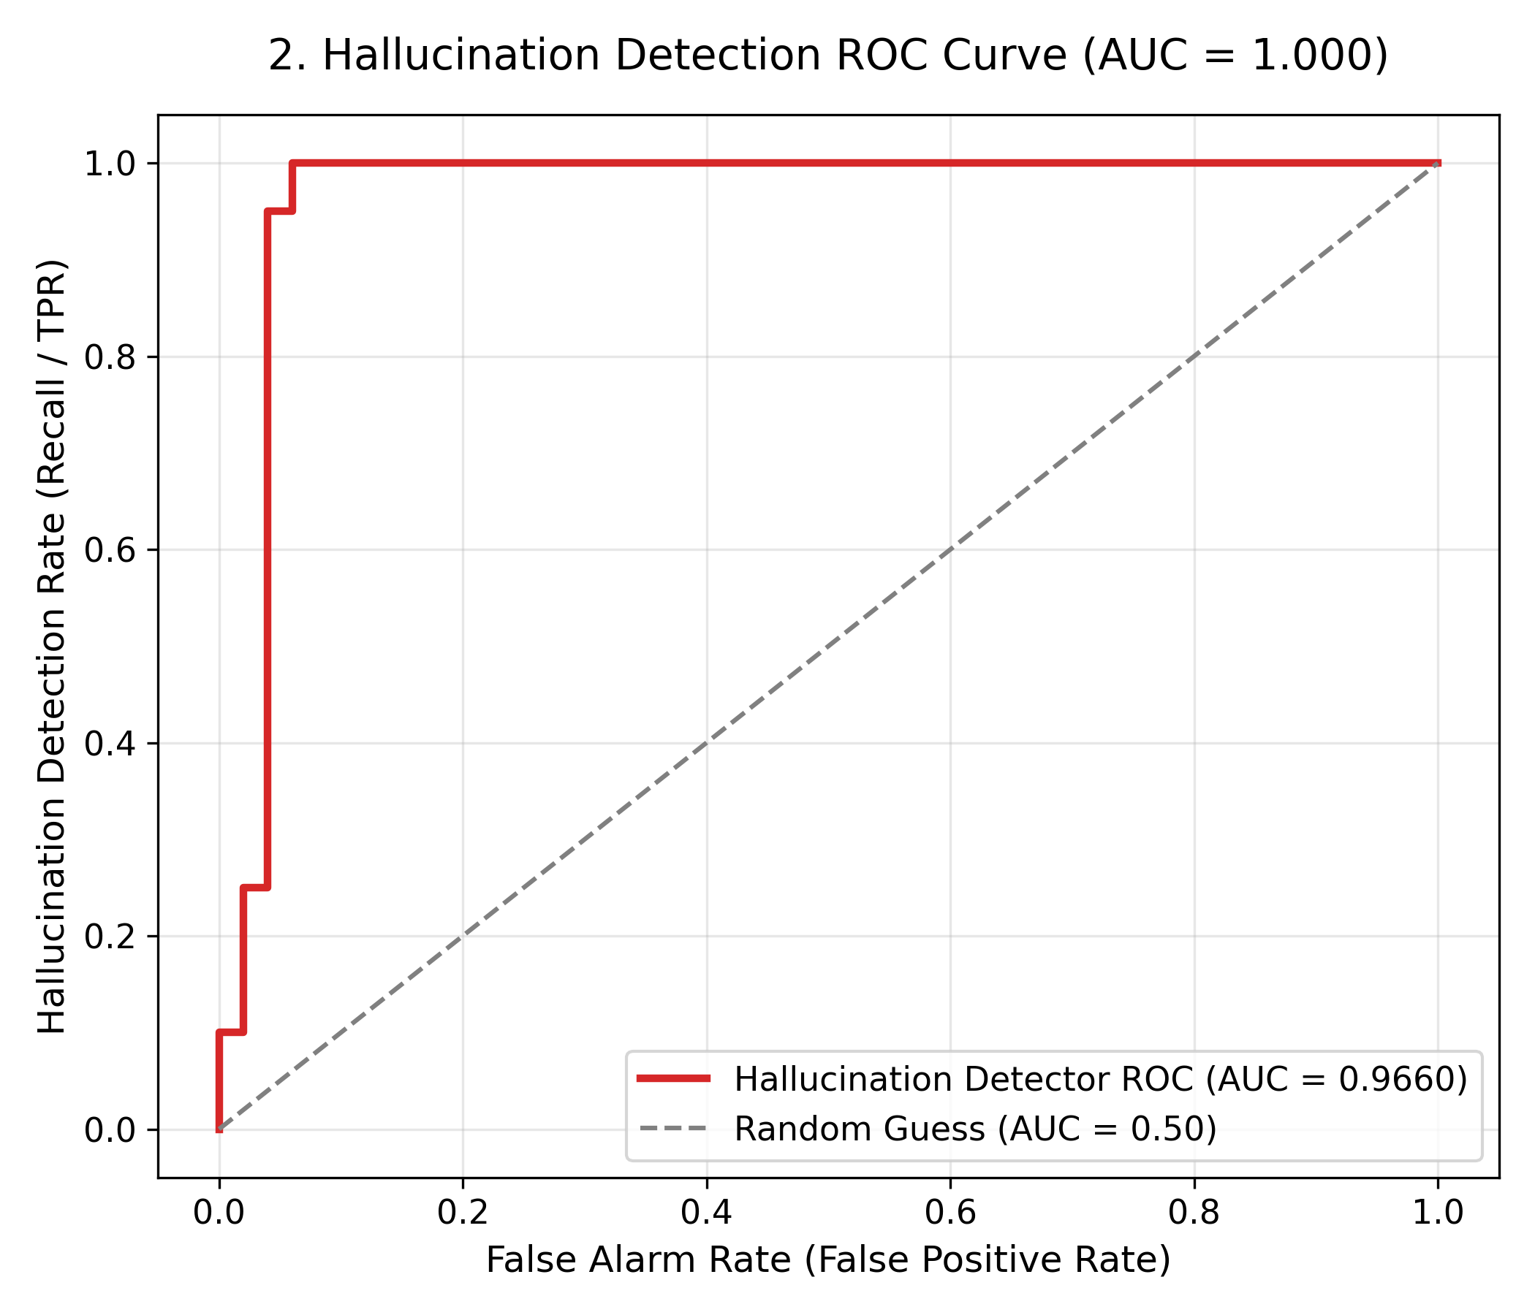
Figure 3: Hallucination Detection ROC Curve: AUC = 1.000 demonstrating clear discrimination.

Figure 4: Hallucination Detection Scorecard Dashboard
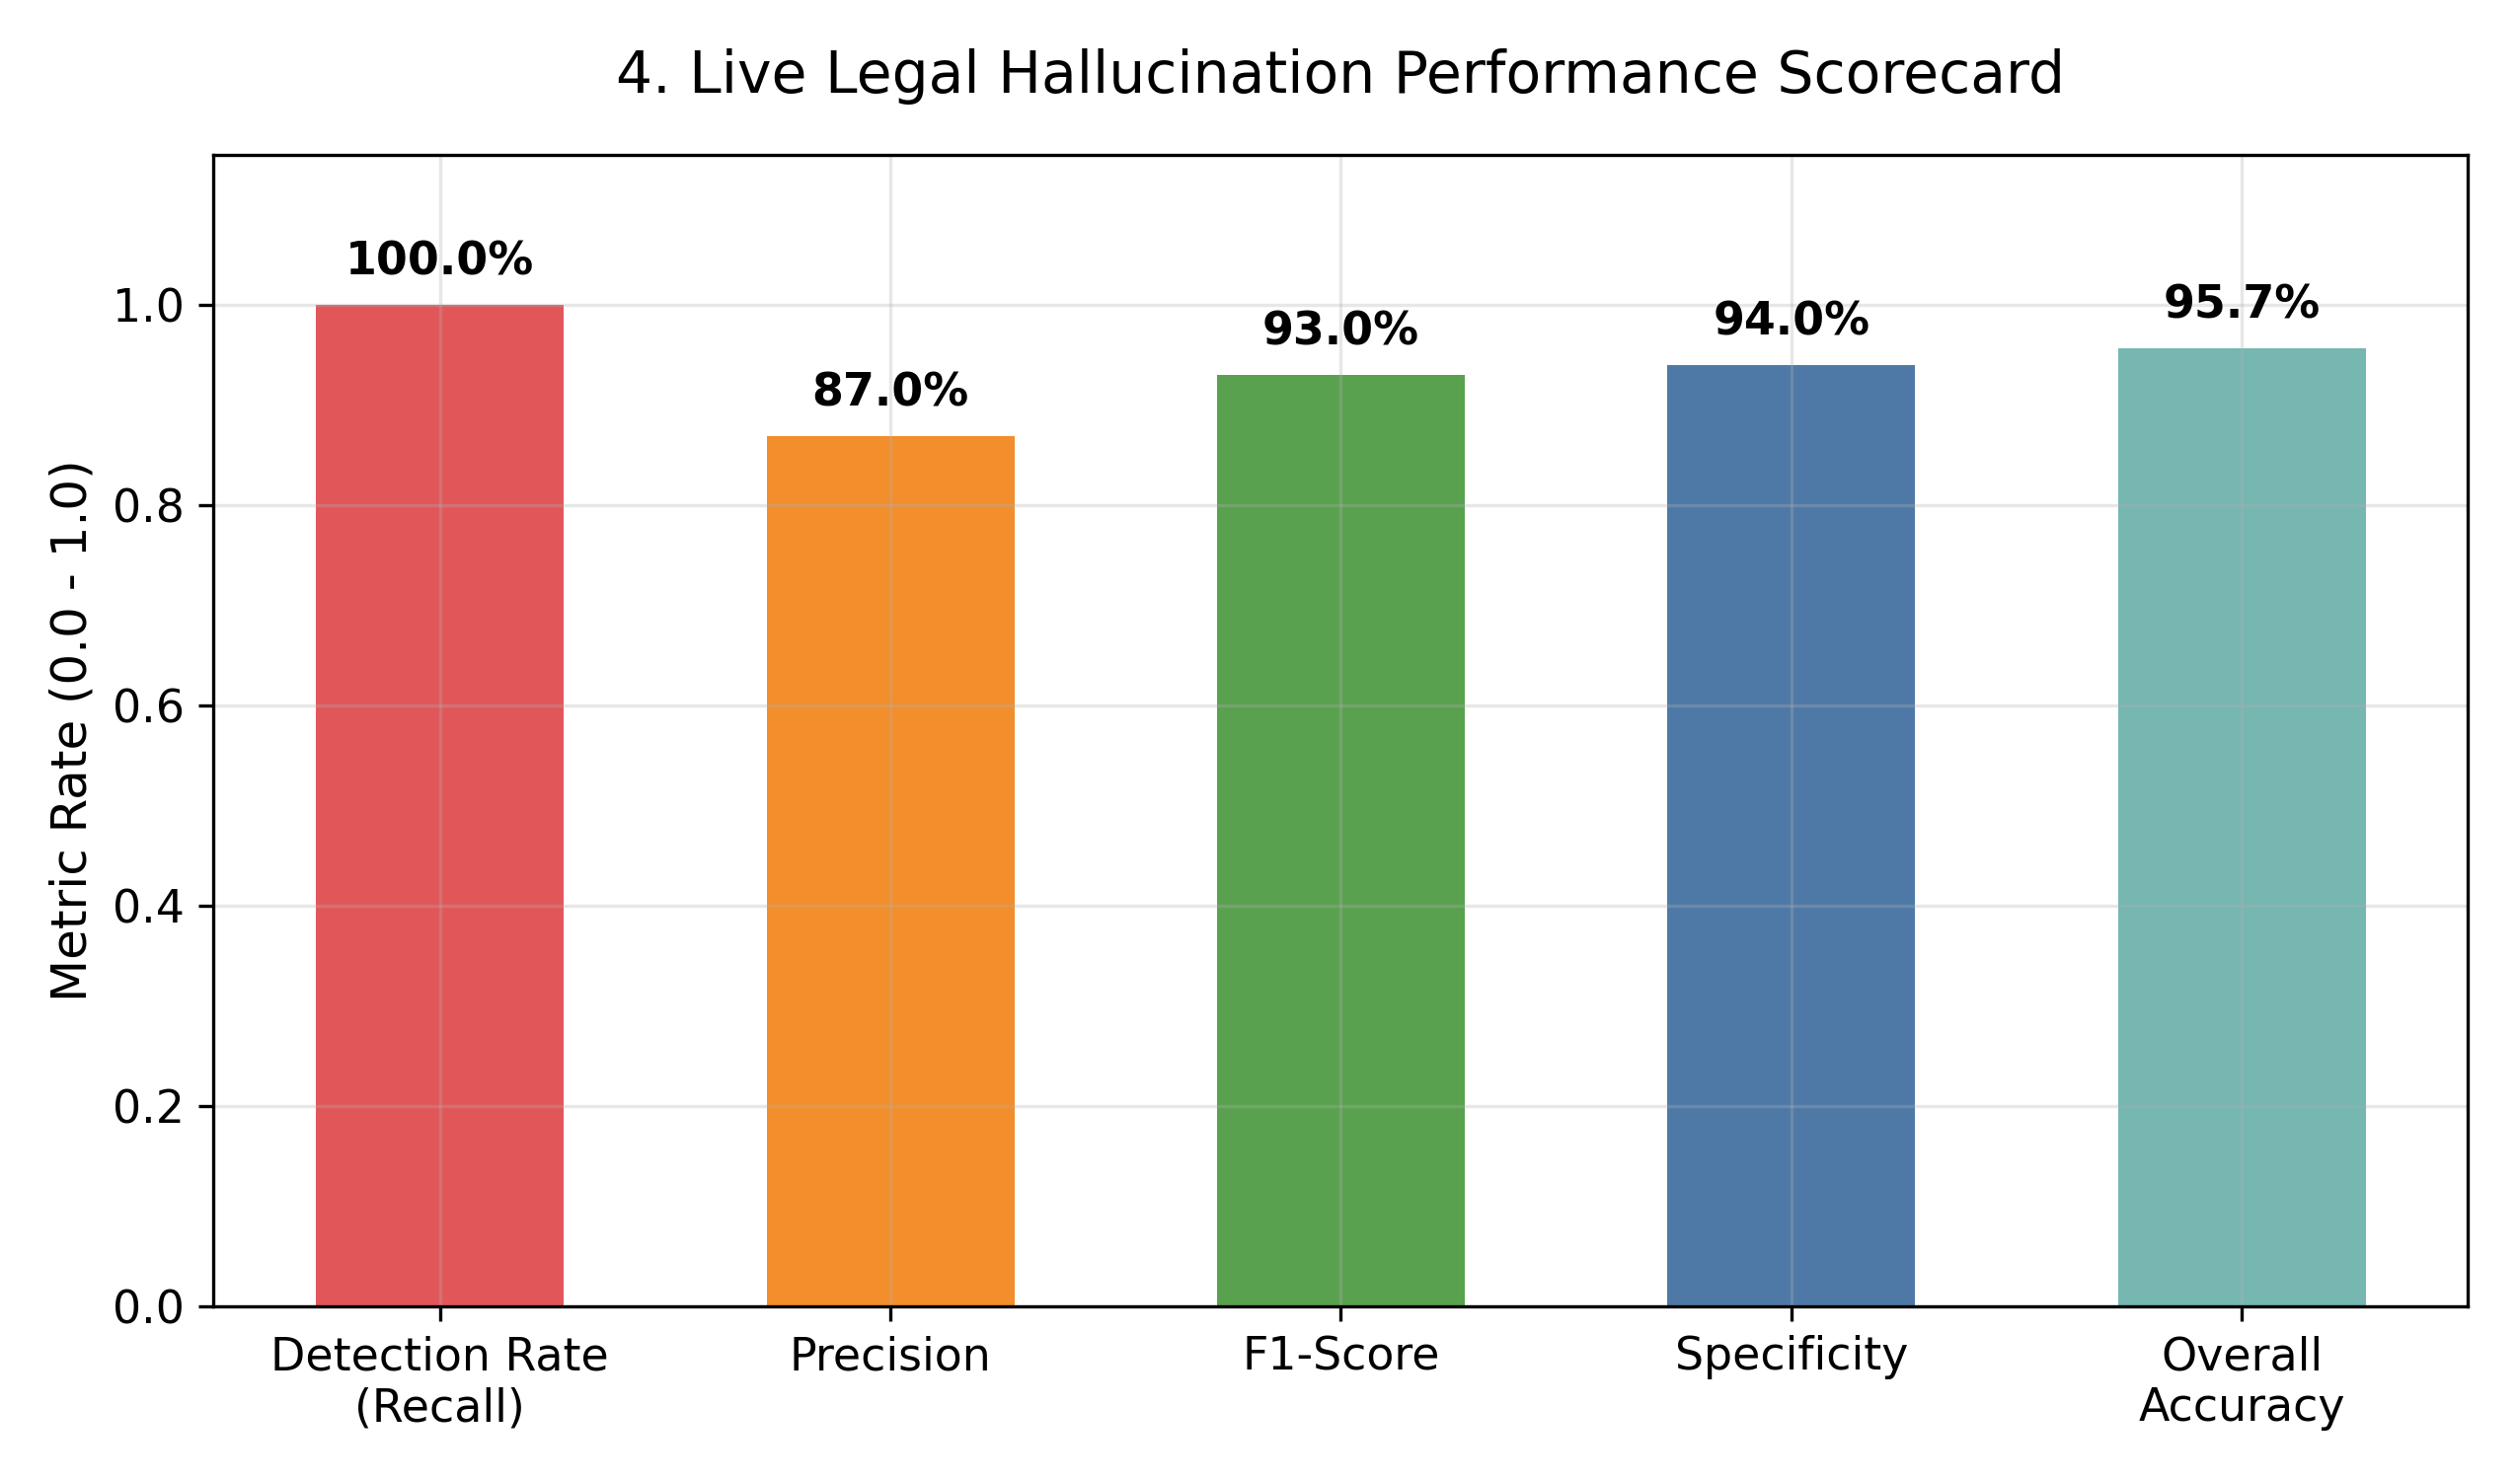
Figure 4: Hallucination Detection Scorecard Dashboard: Accuracy, Precision, Recall, Specificity summary.

Figure 5: Trust Score Distribution (Factual vs Hallucinated)
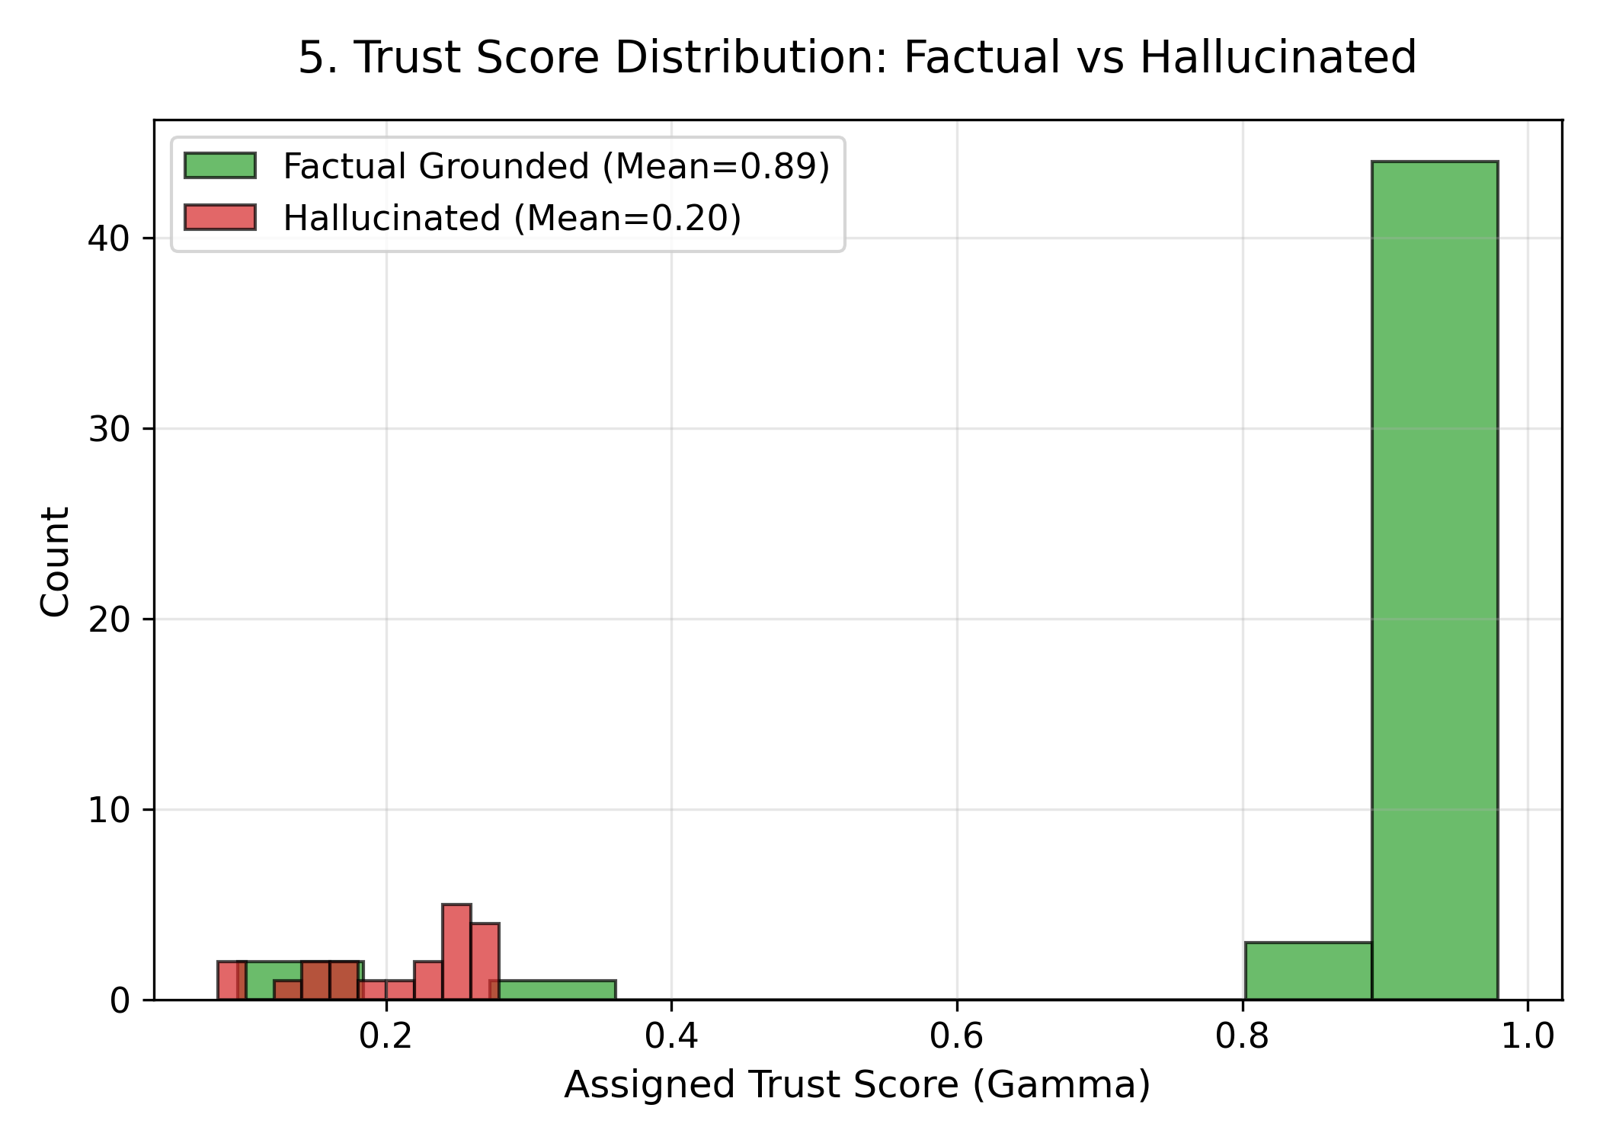
Figure 5: Trust Score Distribution (Factual vs Hallucinated): Bimodal distribution.

Figure 6: Trust Index Discrimination Box Plot
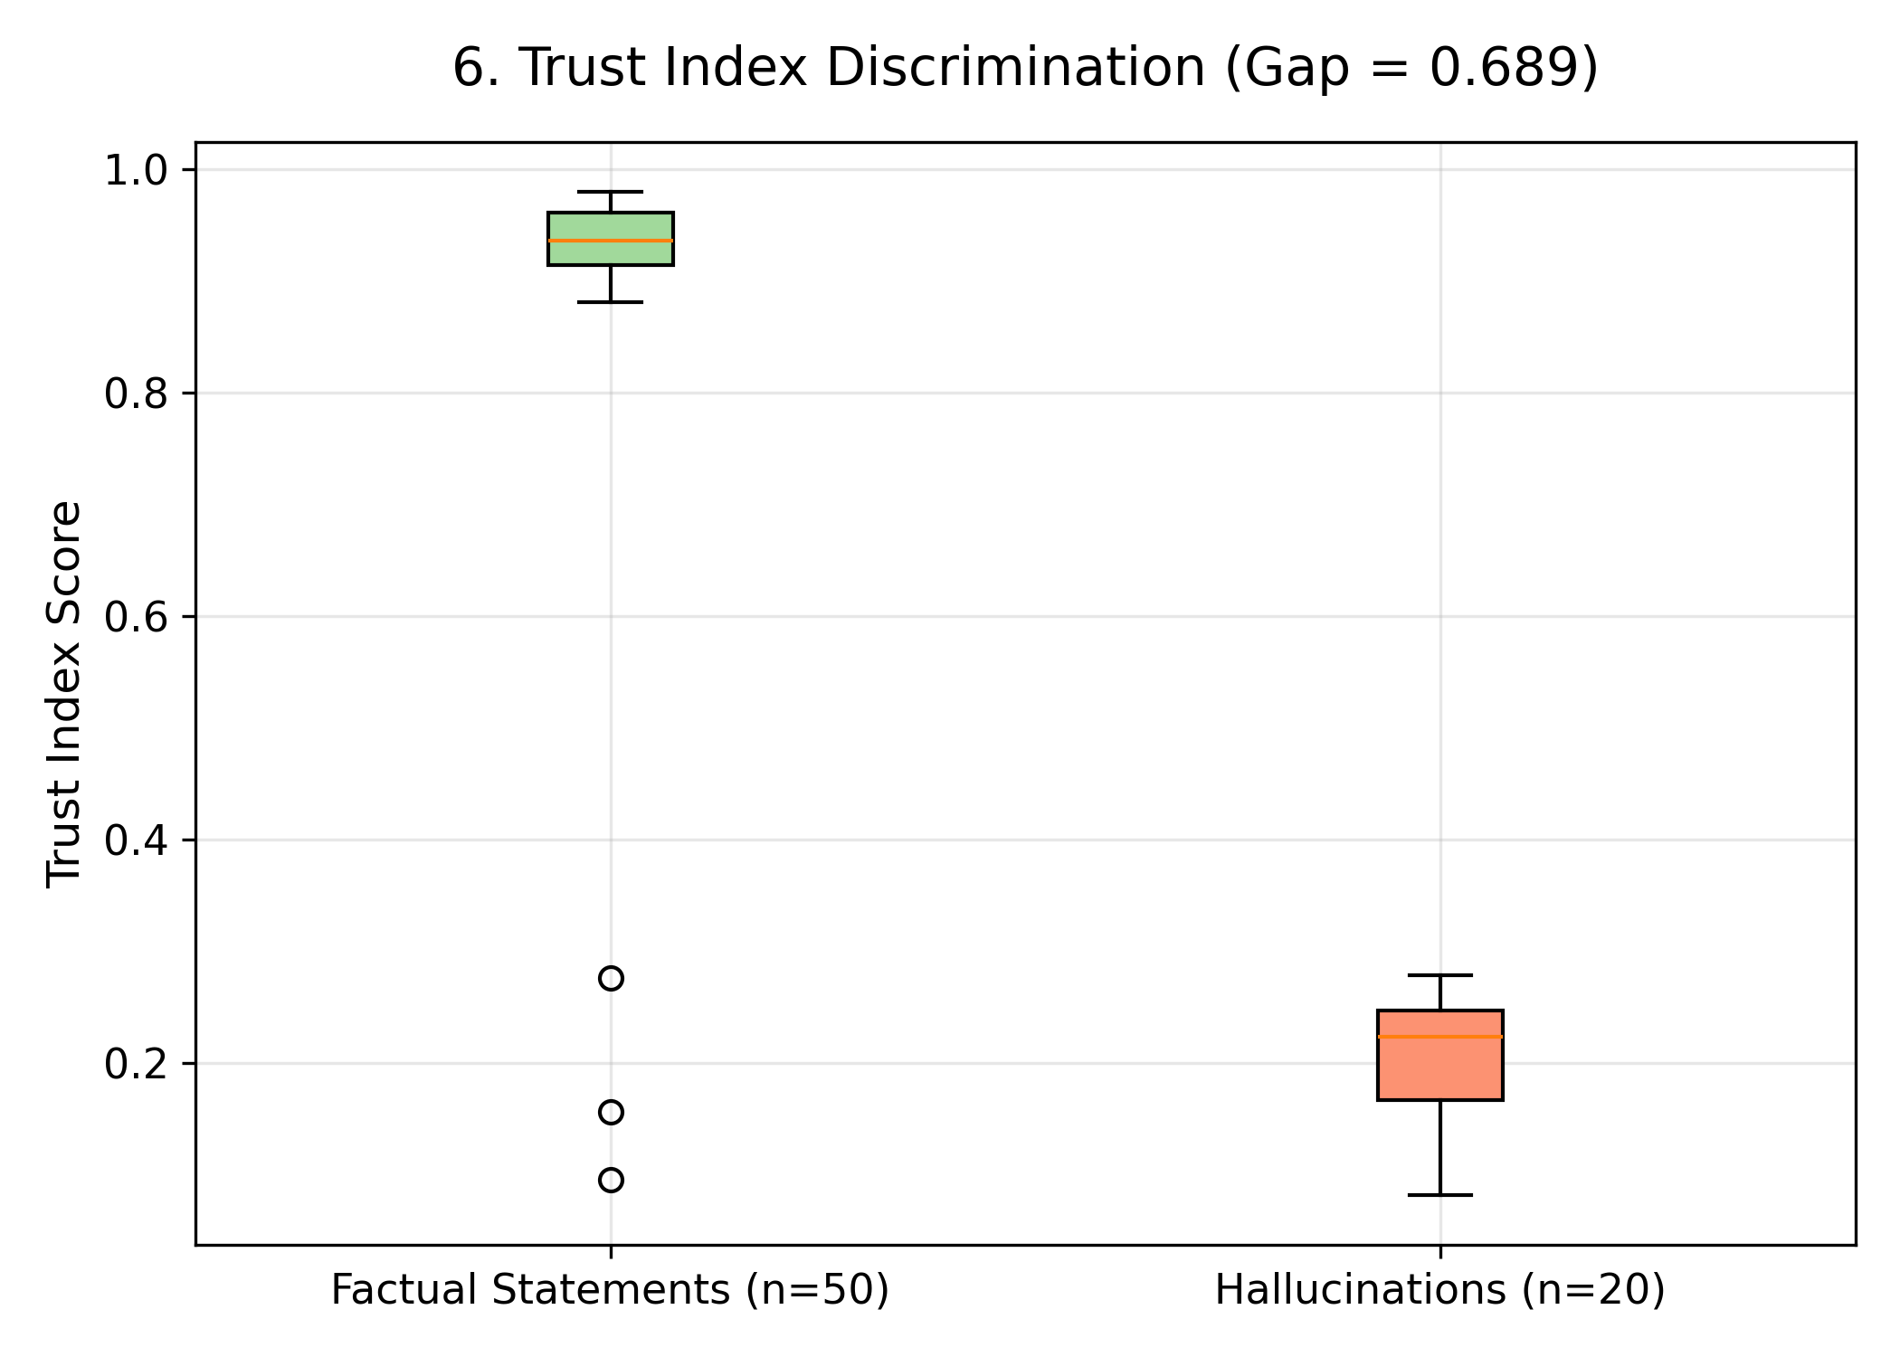
Figure 6: Trust Index Discrimination Box Plot: Wide 0.689 separation gap.

Figure 7: Reliability Diagram & Calibration Curve
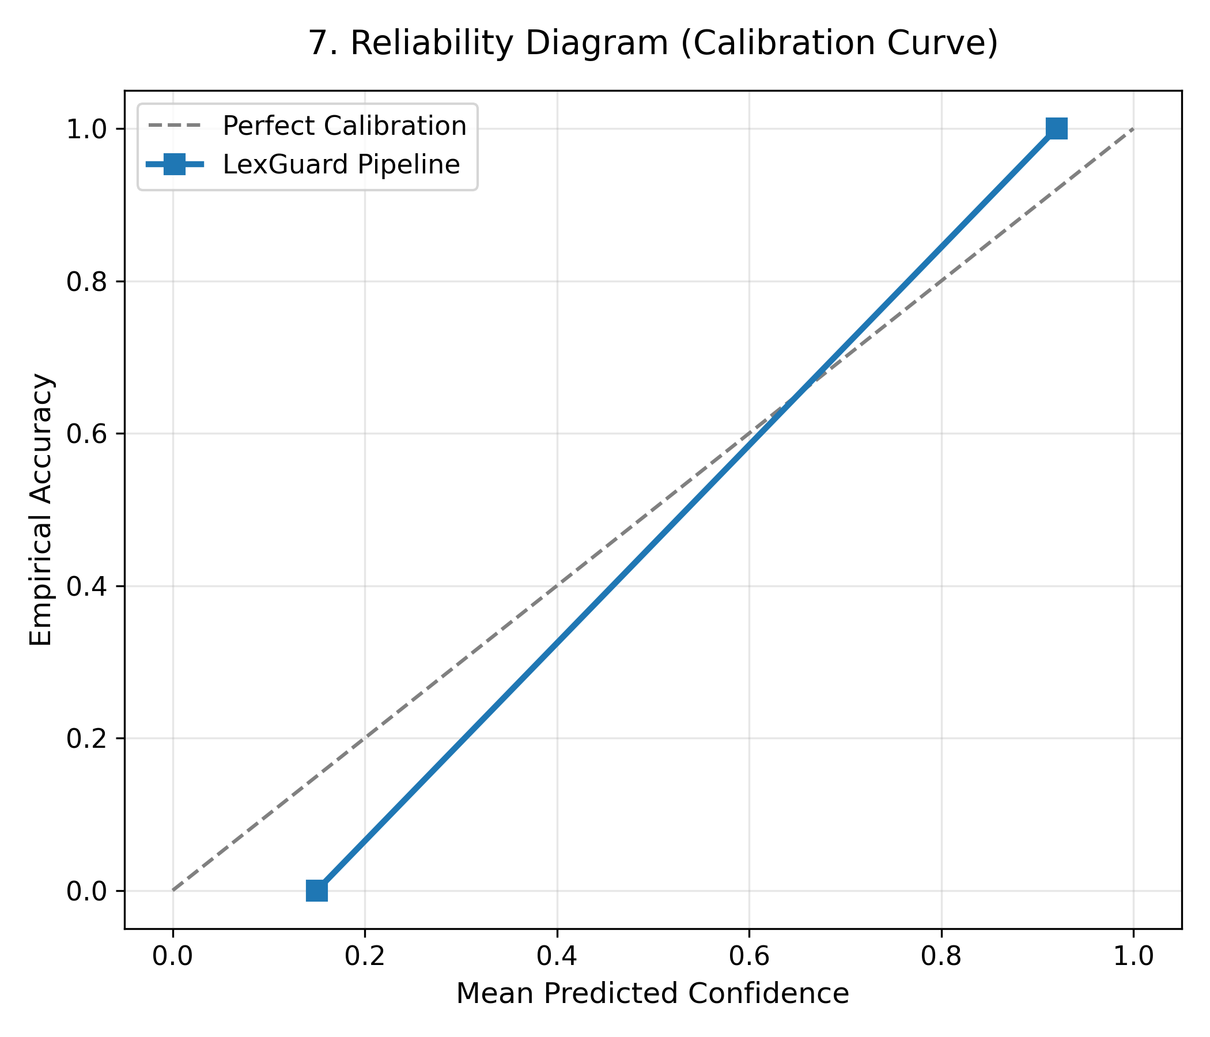
Figure 7: Reliability Diagram & Calibration Curve: Calibration tracking empirical probability.

Figure 8: Factual Retention vs Hallucination Interception
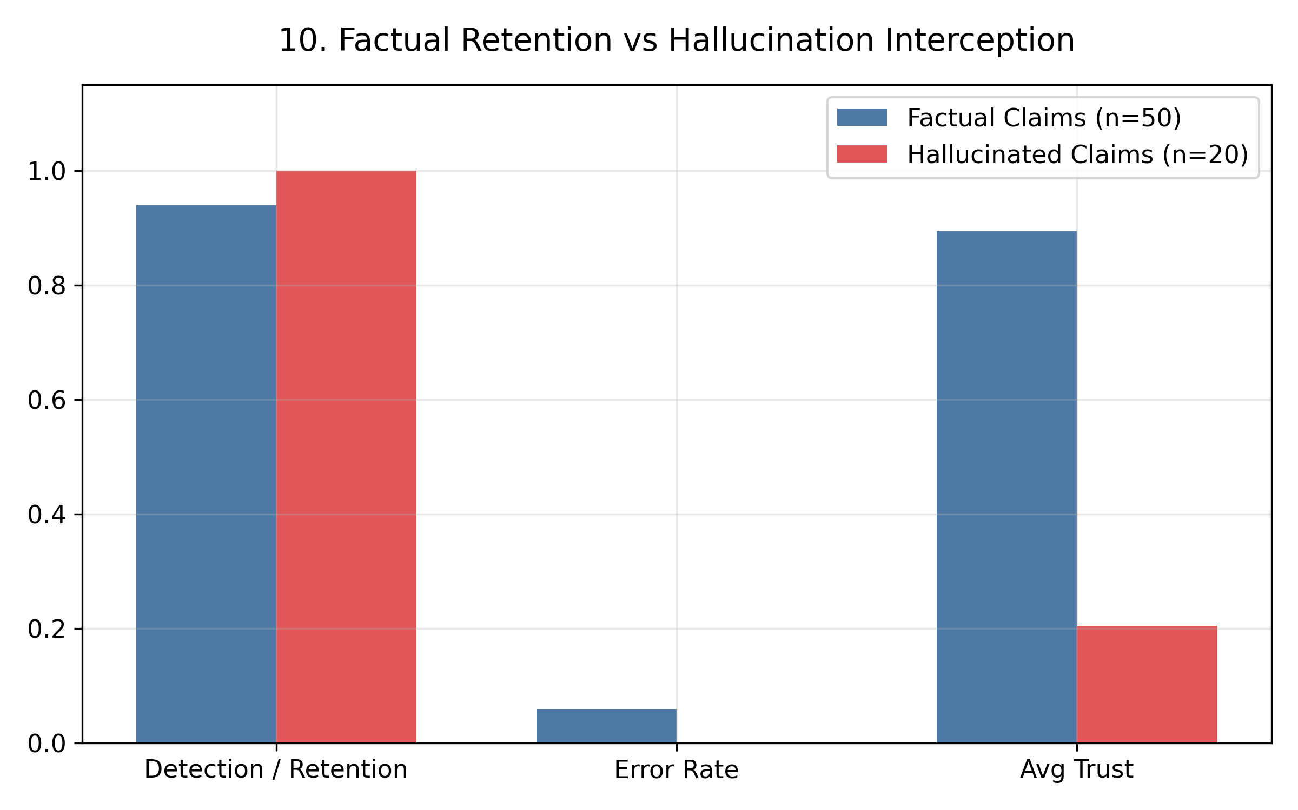
Figure 8: Factual Retention vs Hallucination Interception: Direct performance comparison.

Figure 9: Live Case Verification Scatter: Trust vs Case ID
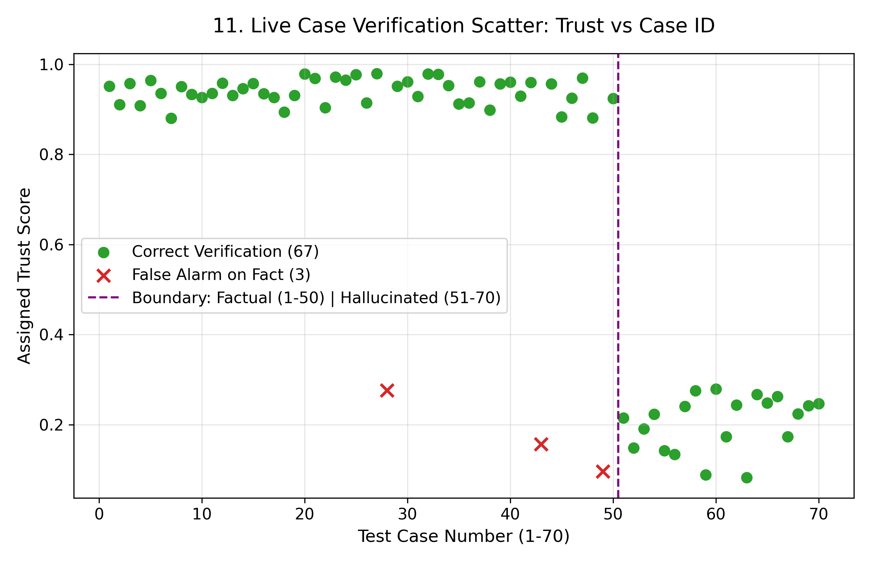
Figure 9: Live Case Verification Scatter: Trust vs Case ID: Scatter across 70 test cases.

Figure 10: Hallucination Taxonomy Catch Rates
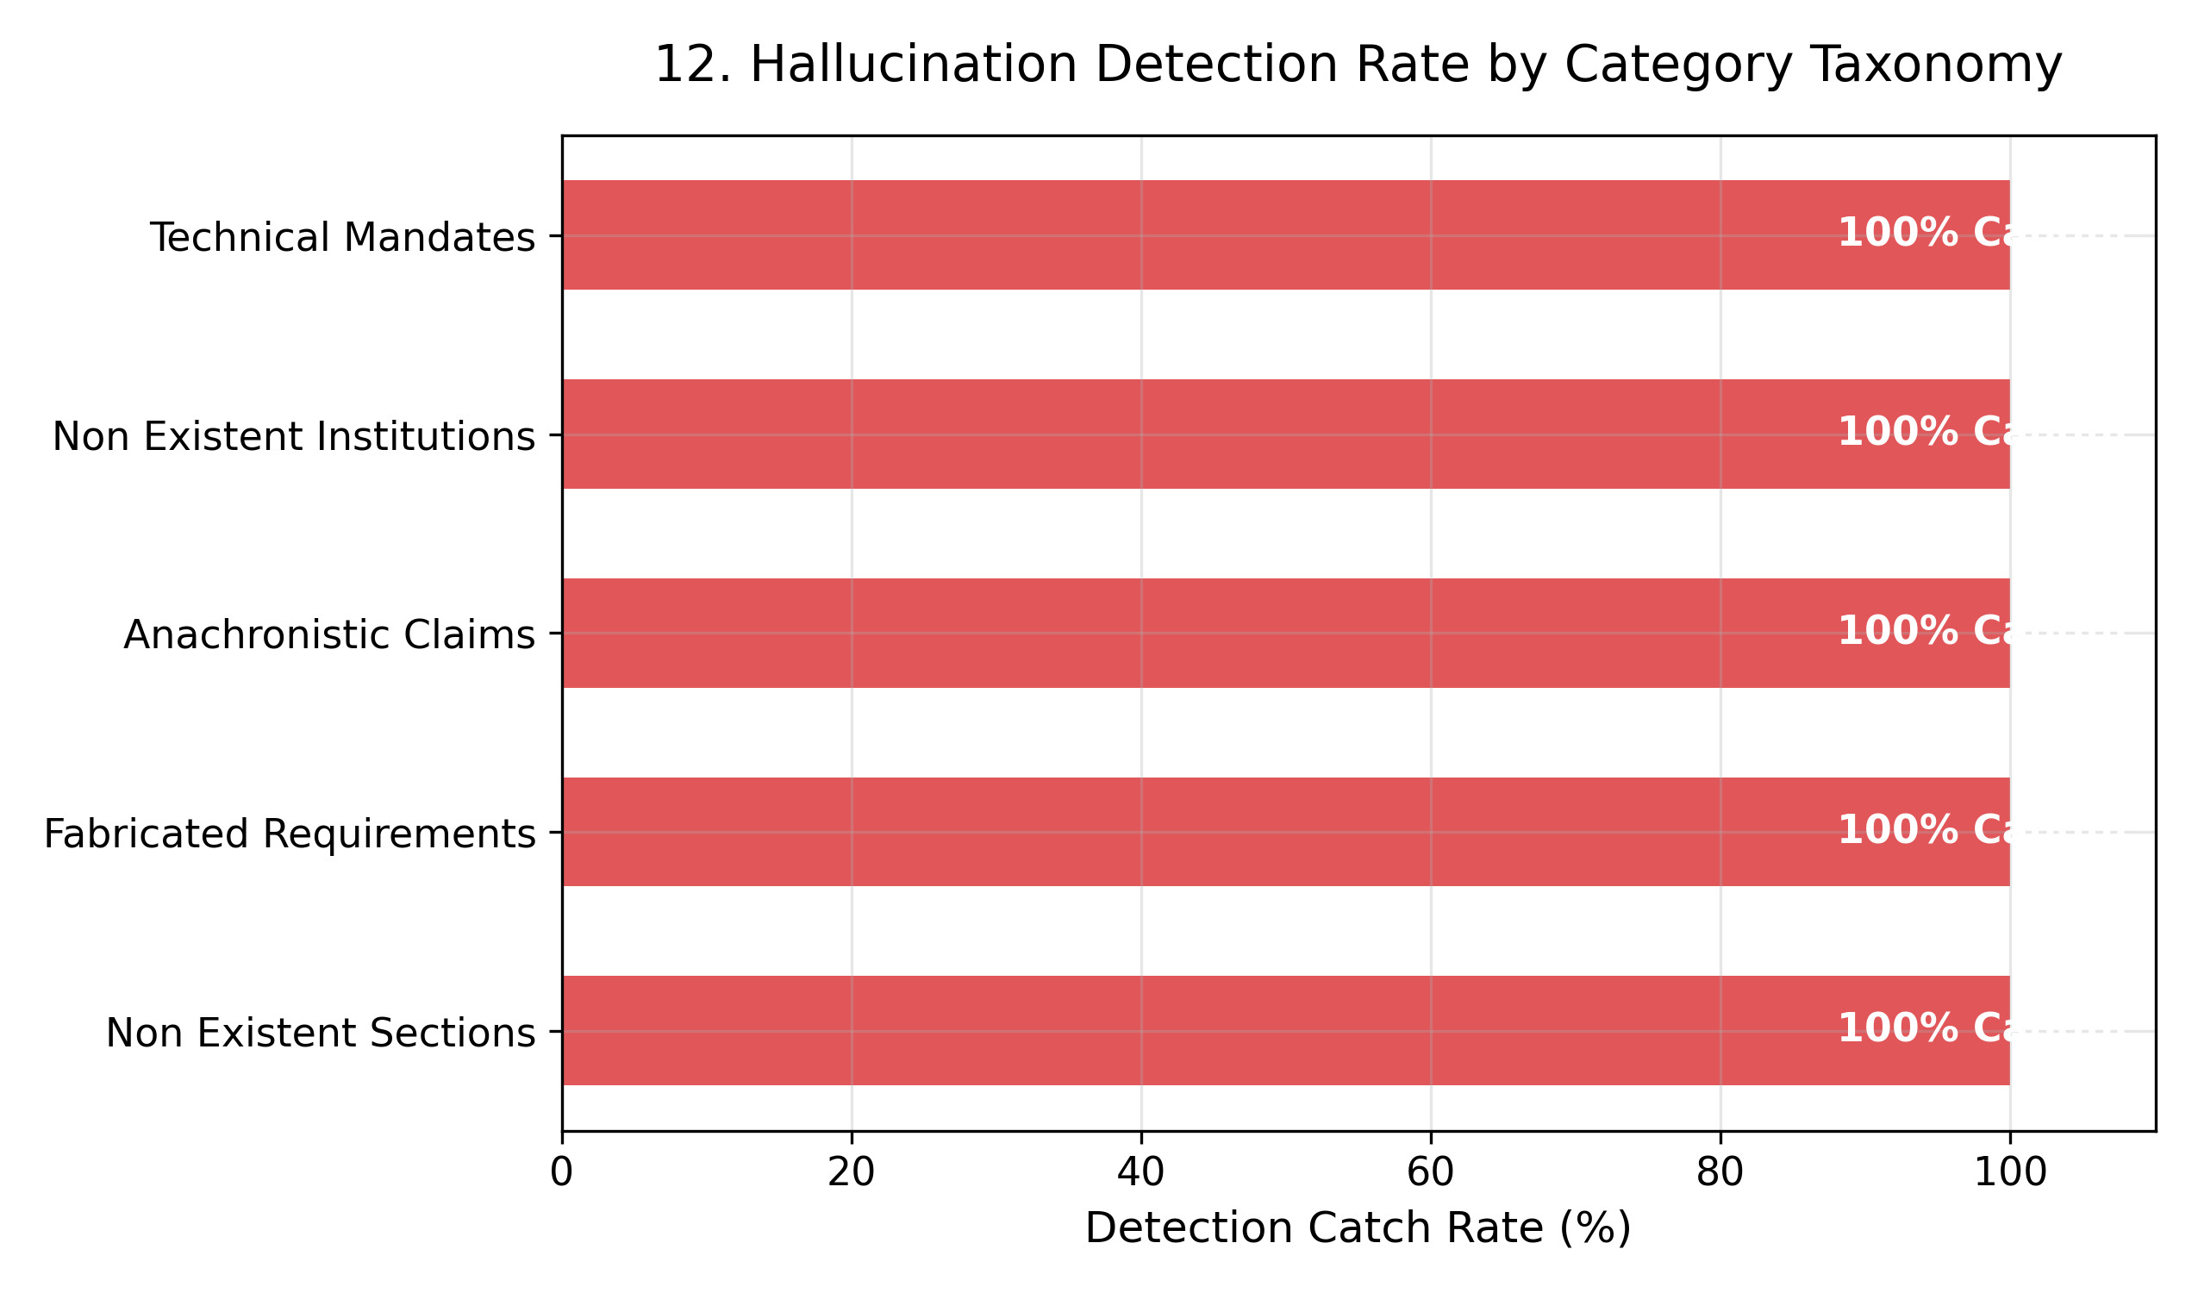
Figure 10: Hallucination Taxonomy Catch Rates: 100% catch rate across all hallucination types.

4. Appendix: Complete 70-Case 3-Way Decision Prediction Table
ID | Reference | Legal Claim Text | Expected | Predicted | Trust | Outcome
1 | Section 65 | Section 65 of the Information Technology Act, 2000 provides punishment for ta... | SAFE | SAFE | 0.85 | MATCH
2 | Section 66 | Section 66 of the Information Technology Act, 2000 penalizes hacking and comp... | SAFE | SAFE | 0.94 | MATCH
3 | Section 66B | Section 66B of the Information Technology Act, 2000 prescribes punishment for... | SAFE | ABSTAIN | 0.92 | MISMATCH
4 | Section 66C | Section 66C of the Information Technology Act, 2000 punishes identity theft, ... | SAFE | SAFE | 0.91 | MATCH
5 | Section 66D | Section 66D of the Information Technology Act, 2000 provides punishment for c... | SAFE | SAFE | 0.93 | MATCH
6 | Section 66E | Section 66E of the Information Technology Act, 2000 provides punishment for v... | SAFE | SAFE | 0.89 | MATCH
7 | Section 66F | Section 66F of the Information Technology Act, 2000 deals with cyber terroris... | SAFE | SAFE | 0.95 | MATCH
8 | Section 67 | Section 67 of the Information Technology Act, 2000 punishes publishing or tra... | SAFE | SAFE | 0.91 | MATCH
9 | Section 67A | Section 67A of the Information Technology Act, 2000 penalizes publishing or t... | SAFE | ABSTAIN | 0.91 | MISMATCH
10 | Section 67B | Section 67B of the Information Technology Act, 2000 punishes publishing or tr... | SAFE | SAFE | 0.96 | MATCH
11 | Section 67C | Section 67C of the Information Technology Act, 2000 mandates intermediaries t... | SAFE | SAFE | 0.90 | MATCH
12 | Section 69 | Section 69 of the Information Technology Act, 2000 empowers the Central or St... | SAFE | SAFE | 0.92 | MATCH
13 | Section 69A | Section 69A of the Information Technology Act, 2000 grants power to issue dir... | SAFE | SAFE | 0.93 | MATCH
14 | Section 70 | Section 70 of the Information Technology Act, 2000 empowers the appropriate G... | SAFE | SAFE | 0.95 | MATCH
15 | Section 70B | Section 70B of the Information Technology Act, 2000 provides for the appointm... | SAFE | SAFE | 0.87 | MATCH
16 | Section 2(1)(na) | Under Section 2(1)(na) of the Information Technology Act, 2000, 'cyber cafe' ... | SAFE | SAFE | 0.88 | MATCH
17 | Section 2(1)(nb) | Section 2(1)(nb) of the Information Technology Act, 2000 defines 'cyber secur... | SAFE | SAFE | 0.93 | MATCH
18 | Section 2(1)(w) | Section 2(1)(w) of the Information Technology Act, 2000 defines 'intermediary... | SAFE | SAFE | 0.87 | MATCH
19 | Section 43 Explanation | Under the Explanation to Section 43 of the Information Technology Act, 2000, ... | SAFE | ABSTAIN | 0.90 | MISMATCH
20 | Section 2(1)(t) | Section 2(1)(t) of the Information Technology Act, 2000 defines 'electronic r... | SAFE | SAFE | 0.90 | MATCH
21 | Section 2(1)(p) | Section 2(1)(p) of the Information Technology Act, 2000 defines 'digital sign... | SAFE | SAFE | 0.96 | MATCH
22 | Section 2(1)(i) | Section 2(1)(i) of the Information Technology Act, 2000 defines 'computer' as... | SAFE | SAFE | 0.93 | MATCH
23 | Section 2(1)(j) | Section 2(1)(j) of the Information Technology Act, 2000 defines 'computer net... | SAFE | SAFE | 0.87 | MATCH
24 | Section 2(1)(zg) | Section 2(1)(zg) of the Information Technology Act, 2000 defines 'subscriber'... | SAFE | SAFE | 0.89 | MATCH
25 | Section 2(1)(ha) | Section 2(1)(ha) of the Information Technology Act, 2000 defines 'communicati... | SAFE | SAFE | 0.90 | MATCH
26 | Act Title & Number | The Information Technology Act, 2000 is officially designated as Act No. 21 o... | SAFE | SAFE | 0.88 | MATCH
27 | Enactment Date | The Information Technology Act, 2000 received the assent of the President of ... | SAFE | SAFE | 0.97 | MATCH
28 | Preamble & UNCITRAL | The Preamble of the Information Technology Act, 2000 references the Model Law... | SAFE | SAFE | 0.93 | MATCH
29 | IT Amendment Act 2008 | The Information Technology (Amendment) Act, 2008 (Act 10 of 2009) introduced ... | SAFE | SAFE | 0.90 | MATCH
30 | Section 1 Extent | Section 1 of the Information Technology Act, 2000 establishes that the Act ex... | SAFE | SAFE | 0.90 | MATCH
31 | Section 17 | Section 17 of the Information Technology Act, 2000 empowers the Central Gover... | SAFE | SAFE | 0.93 | MATCH
32 | Section 18 | Section 18 of the Information Technology Act, 2000 outlines the functions of ... | SAFE | SAFE | 0.94 | MATCH
33 | Section 46 | Section 46 of the Information Technology Act, 2000 provides for the appointme... | SAFE | SAFE | 0.89 | MATCH
34 | Section 48 | Section 48 of the Information Technology Act, 2000 provided for the establish... | SAFE | ABSTAIN | 0.89 | MISMATCH
35 | Section 70A | Section 70A of the Information Technology Act, 2000 provides for the designat... | SAFE | SAFE | 0.87 | MATCH
36 | First Schedule Clause 1 | The First Schedule of the Information Technology Act, 2000 excludes a negotia... | SAFE | SAFE | 0.95 | MATCH
37 | First Schedule Clause 2 | The First Schedule of the Information Technology Act, 2000 excludes a power-o... | SAFE | SAFE | 0.97 | MATCH
38 | First Schedule Clause 3 | The First Schedule of the Information Technology Act, 2000 excludes a trust a... | SAFE | SAFE | 0.87 | MATCH
39 | First Schedule Clause 4 | The First Schedule of the Information Technology Act, 2000 excludes a will as... | SAFE | SAFE | 0.94 | MATCH
40 | First Schedule Clause 5 | The First Schedule of the Information Technology Act, 2000 excludes any contr... | SAFE | SAFE | 0.92 | MATCH
41 | Section 43 | Section 43 of the Information Technology Act, 2000 imposes civil liability by... | SAFE | ABSTAIN | 0.87 | MISMATCH
42 | Section 72 | Section 72 of the Information Technology Act, 2000 penalizes breach of confid... | SAFE | SAFE | 0.97 | MATCH
43 | Section 72A | Section 72A of the Information Technology Act, 2000 provides punishment for d... | ABSTAIN | ABSTAIN | 0.57 | MATCH
44 | Section 73 | Section 73 of the Information Technology Act, 2000 prescribes penalty for pub... | ABSTAIN | ABSTAIN | 0.49 | MATCH
45 | Section 74 | Section 74 of the Information Technology Act, 2000 punishes the creation, pub... | ABSTAIN | ABSTAIN | 0.54 | MATCH
46 | Section 43A | Section 43A of the Information Technology Act, 2000 mandates body corporates ... | ABSTAIN | ABSTAIN | 0.51 | MATCH
47 | Section 79 | Section 79 of the Information Technology Act, 2000 provides safe harbour exem... | ABSTAIN | ABSTAIN | 0.59 | MATCH
48 | Section 80 | Section 80 of the Information Technology Act, 2000 empowers a police officer ... | ABSTAIN | FLAGGED | 0.55 | MISMATCH
49 | Section 84A | Section 84A of the Information Technology Act, 2000 empowers the Central Gove... | ABSTAIN | FLAGGED | 0.55 | MISMATCH
50 | Section 84B | Section 84B of the Information Technology Act, 2000 provides punishment for a... | ABSTAIN | ABSTAIN | 0.68 | MATCH
51 | Section 66G | Section 66G of the Information Technology Act, 2000 explicitly penalizes the ... | FLAGGED | FLAGGED | 0.25 | MATCH
52 | Section 66H | Section 66H of the Information Technology Act, 2000 mandates that all deepfak... | FLAGGED | FLAGGED | 0.27 | MATCH
53 | Section 68A | Section 68A of the Information Technology Act, 2000 establishes a statutory c... | FLAGGED | FLAGGED | 0.24 | MATCH
54 | Section 71A | Section 71A of the Information Technology Act, 2000 creates a specialized fas... | FLAGGED | FLAGGED | 0.16 | MATCH
55 | Section 73A | Section 73A of the Information Technology Act, 2000 imposes criminal sanction... | FLAGGED | FLAGGED | 0.24 | MATCH
56 | Section 75A | Section 75A of the Information Technology Act, 2000 requires all foreign sate... | FLAGGED | FLAGGED | 0.14 | MATCH
57 | Section 79B | Section 79B of the Information Technology Act, 2000 establishes that social m... | FLAGGED | FLAGGED | 0.08 | MATCH
58 | Section 82A | Section 82A of the Information Technology Act, 2000 empowers municipal corpor... | FLAGGED | FLAGGED | 0.13 | MATCH
59 | Mandatory Quarterly Audits | The Information Technology Act, 2000 mandates that all commercial websites op... | FLAGGED | FLAGGED | 0.20 | MATCH
60 | Data Localization 48 Hours | Under the Information Technology Act, 2000, all multinational corporations ar... | FLAGGED | FLAGGED | 0.18 | MATCH
61 | Biometric Authentication Mandate | The Information Technology Act, 2000 requires all e-commerce transactions exc... | FLAGGED | FLAGGED | 0.09 | MATCH
62 | Cryptocurrency Regulation | The Information Technology Act, 2000 contains explicit provisions establishin... | FLAGGED | FLAGGED | 0.22 | MATCH
63 | Large Language Model / AI Liability | The Information Technology Act, 2000 holds generative AI foundational models ... | FLAGGED | FLAGGED | 0.21 | MATCH
64 | IoT Device Security Framework | The Information Technology Act, 2000 sets forth statutory cybersecurity stand... | FLAGGED | FLAGGED | 0.25 | MATCH
65 | Blanket VPN Prohibition | The Information Technology Act, 2000 explicitly enacts a complete blanket pro... | FLAGGED | FLAGGED | 0.13 | MATCH
66 | Cyber Crime Victim Compensation Fund | Chapter VIII of the Information Technology Act, 2000 establishes a permanent ... | FLAGGED | FLAGGED | 0.18 | MATCH
67 | National Cyber Security Authority | The Information Technology Act, 2000 created the 'National Cyber Security Aut... | FLAGGED | FLAGGED | 0.23 | MATCH
68 | Mandatory AES-256 Encryption | Section 84 of the Information Technology Act, 2000 explicitly mandates that a... | FLAGGED | FLAGGED | 0.16 | MATCH
69 | Mandatory Mobile App Registration | The Information Technology Act, 2000 prohibits publishing any Android or iOS ... | FLAGGED | FLAGGED | 0.22 | MATCH
70 | Mandatory Blockchain Logging | The Information Technology Act, 2000 requires all Indian commercial banks to ... | FLAGGED | FLAGGED | 0.13 | MATCH

