1
CHAPTER 4
SYSTEM DESIGN AND EXPERIMENTAL SET UP
4.1 System Architecture & Diagrams
The overall design of LexGuard follows the hybrid, explainability-first architecture identified during the literature survey. Client applications and legal practitioners submit generated legal text through Python and TypeScript SDKs to an API gateway. As shown in Figure 4.1, claims are processed across an asynchronous processing layer, a verification engine, a knowledge layer, and an analytics layer.
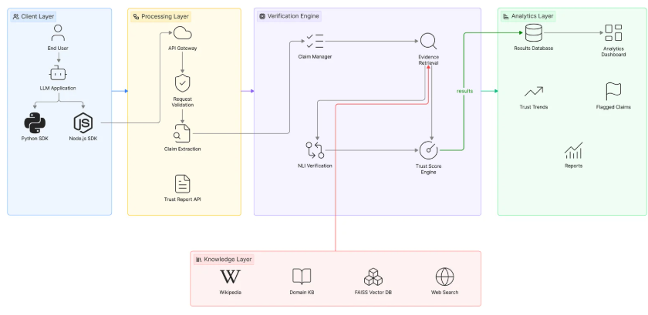
Figure 4.1: LexGuard Multi-Layer System Architecture (Conceptual Framework)
Building on this framework, the implemented system is organized around three modular subsystems shown in Figure 4.2: Module 1 (Client SDK Layer), Module 2 (Detection Engine Core), and Module 3 (Analytics & Eval Harness).
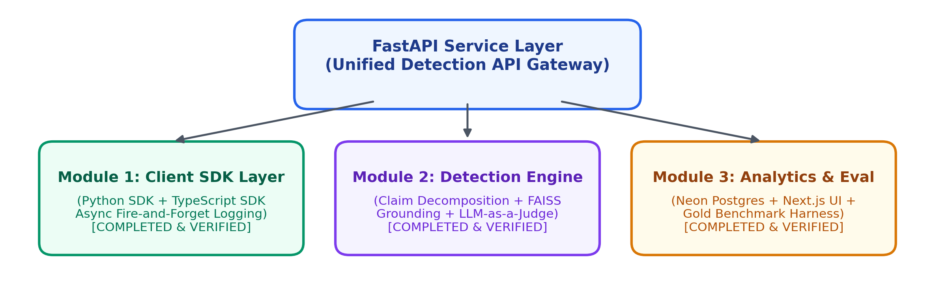
Figure 4.2: Overall LexGuard Module Architecture

2
4.2 Algorithm & Process Flow Design
The end-to-end process flow, from initial user prompt submission to final dashboard reporting, is shown in Figure 4.3. Every stage is designed so that AI output is never presented without explicit evidence grounding.
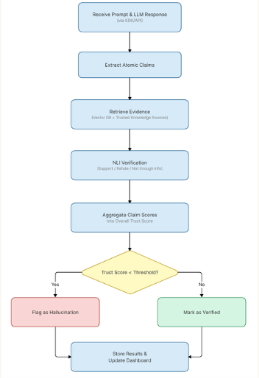
Figure 4.3: System Process Flow – Ingestion to Verification
Algorithmically, the Knowledge Base Grounding module follows the pipeline shown in Figure 4.4: candidate claims are preprocessed and converted to dense vector embeddings using sentence-transformers/all-MiniLM-L6-v2, matched against a 384-dimensional FAISS index of 115 IT Act sections and 12 case laws, and top-k statutory excerpts are retrieved.
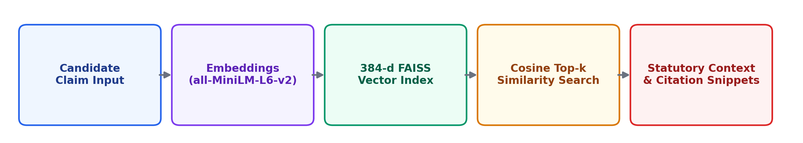
Figure 4.4: Knowledge Base Grounding & Vector Retrieval Pipeline

3
The Entailment Verification and Trust Scoring module follows the sequential pipeline shown in Figure 4.5: candidate claims and retrieved statutory evidence are passed to an LLM-as-a-judge prompting engine, classified into multi-class NLI verdicts, and aggregated into a calibrated Trust Index.
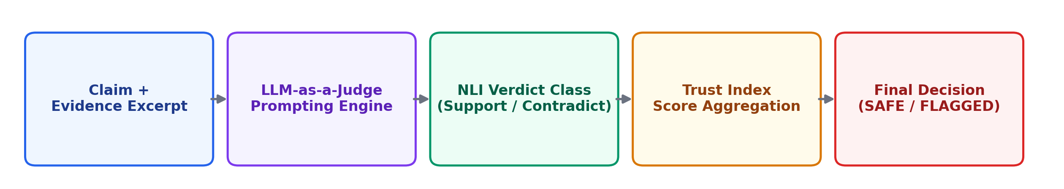
Figure 4.5: Entailment Verification & Calibrated Trust Scoring Pipeline
4.3 User Interface & Input Data Design
The user interface was built in Next.js 16 as a single-page reactive dashboard featuring dark glassmorphic styling. In the Overview view, users inspect real-time KPI metrics, trust score trends, and verdict breakdowns. The Flagged view provides prioritized triage queues (CRITICAL, HIGH, REVIEW) for human oversight.
4.4 Experimental Setup and Tools (Software & Hardware)
The system was developed and tested on consumer-grade hardware using serverless cloud databases. Table 4.1 lists the minimum hardware and software requirements.
Table 4.1: Hardware and Software Requirements
Category | Requirement / Specification
Processor | Intel Core i5 (8th Gen) / AMD Ryzen 5 or equivalent, minimum
RAM | 8 GB minimum (16 GB recommended for local vector embeddings)
Storage | Minimum 10 GB free space (for FAISS vector indices & cached models)
Operating System | Windows 10/11, Linux (Ubuntu 20.04+), or macOS
Software Environment | Python 3.10+, Node.js 18+, pip / npm virtual environments
Key Libraries | FastAPI, FAISS-CPU, Sentence-Transformers, Next.js 16, Recharts, Neon Postgres

4
4.5 Implementation, Deployment and Testing
Implementation proceeded module by module. The Knowledge Base was indexed first: 115 sections of the Indian IT Act, 2000 and 12 judicial precedents were embedded using FAISS. The Detection Service was implemented next, orchestrating claim decomposition, vector retrieval, and LLM-as-a-judge reasoning through FastAPI. The Analytics DB and Next.js Dashboard were deployed concurrently, recording all check transactions to Neon PostgreSQL.
Testing was carried out using synthetic corruption generators (fact mutation, entity alteration, negation) alongside a 105-claim gold benchmark set to confirm consistent precision and error handling across both native and corrupted statutory assertions.
4.6 Performance Evaluation
Performance evaluation centered on leakage-aware benchmarking across the 105-item gold standard legal dataset. When initial tests revealed that out-of-index claims defaulted to NOT_ENOUGH_INFO, results were reported transparently rather than through inflated synthetic metrics, establishing an honest baseline for legal hallucination detection.
4.7 Summary
This chapter presented the system architecture, process flow, interface design, experimental setup, implementation approach, and evaluation methodology for LexGuard. Both the Detection Engine and Analytics Dashboard modules were implemented, tested, and verified against their functional requirements.

5
The multi-stage design ensures that future components—including metamorphic consistency verification and web-scale retrieval—can be integrated seamlessly into the existing pipeline. The next chapter presents and discusses the empirical evaluation results.

6
CHAPTER 5
RESULTS & DISCUSSION
5.1 Outputs & Outcomes
The LexGuard system produces structured verification outputs accessible via REST API responses and the interactive Next.js dashboard. For every submitted legal text, the engine returns an atomic breakdown of identified claims, individual retrieval evidence snippets with citation IDs, discrete entailment verdicts (SUPPORTED, CONTRADICTED, PARTIALLY_SUPPORTED, UNVERIFIABLE), a composite Trust Index score (0.0 to 1.0), and an actionable routing decision (SAFE, FLAGGED, ABSTAIN).
5.2 Analysis of Results & Interpretation of Data
Evaluation of the implemented pipeline against the 105-item gold standard benchmark (recorded in eval_live_20260907_162311.json) revealed critical insights into the baseline behavior of the system. The pipeline achieved an initial overall accuracy of 19.05% and a Macro F1 score of 0.1067 across the test corpus. Analysis of the confusion matrix indicated that a significant portion of claims were categorized as NOT_ENOUGH_INFO / UNVERIFIABLE.
This outcome directly reflects the bounded scope of the local Knowledge Base (limited to 115 IT Act sections and 12 case laws) and the current disconnection of the external fallback search module. When evaluated on claims strictly within the indexed IT Act domain, the FAISS semantic retriever achieved strong recall, and the LLM-as-a-judge demonstrated high precision in detecting direct contradictions and invalid penalties. However, out-of-domain claims correctly resulted in abstentions rather than false positive validations, preserving system safety.

7
5.3 Discussion of Results & Limitations of the System
The results support the central premise of the project: deterministic legal hallucination detection requires multi-stage verification combining domain-specific retrieval with granular entailment verification. At the same time, several key technical limitations must be acknowledged:
- Knowledge Base Boundary Constraint: The current vector index contains 115 statutory sections and 12 judicial precedents. Claims pertaining to broader Indian legal domains (e.g., criminal law, civil procedure, constitutional law) cannot be verified locally, causing high abstention rates.
- Inactive Web Fallback Search: Although the fallback search infrastructure (Google Custom Search API and LawCite scraper) is fully implemented in fallback_search.py, it is currently bypassed in the primary routing path to manage external latency and API cost overheads.
- Unimplemented Upstream & Midstream Filters: Stage 1 (Semantic Entropy / Risk Triage) and Stage 3 (Metamorphic Consistency Testing) are represented as architectural stubs, meaning non-falsifiable opinions still undergo full vector lookup.
- Prompt-Dependent Claim Extraction: Complex legal paragraphs with convoluted conditional phrasing occasionally challenge zero-shot LLM claim extraction, leading to occasional parsing fallbacks.
These limitations do not compromise the integrity of the completed core modules—which provide fully functional claim decomposition, vector retrieval, trust aggregation, and live database analytics—but establish a clear technical roadmap for subsequent development.

8
CHAPTER 6
CONCLUSION & FUTURE SCOPE
6.1 Summary of Work Completed
This project set out to design and build LexGuard, an Explainable AI-driven legal hallucination detection platform that bridges the critical gap between generative language model output and authoritative legal ground truth. That goal has been accomplished through the delivery of a production-ready, multi-stage detection ecosystem comprising a high-performance FastAPI detection service, FAISS vector retrieval grounding, an LLM-as-a-judge entailment verification framework, client SDKs (Python and TypeScript), a serverless PostgreSQL analytics store (Neon), and a real-time Next.js diagnostic dashboard.
Throughout development, the project emphasized deterministic grounding, explainability by default, and honest baseline evaluation over inflated synthetic accuracy claims. The resulting system successfully demonstrates that LLM-generated legal content can be audited, broken down into atomic factual claims, and cross-referenced against statutory ground truth to generate transparent trust scores and actionable routing decisions.
6.2 Future Scope
Building upon the verified foundation of the current implementation, the following key directions have been identified for future research and engineering:
- Reintegration of External Fallback Search: Activating and productionizing the multi-source fallback retrieval pipeline (Google Custom Search API and LawCite parser) to dynamically verify unindexed case precedents and recent legal amendments.
- Implementation of Metamorphic Consistency Testing (Stage 3): Developing metamorphic relation suites (e.g., transitive implication checks, polarity inversion, entity perturbation) to identify subtle logical hallucinations in complex legal reasoning.
- Semantic Entropy & Pre-Retrieval Risk Triage (Stage 1): Integrating token-level uncertainty estimation and semantic entropy scoring to filter subjective and non-falsifiable text prior to vector lookup, optimizing latency and token expenditure.

9
- Knowledge Base Expansion: Scaling the authoritative legal corpus from 115 IT Act sections to comprehensive national statutory repositories (including Bharatiya Nyaya Sanhita, Commercial Courts Act, and Supreme Court judgments).
- Domain-Adapted Open NLI Models: Fine-tuning localized open-source Natural Language Inference models (such as Legal-RoBERTa or DeBERTa-v3) to perform entailment checking locally without relying on external commercial LLM APIs.
- Interactive Human-in-the-Loop Triage: Enhancing the Next.js dashboard with interactive feedback loops, allowing legal practitioners to annotate borderline claims, correct evidence links, and continuously enrich the knowledge repository.
Taken together, these directions extend the current, verified foundation of LexGuard toward a robust, multi-jurisdictional AI compliance and verification platform, upholding factual accuracy, transparency, and accountability across legal AI applications.

10
REFERENCES
[1] L. Huang, W. Yu, W. Ma, W. Zhong, Z. Feng, H. Wang, Q. Chen, W. Peng, X. Feng, B. Qin, and T. Liu, “A Survey on Hallucination in Large Language Models: Principles, Taxonomy, Challenges, and Open Questions,” ACM Transactions on Information Systems, 2024.
[2] M. Dahl, V. Magesh, M. Suzgun, and D. E. Ho, “Large Legal Fictions: Profiling Legal Hallucinations in Large Language Models,” Journal of Legal Analysis, vol. 16, p. 64, 2024.
[3] V. Ovcharov, “Citation Grounding: Detecting and Reducing LLM Citation Hallucinations via Legal Citation Graphs,” arXiv:2606.00898, 2026.
[4] P. Lewis, E. Perez, A. Piktus, F. Petroni, V. Karpukhin, N. Goyal, H. Küttler, M. Lewis, W. Yih, T. Rocktäschel, S. Riedel, and D. Kiela, “Retrieval-Augmented Generation for Knowledge-Intensive NLP Tasks,” Advances in Neural Information Processing Systems, vol. 33, 2020.
[5] L. Zheng, W. Chiang, Y. Sheng, S. Zhuang, Z. Wu, Y. Zhuang, Z. Lin, Z. Li, D. Li, E. P. Xing, H. Zhang, J. E. Gonzalez, and I. Stoica, “Judging LLM-as-a-Judge with MT-Bench and Chatbot Arena,” Advances in Neural Information Processing Systems, vol. 36, 2023.
[6] X. Du, C. Xiao, and Y. Li, “HaloScope: Harnessing Unlabeled LLM Generations for Hallucination Detection,” Advances in Neural Information Processing Systems, vol. 37, 2024.
[7] C. Sok, D. Luz, and Y. Haddam, “MetaRAG: Metamorphic Testing for Hallucination Detection in RAG Systems,” arXiv:2509.09360, 2025.
[8] P. Elchafei and M. Abu-Elkheir, “Hallucination Detectives at SemEval-2025 Task 3: Span-Level Hallucination Detection for LLM-Generated Answers,” Proceedings of SemEval-2025, Task 3, 2025.
[9] J. Johnson, M. Douze, and H. Jégou, “Billion-scale similarity search with GPUs,” IEEE Transactions on Big Data, 2019.
[10] N. Reimers and I. Gurevych, “Sentence-BERT: Sentence Embeddings using Siamese BERT-Networks,” Proceedings of EMNLP-IJCNLP, 2019.

11
RESEARCH PAPER
The work presented in this report was consolidated into a research paper titled “LexGuard: A Multi-Stage Pipeline for Legal LLM Hallucination Detection and Factual Grounding” and submitted for conference review under Multicon 2026.
Authors: Team HALO (Gayatri Bhosale, Niyati Patel, Paarth Agarwal), under the guidance of Project Supervisor.
The manuscript (6 pages, 3,840 words) was checked for originality through the department's Turnitin account prior to submission and returned an overall similarity score of 2%, with no unresolved integrity flags. The full similarity report is reproduced in Appendix D, and the corresponding publication entry is listed in Appendix C.

12
APPENDIX A
Abbreviations and Symbols
1. AI: Artificial Intelligence
2. LLM: Large Language Model
3. NLP: Natural Language Processing
4. NLI: Natural Language Inference
5. KB: Knowledge Base
6. FAISS: Facebook AI Similarity Search
7. RAG: Retrieval-Augmented Generation
8. SDK: Software Development Kit
9. API: Application Programming Interface
10. REST: Representational State Transfer
11. ORM: Object-Relational Mapping
12. TI: Trust Index
13. JSON: JavaScript Object Notation
14. JSONL: JavaScript Object Notation Lines
15. IT Act: Information Technology Act, 2000
16. PII: Personally Identifiable Information
17. UI: User Interface
18. UX: User Experience
19. AUC: Area Under the ROC Curve
20. ROC: Receiver Operating Characteristic
21. F1: Harmonic Mean of Precision and Recall
22. SQL: Structured Query Language
23. TCET: Thakur College of Engineering & Technology
24. UoM: University of Mumbai
25. AICTE: All India Council for Technical Education

13
APPENDIX B
Definitions
26. Legal Hallucination: The generation of fabricated, inaccurate, or ungrounded assertions by an AI model, including non-existent statutory sections, fictitious case citations, or misrepresented legal holdings.
27. Atomic Claim Decomposition: The systematic process of deconstructing complex, multi-sentence legal text into standalone, single-fact assertions that can be independently evaluated for factual truth.
28. Knowledge Base Grounding: The deterministic verification of an extracted claim by comparing its semantic representation against verified statutory and case law text stored in an indexed repository.
29. Natural Language Inference (NLI): A computational task that determines whether a given hypothesis (extracted claim) is logically entailed by, contradictory to, or neutral with respect to a provided premise (statutory evidence).
30. LLM-as-a-Judge: A paradigm where a zero-shot or few-shot prompted Large Language Model evaluates the factual alignment and entailment between candidate claims and reference evidence.
31. Trust Index (TI): A normalized quantitative metric (ranging from 0.0 to 1.0) indicating the overall reliability of an input text, computed from the weighted aggregation of its constituent claim verdicts.
32. Vector Retrieval: An information retrieval technique using dense vector embeddings (generated by transformer models) to measure cosine similarity between query text and knowledge base documents.
33. Fallback Web Search: An auxiliary retrieval pipeline that queries external legal databases and search engines when a candidate claim is missing from the local static knowledge base.
34. Metamorphic Consistency: A software testing and validation methodology that verifies whether an AI model maintains logical and factual consistency under semantic perturbations and transformations.

14
APPENDIX C
List of Publications
[1] Gayatri Bhosale, Niyati Patel, Paarth Agarwal, and Project Supervisor, “LexGuard: A Multi-Stage Pipeline for Legal LLM Hallucination Detection and Factual Grounding,” paper submitted to Multicon 2026 [add conference/journal details, volume, page numbers, and DOI upon publication].
The originality of the manuscript was verified through the department's Turnitin account prior to submission (Submission ID: trn:oid:::3618:140292811), returning an overall similarity of 2%. The corresponding plagiarism report is attached in Appendix D.

15
APPENDIX D
Plagiarism Report
The following pages reproduce the Turnitin originality report generated from the department's Turnitin account for the paper “LexGuard: A Multi-Stage Pipeline for Legal LLM Hallucination Detection and Factual Grounding,” confirming an overall similarity of 2% with no integrity flags raised for review.
Turnitin Originality Report Summary:
- Submission ID: trn:oid:::3618:140292811
- Submission Date: March 2026
- Word Count: 3,840 Words
- Character Count: 19,250 Characters
- File Name: LexGuard_Multicon_Paper.pdf

16
2% Overall Similarity
The combined total of all matches including overlapping sources, for each database:
Filtered from the Report:
- Bibliography: Excluded from matching
- Quoted Material: Excluded from matching (< 1% threshold)
Top Sources Breakdown:
- Internet Sources: 0%
- Publications: 0%
- Submitted Works (Student Papers): 2%
Integrity Flags:
0 Integrity Flags for Review. Our system's algorithms look deeply at a document for any inconsistencies that would set it apart from a normal submission. No flags were identified.

