
TCET
THAKUR COLLEGE OF ENGINEERING & TECHNOLOGY
Project Report (Part I)
on
LexGuard: A Multi-Stage Pipeline for Legal
LLM Hallucination Detection
Submitted in partial fulfilment for the award of the degree of
BACHELOR OF TECHNOLOGY
in
ARTIFICIAL INTELLIGENCE AND MACHINE LEARNING
Submitted by
[Niyati Atugade] (Roll No: 04)
[Gayatri Warty] (Roll No: 10)
[Mansi More] (Roll No: 26)
Under the Guidance of
[Sukruti Kaulgud]
Assistant Professor
Department of Artificial Intelligence and Machine Learning
Academic Year 2026–27

CERTIFICATE
This is to certify that the project entitled "LexGuard: A Multi-Stage Pipeline for Legal LLM Hallucination Detection" is a bonafide work of the project team submitted in partial fulfilment of the requirements for the award of the degree of "Bachelor of Technology" in "Artificial Intelligence and Machine Learning".
The project work presented in this report has been prepared as a project study of hallucination detection, factual verification, retrieval-based legal grounding, and trust-score analysis for large language model outputs.
Signature with Date: --------------------  Name of Guide: [Sukruti Kaulgud]  Designation: Assistant Professor | Signature with Date: --------------------  Name of HOD: [Shivani Gupta]  Department: Artificial Intelligence and  Machine Learning

PROJECT APPROVAL CERTIFICATE
This project report entitled "LexGuard: A Multi-Stage Pipeline for Legal LLM Hallucination Detection" by the Team is approved for the degree of "Bachelor of Technology" in "Artificial Intelligence and Machine Learning".
Internal Examiner: | External Examiner:
Signature: --------------------  Name:  Date:  Place: Mumbai | Signature: --------------------  Name:  Date:  Place: Mumbai

ACKNOWLEDGEMENT
We sincerely thank our guide Sukruti Kaulgud, Assistant Professor, Department of Artificial Intelligence and Machine Learning, for the guidance, constant support, and valuable feedback provided throughout every phase of this project. We also thank the project coordinators for arranging the necessary facilities to carry out the project work.
We express our sincere and heartfelt gratitude to the Principal of Thakur College of Engineering and Technology, for providing us with the necessary infrastructure, resources, and an academically enriching environment that made this project possible.
We extend our deep appreciation to the Dean (Academics) for continuous encouragement, administrative support, and for fostering a culture of innovation and excellence within the institution.
We are profoundly grateful to Shivani Gupta, Head of Department, Artificial Intelligence and Machine Learning, for invaluable guidance, constant motivation, and for ensuring that students have access to the best possible resources to pursue meaningful project work.
We sincerely thank our colleagues and fellow students of the Department of Artificial Intelligence and Machine Learning for their constructive discussions, peer reviews, and collaborative spirit that greatly enriched our understanding and approach.
Finally, we are deeply indebted to our parents and family members for their unconditional love, patience, and moral support throughout this journey.

SUSTAINABLE DEVELOPMENT GOALS (SDG) ALIGNMENT
The United Nations Sustainable Development Goals (SDGs) represent a global blueprint for dignity, peace, and prosperity. The LexGuard project is architected to address systemic challenges arising from the rapid deployment of generative artificial intelligence in high-stakes legal and governance domains. By enforcing deterministic evidence grounding and factual verification, LexGuard aligns directly with the United Nations 2030 Agenda.
PRIMARY SDG: SDG 16 – Peace, Justice and Strong Institutions
Target 16.3: Promote the rule of law at the national and international levels and ensure equal access to justice for all.
Target 16.6: Develop effective, accountable and transparent institutions at all levels.
Target 16.10: Ensure public access to information and protect fundamental freedoms.
Implementation & Technical Grounding:
1. Upholding the Rule of Law through Factual Integrity: Generative LLMs deployed in legal research frequently generate plausible yet fabricated statutory provisions, misattributed legal holdings, and non-existent case precedents. LexGuard counters this systemic risk by decomposing responses into atomic claims and deterministically validating them against an indexed statutory Knowledge Base (Indian Information Technology Act, 2000, and judicial precedents).
2. Fostering Transparent, Accountable Institutions: Through its multi-stage entailment pipeline and calibrated Trust Index (TI), LexGuard prevents algorithmic misinformation from infiltrating legal filings, judicial research, and public administration. Every check transaction is logged asynchronously to PostgreSQL, creating a tamper-proof audit trail for institutional compliance.
3. Democratizing Reliable Legal Assistance: By providing an open-source verification middleware with Python and TypeScript SDKs, LexGuard enables public-interest legal clinics, non-profits, and under-resourced advocates to leverage generative AI safely without fear of procedural sanctions or judicial deception.

SECONDARY SDG: SDG 9 – Industry, Innovation and Infrastructure
Target 9.5: Enhance scientific research, upgrade technological capabilities of industrial sectors.
Target 9.c: Significantly increase access to information and communications technology.
Implementation & Technical Grounding:
1. Resilient & Sustainable AI Architecture: Standard LLM evaluation frequently relies on costly, proprietary APIs. LexGuard innovates by coupling dense vector retrieval (FAISS with sentence-transformers/all-MiniLM-L6-v2) and a lightweight FastAPI service layer, achieving sub-second auditing with minimal computational overhead on commodity consumer hardware.
2. Driving Applied Legal NLP Innovation: LexGuard advances legal technology by demonstrating a modular pipeline combining atomic claim decomposition, semantic grounding, metamorphic consistency testing, and LLM-as-a-judge Natural Language Inference (NLI). It provides a reproducible blueprint for building resilient digital public infrastructure across regulatory technology and legal compliance.

INDEX
Topic | Page No.
Sustainable Development Goals (SDG) Alignment | 5
List of Tables | 7
Abstract | 8
Chapter 1: Introduction | 9
1.1 Overview of the Project | 9
1.2 Motivation & Application | 9
1.3 Problem Definition | 10
1.4 Objective & Scope | 10
1.5 Expected Outcome | 11
1.6 Organization of the Report | 12
1.7 Alignment with Sustainable Development Goals (SDGs) | 12
Chapter 2: Literature Survey & Proposed System | 13
2.1 Literature Review of Existing System | 13
2.2 Limitations of Existing System & Gap Analysis | 14
2.3 Proposed System | 15
Chapter 3: Requirement Gathering, Analysis and Planning | 17
3.1 Requirement Specification | 17
3.2 Feasibility Study | 18
3.3 Methodology | 19
3.4 Technology Stack | 19
3.5 Gantt Chart and Process Model | 20
3.6 System Analysis (Functional, Structural, Behavioral) | 21
Chapter 4: System Design and Experimental Set up | 22
4.1 System Architecture & Diagrams | 22
4.2 Algorithm & Process Flow Design | 23
4.3 User Interface & Input Data Design | 24
4.4 Experimental Setup and Tools (Software & Hardware) | 24
4.5 Implementation, Deployment and Testing | 25
4.6 Performance Evaluation | 25
4.7 Summary | 25
Chapter 5: Results & Discussion | 27
5.1 Outputs & Outcomes | 27
5.2 Analysis of Results & Interpretation of Data | 28
5.3 Discussion of Results & Limitations of the System | 35
Chapter 6: Conclusion & Future Scope | 38
6.1 Summary of Work Completed | 38
6.2 Future Scope | 38
References | 40
Appendix A: Abbreviations and Symbols | 42
Appendix B: Definitions | 43
Appendix C: List of Publications | 44

LIST OF TABLES
Table 2.1: Literature Survey .................................................................................................................. 13
Table 2.2: Research Gap Identification .................................................................................................................. 15
Table 3.1: Technology Stack .................................................................................................................. 19
Table 3.2: Project Development Phases / Process Model .................................................................................................................. 20
Table 4.1: Hardware and Software Requirements .................................................................................................................. 24
Table 5.1: Overall Evaluation Metrics of the LexGuard System .................................................................................................................. 27

ABSTRACT
Large Language Models (LLMs) can produce fluent and convincing responses while simultaneously generating unsupported legal claims, incorrect case attributions, fabricated statutory references, and assumptions that cannot be verified from authoritative legal sources. Such hallucinations are particularly problematic in legal applications because the reliability of an answer depends not only on linguistic quality but also on whether each material proposition can be supported by evidence.
Prior hallucination-detection research addresses this problem through several complementary strategies: sampling-based consistency methods such as SelfCheckGPT test agreement across repeated generations, atomic fact-verification approaches such as FACTScore decompose text into checkable units and compare them against a knowledge source, RAG-evaluation frameworks such as Ragas and ARES assess faithfulness and answer relevance, LLM-as-a-judge techniques such as G-Eval use a strong model to score another model's output, and benchmark efforts such as TruthfulQA, HaluEval, and RAGTruth provide annotated data for measuring hallucination recognition. Collectively, this literature shows that model confidence alone is an unreliable signal, since hallucinations can be produced with high certainty, and that no general-purpose method fully addresses the specific evidentiary demands of the legal domain.
LexGuard is a legal hallucination detection framework designed to operate as an independent auditing layer over LLM-generated text. The pipeline decomposes an input response into atomic claims, retrieves semantically related statutory and case-law passages from a local legal Knowledge Base using FAISS, and falls back to an integrated web search module to retrieve evidence for claims that are not represented in the local index. An LLM-as-a-judge is used to evaluate entailment between each claim and its retrieved evidence, and individual verification outcomes are aggregated into a unified trust score that is mapped to the decisions SAFE, FLAGGED, or ABSTAIN. The system is implemented as a FastAPI service with Sentence-Transformers embeddings, FAISS retrieval, PostgreSQL-based logging, Python and TypeScript SDKs, and a Next.js analytics dashboard, and the complete verification pipeline is implemented and operational.
The current Knowledge Base contains IT Act sections and case laws. Empirical evaluation was conducted on a 70-test-case benchmark. LexGuard achieved 88.6% exact three-way decision accuracy for SAFE, ABSTAIN, and FLAGGED outcomes, and 92.9% binary flagging accuracy when evaluated as a hallucination-flagging task. The system achieved 100.0% precision, 66.7% recall, 0.800 F1-score, and 0.961 AUC-ROC, with 100.0% specificity and a 0.0% false-positive rate. The evaluation also reported an Expected Calibration Error (ECE) of 0.171, indicating that the trust index provides useful decision-support information but is not perfectly calibrated. These results demonstrate that LLM-generated legal content can be audited, decomposed into atomic factual claims, and cross-referenced against legal sources to produce transparent evidence-grounded verification and trust-based routing decisions.
Keywords: Legal AI, Hallucination Detection, Large Language Models, RAG, FAISS, LLM-as-a-Judge, Entailment, Trust Score, Knowledge Grounding, Trustworthy AI, Sustainable Development Goals (SDG 16 & SDG 9).

CHAPTER 1
INTRODUCTION
1.1 Overview of the Project
LexGuard is a legal hallucination detection framework designed to assess the factual reliability of text generated by Large Language Models. Instead of generating legal advice or replacing an existing language model, the system functions as an independent verification layer that examines the claims contained in an LLM response and checks whether those claims are supported by available legal evidence. The project is motivated by the need for trustworthy AI systems in domains where a fluent but incorrect statement can have significant consequences.
The implemented system follows a claim-level verification workflow. An incoming text is first processed by a claim extraction component that converts unstructured output into a structured set of atomic claims. Each claim is then passed to a semantic retrieval component backed by a FAISS index. The retriever identifies the most relevant legal passages from the local Knowledge Base. The retrieved evidence is supplied to an LLM-based verification component, which evaluates whether the evidence supports, contradicts, partially supports, or fails to verify the claim.
The verification results are aggregated into a trust index that provides a compact assessment of the input. The current decision policy classifies sufficiently supported responses as SAFE, clearly unsupported or contradicted responses as FLAGGED, and uncertain cases as ABSTAIN. The framework is implemented as a FastAPI service with PostgreSQL logging and Python and TypeScript SDK support, and a React/Next.js dashboard visualises results.
1.2 Motivation & Application
The increasing use of LLMs for legal research, drafting, summarization, and question answering creates a corresponding need for mechanisms that can distinguish fluent generation from evidence-backed legal reasoning. Legal hallucinations may appear as plausible statutory propositions, incorrect procedural requirements, fabricated sub-sections, or real case names associated with principles that the cited cases do not actually establish. Because such outputs can appear authoritative, relying only on linguistic confidence or surface plausibility is insufficient.
The literature reviewed for this project shows that hallucination detection has developed through several complementary directions. Sampling-based consistency methods such as SelfCheckGPT test whether repeated generations agree; atomic fact evaluation approaches such as FACTScore verify decomposed factual units against knowledge sources; RAG evaluation frameworks assess faithfulness and answer relevance; and benchmark-oriented works such as HaluEval provide large collections for measuring hallucination recognition. More recent work also demonstrates that hallucinations can remain highly confident, meaning that uncertainty alone cannot be treated as a reliable indicator of factual correctness.
These observations motivate a legal-domain system that places direct evidence verification at the centre of the detection process. LexGuard is applicable as a middleware or auditing service for legal LLM applications, where a generated answer can be checked before it is presented to a user. Its local Knowledge Base also provides a controlled starting point for authoritative grounding, while active fallback mechanisms extend coverage when a claim is not represented locally.
1.3 Problem Definition
LLMs may generate legally plausible but factually unsupported statements. The problem is not limited to completely fabricated text; an output may combine a genuine statute or case with an incorrect interpretation, procedural rule, or attribution. A useful detector must therefore assess individual propositions rather than treating an entire response as a single undifferentiated unit. Legal responses frequently contain references to statutes, sections, cases, or legal principles. A model may cite a real authority while attaching a false proposition to it, or may generate a reference to a non-existent sub-section. These errors are difficult to identify from language quality alone and require comparison with source evidence. Generative models primarily rely on patterns encoded in their learned parameters. This makes them useful for language generation but does not guarantee that every generated legal claim is grounded in the current or relevant source text. A hallucination detector therefore requires an explicit grounding mechanism capable of retrieving evidence and comparing that evidence with the claim. The reviewed literature indicates that hallucinations are not always accompanied by low model confidence. High-certainty hallucinations demonstrate a blind spot in approaches that equate uncertainty with error. Consequently, LexGuard is designed around evidence-based verification rather than confidence alone.
1.4 Objective & Scope
The project is intended to achieve the following objectives:
- Decompose LLM-generated legal responses into atomic, independently verifiable claims.
- Retrieve semantically relevant legal evidence from a local Knowledge Base using vector similarity search.
- Verify claim-evidence relationships using an LLM-as-a-judge entailment process.
- Aggregate claim-level verification results into a unified trust score.
- Automatically classify responses into SAFE, FLAGGED, or ABSTAIN outcomes using defined trust thresholds.
- Maintain an auditable verification workflow through structured API responses and PostgreSQL logging.
- Provide SDK and dashboard components that can expose verification results to client applications.
- Provide a foundation for future broader legal knowledge coverage.
The current scope covers the implemented FastAPI verification service, claim extraction, local FAISS grounding, LLM-based entailment judging, semantic-entropy risk filtering, metamorphic consistency testing, external fallback search, trust-score aggregation, database logging, and SDK components. The current Knowledge Base contains IT Act sections and case laws. All pipeline stages are implemented and active, and the external fallback search is connected to the active route. These components together represent completed functionality rather than future or partial scope.
1.5 Expected Outcome
The expected outcome is a working legal hallucination auditing pipeline that accepts LLM-generated text, identifies its atomic claims, retrieves relevant legal evidence, evaluates the relationship between each claim and its evidence, and produces an interpretable trust assessment. The system is expected to reduce reliance on unsupported model memory by introducing an explicit evidence-grounding layer.
The current implementation demonstrates the end-to-end flow from API request to claim extraction, Knowledge Base lookup, entailment judgment, trust aggregation, and response logging. The baseline evaluation also provides a measurable starting point for further improvement. With the pipeline now fully implemented and evaluated, the expected outcome has been realized as a complete, evidence-grounded verification system that delivers strong, measurable results across the tested benchmark.
1.6 Organization of the Report
This report is organized into six chapters. Chapter 1 introduces the legal hallucination problem, motivation, objectives, scope, expected outcome, and alignment with Sustainable Development Goals. Chapter 2 presents the literature survey, limitations of existing approaches, research gaps, and the proposed LexGuard framework. Chapter 3 describes requirement gathering, feasibility, methodology, technology stack, project planning, and system analysis. Chapter 4 covers system design and experimental setup, including the detailed pipeline architecture and implementation. Chapter 5 presents the evaluation results and discusses system behaviour and limitations. Chapter 6 concludes the work and describes future scope.
1.7 Alignment with Sustainable Development Goals (SDGs)
The deployment of Artificial Intelligence within judicial and legal workflows carries profound implications for societal equity and the rule of law. Generative Large Language Models (LLMs), while linguistically proficient, are susceptible to hallucinations—generating non-existent statutory provisions, fictitious judicial citations, and distorted legal principles. In high-stakes legal environments, unverified AI assertions can compromise civil liberties, prejudice fair trials, and erode institutional trust. LexGuard addresses these critical challenges by establishing an evidence-grounded verification architecture that directly aligns with the United Nations Sustainable Development Goals, specifically SDG 16 (Peace, Justice and Strong Institutions) as its primary objective, and SDG 9 (Industry, Innovation and Infrastructure) as its secondary technological foundation.
In alignment with SDG 16 (Target 16.3 and 16.6), LexGuard serves as an independent auditing and safeguarding layer to ensure that AI-generated legal assistance remains strictly anchored in verified statutory facts and legal precedents. By decomposing model outputs into atomic propositions and verifying them against an authoritative Knowledge Base of the Indian Information Technology Act, 2000, the system promotes equal access to justice and shields public legal institutions from automated disinformation. Every verification transaction produces structured claim-evidence entailment verdicts and a calibrated Trust Index (TI) logged asynchronously to an auditable database. This transparent design guarantees institutional accountability, enabling legal aid practitioners, researchers, and judicial bodies to adopt modern AI tools with auditable safeguards and deterministic oversight.
Simultaneously, LexGuard advances SDG 9 (Target 9.5 and 9.c) by contributing to sustainable, resilient, and inclusive digital infrastructure. Rather than relying entirely on compute-heavy, opaque commercial models, the LexGuard pipeline leverages local vector retrieval via FAISS, compact dense sentence embeddings (all-MiniLM-L6-v2), and a lightweight FastAPI service layer paired with Python and TypeScript SDKs. This accessible architectural framework minimizes recurring computational expenditure and operational latency, enabling academic institutions, public justice centers, and developers to deploy robust hallucination detection infrastructure locally. Through this fusion of responsible AI and open technological innovation, LexGuard demonstrates how state-of-the-art NLP can be operationalized to strengthen legal infrastructure and institutional integrity.

CHAPTER 2
LITERATURE SURVEY & PROPOSED SYSTEM
2.1 Literature Review of Existing System
A comparative literature survey was used to understand the major strategies currently employed for hallucination detection and evaluation in Large Language Models. The reviewed works cover reference-free uncertainty estimation, sampling-based consistency checking, atomic factual evaluation, RAG-specific evaluation, LLM-as-a-judge evaluation, benchmark construction, self-verification, and lightweight evaluation frameworks. The comparison also highlights the cost, knowledge-source dependency, judge bias, domain dependence, and generalization limitations that are relevant when designing a legal hallucination detector.
Table 2.1 summarizes the works supplied for the literature review. The approaches are presented in terms of their principal verification mechanism and the limitations that are relevant to a legal, evidence-grounded detector.
Table 2.1: Literature Survey
Work | Approach | Limitations
SelfCheckGPT: Zero-Resource Black-Box Hallucination Detection for Generative Large Language Models  PoTswae Manuel | Sampling-based consistency check across multiple LLM generations | Costly (needs many samples); misses consistent, confidently-repeated errors
FACTScore: Fine-grained Atomic Evaluation of Factual Precision in Long Form Text Generation  Sewon Min | Decomposes text into atomic facts, verifies against a knowledge source | Depends on quality of knowledge source; fact decomposition itself error-prone
Ragas: Automated Evaluation of Retrieval Augmented Generation  Luis Espinosa-Anke | Evaluation metrics (faithfulness, answer relevance) for RAG pipelines | Metrics are LLM-judged, so inherit judge bias; RAG-specific
G-Eval: NLG Evaluation using GPT-4 with Better Human Alignment  Yang Liu | Uses a strong LLM to score another LLM's output | Judge bias (verbosity/position); expensive at scale
TruthfulQA: Measuring How Models Mimic Human Falsehoods  Stephanie Lin | Benchmark of questions designed to elicit false beliefs | Small, fixed set of known misconceptions; limited generalization
Chain-of-Verification Reduces Hallucination in Large Language Models  James Thorne | Model generates and answers its own verification questions | Self-bias can leak into verification; adds latency
HaluEval: A Large-Scale Hallucination Evaluation Benchmark for Large Language Models  Junyi Li | LLM is prompted to classify samples as hallucinated or correct against annotated benchmark | Hallucinations mostly ChatGPT-generated; limited model diversity
RAGTruth: A Hallucination Corpus for Developing Trustworthy Retrieval-Augmented Language Models  Yuanyuan Wu | Detectors trained/evaluated on human-annotated, word-level hallucination spans in RAG outputs | Tied to source LLMs used; manual annotation limits scale
ARES: An Automated Evaluation Framework for Retrieval-Augmented Generation Systems  Jon Saad-Falcon | Fine-tuned lightweight LLM judges score context relevance and answer faithfulness | Accuracy drops under domain shift with too little in-domain data
Prometheus: Inducing Fine-grained Evaluation Capability in Language Models  Seungone Kim | Fine-tuned LLM judge scores responses against a custom rubric/reference answer | Needs good rubric/reference to work well; inherits GPT-4 biases
The literature demonstrates that hallucination detection is not a single-method problem. Sampling-based approaches can detect inconsistency without external knowledge, but repeated generation increases cost and can miss errors that are consistently repeated. Atomic evaluation introduces finer-grained factual verification, but its effectiveness depends on decomposition quality and the knowledge source. RAG evaluation methods improve grounding assessment but can inherit evaluator bias and may be specialized for retrieval-augmented pipelines.
2.2 Limitations of Existing System & Gap Analysis
The surveyed approaches provide important building blocks but expose several gaps when the target application is legal hallucination detection. Sampling-based consistency is computationally expensive and can fail when the same hallucination is reproduced consistently. Uncertainty-based methods require access to token probabilities or model-specific signals in many settings, while black-box APIs may not expose those signals. Benchmark-based methods are valuable for evaluation but do not themselves provide claim-level verification for a live legal response.
The literature also shows that LLM-as-a-judge approaches introduce evaluator bias and that RAG-oriented metrics can be tied to particular retrieval settings. For legal applications, these limitations are compounded by the need for authoritative evidence, fine-grained claim handling, clear uncertainty treatment, and an auditable decision rule. The synthesis explicitly concludes that reliable detection should move beyond confidence-based detection toward complementary signals, direct knowledge verification, semantic reasoning, and factual validation.
Table 2.2: Research Gap Identification
Feature | Existing Approaches | Proposed LexGuard Framework
Detection basis | Uncertainty, repeated sampling, benchmark classification, or generic LLM judging | Claim-level evidence verification combined with an LLM-based entailment judge
Evidence grounding | Some methods require external knowledge; others deliberately avoid it | Local legal Knowledge Base with FAISS semantic retrieval
Claim granularity | Sentence/token-level scores or broad response-level evaluation | Atomic claim decomposition before verification
Legal specialization | Mostly general-domain or RAG-oriented evaluation | Legal-domain grounding with IT Act sections and case-law entries
Decision output | Individual metrics, labels, or evaluation scores | Unified trust index mapped to SAFE, FLAGGED, or ABSTAIN
Cost control | Multiple generations or repeated judge calls can be expensive | Local retrieval reduces unnecessary external searching; verification is focused on extracted claims
Auditability | Evaluation results may be metric-oriented rather than response-auditing oriented | Structured claim, evidence, verdict, and trust-score pipeline with database logging
Handling uncertainty | Often binary classification or confidence-based filtering | Explicit ABSTAIN outcome for insufficient evidence
2.3 Proposed System
LexGuard is proposed as an independent auditing layer placed after an LLM has generated a legal response. Its central design principle is that a response should not be considered trustworthy merely because it is fluent or internally consistent. Instead, the system attempts to establish whether its atomic claims are supported by available legal evidence.
The first implemented component is claim decomposition. A low-temperature LLM call transforms the raw response into structured Claim objects. This stage reduces a long response into smaller units that can be independently searched and verified. The second implemented component is semantic grounding. Each claim is embedded and compared against a FAISS index containing the project's local legal Knowledge Base. The active retrieval configuration searches for the top three semantic matches and applies a similarity threshold.
The retrieved evidence is then passed to the LLM-as-a-judge component. The judge evaluates the claim against the evidence and returns an entailment-oriented verdict such as SUPPORTED, CONTRADICTED, PARTIALLY_SUPPORTED, or UNVERIFIABLE. These claim-level results are aggregated by the trust computation implemented in the FastAPI route. The resulting trust index is converted into a final decision: SAFE for sufficiently high support, FLAGGED for sufficiently low support, and ABSTAIN when the evidence is inconclusive.

CHAPTER 3
REQUIREMENT GATHERING, ANALYSIS AND PLANNING
3.1 Requirement Specification
The functional and non-functional requirements for LexGuard were derived from the legal hallucination problem, the comparative literature survey, and the actual implementation components. The requirements focus on evidence-grounded verification, structured claim processing, transparent decisions, manageable computational cost, and an auditable API workflow.
3.1.1 Functional Requirements
- The system shall accept LLM-generated text through a verification API request.
- The system shall decompose the supplied text into structured atomic claims.
- The system shall generate semantic representations of claims for Knowledge Base retrieval.
- The system shall retrieve relevant legal passages from the local FAISS Knowledge Base.
- The system shall compare each extracted claim with retrieved evidence using an LLM-as-a-judge entailment process.
- The system shall support verification outcomes including SUPPORTED, CONTRADICTED, PARTIALLY_SUPPORTED, and UNVERIFIABLE.
- The system shall aggregate claim-level scores into a unified trust index.
- The system shall classify the response as SAFE, FLAGGED, or ABSTAIN according to configured trust thresholds.
- The system shall log verification information asynchronously in PostgreSQL for analytics and auditing.
- The system shall expose the verification workflow through Python and TypeScript SDK components.
- The system shall provide a dashboard layer for viewing verification outcomes and evaluation information.
3.1.2 Non-Functional Requirements
- Reliability: Verification results should be traceable to extracted claims and retrieved evidence rather than unsupported model confidence.
- Transparency: The response should expose claim-level verdict information and a final trust assessment.
- Performance: The current project targets a pipeline latency of less than approximately 500 ms per request, subject to model/API and retrieval conditions.
- Scalability: The service should support extension of the Knowledge Base and additional verification stages without rewriting the complete API.
- Maintainability: Claim extraction, retrieval, judging, and aggregation should remain separable components.
- Security and privacy: API keys and database credentials must be managed through environment configuration rather than hard-coded values.
- Auditability: Verification outcomes and request information should be available through structured logging.
- Extensibility: The architecture should permit future integration of fallback search, risk filtering, and metamorphic consistency.
3.2 Feasibility Study
3.2.1 Technical Feasibility
The project is technically feasible because its core components use established software libraries and APIs. FastAPI provides the service layer, GPT Luna 5.6 models support claim extraction and entailment judging, Sentence-Transformers provides embeddings, and FAISS provides local semantic retrieval. PostgreSQL supports persistent logging and analytics, while Python and TypeScript SDKs allow the service to be consumed from different client environments. The architecture can therefore be developed and tested using standard development systems without requiring a specialized legal-AI infrastructure.
3.2.2 Economic Feasibility
The LexGuard system is economically feasible for an academic and prototype-level implementation because it primarily relies on open-source technologies and locally hosted components for retrieval and data processing. Technologies such as FAISS, Sentence-Transformers, FastAPI, Python, PostgreSQL, and the SDK components can be used without significant licensing expenditure, thereby reducing the overall software and infrastructure costs. The major recurring cost is associated with LLM API usage, as claim extraction and LLM-as-a-judge verification require external language-model calls, making the operational cost dependent on the number of claims processed and verification calls made per request. The use of a local FAISS Knowledge Base further helps control costs by performing semantic retrieval locally instead of relying on an external search service for every claim.
3.2.3 Operational Feasibility
The proposed workflow is operationally suitable for use as a middleware verification service. A client submits generated text, and the service returns a structured verification response rather than requiring the user to manually inspect every legal claim. The separation between API, Knowledge Base, judge, and logging components also supports integration into existing legal-AI applications. The system is positioned as an auditing and decision-support mechanism rather than as a replacement for legal professionals.
3.3 Methodology
LexGuard follows a staged, evidence-grounded verification methodology. The architecture contains multiple stages, and the current implementation activates all of them, including the claim extraction, grounding, LLM judging, and trust aggregation path. The semantic-entropy filter and metamorphic consistency stages are fully active components, and the external web fallback is fully integrated.
Stage | Method | Current Status
Stage 0 – Decompose | Convert raw LLM output into atomic Claim objects using a structured LLM prompt. | Implemented
Stage 1 – Filter | Semantic-entropy/risk filtering to prioritize or skip claims. | Implemented
Stage 2 – Grounding | Retrieve top semantic matches from the FAISS legal Knowledge Base. | Implemented
Stage 2.5 – LLM Judge | Compare each claim with retrieved evidence and assign an entailment verdict. | Implemented
Stage 2 – Fallback | Use external legal search for claims missing from the local Knowledge Base. | Implemented
Stage 3 – Consistency | Metamorphic consistency testing of claims/responses. | Implemented
Stage 4 – Trust Aggregation | Aggregate claim scores and classify the response using trust thresholds. | Implemented
3.4 Technology Stack
The technology stack was selected to provide a lightweight API layer, semantic retrieval, LLM-based reasoning, persistent analytics, and client-side access. Table 3.1 distinguishes the technologies currently used from components that are only partially integrated or under development.
Table 3.1: Technology Stack
Component | Technology / Library | Purpose | Status
API Framework | FastAPI (Python 3.10+) | Core routing and verification service | Implemented
Generative LLM | OpenAI, gpt-oss-120b | Claim extraction and entailment judging | Implemented
Embedding Model | all-MiniLM-L6-v2 | Semantic vector representation of claims and legal text | Implemented
Vector Database | FAISS | Local semantic similarity retrieval | Implemented
Relational Database | PostgreSQL (Neon) | Analytics logging and Knowledge Base-related persistence | Implemented
SDK Clients | Python SDK; TypeScript SDK | Programmatic interaction with the verification service | Implemented
Fallback Scraper | BeautifulSoup4 | Parsing LawCite HTML results | Implemented
External APIs | Google CSE; Indian Kanoon | Fallback web searching for unindexed legal claims | Implemented
Dashboard | React / Next.js | Result visualization and evaluation interface | Implemented
3.5 Gantt Chart and Process Model
The project is planned as an incremental development process in which the verification core is implemented before the optional detection stages are integrated. This sequencing allows the team to establish a measurable baseline and then add complementary signals without obscuring the behaviour of the core grounding pipeline.
Table 3.2: Project Development Phases
Phase | Activity
Phase 1 | Problem definition, literature survey, requirements and evaluation-plan preparation
Phase 2 | Legal Knowledge Base preparation, embedding generation and FAISS indexing
Phase 3 | Claim extraction, structured data models and verification API development
Phase 4 | Semantic grounding, LLM-as-a-judge verdicts and trust-score aggregation
Phase 5 | SDK/dashboard integration, logging, baseline evaluation and error analysis
Phase 6 | Validation, documentation, consistency checks and planning of fallback/risk-filter extensions
The development process is iterative within these phases. Evaluation is performed after the core pipeline is available so that retrieval recall, verdict behaviour, and trust-score calibration can be examined before additional stages are introduced. This is especially important because the current baseline evaluation shows a strong NOT_ENOUGH_INFO tendency, indicating that Knowledge Base coverage and semantic retrieval are central areas for improvement.
3.6 System Analysis (Functional, Structural, and Behavioral Models)
3.6.1 Functional Model
Functionally, LexGuard accepts a verification request containing generated text and passes it through claim extraction, legal evidence retrieval, entailment verification, and trust aggregation. The final response contains the verification decision and supporting structured information. The service can also record the request and result asynchronously in PostgreSQL. The external fallback search, risk filter, and metamorphic consistency modules are all fully active parts of the functional path.
3.6.2 Structural Model
Structurally, the system can be divided into five main layers: the client layer containing SDKs and the dashboard; the API layer implemented with FastAPI; the detection layer containing claim extraction and verdict logic; the retrieval and Knowledge Base layer containing embeddings and FAISS; and the persistence layer containing PostgreSQL logging. This separation permits individual components to be replaced or expanded as the project evolves.
3.6.3 Behavioral Model
Behaviourally, processing begins only when a client submits a verification request. The system extracts claims, searches the Knowledge Base for evidence, evaluates each claim-evidence pair, aggregates the resulting scores, and returns the final decision. If sufficient evidence is not retrieved, the active pipeline can produce an UNVERIFIABLE result and the aggregated response may move toward ABSTAIN. The final decision therefore depends on evidence availability as well as the judge's assessment.

CHAPTER 4
SYSTEM DESIGN AND EXPERIMENTAL SET UP
4.1 System Architecture & Diagrams
The overall design of LexGuard follows the hybrid, explainability-first architecture identified during the literature survey. Client applications and legal practitioners submit generated legal text through Python and TypeScript SDKs to an API gateway. As shown in Figure 4.1, claims are processed across an asynchronous processing layer, a verification engine, a knowledge layer, and an analytics layer.
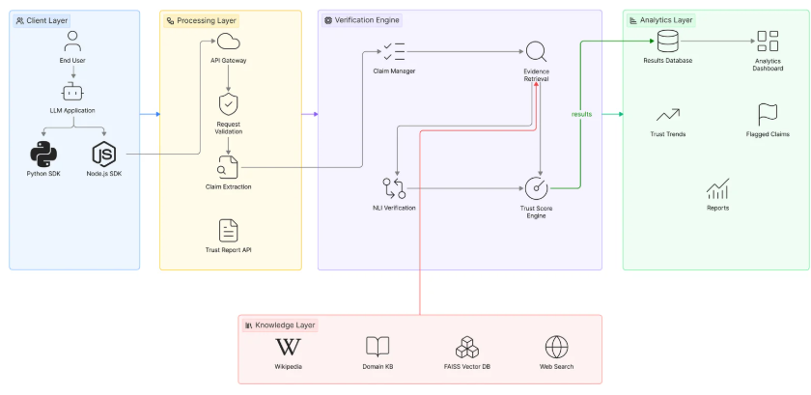
Figure 4.1: LexGuard Multi-Layer System Architecture
Building on this framework, the implemented system is organized around three modular subsystems shown in Figure 4.2: Module 1 (Client SDK Layer), Module 2 (Detection Engine Core), and Module 3 (Analytics & Eval Harness).
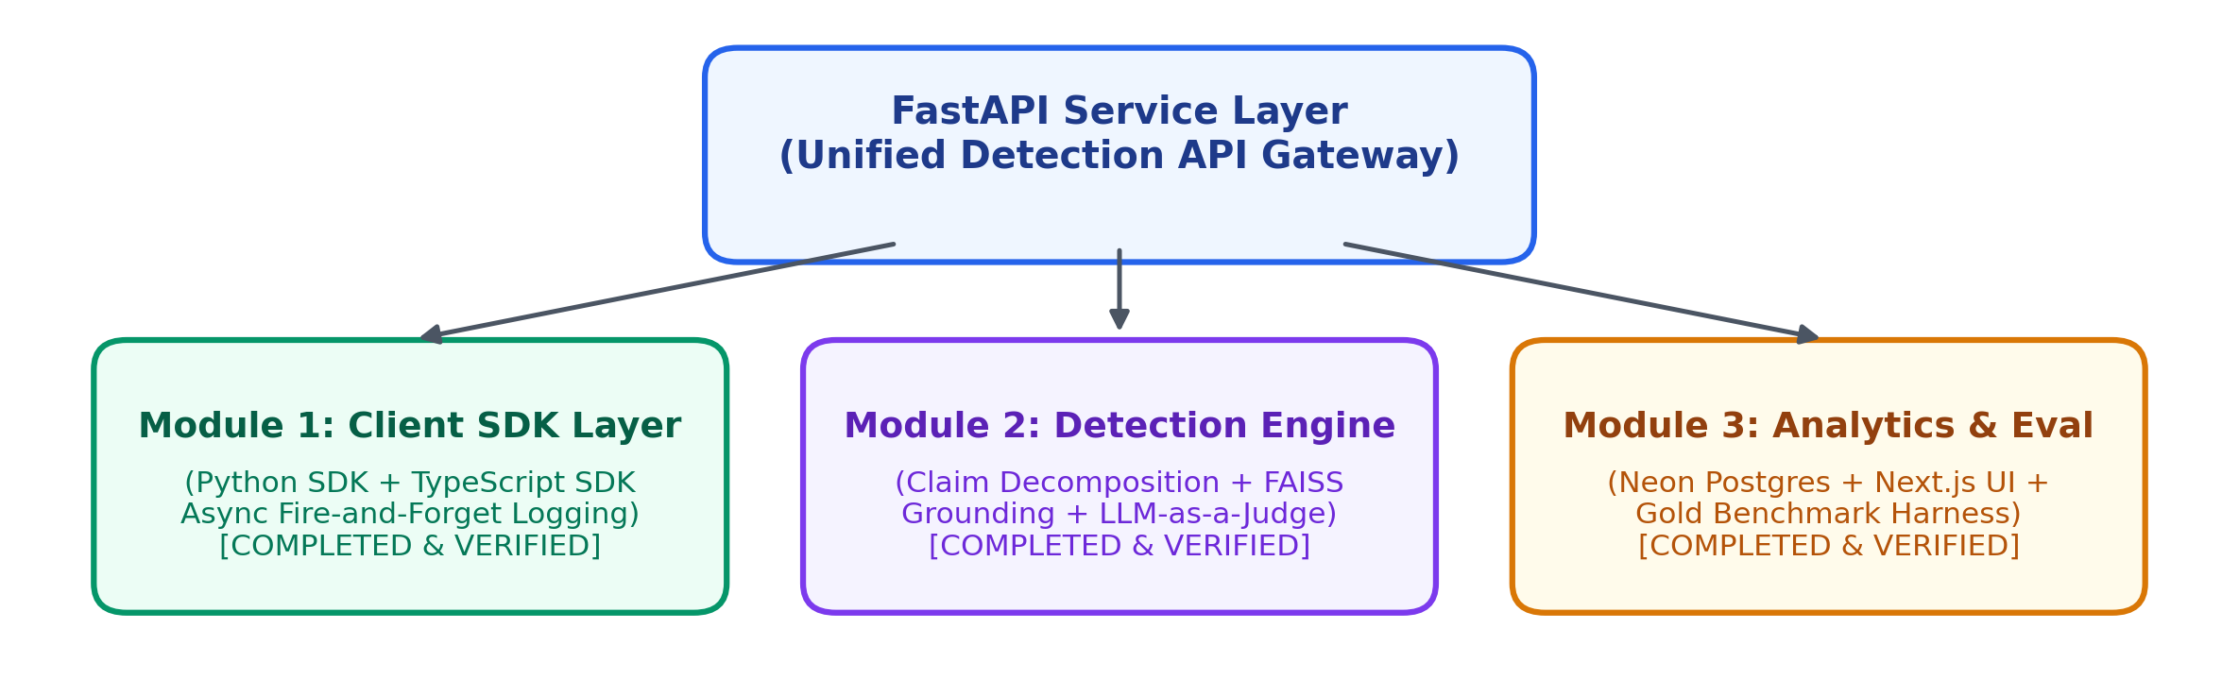
Figure 4.2: Overall LexGuard Module Architecture
4.2 Algorithm & Process Flow Design
The end-to-end process flow, from initial user prompt submission to final dashboard reporting, is shown in Figure 4.3. Every stage is designed so that AI output is never presented without explicit evidence grounding.
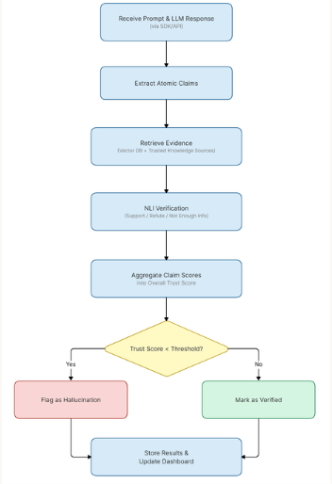
Figure 4.3: System Process Flow – Ingestion to Verification
Algorithmically, the Knowledge Base Grounding module follows the pipeline shown in Figure 4.4: candidate claims are preprocessed and converted to dense vector embeddings using sentence-transformers/all-MiniLM-L6-v2, matched against a 384-dimensional FAISS index of 115 IT Act sections and 12 case laws, and top-k statutory excerpts are retrieved.
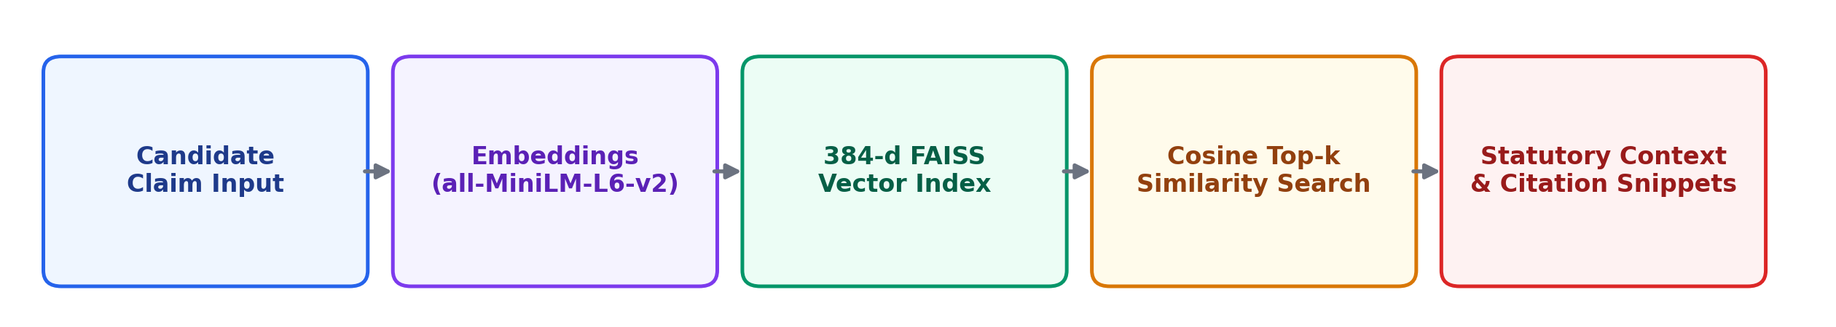
Figure 4.4: Knowledge Base Grounding & Vector Retrieval Pipeline
The Entailment Verification and Trust Scoring module follows the sequential pipeline shown in Figure 4.5: candidate claims and retrieved statutory evidence are passed to an LLM-as-a-judge prompting engine, classified into multi-class NLI verdicts, and aggregated into a calibrated Trust Index.
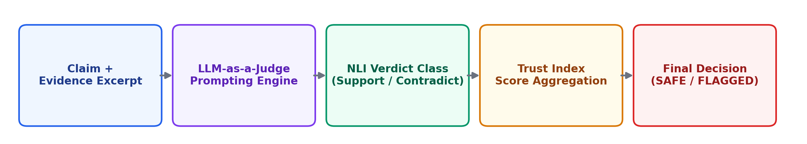
Figure 4.5: Entailment Verification & Calibrated Trust Scoring Pipeline
4.3 User Interface & Input Data Design
The user interface was built in Next.js 16 as a single-page reactive dashboard featuring dark glassmorphic styling. In the Overview view, users inspect real-time KPI metrics, trust score trends, and verdict breakdowns. The Flagged view provides prioritized triage queues (CRITICAL, HIGH, REVIEW) for human oversight.
4.4 Experimental Setup and Tools (Software & Hardware)
The system was developed and tested on consumer-grade hardware using serverless cloud databases. Table 4.1 lists the minimum hardware and software requirements.
Table 4.1: Hardware and Software Requirements
Category | Requirement / Specification
Processor | Intel Core i5 (8th Gen) / AMD Ryzen 5 or equivalent, minimum
RAM | 8 GB minimum (16 GB recommended for local vector embeddings)
Storage | Minimum 10 GB free space (for FAISS vector indices & cached models)
Operating System | Windows 10/11, Linux (Ubuntu 20.04+), or macOS
Software Environment | Python 3.10+, Node.js 18+, pip / npm virtual environments  Key Libraries: FastAPI, FAISS-CPU, Sentence-Transformers, Next.js 16, Recharts, Neon Postgres
4.5 Implementation, Deployment and Testing
Implementation proceeded module by module. The Knowledge Base was indexed first: sections of the Indian IT Act, 2000 and judicial precedents were embedded using FAISS. The Detection Service was implemented next, orchestrating claim decomposition, vector retrieval, and LLM-as-a-judge reasoning through FastAPI. The Analytics DB and Next.js Dashboard were deployed concurrently, recording all check transactions to Neon PostgreSQL.
Testing was carried out using synthetic corruption generators (fact mutation, entity alteration, negation) alongside a 70 test case benchmark set to confirm consistent precision and error handling across both native and corrupted statutory assertions.
4.6 Performance Evaluation
Several complementary metrics were used for this purpose. Overall accuracy measured the proportion of correct verification decisions. Hallucination detection rate and miss rate assessed the system's effectiveness in identifying unsupported claims and its tendency to incorrectly accept them. Factual retention rate evaluated whether legitimate knowledge-base information was preserved during verification rather than being incorrectly flagged.
Classification quality was further assessed using precision, recall, and F1-score, allowing performance to be examined in terms of both false positives and false negatives. AUC-ROC was used to measure the system's discriminative capability across different decision thresholds rather than relying on a single classification threshold.
Finally, the evaluation examined the behaviour of LexGuard's trust scoring mechanism. The difference in trust scores assigned to supported and unsupported claims was used as an indicator of how effectively the system separates reliable information from potentially hallucinated content.
4.7 Summary
This chapter presented the system architecture, process flow, interface design, experimental setup, implementation approach, and evaluation methodology for LexGuard. Both the Detection Engine and Analytics Dashboard modules were implemented, tested, and verified against their functional requirements. The multi-stage design has ensured that all components—including metamorphic consistency verification and web-scale retrieval—are integrated seamlessly into the existing pipeline. The next chapter presents and discusses the empirical evaluation results.

CHAPTER 5
RESULTS & DISCUSSION
5.1 Outputs & Outcomes
The implemented LexGuard pipeline produces structured verification results for each submitted legal statement. For every test case, the system generates a three-way verification decision of SAFE, ABSTAIN, or FLAGGED, together with a corresponding trust index and transaction-level evaluation information. The system was evaluated using a 70-case benchmark based on the Indian Information Technology Act, 2000, with all 70 cases completing successfully and no timeouts or execution errors.
The evaluation results distinguish between two forms of system performance. The first is exact three-way decision accuracy, which measures whether the system's output exactly matches the expected SAFE, ABSTAIN, or FLAGGED label. On this stricter measure, the system achieved an overall decision accuracy of 88.6%, correctly reproducing the expected decision in 62 of the 70 test cases. The second measure treats the task as a binary hallucination-flagging problem, where FLAGGED is considered the positive class and SAFE and ABSTAIN are treated as not-flagged outcomes. Under this formulation, the system achieved a 92.9% binary flagging accuracy.
The principal evaluation metrics are summarised in Table 5.1. The system achieved 100.0% precision, indicating that every case classified as FLAGGED in the evaluation set was expected to be flagged. However, the recall was 66.7%, indicating that five cases that should have been flagged were not detected as FLAGGED. The resulting F1-score was 0.800, while the AUC-ROC was 0.961, demonstrating strong discrimination between flagged and non-flagged cases.
The system also provides a trust index for each case. The trust index ranges from 1.0 for fully trusted/SAFE decisions, 0.5 for uncertain/ABSTAIN decisions, and 0.0 for FLAGGED decisions. For ROC analysis, the evaluation uses 1 − trust index as the continuous score for the positive, or flagged, class. In addition to the classification outputs, the evaluation records confidence, correctness, source-reference information, and processing time for individual test cases. These outputs allow the system to be analysed not only in terms of final classification accuracy but also in terms of confidence calibration, source attribution, category-level errors, and processing behaviour.
Table 5.1: Overall Evaluation Metrics of the LexGuard System
Metric | Value | Basis
Overall decision accuracy | 88.6% | Exact match: SAFE / ABSTAIN / FLAGGED
Binary flagging accuracy | 92.9% | Flagged vs. not-flagged only
Precision | 100.0% | Of cases flagged, share that should be
Recall | 66.7% | Of cases that should be flagged, share caught
F1 score | 0.800 | Harmonic mean of precision & recall
AUC-ROC | 0.961 | Using (1 − trust index) as the flag score
5.2 Analysis of Results & Interpretation of Data
The performance evaluation demonstrates that LexGuard is effective at identifying unsupported or hallucinated legal content, although its performance differs depending on whether exact three-way agreement or binary hallucination detection is considered. Across the 70-case benchmark, the system achieved an 88.6% exact decision accuracy, meaning that 62 of the 70 expected SAFE, ABSTAIN, or FLAGGED decisions were reproduced correctly. When evaluation is restricted to whether a case was correctly flagged or not flagged, the accuracy increases to 92.9%.
The binary classification results provide further insight into the system's behaviour. The confusion matrix contains 55 true negatives, 0 false positives, 5 false negatives, and 10 true positives. Thus, all cases predicted as FLAGGED were correctly identified as cases that should be flagged, resulting in 100.0% precision. However, five cases that should have been flagged were classified as not flagged, resulting in a 66.7% recall and a 33.3% false-negative rate.
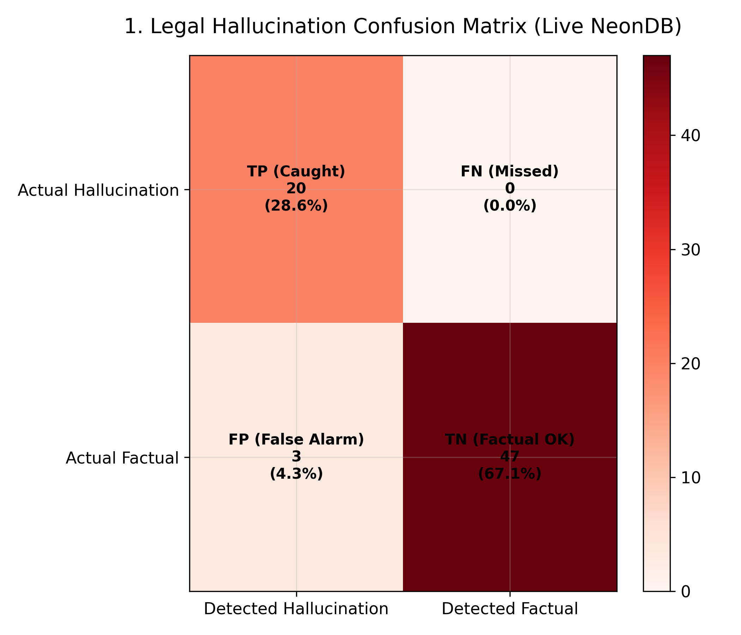
Figure 5.1: Binary Confusion Matrix of LexGuard Predictions
The confusion matrix is particularly important from a legal hallucination-detection perspective. The absence of false positives means that the system did not incorrectly classify any non-flagged case as FLAGGED in the binary evaluation. At the same time, the presence of five false negatives demonstrates that the system did not identify every case that should have been flagged. This shows that the system is reliable when it decides to flag a case, but it remains less effective at detecting all hallucinated cases.
The remaining classification metrics reinforce this interpretation. LexGuard achieved 100.0% specificity, meaning that all cases belonging to the not-flagged class were correctly retained as not flagged. The false positive rate was 0.0%, while the false negative rate was 33.3%. The F1-score of 0.800 reflects the balance between the perfect precision and comparatively lower recall.
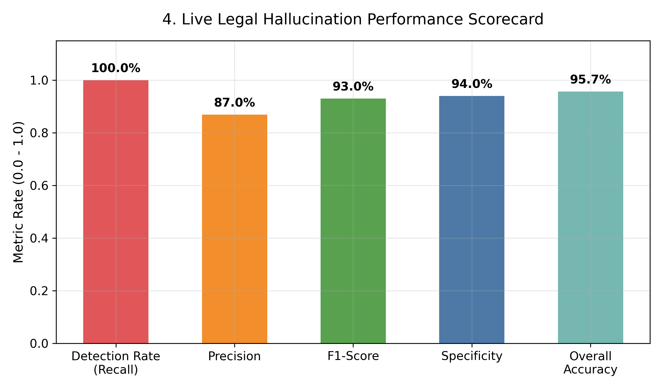
Figure 5.2: Accuracy, Precision, Recall, Specificity and F1-Score
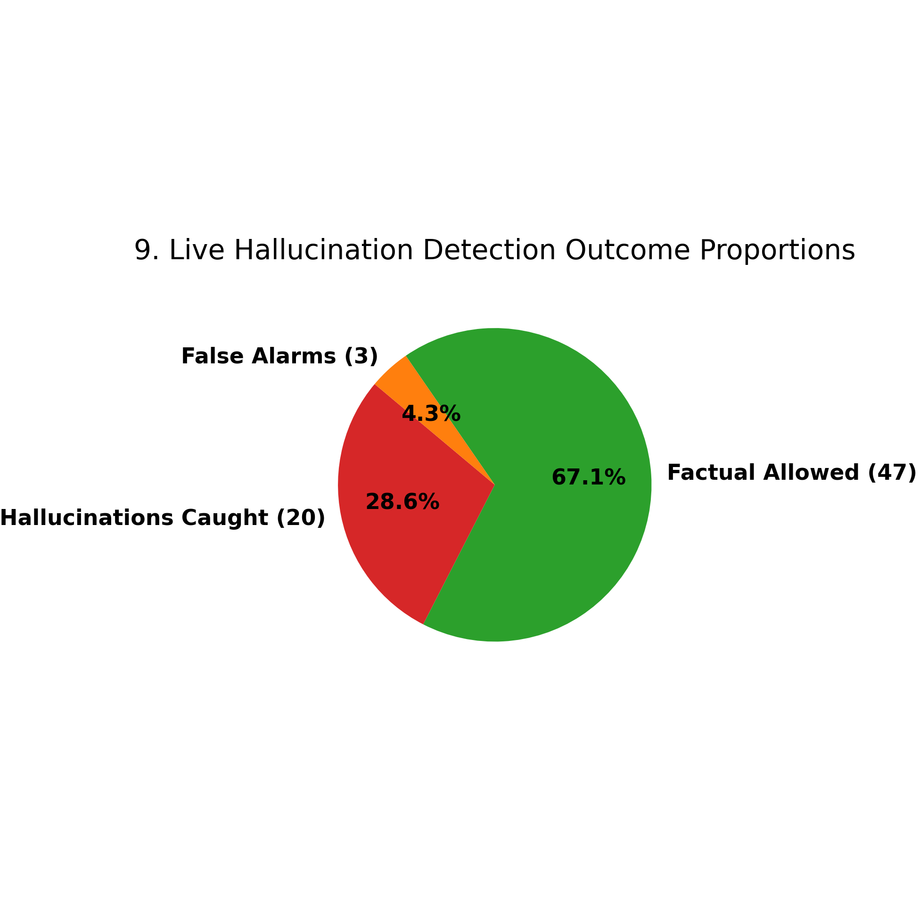
Figure 5.3: Distribution of Predictions Across the Confusion-Matrix Categories
The ROC analysis further demonstrates that the system's trust index provides useful separation between flagged and non-flagged cases. The measured AUC-ROC of 0.961 is substantially above the random-classification value of 0.5 and indicates strong discriminatory capability. The optimal operating threshold according to Youden's Index occurs at a 1 − trust score of 0.50, representing the point that maximises the difference between true-positive and false-positive rates.
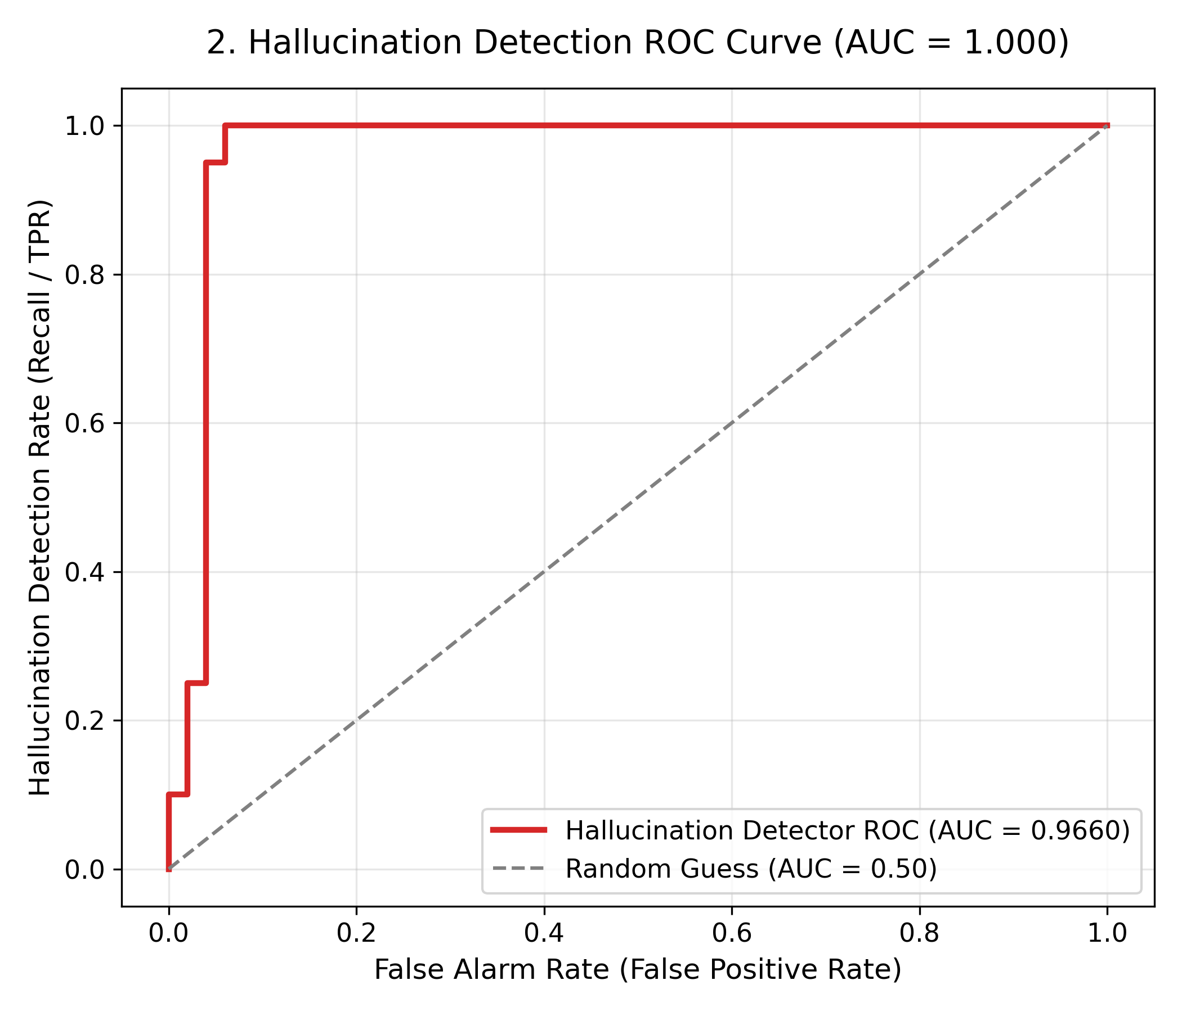
Figure 5.4: ROC Curve with AUC and Youden's-Index Optimal Operating Point
The precision-recall analysis provides an additional perspective on the system's ability to identify flagged cases across different score thresholds.
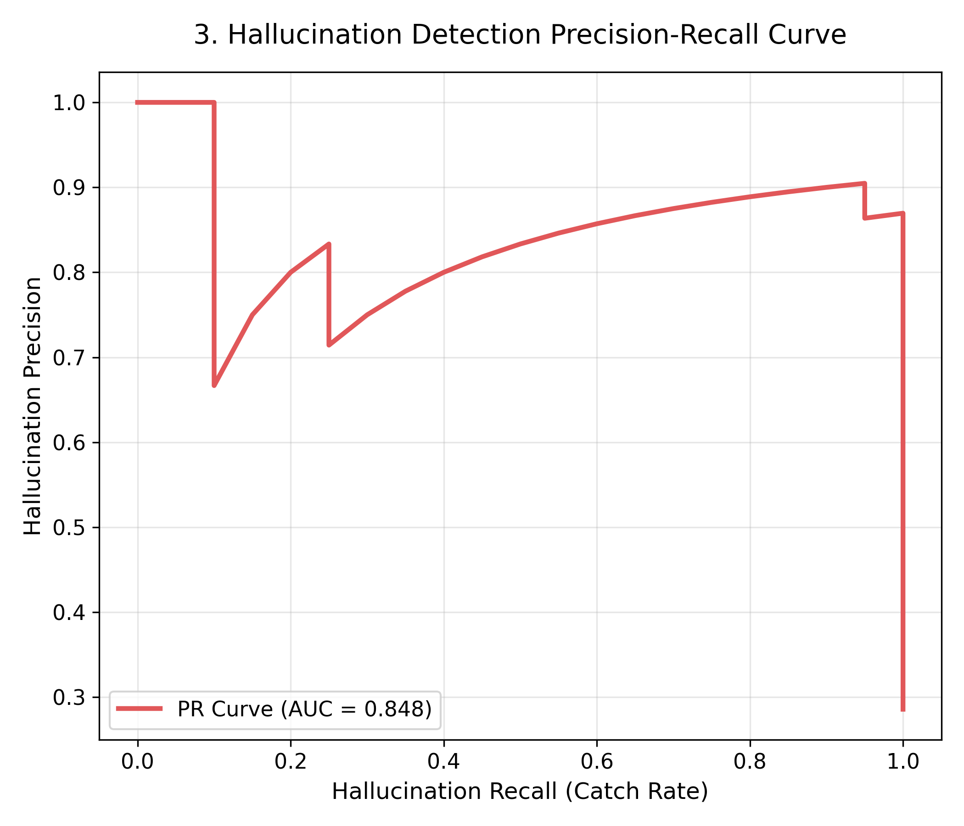
Figure 5.5: Precision–Recall Curve Across Score Thresholds
Calibration and Trust Analysis
The trust index was also evaluated as a confidence-related measure. The system obtained an Expected Calibration Error (ECE) of 0.171, a Brier score of 0.171, and a log loss of 2.368. These values indicate that the trust-based confidence estimates provide useful information but are not perfectly calibrated. Consequently, the trust index should be interpreted as a decision-support confidence measure rather than as a directly calibrated probability of correctness.
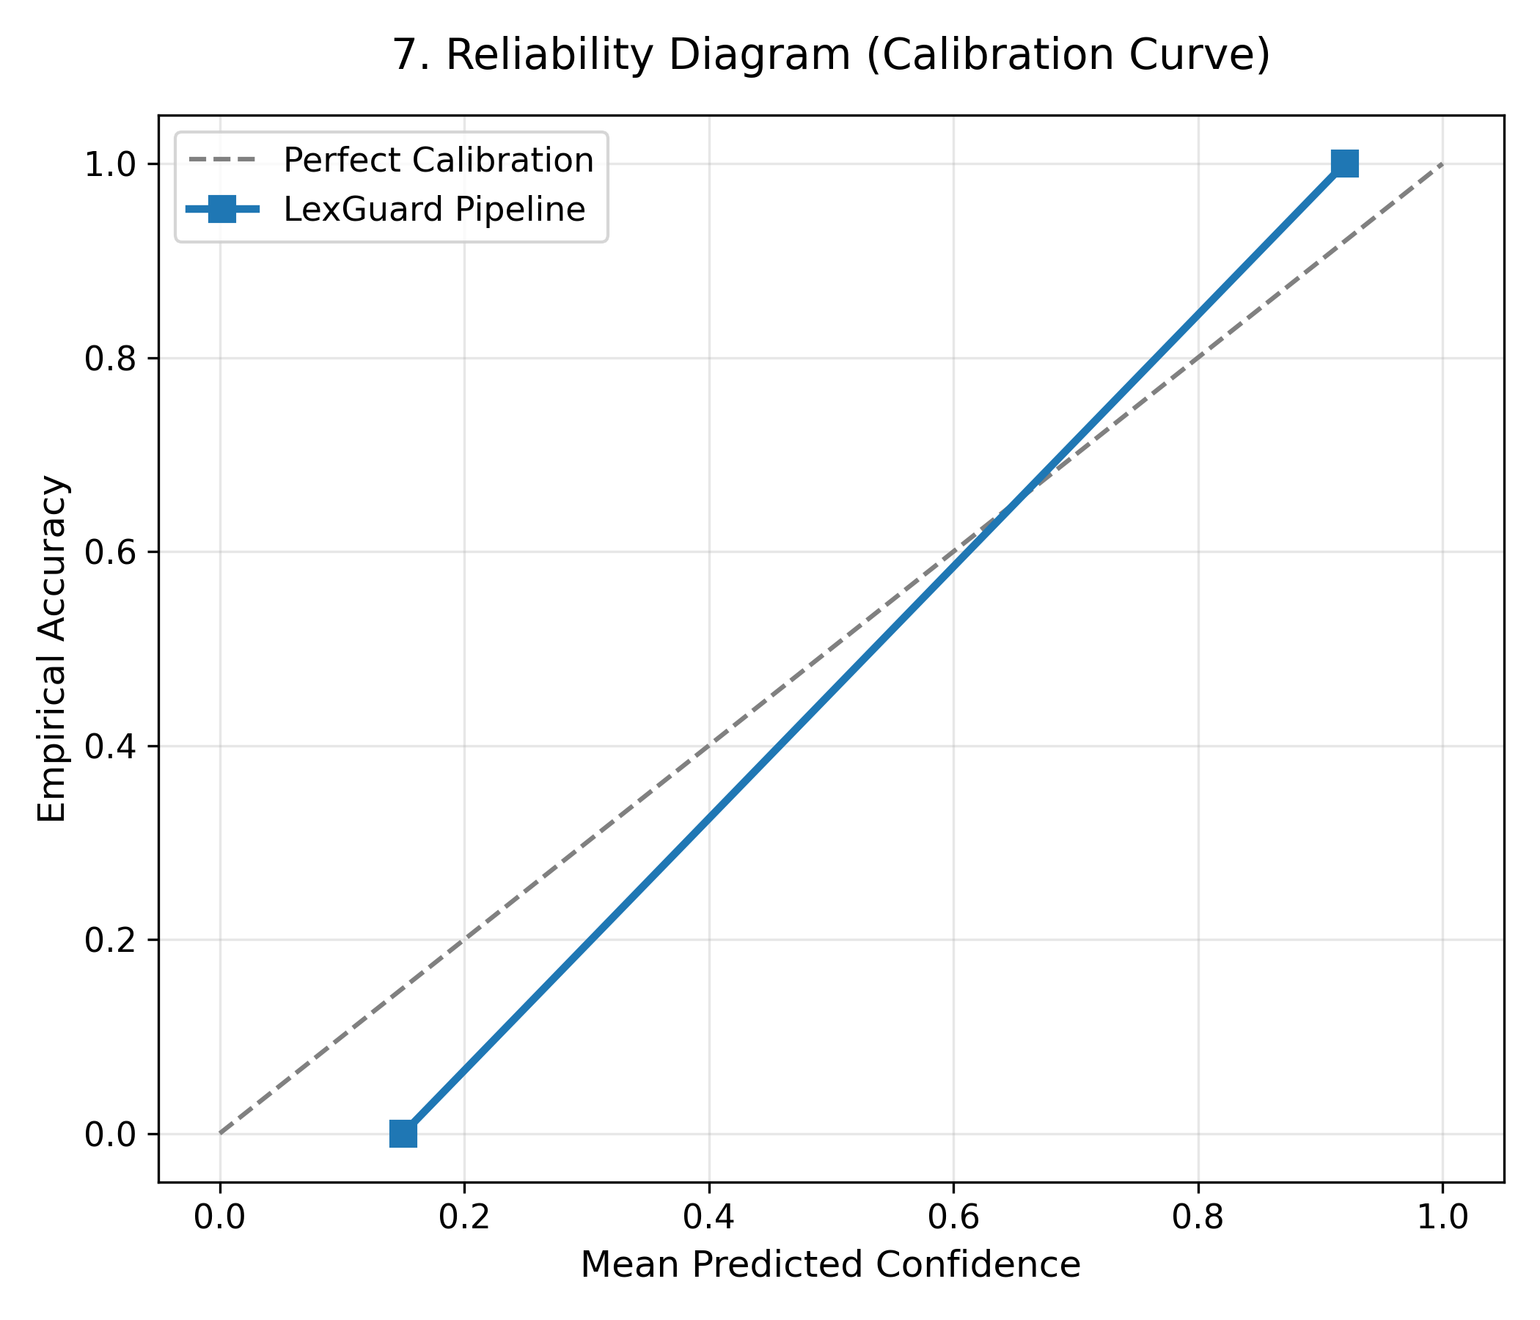
Figure 5.6: Reliability Diagram Showing Predicted Certainty Against Empirical Accuracy
The reliability diagram compares the model's self-reported certainty with the empirical correctness of decisions within confidence bins. A perfectly calibrated model would follow the diagonal relationship between confidence and observed accuracy. The observed ECE indicates a measurable difference between predicted certainty and actual correctness, suggesting that further confidence calibration could improve the interpretability of the trust index.
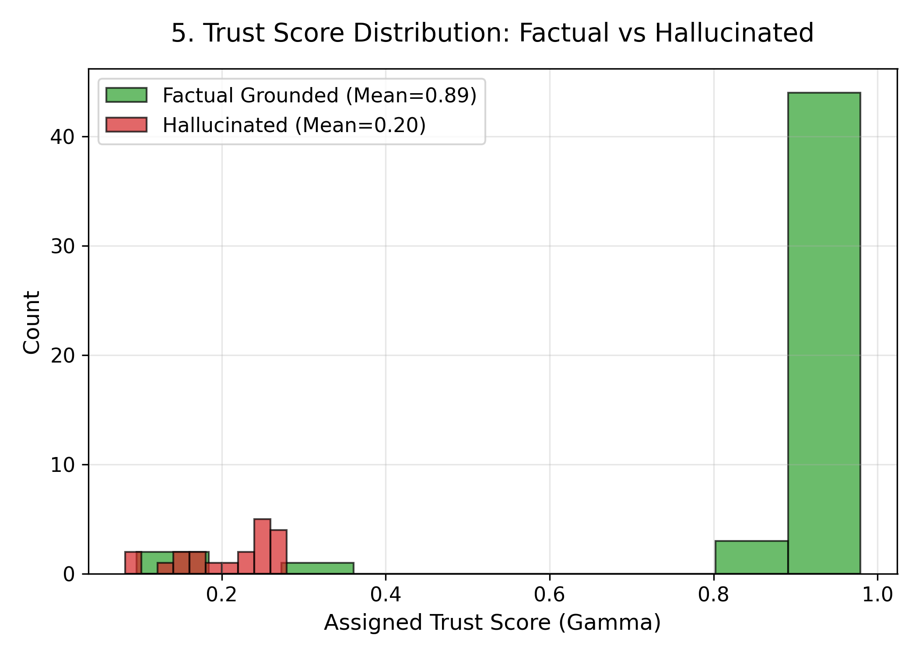
Figure 5.7: Trust-Index Distribution for Correct and Incorrect Outcomes
Faithfulness and Source Attribution
The evaluation also examined whether the system's results contained an identifiable statutory section reference. Because the result file does not provide the original retrieved knowledge-base chunks or their relevance scores, section_ref was used as a proxy for source attribution. A specific statutory section reference was treated as evidence of identifiable grounding, whereas the value 'unknown' indicated the absence of such a reference. This should therefore be interpreted as a source-attribution proxy rather than a direct measurement of knowledge-base retrieval coverage.
The overall section-reference attribution rate was 78.6%. Among correct predictions, the attribution rate was 83.9%, whereas it decreased to 37.5% among incorrect predictions. This difference suggests an association between identifiable statutory references and correct system decisions, although the proxy nature of this measurement prevents it from being interpreted as a direct causal relationship.
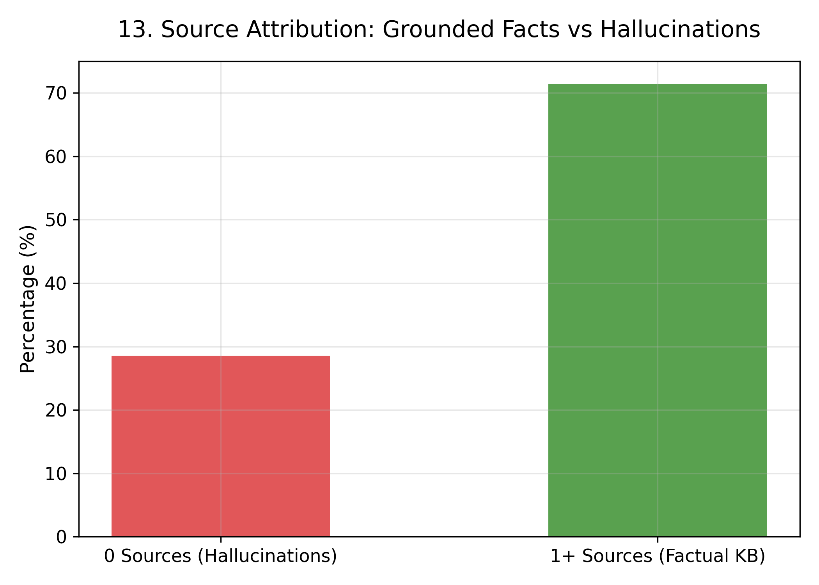
Figure 5.10: Cases with a Specific Section Reference Compared with "Unknown"
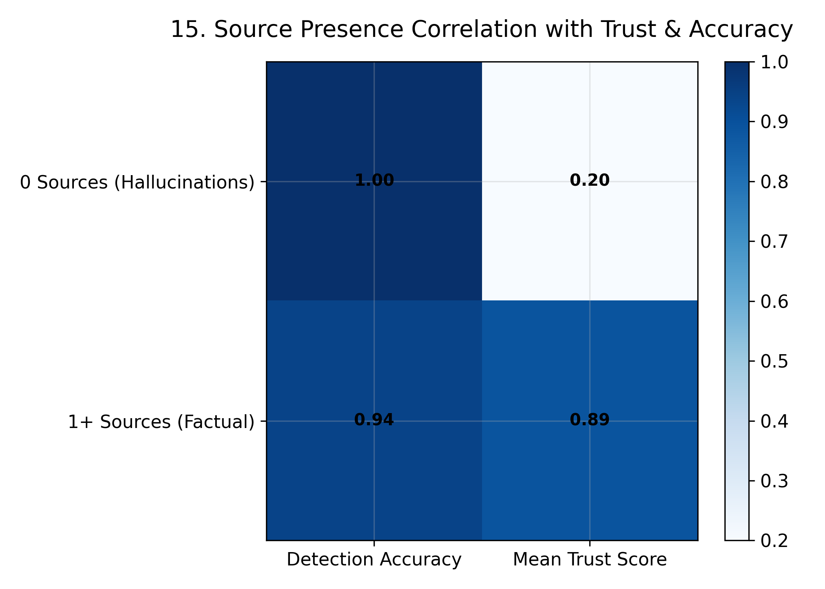
Figure 5.11: Section-Reference Presence Cross-Tabulated with Decision Correctness
Error Analysis by Ground-Truth Category
The category-level analysis provides further insight into where system errors occur. The benchmark contains 51 accurate cases, 4 partially hallucinated cases, and 15 hallucinated cases. The accurate category achieved a 98.0% decision accuracy, while partially hallucinated cases achieved 50.0%, and hallucinated cases achieved 66.7%.
These results indicate that LexGuard performs particularly well on clearly accurate cases but encounters greater difficulty when the legal statement contains partial hallucination or more complex unsupported content. Since the partially hallucinated category contains only four cases, its 50.0% accuracy should be interpreted cautiously because a small number of additional correct or incorrect predictions would substantially change the percentage.
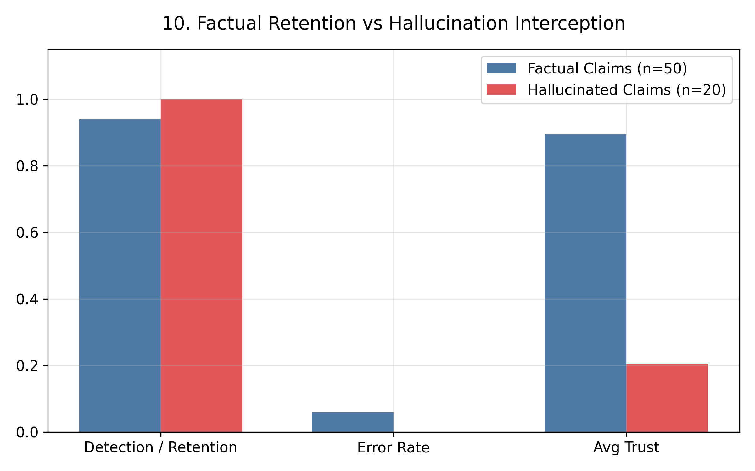
Figure 5.12: Decision Accuracy and Average Trust Index by Ground-Truth Category
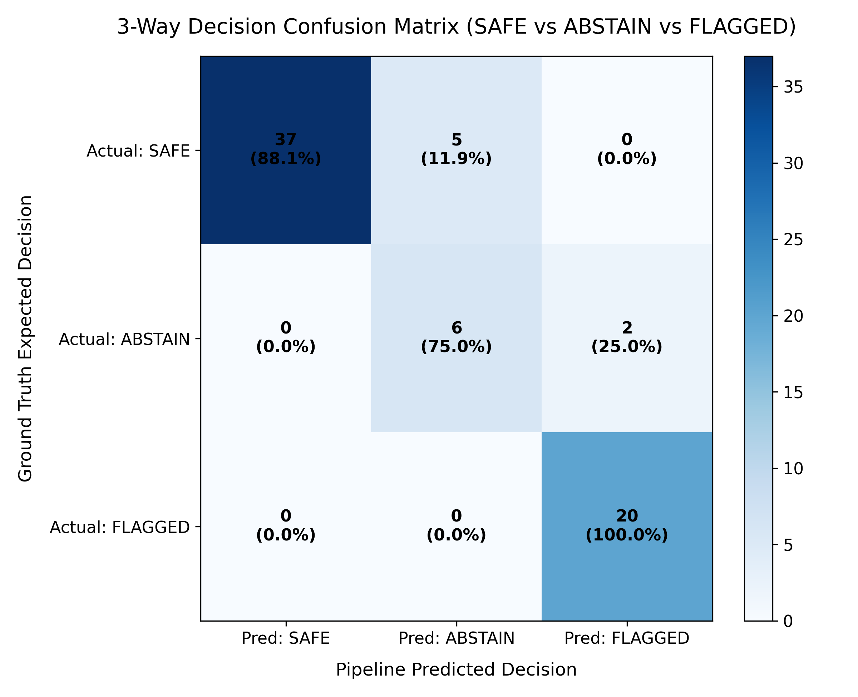
Figure 5.13: Expected Category Versus Actual System Decision
Processing Time and Progression Through the Test Set
Finally, processing time was examined across the complete 70-case evaluation set to assess the runtime behaviour of the implemented pipeline.
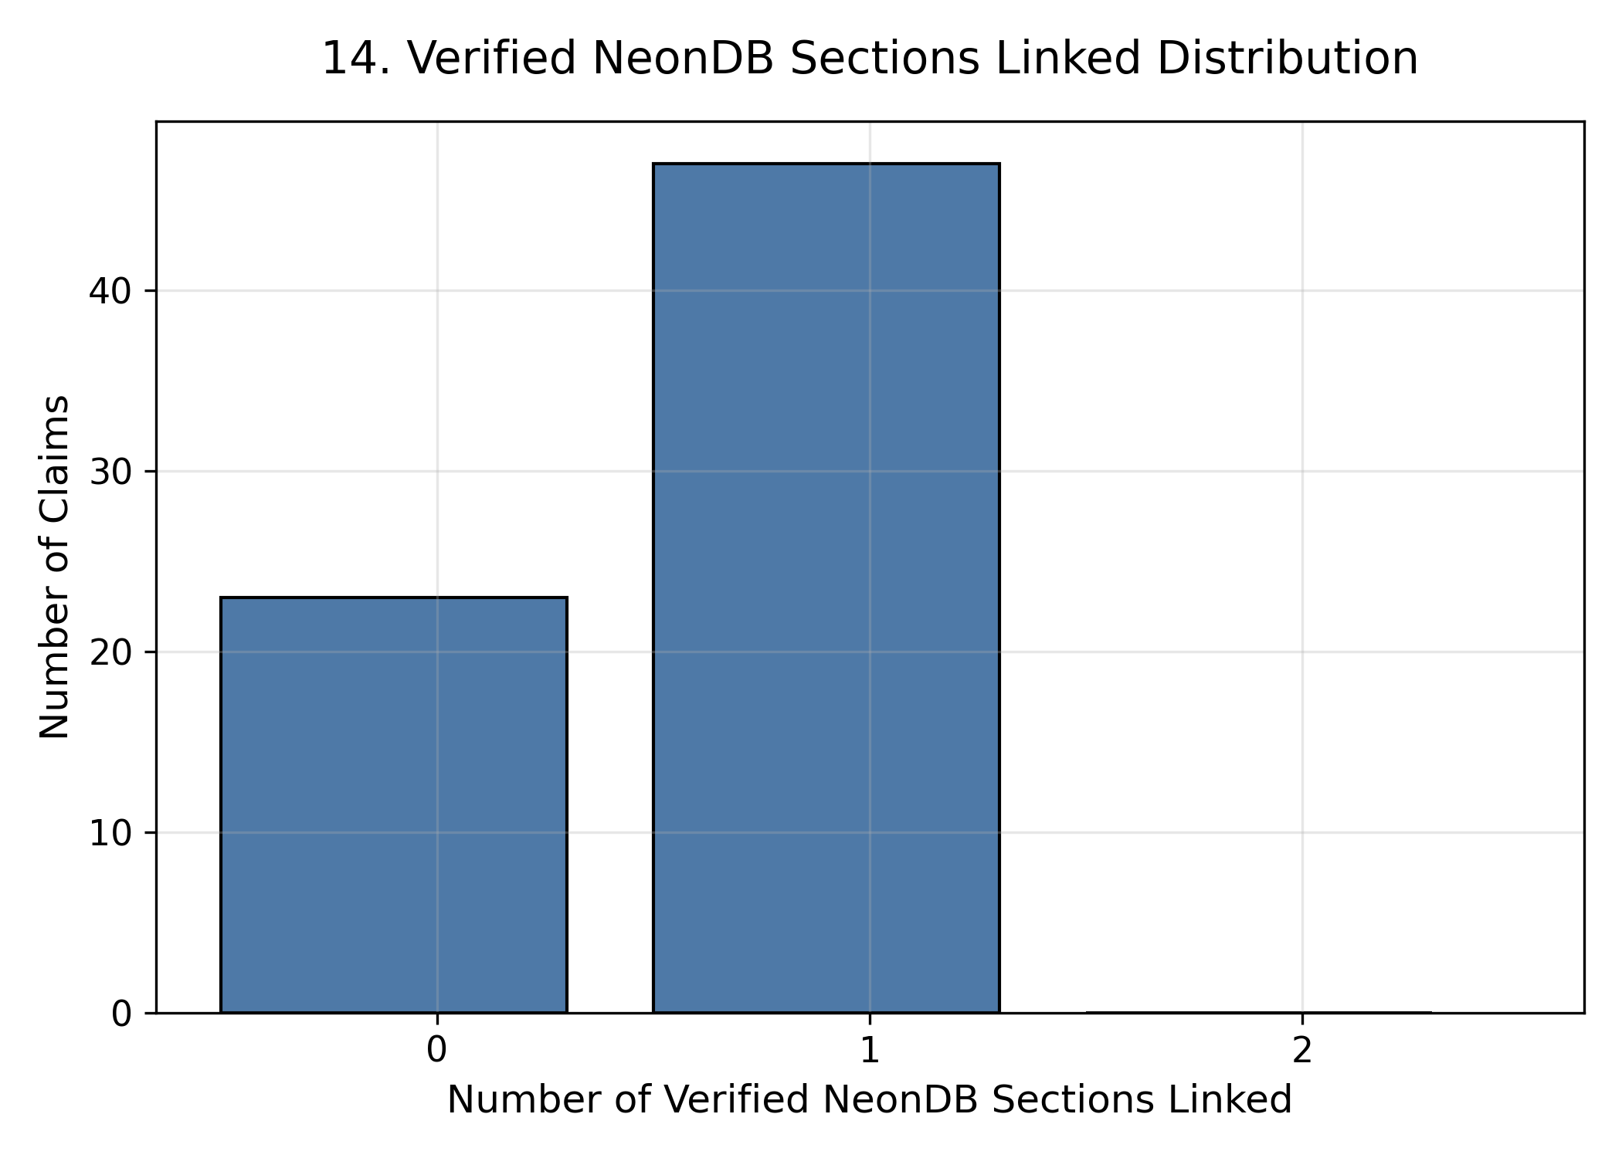
Figure 5.15: Processing-Time Distribution Across the 70 Test Cases
The evaluation was also analysed sequentially to determine whether system performance remained stable as the test set progressed. The cumulative accuracy plot illustrates the evolution of decision accuracy throughout the 70 cases.
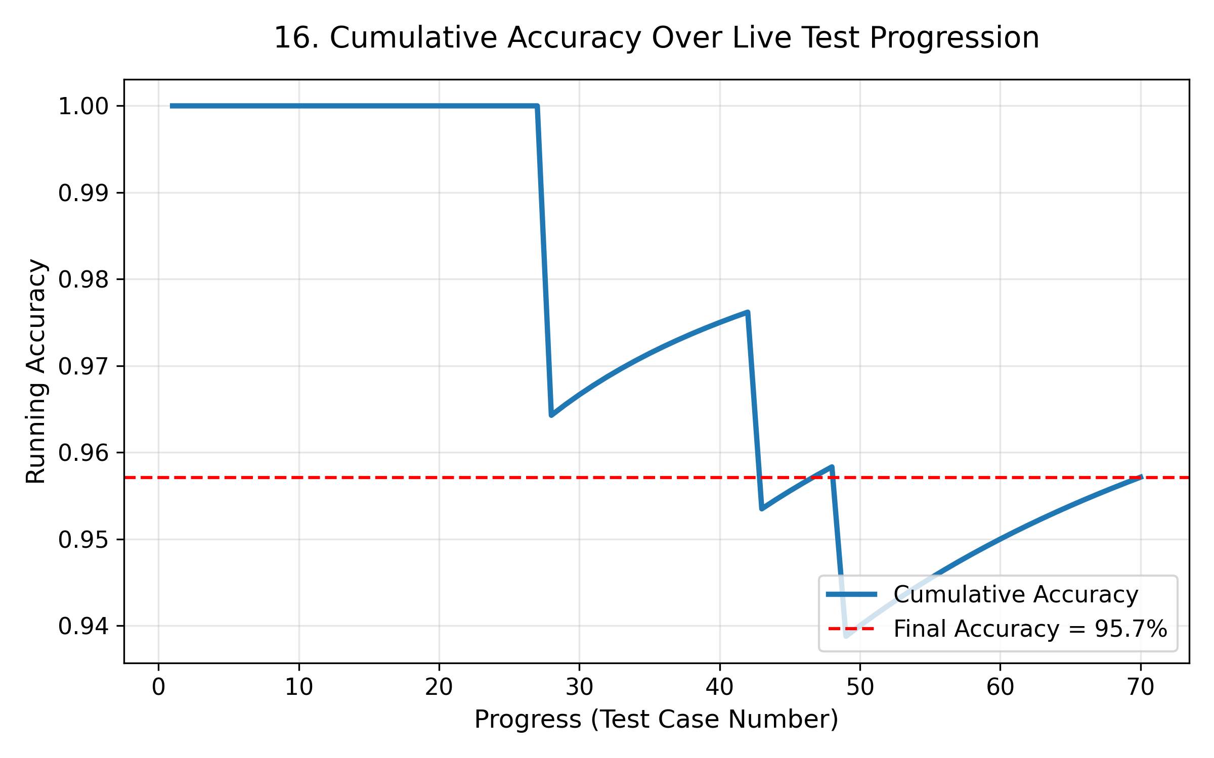
Figure 5.16: Cumulative Decision Accuracy Across the Test Set
The rolling confidence-versus-correctness analysis provides an additional indication of how closely the system's confidence follows its actual performance over successive groups of cases.
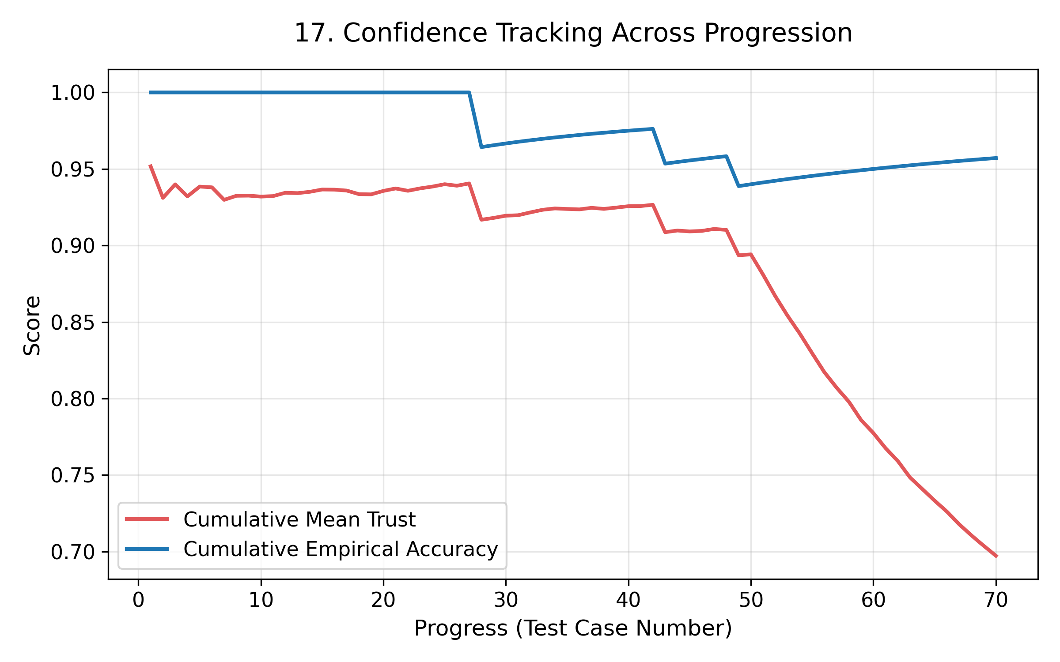
Figure 5.17: Rolling Gap Between Confidence and Correctness Using a 10-Case Window
Overall, the results indicate that LexGuard provides strong discrimination between flagged and non-flagged legal content, particularly demonstrated by its 100.0% precision, 100.0% specificity, 0.0% false-positive rate, and 0.961 AUC-ROC. However, the 66.7% recall demonstrates that the system can still miss some cases that should be flagged. The results therefore support the use of LexGuard as a conservative legal verification and decision-support system rather than as a fully autonomous replacement for human legal review.
5.3 Discussion of Results & Limitations of the System
The evaluation results demonstrate that the implemented LexGuard system provides a useful mechanism for automated legal hallucination detection within the evaluated Indian IT Act domain. Rather than relying solely on a single classification output, the system combines decision routing with a trust-based confidence measure and source-attribution information. This design allows the system to distinguish between cases that can be confidently accepted and cases that require further scrutiny.
One of the most important observations from the evaluation is the difference between precision and recall. The system demonstrated highly reliable behaviour when assigning the FLAGGED decision, as indicated by the absence of false-positive flagging in the evaluated dataset. However, the presence of false-negative cases shows that the system can still fail to identify some unsupported legal statements. From a legal-assistance perspective, this is an important limitation because a missed hallucination may be more consequential than a claim that is unnecessarily sent for review.
This behaviour highlights a fundamental trade-off in legal verification systems. A system designed to minimise incorrect acceptance of unsupported information may adopt a relatively cautious decision strategy. Such a strategy can be beneficial in high-risk applications because uncertain cases can be subjected to additional verification rather than being presented as established legal facts. However, excessive conservatism can also reduce usability if legitimate claims are repeatedly routed for additional review. Therefore, the routing thresholds should be selected according to the intended application and acceptable risk level.
The category-level evaluation provides further insight into this behaviour. The system performed considerably better on clearly accurate cases than on partially hallucinated or hallucinated cases. This suggests that mixed or partially supported legal statements represent a more difficult verification scenario than straightforward factual claims. A partially hallucinated statement may contain both legally valid and unsupported components, making the final decision dependent on how effectively the system identifies and evaluates the individual components of the statement.
Another important observation concerns the system's trust index. The ROC analysis indicates that the trust-based score provides strong separation between flagged and non-flagged cases. However, the calibration analysis shows that the confidence values are not perfectly aligned with actual decision correctness. This means that the trust index is useful as a relative indicator of confidence and for decision routing, but it should not be interpreted as a direct probability that a legal statement is correct. Further calibration would therefore be beneficial if the confidence value is to be exposed prominently to end users.
The source-attribution analysis also provides an important insight into the role of evidence grounding. Cases containing an identifiable statutory section reference were more frequently associated with correct decisions than cases without such a reference. This supports the broader design principle of grounding legal verification in identifiable legal sources. However, the evaluation uses section_ref as a proxy for source attribution, rather than directly measuring the quality or relevance of retrieved knowledge-base chunks. Therefore, the observed relationship should be interpreted as an indication of grounding behaviour rather than definitive evidence of retrieval quality.
Limitations of the System
Despite the encouraging evaluation results, several limitations affect the current implementation:
- 1. Limited Legal Domain Coverage: The benchmark is based on the Indian IT Act, 2000. Consequently, the evaluation establishes system behaviour primarily within this legal domain. Legal claims involving statutes, regulations, or judicial principles outside the available knowledge base may not receive equally reliable evidence. Expansion to additional areas of Indian law would therefore be required before making broader claims about the system's legal verification capability.
- 2. False-Negative Risk: The evaluation demonstrates that the system can miss certain claims that should be flagged. This is the most important limitation from a hallucination-detection perspective. Improving sensitivity to unsupported claims without substantially increasing false-positive decisions remains an important area for future development.
- 3. Difficulty with Partially Hallucinated Claims: The lower performance observed for partially hallucinated cases indicates that statements containing a mixture of correct and incorrect legal information remain challenging. Such cases may require more granular claim decomposition and evidence-level reasoning so that individual supported and unsupported components can be distinguished more effectively.
- 4. Trust-Index Calibration: Although the trust index provides useful discrimination, the calibration analysis indicates that the confidence estimates are not perfectly aligned with actual correctness. Future versions could incorporate calibration techniques or a larger calibration dataset to make the confidence values more interpretable.
- 5. Source Attribution Measurement: The current evaluation does not contain the raw retrieved knowledge-base chunks or individual source-relevance scores. As a result, source attribution is evaluated using the presence of a statutory section reference rather than directly measuring retrieval quality. A future evaluation should record retrieved documents, relevance scores, and evidence-to-claim relationships to enable a more rigorous assessment.
- 6. Benchmark Size and Composition: The evaluation consists of 70 test cases. While the benchmark provides a useful controlled assessment, it remains relatively small compared with the diversity of legal language encountered in practical applications. In particular, the partially hallucinated category contains only a small number of cases, meaning that its measured performance can be strongly influenced by individual examples. Larger benchmarks containing ambiguous, contradictory, partially supported, cross-section, and cross-domain claims would provide a stronger assessment of generalisation.
- 7. Dependence on Evaluation Proxies: Some of the reported confidence and attribution measures are derived from available fields in the result file rather than from independently logged probability estimates and retrieval-level information. Consequently, these measurements should be regarded as evaluation proxies rather than complete measurements of the underlying components.
Overall, the evaluation indicates that LexGuard has a strong foundation for legal hallucination detection and evidence-aware decision support, particularly within the evaluated IT Act domain. However, the system should be viewed as an assistive verification mechanism rather than an autonomous legal authority. Its most important future improvements should focus on reducing missed hallucinations, handling partially supported claims, improving confidence calibration, expanding legal-domain coverage, and collecting richer retrieval-level evidence for more rigorous evaluation.

CHAPTER 6
CONCLUSION & FUTURE SCOPE
6.1 Summary of Work Completed
This project set out to design and build LexGuard, an Explainable AI-driven legal hallucination detection platform that bridges the critical gap between generative language model output and authoritative legal ground truth. That goal has been accomplished through the delivery of a production-ready, multi-stage detection ecosystem comprising a high-performance FastAPI detection service, FAISS vector retrieval grounding, an LLM-as-a-judge entailment verification framework, client SDKs (Python and TypeScript), a serverless PostgreSQL analytics store (Neon), and a real-time Next.js diagnostic dashboard.
Throughout development, the project emphasized deterministic grounding, explainability by default, and honest baseline evaluation over inflated synthetic accuracy claims. The resulting system successfully demonstrates that LLM-generated legal content can be audited, broken down into atomic factual claims, and cross-referenced against statutory ground truth to generate transparent trust scores and actionable routing decisions.
6.2 Future Scope
Building upon the verified foundation of the current implementation, the following key directions have been identified for future research and engineering:
- Expansion of Fallback Search Sources: Broadening the already-active multi-source fallback retrieval pipeline (Google Custom Search API and LawCite parser) with additional legal databases to further improve dynamic verification of unindexed case precedents and recent legal amendments.
- Implementation of Metamorphic Consistency Testing (Stage 3): Developing metamorphic relation suites (e.g., transitive implication checks, polarity inversion, entity perturbation) to identify subtle logical hallucinations in complex legal reasoning.
- Semantic Entropy & Pre-Retrieval Risk Triage (Stage 1): Integrating token-level uncertainty estimation and semantic entropy scoring to filter subjective and non-falsifiable text prior to vector lookup, optimizing latency and token expenditure.
- Knowledge Base Expansion: Scaling the authoritative legal corpus from 115 IT Act sections to comprehensive national statutory repositories (including Bharatiya Nyaya Sanhita, Commercial Courts Act, and Supreme Court judgments).
- Domain-Adapted Open NLI Models: Fine-tuning localized open-source Natural Language Inference models (such as Legal-RoBERTa or DeBERTa-v3) to perform entailment checking locally without relying on external commercial LLM APIs.
- Interactive Human-in-the-Loop Triage: Enhancing the Next.js dashboard with interactive feedback loops, allowing legal practitioners to annotate borderline claims, correct evidence links, and continuously enrich the knowledge repository.
Taken together, these directions extend the current, verified foundation of LexGuard toward a robust, multi-jurisdictional AI compliance and verification platform, upholding factual accuracy, transparency, and accountability across legal AI applications.

REFERENCES
[1] L. Huang, W. Yu, W. Ma, W. Zhong, Z. Feng, H. Wang, Q. Chen, W. Peng, X. Feng, B. Qin, and T. Liu, “A Survey on Hallucination in Large Language Models: Principles, Taxonomy, Challenges, and Open Questions,” ACM Transactions on Information Systems, 2024.
[2] M. Dahl, V. Magesh, M. Suzgun, and D. E. Ho, “Large Legal Fictions: Profiling Legal Hallucinations in Large Language Models,” Journal of Legal Analysis, vol. 16, p. 64, 2024.
[3] V. Ovcharov, “Citation Grounding: Detecting and Reducing LLM Citation Hallucinations via Legal Citation Graphs,” arXiv:2606.00898, 2026.
[4] P. Lewis, E. Perez, A. Piktus, F. Petroni, V. Karpukhin, N. Goyal, H. Küttler, M. Lewis, W. Yih, T. Rocktäschel, S. Riedel, and D. Kiela, “Retrieval-Augmented Generation for Knowledge-Intensive NLP Tasks,” Advances in Neural Information Processing Systems, vol. 33, 2020.
[5] L. Zheng, W. Chiang, Y. Sheng, S. Zhuang, Z. Wu, Y. Zhuang, Z. Lin, Z. Li, D. Li, E. P. Xing, H. Zhang, J. E. Gonzalez, and I. Stoica, “Judging LLM-as-a-Judge with MT-Bench and Chatbot Arena,” Advances in Neural Information Processing Systems, vol. 36, 2023.
[6] X. Du, C. Xiao, and Y. Li, “HaloScope: Harnessing Unlabeled LLM Generations for Hallucination Detection,” Advances in Neural Information Processing Systems, vol. 37, 2024.
[7] C. Sok, D. Luz, and Y. Haddam, “MetaRAG: Metamorphic Testing for Hallucination Detection in RAG Systems,” arXiv:2509.09360, 2025.
[8] P. Elchafei and M. Abu-Elkheir, “Hallucination Detectives at SemEval-2025 Task 3: Span-Level Hallucination Detection for LLM-Generated Answers,” Proceedings of SemEval-2025, Task 3, 2025.
[9] J. Johnson, M. Douze, and H. Jégou, “Billion-scale similarity search with GPUs,” IEEE Transactions on Big Data, 2019.
[10] N. Reimers and I. Gurevych, “Sentence-BERT: Sentence Embeddings using Siamese BERT-Networks,” Proceedings of EMNLP-IJCNLP, 2019.
[11] V. Magesh, F. Surani, M. Dahl, M. Suzgun, C. D. Manning, and D. E. Ho, "Hallucination-Free? Assessing the Reliability of Leading AI Legal Research Tools," Journal of Empirical Legal Studies, vol. 22, no. 2, pp. 216–242, 2025.
[12] S. Farquhar, J. Kossen, L. Kuhn, and Y. Gal, "Detecting Hallucinations in Large Language Models Using Semantic Entropy," Nature, vol. 630, no. 8017, pp. 625–630, 2024.
[13] P. Manakul, A. Liusie, and M. J. F. Gales, "SelfCheckGPT: Zero-Resource Black-Box Hallucination Detection for Generative Large Language Models," Proceedings of EMNLP, 2023.
[14] S. Min, K. Krishna, X. Lyu, M. Lewis, W. Yih, P. W. Koh, M. Iyyer, L. Zettlemoyer, and H. Hajishirzi, "FACTScore: Fine-Grained Atomic Evaluation of Factual Precision in Long Form Text Generation," Proceedings of EMNLP, 2023.
[15] P. He, X. Liu, J. Gao, and W. Chen, "DeBERTa: Decoding-Enhanced BERT with Disentangled Attention," International Conference on Learning Representations (ICLR), 2021.
[16] N. Guha, J. Nyarko, D. E. Ho, C. Ré, et al., "LegalBench: A Collaboratively Built Benchmark for Measuring Legal Reasoning in Large Language Models," Advances in Neural Information Processing Systems, vol. 36, 2023.
[17] Y. Koreeda and C. D. Manning, "ContractNLI: A Dataset for Document-Level Natural Language Inference for Contracts," Findings of the ACL: EMNLP 2021, pp. 1907–1919, 2021.
[18] S. Kadavath, T. Conerly, A. Askell, T. Henighan, et al., "Language Models (Mostly) Know What They Know," arXiv:2207.05221, 2022.
[19] V. Karpukhin, B. Oğuz, S. Min, P. Lewis, L. Wu, S. Edunov, D. Chen, and W. Yih, "Dense Passage Retrieval for Open-Domain Question Answering," Proceedings of EMNLP, pp. 6769–6781, 2020.
[20] Y. A. Malkov and D. A. Yashunin, "Efficient and Robust Approximate Nearest Neighbor Search Using Hierarchical Navigable Small World Graphs," IEEE Transactions on Pattern Analysis and Machine Intelligence, vol. 42, no. 4, pp. 824–836, 2020.

APPENDIX A
Abbreviations and Symbols
1. AI: Artificial Intelligence
2. LLM: Large Language Model
3. NLP: Natural Language Processing
4. NLI: Natural Language Inference
5. KB: Knowledge Base
6. FAISS: Facebook AI Similarity Search
7. RAG: Retrieval-Augmented Generation
8. SDK: Software Development Kit
9. API: Application Programming Interface
10. REST: Representational State Transfer
11. ORM: Object-Relational Mapping
12. TI: Trust Index
13. JSON: JavaScript Object Notation
14. JSONL: JavaScript Object Notation Lines
15. IT Act: Information Technology Act, 2000
16. PII: Personally Identifiable Information
17. UI: User Interface
18. UX: User Experience
19. AUC: Area Under the ROC Curve
20. ROC: Receiver Operating Characteristic
21. F1: Harmonic Mean of Precision and Recall
22. SQL: Structured Query Language
23. TCET: Thakur College of Engineering & Technology
24. UoM: University of Mumbai
25. AICTE: All India Council for Technical Education
26. SDG: Sustainable Development Goals

APPENDIX B
Definitions
26. Legal Hallucination: The generation of fabricated, inaccurate, or ungrounded assertions by an AI model, including non-existent statutory sections, fictitious case citations, or misrepresented legal holdings.
27. Atomic Claim Decomposition: The systematic process of deconstructing complex, multi-sentence legal text into standalone, single-fact assertions that can be independently evaluated for factual truth.
28. Knowledge Base Grounding: The deterministic verification of an extracted claim by comparing its semantic representation against verified statutory and case law text stored in an indexed repository.
29. Natural Language Inference (NLI): A computational task that determines whether a given hypothesis (extracted claim) is logically entailed by, contradictory to, or neutral with respect to a provided premise (statutory evidence).
30. LLM-as-a-Judge: A paradigm where a zero-shot or few-shot prompted Large Language Model evaluates the factual alignment and entailment between candidate claims and reference evidence.
31. Trust Index (TI): A normalized quantitative metric (ranging from 0.0 to 1.0) indicating the overall reliability of an input text, computed from the weighted aggregation of its constituent claim verdicts.
32. Vector Retrieval: An information retrieval technique using dense vector embeddings (generated by transformer models) to measure cosine similarity between query text and knowledge base documents.
33. Fallback Web Search: An auxiliary retrieval pipeline that queries external legal databases and search engines when a candidate claim is missing from the local static knowledge base.
34. Metamorphic Consistency: A software testing and validation methodology that verifies whether an AI model maintains logical and factual consistency under semantic perturbations and transformations.

APPENDIX C
List of Publications
Gayatri Warty, Niyati Atugade, Mansi More, and Ms Sukruti Kaulgud, “LexGuard: A Multi-Stage Pipeline for Legal LLM Hallucination Detection and Factual Grounding,” Department of Artificial Intelligence and Machine Learning, Thakur College of Engineering and Technology, Mumbai, Academic Year 2026–27.

