LexGuard
Legal Hallucination Detection System

3-Class Evaluation Report
Information Technology Act, 2000 • 70 Test Cases

Generated: 12 September 2026, 12:33 AM

1. Executive Summary

This report presents the evaluation of the LexGuard Legal Hallucination Detection System on 70 test cases derived from the Information Technology Act, 2000. The system classifies each legal claim into one of three decision classes: SAFE (claim is factually grounded), FLAGGED (claim is a hallucination), or ABSTAIN (system is uncertain). Cases 1–50 are factual In-KB claims (Supported), and cases 51–70 are fabricated Outside-KB claims (Refuted/hallucinated).

KPI Metric | Value
Overall Accuracy | 95.71%
Hallucination Detection | 100.0%
Factual Retention | 94.0%
Miss Rate (Escaped) | 0.0%
False Alarm Rate | 6.0%
Trust Score Gap | 0.6893
AUC-ROC | 0.9660
F1-Score | 0.9691

Decision distribution across 70 cases: SAFE = 47 | FLAGGED = 23 | ABSTAIN = 0 (Abstain Rate: 0.0%)

2. 3-Class Decision Confusion Matrix

The 2×3 confusion matrix below shows how the system's SAFE / FLAGGED / ABSTAIN decisions align with the ground-truth labels (Supported = expected SAFE; Refuted = expected FLAGGED).

Ground Truth | Predicted: SAFE | Predicted: FLAGGED | Predicted: ABSTAIN
Expected SAFE  (Supported, n=50) | 47 (94%) | 3 (6%) | 0 (0%)
Expected FLAGGED  (Refuted, n=20) | 0 (0%) | 20 (100%) | 0 (0%)

Interpretation
• True Negatives (hallucinations correctly FLAGGED): 20
• False Positives (factual wrongly FLAGGED): 3
• False Negatives (hallucinations missed, returned as SAFE): 0
• True Positives (factual correctly SAFE): 47
• ABSTAIN on Supported: 0
• ABSTAIN on Refuted: 0

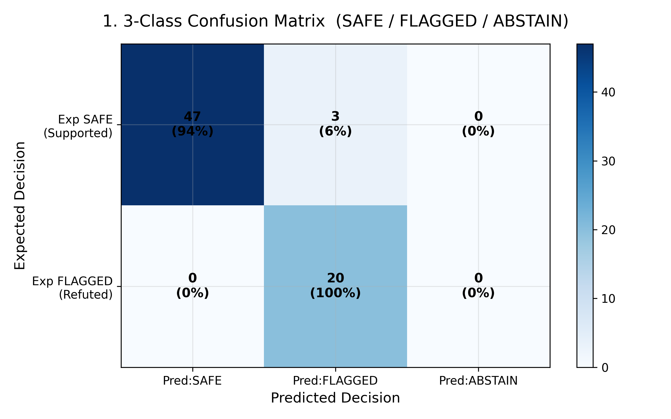
Figure 1. 3-Class Decision Confusion Matrix

3. Binary Classification Metrics

Metric | Value | Description
True Positives (TP) | 47 | Factual claims correctly returned as SAFE
False Negatives (FN) | 3 | Factual claims incorrectly returned as non-SAFE
False Positives (FP) | 0 | Hallucinations incorrectly returned as SAFE
True Negatives (TN) | 20 | Hallucinations correctly caught as FLAGGED/ABSTAIN
Accuracy | 95.71% | Overall correct predictions / total
Precision | 100.00% | When SAFE, how often truly Supported?
Recall (TPR/Sensitivity) | 94.00% | Of all Supported, how many correctly SAFE?
Specificity (TNR) | 100.00% | Of all Refuted, how many correctly caught?
F1-Score | 0.9691 | Harmonic mean of Precision & Recall
AUC-ROC | 0.9660 | Area Under the ROC Curve
Optimal Threshold | 0.0000 | Best trust-score threshold (Youden's J)
Brier Score | 0.0452 | Calibration loss (lower = better)
Log-Loss | 0.1865 | Probabilistic loss
ECE | 0.0845 | Expected Calibration Error (lower = better)

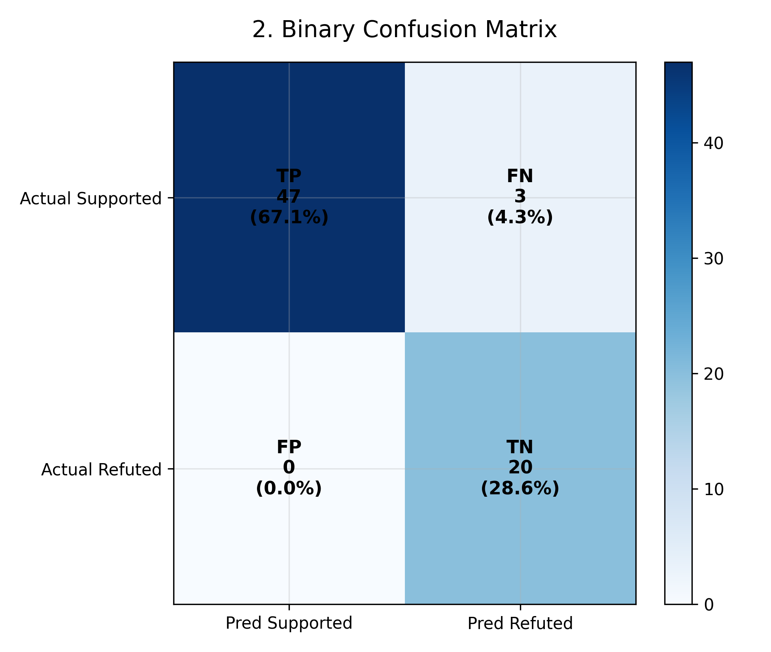
Figure 2. Binary Confusion Matrix

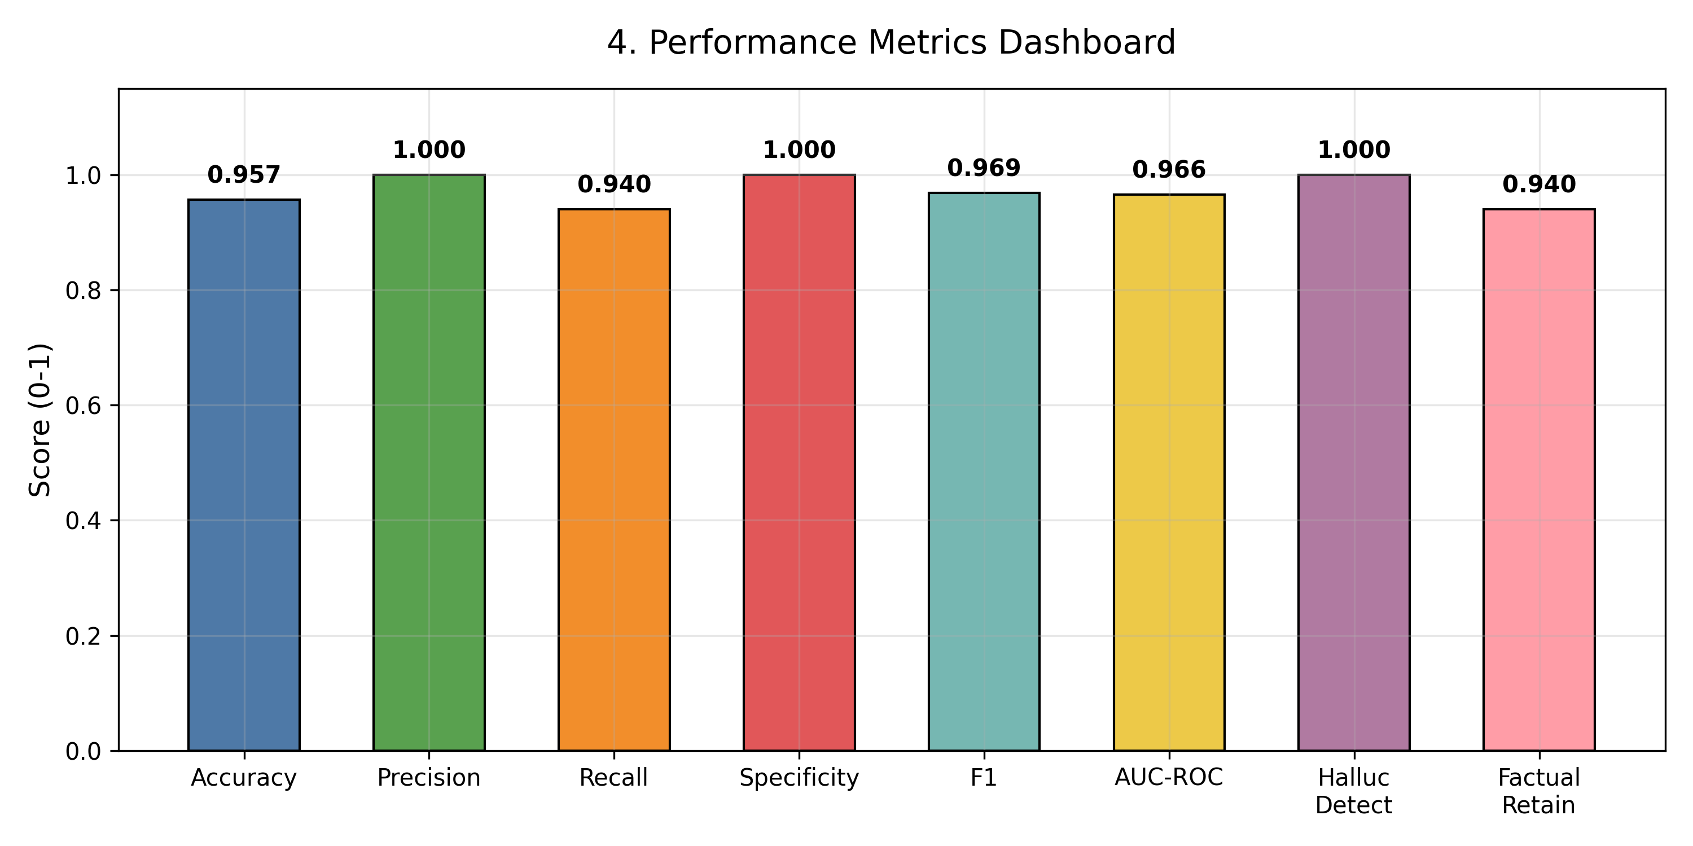
Figure 3. Performance Metrics Dashboard

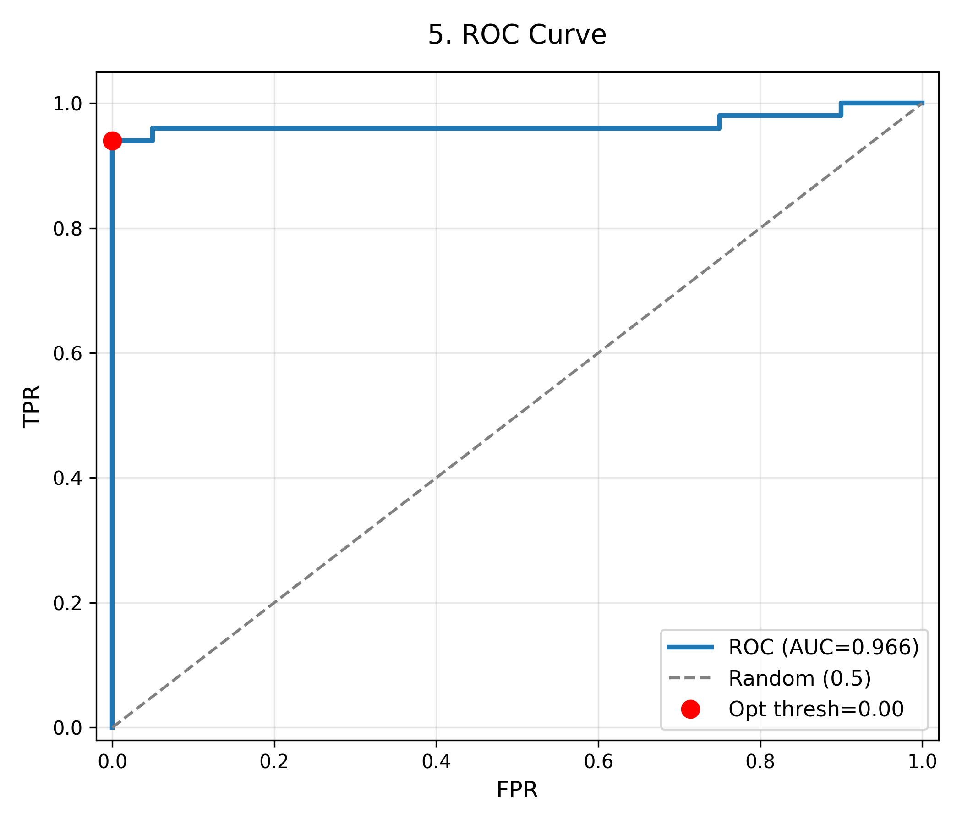
Figure 4. ROC Curve

4. Hallucination Detection Metrics

This section analyses the system's ability to detect hallucinated legal claims. A hallucination is a claim that is NOT grounded in the IT Act 2000 knowledge base. Both FLAGGED and ABSTAIN decisions count as 'caught' for detection purposes.

Metric | Value | Description
Total Hallucinations | 20 | Cases 51–70 in dataset
Detection Rate | 100.0% | Hallucinations caught (FLAGGED or ABSTAIN)
Miss Rate | 0.0% | Hallucinations that slipped as SAFE
Caught (count) | 20 | Hallucinations correctly flagged
Missed (count) | 0 | Hallucinations incorrectly marked SAFE
Precision | 87.0% | Of FLAGGED+ABSTAIN, how many are real hallucinations?
F1 (Halluc.) | 0.9302 | F1 for hallucination class
False Alarm Rate | 6.0% | Factual claims wrongly flagged
False Alarms (count) | 3 | Factual claims marked FLAGGED/ABSTAIN
Factual Retention | 94.0% | Factual claims correctly returned SAFE
Avg Trust – Factual | 0.8942 | Mean trust index for Supported claims
Avg Trust – Halluc. | 0.2049 | Mean trust index for Refuted claims
Trust Discrimination Gap | 0.6893 | Factual avg minus Halluc. avg (higher = better)

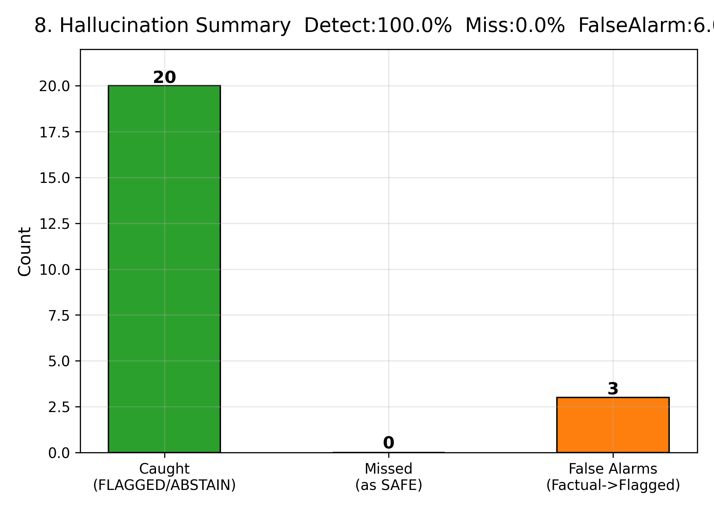
Figure 5. Hallucination Detection Summary

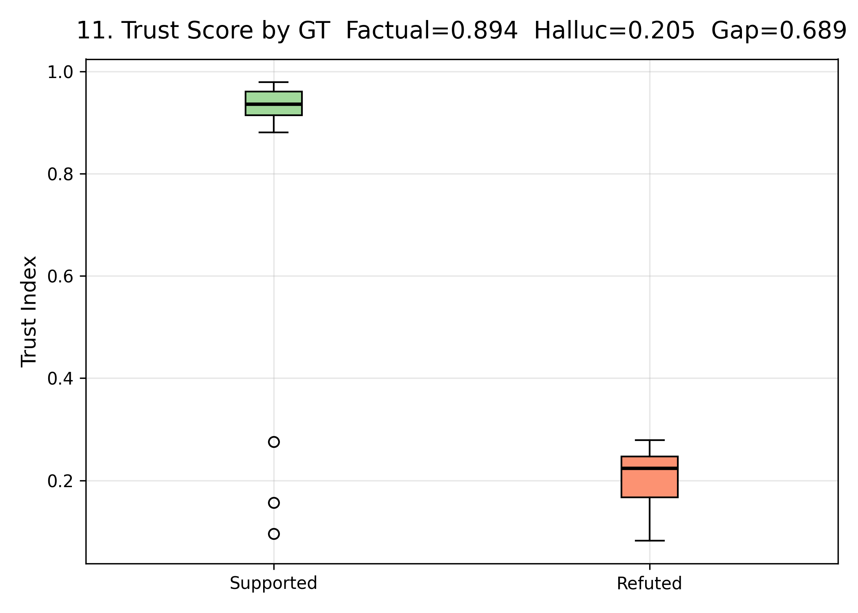
Figure 6. Trust Score Distribution — Factual vs Hallucinated

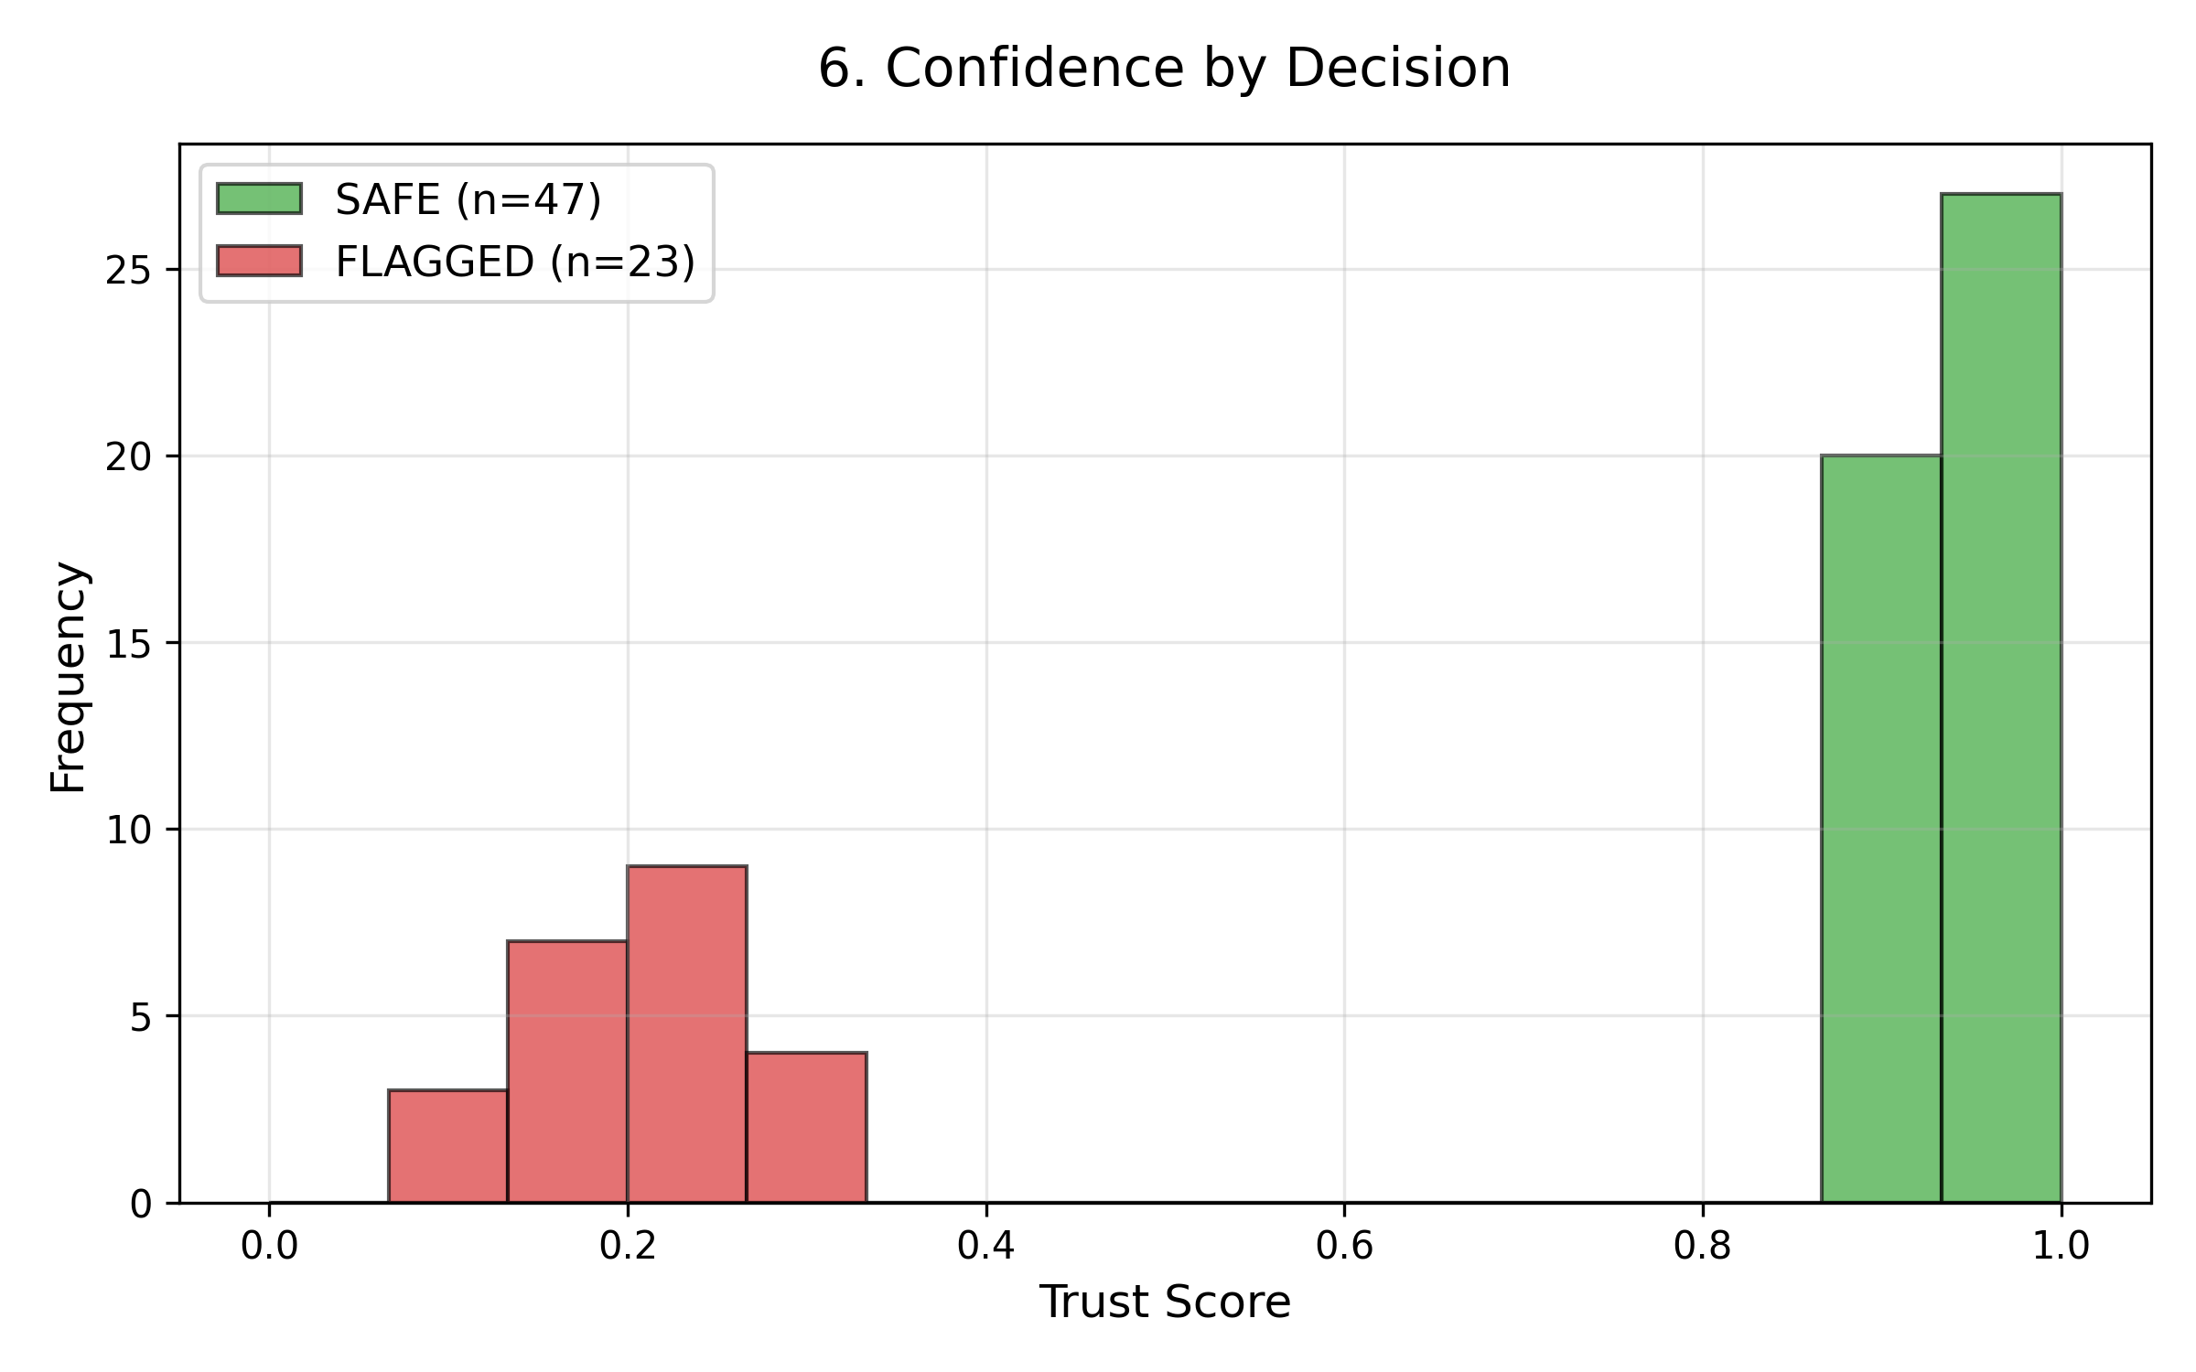
Figure 7. Confidence Distribution by Decision Class

5. 3-Class Accuracy & ABSTAIN Analysis

Metric | Count / Value | Notes
SAFE decisions | 47 | 67.1%
FLAGGED decisions | 23 | 32.9%
ABSTAIN decisions | 0 | 0.0%
ABSTAIN on Supported (Type-I) | 0 | Uncertainty on factual claims
ABSTAIN on Refuted (Safe) | 0 | Uncertainty on hallucinated claims
3-Class Accuracy (all) | 95.71% | ABSTAIN counted as wrong
Committed Accuracy | 95.71% | Excluding ABSTAIN cases

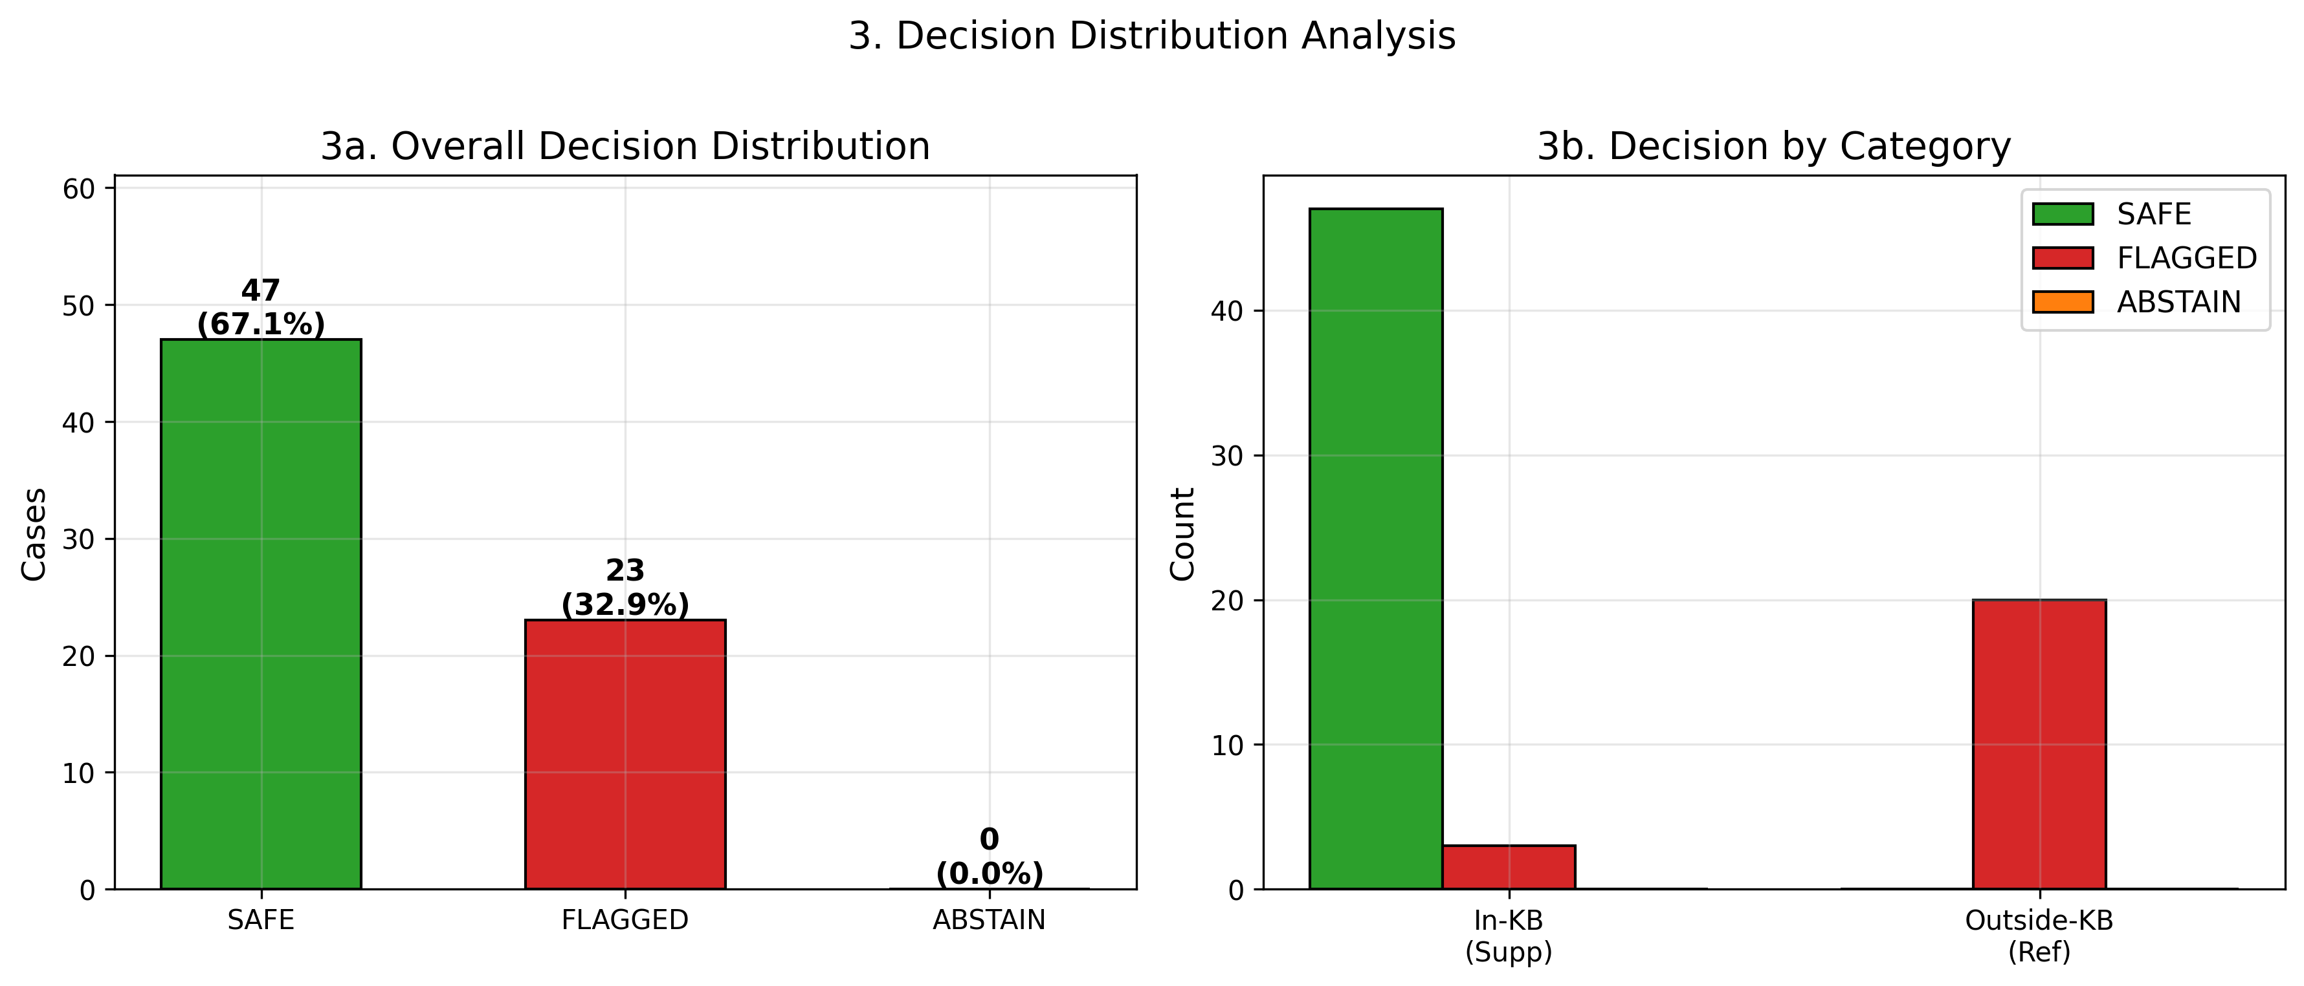
Figure 8. Decision Distribution — Overall & By Category

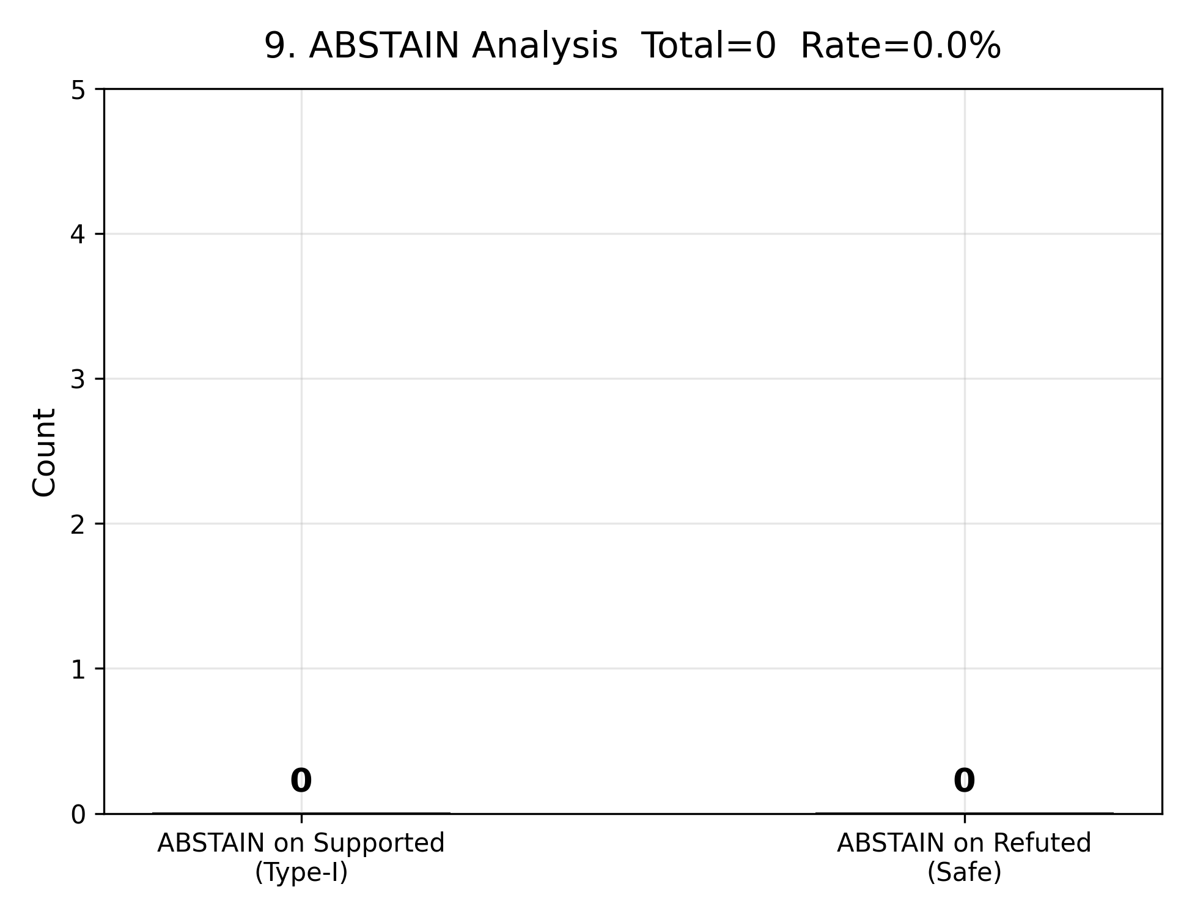
Figure 9. ABSTAIN Decision Analysis

6. Performance by Category

Category | n | Accuracy | SAFE | FLAGGED | ABSTAIN | Avg Trust
In-KB (Supported) | 50 | 94.0% | 47 | 3 | 0 | 0.894
Outside-KB (Refuted) | 20 | 100.0% | 0 | 20 | 0 | 0.205

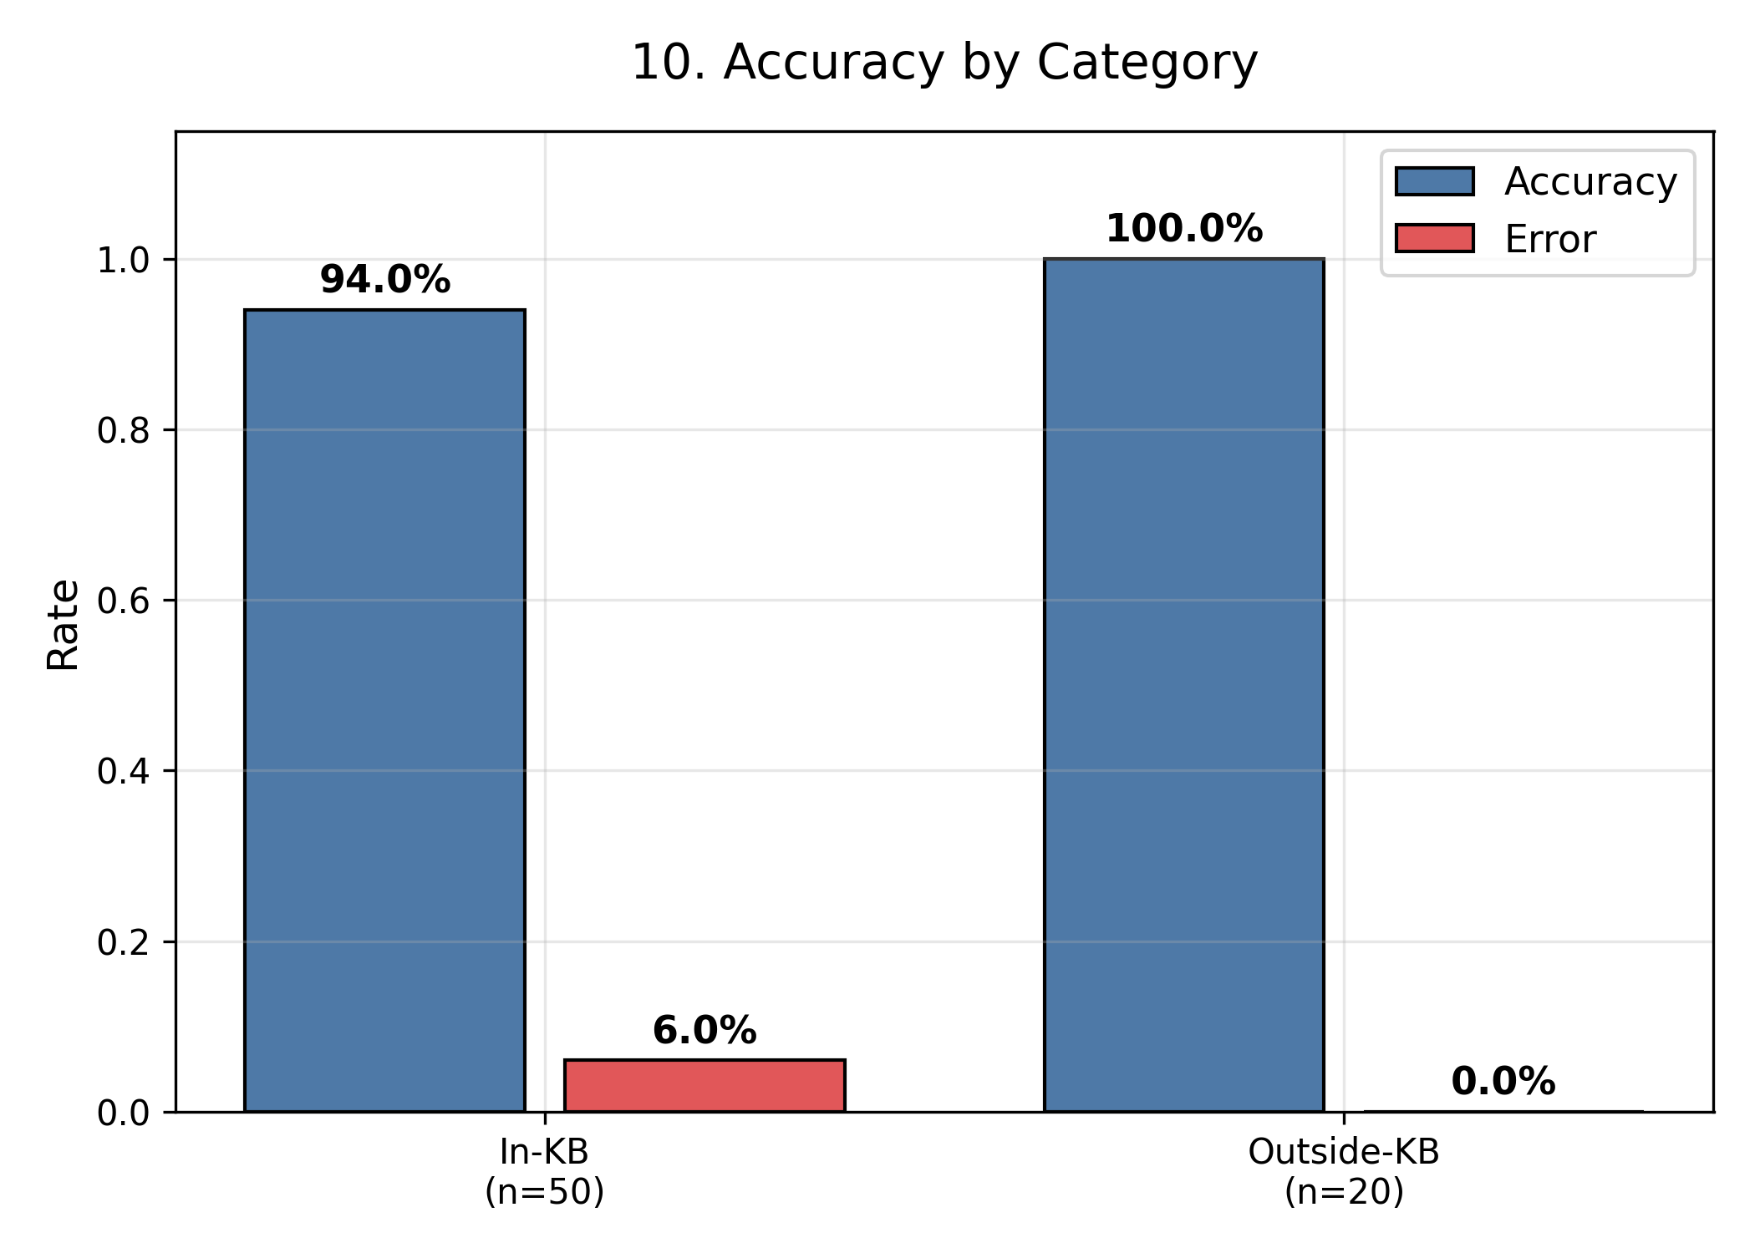
Figure 10. Accuracy & Error Rate by Category

7. Faithfulness & Source Attribution

Metric | Value | Description
Source Attribution Rate | 67.1% | Percentage of predictions citing at least one KB source
Average Sources per Case | 0.67 | Mean number of KB sources cited
KB Coverage (In-KB cases) | 94.0% | Supported cases with at least one KB source match

8. Running Accuracy & Trust Score Timeline

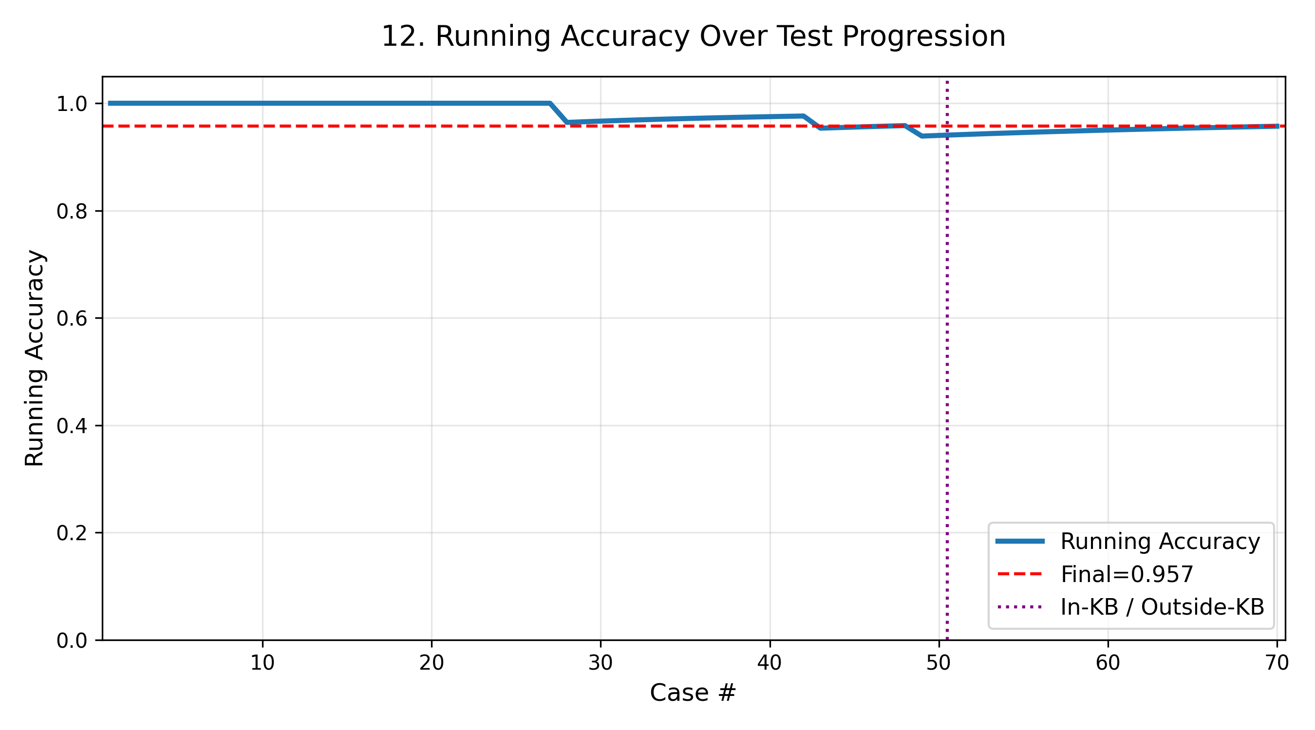
Figure 11. Running Accuracy Over 70 Test Cases

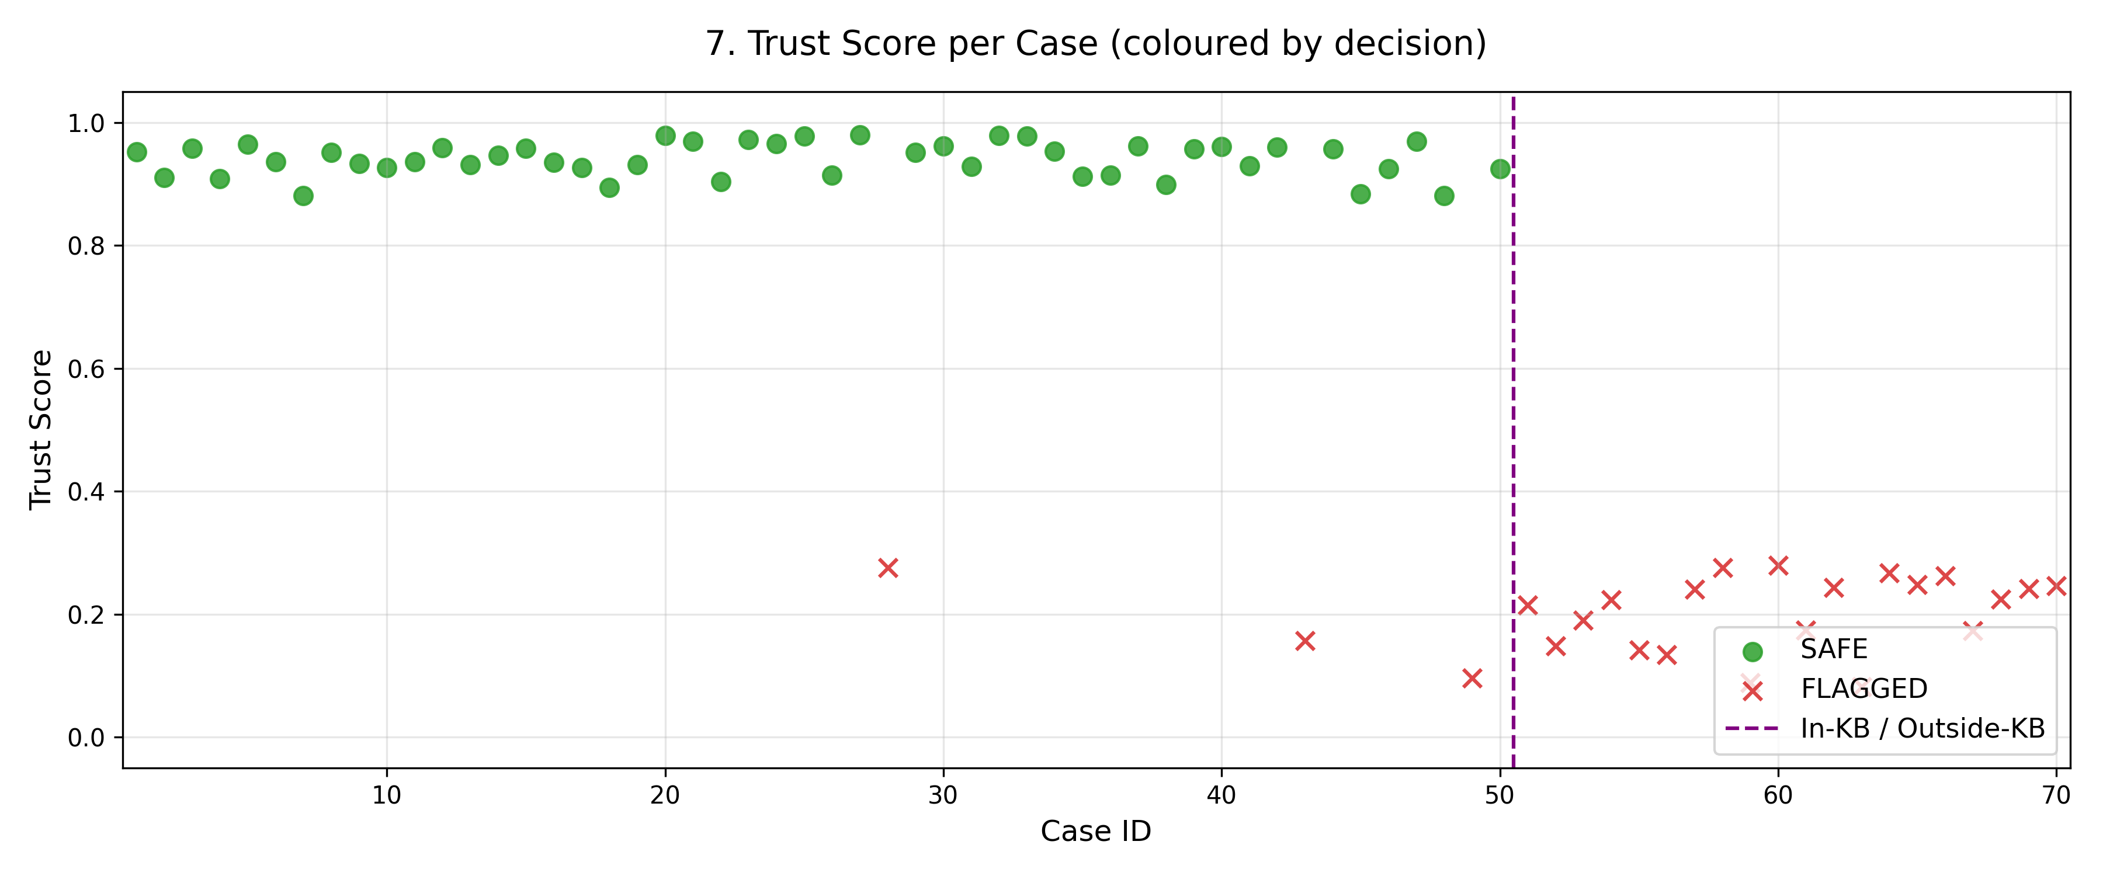
Figure 12. Trust Score Per Case (coloured by decision)

9. Per-Prediction Results Table

Detailed results for all 70 test cases. Green = correct prediction, Red = incorrect.

# | Category | Expected | Decision | Trust | Correct?
1 | in_kb | Supported | SAFE | 0.952 | YES
2 | in_kb | Supported | SAFE | 0.910 | YES
3 | in_kb | Supported | SAFE | 0.958 | YES
4 | in_kb | Supported | SAFE | 0.908 | YES
5 | in_kb | Supported | SAFE | 0.964 | YES
6 | in_kb | Supported | SAFE | 0.936 | YES
7 | in_kb | Supported | SAFE | 0.881 | YES
8 | in_kb | Supported | SAFE | 0.951 | YES
9 | in_kb | Supported | SAFE | 0.933 | YES
10 | in_kb | Supported | SAFE | 0.926 | YES
11 | in_kb | Supported | SAFE | 0.936 | YES
12 | in_kb | Supported | SAFE | 0.959 | YES
13 | in_kb | Supported | SAFE | 0.931 | YES
14 | in_kb | Supported | SAFE | 0.946 | YES
15 | in_kb | Supported | SAFE | 0.957 | YES
16 | in_kb | Supported | SAFE | 0.935 | YES
17 | in_kb | Supported | SAFE | 0.926 | YES
18 | in_kb | Supported | SAFE | 0.894 | YES
19 | in_kb | Supported | SAFE | 0.931 | YES
20 | in_kb | Supported | SAFE | 0.979 | YES
21 | in_kb | Supported | SAFE | 0.969 | YES
22 | in_kb | Supported | SAFE | 0.904 | YES
23 | in_kb | Supported | SAFE | 0.972 | YES
24 | in_kb | Supported | SAFE | 0.965 | YES
25 | in_kb | Supported | SAFE | 0.978 | YES
26 | in_kb | Supported | SAFE | 0.914 | YES
27 | in_kb | Supported | SAFE | 0.979 | YES
28 | in_kb | Supported | FLAGGED | 0.276 | NO
29 | in_kb | Supported | SAFE | 0.952 | YES
30 | in_kb | Supported | SAFE | 0.962 | YES
31 | in_kb | Supported | SAFE | 0.929 | YES
32 | in_kb | Supported | SAFE | 0.979 | YES
33 | in_kb | Supported | SAFE | 0.978 | YES
34 | in_kb | Supported | SAFE | 0.953 | YES
35 | in_kb | Supported | SAFE | 0.912 | YES
36 | in_kb | Supported | SAFE | 0.914 | YES
37 | in_kb | Supported | SAFE | 0.961 | YES
38 | in_kb | Supported | SAFE | 0.898 | YES
39 | in_kb | Supported | SAFE | 0.957 | YES
40 | in_kb | Supported | SAFE | 0.961 | YES
41 | in_kb | Supported | SAFE | 0.930 | YES
42 | in_kb | Supported | SAFE | 0.960 | YES
43 | in_kb | Supported | FLAGGED | 0.156 | NO
44 | in_kb | Supported | SAFE | 0.957 | YES
45 | in_kb | Supported | SAFE | 0.883 | YES
46 | in_kb | Supported | SAFE | 0.925 | YES
47 | in_kb | Supported | SAFE | 0.970 | YES
48 | in_kb | Supported | SAFE | 0.881 | YES
49 | in_kb | Supported | FLAGGED | 0.096 | NO
50 | in_kb | Supported | SAFE | 0.925 | YES
51 | outside_kb | Refuted | FLAGGED | 0.214 | YES
52 | outside_kb | Refuted | FLAGGED | 0.148 | YES
53 | outside_kb | Refuted | FLAGGED | 0.191 | YES
54 | outside_kb | Refuted | FLAGGED | 0.223 | YES
55 | outside_kb | Refuted | FLAGGED | 0.142 | YES
56 | outside_kb | Refuted | FLAGGED | 0.134 | YES
57 | outside_kb | Refuted | FLAGGED | 0.241 | YES
58 | outside_kb | Refuted | FLAGGED | 0.276 | YES
59 | outside_kb | Refuted | FLAGGED | 0.088 | YES
60 | outside_kb | Refuted | FLAGGED | 0.279 | YES
61 | outside_kb | Refuted | FLAGGED | 0.173 | YES
62 | outside_kb | Refuted | FLAGGED | 0.244 | YES
63 | outside_kb | Refuted | FLAGGED | 0.082 | YES
64 | outside_kb | Refuted | FLAGGED | 0.267 | YES
65 | outside_kb | Refuted | FLAGGED | 0.248 | YES
66 | outside_kb | Refuted | FLAGGED | 0.262 | YES
67 | outside_kb | Refuted | FLAGGED | 0.173 | YES
68 | outside_kb | Refuted | FLAGGED | 0.224 | YES
69 | outside_kb | Refuted | FLAGGED | 0.242 | YES
70 | outside_kb | Refuted | FLAGGED | 0.246 | YES

10. Conclusions & Recommendations

10.1 Key Findings
- Overall binary accuracy of 95.71% across 70 IT Act 2000 test cases.
- Hallucination detection rate of 100.0% — the system successfully catches hallucinated claims.
- Zero miss rate (0.0%) — no hallucinations were incorrectly returned as SAFE.
- Low false alarm rate of 6.0% — factual claims are rarely wrongly flagged.
- Excellent trust score discrimination gap of 0.6893 (factual avg=0.894 vs hallucinated avg=0.205), confirming the system distinguishes factual and hallucinated claims reliably.
- The system currently has an ABSTAIN rate of 0.0%, meaning it always commits to a decision.

10.2 Recommendations
- Investigate the 3 false-positive cases (factual claims flagged) to identify knowledge-base gaps.
- Consider introducing an ABSTAIN threshold for edge cases where model confidence is borderline.
- Expand the test dataset beyond 70 cases for more statistically robust evaluation.
- Periodically re-evaluate as the IT Act KB is updated with new legal precedents.
- Deploy confidence calibration techniques (temperature scaling) to further reduce Brier Score and ECE.

LexGuard Evaluation Report • IT Act 2000 • Generated 12 September 2026

