**INTRODUCTION:**

Software engineering is a detailed study of engineering to the design, development and maintenance of software. Software engineering was introduced to address the issues of low-quality software projects. Problems arise when a software generally exceeds timelines, budgets, and reduced levels of quality. It ensures that the application is built consistently, correctly, on time and on budget and within requirements. The demand of software engineering also emerged to cater to the immense rate of change in user requirements and environment on which application is supposed to be working.

What is Hospital Management Software?

As long as each stage implementation needs to be accurate and explicit, the clinic management system provides certain [automation](https://www.medicaldevice-network.com/features/expert-views-benefits-automation-healthcare-industry/) of many vital daily processes. The hospital system software covers the services that unify and simplify the work of healthcare professionals as well as their interactions with patients.

There is always the wide choice of features that can be included in the system. Moreover, the most important thing they are created to streamline various procedures that meet the needs of all the users. The hospital management system feature list is concentrated on providing the smooth experience of patients, staff and hospital authorities. It might seem that their expectations differ, they still are covered by components of the hospital information system. Quality and security still remain the main criteria of the medical industry. It is also known for the constant and rapid changes to improve the efficiency of medical services and satisfaction of the patients.

Hospital management has greatly changed over the last decades. Business expertise, modern technologies, [connected devices](https://existek.com/embedded-software-outsourcing-company-development-services/), mobile apps, and knowledge of healthcare are key elements for the implementation of hospital management system project. The number of healthcare providers has increased and the patients have a wide choice of medical specialists.

**IMPLEMENTATION:**

The project Hospital Management system includes registration of patients, storing their details into the system, and also computerized billing in the pharmacy, and labs. The software has the facility to give a unique id for every patient and stores the details of every patient and the staff automatically. It includes a search facility to know the current status of each room. User can search availability of a doctor and the details of a patient using the id. The Hospital Management System can be entered using a username and password. It inaccessible either by an administrator or receptionist. Only they can add data into the database. The data can be retrieved easily. The interface is very user-friendly. The data are well protected for personal use and makes the data processing very fast. Hospital Management System is powerful, flexible, and easy to use and is designed and developed to deliver real conceivable benefits to hospitals. Hospital Management System is designed for multispecialty hospitals, to cover a wide range of hospital administration and management processes. It is an integrated end-to-end Hospital Management System that provides relevant information across the hospital to support effective decision making for patient care, hospital administration and critical financial accounting, in seamless flow. Hospital Management System is a software product suite designed to improve the quality and management of hospital management in the areas of clinical process analysis and activity-based costing. Hospital Management System enables you to develop your organization and improve its effectiveness and quality of work.

**Objectives:**

1. Define hospital
2. Recording information about the Patients that come.
3. Generating bills.
4. Recording information related to diagnosis given to Patients.
5. Keeping record of the Immunization provided to children/patients.

6) Keeping information about various diseases and medicines available to cure them. These are the various jobs that need to be done in a Hospital by the operational staff and Doctors.

**Scope of the Project:-**

1. Information about Patients is done by just writing the Patients name, age and gender. Whenever the Patient comes up his information is stored freshly.
2. Bills are generated by recording price for each facility provided to Patient on a separate sheet and at last they all are summed up.
3. Diagnosis information to patients is generally recorded on the document, which contains Patient information. It is destroyed after some time period to decrease the paper load in the office.
4. Immunization records of children are maintained in pre-formatted sheets, which are kept

in a file.

1. Information about various diseases is not kept as any document. Doctors themselves do this job by remembering various medicines. All this work is done manually by the receptionist and other operational staff and lot of papers are needed to be handled and taken care of.

**UML Approach:**

**UML Diagram:**

A diagram is the graphical presentation of a set of elements, most often rendered as a connected graph of vertices and arcs . You draw diagram to visualize a system from different perspective, so a diagram is a projection into a system. For all but most trivial systems, a diagram represents an elided view of the elements that make up a system. The same element may appear in all diagrams, only a few diagrams , or in no diagrams at all. In theory, a diagram may contain any combination of things and relationships. In practice, however, a small number of common combinations arise, which are consistent with the five most useful views that comprise the architecture of a software-intensive system. For this reason, the UML includes nine such diagrams:

1. Class diagram

2. Use case diagram

3 .Sequence diagram

4. Collaboration diagram

5. State chart diagram

6. ER diagram

7. Data flow diagram level zero

8. Data flow diagram level one

9. Activity diagram

**1. Class Diagram:**

A Class is a category or group of things that has similar attributes and common behavior. A Rectangle is the icon that represents the class it is divided into three areas. The upper most area contains the name, the middle; area contains the attributes and the lowest areas show the operations. Class diagrams provides the representation that developers work from. Class diagrams help on the analysis side, too.

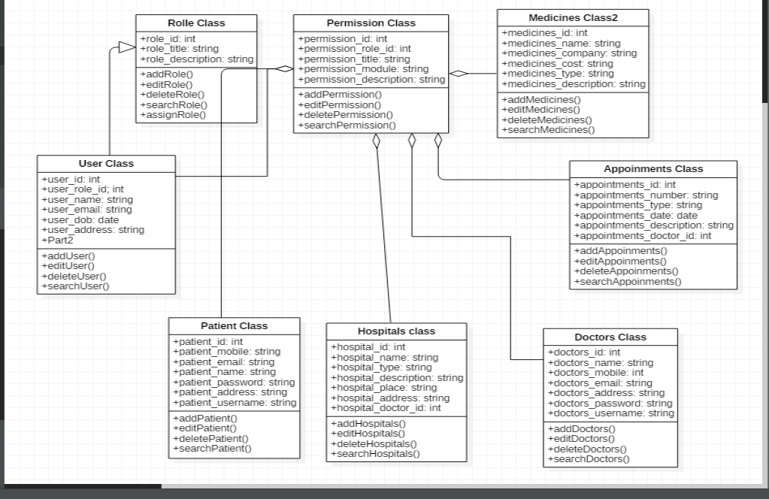

Fig1. Class diagram

**2. USE CASE DIAGRAM:**

A use case diagram in the Unified Modeling Language (UML) is a type of behavioral diagram defined by and created from a use-case analysis. its purpose is to present a graphical overview of the functionality provided by a system in terms of actors, their goals(represented as use cases),and any dependencies between those use cases. Use case diagrams are formally included in two modeling languages defined by the OMG: the unfied modeling language (UML).

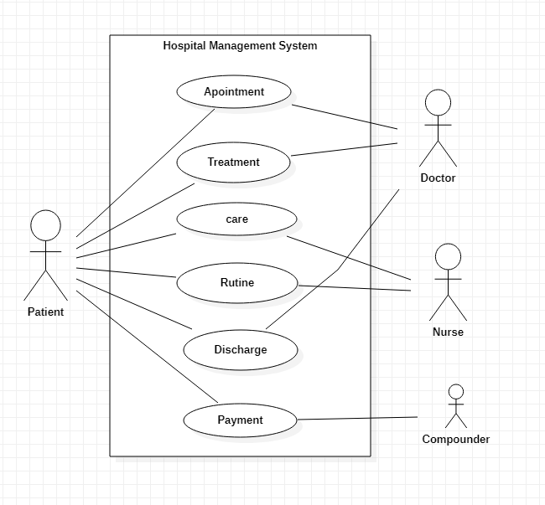

Fig 2. Use Case Diagram

**3. Sequence diagram:**

A Sequence Diagram is an interaction diagram that emphasis the time ordering of messages; a collaboration diagram is an interaction diagram that emphasizes the structural organization of the objects that send and receive messages. Sequence diagrams and collaboration diagrams are isomorphic, meaning that you can take one and transform it into the other.

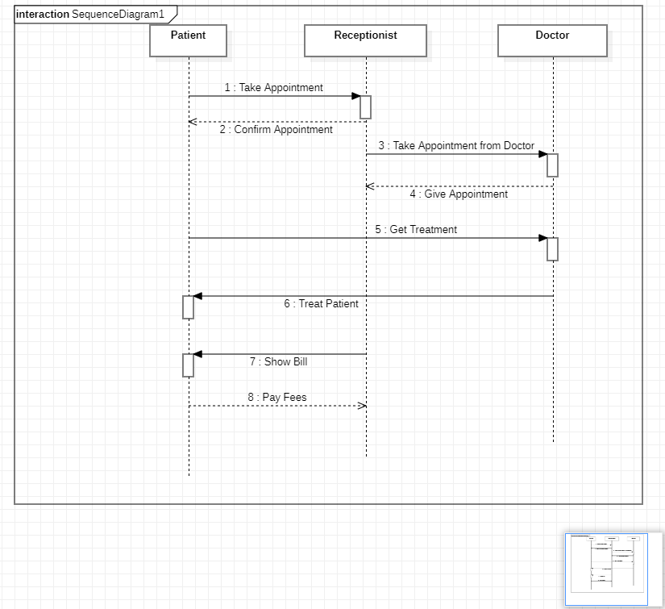

Fig 3. Sequence Diagram

**4. Collaboration diagram:**

A Collaboration Diagram also called a communication diagram or interaction diagram is an illustration of the relationships and interactions among software objects. The concept is more than a decade old although it has been refined as modeling paradigms have evolved.

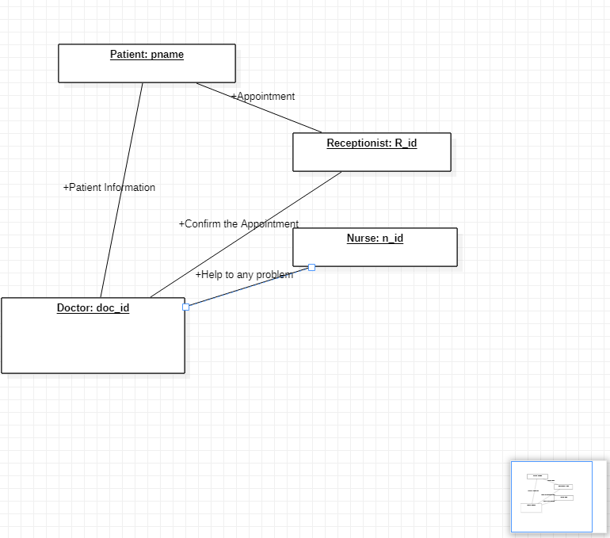

Fig 4. Collabortion diagram

**5. State chart Diagrams:**

The state diagram shows the states of an object and represents activities as arrows connecting the states. The Activity Diagram highlights the activities. Each activity is represented by a rounded rectangle-narrower and more oval-shaped than the state icon. An arrow represents the transition from the one activity to the next. The activity diagram has a starting point represented by filled-in circle, and an end point represented by bulls eye.

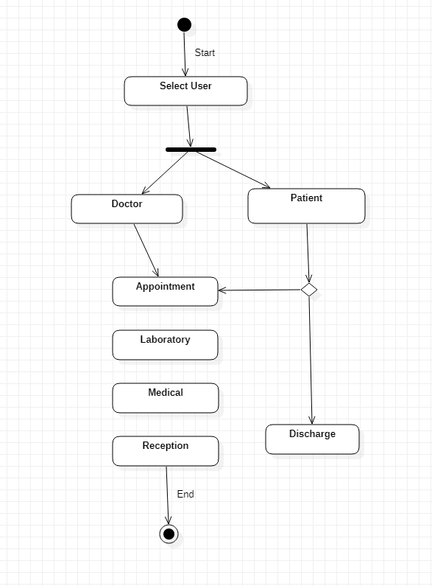

Fig 5. State chart Diagrams

**6. ER Diagram:**

The entity-relationship diagram of Hospital Management System shows all the visual instrument of database tables and the relations between Patient, Nurses, Hospitals, Medicines etc. It used structure data and to define the relationships between structured data groups of Hospital Management System functionalities.

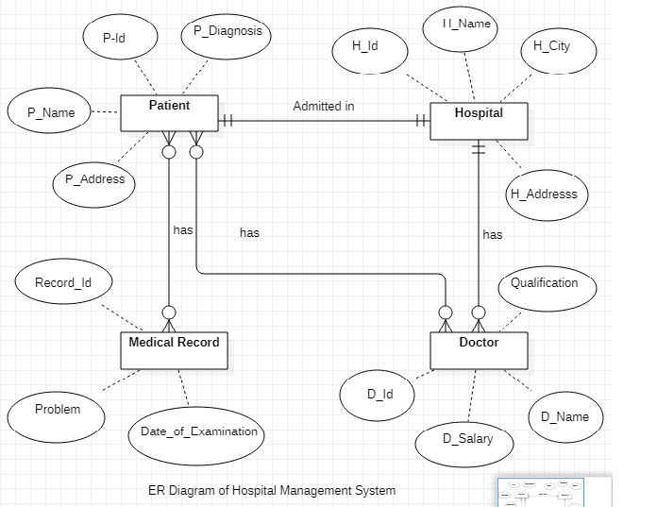

Fig 6.ER Diagram

**7. DFD Level 0:**

It is known as context dig. it is design to be an abstraction view. it represents the entire system as a single bubble with input and output data indicated by incoming and outgoing arrows.

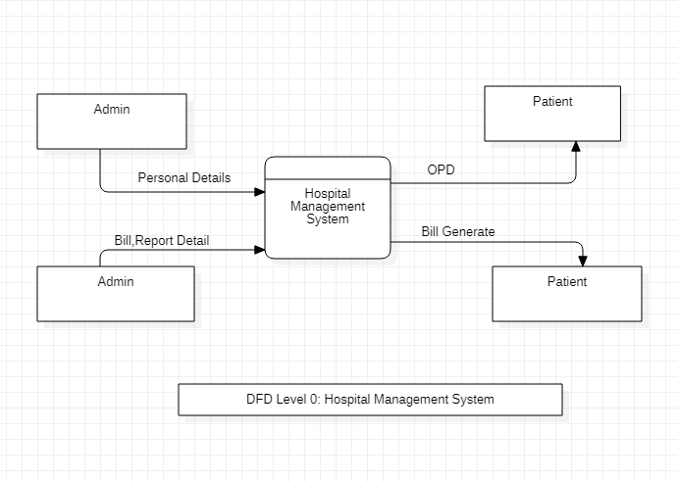

Fig 7. DFD Level 0

**8.DFD LEVEL 1:**

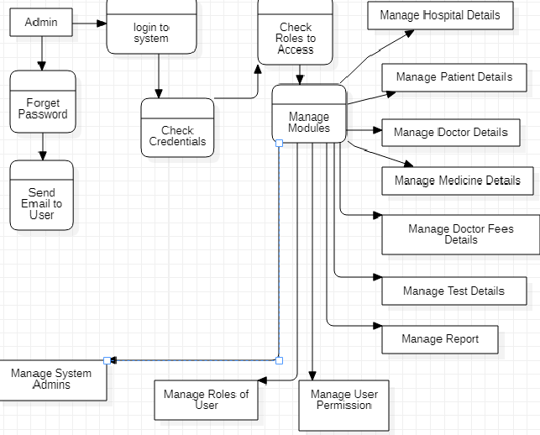

Fig 8.DFD LEVEL 1

**9. Activity diagram:**

Activity diagram is another important diagram in UML to describe the dynamic aspects of the system. Activity diagram is basically a flowchart to represent the flow from one activity to another activity. The activity can be described as an operation of the system. The control flow is drawn from one operation to another.

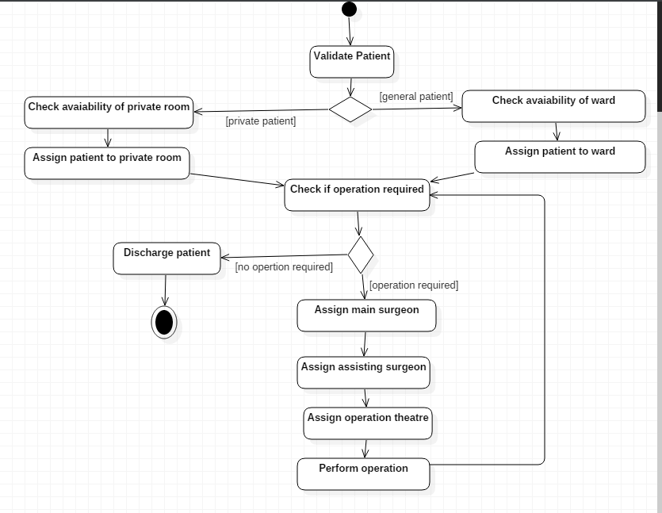

Fig 10.Activity diagram

**CONCLUSION:**

In this way, we create our Software Engineering project **“**Hospital Management System“with partial fulfillment Submitted in partial fulfillment of the requirement for the diploma of computer engineering. The main aim to present this project is increasing the basic general knowledge of students. We create it by using ‘UML’ software.

**REFERENCE:**

1. <https://www.slideshare.net/HimaniChopra/hospital-management-system-project>
2. <https://www.smartdraw.com/uml-diagram/>
3. <https://www.guru99.com/what-is-software-engineering.html>
4. <https://en.wikipedia.org/wiki/Data-flow_diagram>