PSP [20ES104] COURSE PROJECT REPORT

ON

“MOVIE SNACK BILLING SYSTEM”

Developed By:

HT NO. Name

2203a51443 S. Sri Gayatri

2203a51411 . Tejaswi

2203a51412 . Rupasree

2203a51423 . Laxmi Prassanna

BATCH NO.: 07

GROUP LEADER: S. Sri Gayatri

BATCH MEMBERS:

S. Sri Gayatri-2203a51443

D.Tejaswi-2203a51411

E. Rupasree-2203a51412

K. Laxmiprasanna-2203a51423

ABSTRACT:

This project is about writing a code to print the bill when an item is being purchased in movie theatre. Popcorn, cold beverages, fries, sandwich and hamburgers are few examples of various culinary options available. The client can select any quantity of any size. Given is a list of food item with extensive information.

The bill of food products that the specific customer purchased is the project output. Name of food item, quantity, amount, GST, discount, payment mode, total and customers mobile number are all included in the bill.

Details of the project:

The project "MOVIE SNACK" is a basic program used in movie theatres. The main aim is to perform the process of ordering and billing of canteen section in theatre.

The system is named as Movie snack billing. This is design especially for a canteen section which wants to attend their customer in a very well manner. This system has a capability to give the receipt, in which GST also included, to the customers.

The output of the project consists of the menu of the items that include popcorn with three different sizes (small, medium, large), beverages with three types i.e., Pepsi, sprite, water, fries with two flavours (salt, masala); coffees included are cold coffee, americano, cappuccino.

The program consists few kinds of options like read, display, search, sort, delete, insert by which we can search the items, add few more items if require, delete the items from the bill, sorting it according to the rate or size. Individual cost of each item is displayed with the amount of GST added to it.

The menu is as follows:

|  |  |  |
| --- | --- | --- |
| **Food item** | **size** | **Price** |
| 1.Popcorn | Small  Medium  large | 50  80  100 |
| 2. Cold Beverages | Pepsi  Sprite  Water | 60  60  40 |
| 3. Fries | Salted  Masala | 70  90 |
| 4. Coffee | Cold Coffee  Americano  Cappuccino | 120  150  160 |

The project goal is to keep the records of all the purchase orders. The program is easily executable and can be easily accessed by a user. It is a great software for saving time and decrease the work of the owner of the theatre.

Objectives:

• To provide a computer-based billing system for an accurate computation of bills.

• To reduce time, energy, and resources that was being consumed when performing a billing for the customer.

• To generate receipt when performing a service.

• To provide a convenient solution of billing pattern.

The program:

// The program for previous records.

//60 customer records

#include<stdio.h>

struct student{

char name[50];

float price;

};

main(){

struct student s;

FILE *f1;

printf("Enter customer data:");

f1=fopen("C:/Users/seeth/OneDrive/Documents/c/PROJECT/RECORD60.txt","w");

while(fscanf(stdin,"%s%f",s.name,&s.price)!=EOF)

fprintf(f1,"%s %f",s.name,s.price);

fclose(f1);

f1=fopen("C:/Users/seeth/OneDrive/Documents/c/PROJECT/record60.txt","r");

printf("\nName Age Marks");

while(fscanf(f1,"%s%f",s.name,&s.price)!=EOF){

printf("\n---------------------------------------");

fprintf(stdout,"\n%s %f",s.name,s.price);

}

fclose(f1);

}

Working of the code:

This code opens a file in read mode and takes the details of multiple customers i.e., customer name and their bill through keyboard and stores them in that file.

The data stored in that file will be printed onto the screen in a formatted way.

Output:

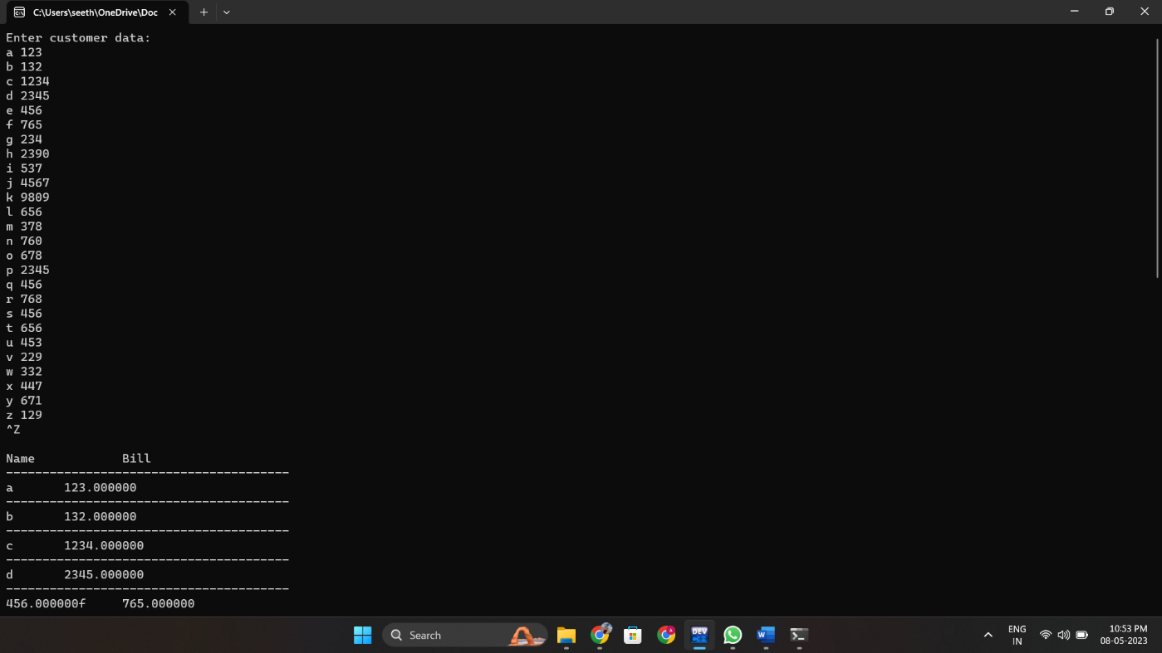

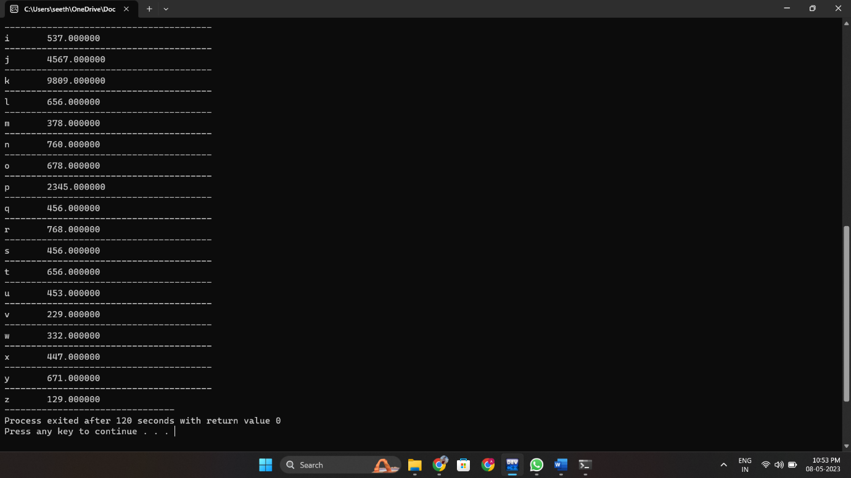

//The main program starts from here.

#include<stdio.h>

#include<string.h>

FILE *f1;

struct customer display();

struct customer search();

struct customer append();

struct customer sort();

struct customer {

char name[100];

float price;

}f;

struct bill popcorn();

struct bill bevrage();

struct bill fries();

struct bill coffee();

struct bill price();

struct bill bill_display();

void display_menu();

struct bill{

char name[50];

int qty1;

int qty2;

int qty3;

int qty4;

int P_price;

int B_price;

int F_price;

int C_price;

float net_price;

}s,c1,c2,c3,c4,c5;

main(){

int choice;char ch;

display_menu();

printf("\n========================================================================================================================\n");

do{

printf("\nEnter your choice to order:");

scanf("%d",&choice);

switch(choice){

case 1:

c1=popcorn(s);

break;

case 2:

c2=bevrage(s);

break;

case 3:

c3=fries(s);

break;

case 4:

c4=coffee(s);

break;

}

printf("\nDo you want to continue?[y/n]:");

scanf(" %c",&ch);

}while(ch=='y');

printf("Enter customer name: ");

scanf("%s",s.name);

c5=bill_display(s,c1,c2,c3,c4);

printf("\n========================================================================================================================\n");

f1=fopen("C:/Users/seeth/OneDrive/Documents/c/PROJECT/RECORD60.txt","a");

fprintf(f1,"%s %f",s.name,c5.net_price);

fclose(f1);

char file,ch1;int i,n,choice1;

printf("\nDo you want to check files? ");

scanf(" %c",&file);

printf("\n1. Append a record\n2. Display record ");

printf("\n---------------------------------------------");

if(file == 'y'){

do{

printf("\nEnter your choice[files]:");

scanf("%d",&choice1);

switch(choice1){

case 1:

f=append();

break;

case 2:

display(f);

break;

}

printf("\nDo you want to continue?[y/n]:");

scanf(" %c",&ch1);

}while(ch1=='y');

}

}

void display_menu()

{

printf(" MOVIE SNACK BILLING");

printf("\n------------------------------------------------------------------------------------------------------------------------\n");

printf("\n---------------------------------------------");

printf("\nFood Size Price");

printf("\n---------------------------------------------");

printf("\n1.popcorn 1-small 50");

printf("\n 2-medium 80");

printf("\n 3-large 100");

printf("\n---------------------------------------------");

printf("\n2.Cold bevrages 1-pepsi 60");printf("\n 2-sprite 60");printf("\n 3-water 40");

printf("\n---------------------------------------------");

printf("\n3.Fries 1-salted 70");printf("\n 2-masala 90");

printf("\n---------------------------------------------");

printf("\n4.Coffee 1-cold coffee 120");printf("\n 2-americano 150");printf("\n 3-cappuccino 160");

printf("\n---------------------------------------------");

printf("\nNOTE: 18percent tax on each product u buy.");

}

struct bill popcorn(struct bill s){

int size1,i,pop1,pop2,pop3;

printf("Enter no. of items for popcorn: ");

scanf("%d",&s.qty1);

pop1=pop2=pop3=0;

for(i=0;i<s.qty1;i++){

printf("Enter the size: ");

scanf("%d",&size1);

}

if(size1==1)

pop1+=(s.qty1*50)+(s.qty1*18);

else if(size1==2)

pop2+=(s.qty1*80)+(s.qty1*18);

else if(size1==3)

pop3+=(s.qty1*100)+(s.qty1*18);

s.P_price=pop1+pop2+pop3;

printf("%d",s.P_price);

return s;

}

struct bill bevrage(struct bill s){

int size2,i,bev1,bev2,bev3;

printf("Enter no. of items for bevrages: ");

scanf("%d",&s.qty2);

bev1=bev2=bev3=0;

for(i=0;i<s.qty2;i++){

printf("Enter the size: ");

scanf("%d",&size2);

}

if(size2==1)

bev1+=(s.qty2*70)+(s.qty2*18);

else if(size2==2)

bev2+=(s.qty2*90)+(s.qty2*18);

else if(size2==3)

bev3+=(s.qty2*40)+(s.qty2*18);

s.B_price=bev1+bev2+bev3;

printf("%d",s.B_price);

return s;

}

struct bill fries(struct bill s){

int size3,i,fry1,fry2;

printf("Enter no. of items for fries: ");

scanf("%d",&s.qty3);

fry1=fry2=0;

for(i=0;i<s.qty3;i++){

printf("Enter the size: ");

scanf("%d",&size3);

}

if(size3==1)

fry1+=(s.qty3*70)+(s.qty3*18);

else if(size3==2)

fry2+=(s.qty3*90)+(s.qty3*18);

s.F_price=fry1+fry2;

printf("%d",s.F_price);

return s;

}

struct bill coffee(struct bill s){

int size4,i,cof1,cof2,cof3;

printf("Enter no. of items for coffee: ");

scanf("%d",&s.qty4);

cof1=cof2=cof3=0;

for(i=0;i<s.qty4;i++){

printf("Enter the size: ");

scanf("%d",&size4);

}

if(size4==1)

cof1+=(s.qty4*50)+(s.qty4*18);

else if(size4==2)

cof2+=(s.qty4*90)+(s.qty4*18);

else if(size4==3)

cof3+=(s.qty4*110)+(s.qty4*18);

s.C_price=cof1+cof2+cof3;

printf("%d",s.C_price);

return s;

}

struct bill bill_display(struct bill s,struct bill c1,struct bill c2,struct bill c3, struct bill c4){

s.net_price=c1.P_price+c2.B_price+c3.F_price+c4.C_price;

printf("%f",s.net_price);

printf("\n========================================================================================================================\n");

printf("\nName: %s",s.name);

printf("\nMobile number: 9121889441");

printf("\n ---------------------------------------------");

printf("\n Movie bill");

printf("\n Food item Qty Price");

printf("\n ---------------------------------------------");

printf("\n Popcorn %d %d",c1.qty1,c1.P_price);

printf("\n Cold bevrages %d %d",c2.qty2,c2.B_price);

printf("\n Fries %d %d",c3.qty3,c3.F_price);

printf("\n Coffee %d %d",c4.qty4,c4.C_price);

printf("\n ---------------------------------------------");

printf("\n Total %f",s.net_price);

return s;

}

struct customer append(){

struct customer s;

printf("Enter customer data:");

f1=fopen("C:/Users/seeth/OneDrive/Documents/c/PROJECT/RECORD60.txt","a");

while(fscanf(stdin,"%s%f",s.name,&s.price)!=EOF)

fprintf(f1,"%s %f",s.name,s.price);

fclose(f1);

return s;

}

struct customer display(struct customer s){

f1=fopen("C:/Users/seeth/OneDrive/Documents/c/PROJECT/record60.txt","r");

printf("\nName Bill");

while(fscanf(f1,"%s %f",s.name,&s.price)!=EOF){

printf("\n---------------------------------------");

fprintf(stdout,"\n%s %f",s.name,s.price);

}

fclose(f1);

}

Output:

