🚀 CollabSpace – Real-Time Team Collaboration System
Using Spring Boot & WebSocket

1️⃣ Introduction
CollabSpace is a real-time team collaboration platform designed to improve communication and task management within organizations.
The system uses:
- Spring Boot for backend development
- WebSocket with STOMP protocol for real-time bidirectional communication
- MySQL for persistent data storage
Unlike traditional HTTP-based systems, this application enables instant updates without refreshing the page.

2️⃣ Objectives
The main objectives of CollabSpace are:
- Enable real-time chat between users
- Provide a Kanban-style task management board (To Do, In Progress, Done)
- Implement secure authentication using JWT
- Store and retrieve data from MySQL database
- Provide live notifications without page refresh

3️⃣ Technologies Used
Layer | Technology
Backend | Spring Boot
Real-Time Communication | WebSocket + STOMP
Database | MySQL
Frontend | HTML, CSS, JavaScript
Security | Spring Security + JWT
Build Tool | Maven
Server | Embedded Tomcat

4️⃣ System Architecture
Client (Browser)
↕ WebSocket / HTTP
Spring Boot Backend
↕ JPA/Hibernate
MySQL Database
Flow Explanation:
- User logs in → JWT token generated
- User connects to WebSocket endpoint
- Messages/tasks are broadcast in real-time
- Data is stored in MySQL

5️⃣ Modules

🔐 5.1 User Management Module
Features:
- User Registration
- User Login
- JWT-based Authentication
- Role-based Access Control (Admin/User)
Working:
After successful login:
- JWT token is generated
- Token is validated for each API request
- Unauthorized users cannot access protected resources

💬 5.2 Real-Time Chat Module
Features:
- One-to-one Chat
- Group Chat
- Online User Indicator
- Typing Indicator
- Message Persistence
Working:
WebSocket enables full-duplex communication between client and server.
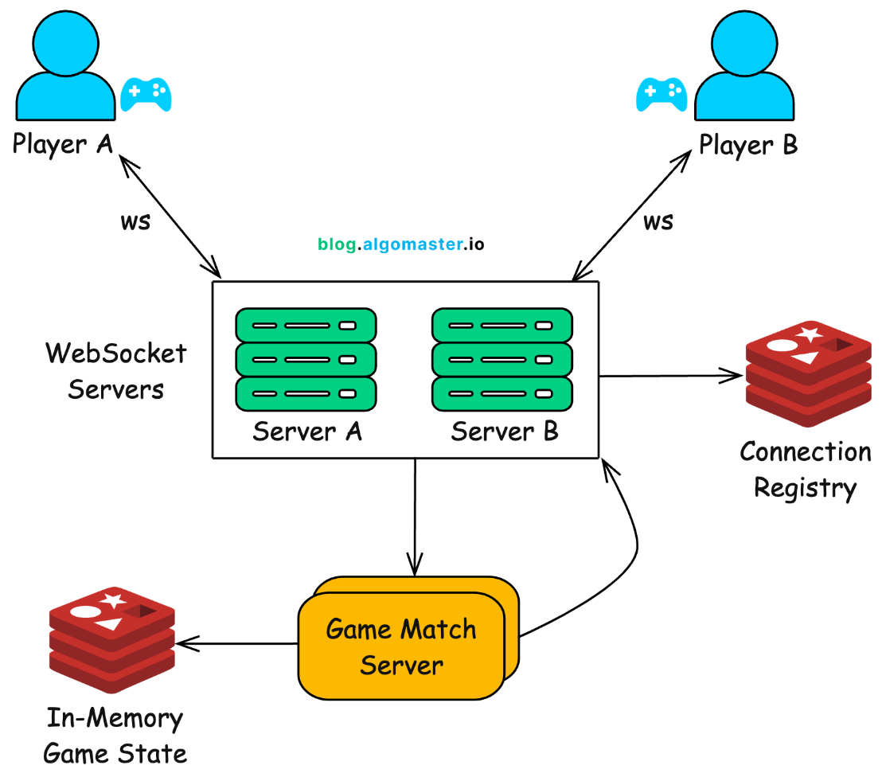
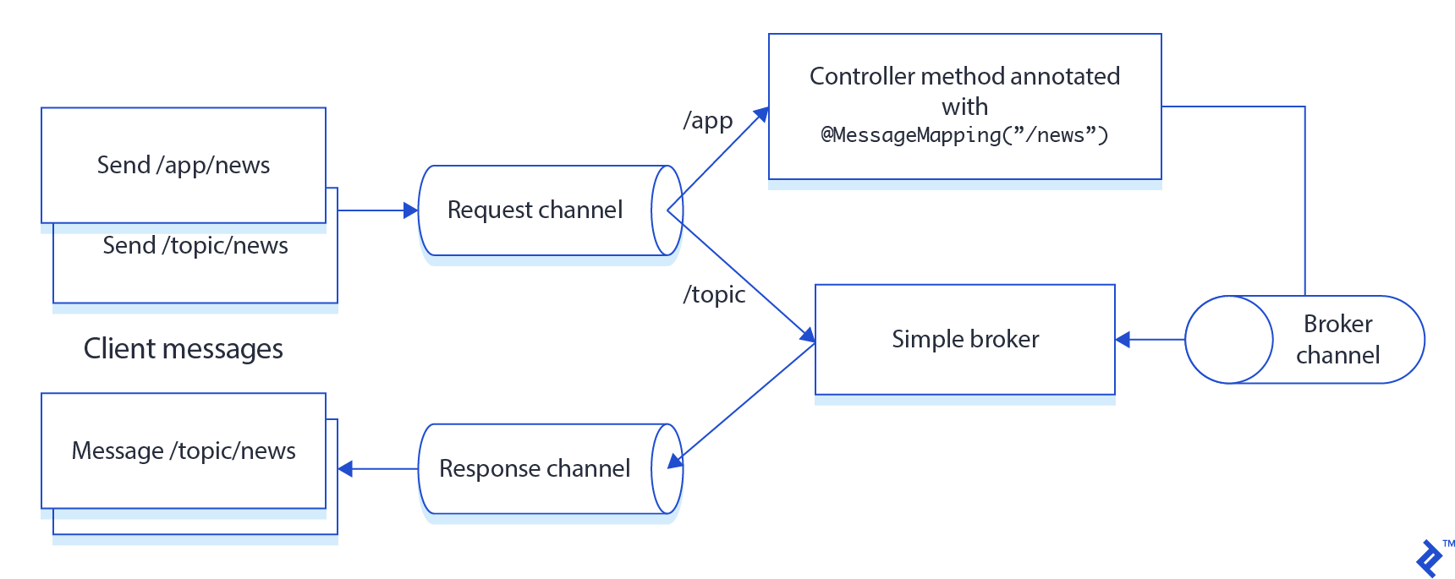
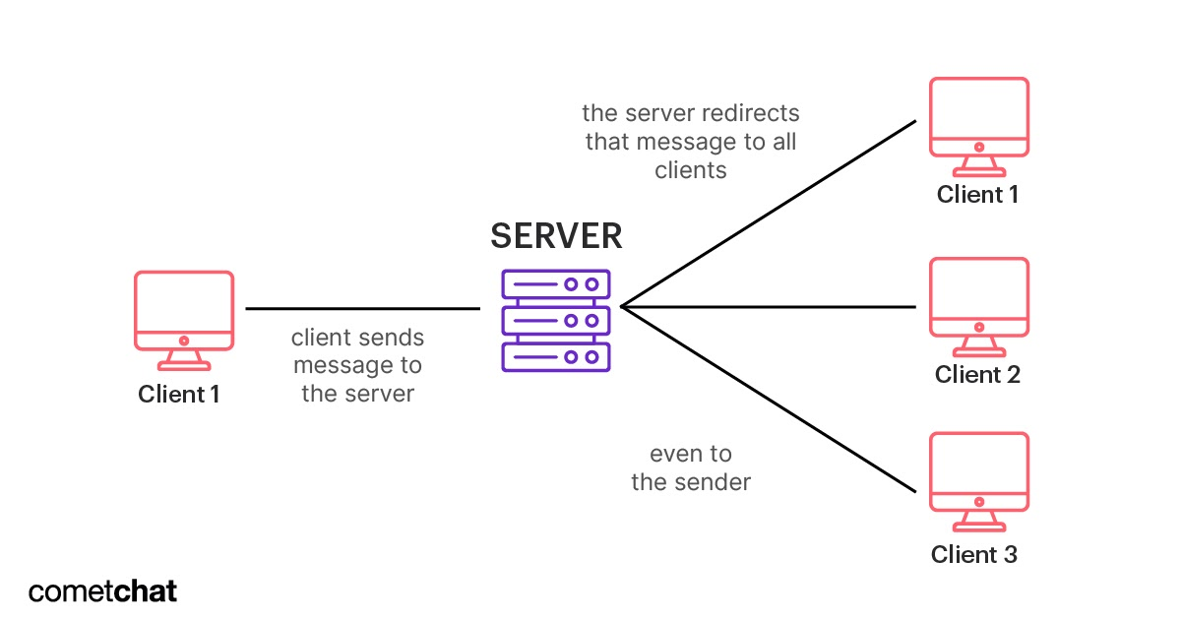
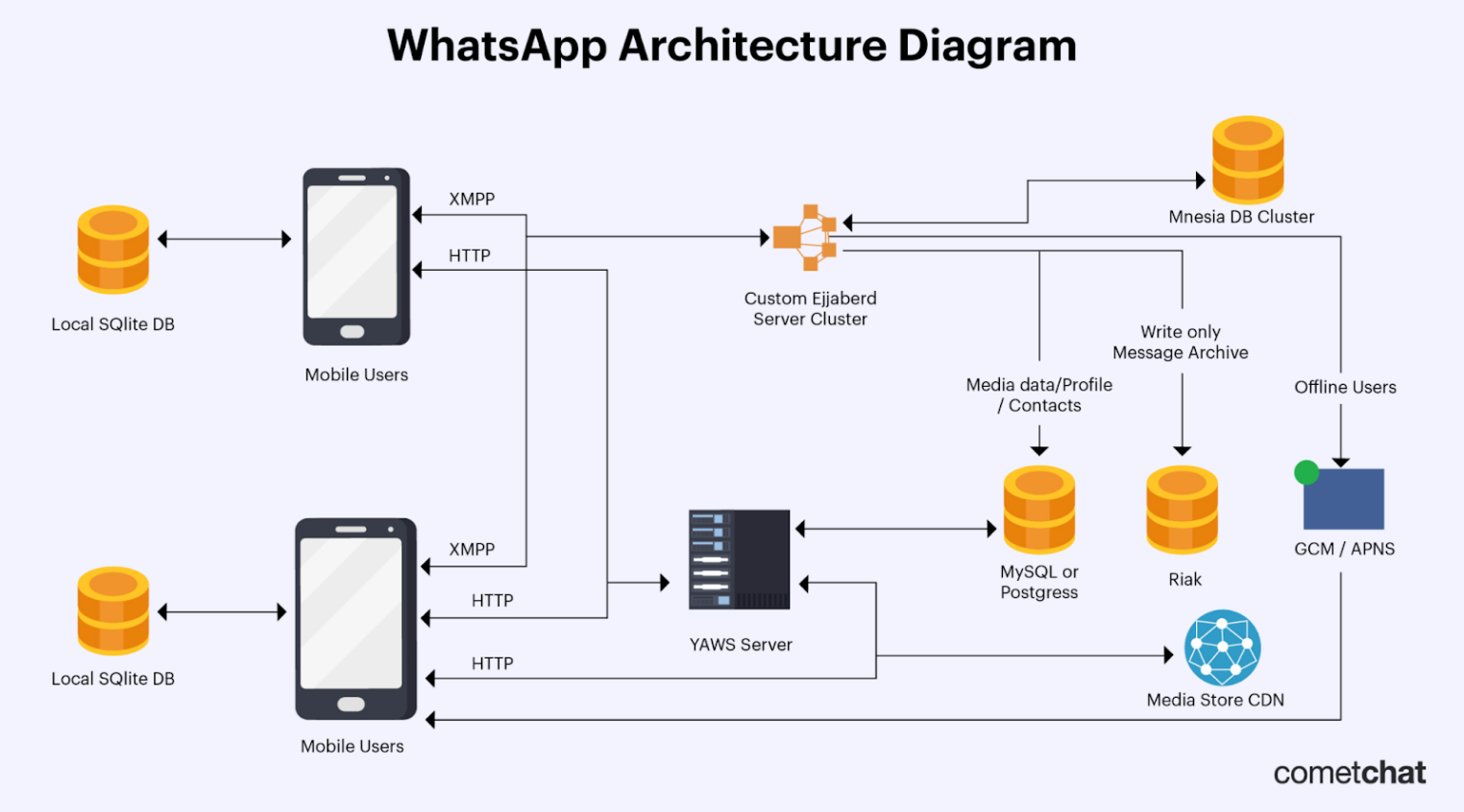
Messages are:
- Sent via STOMP protocol
- Broadcast to subscribed users
- Stored in database for history

📋 5.3 Real-Time Task Board Module
Kanban-style task board with columns:
- To Do
- In Progress
- Done
Features:
- Create Task
- Update Task Status
- Assign Tasks
- Drag & Drop Functionality
- Live Synchronization
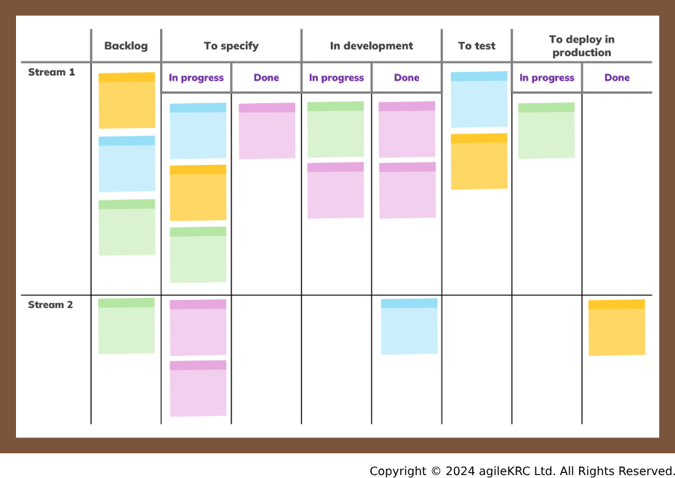
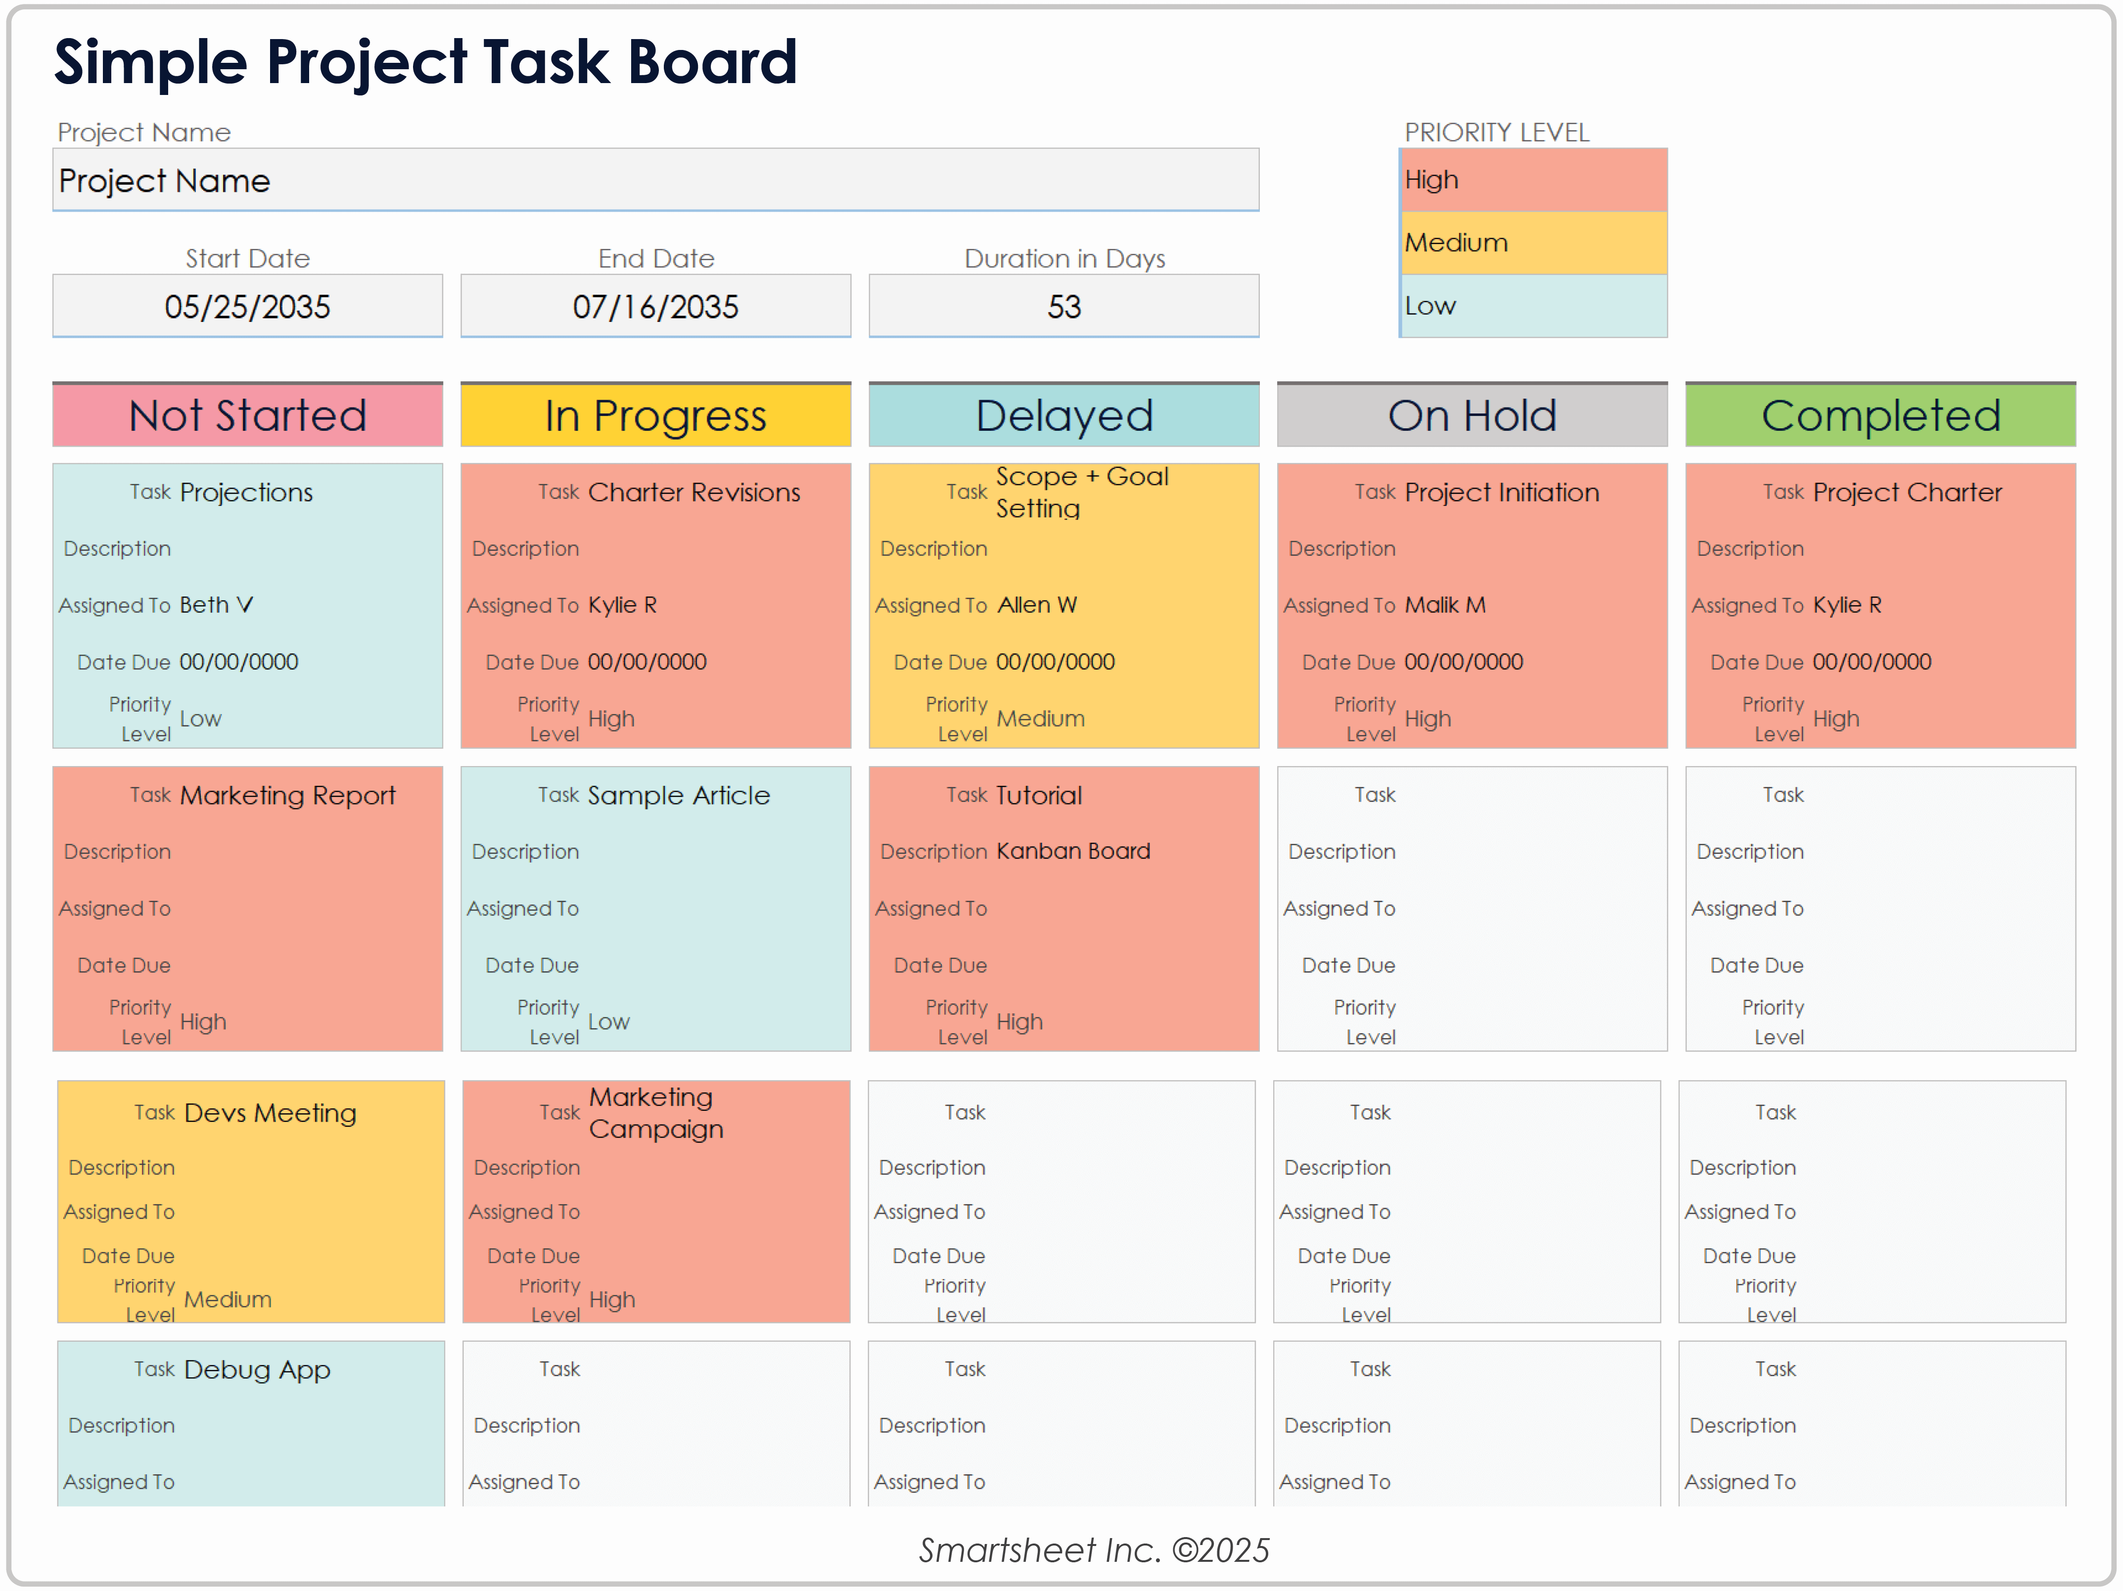
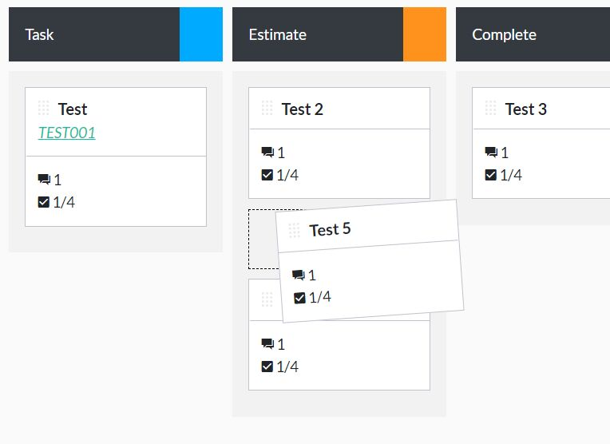
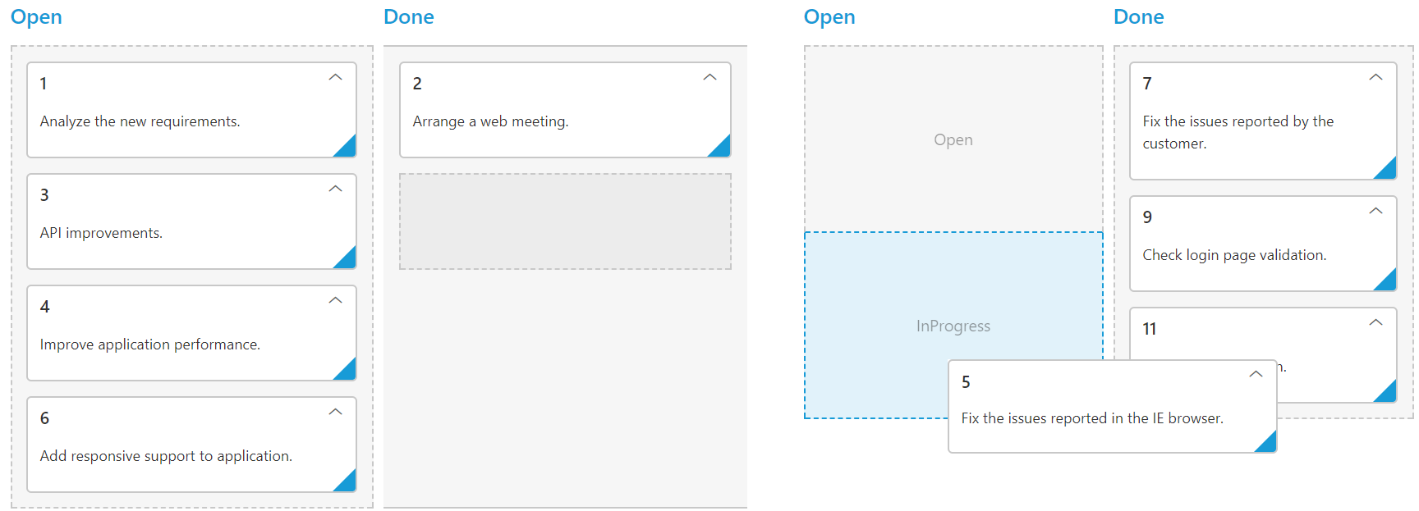
Whenever a task is updated:
- Server broadcasts update via WebSocket
- All connected users see instant changes

🔔 5.4 Notification Module
Features:
- Real-time pop-up notifications
- Task assignment alerts
- New message alerts
Notifications are pushed instantly using WebSocket.

6️⃣ Database Design
🗂 Users Table
- id (Primary Key)
- name
- email
- password (encrypted)
- role
💬 Messages Table
- id
- sender_id (Foreign Key)
- receiver_id (Foreign Key)
- content
- timestamp
📋 Tasks Table
- id
- title
- description
- status
- assigned_user
- created_date
Relationships:
- One user → many messages
- One user → many tasks

7️⃣ Advantages
- Real-time communication
- Scalable microservice-ready architecture
- Secure JWT authentication
- Suitable for enterprise-level systems
- Extensible for cloud deployment

8️⃣ Future Enhancements (Add This in Viva 👌)
- File sharing support
- Video call integration
- Email notifications
- Deployment on AWS / Azure
- Microservices conversion
- Docker containerization
This will impress your panel 🔥

9️⃣ Conclusion
CollabSpace demonstrates the implementation of:
- Real-time communication using WebSocket
- Secure backend with Spring Security + JWT
- Database integration with MySQL
- Live collaborative task management
It reflects strong knowledge of backend architecture, security implementation, and real-time systems design.

Here is the ER Diagram explanation for your project CollabSpace – Real-Time Team Collaboration System.

📌 ER Diagram – CollabSpace
🔷 Main Entities
- User
- Message
- Task
- Role (Optional but recommended for normalization)

📊 ER Diagram (Conceptual Representation)
+-----------+ +------------+ +-----------+
| Users | | Messages | | Tasks |
+-----------+ +------------+ +-----------+
| id (PK) |<------>| sender_id | | id (PK) |
| name | | receiver_id| | title |
| email | | content | | description|
| password | | timestamp | | status |
| role | +------------+ | assigned_user |
+-----------+ | created_date |
+-----------+

🖼️ ER Diagram (Visual Representation)

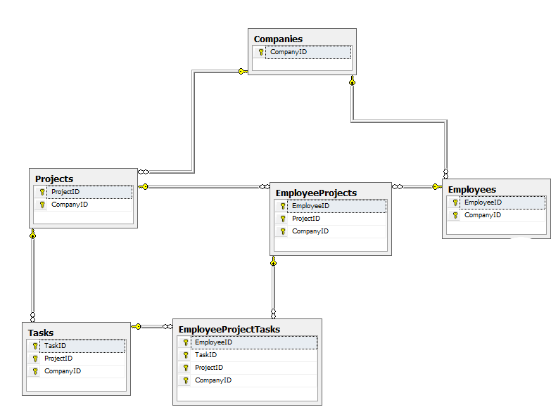
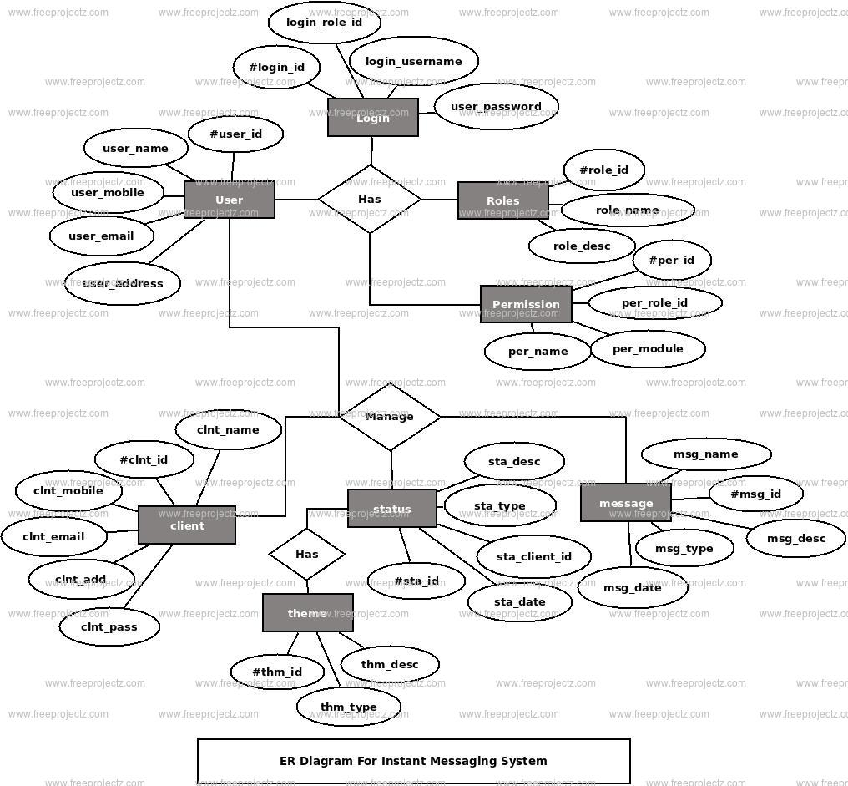

🔎 Entity Explanation

1️⃣ User Entity
Attributes:
- id (Primary Key)
- name
- email
- password
- role (Admin/User)
Relationships:
- One User → Can send many Messages
- One User → Can receive many Messages
- One User → Can be assigned many Tasks

2️⃣ Message Entity
Attributes:
- id (Primary Key)
- sender_id (Foreign Key → Users.id)
- receiver_id (Foreign Key → Users.id)
- content
- timestamp
Relationships:
- Many Messages → Belong to One Sender
- Many Messages → Belong to One Receiver
Cardinality:
- One User ↔ Many Messages

3️⃣ Task Entity
Attributes:
- id (Primary Key)
- title
- description
- status (To Do / In Progress / Done)
- assigned_user (Foreign Key → Users.id)
- created_date
Relationships:
- One User → Many Tasks
- One Task → Assigned to One User
Cardinality:
- 1 : N (User → Task)

🔗 Relationships Summary
Relationship | Type
User → Message (Sender) | 1 : N
User → Message (Receiver) | 1 : N
User → Task | 1 : N

Here is the Database Design section written in a professional format suitable for your MCA project report.

📌 Database Design
Project: CollabSpace – Real-Time Team Collaboration System

1️⃣ Overview
The database for CollabSpace is designed using a relational model to ensure data integrity, normalization, and scalability.
MySQL is used as the database management system.
The core entities of the system are:
- Users
- Roles
- Messages
- Tasks
The database follows 3rd Normal Form (3NF) to avoid redundancy and ensure consistency.

🗂 2️⃣ Tables Description

🔐 2.1 Roles Table
This table stores user roles for role-based access control.
Column Name | Data Type | Constraints
id | INT | Primary Key, Auto Increment
role_name | VARCHAR(50) | NOT NULL, UNIQUE
Purpose:
Separates role information to maintain normalization.

👤 2.2 Users Table
Stores registered user details.
Column Name | Data Type | Constraints
id | INT | Primary Key, Auto Increment
name | VARCHAR(100) | NOT NULL
email | VARCHAR(150) | NOT NULL, UNIQUE
password | VARCHAR(255) | NOT NULL (Encrypted)
role_id | INT | Foreign Key → Roles(id)
created_at | DATETIME | Default Current Timestamp
Relationships:
- One Role → Many Users
- One User → Many Messages
- One User → Many Tasks

💬 2.3 Messages Table
Stores chat messages between users.
Column Name | Data Type | Constraints
id | INT | Primary Key, Auto Increment
sender_id | INT | Foreign Key → Users(id)
receiver_id | INT | Foreign Key → Users(id)
content | TEXT | NOT NULL
timestamp | DATETIME | Default Current Timestamp
Relationship:
- One User → Many Sent Messages
- One User → Many Received Messages
Cardinality:
User (1) — (N) Messages

📋 2.4 Tasks Table
Stores task details in Kanban board format.
Column Name | Data Type | Constraints
id | INT | Primary Key, Auto Increment
title | VARCHAR(200) | NOT NULL
description | TEXT | NULL
status | ENUM('TO_DO','IN_PROGRESS','DONE') | NOT NULL
assigned_user | INT | Foreign Key → Users(id)
created_date | DATETIME | Default Current Timestamp
updated_date | DATETIME | On Update Current Timestamp
Relationship:
- One User → Many Tasks
- One Task → Assigned to One User
Cardinality:
User (1) — (N) Tasks

🔗 3️⃣ Relationships Summary
Parent Table | Child Table | Relationship Type
Roles | Users | 1 : N
Users | Messages | 1 : N
Users | Tasks | 1 : N

🧠 4️⃣ Database Normalization
The database design follows:
✅ First Normal Form (1NF)
- All fields contain atomic values.
- No repeating groups.
✅ Second Normal Form (2NF)
- No partial dependency.
- Non-key attributes fully depend on primary key.
✅ Third Normal Form (3NF)
- No transitive dependency.
- Role details separated into Roles table.

🔐 5️⃣ Security Considerations
- Passwords stored in encrypted format (BCrypt).
- Email field is unique to prevent duplication.
- Foreign key constraints maintain referential integrity.
- JWT used for authentication at application level.

📊 6️⃣ Indexing Strategy
To improve performance:
- Index on email (Users table)
- Index on sender_id and receiver_id (Messages table)
- Index on assigned_user (Tasks table)
- Composite index on (sender_id, receiver_id)

🚀 7️⃣ Scalability Considerations
- Tables designed to support large-scale chat systems.
- Can be extended for:
  - Group Chat table
  - Attachment table
  - Audit log table
- Easily migratable to cloud-based RDS services.

