Project Submitted By

Name | College name | Branch | Email | Expected degree completion year
Devadhe Gayatri Pravin | Pravara Rural Engineering College,Loni | Electronics and Computer Engineering | devadhegayatri@gmail.com | 2027

Project Code
FIP396
Project Name
63satsvulnbank

Abstract
This report presents a security assessment of the VulnBank web application conducted in a controlled laboratory environment to identify common web application vulnerabilities and understand their exploitation impact. The testing process followed standard ethical hacking methodology including reconnaissance, vulnerability identification, exploitation, and risk evaluation.The assessment identified multiple vulnerabilities including SQL Injection, Cross-Site Scripting (XSS), insecure authentication mechanisms, and improper input validation. These weaknesses allow unauthorized data access, session manipulation, and potential compromise of user information. Each vulnerability was analyzed based on severity, exploitation method, and possible impact on confidentiality, integrity, and availability.

Domain
Cybersecurity

Technologies used
PHP based web applications using Apache server sending and accepting res

Tools Used
Kali linux , Burpsuite

Scope of Assessment

The scope of the assessment is to conduct grey box VAPT testing of the application(s) / Network infrastructure for the following:
The assessment was conducted in a staging environment, which is assumed to be a replica of the production environment.
Web Applications – 1
S. No. | Application | Status
1 | http://10.0.2.15/ | Completed

Vulnerability Severity Matrix

Once, the tester has determined the likelihood and impact estimates, they can now combine them to get a final severity rating for this risk. We important to prioritize business impact data over technical impact details if available. However, in the absence of business-specific information, relying on technical impact remains a viable alternative.

Overall Risk Severity
Impact | HIGH | Medium | High | Critical
Impact | MEDIUM | Low | Medium | High
Impact | LOW | Info | Low | Medium
Impact |  | LOW | MEDIUM | HIGH
 | Likelihood

In the example above, if the likelihood is medium, and the technical / business impact is medium, from a purely technical perspective the overall severity is medium.

Executive Summary

Vulnerability scans were conducted on selected servers, networks, websites, and applications in scope. This report contains the discovered potential risks from these scans. Risks have been classified into categories according to the level of threat and degree of potential harm they may pose.
HIGH
7
MEDIUM
1
LOW
3

INFO
0
CRITICAL
3

The following table presents the identified vulnerabilities, along with their corresponding severity levels and current remediation status.
S. No. | Vulnerability Name | Severity | Status
1 | Authentication Bypass via SQL Injection | CRITICAL | OPEN
2 | Transaction Execution without Authentication | CRITICAL | OPEN
3 | Stored Cross-Site Scripting (Persistent XSS) | CRITICAL | OPEN
4 | SSL Not Secure | HIGH | OPEN
5 | CSRF Vulnerability (Username change & Password change) | HIGH | OPEN
6 | Parameter Tampering-Unauthorized Credential Modification | HIGH | OPEN
7 | Lack of Rate Limiting on Authentication/Transaction Endpoints | HIGH | OPEN
8 | Insecure Session Management (Weak/Improper Session Handling) | HIGH | OPEN
9 | Credential Passed in Clear text | HIGH | OPEN
10 | Unrestricted File Upload / Insufficient File Validation | HIGH | OPEN
11 | Unauthorized Amount Manipulation | MEDIUM | OPEN
12 | Information Disclosure | LOW | OPEN
13 | Session Cookie Missing Security Attributes | LOW | OPEN
14 | Clickjacking | LOW | OPEN

Vulnerability Description

8.1. Authentication Bypass via SQL Injection in Login Functionality
Severity / CVSS Score | CRITICAL
Status | OPEN
Vulnerable Location / Path | http://10.0.2.15 /login.php
Description | The login page was found to be vulnerable to SQL Injection, allowing an attacker to bypass authentication by injecting malicious SQL payloads into the username and password fields. During testing, commonly used payloads such as ' OR '1'='1 successfully manipulated the backend SQL query, resulting in unauthorized access without valid credentials. This issue occurs because the application directly concatenates user-supplied input into SQL statements without proper validation or parameterization.
Reference | https://cwe.mitre.org/data/definitions/639.html
Recommendation | It is recommended that the application can implement parameterized queries or prepared statements to ensure user input is never executed as part of an SQL command. Additionally, server-side input validation applied to block SQL meta-characters and enforce safe data formats. The database user associated with the application operate with the least privileges required, minimizing the potential impact of SQL injection attempts. It is also recommended to disable verbose SQL error messages, conduct regular code reviews, and incorporate automated security scanning tools to detect and prevent similar vulnerabilities in the future..

Proof of Concept and Steps to Reproduce:
Step 1: using gobuster finding hidden files

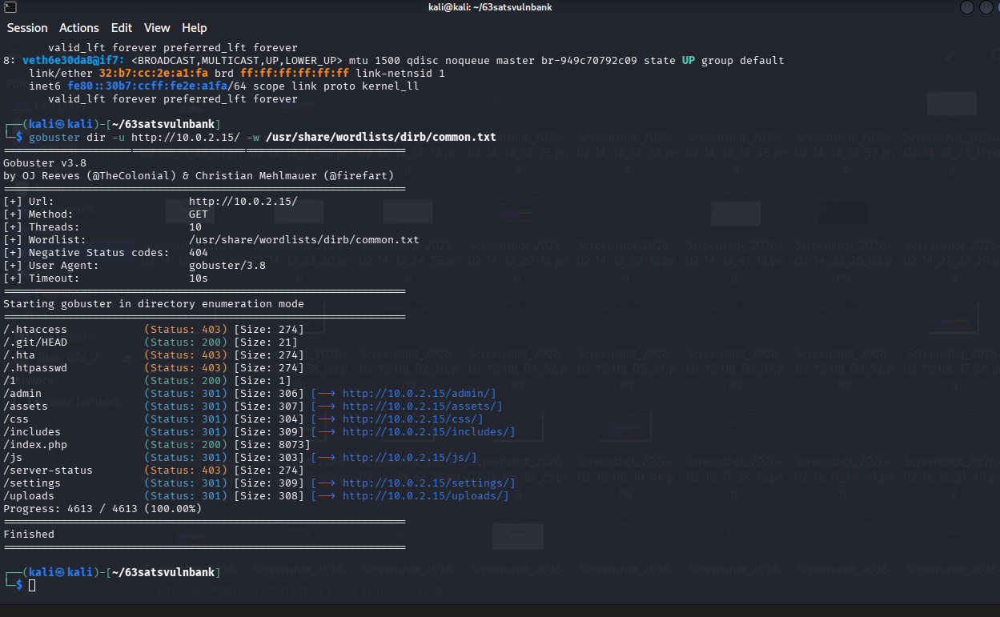
Step 2: Login using the SQL payload:

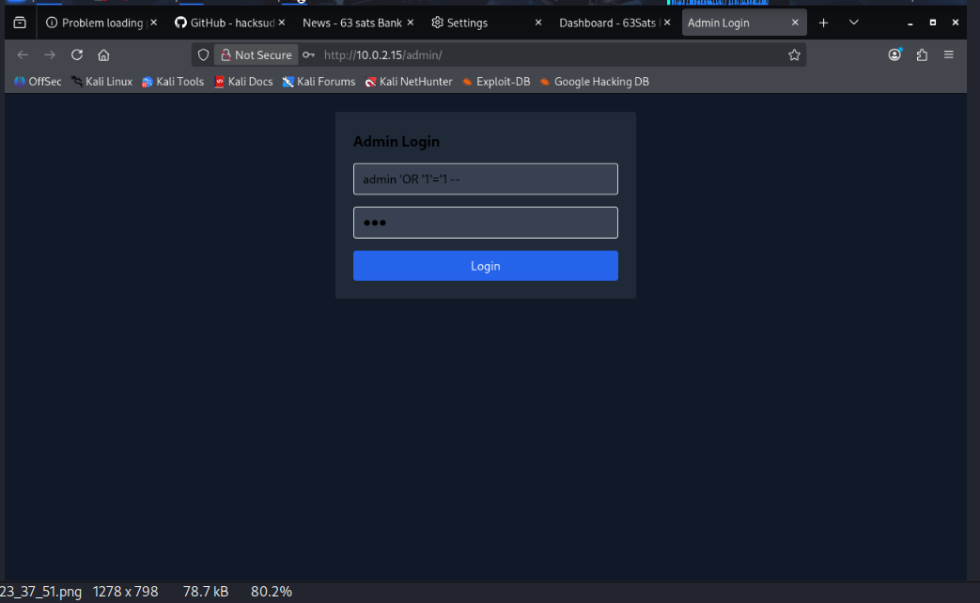

step3: logged in successfully
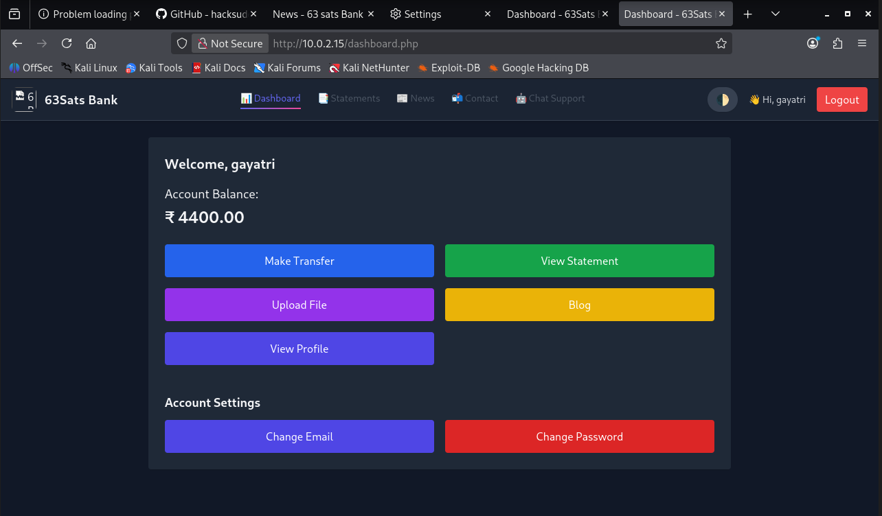

8.2. Transaction Execution without authentication
Severity / CVSS Score | CRITICAL
Status | OPEN
Vulnerable Location / Path | http://10.0.2.15/transfer.php
Description | The application allows critical financial transactions to be executed without requiring the user to be authenticated, resulting in a severe authorization flaw. During testing, it was observed that transaction endpoints could be accessed directly, even when no valid session or login credentials were present. This indicates that the server does not properly verify user authentication before processing sensitive actions. As a result, an attacker can perform transactions without logging in. This vulnerability exposes the application to major risks involving unauthorized actions, fraud, and compromise of integrity.
Reference | https://cwe.mitre.org/data/definitions/284.html
Recommendation | To resolve this issue, the application can enforce mandatory authentication checks for all sensitive transaction-related endpoints. Every request that performs financial or critical actions should validate an active user session or a valid authorization token before processing. Additionally, implement proper access control mechanisms such as server-side role validation, session management, and token expiration handling. It is recommended to block direct access to transaction APIs without authentication, enforce strict session validation on the backend.
Proof of Concept and Steps to Reproduce:

Step 1: Try accessing the transfer page without logging in.

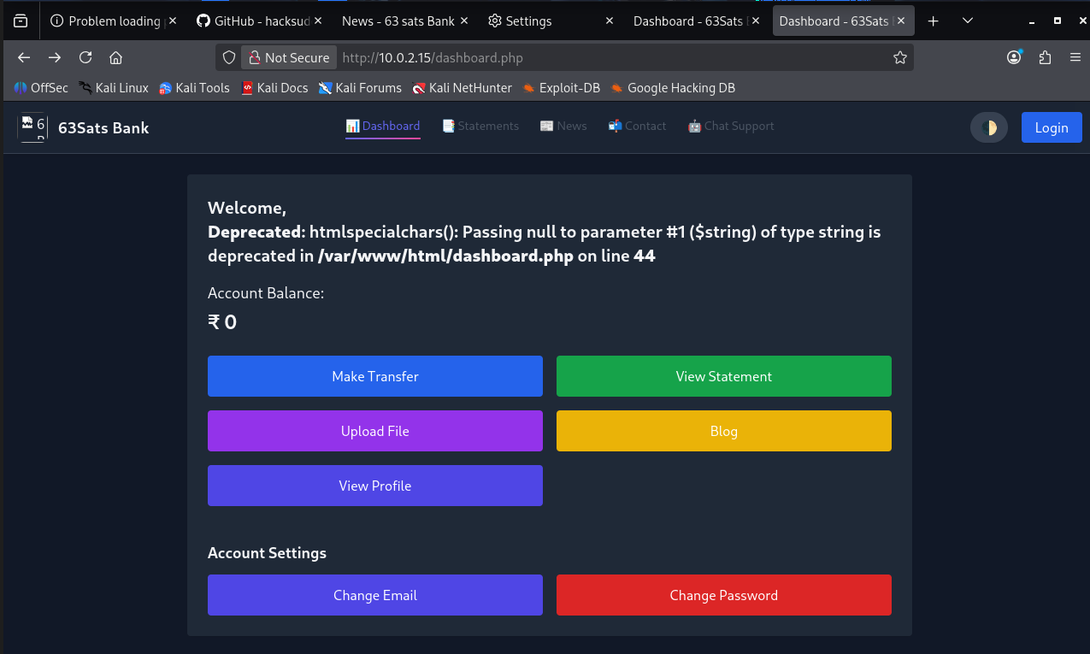
Step 2: Enter the transfer details of the users and send the request

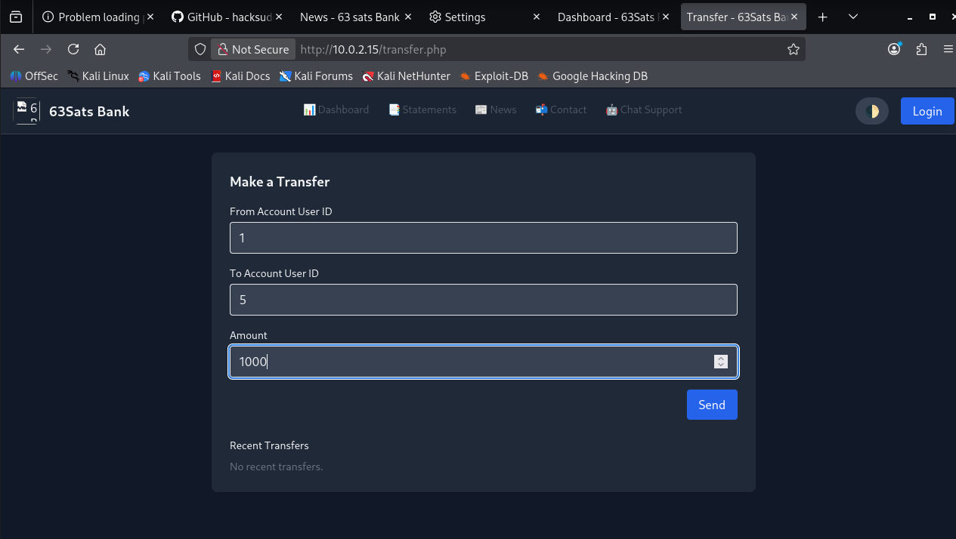
Step 3: You find the transaction was successful

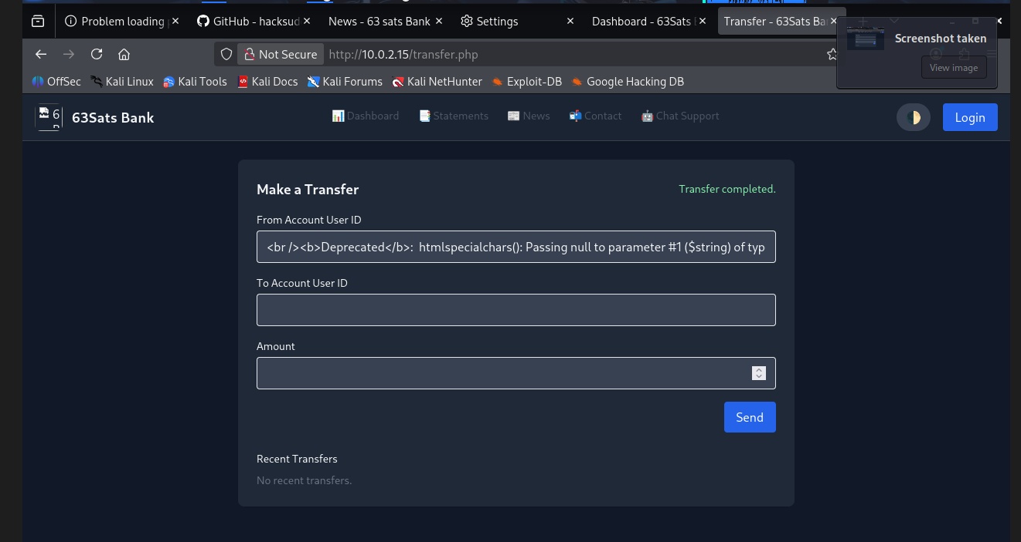
8.3. Stored Cross-Site Scripting (Persistent XSS)
Severity / CVSS Score | CRITICAL
Status | OPEN
Vulnerable Location / Path | http://10.0.2.15/blog.php
Description | It was observed that the application’s blog management functionality exhibited a critical Stored Cross-Site Scripting (XSS) vulnerability within the title and content input fields. During testing, it was identified that the application failed to properly sanitize or encode user-supplied data before storing it in the backend database.  By injecting a malicious Script into the blog post creation form, the payload was permanently saved. Subsequently, whenever a victim reads the malicious blog, the malicious script was retrieved from the database and executed automatically within their browser session.
Reference | https://cwe.mitre.org/data/definitions/79.html
Recommendation | It is recommended to implement strict Context-Sensitive Output Encoding for all user-supplied data before rendering it in the browser. This ensures that browsers interpret characters as text rather than executable code.  Since this is a blog feature that may require some HTML formatting, simple encoding might break functionality. Therefore, it is strongly advised to utilize a secure HTML Sanitization Library to strip out dangerous tags while permitting safe HTML tags. Additionally, implementing a robust Content Security Policy (CSP) can serve as a defence-in-depth layer by restricting the sources from which scripts are allowed to execute.

Proof of Concept and Steps to Reproduce :
Step 1: Access the Blog page from the dashboard

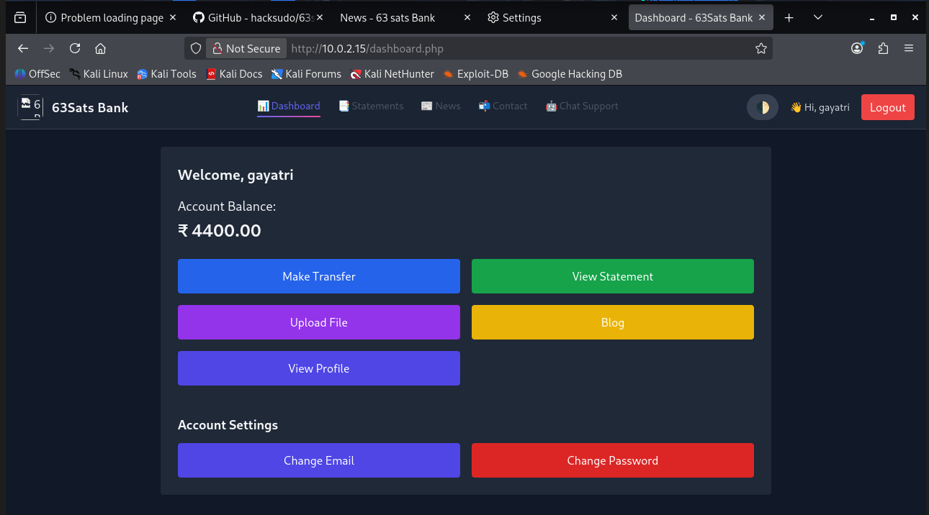
Step 2: Publish the blog with malicious stored XSS payload

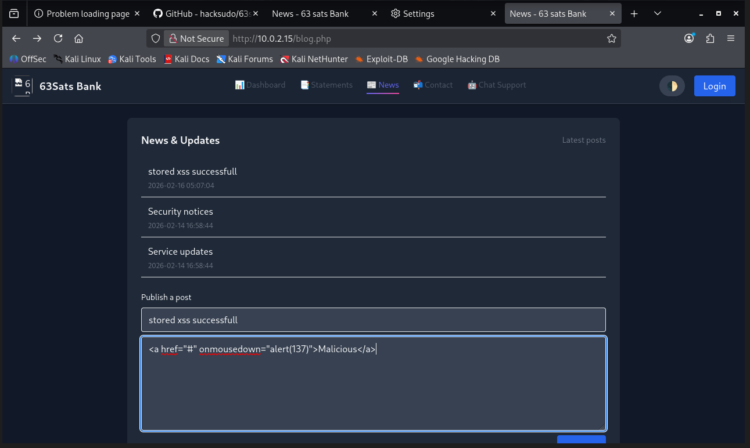
Step 3: Blog with malicious xss payload successfully published and stored

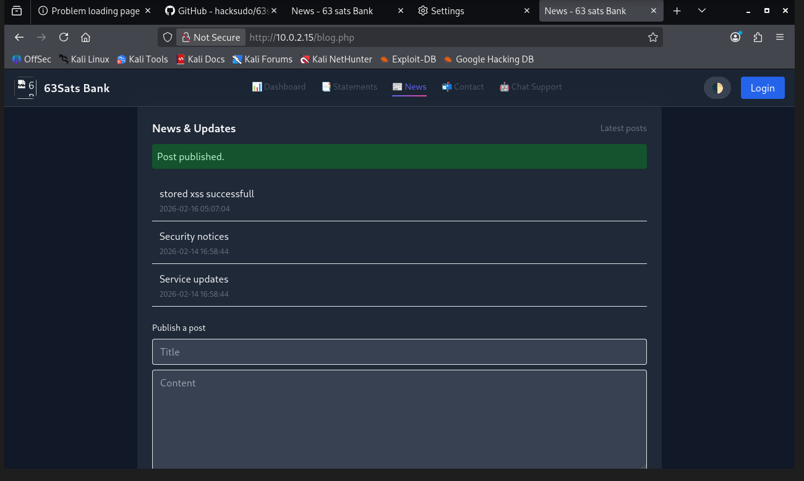
Step 4: Click the blog to read

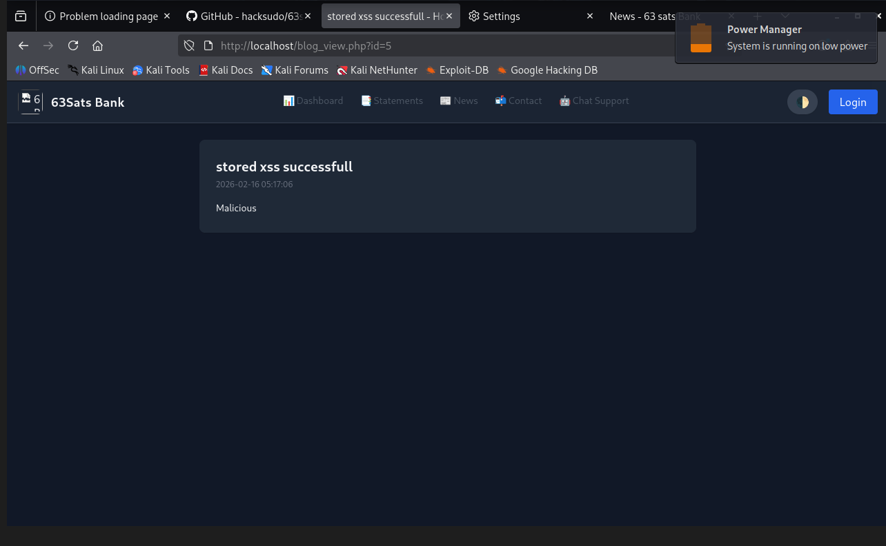
Step 5: After the click you get the alert as successful XSS payload performance.

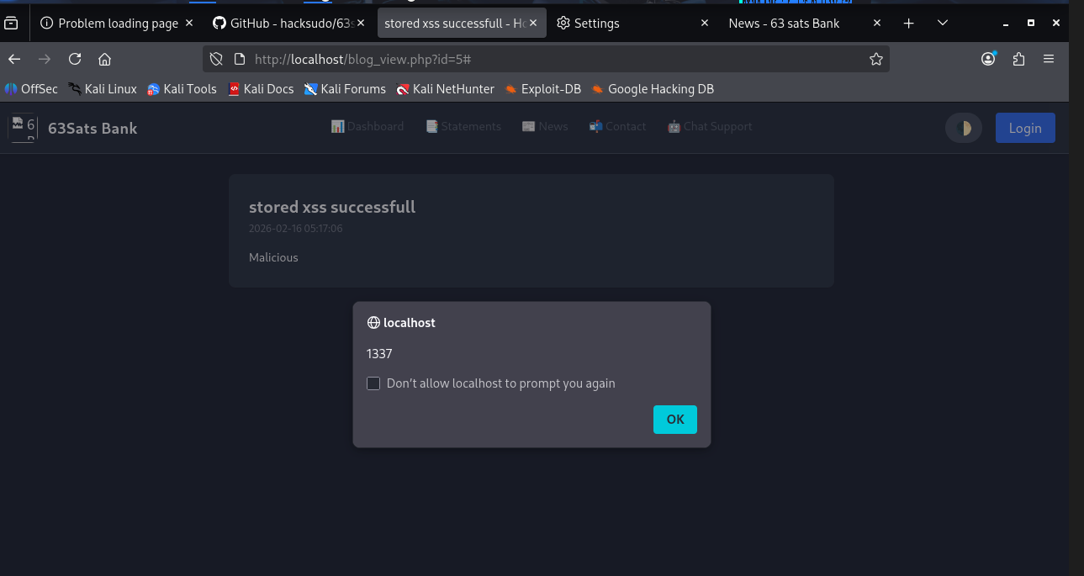

8.4. SSL Not Secure
Severity / CVSS Score | HIGH
Status | OPEN
Vulnerable Location / Path | http://10.0.2.15/
Description | It was observed that the application relies on the unencrypted HTTP protocol for data transmission and fails to enforce a secure HTTPS connection. During testing, the application accepted connections without redirecting to a secure channel, causing all data exchanged between the user and the server—including credentials, session identifiers, and personal information—to be transmitted in clear text. This lack of encryption exposes the application to attacks, where a malicious actor on the network can intercept, read, or modify the traffic, compromising both the confidentiality and integrity of the user's session.
Reference | https://cwe.mitre.org/data/definitions/295.html
Recommendation | It is recommended to obtain and install a valid SSL/TLS certificate from a trusted Certificate Authority and configure the web server to strictly enforce HTTPS for all connections. All incoming HTTP traffic should be automatically redirected to the HTTPS counterpart using a 301 Moved Permanently response.

Proof of Concept and Steps to Reproduce:
Step1: The page is not secure as it is not secure.
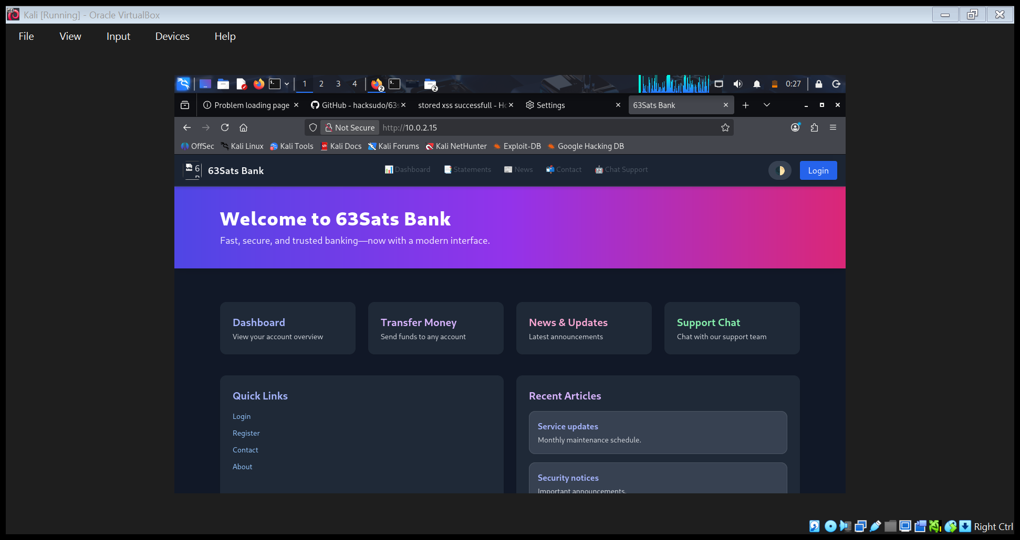

8.5. Credential Passed in Clear Text
Severity / CVSS Score | HIGH
Status | OPEN
Vulnerable Location / Path | http://10.0.2.15/register.php
Description | It was observed that the application fails to enforce encryption during critical user interactions, specifically the user registration process. During testing, it was identified that sensitive personally identifiable information and security credentials—including the username, email, and password—were transmitted in clear text (via HTTP) rather than through an encrypted channel (HTTPS/TLS).  By analysing the network traffic, the registration request body was intercepted in a readable format without any decryption required.
Reference | https://cwe.mitre.org/data/definitions/310.html
Recommendation | It is recommended to enforce the use of Transport Layer Security (TLS) encryption, specifically version 1.2 or higher, for all application communications to ensure that sensitive data such as credentials and personal information are never transmitted in clear text. The web server must be configured to automatically redirect all unencrypted HTTP traffic to HTTPS

Proof of Concept and Steps to Reproduce:
Step 1: enter username and password for login

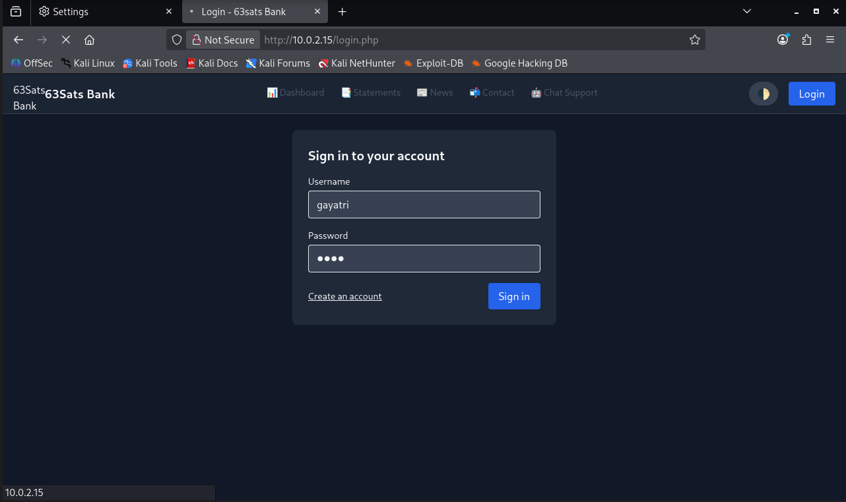
Step 2: Data transmitted is not been encrypted during the user login, which is vulnerable. 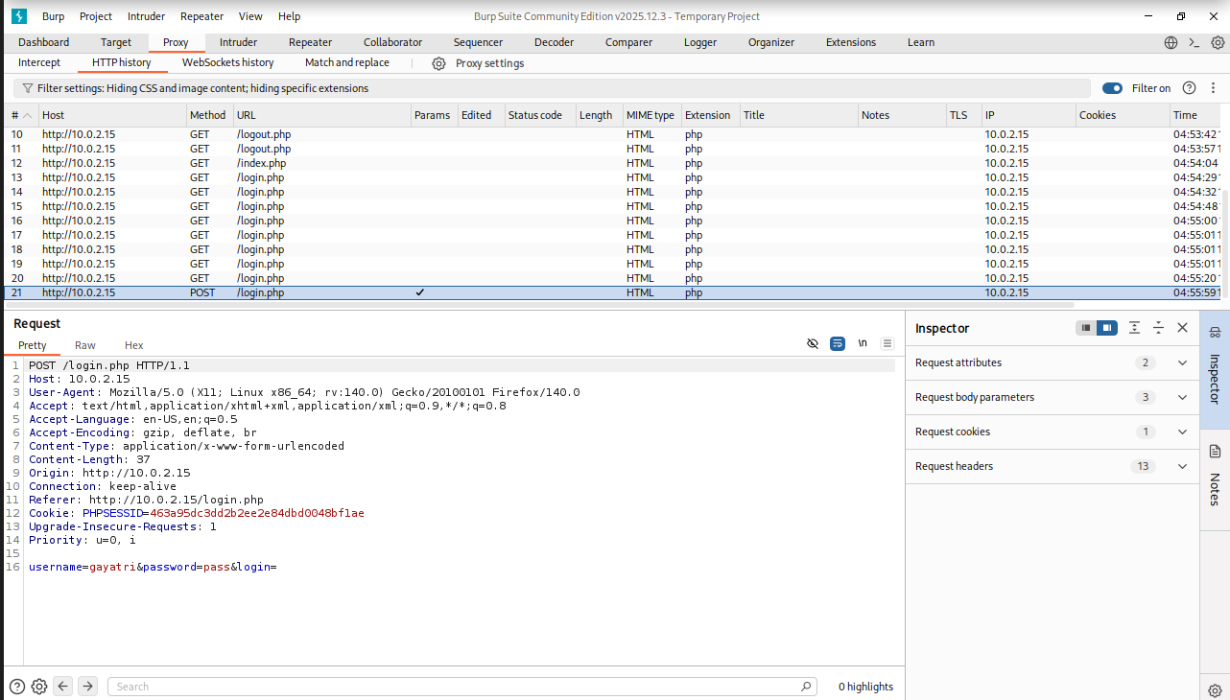

Step 3: Registration Successful

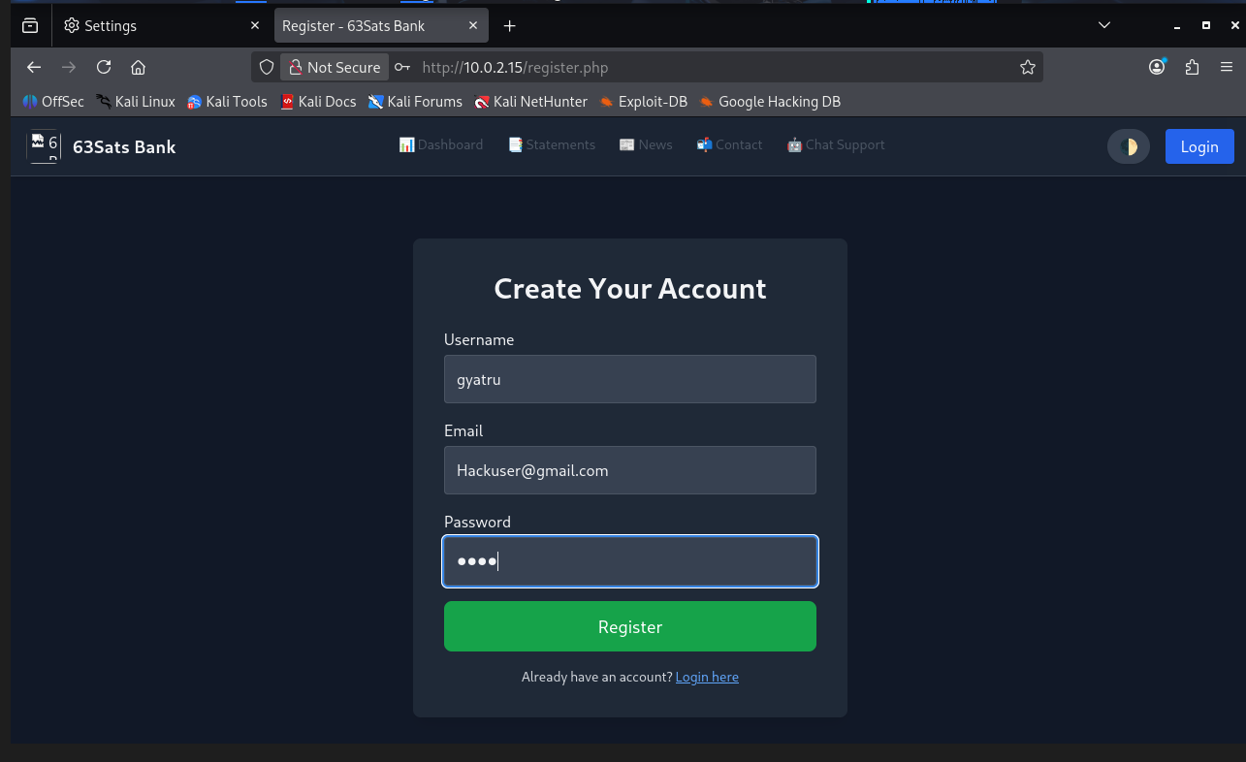
Step 4: Data transmitted is not been encrypted during the user creation, which is vulnerable.
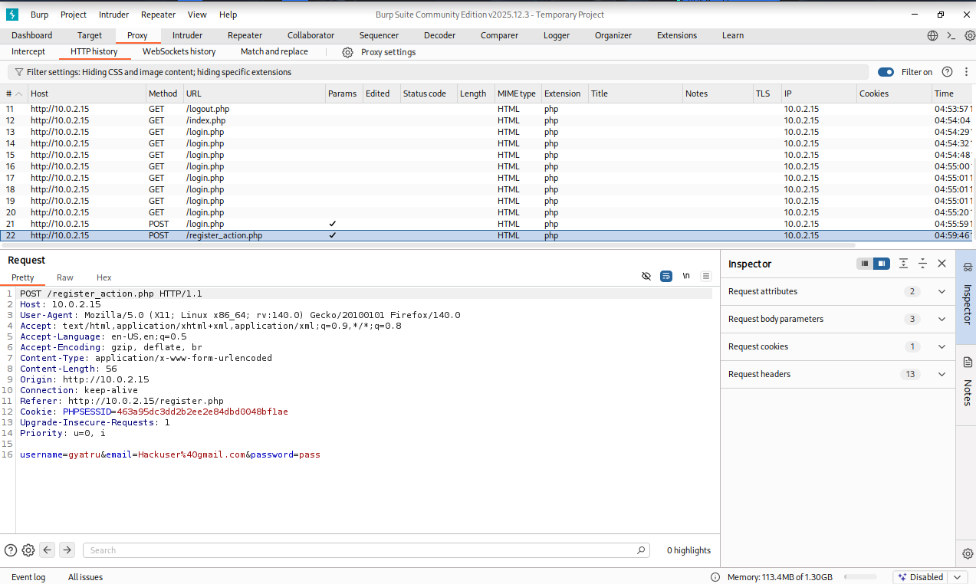

8.6. Unrestricted File Upload / Insufficient File Validation
Severity / CVSS Score | HIGH
Status | OPEN
Vulnerable Location / Path | http://10.0.2.15/upload.php
Description | It was observed that the application’s file upload mechanism exhibited a critical vulnerability regarding insufficient file extension validation. During testing, it was identified that the server relies on weak validation logic that checks only the final extension of a filename or relies solely on client-side restrictions.  By renaming a malicious PHP script with a double extension the application accepted the file as a valid image. This allows an attacker to upload a Web Shell or malicious script to the server. Once accessed via the browser, the server executes the PHP code contained within the file, leading to Remote Code Execution (RCE). This grants the attacker full control over the web server, including the ability to read sensitive files, modify data, and pivot to internal network systems.
Reference | https://cwe.mitre.org/data/definitions/434.html
Recommendation | It is recommended to enforce a strict allow-list validation mechanism that accepts only specific, necessary file extensions while rejecting all others. Crucially, validation should not rely solely on the filename or extension; instead, the application must verify the file's content by checking the Magic Bytes (file signature) to ensure the actual data matches the declared type. To further mitigate risk, the application can rename all uploaded files to a random, system-generated identifier (e.g., UUID) to neutralize double-extension attacks (like file.php.png) and configure the web server to explicitly disable script execution permissions within the designated upload directory.

Proof of Concept and Steps to Reproduce:
Step 1: Access the file upload page

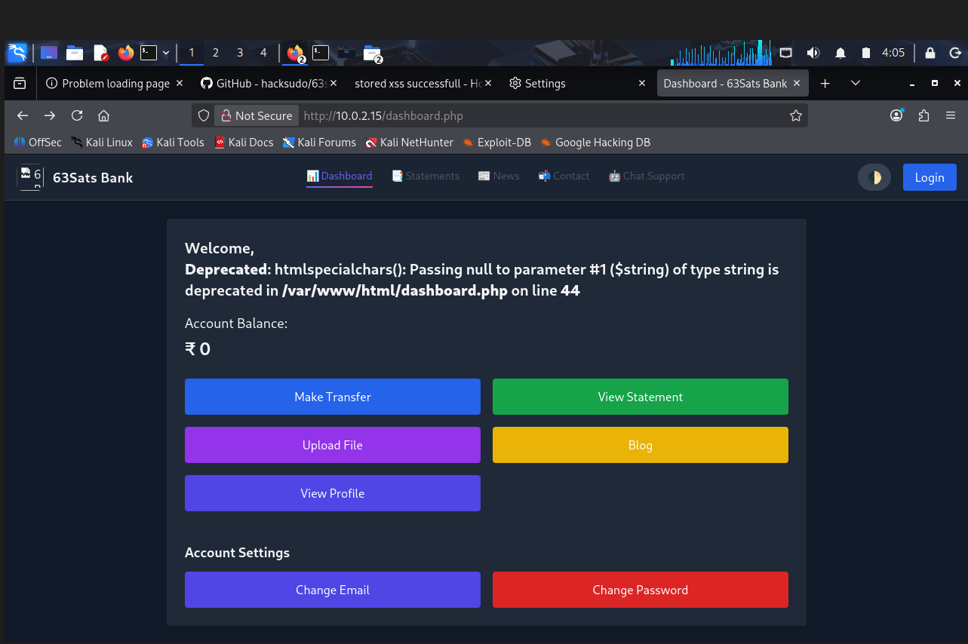

Step 2: ability to upload files with double extensions (newshell.jpg) and already uploaded malicious files

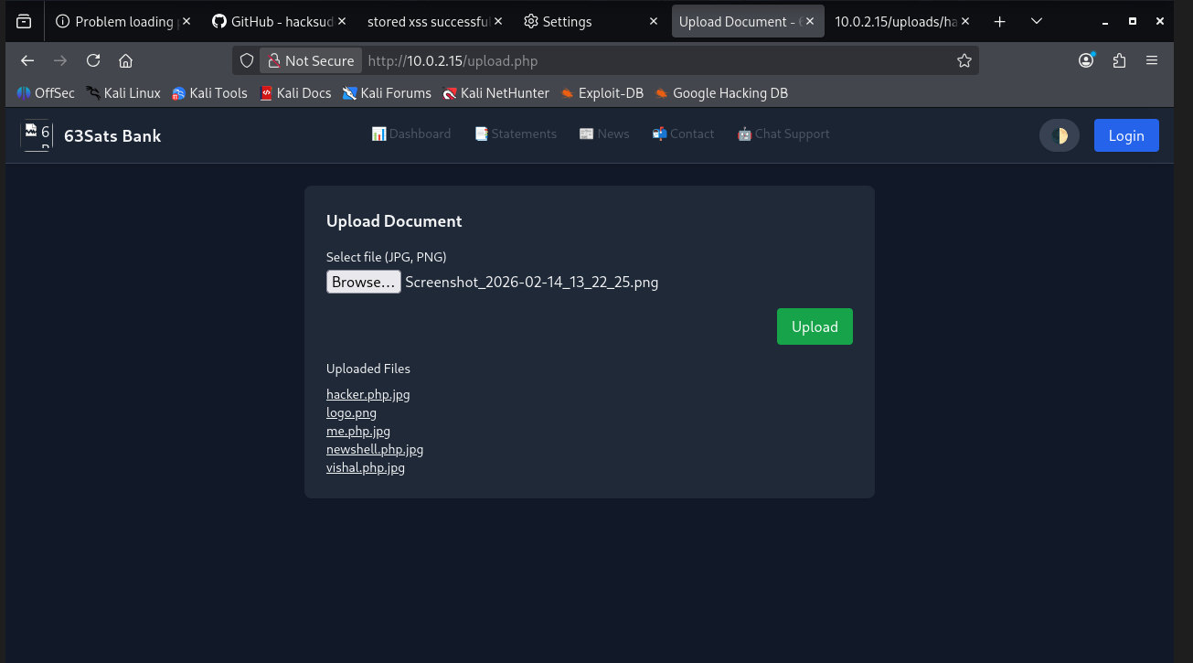

8.11. Unauthorized Amount Manipulation
Severity / CVSS Score | MEDIUM
Status | OPEN
Vulnerable Location / Path | http://10.0.2.15/transfer.php
Description | It was discovered that the application’s transaction processing functionality is vulnerable to an Insecure Direct Object Reference (IDOR) flaw, allowing manipulation of user IDs to perform unauthorized fund transfers. Although User 1 had a balance of 0 and should not have been able to initiate a transfer, intercepting the request and modifying the user ID parameter from another user to User 1 enabled the transaction to complete successfully. This demonstrates that the backend is not validating the legitimacy of the user initiating the transaction or verifying whether the balance and account details correspond to the authenticated user. As a result, an attacker can manipulate request parameters to perform unauthorized transfers, alter account balances, or abuse financial operations, leading to serious integrity and financial risks.
Reference | https://cwe.mitre.org/data/definitions/840.html
Recommendation | To mitigate this vulnerability, the application can enforce strict server-side validation of user identity, account ownership, and transaction eligibility before processing any financial request. All sensitive parameters—such as user ID, sender account, and balance—should be derived from the authenticated session rather than from client-supplied input. Implement authorization checks ensuring that the logged-in user is the actual owner of the account involved in the transaction. Additionally, enforce robust balance validation and block transactions if the user lacks sufficient funds.

Proof of Concept and Steps to Reproduce:
Step 1: Initial account statement of user John.
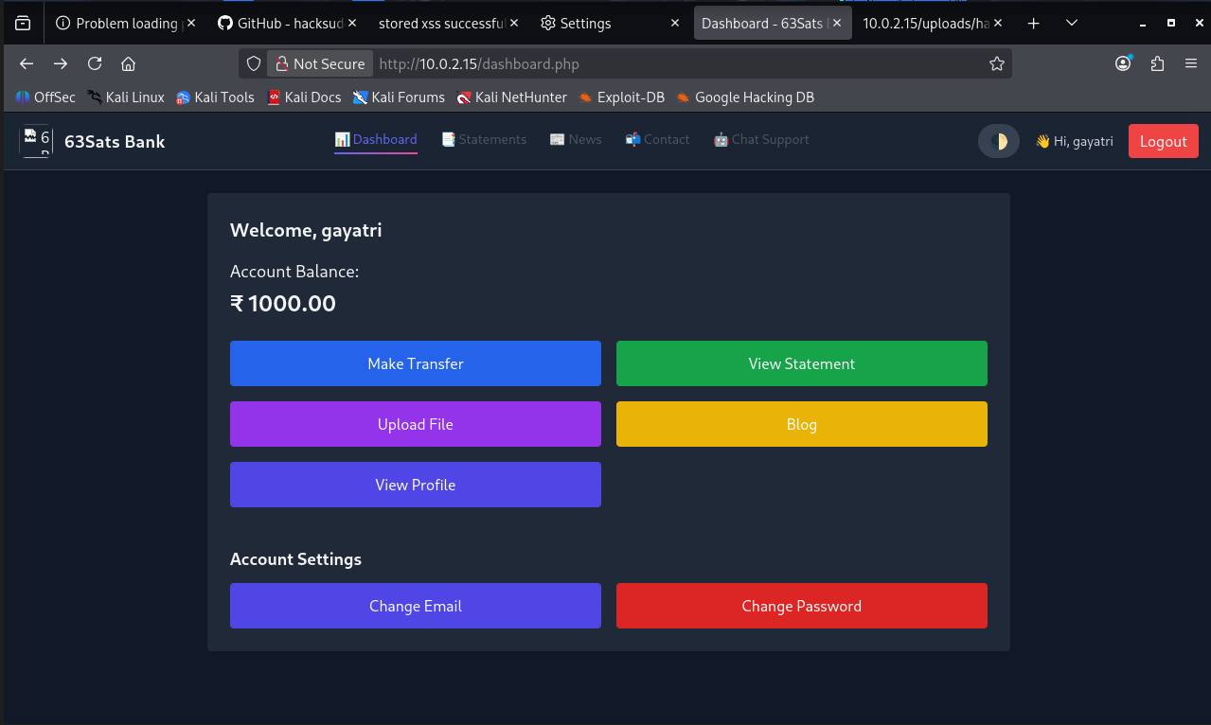

Step 2: user_id = 5

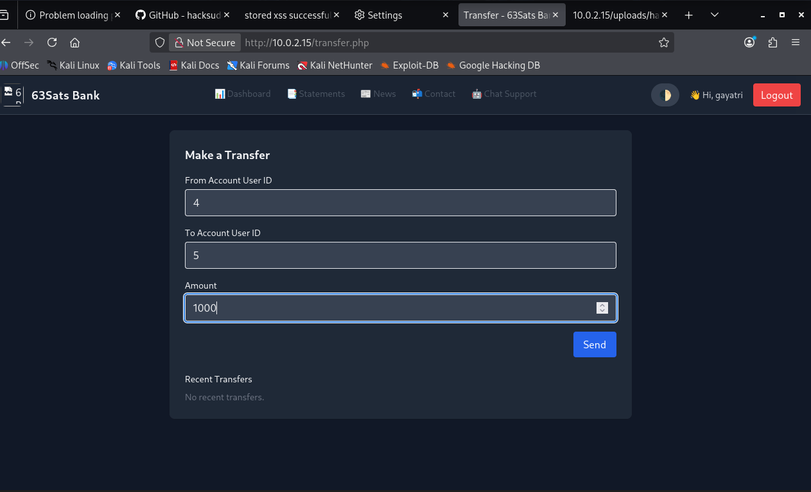
Step 3: transfer completed
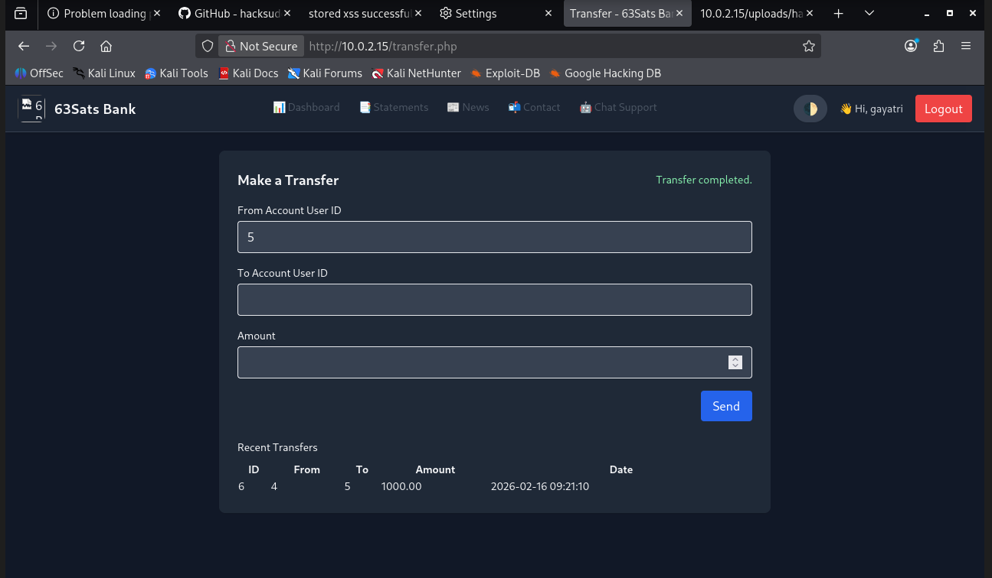
Step 7: Successful parameters change and successful account balance modification
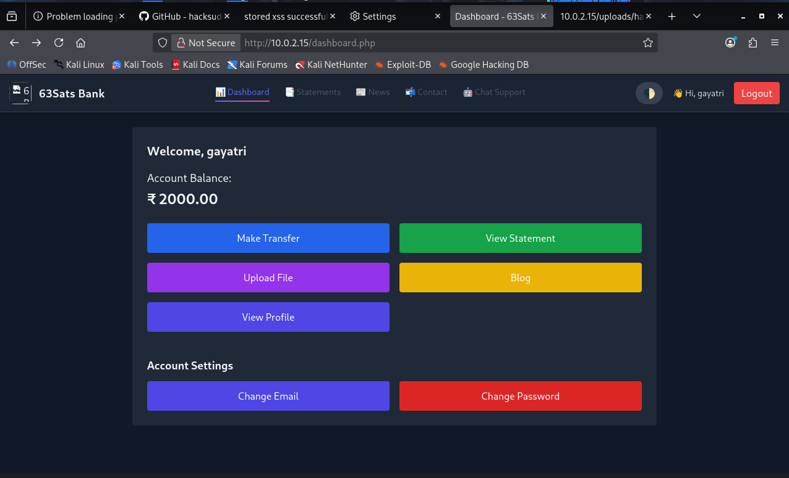

8.12. Information Disclosure
Severity / CVSS Score | LOW
Status | OPEN
Vulnerable Location / Path | http://10.0.2.15/index.php
Description | It was observed that the application’s HTTP response headers disclosed sensitive information regarding the underlying server infrastructure and software versions. During testing (via Burp Suite), it was noted that headers such as Server, X-Powered-By, or X-AspNet-Version were present in the server responses, revealing specific version numbers of the web server (e.g., Apache 2.4, Nginx 1.18) and the scripting language (e.g., PHP 7.4, ASP.NET).
Reference | https://cwe.mitre.org/data/definitions/200.html
Recommendation | It is recommended to harden the web server configuration to suppress all system-identification headers. Specifically, the Server header should be configured to display minimal information (e.g., just "Apache" without version numbers) or be removed entirely, and technology-specific headers like X-Powered-By and X-AspNet-Version should be disabled in the application framework.

Proof of Concept and Steps to Reproduce:
Step1: The HTTP response headers disclosed sensitive information regarding the underlying server infrastructure and software versions.
