**Program 7 : Find The Entered Number Is Prime.**

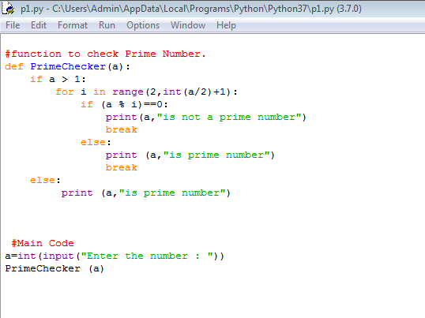

**Output:**

