Login and Logout:

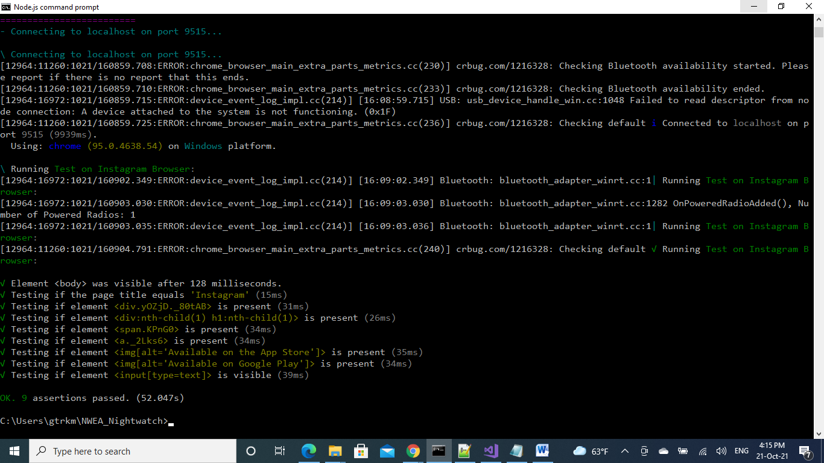

User is logged in, then close the window

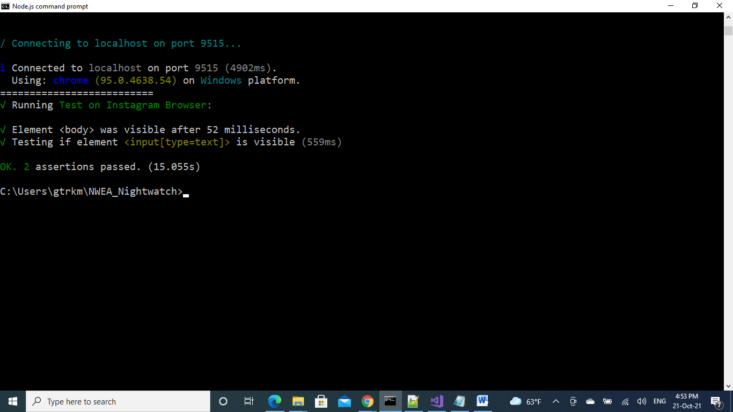

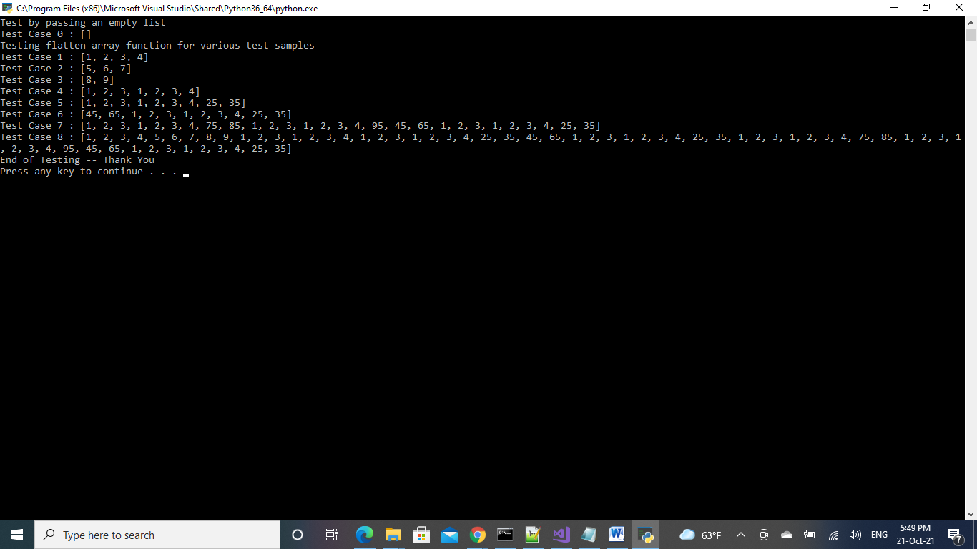

**QA Automation Coding Test**

1. Use Nightwatch/Cypress to automate the verification of all visible elements on the Instagram Login page.
   * NOTE: If a test fails, it should NOT stop the test run. Testing should complete and should report number of tests that passed/failed.
2. Open Chrome
3. Open the Instagram Home page
4. Check whether a user is logged in
   1. If user is logged in, log them out
   2. Verify user is logged out and home page is in the expected initial state.
5. Verify expected graphics are in place
6. Verify expected text is in place and that it is correct
7. Verify all expected data entry fields are in place
8. Verify expected buttons are in place
9. Verify all expected links are in place and that they are correct.
10. Once you are satisfied, zip your entire code directory up so that we can run it here and examine your results.

2) Given a nested list of integers, implement a function to flatten it. Each element is either an integer, or a list -- whose elements may also be integers or other lists. Provide a github gist link to your code and tests, You may use whatever language you are comfortable with but do not use any built-in flattening functions that provide this functionality like Ruby’s Array.flatten.