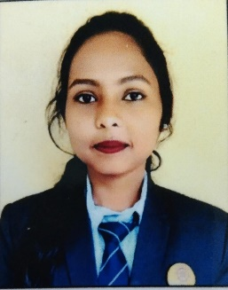
SHRUSHTI ARUN BORKAR
Pursuing 2nd Year in Electronic & Communication Engineering

Contact No.- +91 8605805828


Email Id. – shrushtiborkar3@gmail.com

Shrushti Borkar
Shrushti Borkar

CARRIER OBJECTIVE
As a second year student, fluent in C and python programming I am very enthusiastic about leveraging my skills to contribute effectively to projects and gain valuable experience .Seeking opportunities to apply my programming expertise, learn new technologies, and collaborate with teams to solve real-world problems.

EDUCATION
- Pursuing Electronics and communication Engineering
Rajiv Gandhi College of Engineering Research and Technology, Chandrapur
Dbatu university

HSC (66.00% | 2022)

Bhawanjibhai chauhan high school. College, Chandrapur
- SSC (79.80% | 2020)
St.michael's English school, Chandrapur

PROJECT
- Online Quiz Application (Python):
Developed a simple quiz application using Python.
Implemented features such as multiple-choice questions, scoring, and result display.
- Student Record System (C):
Created a student record management system in C.
Utilized file handling for data storage and retrieval.

TECHNICAL SKILLS

- Programming Languages: C, Python
- Data Structures and Algorithms
- Object-Oriented Programming (OOP) Concepts
- Problem Solving and Logic Building
- Basic Software Development Lifecycle (SDLC) Knowledge
- Debugging and Troubleshooting Skills
- Basic Understanding of Computer Networking Concepts

ACHIEVEMENTS
- Awarded for excellence in the "Introduction to Programming" course

EXTRA CURRICULAR ACTIVITIES
- Attended [Coding Competition in college, DevFest Nagpur Event]
- Participated in [Poster Competition, Quiz Competition, chess competition]
- Organize seminar [Artificial Intelligence , Augmented reality]

RELEVANT COURSEWORK
- Introduction to Programming in C
- Data analytics
- Data Structures and Algorithms
- Object-Oriented Programming with Python
- Database Management Systems

PERSONAL INFORMATION
- DOB: 31-05-2004
- Languages: English, Hindi, Marathi.
- Hobbies:
1) Reading Books
2) Dancing
3) Singing
4) Travelling

