Assignment 2: DML Commands (select,where,like,group by, order by, limit

between,date)

Name:Gayatri Suresh Chaudhari

CNUM:C22019221323 ROLL NO.-3321

**************************************************************

1. Display books,members and staff table.

mysql> SELECT * FROM BOOKS;

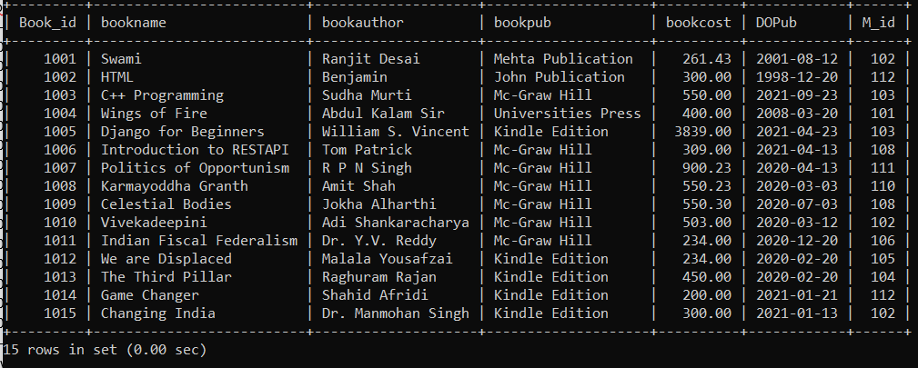

mysql> SELECT * FROM MEMBER;

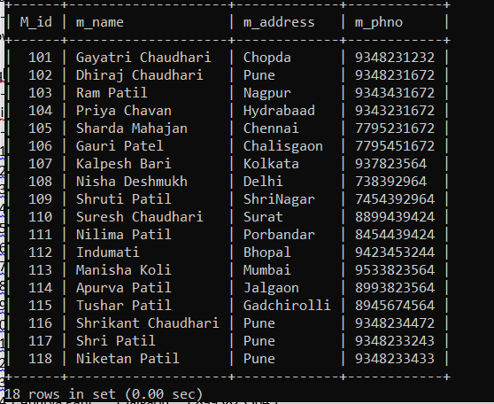

mysql> SELECT * FROM STAFF;

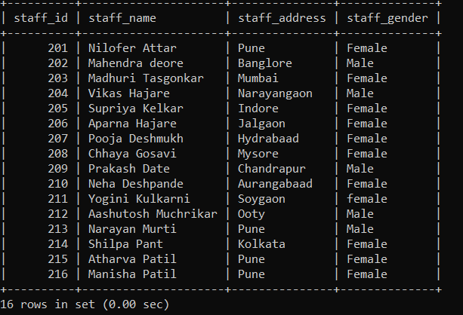

1. Display names of all the books along with their author.

mysql> SELECT bookname,bookauthor FROM books;

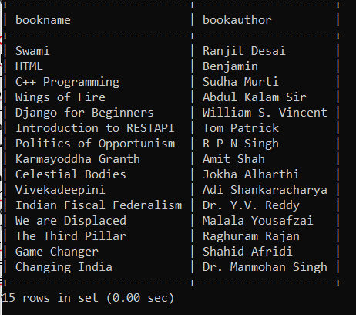

3.Display all books published by Mc-Graw Hill publications.

mysql> SELECT * FROM BOOKS WHERE bookpub="Mc-Graw Hill";

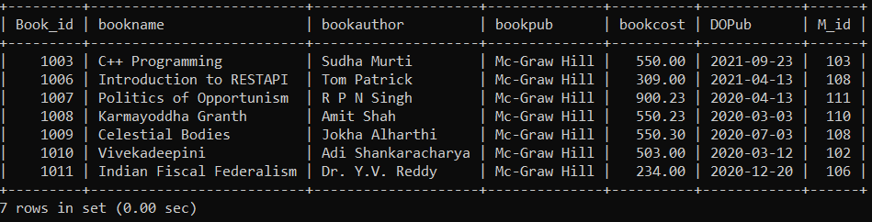

4.Display all books of the member id 102.

mysql> SELECT * FROM BOOKS WHERE M_ID=102;

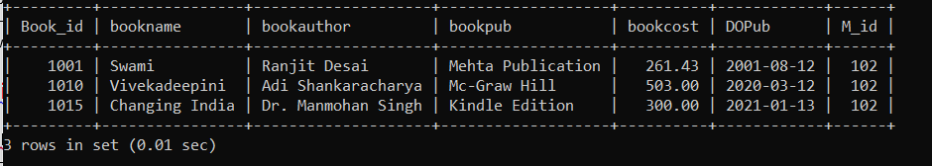

5. Display books information in following order bookname, bookcost, bookpub,DOpub

mysql> SELECT bookname,bookcost,bookpub,DOPub FROM books;

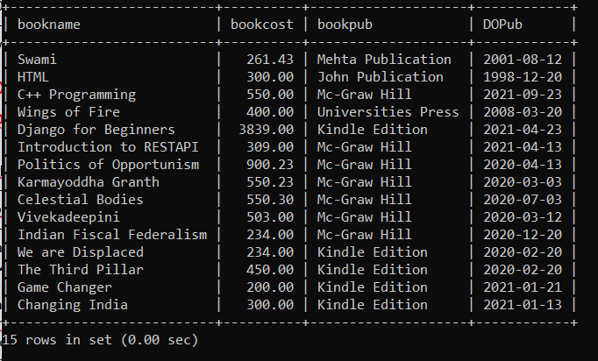

6. Display all members living in Pune.

mysql> SELECT * FROM member WHERE m_address="Pune";

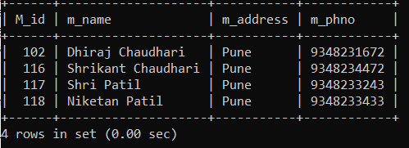

7. Write a command to remove member “Shruti Patil”.

mysql> DELETE FROM member WHERE m_name="Shruti Patil";

Query OK, 1 row affected (0.01 sec)

mysql> select * from member;

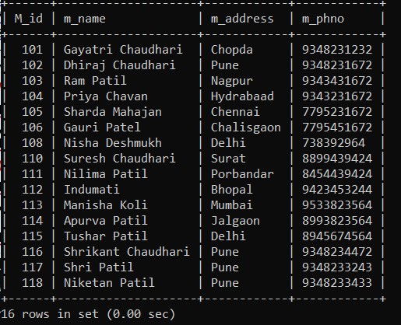

8. Delete record of m_id 50.

mysql> DELETE FROM member WHERE m_id=107;

Query OK, 1 row affected (0.01 sec)

mysql> SELECT * FROM member;

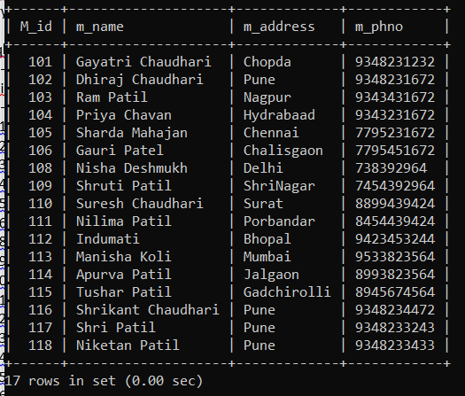

9. Change address of John to “Delhi”.

mysql> UPDATE member SET m_address="Delhi" WHERE m_name="Tushar Patil";

Query OK, 1 row affected (0.01 sec)

Rows matched: 1 Changed: 1 Warnings: 0

mysql> SELECT * FROM member;

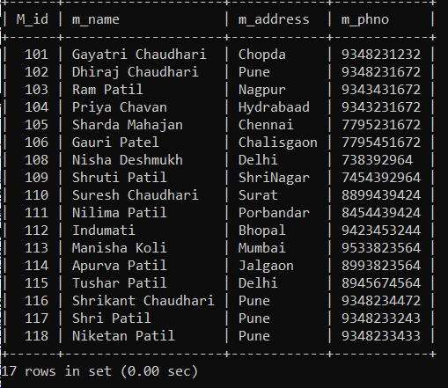

10. Generate alphabetical list of members.

mysql> SELECT * FROM member ORDER BY m_name;

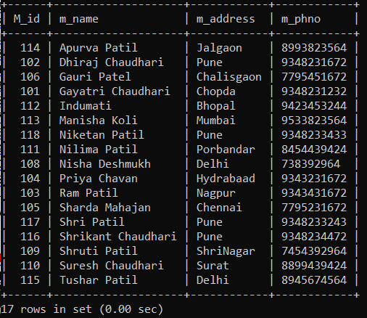

11. Display the bookname and book author whose book cost is more

than 500

mysql> SELECT bookname,bookauthor FROM books WHERE bookcost>500;

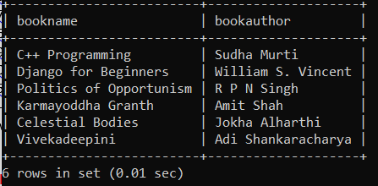

12. Display all books published by Mc-Graw Hill publications with cost less than 1000

mysql> SELECT * FROM books WHERE bookpub="Mc-Graw Hill" and bookcost<550;

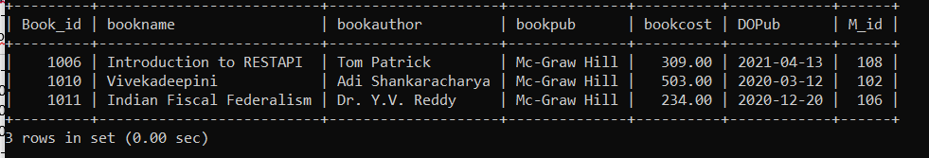

13. Display list of books with cost in the range 500 to 1000 (use between clause)

mysql> SELECT * FROM books WHERE bookcost BETWEEN 500 AND 1000;

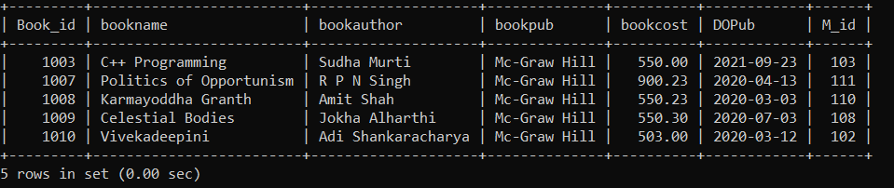

14. Display all the authors who have written books with cost greater than 1000.

mysql> SELECT bookauthor FROM books WHERE bookcost>800;

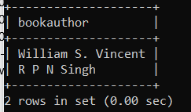

15. Display all books in descending order of cost.

mysql> SELECT * FROM books ORDER BY bookcost DESC;

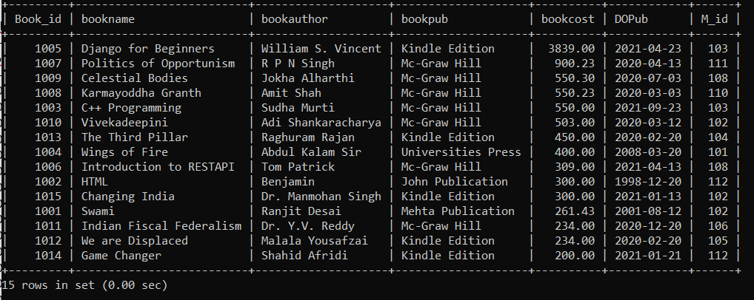

16. List all books which were published in April 2021.

mysql> SELECT * FROM books WHERE MONTH(Dopub)=4;

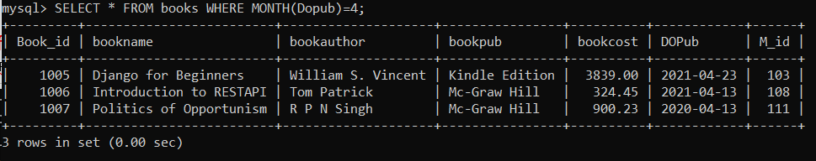

17. Display the book name , book cost published on the date “13rd April 2021”

mysql> SELECT * FROM books WHERE MONTH(Dopub)=4 AND YEAR(Dopub)=2021 AND DAY(dopub)=13;

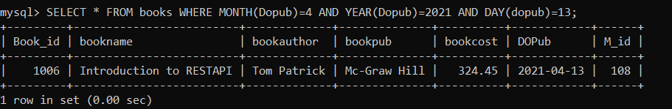

18. Display the staff table with staff_name in capital letters

mysql> SELECT staff_id,UPPER(staff_name),staff_address,staff_gender FROM staff;

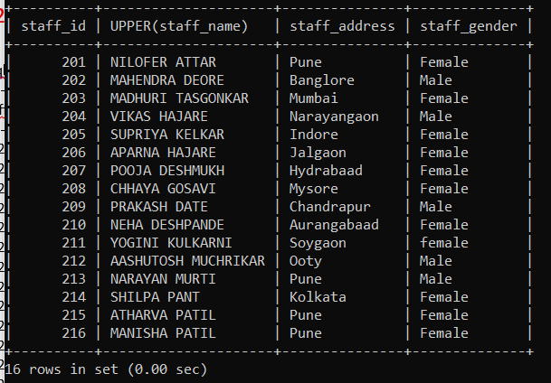

19. Display name of all the female staff from the staff table.

mysql> SELECT staff_name FROM staff WHERE staff_gender="Female";

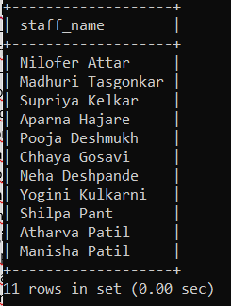

20. Display the Average, minimum and maximum cost of books

mysql> SELECT avg(bookcost) FROM books;

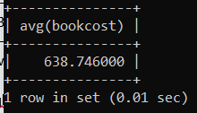

mysql> SELECT MIN(bookcost) FROM books;

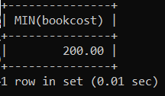

mysql> SELECT MAX(bookcost) FROM books;

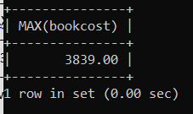

21. Display the average price of books which is belonging to ‘Mc-Graw Hill’

mysql> SELECT AVG(bookcost) FROM books WHERE bookpub="Mc-Graw Hill";

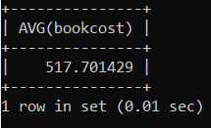

22. Count the no. Of books in library which are having cost less than

500

mysql> SELECT COUNT(bookname) FROM books WHERE bookcost<500;

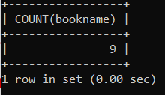

23. Display the names of members in uppercase.

mysql> SELECT UPPER(m_name) FROM member;

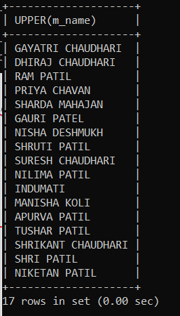

24. Display the cost of books when incremented by 5% for cost<500.

mysql> UPDATE books SET bookcost=bookcost+(bookcost*0.05) WHERE bookcost<500;

Query OK, 9 rows affected, 1 warning (0.01 sec)

Rows matched: 9 Changed: 9 Warnings: 1

mysql> SELECT * FROM books;

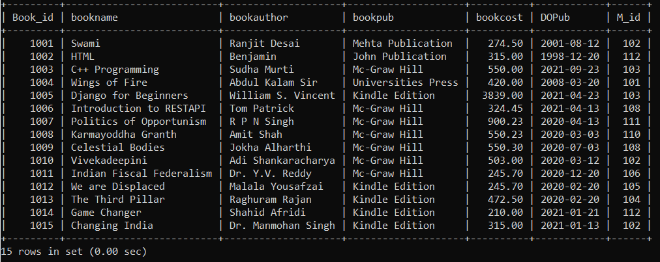

25. Display members whose address is Mumbai and phone no is 8989 0r 3212

mysql> SELECT * FROM member WHERE m_address="Pune" AND (m_phno LIKE "9348%" OR m_phno LIKE "%672");

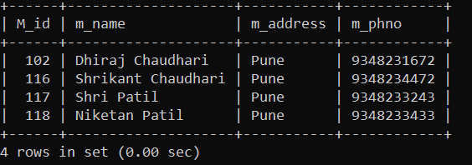

26. Display all members whose names begin with letter from A to K.

mysql> SELECT * FROM member WHERE m_name LIKE "A%" OR m_name LIKE "B%" OR m_name LIKE "C%" OR m_name LIKE "D%" OR m_name LIKE "E%" OR m_name LIKE "F%" OR m_name LIKE "G%" OR m_name LIKE "H%" OR m_name LIKE "I%" OR m_name LIKE "J%" OR m_name LIKE "K%";

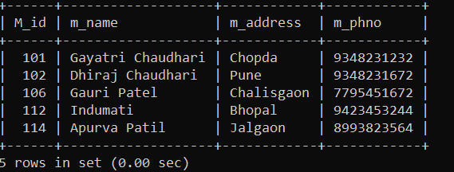

27. Display all members whose name starts with M.

mysql> SELECT * FROM member WHERE m_name LIKE "S%";

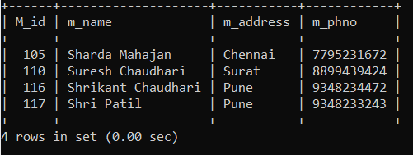

28. Display all members whose name ends with R.

mysql> SELECT * FROM member WHERE m_name LIKE "%L";

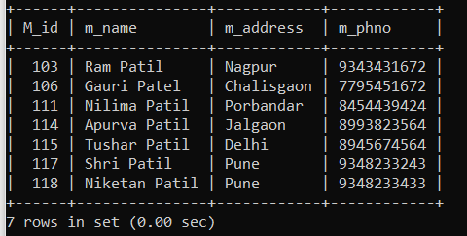

29. Display all members whose name has i as 2nd character.

mysql> SELECT * FROM member WHERE m_name LIKE "_i%";

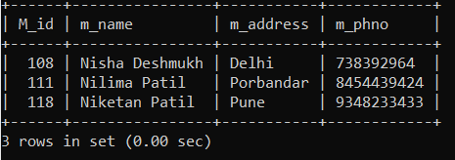

30. Show the different types of cities from staff addresses by eliminating the repeated one.

mysql> SELECT DISTINCT staff_address FROM staff;

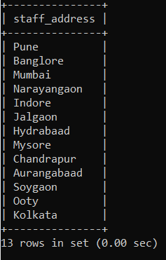

31. Display the Dopub from Books table in different formats.

mysql> SELECT bookname,DATE_FORMAT(Dopub,'%W %D %M %Y') Dopub,

-> DATE_FORMAT(Dopub, '%a %D %b %Y') Dopub

-> FROM books;

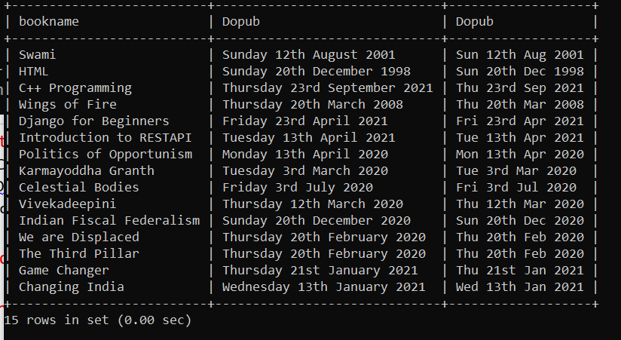

32. Display count of the members citiwise (groupby)

mysql> SELECT m_address,COUNT(m_name) FROM member GROUP BY m_address;

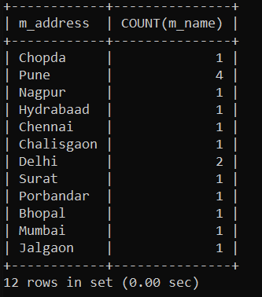

33. find sum of bookcost according to the publications (groupby)

mysql> SELECT bookpub,SUM(bookcost) FROM books GROUP BY bookpub;

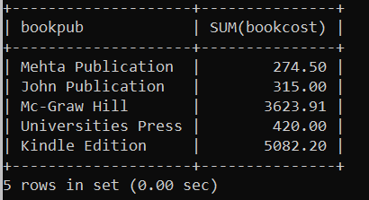

34. Display all the members agewise with age more than 20 (groupby)

mysql> SELECT * FROM STAFFS WHERE staff_age>20 GROUP BY STAFF_age;

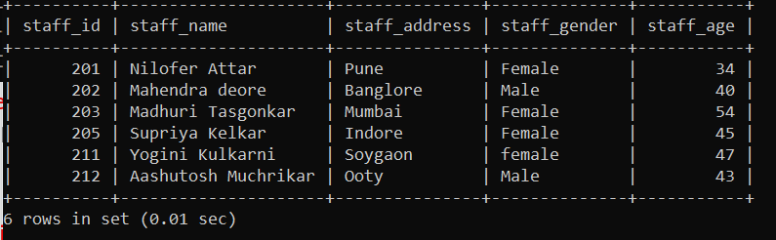

35. Display only first 3 records of the members table (limit)

mysql> SELECT * FROM member LIMIT 3;

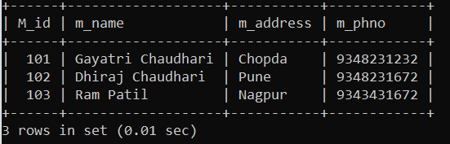

36. Display 5 records from books table starting from record 2 (limit)

mysql> SELECT * FROM books LIMIT 2,5;

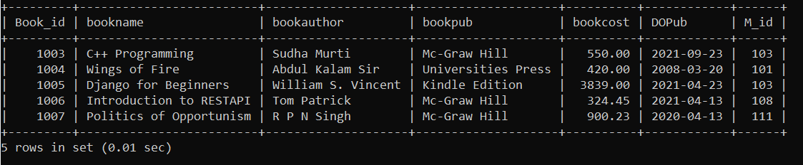

37. Display all the books issued by member 102 and 103 (use union)

mysql> SELECT * FROM books WHERE M_id=102

-> UNION

-> SELECT * FROM books WHERE M_id=103;

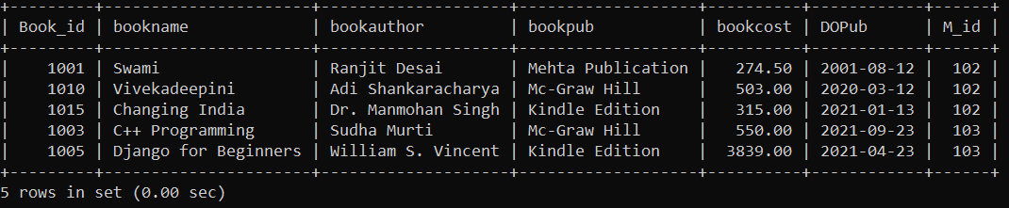

38. Display the books publication dates in following format

a) Month Day Year HH:MM:SS AM/PM

mysql> SELECT bookname,DATE_FORMAT(Dopub,'%b %D %Y %l:%i:%S %p') Dopub FROM books;

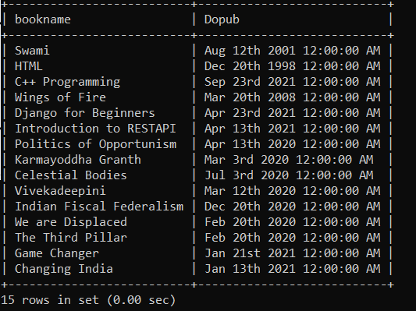

b) DD-MM-YYYY

mysql> SELECT bookname,DATE_FORMAT(Dopub,'%d-%m-%Y') Dopub FROM books;

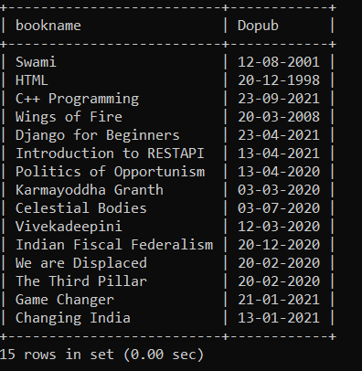

c) Day Month Year (dd-mm-yy)

mysql> SELECT bookname,DATE_FORMAT(Dopub,'%d-%m-%y') Dopub FROM books;

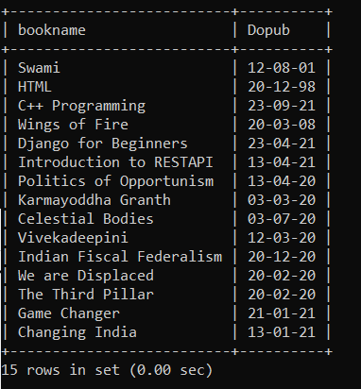

d) dd-mm-YYYY HH:mm:SS:ms

mysql> SELECT bookname,DATE_FORMAT(Dopub,'%d-%m-%Y %l:%i:%S:%f') Dopub FROM books;

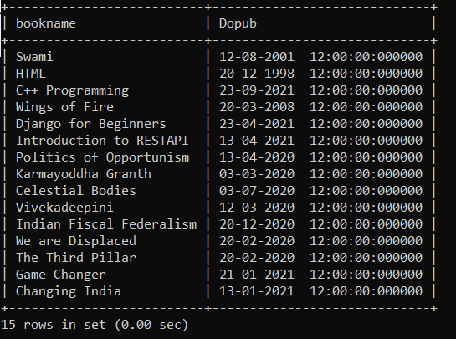

e)Day Month year

mysql> SELECT bookname,DATE_FORMAT(Dopub,'%D %b %y') Dopub FROM books;

