1. Display Display Book_id, bookname,cost,member name and phno.

mysql> select book_id,bookname,bookcost,m_name,m_phno from books inner join member on books.m_id=member.m_id;

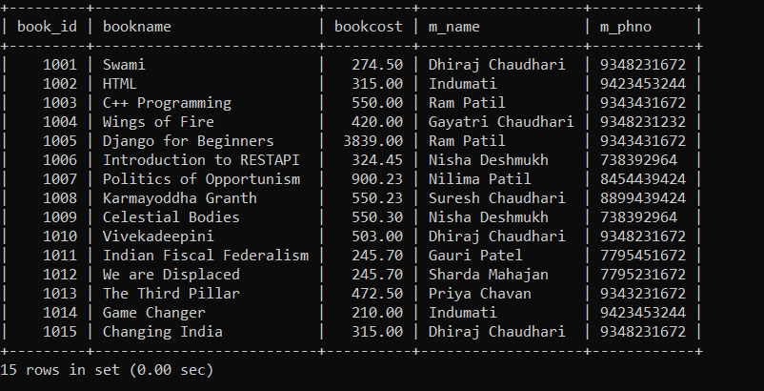

1. Write a query to count the number of books owned by Dhiraj Chaudhari

mysql> select count(book_id) as Books_owned_by_Dhiraj from books where m_id=(select m_id from member where m_name="Dhiraj Chaudhari");

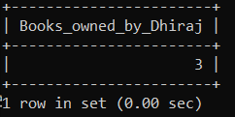

3. Write a query to display sum of cost of all the books issued by 'Ram Patil'.

mysql> select sum(bookcost) from member,books where books.m_id=member.m_id and m_name='Ram Patil';

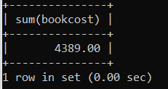

4. Write a query to display the book code, book title of the books which are issued on the date 25th May 2021 (inner join)

mysql> SELECT books.book_id,books.bookname FROM books INNER JOIN issue ON books.Book_id=issue.book_id where issue.issue_date='2021-05-25';

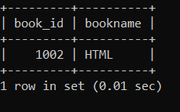

5. Write a query to display the member id, member name, address of members with the total fine paid by them with alias name “Fine_Amount”. (inner join)

mysql> select member.m_id,m_name,m_address,sum(issue.fine) as Fine_amount

-> from member

-> INNER JOIN issue ON

-> member.m_id=issue.m_id

-> group by issue.m_id;

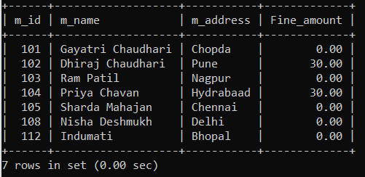

6.Write a query to display list of all members who have issued the book “HTML”.

mysql> select member.m_id,m_name,bookname from member,books,issue where member.m_id=issue.m_id and books.book_id=issue.book_id and bookname="HTML";

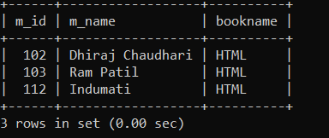

7. List the member details along with the book names they have issued.

mysql> select member.m_id,m_name,m_address ,m_phno,bookname from member inner JOIN issue ON member.m_id=issue.m_id inner JOIN books ON issue.book_id=Books.book_id;

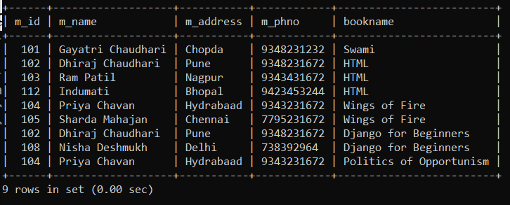

8. Display all members and any books they might have have issued (use left and right join)

mysql> select member.m_id,m_name,m_address ,m_phno,bookname from member LEFT JOIN issue ON member.m_id=issue.m_id LEFT JOIN books ON issue.book_id=Books.book_id;

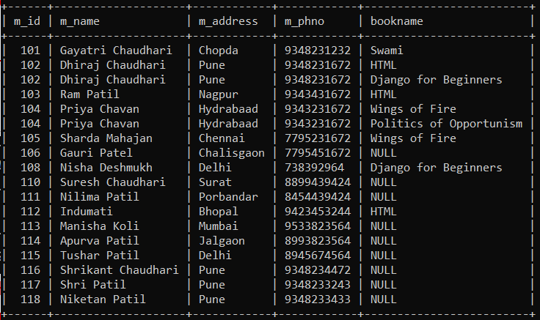

9. Write a query to display the total number of books available in the library with alias name

“NO_OF_BOOKS_AVAILABLE”

mysql> SELECT COUNT(BOOK_ID) AS NO_OF_BOOKS_AVAILABLE FROM BOOKS;

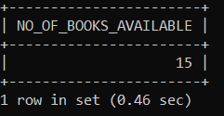

10. Find those books whose cost exists between 500 and 2000. Return bookid, book name,member

name,mem id.

mysql> SELECT book_id,bookname,m_name,books.m_id,bookcost from books inner JOIN member where books.m_id=member.m_id AND bookcost BETWEEN 500 AND 2000;

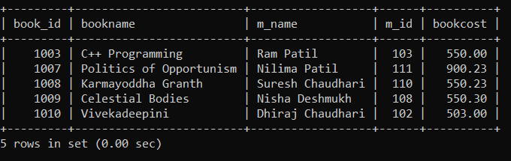

11. Write a SQL statement to make a join on the tables books,members and issue in such a form

that the same column of each table will appear once and only the relational rows will

come.(natural join)

mysql> SELECT * FROM MEMBER NATURAL JOIN BOOKS NATURAL JOIN ISSUE;



12. Create a view to access m_id,m_name,m_address,m_phno. Find out whether the view is an

updatable view.

mysql> create view memberview1 as select m_id,m_name,m_address,m_phno from member;

Query OK, 0 rows affected (0.03 sec)

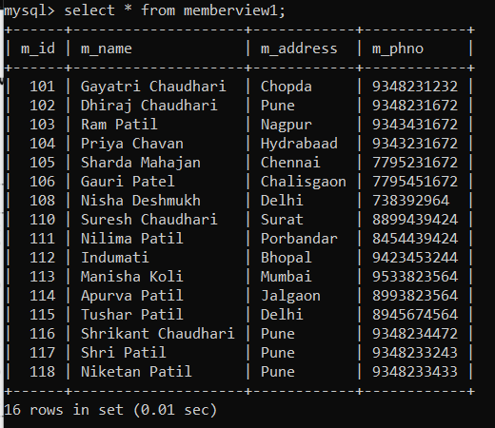

mysql> update memberview1 set m_name="Sharda Patil" where m_name="Sharda Mahajan";

Query OK, 1 row affected (0.01 sec)

Rows matched: 1 Changed: 1 Warnings: 0

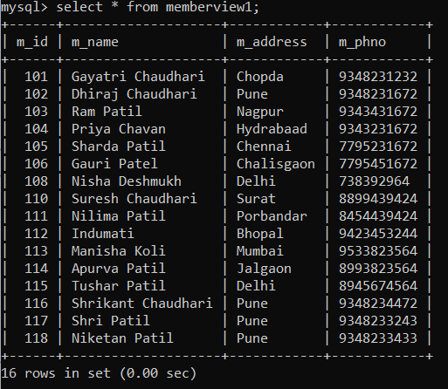

Yes, it is a updatable view.

13. Create a view to access m_name,book_id and bookpub. Find out whether the view is an updatable view.

mysql> create view bookmemberview as select member.m_name,books.book_id,books.bookpub from member,books where member.m_id=books.m_id;

Query OK, 0 rows affected (0.01 sec)

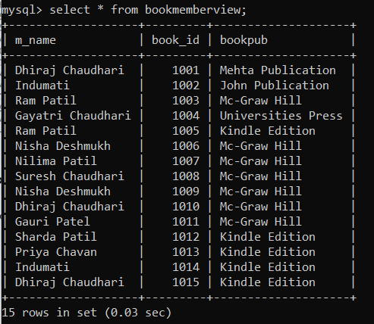

mysql> update bookmemberview set m_name="Rohan Shinde" where book_id=1001;

Query OK, 1 row affected (0.01 sec)

Rows matched: 1 Changed: 1 Warnings: 0

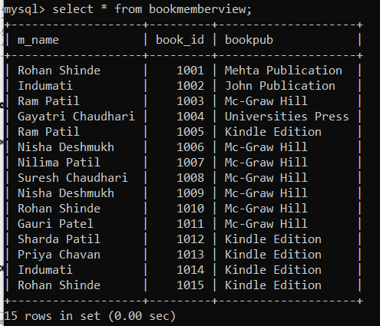

Yes, it is a updatable view.

14. Create suitable index on books table and find the performance improvement

mysql> explain select bookcost from books where bookname="Swami";

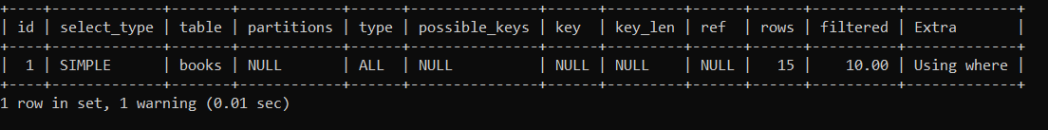

mysql> create index bookindex on books(bookname,bookcost);

Query OK, 0 rows affected (0.09 sec)

Records: 0 Duplicates: 0 Warnings: 0

mysql> explain select bookcost from books where bookname="Swami";

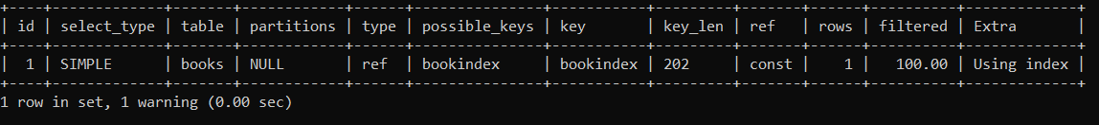

15. Display list of all members who live in the same city as 'Rohan Shinde”.(subquery)

mysql> select m_name from member where m_address=(select m_address from member where m_name='Rohan Shinde');

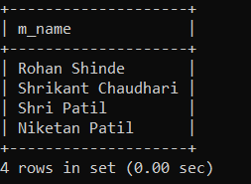

16. Write a query that uses sub query to obtain all the books owned by 'Rohan Shinde'

mysql> select bookname from books where m_id=(select m_id from member where m_name='Rohan Shinde');

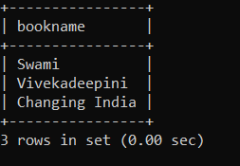

17. Display the name of member who has paid highest fine for the book.(subquery)

mysql> select m_name from member where m_id=(select m_id from issue where fine=(select max(fine) from issue));

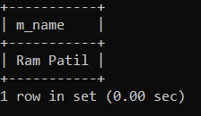

18. Display members who have issued books (subquery-use IN)

mysql> select m_name from member where m_id in (select m_id from issue);

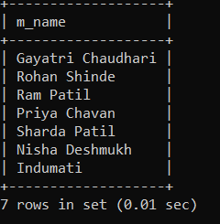

19. Display the list of members id who are members but they have not issued any book. (subquery-

NOT IN)

mysql> select m_name from member where m_id not in (select m_id from issue);

