

eShowBizz_SC1_Run5_17thMar - #22

PASSED



# Summary

|  |  |
| --- | --- |
| Run ID | #22 |
| Status | Passed |
| Duration | 00:00:53 |
| Run mode | Iterations |
| Think time | Included |
| Errors | 0 |
| LG alerts | 0 |
| Date | Mar 18, 2023 |
| Time | 10:55 (GMT +05:30) |
| Percentile algorithm | Optimal |
| Percentile value | 90 |
| Average Throughput | 17.575 KB/s |
| Total Throughput | 439.380 KB |
| Average Hits | 10.800 Hits/s |
| Total Hits | 270 |
| Passed Transactions | 270 |
| Failed Transactions | 0 |
| Passed TRT breakers | - |
| Failed TRT breakers | - |
| Total WEB Vusers | 90 |
| Total Failed Vusers | 0 |

# Top 10 transactions

|  |  |  |  |  |  |  |  |  |  |  |
| --- | --- | --- | --- | --- | --- | --- | --- | --- | --- | --- |
| Script | Transaction | SLA status | Avg | Min | Max | STD | TRT percentile Threshold | 90th | Passed | Failed |
| 84_eShowBizz_02_CWS_Book_Buy (1) | Eshowbizz_04_Buy | N/A | 2.195 | 0.604 | 5.192 | 1.182 | 0.000 | 4.018 | 90 | 0 |
| 84_eShowBizz_02_CWS_Book_Buy (1) | ShowSeats_AllClasses_Open | N/A | 1.967 | 0.031 | 4.512 | 1.441 | 0.000 | 4.010 | 90 | 0 |
| 84_eShowBizz_02_CWS_Book_Buy (1) | Eshowbizz_03_BookSeats | N/A | 1.201 | 0.054 | 5.897 | 1.513 | 0.000 | 3.240 | 90 | 0 |

# Passed & Failed TRX / sec

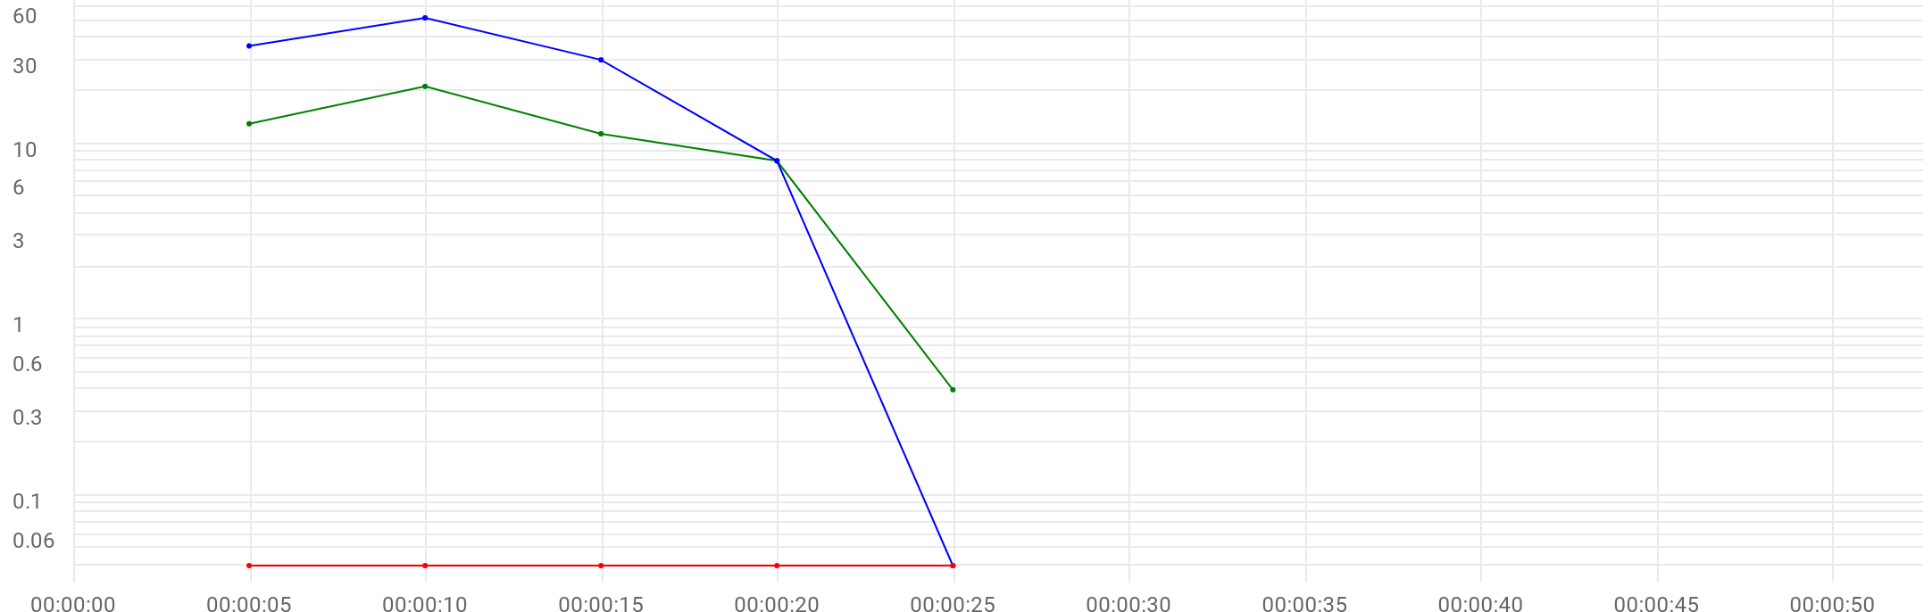

|  |  |  |  |  |  |  |  |
| --- | --- | --- | --- | --- | --- | --- | --- |
|  | Metric | Max | Min | Graph max | Graph avg | Graph min | Med |
| |  | | --- | |  | | Running Vusers | 52 | 0 | 52 | 25.2 | 0 | 36 |
| |  | | --- | |  | | Passed transactions per second | N/A | N/A | 21.2 | 10.8 | 0.4 | 13 |
| |  | | --- | |  | | Failed transactions per second | N/A | N/A | 0 | 0 | 0 | 0 |

# Transactions

**84_eShowBizz_02_CWS_Book_Buy (1)**

|  |  |  |  |  |  |  |  |  |  |
| --- | --- | --- | --- | --- | --- | --- | --- | --- | --- |
| Transaction | SLA status | Avg | Min | Max | STD | TRT percentile Threshold | Custom 95th | Passed | Failed |
| Eshowbizz_03_BookSeats | N/A | 1.201 | 0.054 | 5.897 | 1.513 | 0.000 | 5.025 | 90 | 0 |
| Eshowbizz_04_Buy | N/A | 2.195 | 0.604 | 5.192 | 1.182 | 0.000 | 4.524 | 90 | 0 |
| ShowSeats_AllClasses_Open | N/A | 1.967 | 0.031 | 4.512 | 1.441 | 0.000 | 4.509 | 90 | 0 |

# Errors / sec

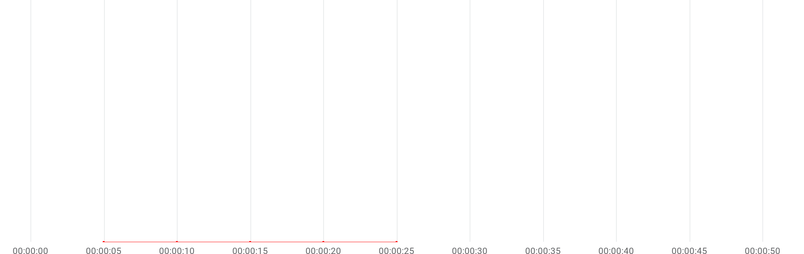

|  |  |  |  |  |  |  |  |
| --- | --- | --- | --- | --- | --- | --- | --- |
|  | Metric | Max | Min | Graph max | Graph avg | Graph min | Med |
| |  | | --- | |  | | Errors per second | N/A | N/A | 0 | 0 | 0 | 0 |

# Errors summary

No Data available

# Throughput & Hits / sec

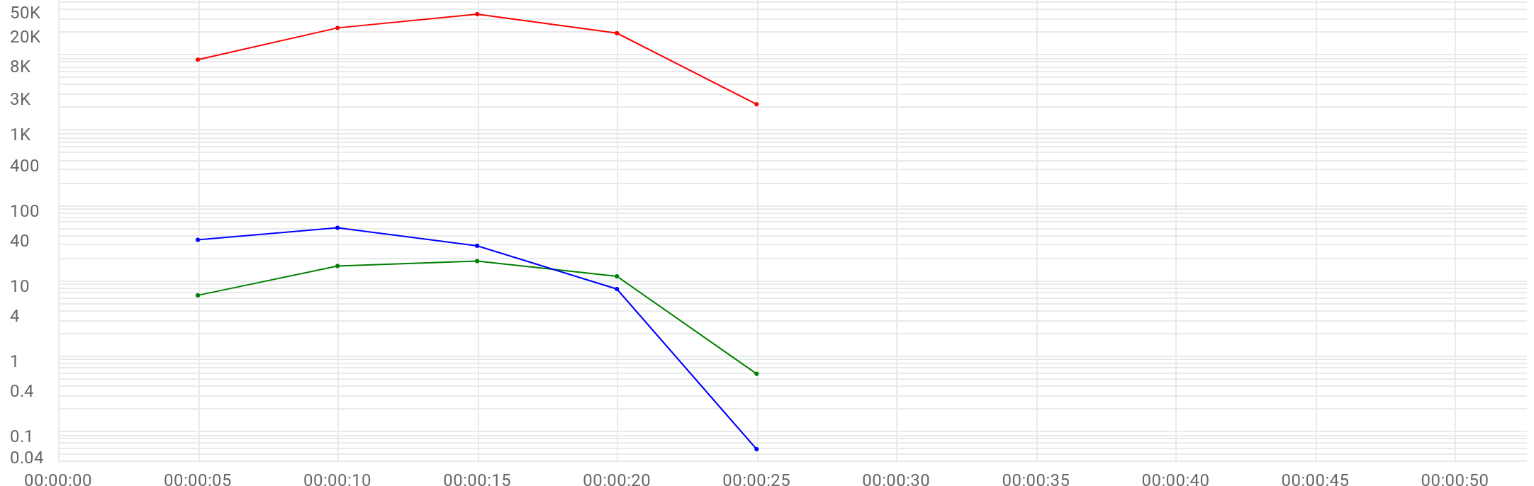

|  |  |  |  |  |  |  |  |
| --- | --- | --- | --- | --- | --- | --- | --- |
|  | Metric | Max | Min | Graph max | Graph avg | Graph min | Med |
| |  | | --- | |  | | Running Vusers | 52 | 0 | 52 | 25.2 | 0 | 36 |
| |  | | --- | |  | | Hits per second | 18.8 | 0.6 | 18.8 | 10.8 | 0.6 | 16.2 |
| |  | | --- | |  | | Throughput | 34.731 KB/s | 2.215 KB/s | 34.731 KB/s | 17.575 KB/s | 2.215 KB/s | 22.838 KB/s |

# Scripts

|  |  |  |  |  |  |  |
| --- | --- | --- | --- | --- | --- | --- |
| Script | Vusers | Ramp up | Iterations planned | Duration | Max duration | Location |
| 84_eShowBizz_02_CWS_Book_Buy (1) | 90 | 00:00:10 | 1 | 00:00:11 | 00:01:00 | On Premise |

# Distribution

|  |  |  |
| --- | --- | --- |
| Distribution | %Vusers | No Emulation |
| On-Premise | 100.0% | 100.0% |

# LG health monitoring

|  |  |  |  |  |
| --- | --- | --- | --- | --- |
| LOCATION | Host | Metric | Max | Avg |
| On-Premise | EC2AMAZ-2O3HKBP-172.31.11.184 | CPU | 2.1% | 2.1% |
| On-Premise | EC2AMAZ-2O3HKBP-172.31.11.184 | DISK | 24.23% | 24.23% |
| On-Premise | EC2AMAZ-2O3HKBP-172.31.11.184 | MEMORY | 13.28% | 13.28% |

# Running Vusers | Hits per second



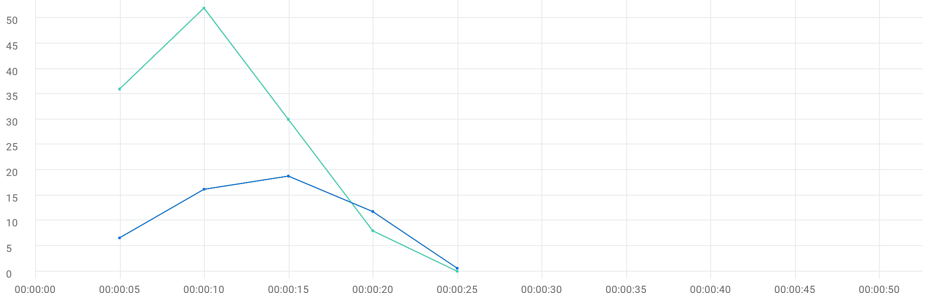

|  |  |  |  |  |  |  |  |  |  |  |
| --- | --- | --- | --- | --- | --- | --- | --- | --- | --- | --- |
|  | Metric | Script | Location | Emulation | Max | Min | Graph max | Graph avg | Graph min | Med |
| |  | | --- | |  | | Running Vusers | All | All | All | 52 | 0 | 52 | 25.2 | 0 | 36 |
| |  | | --- | |  | | Hits per second | 84_eShowBizz_02_CWS_Book_Buy (1) | All | All | 18.8 | 0.6 | 18.8 | 10.8 | 0.6 | 16.2 |
| |  | | --- | |  | | Running Vusers | 84_eShowBizz_02_CWS_Book_Buy (1) | All | All | 52 | 0 | 52 | 25.2 | 0 | 36 |
| |  | | --- | |  | | Hits per second | 84_eShowBizz_02_CWS_Book_Buy (1) | On-Premise | All | 18.8 | 0.6 | 18.8 | 10.8 | 0.6 | 16.2 |
| |  | | --- | |  | | Running Vusers | 84_eShowBizz_02_CWS_Book_Buy (1) | On-Premise | All | 52 | 0 | 52 | 25.2 | 0 | 36 |
| |  | | --- | |  | | Hits per second | 84_eShowBizz_02_CWS_Book_Buy (1) | On-Premise | No Emulation | 18.8 | 0.6 | 18.8 | 10.8 | 0.6 | 16.2 |
| |  | | --- | |  | | Running Vusers | 84_eShowBizz_02_CWS_Book_Buy (1) | On-Premise | No Emulation | 52 | 0 | 52 | 25.2 | 0 | 36 |
| |  | | --- | |  | | HTTP_200 | 84_eShowBizz_02_CWS_Book_Buy (1) | On-Premise | No Emulation | 18.8 | 0.6 | 18.8 | 10.8 | 0.6 | 16.2 |

# Running Vusers



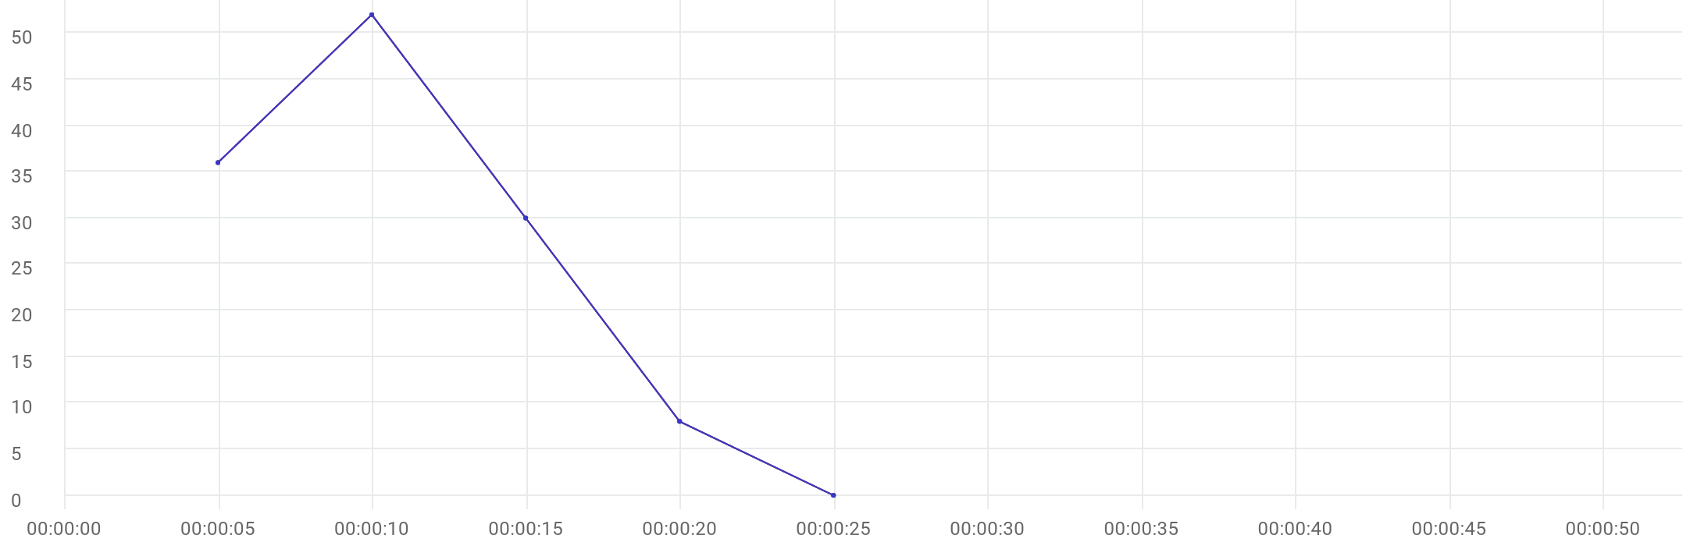

|  |  |  |  |  |  |  |  |  |  |  |
| --- | --- | --- | --- | --- | --- | --- | --- | --- | --- | --- |
|  | Metric | Script | Location | Emulation | Max | Min | Graph max | Graph avg | Graph min | Med |
| |  | | --- | |  | | Running Vusers | 84_eShowBizz_02_CWS_Book_Buy (1) | All | All | 52 | 0 | 52 | 25.2 | 0 | 36 |
| |  | | --- | |  | | Running Vusers | 84_eShowBizz_02_CWS_Book_Buy (1) | On-Premise | All | 52 | 0 | 52 | 25.2 | 0 | 36 |
| |  | | --- | |  | | Running Vusers | 84_eShowBizz_02_CWS_Book_Buy (1) | On-Premise | No Emulation | 52 | 0 | 52 | 25.2 | 0 | 36 |

# Failed Vusers



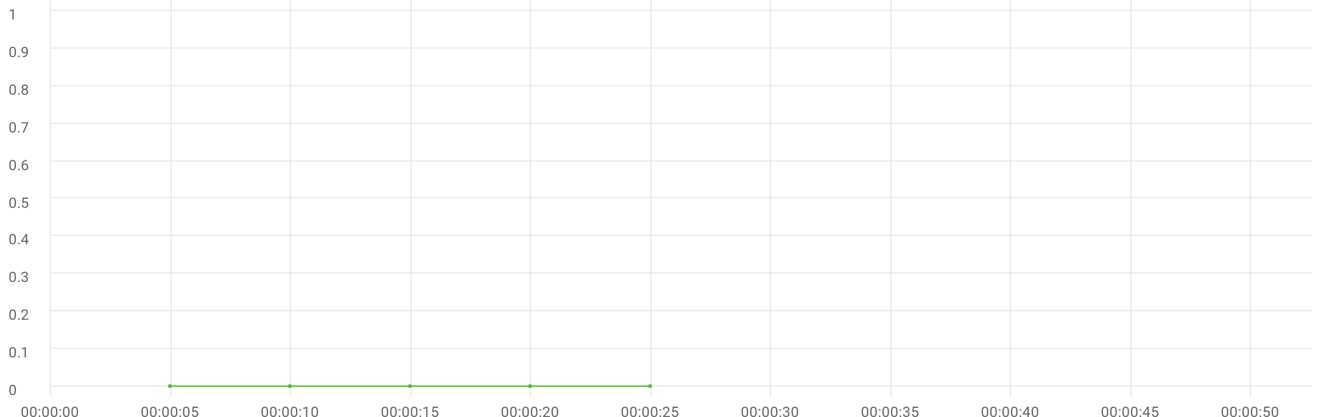

|  |  |  |  |  |  |  |  |  |  |  |
| --- | --- | --- | --- | --- | --- | --- | --- | --- | --- | --- |
|  | Metric | Script | Location | Emulation | Max | Min | Graph max | Graph avg | Graph min | Med |
| |  | | --- | |  | | Failed Vusers | 84_eShowBizz_02_CWS_Book_Buy (1) | All | All | 0 | 0 | 0 | 0 | 0 | 0 |
| |  | | --- | |  | | Failed Vusers | 84_eShowBizz_02_CWS_Book_Buy (1) | On-Premise | All | 0 | 0 | 0 | 0 | 0 | 0 |
| |  | | --- | |  | | Failed Vusers | 84_eShowBizz_02_CWS_Book_Buy (1) | On-Premise | No Emulation | 0 | 0 | 0 | 0 | 0 | 0 |

# Hits per second



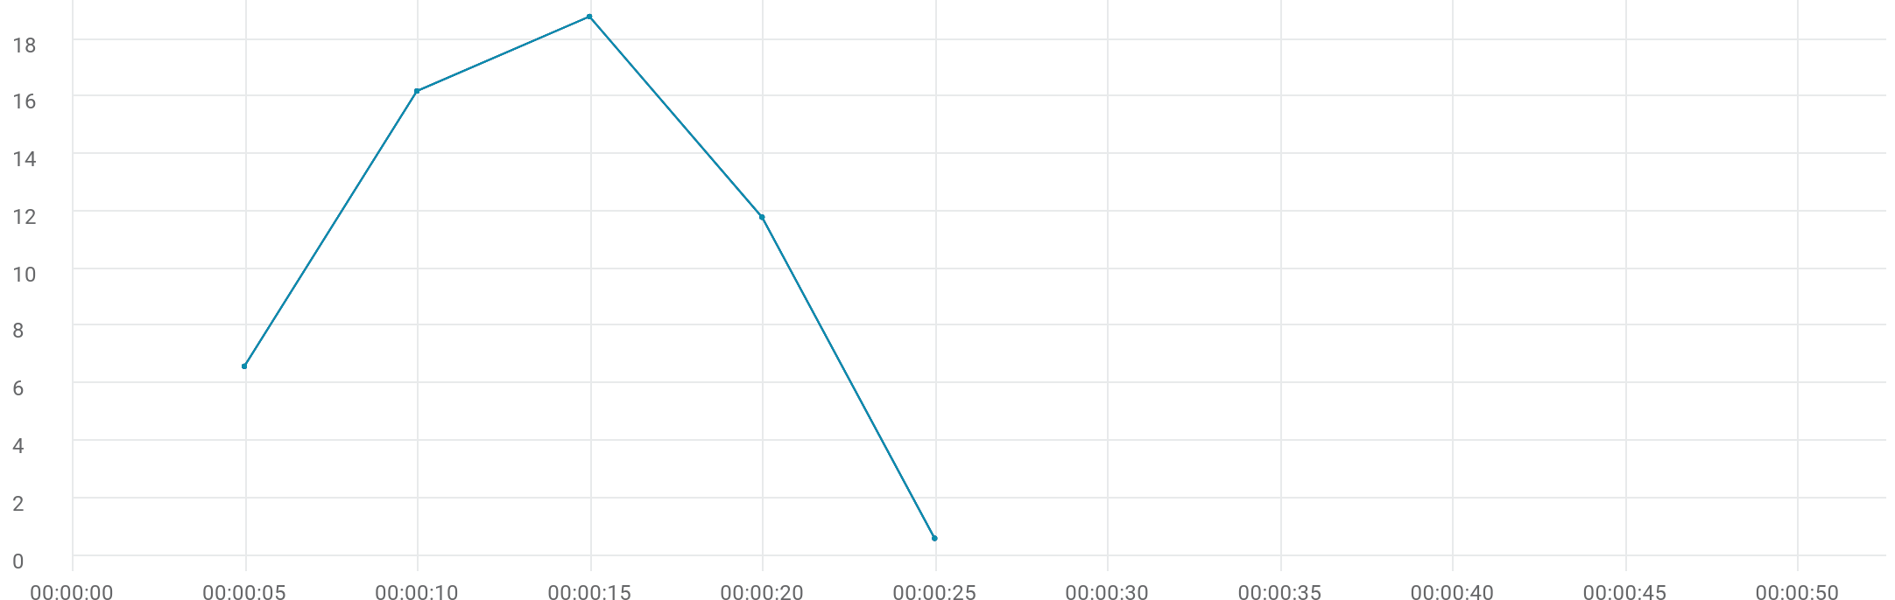

|  |  |  |  |  |  |  |  |  |  |  |
| --- | --- | --- | --- | --- | --- | --- | --- | --- | --- | --- |
|  | Metric | Script | Location | Emulation | Max | Min | Graph max | Graph avg | Graph min | Med |
| |  | | --- | |  | | Hits per second | 84_eShowBizz_02_CWS_Book_Buy (1) | All | All | 18.8 | 0.6 | 18.8 | 10.8 | 0.6 | 16.2 |
| |  | | --- | |  | | Hits per second | 84_eShowBizz_02_CWS_Book_Buy (1) | On-Premise | All | 18.8 | 0.6 | 18.8 | 10.8 | 0.6 | 16.2 |
| |  | | --- | |  | | Hits per second | 84_eShowBizz_02_CWS_Book_Buy (1) | On-Premise | No Emulation | 18.8 | 0.6 | 18.8 | 10.8 | 0.6 | 16.2 |
| |  | | --- | |  | | HTTP_200 | 84_eShowBizz_02_CWS_Book_Buy (1) | On-Premise | No Emulation | 18.8 | 0.6 | 18.8 | 10.8 | 0.6 | 16.2 |

# Throughput



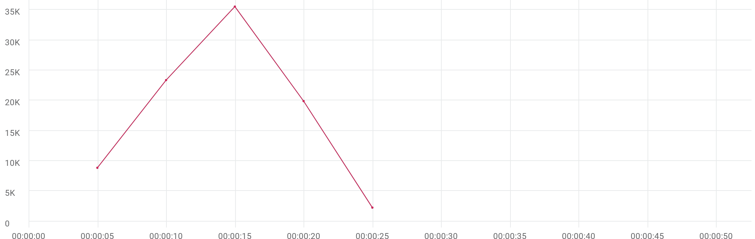

|  |  |  |  |  |  |  |  |  |  |  |
| --- | --- | --- | --- | --- | --- | --- | --- | --- | --- | --- |
|  | Metric | Script | Location | Emulation | Max | Min | Graph max | Graph avg | Graph min | Med |
| |  | | --- | |  | | Throughput | 84_eShowBizz_02_CWS_Book_Buy (1) | All | All | 34.731 KB/s | 2.215 KB/s | 34.731 KB/s | 17.575 KB/s | 2.215 KB/s | 22.838 KB/s |
| |  | | --- | |  | | Throughput | 84_eShowBizz_02_CWS_Book_Buy (1) | On-Premise | All | 34.731 KB/s | 2.215 KB/s | 34.731 KB/s | 17.575 KB/s | 2.215 KB/s | 22.838 KB/s |
| |  | | --- | |  | | Throughput | 84_eShowBizz_02_CWS_Book_Buy (1) | On-Premise | No Emulation | 34.731 KB/s | 2.215 KB/s | 34.731 KB/s | 17.575 KB/s | 2.215 KB/s | 22.838 KB/s |

# Errors per second



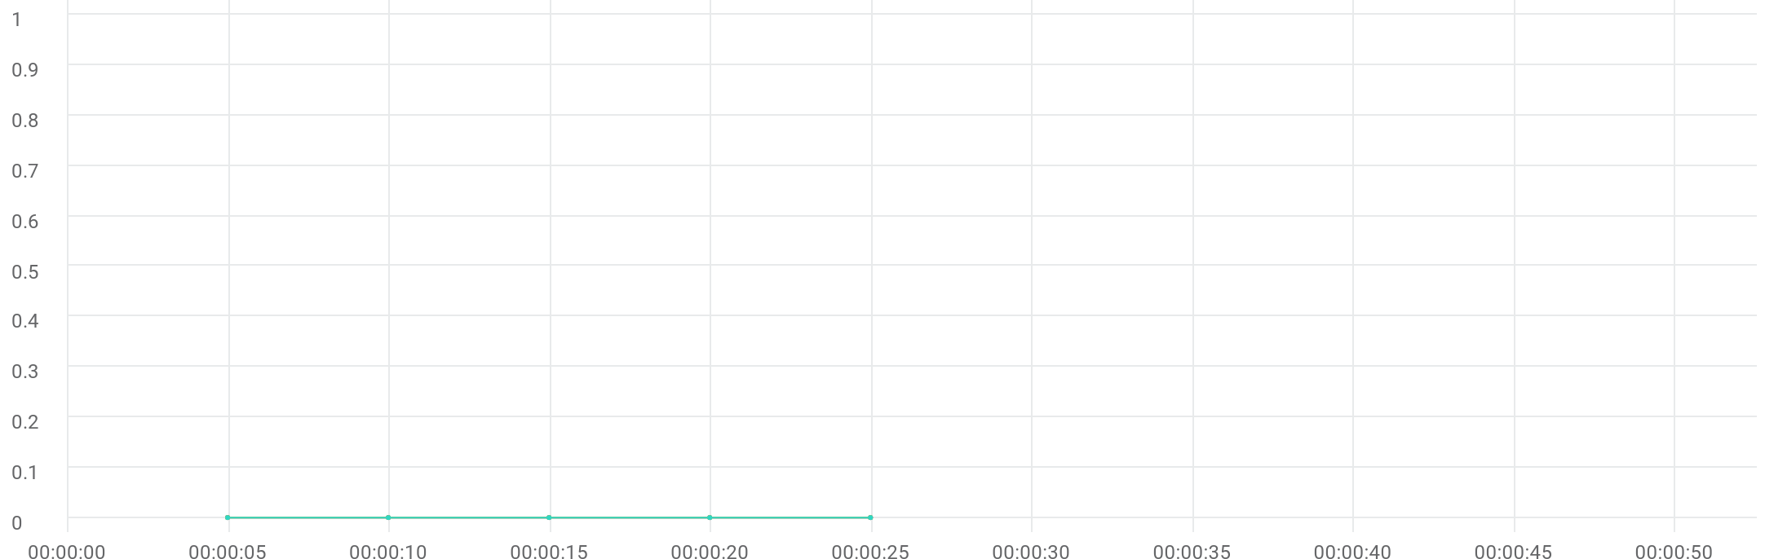

|  |  |  |  |  |  |  |  |  |  |  |
| --- | --- | --- | --- | --- | --- | --- | --- | --- | --- | --- |
|  | Metric | Script | Location | Emulation | Max | Min | Graph max | Graph avg | Graph min | Med |
| |  | | --- | |  | | Errors per second | 84_eShowBizz_02_CWS_Book_Buy (1) | All | All | N/A | N/A | 0 | 0 | 0 | 0 |
| |  | | --- | |  | | Errors per second | 84_eShowBizz_02_CWS_Book_Buy (1) | On-Premise | All | N/A | N/A | 0 | 0 | 0 | 0 |
| |  | | --- | |  | | Errors per second | 84_eShowBizz_02_CWS_Book_Buy (1) | On-Premise | No Emulation | N/A | N/A | 0 | 0 | 0 | 0 |

# TRT [90th]



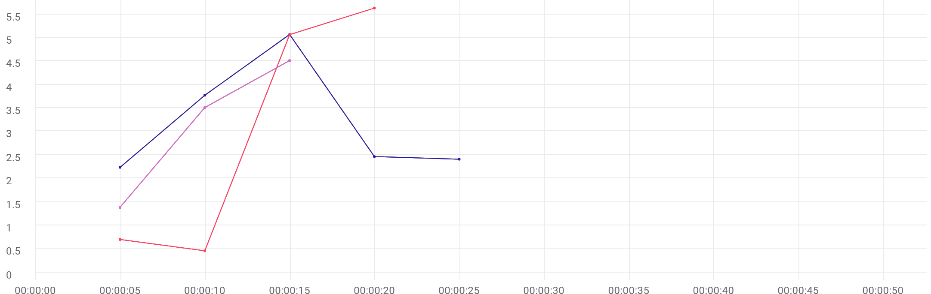

|  |  |  |  |  |  |  |  |  |  |  |  |
| --- | --- | --- | --- | --- | --- | --- | --- | --- | --- | --- | --- |
|  | Metric | Transaction | Script | Location | Emulation | Max | Min | Graph max | Graph avg | Graph min | Med |
| |  | | --- | |  | | TRT [90 th percentile] | Eshowbizz_04_Buy | 84_eShowBizz_02_CWS_Book_Buy (1) | All | All | N/A | N/A | 5.07 sec | 3.191 sec | 2.237 sec | 3.774 sec |
| |  | | --- | |  | | TRT [90 th percentile] | Eshowbizz_03_BookSeats | 84_eShowBizz_02_CWS_Book_Buy (1) | All | All | N/A | N/A | 5.632 sec | 2.963 sec | 456.486 ms | 5.065 sec |
| |  | | --- | |  | | TRT [90 th percentile] | ShowSeats_AllClasses_Open | 84_eShowBizz_02_CWS_Book_Buy (1) | All | All | N/A | N/A | 4.512 sec | 3.136 sec | 1.384 sec | 4.512 sec |
| |  | | --- | |  | | TRT [90 th percentile] | Eshowbizz_04_Buy | 84_eShowBizz_02_CWS_Book_Buy (1) | On-Premise | All | N/A | N/A | 5.07 sec | 3.191 sec | 2.237 sec | 3.774 sec |
| |  | | --- | |  | | TRT [90 th percentile] | Eshowbizz_03_BookSeats | 84_eShowBizz_02_CWS_Book_Buy (1) | On-Premise | All | N/A | N/A | 5.632 sec | 2.963 sec | 456.486 ms | 5.065 sec |
| |  | | --- | |  | | TRT [90 th percentile] | ShowSeats_AllClasses_Open | 84_eShowBizz_02_CWS_Book_Buy (1) | On-Premise | All | N/A | N/A | 4.512 sec | 3.136 sec | 1.384 sec | 4.512 sec |
| |  | | --- | |  | | TRT [90 th percentile] | Eshowbizz_04_Buy | 84_eShowBizz_02_CWS_Book_Buy (1) | On-Premise | No Emulation | N/A | N/A | 5.07 sec | 3.191 sec | 2.237 sec | 3.774 sec |
| |  | | --- | |  | | TRT [90 th percentile] | Eshowbizz_03_BookSeats | 84_eShowBizz_02_CWS_Book_Buy (1) | On-Premise | No Emulation | N/A | N/A | 5.632 sec | 2.963 sec | 456.486 ms | 5.065 sec |
| |  | | --- | |  | | TRT [90 th percentile] | ShowSeats_AllClasses_Open | 84_eShowBizz_02_CWS_Book_Buy (1) | On-Premise | No Emulation | N/A | N/A | 4.512 sec | 3.136 sec | 1.384 sec | 4.512 sec |

# TRT [AVG]



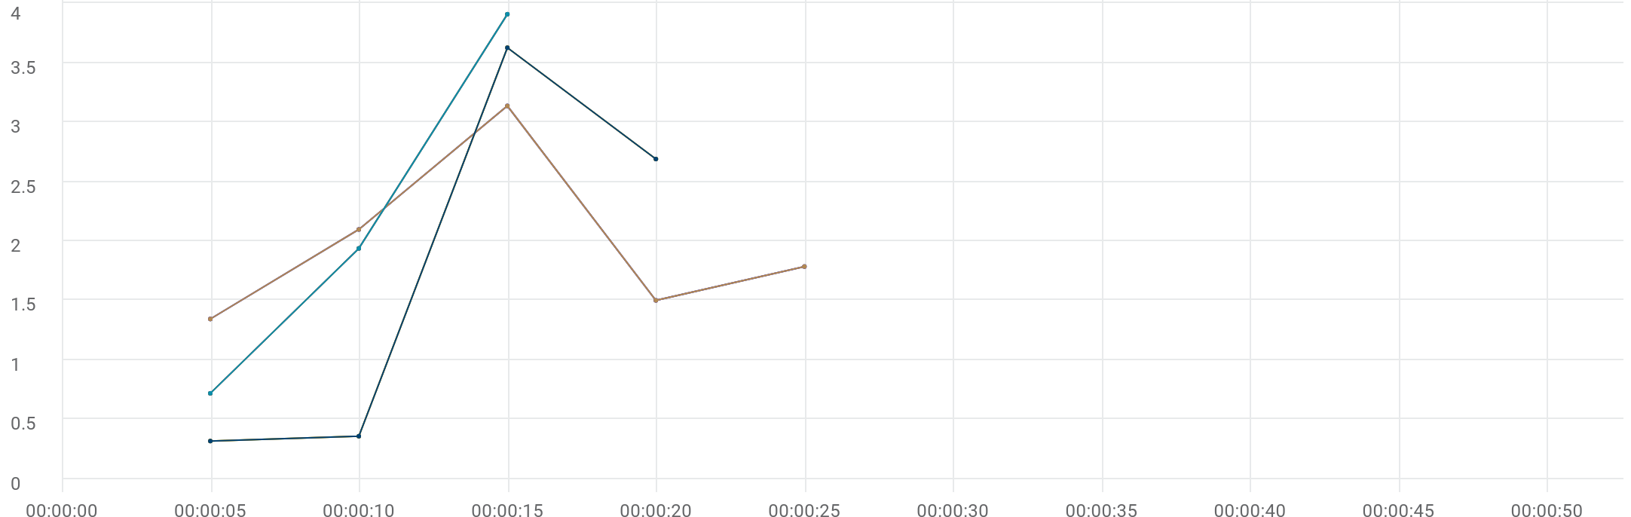

|  |  |  |  |  |  |  |  |  |  |  |  |
| --- | --- | --- | --- | --- | --- | --- | --- | --- | --- | --- | --- |
|  | Metric | Transaction | Script | Location | Emulation | Max | Min | Graph max | Graph avg | Graph min | Med |
| |  | | --- | |  | | TRT [AVG] | Eshowbizz_04_Buy | 84_eShowBizz_02_CWS_Book_Buy (1) | All | All | N/A | N/A | 3.138 sec | 1.973 sec | 1.344 sec | 2.098 sec |
| |  | | --- | |  | | TRT [AVG] | Eshowbizz_03_BookSeats | 84_eShowBizz_02_CWS_Book_Buy (1) | All | All | N/A | N/A | 3.628 sec | 1.748 sec | 316.637 ms | 2.691 sec |
| |  | | --- | |  | | TRT [AVG] | ShowSeats_AllClasses_Open | 84_eShowBizz_02_CWS_Book_Buy (1) | All | All | N/A | N/A | 3.91 sec | 2.189 sec | 718.671 ms | 3.91 sec |
| |  | | --- | |  | | TRT [AVG] | Eshowbizz_04_Buy | 84_eShowBizz_02_CWS_Book_Buy (1) | On-Premise | All | N/A | N/A | 3.138 sec | 1.973 sec | 1.344 sec | 2.098 sec |
| |  | | --- | |  | | TRT [AVG] | Eshowbizz_03_BookSeats | 84_eShowBizz_02_CWS_Book_Buy (1) | On-Premise | All | N/A | N/A | 3.628 sec | 1.748 sec | 316.637 ms | 2.691 sec |
| |  | | --- | |  | | TRT [AVG] | ShowSeats_AllClasses_Open | 84_eShowBizz_02_CWS_Book_Buy (1) | On-Premise | All | N/A | N/A | 3.91 sec | 2.189 sec | 718.671 ms | 3.91 sec |
| |  | | --- | |  | | TRT [AVG] | Eshowbizz_04_Buy | 84_eShowBizz_02_CWS_Book_Buy (1) | On-Premise | No Emulation | N/A | N/A | 3.138 sec | 1.973 sec | 1.344 sec | 2.098 sec |
| |  | | --- | |  | | TRT [AVG] | Eshowbizz_03_BookSeats | 84_eShowBizz_02_CWS_Book_Buy (1) | On-Premise | No Emulation | N/A | N/A | 3.628 sec | 1.748 sec | 316.637 ms | 2.691 sec |
| |  | | --- | |  | | TRT [AVG] | ShowSeats_AllClasses_Open | 84_eShowBizz_02_CWS_Book_Buy (1) | On-Premise | No Emulation | N/A | N/A | 3.91 sec | 2.189 sec | 718.671 ms | 3.91 sec |

# TRT [MIN]



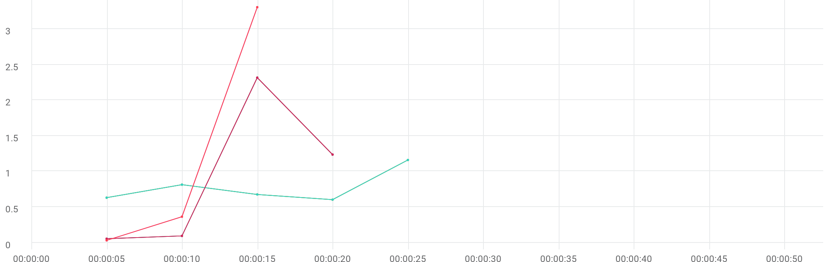

|  |  |  |  |  |  |  |  |  |  |  |  |
| --- | --- | --- | --- | --- | --- | --- | --- | --- | --- | --- | --- |
|  | Metric | Transaction | Script | Location | Emulation | Max | Min | Graph max | Graph avg | Graph min | Med |
| |  | | --- | |  | | TRT [MIN] | Eshowbizz_04_Buy | 84_eShowBizz_02_CWS_Book_Buy (1) | All | All | N/A | N/A | 1.161 sec | 777.416 ms | 603.618 ms | 814.546 ms |
| |  | | --- | |  | | TRT [MIN] | Eshowbizz_03_BookSeats | 84_eShowBizz_02_CWS_Book_Buy (1) | All | All | N/A | N/A | 2.319 sec | 926.117 ms | 54.435 ms | 1.237 sec |
| |  | | --- | |  | | TRT [MIN] | ShowSeats_AllClasses_Open | 84_eShowBizz_02_CWS_Book_Buy (1) | All | All | N/A | N/A | 3.309 sec | 1.235 sec | 31.214 ms | 3.309 sec |
| |  | | --- | |  | | TRT [MIN] | Eshowbizz_04_Buy | 84_eShowBizz_02_CWS_Book_Buy (1) | On-Premise | All | N/A | N/A | 1.161 sec | 777.416 ms | 603.618 ms | 814.546 ms |
| |  | | --- | |  | | TRT [MIN] | Eshowbizz_03_BookSeats | 84_eShowBizz_02_CWS_Book_Buy (1) | On-Premise | All | N/A | N/A | 2.319 sec | 926.117 ms | 54.435 ms | 1.237 sec |
| |  | | --- | |  | | TRT [MIN] | ShowSeats_AllClasses_Open | 84_eShowBizz_02_CWS_Book_Buy (1) | On-Premise | All | N/A | N/A | 3.309 sec | 1.235 sec | 31.214 ms | 3.309 sec |
| |  | | --- | |  | | TRT [MIN] | Eshowbizz_04_Buy | 84_eShowBizz_02_CWS_Book_Buy (1) | On-Premise | No Emulation | N/A | N/A | 1.161 sec | 777.416 ms | 603.618 ms | 814.546 ms |
| |  | | --- | |  | | TRT [MIN] | Eshowbizz_03_BookSeats | 84_eShowBizz_02_CWS_Book_Buy (1) | On-Premise | No Emulation | N/A | N/A | 2.319 sec | 926.117 ms | 54.435 ms | 1.237 sec |
| |  | | --- | |  | | TRT [MIN] | ShowSeats_AllClasses_Open | 84_eShowBizz_02_CWS_Book_Buy (1) | On-Premise | No Emulation | N/A | N/A | 3.309 sec | 1.235 sec | 31.214 ms | 3.309 sec |

# TRT [MAX]



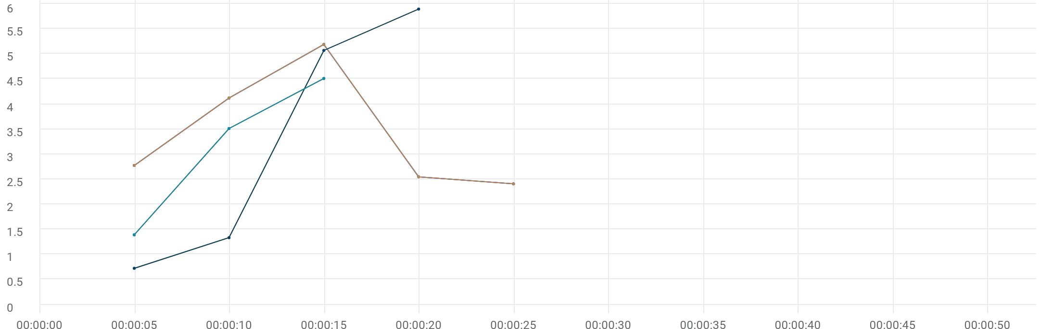

|  |  |  |  |  |  |  |  |  |  |  |  |
| --- | --- | --- | --- | --- | --- | --- | --- | --- | --- | --- | --- |
|  | Metric | Transaction | Script | Location | Emulation | Max | Min | Graph max | Graph avg | Graph min | Med |
| |  | | --- | |  | | TRT [MAX] | Eshowbizz_04_Buy | 84_eShowBizz_02_CWS_Book_Buy (1) | All | All | N/A | N/A | 5.192 sec | 3.41 sec | 2.41 sec | 4.121 sec |
| |  | | --- | |  | | TRT [MAX] | Eshowbizz_03_BookSeats | 84_eShowBizz_02_CWS_Book_Buy (1) | All | All | N/A | N/A | 5.897 sec | 3.257 sec | 724.493 ms | 5.071 sec |
| |  | | --- | |  | | TRT [MAX] | ShowSeats_AllClasses_Open | 84_eShowBizz_02_CWS_Book_Buy (1) | All | All | N/A | N/A | 4.512 sec | 3.14 sec | 1.393 sec | 4.512 sec |
| |  | | --- | |  | | TRT [MAX] | Eshowbizz_04_Buy | 84_eShowBizz_02_CWS_Book_Buy (1) | On-Premise | All | N/A | N/A | 5.192 sec | 3.41 sec | 2.41 sec | 4.121 sec |
| |  | | --- | |  | | TRT [MAX] | Eshowbizz_03_BookSeats | 84_eShowBizz_02_CWS_Book_Buy (1) | On-Premise | All | N/A | N/A | 5.897 sec | 3.257 sec | 724.493 ms | 5.071 sec |
| |  | | --- | |  | | TRT [MAX] | ShowSeats_AllClasses_Open | 84_eShowBizz_02_CWS_Book_Buy (1) | On-Premise | All | N/A | N/A | 4.512 sec | 3.14 sec | 1.393 sec | 4.512 sec |
| |  | | --- | |  | | TRT [MAX] | Eshowbizz_04_Buy | 84_eShowBizz_02_CWS_Book_Buy (1) | On-Premise | No Emulation | N/A | N/A | 5.192 sec | 3.41 sec | 2.41 sec | 4.121 sec |
| |  | | --- | |  | | TRT [MAX] | Eshowbizz_03_BookSeats | 84_eShowBizz_02_CWS_Book_Buy (1) | On-Premise | No Emulation | N/A | N/A | 5.897 sec | 3.257 sec | 724.493 ms | 5.071 sec |
| |  | | --- | |  | | TRT [MAX] | ShowSeats_AllClasses_Open | 84_eShowBizz_02_CWS_Book_Buy (1) | On-Premise | No Emulation | N/A | N/A | 4.512 sec | 3.14 sec | 1.393 sec | 4.512 sec |