

eShowBizz_SC2_18thMarch - #29

PASSED



# Summary

|  |  |
| --- | --- |
| Run ID | #29 |
| Status | Passed |
| Duration | 00:01:08 |
| Run mode | Iterations |
| Think time | Included |
| Errors | 0 |
| LG alerts | 0 |
| Date | Mar 18, 2023 |
| Time | 16:22 (GMT +05:30) |
| Percentile algorithm | Optimal |
| Percentile value | 90 |
| Average Throughput | 520.080 KB/s |
| Total Throughput | 20.316 MB |
| Average Hits | 229.500 Hits/s |
| Total Hits | 9,180 |
| Passed Transactions | 9,180 |
| Failed Transactions | 0 |
| Passed TRT breakers | - |
| Failed TRT breakers | - |
| Total WEB Vusers | 9,000 |
| Total Failed Vusers | 0 |

# Top 10 transactions

|  |  |  |  |  |  |  |  |  |  |  |
| --- | --- | --- | --- | --- | --- | --- | --- | --- | --- | --- |
| Script | Transaction | SLA status | Avg | Min | Max | STD | TRT percentile Threshold | 90th | Passed | Failed |
| 101_eShowBizz_ShowSeats_AllClassOpen | ShowSeats_AllClasses_Open | N/A | 6.158 | 0.020 | 22.889 | 4.837 | 0.000 | 18.265 | 8910 | 0 |
| 102_eShowBizz_CWS_Book_Buy | ShowSeats_AllClasses_Open | N/A | 6.704 | 0.033 | 23.883 | 5.582 | 0.000 | 14.914 | 90 | 0 |
| 102_eShowBizz_CWS_Book_Buy | Eshowbizz_03_BookSeats | N/A | 5.634 | 0.078 | 16.096 | 4.354 | 0.000 | 11.633 | 90 | 0 |
| 102_eShowBizz_CWS_Book_Buy | Eshowbizz_04_Buy | N/A | 3.152 | 0.588 | 16.610 | 3.023 | 0.000 | 6.780 | 90 | 0 |

# Passed & Failed TRX / sec

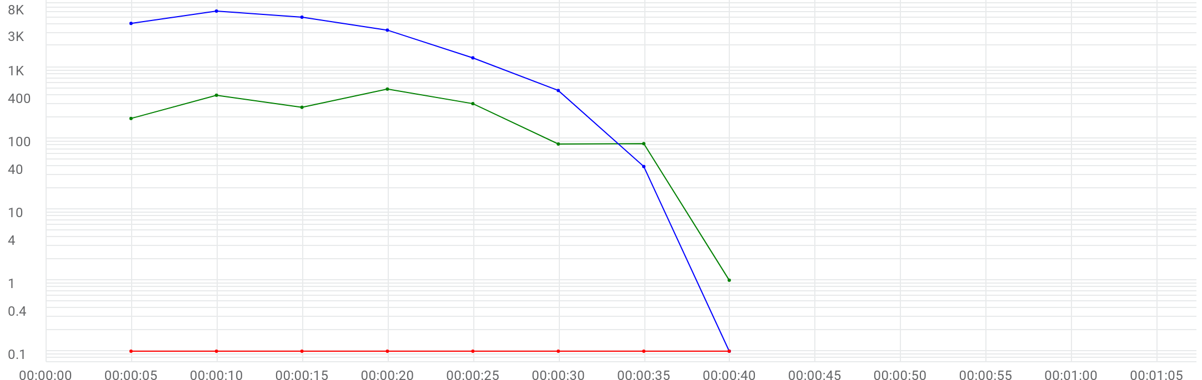

|  |  |  |  |  |  |  |  |
| --- | --- | --- | --- | --- | --- | --- | --- |
|  | Metric | Max | Min | Graph max | Graph avg | Graph min | Med |
| |  | | --- | |  | | Running Vusers | 6196 | 0 | 6196 | 2580.375 | 0 | 3338 |
| |  | | --- | |  | | Passed transactions per second | N/A | N/A | 493.2 | 229.5 | 1 | 273.2 |
| |  | | --- | |  | | Failed transactions per second | N/A | N/A | 0 | 0 | 0 | 0 |

# Transactions

**102_eShowBizz_CWS_Book_Buy**

|  |  |  |  |  |  |  |  |  |  |
| --- | --- | --- | --- | --- | --- | --- | --- | --- | --- |
| Transaction | SLA status | Avg | Min | Max | STD | TRT percentile Threshold | 90th | Passed | Failed |
| Eshowbizz_03_BookSeats | N/A | 5.634 | 0.078 | 16.096 | 4.354 | 0.000 | 11.633 | 90 | 0 |
| Eshowbizz_04_Buy | N/A | 3.152 | 0.588 | 16.610 | 3.023 | 0.000 | 6.780 | 90 | 0 |
| ShowSeats_AllClasses_Open | N/A | 6.704 | 0.033 | 23.883 | 5.582 | 0.000 | 14.914 | 90 | 0 |

**101_eShowBizz_ShowSeats_AllClassOpen**

|  |  |  |  |  |  |  |  |  |  |
| --- | --- | --- | --- | --- | --- | --- | --- | --- | --- |
| Transaction | SLA status | Avg | Min | Max | STD | TRT percentile Threshold | 90th | Passed | Failed |
| ShowSeats_AllClasses_Open | N/A | 6.158 | 0.020 | 22.889 | 4.837 | 0.000 | 18.265 | 8910 | 0 |

# Errors / sec

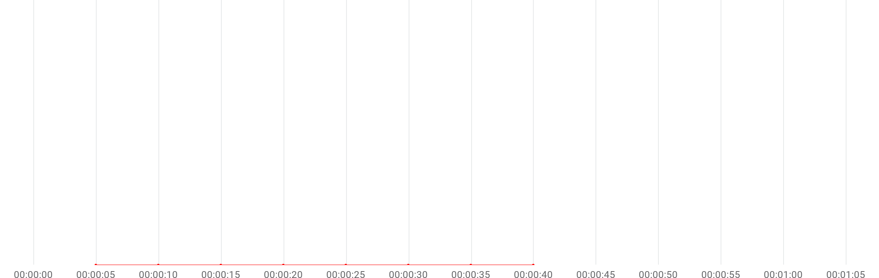

|  |  |  |  |  |  |  |  |
| --- | --- | --- | --- | --- | --- | --- | --- |
|  | Metric | Max | Min | Graph max | Graph avg | Graph min | Med |
| |  | | --- | |  | | Errors per second | N/A | N/A | 0 | 0 | 0 | 0 |

# Errors summary

No Data available

# Throughput & Hits / sec

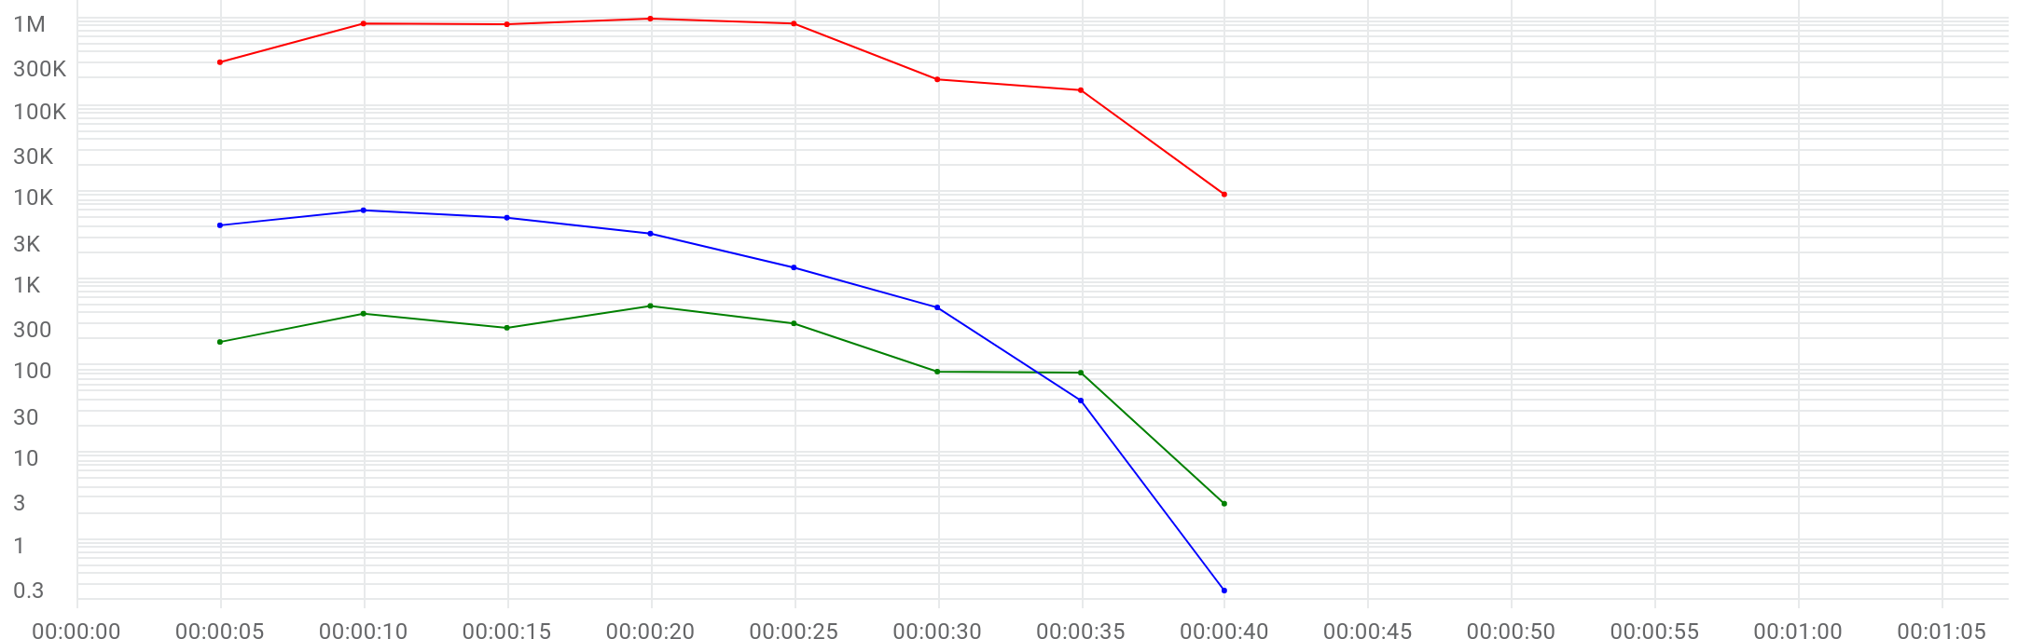

|  |  |  |  |  |  |  |  |
| --- | --- | --- | --- | --- | --- | --- | --- |
|  | Metric | Max | Min | Graph max | Graph avg | Graph min | Med |
| |  | | --- | |  | | Running Vusers | 6196 | 0 | 6196 | 2580.375 | 0 | 3338 |
| |  | | --- | |  | | Hits per second | 491 | 2.6 | 491 | 229.5 | 2.6 | 275 |
| |  | | --- | |  | | Throughput | 970.222 KB/s | 9.217 KB/s | 970.222 KB/s | 520.08 KB/s | 9.217 KB/s | 834.427 KB/s |

# Scripts

|  |  |  |  |  |  |  |
| --- | --- | --- | --- | --- | --- | --- |
| Script | Vusers | Ramp up | Iterations planned | Duration | Max duration | Location |
| 101_eShowBizz_ShowSeats_AllClassOpen | 8910 | 00:00:14 / 00:00:10 | 1 | 00:00:20 | 00:05:00 | On Premise |
| 102_eShowBizz_CWS_Book_Buy | 90 | 00:00:14 / 00:00:10 | 1 | 00:00:22 | 00:05:00 | On Premise |

# Distribution

|  |  |  |
| --- | --- | --- |
| Distribution | %Vusers | No Emulation |
| On-Premise | 100.0% | 100.0% |

# TRT [90th]



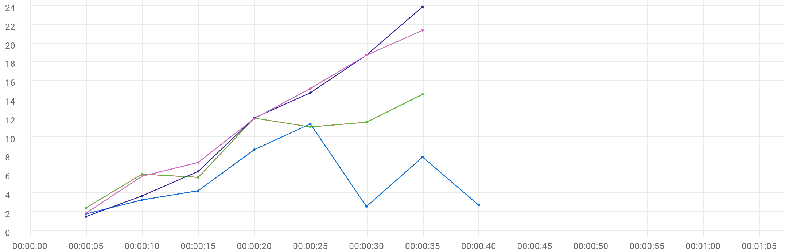

|  |  |  |  |  |  |  |  |  |  |  |  |
| --- | --- | --- | --- | --- | --- | --- | --- | --- | --- | --- | --- |
|  | Metric | Transaction | Script | Location | Emulation | Max | Min | Graph max | Graph avg | Graph min | Med |
| |  | | --- | |  | | TRT [90 th percentile] | Eshowbizz_04_Buy | 102_eShowBizz_CWS_Book_Buy | All | All | N/A | N/A | 11.381 sec | 5.303 sec | 1.768 sec | 4.246 sec |
| |  | | --- | |  | | TRT [90 th percentile] | Eshowbizz_03_BookSeats | 102_eShowBizz_CWS_Book_Buy | All | All | N/A | N/A | 14.538 sec | 9.042 sec | 2.424 sec | 11.564 sec |
| |  | | --- | |  | | TRT [90 th percentile] | ShowSeats_AllClasses_Open | 102_eShowBizz_CWS_Book_Buy | All | All | N/A | N/A | 23.883 sec | 11.55 sec | 1.493 sec | 14.706 sec |
| |  | | --- | |  | | TRT [90 th percentile] | ShowSeats_AllClasses_Open | 101_eShowBizz_ShowSeats_AllClassOpen | All | All | N/A | N/A | 21.374 sec | 11.735 sec | 1.862 sec | 15.159 sec |
| |  | | --- | |  | | TRT [90 th percentile] | Eshowbizz_04_Buy | 102_eShowBizz_CWS_Book_Buy | On-Premise | All | N/A | N/A | 11.381 sec | 5.303 sec | 1.768 sec | 4.246 sec |
| |  | | --- | |  | | TRT [90 th percentile] | Eshowbizz_03_BookSeats | 102_eShowBizz_CWS_Book_Buy | On-Premise | All | N/A | N/A | 14.538 sec | 9.042 sec | 2.424 sec | 11.564 sec |
| |  | | --- | |  | | TRT [90 th percentile] | ShowSeats_AllClasses_Open | 102_eShowBizz_CWS_Book_Buy | On-Premise | All | N/A | N/A | 23.883 sec | 11.55 sec | 1.493 sec | 14.706 sec |
| |  | | --- | |  | | TRT [90 th percentile] | ShowSeats_AllClasses_Open | 101_eShowBizz_ShowSeats_AllClassOpen | On-Premise | All | N/A | N/A | 21.374 sec | 11.735 sec | 1.862 sec | 15.159 sec |
| |  | | --- | |  | | TRT [90 th percentile] | Eshowbizz_04_Buy | 102_eShowBizz_CWS_Book_Buy | On-Premise | No Emulation | N/A | N/A | 11.381 sec | 5.303 sec | 1.768 sec | 4.246 sec |
| |  | | --- | |  | | TRT [90 th percentile] | Eshowbizz_03_BookSeats | 102_eShowBizz_CWS_Book_Buy | On-Premise | No Emulation | N/A | N/A | 14.538 sec | 9.042 sec | 2.424 sec | 11.564 sec |
| |  | | --- | |  | | TRT [90 th percentile] | ShowSeats_AllClasses_Open | 102_eShowBizz_CWS_Book_Buy | On-Premise | No Emulation | N/A | N/A | 23.883 sec | 11.55 sec | 1.493 sec | 14.706 sec |
| |  | | --- | |  | | TRT [90 th percentile] | ShowSeats_AllClasses_Open | 101_eShowBizz_ShowSeats_AllClassOpen | On-Premise | No Emulation | N/A | N/A | 21.374 sec | 11.735 sec | 1.862 sec | 15.159 sec |

# Running Vusers



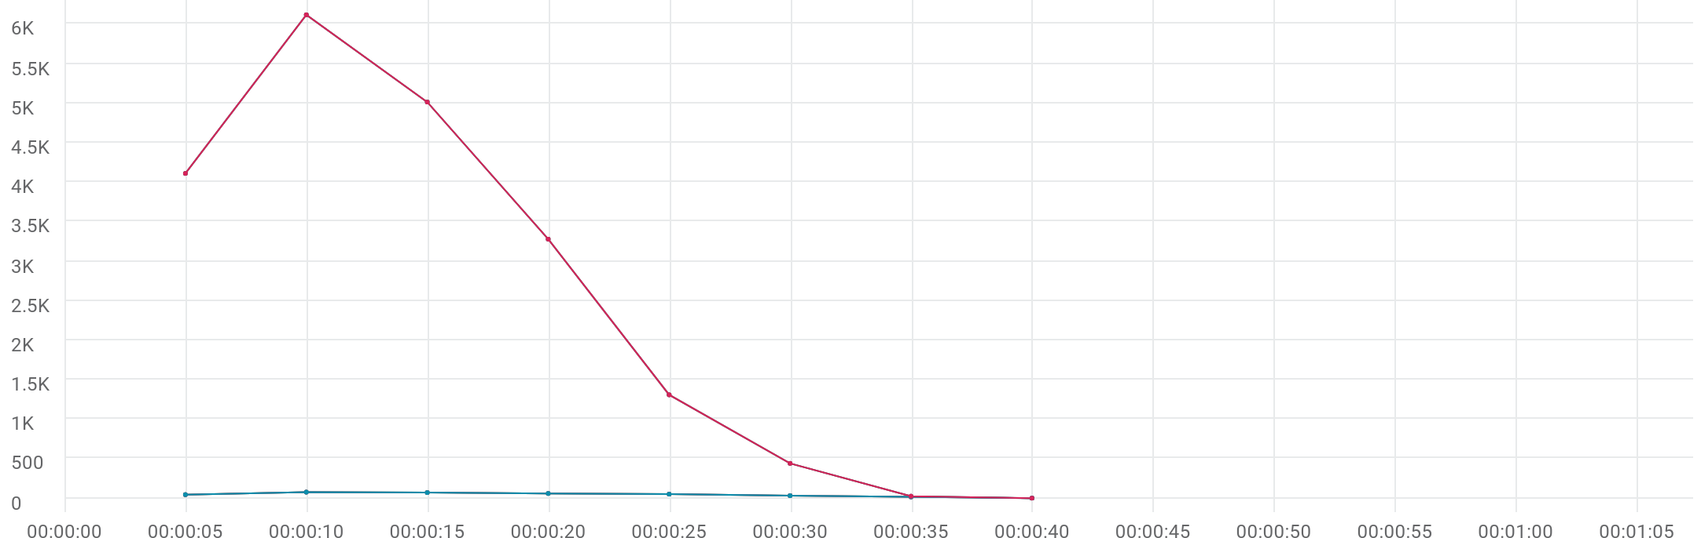

|  |  |  |  |  |  |  |  |  |  |  |
| --- | --- | --- | --- | --- | --- | --- | --- | --- | --- | --- |
|  | Metric | Script | Location | Emulation | Max | Min | Graph max | Graph avg | Graph min | Med |
| |  | | --- | |  | | Running Vusers | 102_eShowBizz_CWS_Book_Buy | All | All | 76 | 0 | 76 | 43.25 | 0 | 50 |
| |  | | --- | |  | | Running Vusers | 101_eShowBizz_ShowSeats_AllClassOpen | All | All | 6120 | 0 | 6120 | 2537.125 | 0 | 3279 |
| |  | | --- | |  | | Running Vusers | 102_eShowBizz_CWS_Book_Buy | On-Premise | All | 76 | 0 | 76 | 43.25 | 0 | 50 |
| |  | | --- | |  | | Running Vusers | 101_eShowBizz_ShowSeats_AllClassOpen | On-Premise | All | 6120 | 0 | 6120 | 2537.125 | 0 | 3279 |
| |  | | --- | |  | | Running Vusers | 102_eShowBizz_CWS_Book_Buy | On-Premise | No Emulation | 76 | 0 | 76 | 43.25 | 0 | 50 |
| |  | | --- | |  | | Running Vusers | 101_eShowBizz_ShowSeats_AllClassOpen | On-Premise | No Emulation | 6120 | 0 | 6120 | 2537.125 | 0 | 3279 |

# Failed Vusers



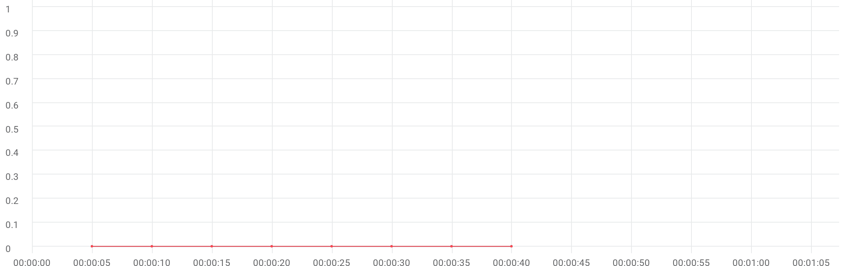

|  |  |  |  |  |  |  |  |  |  |  |
| --- | --- | --- | --- | --- | --- | --- | --- | --- | --- | --- |
|  | Metric | Script | Location | Emulation | Max | Min | Graph max | Graph avg | Graph min | Med |
| |  | | --- | |  | | Failed Vusers | 102_eShowBizz_CWS_Book_Buy | All | All | 0 | 0 | 0 | 0 | 0 | 0 |
| |  | | --- | |  | | Failed Vusers | 101_eShowBizz_ShowSeats_AllClassOpen | All | All | 0 | 0 | 0 | 0 | 0 | 0 |
| |  | | --- | |  | | Failed Vusers | 102_eShowBizz_CWS_Book_Buy | On-Premise | All | 0 | 0 | 0 | 0 | 0 | 0 |
| |  | | --- | |  | | Failed Vusers | 101_eShowBizz_ShowSeats_AllClassOpen | On-Premise | All | 0 | 0 | 0 | 0 | 0 | 0 |
| |  | | --- | |  | | Failed Vusers | 102_eShowBizz_CWS_Book_Buy | On-Premise | No Emulation | 0 | 0 | 0 | 0 | 0 | 0 |
| |  | | --- | |  | | Failed Vusers | 101_eShowBizz_ShowSeats_AllClassOpen | On-Premise | No Emulation | 0 | 0 | 0 | 0 | 0 | 0 |

# Hits per second



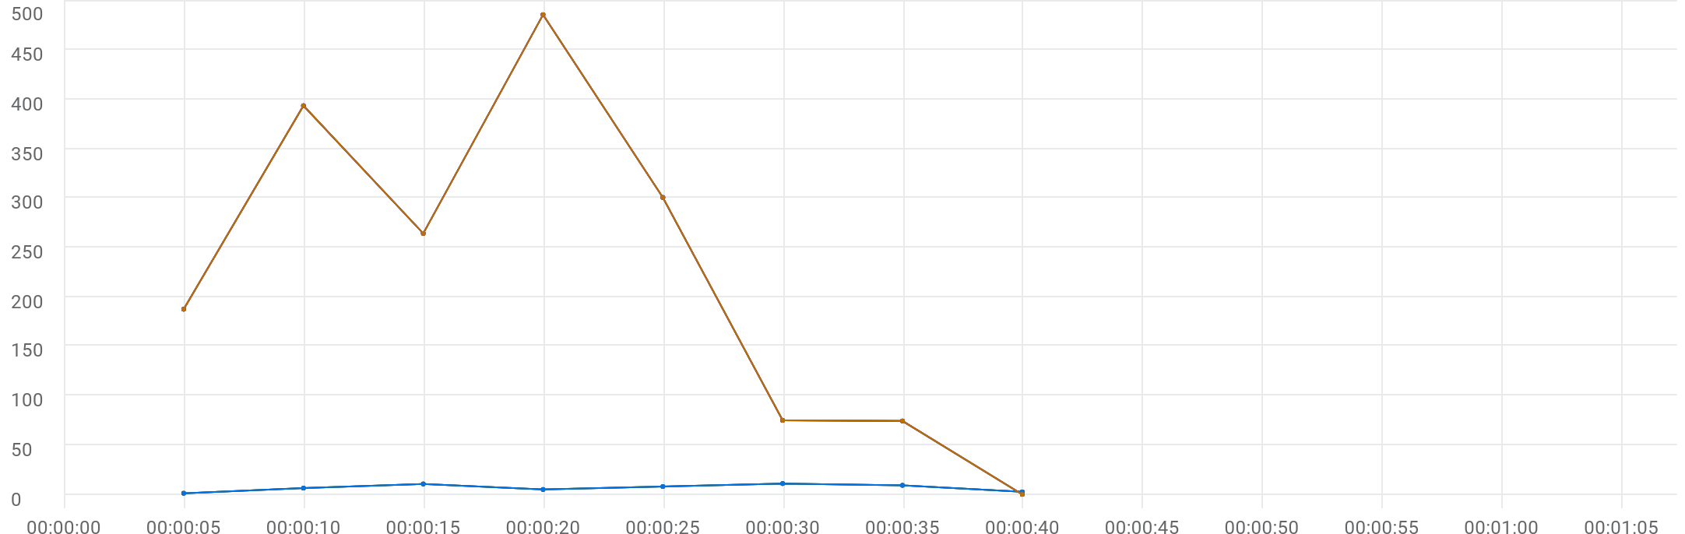

|  |  |  |  |  |  |  |  |  |  |  |
| --- | --- | --- | --- | --- | --- | --- | --- | --- | --- | --- |
|  | Metric | Script | Location | Emulation | Max | Min | Graph max | Graph avg | Graph min | Med |
| |  | | --- | |  | | Hits per second | 102_eShowBizz_CWS_Book_Buy | All | All | 11 | 1.2 | 11 | 6.75 | 1.2 | 8 |
| |  | | --- | |  | | Hits per second | 101_eShowBizz_ShowSeats_AllClassOpen | All | All | 486 | 0 | 486 | 222.75 | 0 | 264.4 |
| |  | | --- | |  | | Hits per second | 102_eShowBizz_CWS_Book_Buy | On-Premise | All | 11 | 1.2 | 11 | 6.75 | 1.2 | 8 |
| |  | | --- | |  | | Hits per second | 101_eShowBizz_ShowSeats_AllClassOpen | On-Premise | All | 486 | 0 | 486 | 222.75 | 0 | 264.4 |
| |  | | --- | |  | | Hits per second | 102_eShowBizz_CWS_Book_Buy | On-Premise | No Emulation | 11 | 1.2 | 11 | 6.75 | 1.2 | 8 |
| |  | | --- | |  | | Hits per second | 101_eShowBizz_ShowSeats_AllClassOpen | On-Premise | No Emulation | 486 | 0 | 486 | 222.75 | 0 | 264.4 |
| |  | | --- | |  | | HTTP_200 | 102_eShowBizz_CWS_Book_Buy | On-Premise | No Emulation | 11 | 1.2 | 11 | 6.75 | 1.2 | 8 |
| |  | | --- | |  | | HTTP_200 | 101_eShowBizz_ShowSeats_AllClassOpen | On-Premise | No Emulation | 486 | 0 | 486 | 222.75 | 0 | 264.4 |

# Throughput



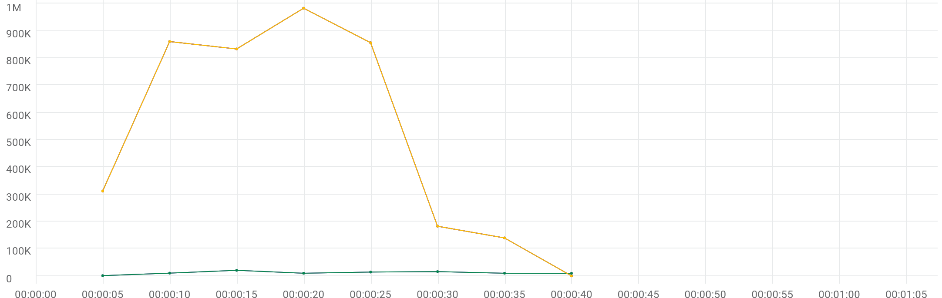

|  |  |  |  |  |  |  |  |  |  |  |
| --- | --- | --- | --- | --- | --- | --- | --- | --- | --- | --- |
|  | Metric | Script | Location | Emulation | Max | Min | Graph max | Graph avg | Graph min | Med |
| |  | | --- | |  | | Throughput | 102_eShowBizz_CWS_Book_Buy | All | All | 19.971 KB/s | 1.04 KB/s | 19.971 KB/s | 11.087 KB/s | 1.04 KB/s | 9.964 KB/s |
| |  | | --- | |  | | Throughput | 101_eShowBizz_ShowSeats_AllClassOpen | All | All | 960.707 KB/s | 0 Byte/s | 960.707 KB/s | 508.993 KB/s | 0 Byte/s | 814.455 KB/s |
| |  | | --- | |  | | Throughput | 102_eShowBizz_CWS_Book_Buy | On-Premise | All | 19.971 KB/s | 1.04 KB/s | 19.971 KB/s | 11.087 KB/s | 1.04 KB/s | 9.964 KB/s |
| |  | | --- | |  | | Throughput | 101_eShowBizz_ShowSeats_AllClassOpen | On-Premise | All | 960.707 KB/s | 0 Byte/s | 960.707 KB/s | 508.993 KB/s | 0 Byte/s | 814.455 KB/s |
| |  | | --- | |  | | Throughput | 102_eShowBizz_CWS_Book_Buy | On-Premise | No Emulation | 19.971 KB/s | 1.04 KB/s | 19.971 KB/s | 11.087 KB/s | 1.04 KB/s | 9.964 KB/s |
| |  | | --- | |  | | Throughput | 101_eShowBizz_ShowSeats_AllClassOpen | On-Premise | No Emulation | 960.707 KB/s | 0 Byte/s | 960.707 KB/s | 508.993 KB/s | 0 Byte/s | 814.455 KB/s |

# Errors



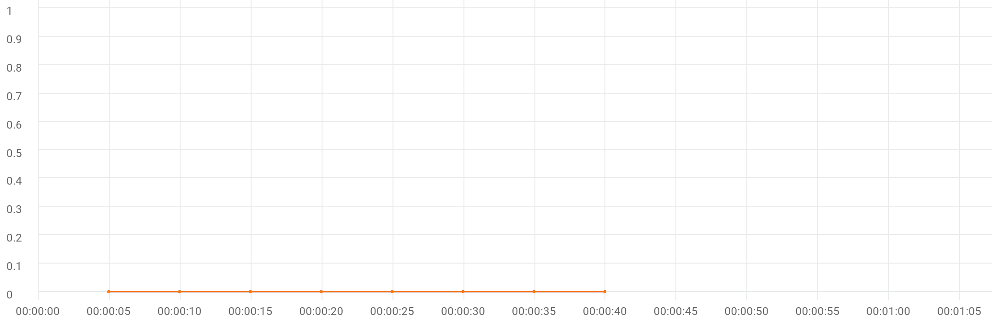

|  |  |  |  |  |  |  |  |  |  |  |
| --- | --- | --- | --- | --- | --- | --- | --- | --- | --- | --- |
|  | Metric | Script | Location | Emulation | Max | Min | Graph max | Graph avg | Graph min | Med |
| |  | | --- | |  | | Errors | 102_eShowBizz_CWS_Book_Buy | All | All | N/A | N/A | 0 | 0 | 0 | 0 |
| |  | | --- | |  | | Errors | 101_eShowBizz_ShowSeats_AllClassOpen | All | All | N/A | N/A | 0 | 0 | 0 | 0 |
| |  | | --- | |  | | Errors | 102_eShowBizz_CWS_Book_Buy | On-Premise | All | N/A | N/A | 0 | 0 | 0 | 0 |
| |  | | --- | |  | | Errors | 101_eShowBizz_ShowSeats_AllClassOpen | On-Premise | All | N/A | N/A | 0 | 0 | 0 | 0 |
| |  | | --- | |  | | Errors | 102_eShowBizz_CWS_Book_Buy | On-Premise | No Emulation | N/A | N/A | 0 | 0 | 0 | 0 |
| |  | | --- | |  | | Errors | 101_eShowBizz_ShowSeats_AllClassOpen | On-Premise | No Emulation | N/A | N/A | 0 | 0 | 0 | 0 |

# TRT [AVG]



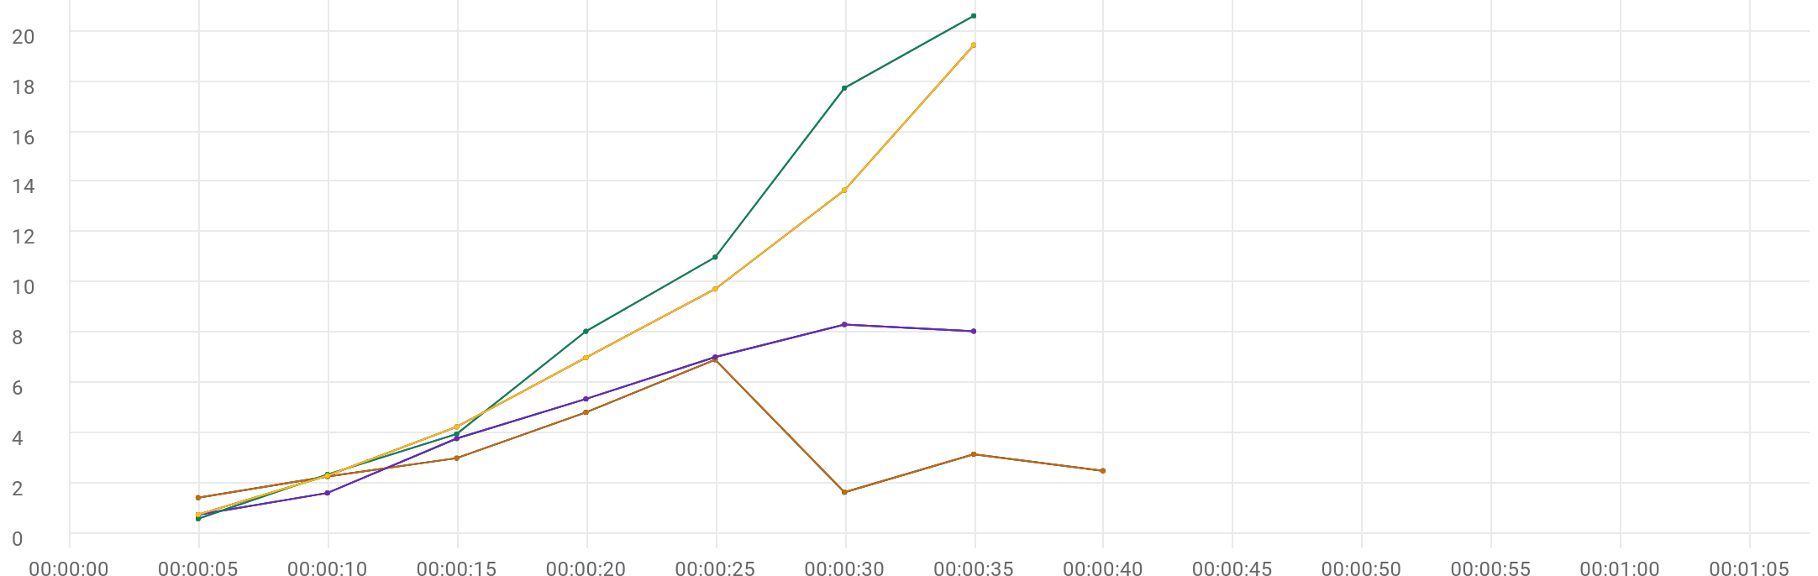

|  |  |  |  |  |  |  |  |  |  |  |  |
| --- | --- | --- | --- | --- | --- | --- | --- | --- | --- | --- | --- |
|  | Metric | Transaction | Script | Location | Emulation | Max | Min | Graph max | Graph avg | Graph min | Med |
| |  | | --- | |  | | TRT [AVG] | Eshowbizz_04_Buy | 102_eShowBizz_CWS_Book_Buy | All | All | N/A | N/A | 6.922 sec | 3.214 sec | 1.42 sec | 2.997 sec |
| |  | | --- | |  | | TRT [AVG] | Eshowbizz_03_BookSeats | 102_eShowBizz_CWS_Book_Buy | All | All | N/A | N/A | 8.323 sec | 4.983 sec | 741.488 ms | 7.023 sec |
| |  | | --- | |  | | TRT [AVG] | ShowSeats_AllClasses_Open | 102_eShowBizz_CWS_Book_Buy | All | All | N/A | N/A | 20.629 sec | 9.19 sec | 581.656 ms | 11.009 sec |
| |  | | --- | |  | | TRT [AVG] | ShowSeats_AllClasses_Open | 101_eShowBizz_ShowSeats_AllClassOpen | All | All | N/A | N/A | 19.462 sec | 8.167 sec | 745.688 ms | 9.737 sec |
| |  | | --- | |  | | TRT [AVG] | Eshowbizz_04_Buy | 102_eShowBizz_CWS_Book_Buy | On-Premise | All | N/A | N/A | 6.922 sec | 3.214 sec | 1.42 sec | 2.997 sec |
| |  | | --- | |  | | TRT [AVG] | Eshowbizz_03_BookSeats | 102_eShowBizz_CWS_Book_Buy | On-Premise | All | N/A | N/A | 8.323 sec | 4.983 sec | 741.488 ms | 7.023 sec |
| |  | | --- | |  | | TRT [AVG] | ShowSeats_AllClasses_Open | 102_eShowBizz_CWS_Book_Buy | On-Premise | All | N/A | N/A | 20.629 sec | 9.19 sec | 581.656 ms | 11.009 sec |
| |  | | --- | |  | | TRT [AVG] | ShowSeats_AllClasses_Open | 101_eShowBizz_ShowSeats_AllClassOpen | On-Premise | All | N/A | N/A | 19.462 sec | 8.167 sec | 745.688 ms | 9.737 sec |
| |  | | --- | |  | | TRT [AVG] | Eshowbizz_04_Buy | 102_eShowBizz_CWS_Book_Buy | On-Premise | No Emulation | N/A | N/A | 6.922 sec | 3.214 sec | 1.42 sec | 2.997 sec |
| |  | | --- | |  | | TRT [AVG] | Eshowbizz_03_BookSeats | 102_eShowBizz_CWS_Book_Buy | On-Premise | No Emulation | N/A | N/A | 8.323 sec | 4.983 sec | 741.488 ms | 7.023 sec |
| |  | | --- | |  | | TRT [AVG] | ShowSeats_AllClasses_Open | 102_eShowBizz_CWS_Book_Buy | On-Premise | No Emulation | N/A | N/A | 20.629 sec | 9.19 sec | 581.656 ms | 11.009 sec |
| |  | | --- | |  | | TRT [AVG] | ShowSeats_AllClasses_Open | 101_eShowBizz_ShowSeats_AllClassOpen | On-Premise | No Emulation | N/A | N/A | 19.462 sec | 8.167 sec | 745.688 ms | 9.737 sec |

# TRT [MIN]



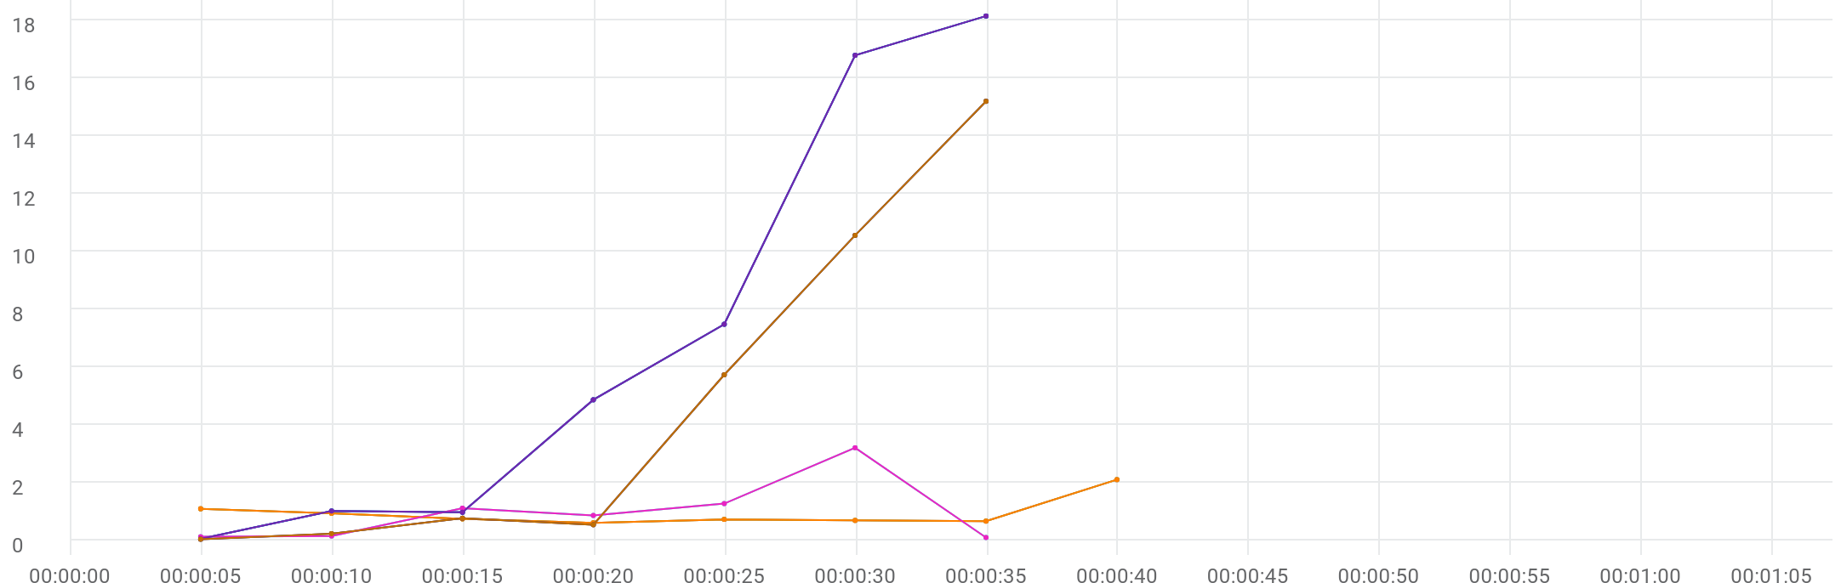

|  |  |  |  |  |  |  |  |  |  |  |  |
| --- | --- | --- | --- | --- | --- | --- | --- | --- | --- | --- | --- |
|  | Metric | Transaction | Script | Location | Emulation | Max | Min | Graph max | Graph avg | Graph min | Med |
| |  | | --- | |  | | TRT [MIN] | Eshowbizz_04_Buy | 102_eShowBizz_CWS_Book_Buy | All | All | N/A | N/A | 2.082 sec | 925.869 ms | 588.131 ms | 724.165 ms |
| |  | | --- | |  | | TRT [MIN] | Eshowbizz_03_BookSeats | 102_eShowBizz_CWS_Book_Buy | All | All | N/A | N/A | 3.186 sec | 955.795 ms | 78.376 ms | 1.095 sec |
| |  | | --- | |  | | TRT [MIN] | ShowSeats_AllClasses_Open | 102_eShowBizz_CWS_Book_Buy | All | All | N/A | N/A | 18.131 sec | 7.027 sec | 33.355 ms | 7.462 sec |
| |  | | --- | |  | | TRT [MIN] | Eshowbizz_04_Buy | 102_eShowBizz_CWS_Book_Buy | On-Premise | All | N/A | N/A | 2.082 sec | 925.869 ms | 588.131 ms | 724.165 ms |
| |  | | --- | |  | | TRT [MIN] | ShowSeats_AllClasses_Open | 101_eShowBizz_ShowSeats_AllClassOpen | All | All | N/A | N/A | 15.179 sec | 4.704 sec | 20.118 ms | 5.712 sec |
| |  | | --- | |  | | TRT [MIN] | Eshowbizz_03_BookSeats | 102_eShowBizz_CWS_Book_Buy | On-Premise | All | N/A | N/A | 3.186 sec | 955.795 ms | 78.376 ms | 1.095 sec |
| |  | | --- | |  | | TRT [MIN] | ShowSeats_AllClasses_Open | 102_eShowBizz_CWS_Book_Buy | On-Premise | All | N/A | N/A | 18.131 sec | 7.027 sec | 33.355 ms | 7.462 sec |
| |  | | --- | |  | | TRT [MIN] | Eshowbizz_04_Buy | 102_eShowBizz_CWS_Book_Buy | On-Premise | No Emulation | N/A | N/A | 2.082 sec | 925.869 ms | 588.131 ms | 724.165 ms |
| |  | | --- | |  | | TRT [MIN] | ShowSeats_AllClasses_Open | 101_eShowBizz_ShowSeats_AllClassOpen | On-Premise | All | N/A | N/A | 15.179 sec | 4.704 sec | 20.118 ms | 5.712 sec |
| |  | | --- | |  | | TRT [MIN] | Eshowbizz_03_BookSeats | 102_eShowBizz_CWS_Book_Buy | On-Premise | No Emulation | N/A | N/A | 3.186 sec | 955.795 ms | 78.376 ms | 1.095 sec |
| |  | | --- | |  | | TRT [MIN] | ShowSeats_AllClasses_Open | 102_eShowBizz_CWS_Book_Buy | On-Premise | No Emulation | N/A | N/A | 18.131 sec | 7.027 sec | 33.355 ms | 7.462 sec |
| |  | | --- | |  | | TRT [MIN] | ShowSeats_AllClasses_Open | 101_eShowBizz_ShowSeats_AllClassOpen | On-Premise | No Emulation | N/A | N/A | 15.179 sec | 4.704 sec | 20.118 ms | 5.712 sec |

# TRT [MAX]



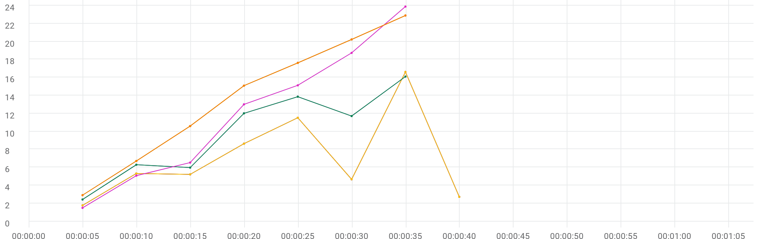

|  |  |  |  |  |  |  |  |  |  |  |  |
| --- | --- | --- | --- | --- | --- | --- | --- | --- | --- | --- | --- |
|  | Metric | Transaction | Script | Location | Emulation | Max | Min | Graph max | Graph avg | Graph min | Med |
| |  | | --- | |  | | TRT [MAX] | Eshowbizz_04_Buy | 102_eShowBizz_CWS_Book_Buy | All | All | N/A | N/A | 16.61 sec | 7.057 sec | 1.768 sec | 5.316 sec |
| |  | | --- | |  | | TRT [MAX] | Eshowbizz_03_BookSeats | 102_eShowBizz_CWS_Book_Buy | All | All | N/A | N/A | 16.096 sec | 9.765 sec | 2.424 sec | 12.008 sec |
| |  | | --- | |  | | TRT [MAX] | ShowSeats_AllClasses_Open | 102_eShowBizz_CWS_Book_Buy | All | All | N/A | N/A | 23.883 sec | 11.977 sec | 1.493 sec | 15.123 sec |
| |  | | --- | |  | | TRT [MAX] | Eshowbizz_04_Buy | 102_eShowBizz_CWS_Book_Buy | On-Premise | All | N/A | N/A | 16.61 sec | 7.057 sec | 1.768 sec | 5.316 sec |
| |  | | --- | |  | | TRT [MAX] | ShowSeats_AllClasses_Open | 101_eShowBizz_ShowSeats_AllClassOpen | All | All | N/A | N/A | 22.889 sec | 13.717 sec | 2.902 sec | 17.62 sec |
| |  | | --- | |  | | TRT [MAX] | Eshowbizz_03_BookSeats | 102_eShowBizz_CWS_Book_Buy | On-Premise | All | N/A | N/A | 16.096 sec | 9.765 sec | 2.424 sec | 12.008 sec |
| |  | | --- | |  | | TRT [MAX] | ShowSeats_AllClasses_Open | 102_eShowBizz_CWS_Book_Buy | On-Premise | All | N/A | N/A | 23.883 sec | 11.977 sec | 1.493 sec | 15.123 sec |
| |  | | --- | |  | | TRT [MAX] | Eshowbizz_04_Buy | 102_eShowBizz_CWS_Book_Buy | On-Premise | No Emulation | N/A | N/A | 16.61 sec | 7.057 sec | 1.768 sec | 5.316 sec |
| |  | | --- | |  | | TRT [MAX] | ShowSeats_AllClasses_Open | 101_eShowBizz_ShowSeats_AllClassOpen | On-Premise | All | N/A | N/A | 22.889 sec | 13.717 sec | 2.902 sec | 17.62 sec |
| |  | | --- | |  | | TRT [MAX] | Eshowbizz_03_BookSeats | 102_eShowBizz_CWS_Book_Buy | On-Premise | No Emulation | N/A | N/A | 16.096 sec | 9.765 sec | 2.424 sec | 12.008 sec |
| |  | | --- | |  | | TRT [MAX] | ShowSeats_AllClasses_Open | 102_eShowBizz_CWS_Book_Buy | On-Premise | No Emulation | N/A | N/A | 23.883 sec | 11.977 sec | 1.493 sec | 15.123 sec |
| |  | | --- | |  | | TRT [MAX] | ShowSeats_AllClasses_Open | 101_eShowBizz_ShowSeats_AllClassOpen | On-Premise | No Emulation | N/A | N/A | 22.889 sec | 13.717 sec | 2.902 sec | 17.62 sec |