

eShowBizz_SC3_18thMarch - #23

PASSED



# Summary

|  |  |
| --- | --- |
| Run ID | #23 |
| Status | Passed |
| Duration | 00:00:53 |
| Run mode | Iterations |
| Think time | Included |
| Errors | 4 |
| LG alerts | 0 |
| Date | Mar 18, 2023 |
| Time | 13:48 (GMT +05:30) |
| Percentile algorithm | Optimal |
| Percentile value | 90 |
| Average Throughput | 73.651 KB/s |
| Total Throughput | 1.798 MB |
| Average Hits | 43.040 Hits/s |
| Total Hits | 1,076 |
| Passed Transactions | 1,072 |
| Failed Transactions | 4 |
| Passed TRT breakers | - |
| Failed TRT breakers | - |
| Total WEB Vusers | 360 |
| Total Failed Vusers | 0 |

# Top 10 transactions

|  |  |  |  |  |  |  |  |  |  |  |
| --- | --- | --- | --- | --- | --- | --- | --- | --- | --- | --- |
| Script | Transaction | SLA status | Avg | Min | Max | STD | TRT percentile Threshold | 90th | Passed | Failed |
| 91_eShowBizz_CWS_Book_Buy251 (1) | Eshowbizz_04_Buy_251 | N/A | 2.413 | 0.618 | 7.129 | 1.427 | 0.000 | 4.522 | 90 | 0 |
| 91_eShowBizz_CWS_Book_Buy251 (1) | ShowSeats_AllClasses_Open_251 | N/A | 1.607 | 0.019 | 5.156 | 1.402 | 0.000 | 3.947 | 90 | 0 |
| 91_eShowBizz_CWS_Book_Buy251 (1) | Eshowbizz_03_BookSeats_251 | N/A | 0.988 | 0.039 | 4.726 | 1.124 | 0.000 | 2.393 | 90 | 0 |
| 92_eShowBizz_CWS_Book_Buy232 (1) | ShowSeats_AllClasses_Open_232 | N/A | 0.293 | 0.013 | 1.551 | 0.438 | 0.000 | 0.733 | 90 | 0 |
| 89_eShowBizz_CWS_Book_Buy202 (1) | Eshowbizz_04_Buy_202 | N/A | 0.216 | 0.062 | 0.894 | 0.128 | 0.000 | 0.283 | 90 | 0 |
| 89_eShowBizz_CWS_Book_Buy202 (1) | Eshowbizz_03_BookSeats_202 | N/A | 0.174 | 0.036 | 0.904 | 0.190 | 0.000 | 0.326 | 90 | 0 |
| 90_eShowBizz_CWS_Book_Buy183 (1) | Eshowbizz_04_Buy_183 | N/A | 0.157 | 0.042 | 0.287 | 0.063 | 0.000 | 0.238 | 90 | 0 |
| 90_eShowBizz_CWS_Book_Buy183 (1) | Eshowbizz_03_BookSeats_183 | N/A | 0.122 | 0.047 | 0.924 | 0.099 | 0.000 | 0.191 | 90 | 0 |
| 89_eShowBizz_CWS_Book_Buy202 (1) | ShowSeats_AllClasses_Open_202 | N/A | 0.122 | 0.012 | 0.776 | 0.206 | 0.000 | 0.457 | 90 | 0 |
| 90_eShowBizz_CWS_Book_Buy183 (1) | ShowSeats_AllClasses_Open_183 | N/A | 0.079 | 0.020 | 0.479 | 0.126 | 0.000 | 0.225 | 90 | 0 |

# Passed & Failed TRX / sec

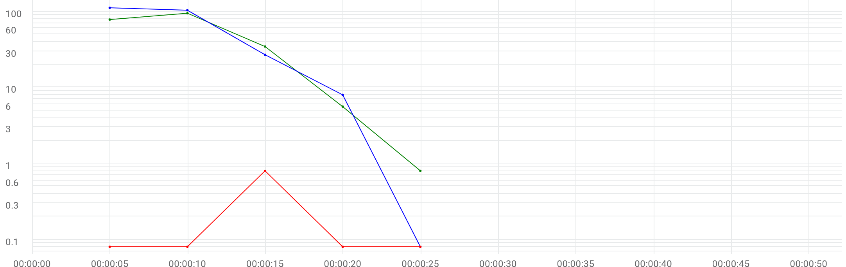

|  |  |  |  |  |  |  |  |
| --- | --- | --- | --- | --- | --- | --- | --- |
|  | Metric | Max | Min | Graph max | Graph avg | Graph min | Med |
| |  | | --- | |  | | Running Vusers | 112 | 0 | 112 | 50.2 | 0 | 104 |
| |  | | --- | |  | | Passed transactions per second | N/A | N/A | 95 | 42.88 | 0.8 | 78.4 |
| |  | | --- | |  | | Failed transactions per second | N/A | N/A | 0.8 | 0.16 | 0 | 0 |

# Transactions

**90_eShowBizz_CWS_Book_Buy183 (1)**

|  |  |  |  |  |  |  |  |  |  |
| --- | --- | --- | --- | --- | --- | --- | --- | --- | --- |
| Transaction | SLA status | Avg | Min | Max | STD | TRT percentile Threshold | 90th | Passed | Failed |
| Eshowbizz_03_BookSeats_183 | N/A | 0.122 | 0.047 | 0.924 | 0.099 | 0.000 | 0.191 | 90 | 0 |
| Eshowbizz_04_Buy_183 | N/A | 0.157 | 0.042 | 0.287 | 0.063 | 0.000 | 0.238 | 90 | 0 |
| ShowSeats_AllClasses_Open_183 | N/A | 0.079 | 0.020 | 0.479 | 0.126 | 0.000 | 0.225 | 90 | 0 |

**89_eShowBizz_CWS_Book_Buy202 (1)**

|  |  |  |  |  |  |  |  |  |  |
| --- | --- | --- | --- | --- | --- | --- | --- | --- | --- |
| Transaction | SLA status | Avg | Min | Max | STD | TRT percentile Threshold | 90th | Passed | Failed |
| Eshowbizz_03_BookSeats_202 | N/A | 0.174 | 0.036 | 0.904 | 0.190 | 0.000 | 0.326 | 90 | 0 |
| Eshowbizz_04_Buy_202 | N/A | 0.216 | 0.062 | 0.894 | 0.128 | 0.000 | 0.283 | 90 | 0 |
| ShowSeats_AllClasses_Open_202 | N/A | 0.122 | 0.012 | 0.776 | 0.206 | 0.000 | 0.457 | 90 | 0 |

**92_eShowBizz_CWS_Book_Buy232 (1)**

|  |  |  |  |  |  |  |  |  |  |
| --- | --- | --- | --- | --- | --- | --- | --- | --- | --- |
| Transaction | SLA status | Avg | Min | Max | STD | TRT percentile Threshold | 90th | Passed | Failed |
| Eshowbizz_03_BookSeats_232 | N/A | 0.343 | 0.032 | 1.201 | 0.329 | 0.000 | 0.915 | 86 | 4 |
| Eshowbizz_04_Buy_232 | N/A | 0.336 | 0.040 | 1.702 | 0.334 | 0.000 | 0.988 | 86 | 0 |
| ShowSeats_AllClasses_Open_232 | N/A | 0.293 | 0.013 | 1.551 | 0.438 | 0.000 | 0.733 | 90 | 0 |

**91_eShowBizz_CWS_Book_Buy251 (1)**

|  |  |  |  |  |  |  |  |  |  |
| --- | --- | --- | --- | --- | --- | --- | --- | --- | --- |
| Transaction | SLA status | Avg | Min | Max | STD | TRT percentile Threshold | 90th | Passed | Failed |
| Eshowbizz_03_BookSeats_251 | N/A | 0.988 | 0.039 | 4.726 | 1.124 | 0.000 | 2.393 | 90 | 0 |
| Eshowbizz_04_Buy_251 | N/A | 2.413 | 0.618 | 7.129 | 1.427 | 0.000 | 4.522 | 90 | 0 |
| ShowSeats_AllClasses_Open_251 | N/A | 1.607 | 0.019 | 5.156 | 1.402 | 0.000 | 3.947 | 90 | 0 |

# Errors / sec

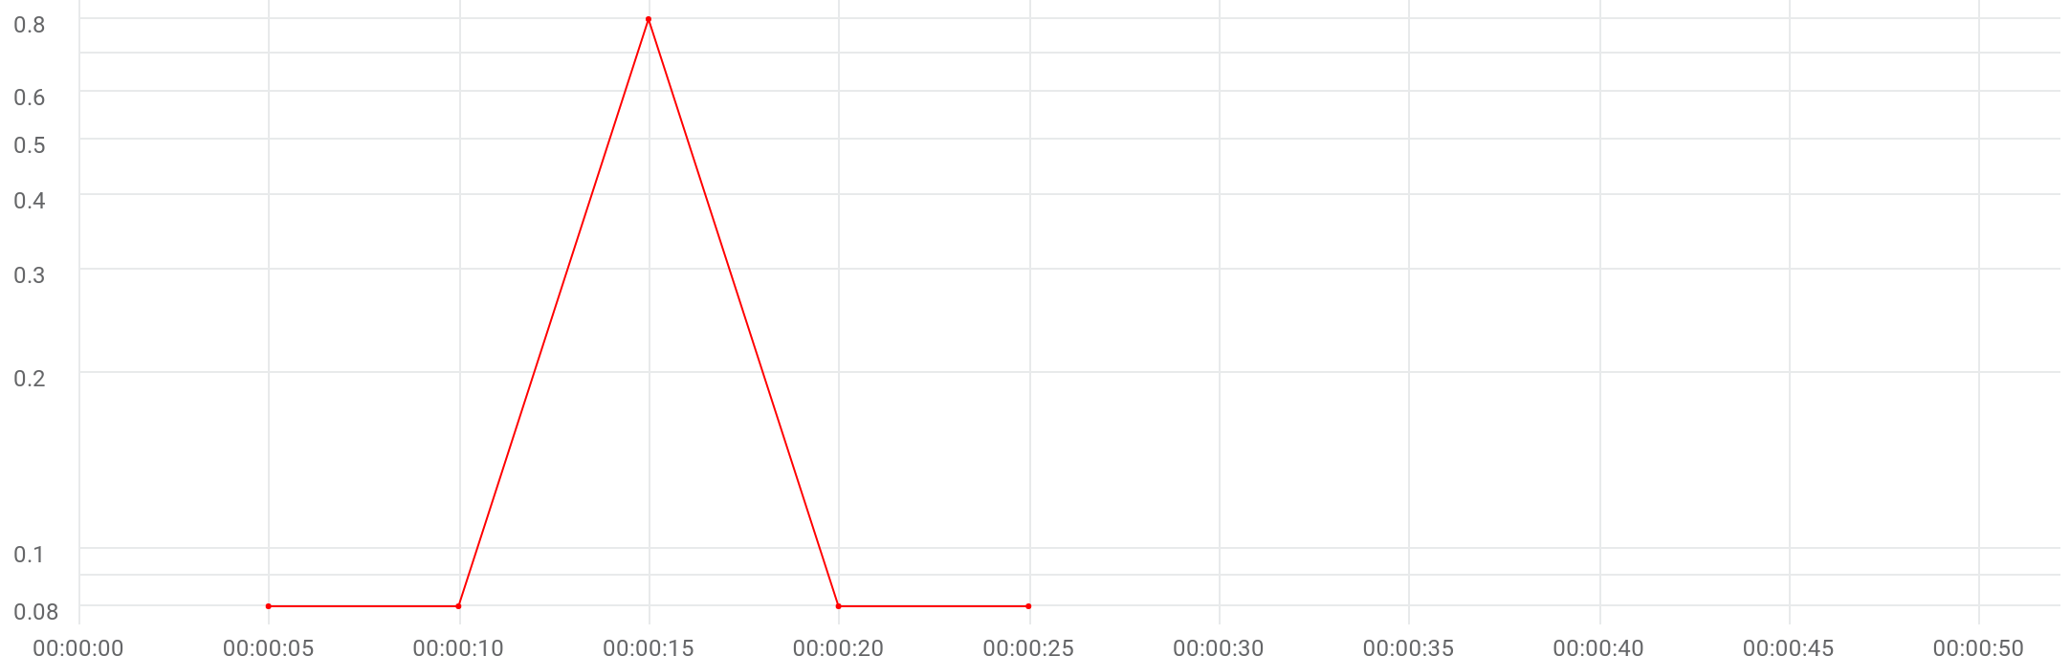

|  |  |  |  |  |  |  |  |
| --- | --- | --- | --- | --- | --- | --- | --- |
|  | Metric | Max | Min | Graph max | Graph avg | Graph min | Med |
| |  | | --- | |  | | Errors per second | N/A | N/A | 0.8 | 0.16 | 0 | 0 |

# Errors summary

**92_eShowBizz_CWS_Book_Buy232 (1)**

|  |  |  |
| --- | --- | --- |
| Error ID | Error message | Count |
| -26366 | Action.c(48): Error -26366: "Text=Available" not found for web_reg_find, Snapshot Info [MSH 1 2] [MsgId: MERR-26366] | 4 |

# Throughput & Hits / sec

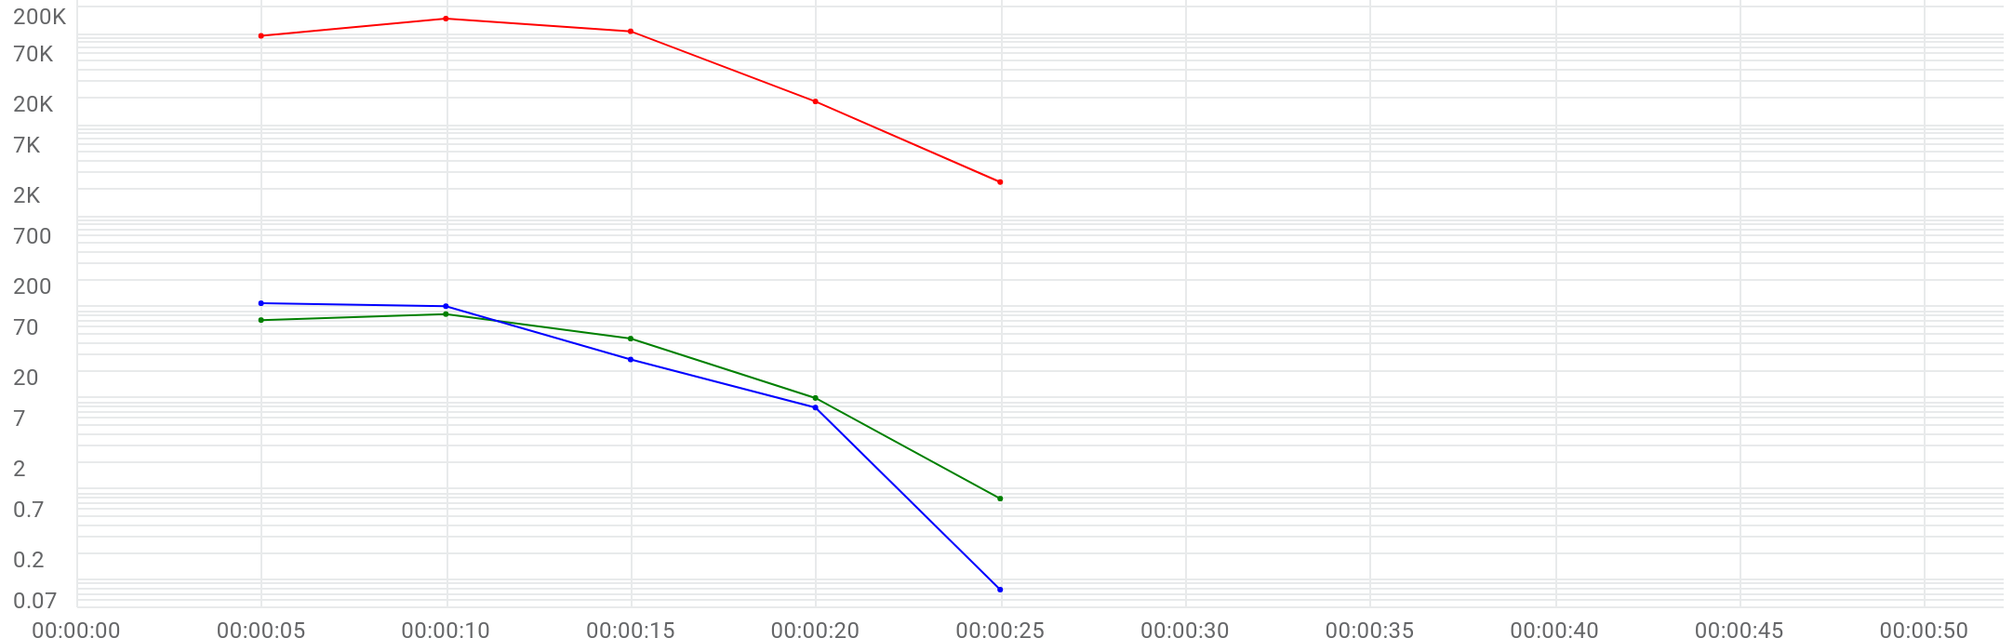

|  |  |  |  |  |  |  |  |
| --- | --- | --- | --- | --- | --- | --- | --- |
|  | Metric | Max | Min | Graph max | Graph avg | Graph min | Med |
| |  | | --- | |  | | Running Vusers | 112 | 0 | 112 | 50.2 | 0 | 104 |
| |  | | --- | |  | | Hits per second | 85.2 | 0.8 | 85.2 | 43.04 | 0.8 | 73.2 |
| |  | | --- | |  | | Throughput | 146.663 KB/s | 2.348 KB/s | 146.663 KB/s | 73.651 KB/s | 2.348 KB/s | 106.379 KB/s |

# Scripts

|  |  |  |  |  |  |  |
| --- | --- | --- | --- | --- | --- | --- |
| Script | Vusers | Ramp up | Iterations planned | Duration | Max duration | Location |
| 89_eShowBizz_CWS_Book_Buy202 (1) | 90 | 00:00:10 | 1 | 00:00:02 | 00:05:00 | On Premise |
| 90_eShowBizz_CWS_Book_Buy183 (1) | 90 | 00:00:10 | 1 | 00:00:03 | 00:05:00 | On Premise |
| 91_eShowBizz_CWS_Book_Buy251 (1) | 90 | 00:00:10 | 1 | 00:00:11 | 00:05:00 | On Premise |
| 92_eShowBizz_CWS_Book_Buy232 (1) | 90 | 00:00:10 | 1 | 00:00:02 | 00:05:00 | On Premise |

# Distribution

|  |  |  |
| --- | --- | --- |
| Distribution | %Vusers | No Emulation |
| On-Premise | 100.0% | 100.0% |

# LG health monitoring

|  |  |  |  |  |
| --- | --- | --- | --- | --- |
| LOCATION | Host | Metric | Max | Avg |
| On-Premise | EC2AMAZ-2O3HKBP-172.31.11.184 | CPU | 0.6% | 0.6% |
| On-Premise | EC2AMAZ-2O3HKBP-172.31.11.184 | DISK | 24.25% | 24.25% |
| On-Premise | EC2AMAZ-2O3HKBP-172.31.11.184 | MEMORY | 13.64% | 13.64% |

# HTTP responses

**89_eShowBizz_CWS_Book_Buy202 (1)**

|  |  |  |
| --- | --- | --- |
| HTTP response | Total | Avg |
| HTTP_200 | 270 | 18 |

**90_eShowBizz_CWS_Book_Buy183 (1)**

|  |  |  |
| --- | --- | --- |
| HTTP response | Total | Avg |
| HTTP_200 | 270 | 18 |

**91_eShowBizz_CWS_Book_Buy251 (1)**

|  |  |  |
| --- | --- | --- |
| HTTP response | Total | Avg |
| HTTP_200 | 270 | 10.8 |

**92_eShowBizz_CWS_Book_Buy232 (1)**

|  |  |  |
| --- | --- | --- |
| HTTP response | Total | Avg |
| HTTP_200 | 266 | 17.733 |

# OPLG scripts

|  |  |  |
| --- | --- | --- |
| Load generator | Script | Vusers |
| eShowBizz | eShowBizz_CWS_Book_Buy232 (1) | 90 |
| eShowBizz | eShowBizz_CWS_Book_Buy202 (1) | 90 |
| eShowBizz | eShowBizz_CWS_Book_Buy183 (1) | 90 |
| eShowBizz | eShowBizz_CWS_Book_Buy251 (1) | 90 |

# OPLG errors

**eShowBizz**

|  |  |  |  |
| --- | --- | --- | --- |
| Script | Error ID | Error message | Error count |
| eShowBizz_CWS_Book_Buy232 (1) | -26366 | Action.c(48): Error -26366: "Text=Available" not found for web_reg_find, Snapshot Info [MSH 1 2] [MsgId: MERR-26366] | 4 |

# Running Vusers



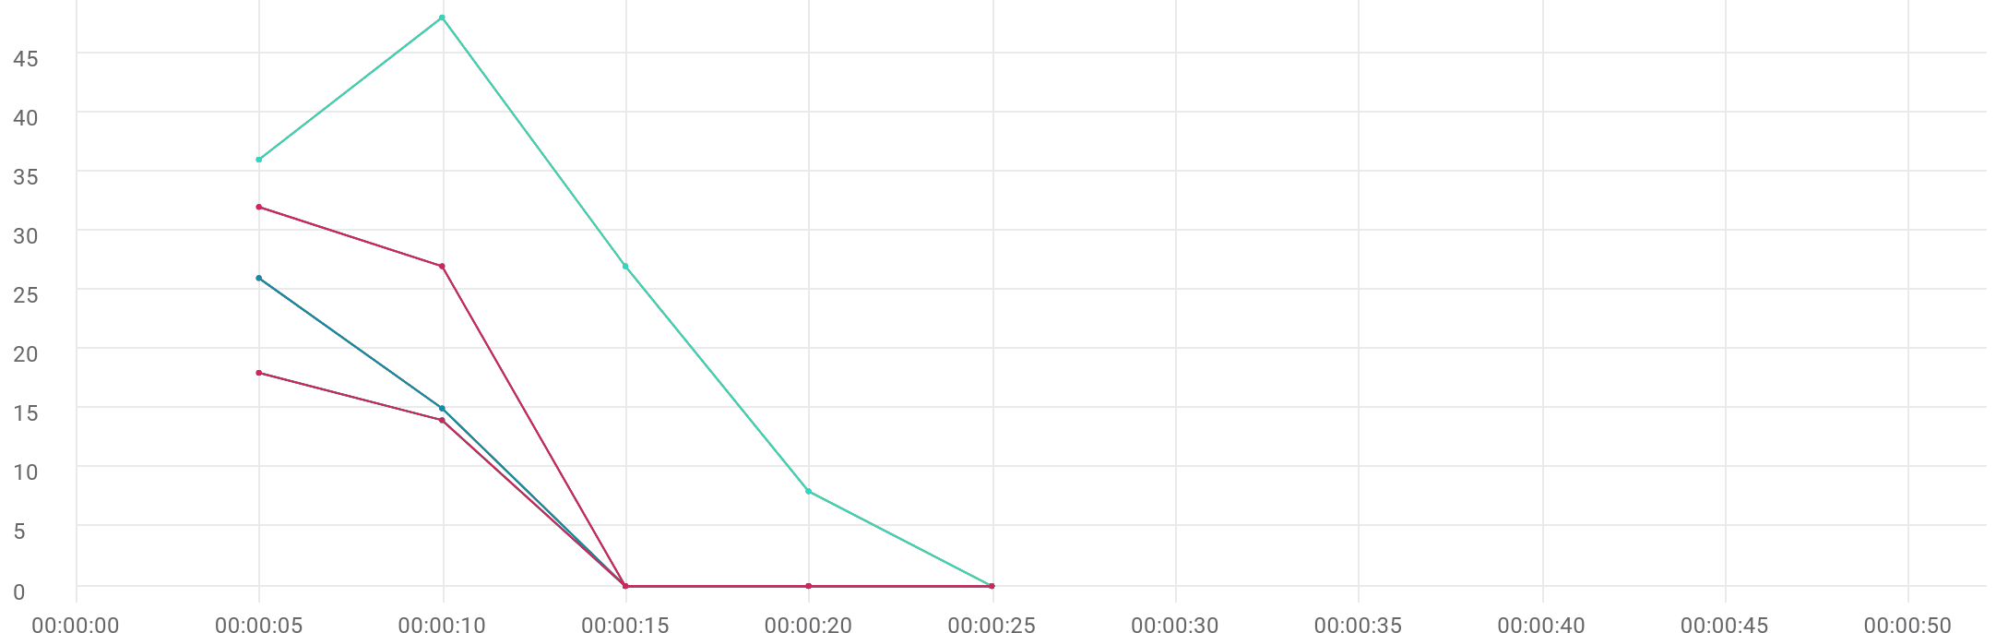

|  |  |  |  |  |  |  |  |  |  |  |
| --- | --- | --- | --- | --- | --- | --- | --- | --- | --- | --- |
|  | Metric | Script | Location | Emulation | Max | Min | Graph max | Graph avg | Graph min | Med |
| |  | | --- | |  | | Running Vusers | 89_eShowBizz_CWS_Book_Buy202 (1) | All | All | 26 | 0 | 26 | 8.2 | 0 | 15 |
| |  | | --- | |  | | Running Vusers | 90_eShowBizz_CWS_Book_Buy183 (1) | All | All | 18 | 0 | 18 | 6.4 | 0 | 14 |
| |  | | --- | |  | | Running Vusers | 91_eShowBizz_CWS_Book_Buy251 (1) | All | All | 48 | 0 | 48 | 23.8 | 0 | 36 |
| |  | | --- | |  | | Running Vusers | 92_eShowBizz_CWS_Book_Buy232 (1) | All | All | 32 | 0 | 32 | 11.8 | 0 | 27 |
| |  | | --- | |  | | Running Vusers | 89_eShowBizz_CWS_Book_Buy202 (1) | On-Premise | All | 26 | 0 | 26 | 8.2 | 0 | 15 |
| |  | | --- | |  | | Running Vusers | 90_eShowBizz_CWS_Book_Buy183 (1) | On-Premise | All | 18 | 0 | 18 | 6.4 | 0 | 14 |
| |  | | --- | |  | | Running Vusers | 91_eShowBizz_CWS_Book_Buy251 (1) | On-Premise | All | 48 | 0 | 48 | 23.8 | 0 | 36 |
| |  | | --- | |  | | Running Vusers | 92_eShowBizz_CWS_Book_Buy232 (1) | On-Premise | All | 32 | 0 | 32 | 11.8 | 0 | 27 |
| |  | | --- | |  | | Running Vusers | 89_eShowBizz_CWS_Book_Buy202 (1) | On-Premise | No Emulation | 26 | 0 | 26 | 8.2 | 0 | 15 |
| |  | | --- | |  | | Running Vusers | 90_eShowBizz_CWS_Book_Buy183 (1) | On-Premise | No Emulation | 18 | 0 | 18 | 6.4 | 0 | 14 |
| |  | | --- | |  | | Running Vusers | 91_eShowBizz_CWS_Book_Buy251 (1) | On-Premise | No Emulation | 48 | 0 | 48 | 23.8 | 0 | 36 |
| |  | | --- | |  | | Running Vusers | 92_eShowBizz_CWS_Book_Buy232 (1) | On-Premise | No Emulation | 32 | 0 | 32 | 11.8 | 0 | 27 |

# Failed Vusers



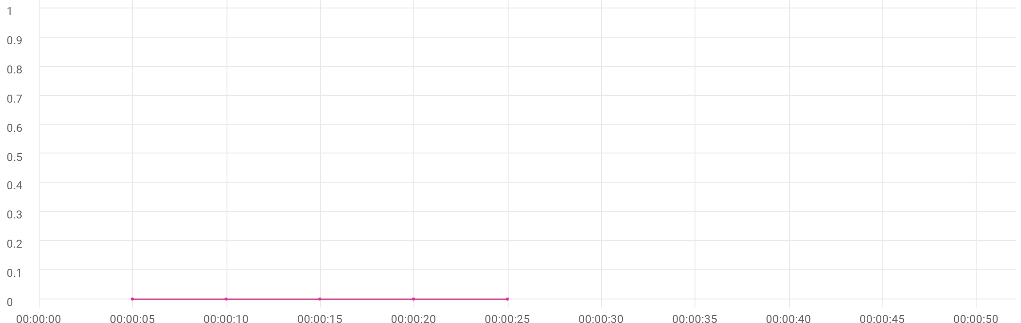

|  |  |  |  |  |  |  |  |  |  |  |
| --- | --- | --- | --- | --- | --- | --- | --- | --- | --- | --- |
|  | Metric | Script | Location | Emulation | Max | Min | Graph max | Graph avg | Graph min | Med |
| |  | | --- | |  | | Failed Vusers | 89_eShowBizz_CWS_Book_Buy202 (1) | All | All | 0 | 0 | 0 | 0 | 0 | 0 |
| |  | | --- | |  | | Failed Vusers | 90_eShowBizz_CWS_Book_Buy183 (1) | All | All | 0 | 0 | 0 | 0 | 0 | 0 |
| |  | | --- | |  | | Failed Vusers | 91_eShowBizz_CWS_Book_Buy251 (1) | All | All | 0 | 0 | 0 | 0 | 0 | 0 |
| |  | | --- | |  | | Failed Vusers | 92_eShowBizz_CWS_Book_Buy232 (1) | All | All | 0 | 0 | 0 | 0 | 0 | 0 |
| |  | | --- | |  | | Failed Vusers | 89_eShowBizz_CWS_Book_Buy202 (1) | On-Premise | All | 0 | 0 | 0 | 0 | 0 | 0 |
| |  | | --- | |  | | Failed Vusers | 90_eShowBizz_CWS_Book_Buy183 (1) | On-Premise | All | 0 | 0 | 0 | 0 | 0 | 0 |
| |  | | --- | |  | | Failed Vusers | 91_eShowBizz_CWS_Book_Buy251 (1) | On-Premise | All | 0 | 0 | 0 | 0 | 0 | 0 |
| |  | | --- | |  | | Failed Vusers | 92_eShowBizz_CWS_Book_Buy232 (1) | On-Premise | All | 0 | 0 | 0 | 0 | 0 | 0 |
| |  | | --- | |  | | Failed Vusers | 89_eShowBizz_CWS_Book_Buy202 (1) | On-Premise | No Emulation | 0 | 0 | 0 | 0 | 0 | 0 |
| |  | | --- | |  | | Failed Vusers | 90_eShowBizz_CWS_Book_Buy183 (1) | On-Premise | No Emulation | 0 | 0 | 0 | 0 | 0 | 0 |
| |  | | --- | |  | | Failed Vusers | 91_eShowBizz_CWS_Book_Buy251 (1) | On-Premise | No Emulation | 0 | 0 | 0 | 0 | 0 | 0 |
| |  | | --- | |  | | Failed Vusers | 92_eShowBizz_CWS_Book_Buy232 (1) | On-Premise | No Emulation | 0 | 0 | 0 | 0 | 0 | 0 |

# Hits per second



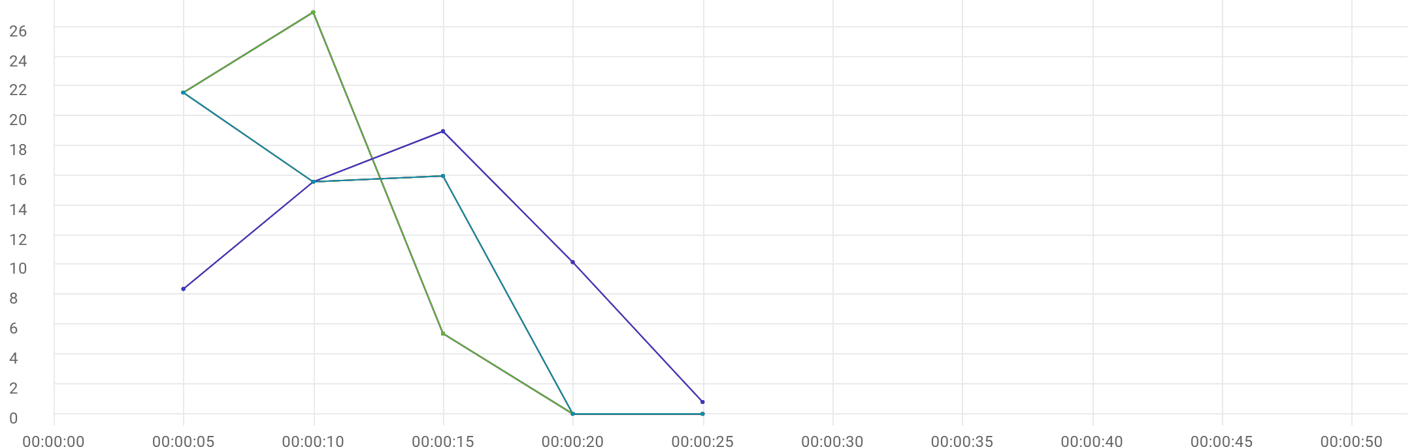

|  |  |  |  |  |  |  |  |  |  |  |
| --- | --- | --- | --- | --- | --- | --- | --- | --- | --- | --- |
|  | Metric | Script | Location | Emulation | Max | Min | Graph max | Graph avg | Graph min | Med |
| |  | | --- | |  | | Hits per second | 89_eShowBizz_CWS_Book_Buy202 (1) | All | All | 27 | 0 | 27 | 10.8 | 0 | 21.6 |
| |  | | --- | |  | | Hits per second | 90_eShowBizz_CWS_Book_Buy183 (1) | All | All | 27 | 0 | 27 | 10.8 | 0 | 21.6 |
| |  | | --- | |  | | Hits per second | 91_eShowBizz_CWS_Book_Buy251 (1) | All | All | 19 | 0.8 | 19 | 10.8 | 0.8 | 15.6 |
| |  | | --- | |  | | Hits per second | 92_eShowBizz_CWS_Book_Buy232 (1) | All | All | 21.6 | 0 | 21.6 | 10.64 | 0 | 16 |
| |  | | --- | |  | | Hits per second | 89_eShowBizz_CWS_Book_Buy202 (1) | On-Premise | All | 27 | 0 | 27 | 10.8 | 0 | 21.6 |
| |  | | --- | |  | | Hits per second | 90_eShowBizz_CWS_Book_Buy183 (1) | On-Premise | All | 27 | 0 | 27 | 10.8 | 0 | 21.6 |
| |  | | --- | |  | | Hits per second | 91_eShowBizz_CWS_Book_Buy251 (1) | On-Premise | All | 19 | 0.8 | 19 | 10.8 | 0.8 | 15.6 |
| |  | | --- | |  | | Hits per second | 92_eShowBizz_CWS_Book_Buy232 (1) | On-Premise | All | 21.6 | 0 | 21.6 | 10.64 | 0 | 16 |
| |  | | --- | |  | | Hits per second | 89_eShowBizz_CWS_Book_Buy202 (1) | On-Premise | No Emulation | 27 | 0 | 27 | 10.8 | 0 | 21.6 |
| |  | | --- | |  | | Hits per second | 90_eShowBizz_CWS_Book_Buy183 (1) | On-Premise | No Emulation | 27 | 0 | 27 | 10.8 | 0 | 21.6 |
| |  | | --- | |  | | Hits per second | 91_eShowBizz_CWS_Book_Buy251 (1) | On-Premise | No Emulation | 19 | 0.8 | 19 | 10.8 | 0.8 | 15.6 |
| |  | | --- | |  | | Hits per second | 92_eShowBizz_CWS_Book_Buy232 (1) | On-Premise | No Emulation | 21.6 | 0 | 21.6 | 10.64 | 0 | 16 |
| |  | | --- | |  | | HTTP_200 | 89_eShowBizz_CWS_Book_Buy202 (1) | On-Premise | No Emulation | 27 | 0 | 27 | 10.8 | 0 | 21.6 |
| |  | | --- | |  | | HTTP_200 | 90_eShowBizz_CWS_Book_Buy183 (1) | On-Premise | No Emulation | 27 | 0 | 27 | 10.8 | 0 | 21.6 |
| |  | | --- | |  | | HTTP_200 | 91_eShowBizz_CWS_Book_Buy251 (1) | On-Premise | No Emulation | 19 | 0.8 | 19 | 10.8 | 0.8 | 15.6 |
| |  | | --- | |  | | HTTP_200 | 92_eShowBizz_CWS_Book_Buy232 (1) | On-Premise | No Emulation | 21.6 | 0 | 21.6 | 10.64 | 0 | 16 |

# Throughput



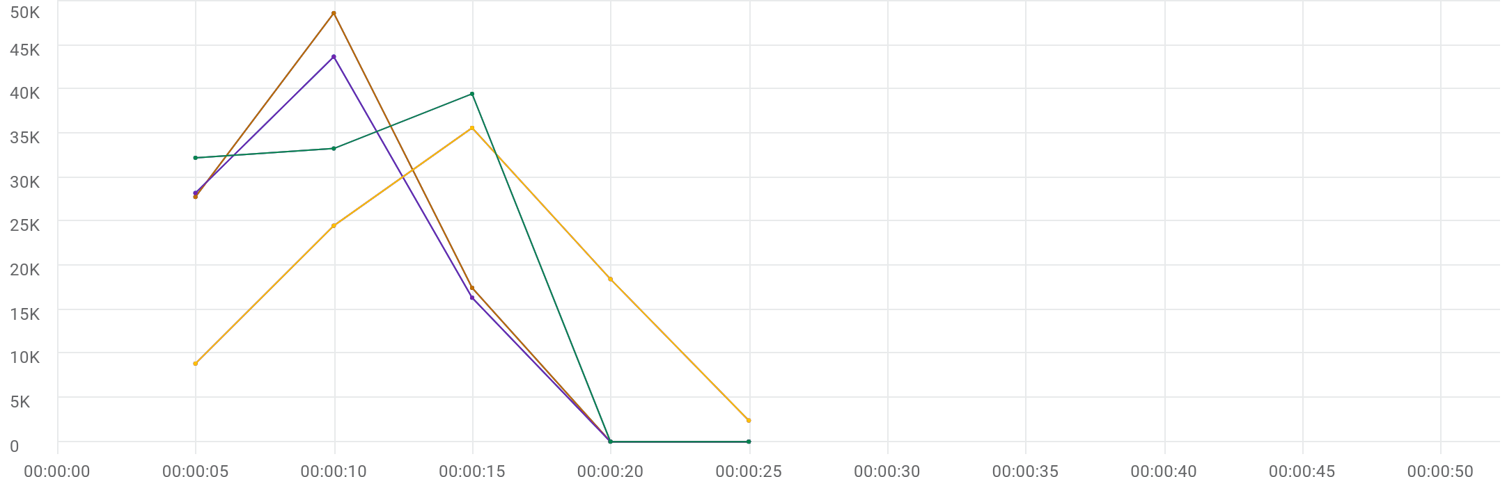

|  |  |  |  |  |  |  |  |  |  |  |
| --- | --- | --- | --- | --- | --- | --- | --- | --- | --- | --- |
|  | Metric | Script | Location | Emulation | Max | Min | Graph max | Graph avg | Graph min | Med |
| |  | | --- | |  | | Throughput | 89_eShowBizz_CWS_Book_Buy202 (1) | All | All | 47.52 KB/s | 0 Byte/s | 47.52 KB/s | 18.343 KB/s | 0 Byte/s | 27.137 KB/s |
| |  | | --- | |  | | Throughput | 90_eShowBizz_CWS_Book_Buy183 (1) | All | All | 42.689 KB/s | 0 Byte/s | 42.689 KB/s | 17.243 KB/s | 0 Byte/s | 27.569 KB/s |
| |  | | --- | |  | | Throughput | 91_eShowBizz_CWS_Book_Buy251 (1) | All | All | 34.795 KB/s | 2.348 KB/s | 34.795 KB/s | 17.555 KB/s | 2.348 KB/s | 23.947 KB/s |
| |  | | --- | |  | | Throughput | 92_eShowBizz_CWS_Book_Buy232 (1) | All | All | 38.57 KB/s | 0 Byte/s | 38.57 KB/s | 20.51 KB/s | 0 Byte/s | 32.507 KB/s |
| |  | | --- | |  | | Throughput | 89_eShowBizz_CWS_Book_Buy202 (1) | On-Premise | All | 47.52 KB/s | 0 Byte/s | 47.52 KB/s | 18.343 KB/s | 0 Byte/s | 27.137 KB/s |
| |  | | --- | |  | | Throughput | 90_eShowBizz_CWS_Book_Buy183 (1) | On-Premise | All | 42.689 KB/s | 0 Byte/s | 42.689 KB/s | 17.243 KB/s | 0 Byte/s | 27.569 KB/s |
| |  | | --- | |  | | Throughput | 91_eShowBizz_CWS_Book_Buy251 (1) | On-Premise | All | 34.795 KB/s | 2.348 KB/s | 34.795 KB/s | 17.555 KB/s | 2.348 KB/s | 23.947 KB/s |
| |  | | --- | |  | | Throughput | 92_eShowBizz_CWS_Book_Buy232 (1) | On-Premise | All | 38.57 KB/s | 0 Byte/s | 38.57 KB/s | 20.51 KB/s | 0 Byte/s | 32.507 KB/s |
| |  | | --- | |  | | Throughput | 89_eShowBizz_CWS_Book_Buy202 (1) | On-Premise | No Emulation | 47.52 KB/s | 0 Byte/s | 47.52 KB/s | 18.343 KB/s | 0 Byte/s | 27.137 KB/s |
| |  | | --- | |  | | Throughput | 90_eShowBizz_CWS_Book_Buy183 (1) | On-Premise | No Emulation | 42.689 KB/s | 0 Byte/s | 42.689 KB/s | 17.243 KB/s | 0 Byte/s | 27.569 KB/s |
| |  | | --- | |  | | Throughput | 91_eShowBizz_CWS_Book_Buy251 (1) | On-Premise | No Emulation | 34.795 KB/s | 2.348 KB/s | 34.795 KB/s | 17.555 KB/s | 2.348 KB/s | 23.947 KB/s |
| |  | | --- | |  | | Throughput | 92_eShowBizz_CWS_Book_Buy232 (1) | On-Premise | No Emulation | 38.57 KB/s | 0 Byte/s | 38.57 KB/s | 20.51 KB/s | 0 Byte/s | 32.507 KB/s |

# Errors



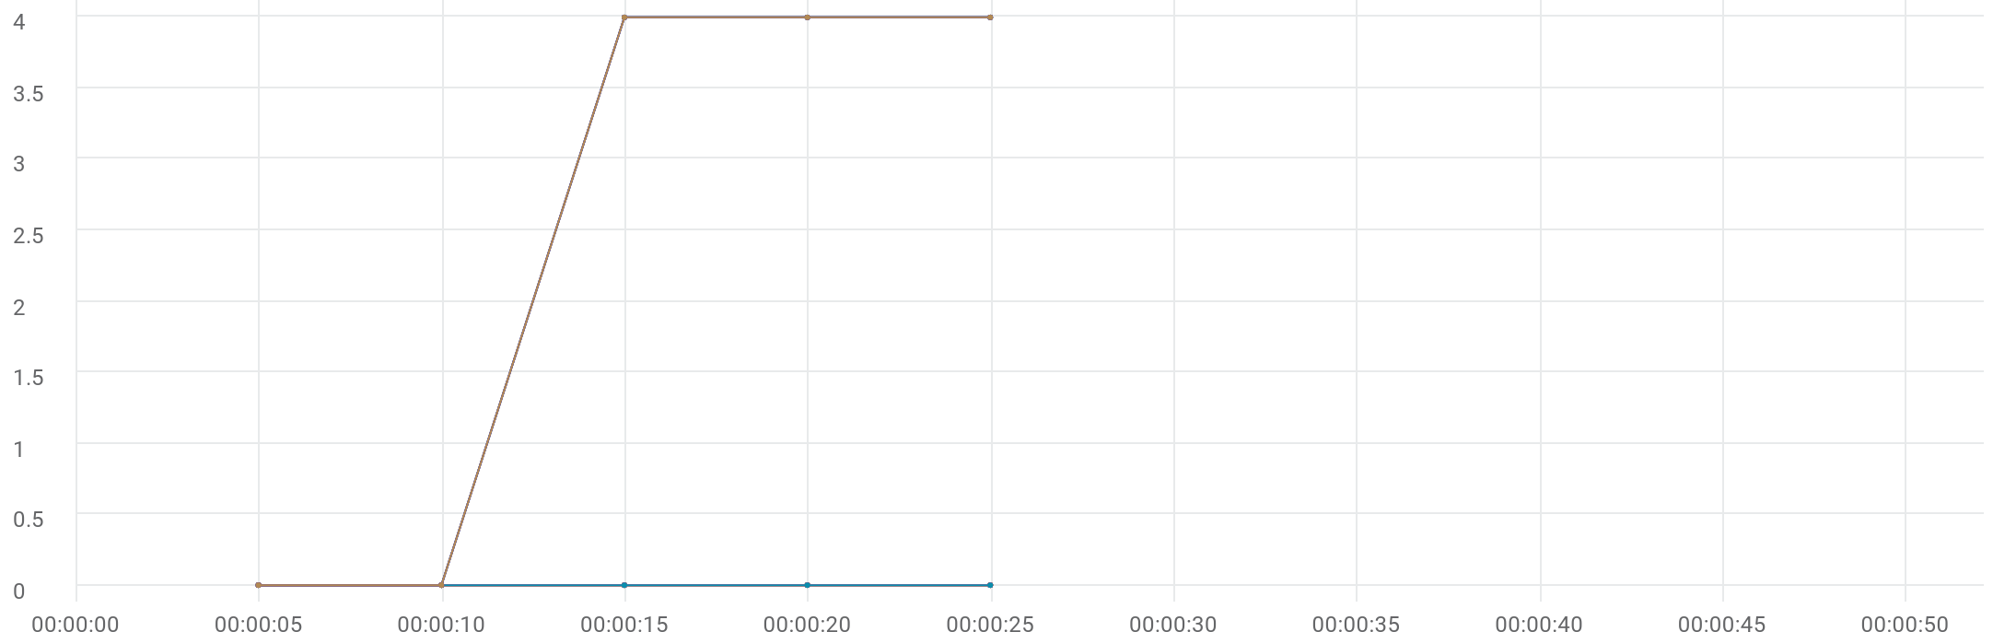

|  |  |  |  |  |  |  |  |  |  |  |
| --- | --- | --- | --- | --- | --- | --- | --- | --- | --- | --- |
|  | Metric | Script | Location | Emulation | Max | Min | Graph max | Graph avg | Graph min | Med |
| |  | | --- | |  | | Errors | 89_eShowBizz_CWS_Book_Buy202 (1) | All | All | N/A | N/A | 0 | 0 | 0 | 0 |
| |  | | --- | |  | | Errors | 90_eShowBizz_CWS_Book_Buy183 (1) | All | All | N/A | N/A | 0 | 0 | 0 | 0 |
| |  | | --- | |  | | Errors | 91_eShowBizz_CWS_Book_Buy251 (1) | All | All | N/A | N/A | 0 | 0 | 0 | 0 |
| |  | | --- | |  | | Errors | 92_eShowBizz_CWS_Book_Buy232 (1) | All | All | N/A | N/A | 4 | 2.4 | 0 | 4 |
| |  | | --- | |  | | Errors | 89_eShowBizz_CWS_Book_Buy202 (1) | On-Premise | All | N/A | N/A | 0 | 0 | 0 | 0 |
| |  | | --- | |  | | Errors | 90_eShowBizz_CWS_Book_Buy183 (1) | On-Premise | All | N/A | N/A | 0 | 0 | 0 | 0 |
| |  | | --- | |  | | Errors | 91_eShowBizz_CWS_Book_Buy251 (1) | On-Premise | All | N/A | N/A | 0 | 0 | 0 | 0 |
| |  | | --- | |  | | Errors | 92_eShowBizz_CWS_Book_Buy232 (1) | On-Premise | All | N/A | N/A | 4 | 2.4 | 0 | 4 |
| |  | | --- | |  | | Errors | 89_eShowBizz_CWS_Book_Buy202 (1) | On-Premise | No Emulation | N/A | N/A | 0 | 0 | 0 | 0 |
| |  | | --- | |  | | Errors | 90_eShowBizz_CWS_Book_Buy183 (1) | On-Premise | No Emulation | N/A | N/A | 0 | 0 | 0 | 0 |
| |  | | --- | |  | | Errors | 91_eShowBizz_CWS_Book_Buy251 (1) | On-Premise | No Emulation | N/A | N/A | 0 | 0 | 0 | 0 |
| |  | | --- | |  | | Errors | 92_eShowBizz_CWS_Book_Buy232 (1) | On-Premise | No Emulation | N/A | N/A | 4 | 2.4 | 0 | 4 |
| |  | | --- | |  | | Errors -26366 | 92_eShowBizz_CWS_Book_Buy232 (1) | On-Premise | No Emulation | N/A | N/A | 4 | 2.4 | 0 | 4 |

# TRT [90th]



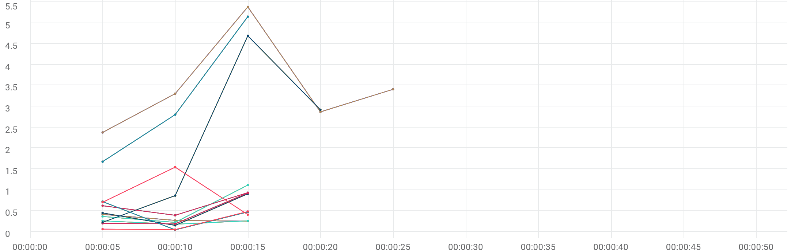

|  |  |  |  |  |  |  |  |  |  |  |  |
| --- | --- | --- | --- | --- | --- | --- | --- | --- | --- | --- | --- |
|  | Metric | Transaction | Script | Location | Emulation | Max | Min | Graph max | Graph avg | Graph min | Med |
| |  | | --- | |  | | TRT [90 th percentile] | Eshowbizz_04_Buy_202 | 89_eShowBizz_CWS_Book_Buy202 (1) | All | All | N/A | N/A | 411.123 ms | 307.366 ms | 245.239 ms | 411.123 ms |
| |  | | --- | |  | | TRT [90 th percentile] | Eshowbizz_04_Buy_183 | 90_eShowBizz_CWS_Book_Buy183 (1) | All | All | N/A | N/A | 255.023 ms | 228.241 ms | 174.725 ms | 255.023 ms |
| |  | | --- | |  | | TRT [90 th percentile] | Eshowbizz_04_Buy_251 | 91_eShowBizz_CWS_Book_Buy251 (1) | All | All | N/A | N/A | 5.389 sec | 3.47 sec | 2.376 sec | 3.411 sec |
| |  | | --- | |  | | TRT [90 th percentile] | Eshowbizz_04_Buy_232 | 92_eShowBizz_CWS_Book_Buy232 (1) | All | All | N/A | N/A | 1.113 sec | 564.08 ms | 218.861 ms | 1.113 sec |
| |  | | --- | |  | | TRT [90 th percentile] | Eshowbizz_03_BookSeats_202 | 89_eShowBizz_CWS_Book_Buy202 (1) | All | All | N/A | N/A | 903.715 ms | 498.138 ms | 146.092 ms | 903.715 ms |
| |  | | --- | |  | | TRT [90 th percentile] | Eshowbizz_03_BookSeats_183 | 90_eShowBizz_CWS_Book_Buy183 (1) | All | All | N/A | N/A | 923.555 ms | 433.471 ms | 182.588 ms | 923.555 ms |
| |  | | --- | |  | | TRT [90 th percentile] | Eshowbizz_03_BookSeats_251 | 91_eShowBizz_CWS_Book_Buy251 (1) | All | All | N/A | N/A | 4.694 sec | 2.173 sec | 218.496 ms | 2.92 sec |
| |  | | --- | |  | | TRT [90 th percentile] | Eshowbizz_03_BookSeats_232 | 92_eShowBizz_CWS_Book_Buy232 (1) | All | All | N/A | N/A | 931.473 ms | 645.565 ms | 387.911 ms | 931.473 ms |
| |  | | --- | |  | | TRT [90 th percentile] | ShowSeats_AllClasses_Open_202 | 89_eShowBizz_CWS_Book_Buy202 (1) | All | All | N/A | N/A | 717.581 ms | 408.456 ms | 39.861 ms | 717.581 ms |
| |  | | --- | |  | | TRT [90 th percentile] | ShowSeats_AllClasses_Open_183 | 90_eShowBizz_CWS_Book_Buy183 (1) | All | All | N/A | N/A | 479.255 ms | 193.849 ms | 45.698 ms | 479.255 ms |
| |  | | --- | |  | | TRT [90 th percentile] | ShowSeats_AllClasses_Open_251 | 91_eShowBizz_CWS_Book_Buy251 (1) | All | All | N/A | N/A | 5.154 sec | 3.211 sec | 1.674 sec | 5.154 sec |
| |  | | --- | |  | | TRT [90 th percentile] | ShowSeats_AllClasses_Open_232 | 92_eShowBizz_CWS_Book_Buy232 (1) | All | All | N/A | N/A | 1.543 sec | 882.536 ms | 403.794 ms | 1.543 sec |
| |  | | --- | |  | | TRT [90 th percentile] | Eshowbizz_04_Buy_202 | 89_eShowBizz_CWS_Book_Buy202 (1) | On-Premise | All | N/A | N/A | 411.123 ms | 307.366 ms | 245.239 ms | 411.123 ms |
| |  | | --- | |  | | TRT [90 th percentile] | Eshowbizz_04_Buy_183 | 90_eShowBizz_CWS_Book_Buy183 (1) | On-Premise | All | N/A | N/A | 255.023 ms | 228.241 ms | 174.725 ms | 255.023 ms |
| |  | | --- | |  | | TRT [90 th percentile] | Eshowbizz_04_Buy_251 | 91_eShowBizz_CWS_Book_Buy251 (1) | On-Premise | All | N/A | N/A | 5.389 sec | 3.47 sec | 2.376 sec | 3.411 sec |
| |  | | --- | |  | | TRT [90 th percentile] | Eshowbizz_04_Buy_232 | 92_eShowBizz_CWS_Book_Buy232 (1) | On-Premise | All | N/A | N/A | 1.113 sec | 564.08 ms | 218.861 ms | 1.113 sec |
| |  | | --- | |  | | TRT [90 th percentile] | Eshowbizz_03_BookSeats_202 | 89_eShowBizz_CWS_Book_Buy202 (1) | On-Premise | All | N/A | N/A | 903.715 ms | 498.138 ms | 146.092 ms | 903.715 ms |
| |  | | --- | |  | | TRT [90 th percentile] | Eshowbizz_03_BookSeats_183 | 90_eShowBizz_CWS_Book_Buy183 (1) | On-Premise | All | N/A | N/A | 923.555 ms | 433.471 ms | 182.588 ms | 923.555 ms |
| |  | | --- | |  | | TRT [90 th percentile] | Eshowbizz_03_BookSeats_251 | 91_eShowBizz_CWS_Book_Buy251 (1) | On-Premise | All | N/A | N/A | 4.694 sec | 2.173 sec | 218.496 ms | 2.92 sec |
| |  | | --- | |  | | TRT [90 th percentile] | Eshowbizz_03_BookSeats_232 | 92_eShowBizz_CWS_Book_Buy232 (1) | On-Premise | All | N/A | N/A | 931.473 ms | 645.565 ms | 387.911 ms | 931.473 ms |
| |  | | --- | |  | | TRT [90 th percentile] | ShowSeats_AllClasses_Open_202 | 89_eShowBizz_CWS_Book_Buy202 (1) | On-Premise | All | N/A | N/A | 717.581 ms | 408.456 ms | 39.861 ms | 717.581 ms |
| |  | | --- | |  | | TRT [90 th percentile] | ShowSeats_AllClasses_Open_183 | 90_eShowBizz_CWS_Book_Buy183 (1) | On-Premise | All | N/A | N/A | 479.255 ms | 193.849 ms | 45.698 ms | 479.255 ms |
| |  | | --- | |  | | TRT [90 th percentile] | ShowSeats_AllClasses_Open_251 | 91_eShowBizz_CWS_Book_Buy251 (1) | On-Premise | All | N/A | N/A | 5.154 sec | 3.211 sec | 1.674 sec | 5.154 sec |
| |  | | --- | |  | | TRT [90 th percentile] | ShowSeats_AllClasses_Open_232 | 92_eShowBizz_CWS_Book_Buy232 (1) | On-Premise | All | N/A | N/A | 1.543 sec | 882.536 ms | 403.794 ms | 1.543 sec |
| |  | | --- | |  | | TRT [90 th percentile] | Eshowbizz_04_Buy_202 | 89_eShowBizz_CWS_Book_Buy202 (1) | On-Premise | No Emulation | N/A | N/A | 411.123 ms | 307.366 ms | 245.239 ms | 411.123 ms |
| |  | | --- | |  | | TRT [90 th percentile] | Eshowbizz_04_Buy_183 | 90_eShowBizz_CWS_Book_Buy183 (1) | On-Premise | No Emulation | N/A | N/A | 255.023 ms | 228.241 ms | 174.725 ms | 255.023 ms |
| |  | | --- | |  | | TRT [90 th percentile] | Eshowbizz_04_Buy_251 | 91_eShowBizz_CWS_Book_Buy251 (1) | On-Premise | No Emulation | N/A | N/A | 5.389 sec | 3.47 sec | 2.376 sec | 3.411 sec |
| |  | | --- | |  | | TRT [90 th percentile] | Eshowbizz_04_Buy_232 | 92_eShowBizz_CWS_Book_Buy232 (1) | On-Premise | No Emulation | N/A | N/A | 1.113 sec | 564.08 ms | 218.861 ms | 1.113 sec |
| |  | | --- | |  | | TRT [90 th percentile] | Eshowbizz_03_BookSeats_202 | 89_eShowBizz_CWS_Book_Buy202 (1) | On-Premise | No Emulation | N/A | N/A | 903.715 ms | 498.138 ms | 146.092 ms | 903.715 ms |
| |  | | --- | |  | | TRT [90 th percentile] | Eshowbizz_03_BookSeats_183 | 90_eShowBizz_CWS_Book_Buy183 (1) | On-Premise | No Emulation | N/A | N/A | 923.555 ms | 433.471 ms | 182.588 ms | 923.555 ms |
| |  | | --- | |  | | TRT [90 th percentile] | Eshowbizz_03_BookSeats_251 | 91_eShowBizz_CWS_Book_Buy251 (1) | On-Premise | No Emulation | N/A | N/A | 4.694 sec | 2.173 sec | 218.496 ms | 2.92 sec |
| |  | | --- | |  | | TRT [90 th percentile] | Eshowbizz_03_BookSeats_232 | 92_eShowBizz_CWS_Book_Buy232 (1) | On-Premise | No Emulation | N/A | N/A | 931.473 ms | 645.565 ms | 387.911 ms | 931.473 ms |
| |  | | --- | |  | | TRT [90 th percentile] | ShowSeats_AllClasses_Open_202 | 89_eShowBizz_CWS_Book_Buy202 (1) | On-Premise | No Emulation | N/A | N/A | 717.581 ms | 408.456 ms | 39.861 ms | 717.581 ms |
| |  | | --- | |  | | TRT [90 th percentile] | ShowSeats_AllClasses_Open_183 | 90_eShowBizz_CWS_Book_Buy183 (1) | On-Premise | No Emulation | N/A | N/A | 479.255 ms | 193.849 ms | 45.698 ms | 479.255 ms |
| |  | | --- | |  | | TRT [90 th percentile] | ShowSeats_AllClasses_Open_251 | 91_eShowBizz_CWS_Book_Buy251 (1) | On-Premise | No Emulation | N/A | N/A | 5.154 sec | 3.211 sec | 1.674 sec | 5.154 sec |
| |  | | --- | |  | | TRT [90 th percentile] | ShowSeats_AllClasses_Open_232 | 92_eShowBizz_CWS_Book_Buy232 (1) | On-Premise | No Emulation | N/A | N/A | 1.543 sec | 882.536 ms | 403.794 ms | 1.543 sec |

# TRT [AVG]



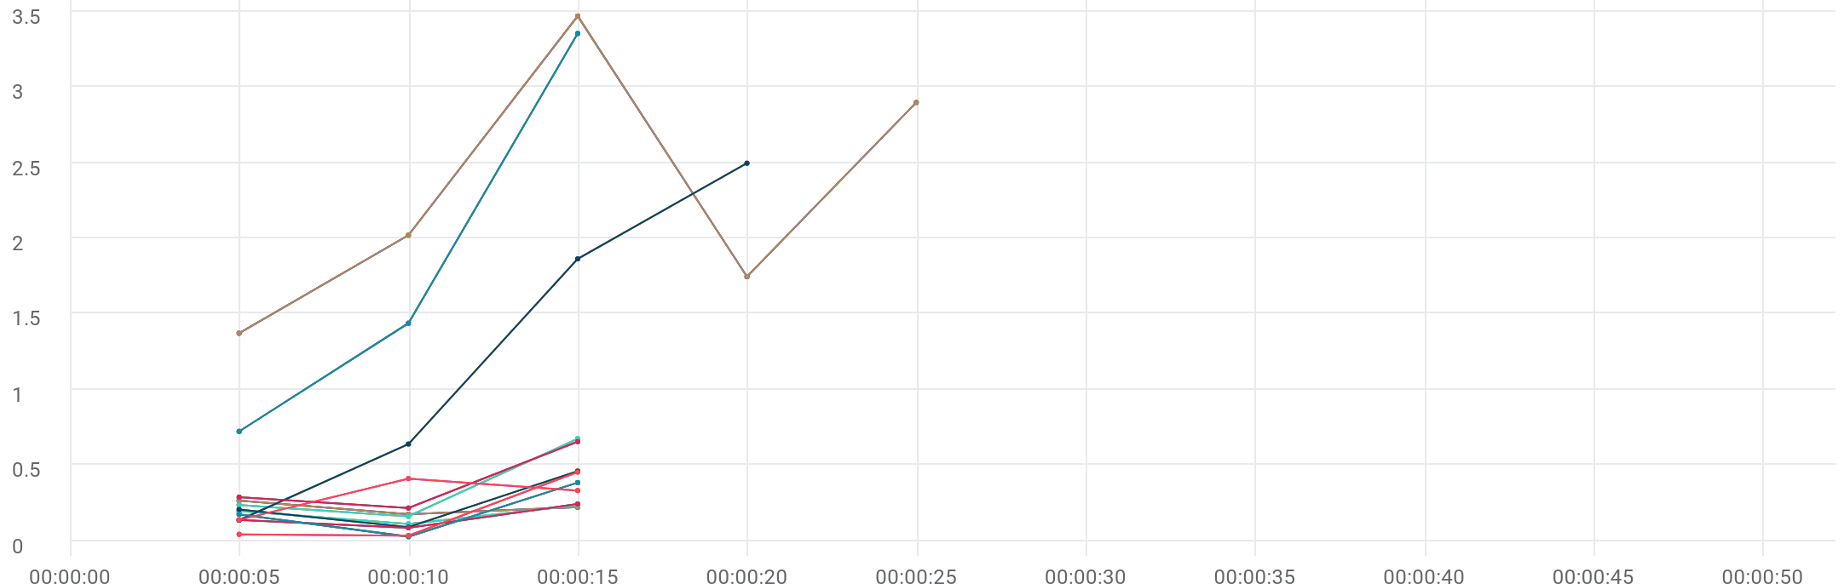

|  |  |  |  |  |  |  |  |  |  |  |  |
| --- | --- | --- | --- | --- | --- | --- | --- | --- | --- | --- | --- |
|  | Metric | Transaction | Script | Location | Emulation | Max | Min | Graph max | Graph avg | Graph min | Med |
| |  | | --- | |  | | TRT [AVG] | Eshowbizz_04_Buy_202 | 89_eShowBizz_CWS_Book_Buy202 (1) | All | All | N/A | N/A | 264.994 ms | 220.631 ms | 175.438 ms | 264.994 ms |
| |  | | --- | |  | | TRT [AVG] | Eshowbizz_04_Buy_183 | 90_eShowBizz_CWS_Book_Buy183 (1) | All | All | N/A | N/A | 234.161 ms | 180.417 ms | 111.128 ms | 234.161 ms |
| |  | | --- | |  | | TRT [AVG] | Eshowbizz_04_Buy_251 | 91_eShowBizz_CWS_Book_Buy251 (1) | All | All | N/A | N/A | 3.47 sec | 2.302 sec | 1.372 sec | 2.899 sec |
| |  | | --- | |  | | TRT [AVG] | Eshowbizz_04_Buy_232 | 92_eShowBizz_CWS_Book_Buy232 (1) | All | All | N/A | N/A | 674.186 ms | 357.283 ms | 161.678 ms | 674.186 ms |
| |  | | --- | |  | | TRT [AVG] | Eshowbizz_03_BookSeats_202 | 89_eShowBizz_CWS_Book_Buy202 (1) | All | All | N/A | N/A | 460.357 ms | 252.297 ms | 90.139 ms | 460.357 ms |
| |  | | --- | |  | | TRT [AVG] | Eshowbizz_03_BookSeats_183 | 90_eShowBizz_CWS_Book_Buy183 (1) | All | All | N/A | N/A | 242.475 ms | 155.069 ms | 85.79 ms | 242.475 ms |
| |  | | --- | |  | | TRT [AVG] | Eshowbizz_03_BookSeats_251 | 91_eShowBizz_CWS_Book_Buy251 (1) | All | All | N/A | N/A | 2.497 sec | 1.284 sec | 135.941 ms | 1.864 sec |
| |  | | --- | |  | | TRT [AVG] | Eshowbizz_03_BookSeats_232 | 92_eShowBizz_CWS_Book_Buy232 (1) | All | All | N/A | N/A | 655.739 ms | 386.584 ms | 216.099 ms | 655.739 ms |
| |  | | --- | |  | | TRT [AVG] | ShowSeats_AllClasses_Open_202 | 89_eShowBizz_CWS_Book_Buy202 (1) | All | All | N/A | N/A | 384.518 ms | 195.194 ms | 26.962 ms | 384.518 ms |
| |  | | --- | |  | | TRT [AVG] | ShowSeats_AllClasses_Open_183 | 90_eShowBizz_CWS_Book_Buy183 (1) | All | All | N/A | N/A | 454.188 ms | 176.716 ms | 33.934 ms | 454.188 ms |
| |  | | --- | |  | | TRT [AVG] | ShowSeats_AllClasses_Open_251 | 91_eShowBizz_CWS_Book_Buy251 (1) | All | All | N/A | N/A | 3.355 sec | 1.839 sec | 722.978 ms | 3.355 sec |
| |  | | --- | |  | | TRT [AVG] | ShowSeats_AllClasses_Open_232 | 92_eShowBizz_CWS_Book_Buy232 (1) | All | All | N/A | N/A | 410.774 ms | 293.619 ms | 138.182 ms | 410.774 ms |
| |  | | --- | |  | | TRT [AVG] | Eshowbizz_04_Buy_202 | 89_eShowBizz_CWS_Book_Buy202 (1) | On-Premise | All | N/A | N/A | 264.994 ms | 220.631 ms | 175.438 ms | 264.994 ms |
| |  | | --- | |  | | TRT [AVG] | Eshowbizz_04_Buy_183 | 90_eShowBizz_CWS_Book_Buy183 (1) | On-Premise | All | N/A | N/A | 234.161 ms | 180.417 ms | 111.128 ms | 234.161 ms |
| |  | | --- | |  | | TRT [AVG] | Eshowbizz_04_Buy_251 | 91_eShowBizz_CWS_Book_Buy251 (1) | On-Premise | All | N/A | N/A | 3.47 sec | 2.302 sec | 1.372 sec | 2.899 sec |
| |  | | --- | |  | | TRT [AVG] | Eshowbizz_04_Buy_232 | 92_eShowBizz_CWS_Book_Buy232 (1) | On-Premise | All | N/A | N/A | 674.186 ms | 357.283 ms | 161.678 ms | 674.186 ms |
| |  | | --- | |  | | TRT [AVG] | Eshowbizz_03_BookSeats_202 | 89_eShowBizz_CWS_Book_Buy202 (1) | On-Premise | All | N/A | N/A | 460.357 ms | 252.297 ms | 90.139 ms | 460.357 ms |
| |  | | --- | |  | | TRT [AVG] | Eshowbizz_03_BookSeats_183 | 90_eShowBizz_CWS_Book_Buy183 (1) | On-Premise | All | N/A | N/A | 242.475 ms | 155.069 ms | 85.79 ms | 242.475 ms |
| |  | | --- | |  | | TRT [AVG] | Eshowbizz_03_BookSeats_251 | 91_eShowBizz_CWS_Book_Buy251 (1) | On-Premise | All | N/A | N/A | 2.497 sec | 1.284 sec | 135.941 ms | 1.864 sec |
| |  | | --- | |  | | TRT [AVG] | Eshowbizz_03_BookSeats_232 | 92_eShowBizz_CWS_Book_Buy232 (1) | On-Premise | All | N/A | N/A | 655.739 ms | 386.584 ms | 216.099 ms | 655.739 ms |
| |  | | --- | |  | | TRT [AVG] | ShowSeats_AllClasses_Open_202 | 89_eShowBizz_CWS_Book_Buy202 (1) | On-Premise | All | N/A | N/A | 384.518 ms | 195.194 ms | 26.962 ms | 384.518 ms |
| |  | | --- | |  | | TRT [AVG] | ShowSeats_AllClasses_Open_183 | 90_eShowBizz_CWS_Book_Buy183 (1) | On-Premise | All | N/A | N/A | 454.188 ms | 176.716 ms | 33.934 ms | 454.188 ms |
| |  | | --- | |  | | TRT [AVG] | ShowSeats_AllClasses_Open_251 | 91_eShowBizz_CWS_Book_Buy251 (1) | On-Premise | All | N/A | N/A | 3.355 sec | 1.839 sec | 722.978 ms | 3.355 sec |
| |  | | --- | |  | | TRT [AVG] | ShowSeats_AllClasses_Open_232 | 92_eShowBizz_CWS_Book_Buy232 (1) | On-Premise | All | N/A | N/A | 410.774 ms | 293.619 ms | 138.182 ms | 410.774 ms |
| |  | | --- | |  | | TRT [AVG] | Eshowbizz_04_Buy_202 | 89_eShowBizz_CWS_Book_Buy202 (1) | On-Premise | No Emulation | N/A | N/A | 264.994 ms | 220.631 ms | 175.438 ms | 264.994 ms |
| |  | | --- | |  | | TRT [AVG] | Eshowbizz_04_Buy_183 | 90_eShowBizz_CWS_Book_Buy183 (1) | On-Premise | No Emulation | N/A | N/A | 234.161 ms | 180.417 ms | 111.128 ms | 234.161 ms |
| |  | | --- | |  | | TRT [AVG] | Eshowbizz_04_Buy_251 | 91_eShowBizz_CWS_Book_Buy251 (1) | On-Premise | No Emulation | N/A | N/A | 3.47 sec | 2.302 sec | 1.372 sec | 2.899 sec |
| |  | | --- | |  | | TRT [AVG] | Eshowbizz_04_Buy_232 | 92_eShowBizz_CWS_Book_Buy232 (1) | On-Premise | No Emulation | N/A | N/A | 674.186 ms | 357.283 ms | 161.678 ms | 674.186 ms |
| |  | | --- | |  | | TRT [AVG] | Eshowbizz_03_BookSeats_202 | 89_eShowBizz_CWS_Book_Buy202 (1) | On-Premise | No Emulation | N/A | N/A | 460.357 ms | 252.297 ms | 90.139 ms | 460.357 ms |
| |  | | --- | |  | | TRT [AVG] | Eshowbizz_03_BookSeats_183 | 90_eShowBizz_CWS_Book_Buy183 (1) | On-Premise | No Emulation | N/A | N/A | 242.475 ms | 155.069 ms | 85.79 ms | 242.475 ms |
| |  | | --- | |  | | TRT [AVG] | Eshowbizz_03_BookSeats_251 | 91_eShowBizz_CWS_Book_Buy251 (1) | On-Premise | No Emulation | N/A | N/A | 2.497 sec | 1.284 sec | 135.941 ms | 1.864 sec |
| |  | | --- | |  | | TRT [AVG] | Eshowbizz_03_BookSeats_232 | 92_eShowBizz_CWS_Book_Buy232 (1) | On-Premise | No Emulation | N/A | N/A | 655.739 ms | 386.584 ms | 216.099 ms | 655.739 ms |
| |  | | --- | |  | | TRT [AVG] | ShowSeats_AllClasses_Open_202 | 89_eShowBizz_CWS_Book_Buy202 (1) | On-Premise | No Emulation | N/A | N/A | 384.518 ms | 195.194 ms | 26.962 ms | 384.518 ms |
| |  | | --- | |  | | TRT [AVG] | ShowSeats_AllClasses_Open_183 | 90_eShowBizz_CWS_Book_Buy183 (1) | On-Premise | No Emulation | N/A | N/A | 454.188 ms | 176.716 ms | 33.934 ms | 454.188 ms |
| |  | | --- | |  | | TRT [AVG] | ShowSeats_AllClasses_Open_251 | 91_eShowBizz_CWS_Book_Buy251 (1) | On-Premise | No Emulation | N/A | N/A | 3.355 sec | 1.839 sec | 722.978 ms | 3.355 sec |
| |  | | --- | |  | | TRT [AVG] | ShowSeats_AllClasses_Open_232 | 92_eShowBizz_CWS_Book_Buy232 (1) | On-Premise | No Emulation | N/A | N/A | 410.774 ms | 293.619 ms | 138.182 ms | 410.774 ms |

# TRT [MIN]



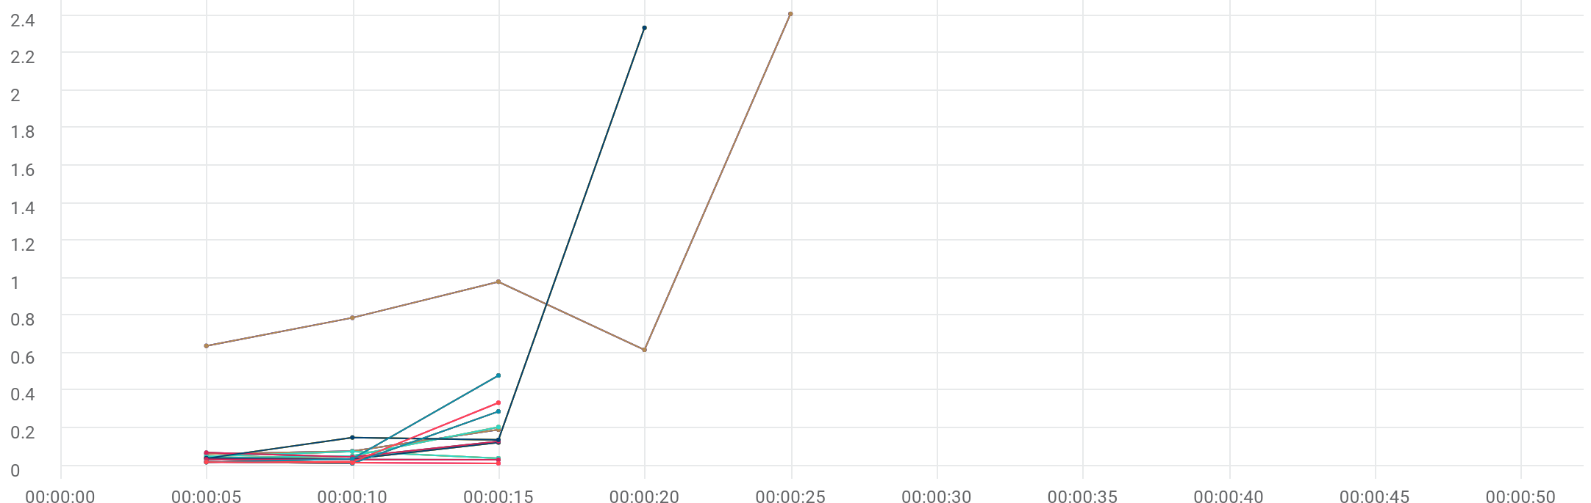

|  |  |  |  |  |  |  |  |  |  |  |  |
| --- | --- | --- | --- | --- | --- | --- | --- | --- | --- | --- | --- |
|  | Metric | Transaction | Script | Location | Emulation | Max | Min | Graph max | Graph avg | Graph min | Med |
| |  | | --- | |  | | TRT [MIN] | Eshowbizz_04_Buy_202 | 89_eShowBizz_CWS_Book_Buy202 (1) | All | All | N/A | N/A | 192.325 ms | 110.985 ms | 62.475 ms | 192.325 ms |
| |  | | --- | |  | | TRT [MIN] | Eshowbizz_04_Buy_183 | 90_eShowBizz_CWS_Book_Buy183 (1) | All | All | N/A | N/A | 206.287 ms | 100.293 ms | 41.685 ms | 206.287 ms |
| |  | | --- | |  | | TRT [MIN] | Eshowbizz_04_Buy_251 | 91_eShowBizz_CWS_Book_Buy251 (1) | All | All | N/A | N/A | 2.411 sec | 1.088 sec | 618.36 ms | 981.543 ms |
| |  | | --- | |  | | TRT [MIN] | Eshowbizz_04_Buy_232 | 92_eShowBizz_CWS_Book_Buy232 (1) | All | All | N/A | N/A | 75.812 ms | 55.326 ms | 40.2 ms | 75.812 ms |
| |  | | --- | |  | | TRT [MIN] | Eshowbizz_03_BookSeats_202 | 89_eShowBizz_CWS_Book_Buy202 (1) | All | All | N/A | N/A | 123.994 ms | 66.776 ms | 35.502 ms | 123.994 ms |
| |  | | --- | |  | | TRT [MIN] | Eshowbizz_03_BookSeats_183 | 90_eShowBizz_CWS_Book_Buy183 (1) | All | All | N/A | N/A | 130.162 ms | 82.139 ms | 46.648 ms | 130.162 ms |
| |  | | --- | |  | | TRT [MIN] | Eshowbizz_03_BookSeats_251 | 91_eShowBizz_CWS_Book_Buy251 (1) | All | All | N/A | N/A | 2.336 sec | 666.085 ms | 39.262 ms | 150.602 ms |
| |  | | --- | |  | | TRT [MIN] | Eshowbizz_03_BookSeats_232 | 92_eShowBizz_CWS_Book_Buy232 (1) | All | All | N/A | N/A | 34.226 ms | 32.878 ms | 31.627 ms | 34.226 ms |
| |  | | --- | |  | | TRT [MIN] | ShowSeats_AllClasses_Open_202 | 89_eShowBizz_CWS_Book_Buy202 (1) | All | All | N/A | N/A | 289.36 ms | 107.615 ms | 12.208 ms | 289.36 ms |
| |  | | --- | |  | | TRT [MIN] | ShowSeats_AllClasses_Open_183 | 90_eShowBizz_CWS_Book_Buy183 (1) | All | All | N/A | N/A | 336.084 ms | 125.164 ms | 19.691 ms | 336.084 ms |
| |  | | --- | |  | | TRT [MIN] | ShowSeats_AllClasses_Open_251 | 91_eShowBizz_CWS_Book_Buy251 (1) | All | All | N/A | N/A | 481.216 ms | 178.783 ms | 18.663 ms | 481.216 ms |
| |  | | --- | |  | | TRT [MIN] | ShowSeats_AllClasses_Open_232 | 92_eShowBizz_CWS_Book_Buy232 (1) | All | All | N/A | N/A | 19.63 ms | 16.193 ms | 12.815 ms | 19.63 ms |
| |  | | --- | |  | | TRT [MIN] | Eshowbizz_04_Buy_202 | 89_eShowBizz_CWS_Book_Buy202 (1) | On-Premise | All | N/A | N/A | 192.325 ms | 110.985 ms | 62.475 ms | 192.325 ms |
| |  | | --- | |  | | TRT [MIN] | Eshowbizz_04_Buy_183 | 90_eShowBizz_CWS_Book_Buy183 (1) | On-Premise | All | N/A | N/A | 206.287 ms | 100.293 ms | 41.685 ms | 206.287 ms |
| |  | | --- | |  | | TRT [MIN] | Eshowbizz_04_Buy_251 | 91_eShowBizz_CWS_Book_Buy251 (1) | On-Premise | All | N/A | N/A | 2.411 sec | 1.088 sec | 618.36 ms | 981.543 ms |
| |  | | --- | |  | | TRT [MIN] | Eshowbizz_04_Buy_232 | 92_eShowBizz_CWS_Book_Buy232 (1) | On-Premise | All | N/A | N/A | 75.812 ms | 55.326 ms | 40.2 ms | 75.812 ms |
| |  | | --- | |  | | TRT [MIN] | Eshowbizz_03_BookSeats_202 | 89_eShowBizz_CWS_Book_Buy202 (1) | On-Premise | All | N/A | N/A | 123.994 ms | 66.776 ms | 35.502 ms | 123.994 ms |
| |  | | --- | |  | | TRT [MIN] | Eshowbizz_03_BookSeats_183 | 90_eShowBizz_CWS_Book_Buy183 (1) | On-Premise | All | N/A | N/A | 130.162 ms | 82.139 ms | 46.648 ms | 130.162 ms |
| |  | | --- | |  | | TRT [MIN] | Eshowbizz_03_BookSeats_251 | 91_eShowBizz_CWS_Book_Buy251 (1) | On-Premise | All | N/A | N/A | 2.336 sec | 666.085 ms | 39.262 ms | 150.602 ms |
| |  | | --- | |  | | TRT [MIN] | Eshowbizz_03_BookSeats_232 | 92_eShowBizz_CWS_Book_Buy232 (1) | On-Premise | All | N/A | N/A | 34.226 ms | 32.878 ms | 31.627 ms | 34.226 ms |
| |  | | --- | |  | | TRT [MIN] | ShowSeats_AllClasses_Open_202 | 89_eShowBizz_CWS_Book_Buy202 (1) | On-Premise | All | N/A | N/A | 289.36 ms | 107.615 ms | 12.208 ms | 289.36 ms |
| |  | | --- | |  | | TRT [MIN] | ShowSeats_AllClasses_Open_183 | 90_eShowBizz_CWS_Book_Buy183 (1) | On-Premise | All | N/A | N/A | 336.084 ms | 125.164 ms | 19.691 ms | 336.084 ms |
| |  | | --- | |  | | TRT [MIN] | ShowSeats_AllClasses_Open_251 | 91_eShowBizz_CWS_Book_Buy251 (1) | On-Premise | All | N/A | N/A | 481.216 ms | 178.783 ms | 18.663 ms | 481.216 ms |
| |  | | --- | |  | | TRT [MIN] | ShowSeats_AllClasses_Open_232 | 92_eShowBizz_CWS_Book_Buy232 (1) | On-Premise | All | N/A | N/A | 19.63 ms | 16.193 ms | 12.815 ms | 19.63 ms |
| |  | | --- | |  | | TRT [MIN] | Eshowbizz_04_Buy_202 | 89_eShowBizz_CWS_Book_Buy202 (1) | On-Premise | No Emulation | N/A | N/A | 192.325 ms | 110.985 ms | 62.475 ms | 192.325 ms |
| |  | | --- | |  | | TRT [MIN] | Eshowbizz_04_Buy_183 | 90_eShowBizz_CWS_Book_Buy183 (1) | On-Premise | No Emulation | N/A | N/A | 206.287 ms | 100.293 ms | 41.685 ms | 206.287 ms |
| |  | | --- | |  | | TRT [MIN] | Eshowbizz_04_Buy_251 | 91_eShowBizz_CWS_Book_Buy251 (1) | On-Premise | No Emulation | N/A | N/A | 2.411 sec | 1.088 sec | 618.36 ms | 981.543 ms |
| |  | | --- | |  | | TRT [MIN] | Eshowbizz_04_Buy_232 | 92_eShowBizz_CWS_Book_Buy232 (1) | On-Premise | No Emulation | N/A | N/A | 75.812 ms | 55.326 ms | 40.2 ms | 75.812 ms |
| |  | | --- | |  | | TRT [MIN] | Eshowbizz_03_BookSeats_202 | 89_eShowBizz_CWS_Book_Buy202 (1) | On-Premise | No Emulation | N/A | N/A | 123.994 ms | 66.776 ms | 35.502 ms | 123.994 ms |
| |  | | --- | |  | | TRT [MIN] | Eshowbizz_03_BookSeats_183 | 90_eShowBizz_CWS_Book_Buy183 (1) | On-Premise | No Emulation | N/A | N/A | 130.162 ms | 82.139 ms | 46.648 ms | 130.162 ms |
| |  | | --- | |  | | TRT [MIN] | Eshowbizz_03_BookSeats_251 | 91_eShowBizz_CWS_Book_Buy251 (1) | On-Premise | No Emulation | N/A | N/A | 2.336 sec | 666.085 ms | 39.262 ms | 150.602 ms |
| |  | | --- | |  | | TRT [MIN] | Eshowbizz_03_BookSeats_232 | 92_eShowBizz_CWS_Book_Buy232 (1) | On-Premise | No Emulation | N/A | N/A | 34.226 ms | 32.878 ms | 31.627 ms | 34.226 ms |
| |  | | --- | |  | | TRT [MIN] | ShowSeats_AllClasses_Open_202 | 89_eShowBizz_CWS_Book_Buy202 (1) | On-Premise | No Emulation | N/A | N/A | 289.36 ms | 107.615 ms | 12.208 ms | 289.36 ms |
| |  | | --- | |  | | TRT [MIN] | ShowSeats_AllClasses_Open_183 | 90_eShowBizz_CWS_Book_Buy183 (1) | On-Premise | No Emulation | N/A | N/A | 336.084 ms | 125.164 ms | 19.691 ms | 336.084 ms |
| |  | | --- | |  | | TRT [MIN] | ShowSeats_AllClasses_Open_251 | 91_eShowBizz_CWS_Book_Buy251 (1) | On-Premise | No Emulation | N/A | N/A | 481.216 ms | 178.783 ms | 18.663 ms | 481.216 ms |
| |  | | --- | |  | | TRT [MIN] | ShowSeats_AllClasses_Open_232 | 92_eShowBizz_CWS_Book_Buy232 (1) | On-Premise | No Emulation | N/A | N/A | 19.63 ms | 16.193 ms | 12.815 ms | 19.63 ms |

# TRT [MAX]



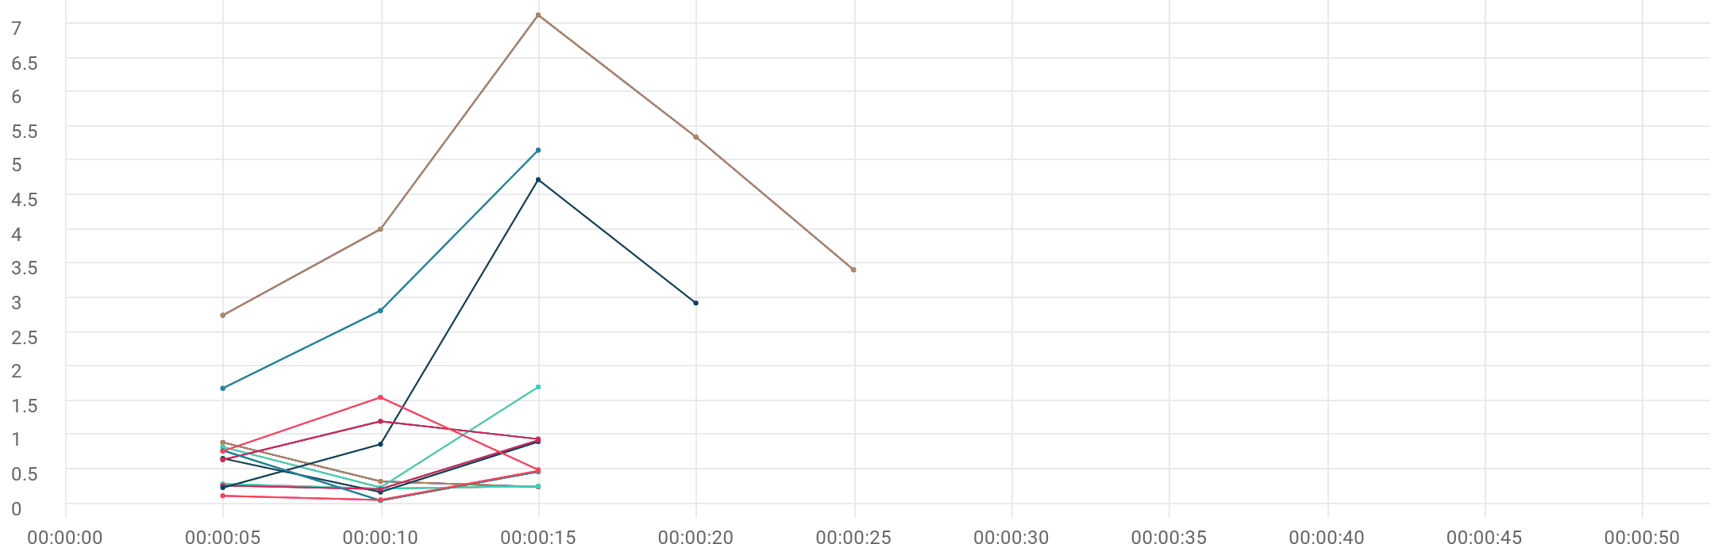

|  |  |  |  |  |  |  |  |  |  |  |  |
| --- | --- | --- | --- | --- | --- | --- | --- | --- | --- | --- | --- |
|  | Metric | Transaction | Script | Location | Emulation | Max | Min | Graph max | Graph avg | Graph min | Med |
| |  | | --- | |  | | TRT [MAX] | Eshowbizz_04_Buy_202 | 89_eShowBizz_CWS_Book_Buy202 (1) | All | All | N/A | N/A | 893.528 ms | 488.544 ms | 245.239 ms | 893.528 ms |
| |  | | --- | |  | | TRT [MAX] | Eshowbizz_04_Buy_183 | 90_eShowBizz_CWS_Book_Buy183 (1) | All | All | N/A | N/A | 287.053 ms | 254.005 ms | 219.939 ms | 287.053 ms |
| |  | | --- | |  | | TRT [MAX] | Eshowbizz_04_Buy_251 | 91_eShowBizz_CWS_Book_Buy251 (1) | All | All | N/A | N/A | 7.129 sec | 4.528 sec | 2.748 sec | 5.348 sec |
| |  | | --- | |  | | TRT [MAX] | Eshowbizz_04_Buy_232 | 92_eShowBizz_CWS_Book_Buy232 (1) | All | All | N/A | N/A | 1.702 sec | 921.555 ms | 235.513 ms | 1.702 sec |
| |  | | --- | |  | | TRT [MAX] | Eshowbizz_03_BookSeats_202 | 89_eShowBizz_CWS_Book_Buy202 (1) | All | All | N/A | N/A | 903.715 ms | 577.59 ms | 169.387 ms | 903.715 ms |
| |  | | --- | |  | | TRT [MAX] | Eshowbizz_03_BookSeats_183 | 90_eShowBizz_CWS_Book_Buy183 (1) | All | All | N/A | N/A | 923.555 ms | 467.119 ms | 212.325 ms | 923.555 ms |
| |  | | --- | |  | | TRT [MAX] | Eshowbizz_03_BookSeats_251 | 91_eShowBizz_CWS_Book_Buy251 (1) | All | All | N/A | N/A | 4.726 sec | 2.188 sec | 234.116 ms | 2.926 sec |
| |  | | --- | |  | | TRT [MAX] | Eshowbizz_03_BookSeats_232 | 92_eShowBizz_CWS_Book_Buy232 (1) | All | All | N/A | N/A | 1.201 sec | 928.391 ms | 640.918 ms | 1.201 sec |
| |  | | --- | |  | | TRT [MAX] | ShowSeats_AllClasses_Open_202 | 89_eShowBizz_CWS_Book_Buy202 (1) | All | All | N/A | N/A | 775.839 ms | 430.194 ms | 46.82 ms | 775.839 ms |
| |  | | --- | |  | | TRT [MAX] | ShowSeats_AllClasses_Open_183 | 90_eShowBizz_CWS_Book_Buy183 (1) | All | All | N/A | N/A | 479.255 ms | 216.081 ms | 54.284 ms | 479.255 ms |
| |  | | --- | |  | | TRT [MAX] | ShowSeats_AllClasses_Open_251 | 91_eShowBizz_CWS_Book_Buy251 (1) | All | All | N/A | N/A | 5.156 sec | 3.218 sec | 1.682 sec | 5.156 sec |
| |  | | --- | |  | | TRT [MAX] | ShowSeats_AllClasses_Open_232 | 92_eShowBizz_CWS_Book_Buy232 (1) | All | All | N/A | N/A | 1.551 sec | 937.013 ms | 493.931 ms | 1.551 sec |
| |  | | --- | |  | | TRT [MAX] | Eshowbizz_04_Buy_202 | 89_eShowBizz_CWS_Book_Buy202 (1) | On-Premise | All | N/A | N/A | 893.528 ms | 488.544 ms | 245.239 ms | 893.528 ms |
| |  | | --- | |  | | TRT [MAX] | Eshowbizz_04_Buy_183 | 90_eShowBizz_CWS_Book_Buy183 (1) | On-Premise | All | N/A | N/A | 287.053 ms | 254.005 ms | 219.939 ms | 287.053 ms |
| |  | | --- | |  | | TRT [MAX] | Eshowbizz_04_Buy_251 | 91_eShowBizz_CWS_Book_Buy251 (1) | On-Premise | All | N/A | N/A | 7.129 sec | 4.528 sec | 2.748 sec | 5.348 sec |
| |  | | --- | |  | | TRT [MAX] | Eshowbizz_04_Buy_232 | 92_eShowBizz_CWS_Book_Buy232 (1) | On-Premise | All | N/A | N/A | 1.702 sec | 921.555 ms | 235.513 ms | 1.702 sec |
| |  | | --- | |  | | TRT [MAX] | Eshowbizz_03_BookSeats_202 | 89_eShowBizz_CWS_Book_Buy202 (1) | On-Premise | All | N/A | N/A | 903.715 ms | 577.59 ms | 169.387 ms | 903.715 ms |
| |  | | --- | |  | | TRT [MAX] | Eshowbizz_03_BookSeats_183 | 90_eShowBizz_CWS_Book_Buy183 (1) | On-Premise | All | N/A | N/A | 923.555 ms | 467.119 ms | 212.325 ms | 923.555 ms |
| |  | | --- | |  | | TRT [MAX] | Eshowbizz_03_BookSeats_251 | 91_eShowBizz_CWS_Book_Buy251 (1) | On-Premise | All | N/A | N/A | 4.726 sec | 2.188 sec | 234.116 ms | 2.926 sec |
| |  | | --- | |  | | TRT [MAX] | Eshowbizz_03_BookSeats_232 | 92_eShowBizz_CWS_Book_Buy232 (1) | On-Premise | All | N/A | N/A | 1.201 sec | 928.391 ms | 640.918 ms | 1.201 sec |
| |  | | --- | |  | | TRT [MAX] | ShowSeats_AllClasses_Open_202 | 89_eShowBizz_CWS_Book_Buy202 (1) | On-Premise | All | N/A | N/A | 775.839 ms | 430.194 ms | 46.82 ms | 775.839 ms |
| |  | | --- | |  | | TRT [MAX] | ShowSeats_AllClasses_Open_183 | 90_eShowBizz_CWS_Book_Buy183 (1) | On-Premise | All | N/A | N/A | 479.255 ms | 216.081 ms | 54.284 ms | 479.255 ms |
| |  | | --- | |  | | TRT [MAX] | ShowSeats_AllClasses_Open_251 | 91_eShowBizz_CWS_Book_Buy251 (1) | On-Premise | All | N/A | N/A | 5.156 sec | 3.218 sec | 1.682 sec | 5.156 sec |
| |  | | --- | |  | | TRT [MAX] | ShowSeats_AllClasses_Open_232 | 92_eShowBizz_CWS_Book_Buy232 (1) | On-Premise | All | N/A | N/A | 1.551 sec | 937.013 ms | 493.931 ms | 1.551 sec |
| |  | | --- | |  | | TRT [MAX] | Eshowbizz_04_Buy_202 | 89_eShowBizz_CWS_Book_Buy202 (1) | On-Premise | No Emulation | N/A | N/A | 893.528 ms | 488.544 ms | 245.239 ms | 893.528 ms |
| |  | | --- | |  | | TRT [MAX] | Eshowbizz_04_Buy_183 | 90_eShowBizz_CWS_Book_Buy183 (1) | On-Premise | No Emulation | N/A | N/A | 287.053 ms | 254.005 ms | 219.939 ms | 287.053 ms |
| |  | | --- | |  | | TRT [MAX] | Eshowbizz_04_Buy_251 | 91_eShowBizz_CWS_Book_Buy251 (1) | On-Premise | No Emulation | N/A | N/A | 7.129 sec | 4.528 sec | 2.748 sec | 5.348 sec |
| |  | | --- | |  | | TRT [MAX] | Eshowbizz_04_Buy_232 | 92_eShowBizz_CWS_Book_Buy232 (1) | On-Premise | No Emulation | N/A | N/A | 1.702 sec | 921.555 ms | 235.513 ms | 1.702 sec |
| |  | | --- | |  | | TRT [MAX] | Eshowbizz_03_BookSeats_202 | 89_eShowBizz_CWS_Book_Buy202 (1) | On-Premise | No Emulation | N/A | N/A | 903.715 ms | 577.59 ms | 169.387 ms | 903.715 ms |
| |  | | --- | |  | | TRT [MAX] | Eshowbizz_03_BookSeats_183 | 90_eShowBizz_CWS_Book_Buy183 (1) | On-Premise | No Emulation | N/A | N/A | 923.555 ms | 467.119 ms | 212.325 ms | 923.555 ms |
| |  | | --- | |  | | TRT [MAX] | Eshowbizz_03_BookSeats_251 | 91_eShowBizz_CWS_Book_Buy251 (1) | On-Premise | No Emulation | N/A | N/A | 4.726 sec | 2.188 sec | 234.116 ms | 2.926 sec |
| |  | | --- | |  | | TRT [MAX] | Eshowbizz_03_BookSeats_232 | 92_eShowBizz_CWS_Book_Buy232 (1) | On-Premise | No Emulation | N/A | N/A | 1.201 sec | 928.391 ms | 640.918 ms | 1.201 sec |
| |  | | --- | |  | | TRT [MAX] | ShowSeats_AllClasses_Open_202 | 89_eShowBizz_CWS_Book_Buy202 (1) | On-Premise | No Emulation | N/A | N/A | 775.839 ms | 430.194 ms | 46.82 ms | 775.839 ms |
| |  | | --- | |  | | TRT [MAX] | ShowSeats_AllClasses_Open_183 | 90_eShowBizz_CWS_Book_Buy183 (1) | On-Premise | No Emulation | N/A | N/A | 479.255 ms | 216.081 ms | 54.284 ms | 479.255 ms |
| |  | | --- | |  | | TRT [MAX] | ShowSeats_AllClasses_Open_251 | 91_eShowBizz_CWS_Book_Buy251 (1) | On-Premise | No Emulation | N/A | N/A | 5.156 sec | 3.218 sec | 1.682 sec | 5.156 sec |
| |  | | --- | |  | | TRT [MAX] | ShowSeats_AllClasses_Open_232 | 92_eShowBizz_CWS_Book_Buy232 (1) | On-Premise | No Emulation | N/A | N/A | 1.551 sec | 937.013 ms | 493.931 ms | 1.551 sec |

# Total transactions



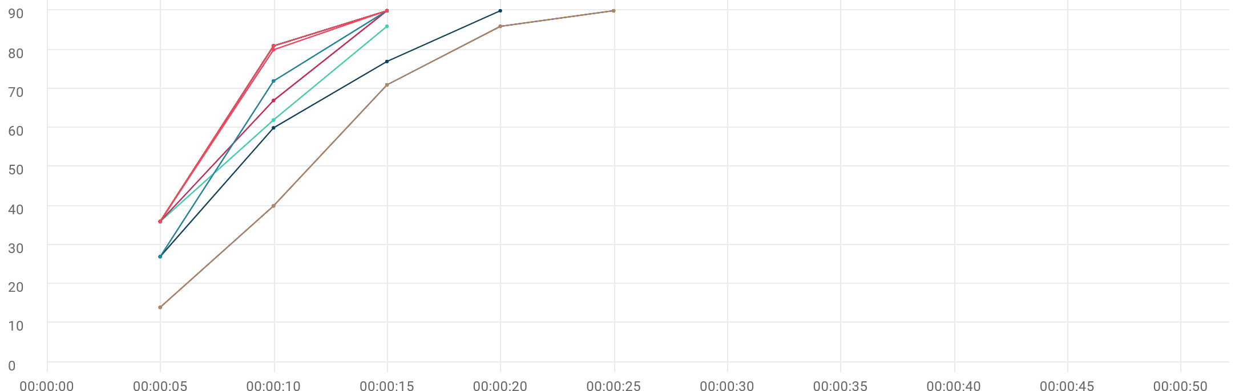

|  |  |  |  |  |  |  |  |  |  |  |  |
| --- | --- | --- | --- | --- | --- | --- | --- | --- | --- | --- | --- |
|  | Metric | Transaction | Script | Location | Emulation | Max | Min | Graph max | Graph avg | Graph min | Med |
| |  | | --- | |  | | Total transactions | Eshowbizz_04_Buy_202 | 89_eShowBizz_CWS_Book_Buy202 (1) | All | All | N/A | N/A | 90 | 69 | 36 | 90 |
| |  | | --- | |  | | Total transactions | Eshowbizz_04_Buy_183 | 90_eShowBizz_CWS_Book_Buy183 (1) | All | All | N/A | N/A | 90 | 69 | 36 | 90 |
| |  | | --- | |  | | Total transactions | Eshowbizz_04_Buy_251 | 91_eShowBizz_CWS_Book_Buy251 (1) | All | All | N/A | N/A | 90 | 60.2 | 14 | 86 |
| |  | | --- | |  | | Total transactions | Eshowbizz_04_Buy_232 | 92_eShowBizz_CWS_Book_Buy232 (1) | All | All | N/A | N/A | 86 | 61.333 | 36 | 86 |
| |  | | --- | |  | | Total transactions | Eshowbizz_03_BookSeats_202 | 89_eShowBizz_CWS_Book_Buy202 (1) | All | All | N/A | N/A | 90 | 69 | 36 | 90 |
| |  | | --- | |  | | Total transactions | Eshowbizz_03_BookSeats_183 | 90_eShowBizz_CWS_Book_Buy183 (1) | All | All | N/A | N/A | 90 | 69 | 36 | 90 |
| |  | | --- | |  | | Total transactions | Eshowbizz_03_BookSeats_251 | 91_eShowBizz_CWS_Book_Buy251 (1) | All | All | N/A | N/A | 90 | 63.5 | 27 | 77 |
| |  | | --- | |  | | Total transactions | Eshowbizz_03_BookSeats_232 | 92_eShowBizz_CWS_Book_Buy232 (1) | All | All | N/A | N/A | 90 | 64.333 | 36 | 90 |
| |  | | --- | |  | | Total transactions | ShowSeats_AllClasses_Open_202 | 89_eShowBizz_CWS_Book_Buy202 (1) | All | All | N/A | N/A | 90 | 69 | 36 | 90 |
| |  | | --- | |  | | Total transactions | ShowSeats_AllClasses_Open_183 | 90_eShowBizz_CWS_Book_Buy183 (1) | All | All | N/A | N/A | 90 | 69 | 36 | 90 |
| |  | | --- | |  | | Total transactions | ShowSeats_AllClasses_Open_251 | 91_eShowBizz_CWS_Book_Buy251 (1) | All | All | N/A | N/A | 90 | 63 | 27 | 90 |
| |  | | --- | |  | | Total transactions | ShowSeats_AllClasses_Open_232 | 92_eShowBizz_CWS_Book_Buy232 (1) | All | All | N/A | N/A | 90 | 68.667 | 36 | 90 |
| |  | | --- | |  | | Total transactions | Eshowbizz_04_Buy_202 | 89_eShowBizz_CWS_Book_Buy202 (1) | On-Premise | All | N/A | N/A | 90 | 69 | 36 | 90 |
| |  | | --- | |  | | Total transactions | Eshowbizz_04_Buy_183 | 90_eShowBizz_CWS_Book_Buy183 (1) | On-Premise | All | N/A | N/A | 90 | 69 | 36 | 90 |
| |  | | --- | |  | | Total transactions | Eshowbizz_04_Buy_251 | 91_eShowBizz_CWS_Book_Buy251 (1) | On-Premise | All | N/A | N/A | 90 | 60.2 | 14 | 86 |
| |  | | --- | |  | | Total transactions | Eshowbizz_04_Buy_232 | 92_eShowBizz_CWS_Book_Buy232 (1) | On-Premise | All | N/A | N/A | 86 | 61.333 | 36 | 86 |
| |  | | --- | |  | | Total transactions | Eshowbizz_03_BookSeats_202 | 89_eShowBizz_CWS_Book_Buy202 (1) | On-Premise | All | N/A | N/A | 90 | 69 | 36 | 90 |
| |  | | --- | |  | | Total transactions | Eshowbizz_03_BookSeats_183 | 90_eShowBizz_CWS_Book_Buy183 (1) | On-Premise | All | N/A | N/A | 90 | 69 | 36 | 90 |
| |  | | --- | |  | | Total transactions | Eshowbizz_03_BookSeats_251 | 91_eShowBizz_CWS_Book_Buy251 (1) | On-Premise | All | N/A | N/A | 90 | 63.5 | 27 | 77 |
| |  | | --- | |  | | Total transactions | Eshowbizz_03_BookSeats_232 | 92_eShowBizz_CWS_Book_Buy232 (1) | On-Premise | All | N/A | N/A | 90 | 64.333 | 36 | 90 |
| |  | | --- | |  | | Total transactions | ShowSeats_AllClasses_Open_202 | 89_eShowBizz_CWS_Book_Buy202 (1) | On-Premise | All | N/A | N/A | 90 | 69 | 36 | 90 |
| |  | | --- | |  | | Total transactions | ShowSeats_AllClasses_Open_183 | 90_eShowBizz_CWS_Book_Buy183 (1) | On-Premise | All | N/A | N/A | 90 | 69 | 36 | 90 |
| |  | | --- | |  | | Total transactions | ShowSeats_AllClasses_Open_251 | 91_eShowBizz_CWS_Book_Buy251 (1) | On-Premise | All | N/A | N/A | 90 | 63 | 27 | 90 |
| |  | | --- | |  | | Total transactions | ShowSeats_AllClasses_Open_232 | 92_eShowBizz_CWS_Book_Buy232 (1) | On-Premise | All | N/A | N/A | 90 | 68.667 | 36 | 90 |
| |  | | --- | |  | | Total transactions | Eshowbizz_04_Buy_202 | 89_eShowBizz_CWS_Book_Buy202 (1) | On-Premise | No Emulation | N/A | N/A | 90 | 69 | 36 | 90 |
| |  | | --- | |  | | Total transactions | Eshowbizz_04_Buy_183 | 90_eShowBizz_CWS_Book_Buy183 (1) | On-Premise | No Emulation | N/A | N/A | 90 | 69 | 36 | 90 |
| |  | | --- | |  | | Total transactions | Eshowbizz_04_Buy_251 | 91_eShowBizz_CWS_Book_Buy251 (1) | On-Premise | No Emulation | N/A | N/A | 90 | 60.2 | 14 | 86 |
| |  | | --- | |  | | Total transactions | Eshowbizz_04_Buy_232 | 92_eShowBizz_CWS_Book_Buy232 (1) | On-Premise | No Emulation | N/A | N/A | 86 | 61.333 | 36 | 86 |
| |  | | --- | |  | | Total transactions | Eshowbizz_03_BookSeats_202 | 89_eShowBizz_CWS_Book_Buy202 (1) | On-Premise | No Emulation | N/A | N/A | 90 | 69 | 36 | 90 |
| |  | | --- | |  | | Total transactions | Eshowbizz_03_BookSeats_183 | 90_eShowBizz_CWS_Book_Buy183 (1) | On-Premise | No Emulation | N/A | N/A | 90 | 69 | 36 | 90 |
| |  | | --- | |  | | Total transactions | Eshowbizz_03_BookSeats_251 | 91_eShowBizz_CWS_Book_Buy251 (1) | On-Premise | No Emulation | N/A | N/A | 90 | 63.5 | 27 | 77 |
| |  | | --- | |  | | Total transactions | Eshowbizz_03_BookSeats_232 | 92_eShowBizz_CWS_Book_Buy232 (1) | On-Premise | No Emulation | N/A | N/A | 90 | 64.333 | 36 | 90 |
| |  | | --- | |  | | Total transactions | ShowSeats_AllClasses_Open_202 | 89_eShowBizz_CWS_Book_Buy202 (1) | On-Premise | No Emulation | N/A | N/A | 90 | 69 | 36 | 90 |
| |  | | --- | |  | | Total transactions | ShowSeats_AllClasses_Open_183 | 90_eShowBizz_CWS_Book_Buy183 (1) | On-Premise | No Emulation | N/A | N/A | 90 | 69 | 36 | 90 |
| |  | | --- | |  | | Total transactions | ShowSeats_AllClasses_Open_251 | 91_eShowBizz_CWS_Book_Buy251 (1) | On-Premise | No Emulation | N/A | N/A | 90 | 63 | 27 | 90 |
| |  | | --- | |  | | Total transactions | ShowSeats_AllClasses_Open_232 | 92_eShowBizz_CWS_Book_Buy232 (1) | On-Premise | No Emulation | N/A | N/A | 90 | 68.667 | 36 | 90 |