

eShowBizz_SC4_18thMarch - #27

PASSED



# Summary

|  |  |
| --- | --- |
| Run ID | #27 |
| Status | Passed |
| Duration | 00:00:58 |
| Run mode | Iterations |
| Think time | Included |
| Errors | 0 |
| LG alerts | 0 |
| Date | Mar 18, 2023 |
| Time | 15:37 (GMT +05:30) |
| Percentile algorithm | Optimal |
| Percentile value | 90 |
| Average Throughput | 779.888 KB/s |
| Total Throughput | 22.848 MB |
| Average Hits | 324.000 Hits/s |
| Total Hits | 9,720 |
| Passed Transactions | 9,720 |
| Failed Transactions | 0 |
| Passed TRT breakers | - |
| Failed TRT breakers | - |
| Total WEB Vusers | 9,000 |
| Total Failed Vusers | 0 |

# Top 10 transactions

|  |  |  |  |  |  |  |  |  |  |  |
| --- | --- | --- | --- | --- | --- | --- | --- | --- | --- | --- |
| Script | Transaction | SLA status | Avg | Min | Max | STD | TRT percentile Threshold | 90th | Passed | Failed |
| 94_eShowBizz_ShowSeats_AllClassOpen251 | ShowSeats_AllClasses_Open_251 | N/A | 2.892 | 0.019 | 14.260 | 2.462 | 0.000 | 7.343 | 2250 | 0 |
| 96_eShowBizz_ShowSeats_AllClassOpen202 | ShowSeats_AllClasses_Open_202 | N/A | 2.320 | 0.012 | 11.311 | 2.302 | 0.000 | 6.581 | 2250 | 0 |
| 95_eShowBizz_ShowSeats_AllClassOpen232 | ShowSeats_AllClasses_Open_232 | N/A | 2.255 | 0.012 | 12.567 | 2.245 | 0.000 | 6.698 | 2240 | 0 |
| 93_eShowBizz_ShowSeats_AllClassOpen183 | ShowSeats_AllClasses_Open_183 | N/A | 2.465 | 0.018 | 9.922 | 2.432 | 0.000 | 6.978 | 1900 | 0 |
| 100_eShowBizz_CWS_Book_Buy251 (2) | Eshowbizz_03_BookSeats_251 | N/A | 3.284 | 0.060 | 10.586 | 2.494 | 0.000 | 8.127 | 90 | 0 |
| 100_eShowBizz_CWS_Book_Buy251 (2) | ShowSeats_AllClasses_Open_251 | N/A | 3.097 | 0.212 | 9.823 | 2.522 | 0.000 | 8.412 | 90 | 0 |
| 100_eShowBizz_CWS_Book_Buy251 (2) | Eshowbizz_04_Buy_251 | N/A | 3.063 | 0.601 | 11.898 | 2.357 | 0.000 | 6.643 | 90 | 0 |
| 97_eShowBizz_CWS_Book_Buy183 (2) | Eshowbizz_03_BookSeats_183 | N/A | 2.521 | 0.039 | 8.879 | 2.667 | 0.000 | 7.219 | 90 | 0 |
| 97_eShowBizz_CWS_Book_Buy183 (2) | Eshowbizz_04_Buy_183 | N/A | 2.300 | 0.046 | 9.715 | 2.690 | 0.000 | 7.473 | 90 | 0 |
| 99_eShowBizz_CWS_Book_Buy232 (2) | ShowSeats_AllClasses_Open_232 | N/A | 2.272 | 0.016 | 9.766 | 2.223 | 0.000 | 6.144 | 90 | 0 |

# Passed & Failed TRX / sec

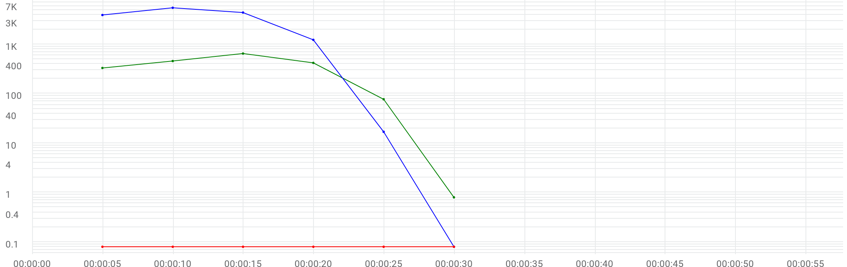

|  |  |  |  |  |  |  |  |
| --- | --- | --- | --- | --- | --- | --- | --- |
|  | Metric | Max | Min | Graph max | Graph avg | Graph min | Med |
| |  | | --- | |  | | Running Vusers | 5500 | 0 | 5500 | 2513.833 | 0 | 3926 |
| |  | | --- | |  | | Passed transactions per second | N/A | N/A | 651.8 | 324 | 0.8 | 421.8 |
| |  | | --- | |  | | Failed transactions per second | N/A | N/A | 0 | 0 | 0 | 0 |

# Transactions

**97_eShowBizz_CWS_Book_Buy183 (2)**

|  |  |  |  |  |  |  |  |  |  |
| --- | --- | --- | --- | --- | --- | --- | --- | --- | --- |
| Transaction | SLA status | Avg | Min | Max | STD | TRT percentile Threshold | Custom 95th | Passed | Failed |
| Eshowbizz_03_BookSeats_183 | N/A | 2.521 | 0.039 | 8.879 | 2.667 | 0.000 | 8.180 | 90 | 0 |
| Eshowbizz_04_Buy_183 | N/A | 2.300 | 0.046 | 9.715 | 2.690 | 0.000 | 8.628 | 90 | 0 |
| ShowSeats_AllClasses_Open_183 | N/A | 2.080 | 0.020 | 8.354 | 2.148 | 0.000 | 7.933 | 90 | 0 |

**98_eShowBizz_CWS_Book_Buy202 (2)**

|  |  |  |  |  |  |  |  |  |  |
| --- | --- | --- | --- | --- | --- | --- | --- | --- | --- |
| Transaction | SLA status | Avg | Min | Max | STD | TRT percentile Threshold | Custom 95th | Passed | Failed |
| Eshowbizz_03_BookSeats_202 | N/A | 1.820 | 0.030 | 8.507 | 1.961 | 0.000 | 7.558 | 90 | 0 |
| Eshowbizz_04_Buy_202 | N/A | 2.237 | 0.049 | 9.541 | 2.214 | 0.000 | 6.754 | 90 | 0 |
| ShowSeats_AllClasses_Open_202 | N/A | 1.692 | 0.028 | 8.072 | 1.569 | 0.000 | 5.043 | 90 | 0 |

**99_eShowBizz_CWS_Book_Buy232 (2)**

|  |  |  |  |  |  |  |  |  |  |
| --- | --- | --- | --- | --- | --- | --- | --- | --- | --- |
| Transaction | SLA status | Avg | Min | Max | STD | TRT percentile Threshold | Custom 95th | Passed | Failed |
| Eshowbizz_03_BookSeats_232 | N/A | 2.261 | 0.028 | 9.143 | 2.434 | 0.000 | 8.442 | 90 | 0 |
| Eshowbizz_04_Buy_232 | N/A | 1.977 | 0.042 | 8.648 | 2.302 | 0.000 | 8.072 | 90 | 0 |
| ShowSeats_AllClasses_Open_232 | N/A | 2.272 | 0.016 | 9.766 | 2.223 | 0.000 | 8.093 | 90 | 0 |

**100_eShowBizz_CWS_Book_Buy251 (2)**

|  |  |  |  |  |  |  |  |  |  |
| --- | --- | --- | --- | --- | --- | --- | --- | --- | --- |
| Transaction | SLA status | Avg | Min | Max | STD | TRT percentile Threshold | Custom 95th | Passed | Failed |
| Eshowbizz_03_BookSeats_251 | N/A | 3.284 | 0.060 | 10.586 | 2.494 | 0.000 | 8.600 | 90 | 0 |
| Eshowbizz_04_Buy_251 | N/A | 3.063 | 0.601 | 11.898 | 2.357 | 0.000 | 8.949 | 90 | 0 |
| ShowSeats_AllClasses_Open_251 | N/A | 3.097 | 0.212 | 9.823 | 2.522 | 0.000 | 8.779 | 90 | 0 |

**93_eShowBizz_ShowSeats_AllClassOpen183**

|  |  |  |  |  |  |  |  |  |  |
| --- | --- | --- | --- | --- | --- | --- | --- | --- | --- |
| Transaction | SLA status | Avg | Min | Max | STD | TRT percentile Threshold | Custom 95th | Passed | Failed |
| ShowSeats_AllClasses_Open_183 | N/A | 2.465 | 0.018 | 9.922 | 2.432 | 0.000 | 8.157 | 1900 | 0 |

**96_eShowBizz_ShowSeats_AllClassOpen202**

|  |  |  |  |  |  |  |  |  |  |
| --- | --- | --- | --- | --- | --- | --- | --- | --- | --- |
| Transaction | SLA status | Avg | Min | Max | STD | TRT percentile Threshold | Custom 95th | Passed | Failed |
| ShowSeats_AllClasses_Open_202 | N/A | 2.320 | 0.012 | 11.311 | 2.302 | 0.000 | 7.880 | 2250 | 0 |

**95_eShowBizz_ShowSeats_AllClassOpen232**

|  |  |  |  |  |  |  |  |  |  |
| --- | --- | --- | --- | --- | --- | --- | --- | --- | --- |
| Transaction | SLA status | Avg | Min | Max | STD | TRT percentile Threshold | Custom 95th | Passed | Failed |
| ShowSeats_AllClasses_Open_232 | N/A | 2.255 | 0.012 | 12.567 | 2.245 | 0.000 | 7.986 | 2240 | 0 |

**94_eShowBizz_ShowSeats_AllClassOpen251**

|  |  |  |  |  |  |  |  |  |  |
| --- | --- | --- | --- | --- | --- | --- | --- | --- | --- |
| Transaction | SLA status | Avg | Min | Max | STD | TRT percentile Threshold | Custom 95th | Passed | Failed |
| ShowSeats_AllClasses_Open_251 | N/A | 2.892 | 0.019 | 14.260 | 2.462 | 0.000 | 8.806 | 2250 | 0 |

# Errors / sec

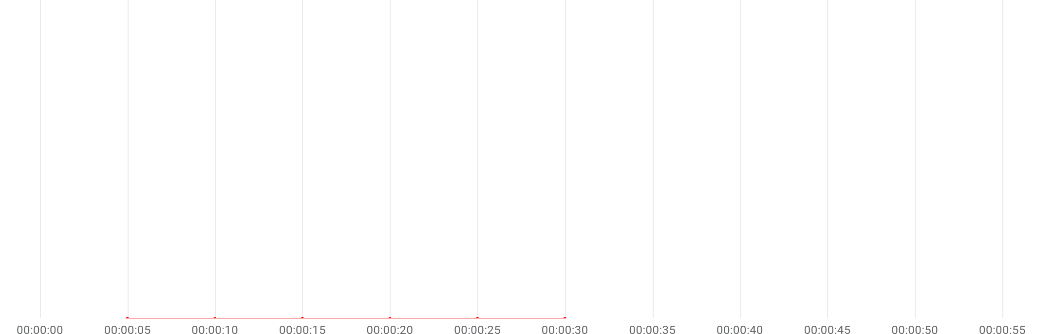

|  |  |  |  |  |  |  |  |
| --- | --- | --- | --- | --- | --- | --- | --- |
|  | Metric | Max | Min | Graph max | Graph avg | Graph min | Med |
| |  | | --- | |  | | Errors per second | N/A | N/A | 0 | 0 | 0 | 0 |

# Errors summary

No Data available

# Throughput & Hits / sec

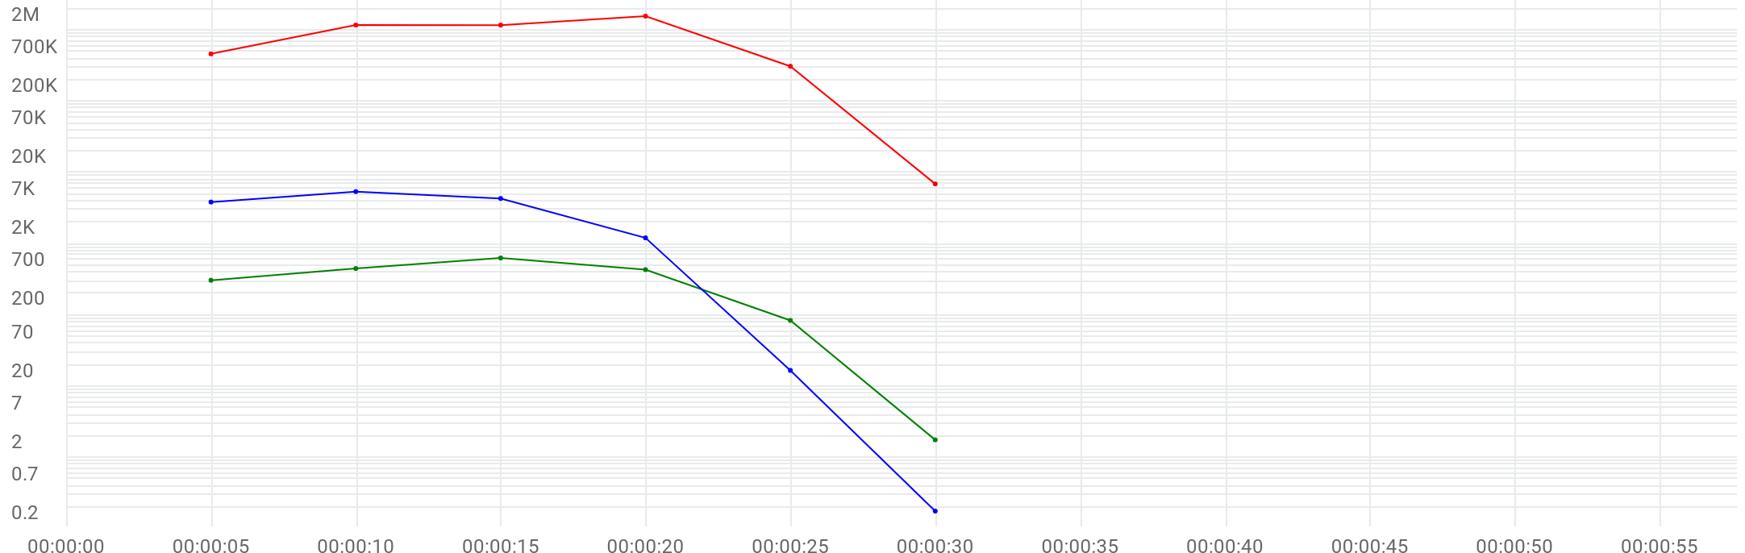

|  |  |  |  |  |  |  |  |
| --- | --- | --- | --- | --- | --- | --- | --- |
|  | Metric | Max | Min | Graph max | Graph avg | Graph min | Med |
| |  | | --- | |  | | Running Vusers | 5500 | 0 | 5500 | 2513.833 | 0 | 3926 |
| |  | | --- | |  | | Hits per second | 643.6 | 1.8 | 643.6 | 324 | 1.8 | 441.6 |
| |  | | --- | |  | | Throughput | 1.527 MB/s | 6.891 KB/s | 1.527 MB/s | 779.888 KB/s | 6.891 KB/s | 1.141 MB/s |

# Scripts

|  |  |  |  |  |  |  |
| --- | --- | --- | --- | --- | --- | --- |
| Script | Vusers | Ramp up | Iterations planned | Duration | Max duration | Location |
| 100_eShowBizz_CWS_Book_Buy251 (2) | 90 | 00:00:17 / 00:00:10 | 1 | 00:00:10 | 00:05:00 | On Premise |
| 93_eShowBizz_ShowSeats_AllClassOpen183 | 1900 | 00:00:17 / 00:00:10 | 1 | 00:00:06 | 00:05:00 | On Premise |
| 94_eShowBizz_ShowSeats_AllClassOpen251 | 2250 | 00:00:18 / 00:00:10 | 1 | 00:00:07 | 00:05:00 | On Premise |
| 95_eShowBizz_ShowSeats_AllClassOpen232 | 2240 | 00:00:17 / 00:00:10 | 1 | 00:00:07 | 00:05:00 | On Premise |
| 96_eShowBizz_ShowSeats_AllClassOpen202 | 2250 | 00:00:19 / 00:00:10 | 1 | 00:00:04 | 00:05:00 | On Premise |
| 97_eShowBizz_CWS_Book_Buy183 (2) | 90 | 00:00:17 / 00:00:10 | 1 | 00:00:06 | 00:05:00 | On Premise |
| 98_eShowBizz_CWS_Book_Buy202 (2) | 90 | 00:00:17 / 00:00:10 | 1 | 00:00:06 | 00:05:00 | On Premise |
| 99_eShowBizz_CWS_Book_Buy232 (2) | 90 | 00:00:14 / 00:00:10 | 1 | 00:00:08 | 00:05:00 | On Premise |

# Distribution

|  |  |  |
| --- | --- | --- |
| Distribution | %Vusers | No Emulation |
| On-Premise | 100.0% | 100.0% |

# LG health monitoring

|  |  |  |  |  |
| --- | --- | --- | --- | --- |
| LOCATION | Host | Metric | Max | Avg |
| On-Premise | EC2AMAZ-2O3HKBP-172.31.11.184 | CPU | 86.6% | 49.94% |
| On-Premise | EC2AMAZ-2O3HKBP-172.31.11.184 | DISK | 24.55% | 24.545% |
| On-Premise | EC2AMAZ-2O3HKBP-172.31.11.184 | MEMORY | 49.88% | 34.435% |

# HTTP responses

**100_eShowBizz_CWS_Book_Buy251 (2)**

|  |  |  |
| --- | --- | --- |
| HTTP response | Total | Avg |
| HTTP_200 | 270 | 9 |

**93_eShowBizz_ShowSeats_AllClassOpen183**

|  |  |  |
| --- | --- | --- |
| HTTP response | Total | Avg |
| HTTP_200 | 1,900 | 76 |

**94_eShowBizz_ShowSeats_AllClassOpen251**

|  |  |  |
| --- | --- | --- |
| HTTP response | Total | Avg |
| HTTP_200 | 2,250 | 90 |

**95_eShowBizz_ShowSeats_AllClassOpen232**

|  |  |  |
| --- | --- | --- |
| HTTP response | Total | Avg |
| HTTP_200 | 2,240 | 89.6 |

**96_eShowBizz_ShowSeats_AllClassOpen202**

|  |  |  |
| --- | --- | --- |
| HTTP response | Total | Avg |
| HTTP_200 | 2,250 | 90 |

**97_eShowBizz_CWS_Book_Buy183 (2)**

|  |  |  |
| --- | --- | --- |
| HTTP response | Total | Avg |
| HTTP_200 | 270 | 13.5 |

**98_eShowBizz_CWS_Book_Buy202 (2)**

|  |  |  |
| --- | --- | --- |
| HTTP response | Total | Avg |
| HTTP_200 | 270 | 13.5 |

**99_eShowBizz_CWS_Book_Buy232 (2)**

|  |  |  |
| --- | --- | --- |
| HTTP response | Total | Avg |
| HTTP_200 | 270 | 13.5 |

# OPLG scripts

|  |  |  |
| --- | --- | --- |
| Load generator | Script | Vusers |
| eShowBizz | eShowBizz_ShowSeats_AllClassOpen183 | 1900 |
| eShowBizz | eShowBizz_ShowSeats_AllClassOpen251 | 2250 |
| eShowBizz | eShowBizz_ShowSeats_AllClassOpen232 | 2240 |
| eShowBizz | eShowBizz_ShowSeats_AllClassOpen202 | 2250 |
| eShowBizz | eShowBizz_CWS_Book_Buy183 (2) | 90 |
| eShowBizz | eShowBizz_CWS_Book_Buy202 (2) | 90 |
| eShowBizz | eShowBizz_CWS_Book_Buy232 (2) | 90 |
| eShowBizz | eShowBizz_CWS_Book_Buy251 (2) | 90 |

# OPLG errors

No Data available

# Running Vusers



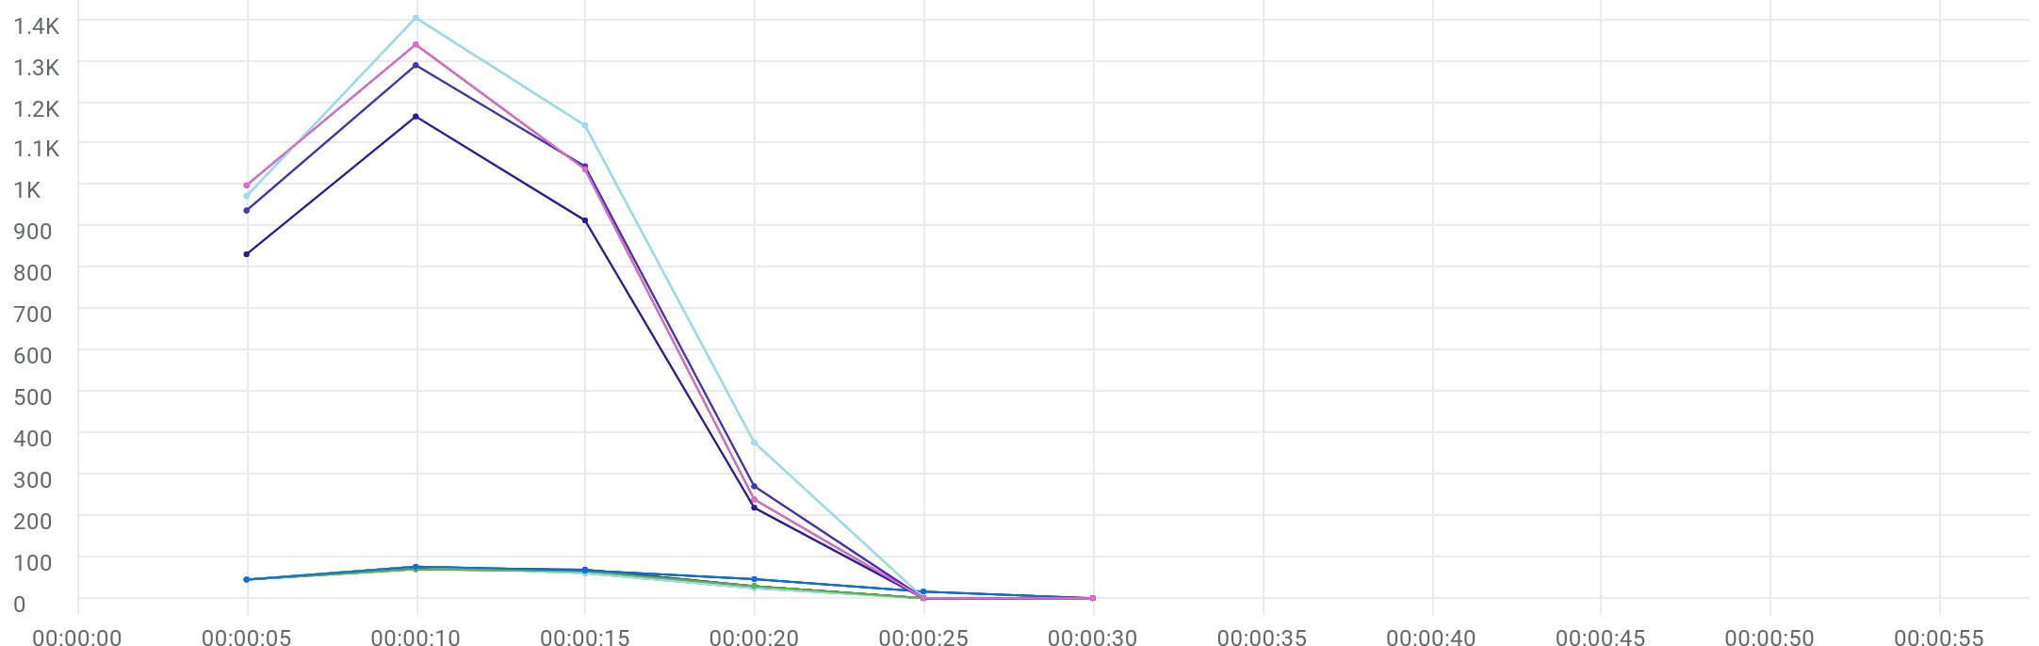

|  |  |  |  |  |  |  |  |  |  |  |
| --- | --- | --- | --- | --- | --- | --- | --- | --- | --- | --- |
|  | Metric | Script | Location | Emulation | Max | Min | Graph max | Graph avg | Graph min | Med |
| |  | | --- | |  | | Running Vusers | 100_eShowBizz_CWS_Book_Buy251 (2) | All | All | 76 | 0 | 76 | 41.667 | 0 | 46 |
| |  | | --- | |  | | Running Vusers | 97_eShowBizz_CWS_Book_Buy183 (2) | All | All | 73 | 0 | 73 | 36 | 0 | 45 |
| |  | | --- | |  | | Running Vusers | 98_eShowBizz_CWS_Book_Buy202 (2) | All | All | 76 | 0 | 76 | 34.167 | 0 | 45 |
| |  | | --- | |  | | Running Vusers | 99_eShowBizz_CWS_Book_Buy232 (2) | All | All | 70 | 0 | 70 | 34.833 | 0 | 45 |
| |  | | --- | |  | | Running Vusers | 94_eShowBizz_ShowSeats_AllClassOpen251 | All | All | 1406 | 0 | 1406 | 650.5 | 0 | 974 |
| |  | | --- | |  | | Running Vusers | 95_eShowBizz_ShowSeats_AllClassOpen232 | All | All | 1291 | 0 | 1291 | 591.167 | 0 | 939 |
| |  | | --- | |  | | Running Vusers | 96_eShowBizz_ShowSeats_AllClassOpen202 | All | All | 1341 | 0 | 1341 | 603.167 | 0 | 1000 |
| |  | | --- | |  | | Running Vusers | 93_eShowBizz_ShowSeats_AllClassOpen183 | All | All | 1167 | 0 | 1167 | 522.333 | 0 | 833 |
| |  | | --- | |  | | Running Vusers | 97_eShowBizz_CWS_Book_Buy183 (2) | On-Premise | All | 73 | 0 | 73 | 36 | 0 | 45 |
| |  | | --- | |  | | Running Vusers | 98_eShowBizz_CWS_Book_Buy202 (2) | On-Premise | All | 76 | 0 | 76 | 34.167 | 0 | 45 |
| |  | | --- | |  | | Running Vusers | 99_eShowBizz_CWS_Book_Buy232 (2) | On-Premise | All | 70 | 0 | 70 | 34.833 | 0 | 45 |
| |  | | --- | |  | | Running Vusers | 100_eShowBizz_CWS_Book_Buy251 (2) | On-Premise | All | 76 | 0 | 76 | 41.667 | 0 | 46 |
| |  | | --- | |  | | Running Vusers | 94_eShowBizz_ShowSeats_AllClassOpen251 | On-Premise | All | 1406 | 0 | 1406 | 650.5 | 0 | 974 |
| |  | | --- | |  | | Running Vusers | 95_eShowBizz_ShowSeats_AllClassOpen232 | On-Premise | All | 1291 | 0 | 1291 | 591.167 | 0 | 939 |
| |  | | --- | |  | | Running Vusers | 96_eShowBizz_ShowSeats_AllClassOpen202 | On-Premise | All | 1341 | 0 | 1341 | 603.167 | 0 | 1000 |
| |  | | --- | |  | | Running Vusers | 93_eShowBizz_ShowSeats_AllClassOpen183 | On-Premise | All | 1167 | 0 | 1167 | 522.333 | 0 | 833 |
| |  | | --- | |  | | Running Vusers | 97_eShowBizz_CWS_Book_Buy183 (2) | On-Premise | No Emulation | 73 | 0 | 73 | 36 | 0 | 45 |
| |  | | --- | |  | | Running Vusers | 98_eShowBizz_CWS_Book_Buy202 (2) | On-Premise | No Emulation | 76 | 0 | 76 | 34.167 | 0 | 45 |
| |  | | --- | |  | | Running Vusers | 99_eShowBizz_CWS_Book_Buy232 (2) | On-Premise | No Emulation | 70 | 0 | 70 | 34.833 | 0 | 45 |
| |  | | --- | |  | | Running Vusers | 100_eShowBizz_CWS_Book_Buy251 (2) | On-Premise | No Emulation | 76 | 0 | 76 | 41.667 | 0 | 46 |
| |  | | --- | |  | | Running Vusers | 93_eShowBizz_ShowSeats_AllClassOpen183 | On-Premise | No Emulation | 1167 | 0 | 1167 | 522.333 | 0 | 833 |
| |  | | --- | |  | | Running Vusers | 94_eShowBizz_ShowSeats_AllClassOpen251 | On-Premise | No Emulation | 1406 | 0 | 1406 | 650.5 | 0 | 974 |
| |  | | --- | |  | | Running Vusers | 95_eShowBizz_ShowSeats_AllClassOpen232 | On-Premise | No Emulation | 1291 | 0 | 1291 | 591.167 | 0 | 939 |
| |  | | --- | |  | | Running Vusers | 96_eShowBizz_ShowSeats_AllClassOpen202 | On-Premise | No Emulation | 1341 | 0 | 1341 | 603.167 | 0 | 1000 |

# Failed Vusers



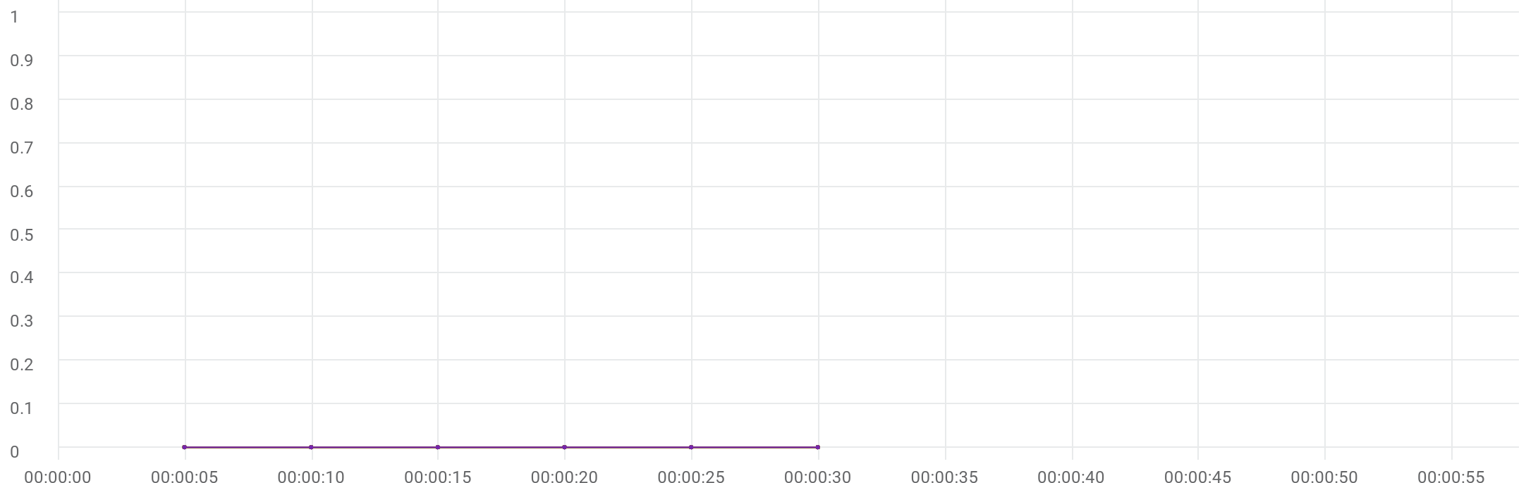

|  |  |  |  |  |  |  |  |  |  |  |
| --- | --- | --- | --- | --- | --- | --- | --- | --- | --- | --- |
|  | Metric | Script | Location | Emulation | Max | Min | Graph max | Graph avg | Graph min | Med |
| |  | | --- | |  | | Failed Vusers | 97_eShowBizz_CWS_Book_Buy183 (2) | All | All | 0 | 0 | 0 | 0 | 0 | 0 |
| |  | | --- | |  | | Failed Vusers | 98_eShowBizz_CWS_Book_Buy202 (2) | All | All | 0 | 0 | 0 | 0 | 0 | 0 |
| |  | | --- | |  | | Failed Vusers | 99_eShowBizz_CWS_Book_Buy232 (2) | All | All | 0 | 0 | 0 | 0 | 0 | 0 |
| |  | | --- | |  | | Failed Vusers | 100_eShowBizz_CWS_Book_Buy251 (2) | All | All | 0 | 0 | 0 | 0 | 0 | 0 |
| |  | | --- | |  | | Failed Vusers | 93_eShowBizz_ShowSeats_AllClassOpen183 | All | All | 0 | 0 | 0 | 0 | 0 | 0 |
| |  | | --- | |  | | Failed Vusers | 94_eShowBizz_ShowSeats_AllClassOpen251 | All | All | 0 | 0 | 0 | 0 | 0 | 0 |
| |  | | --- | |  | | Failed Vusers | 95_eShowBizz_ShowSeats_AllClassOpen232 | All | All | 0 | 0 | 0 | 0 | 0 | 0 |
| |  | | --- | |  | | Failed Vusers | 96_eShowBizz_ShowSeats_AllClassOpen202 | All | All | 0 | 0 | 0 | 0 | 0 | 0 |
| |  | | --- | |  | | Failed Vusers | 97_eShowBizz_CWS_Book_Buy183 (2) | On-Premise | All | 0 | 0 | 0 | 0 | 0 | 0 |
| |  | | --- | |  | | Failed Vusers | 98_eShowBizz_CWS_Book_Buy202 (2) | On-Premise | All | 0 | 0 | 0 | 0 | 0 | 0 |
| |  | | --- | |  | | Failed Vusers | 99_eShowBizz_CWS_Book_Buy232 (2) | On-Premise | All | 0 | 0 | 0 | 0 | 0 | 0 |
| |  | | --- | |  | | Failed Vusers | 100_eShowBizz_CWS_Book_Buy251 (2) | On-Premise | All | 0 | 0 | 0 | 0 | 0 | 0 |
| |  | | --- | |  | | Failed Vusers | 93_eShowBizz_ShowSeats_AllClassOpen183 | On-Premise | All | 0 | 0 | 0 | 0 | 0 | 0 |
| |  | | --- | |  | | Failed Vusers | 94_eShowBizz_ShowSeats_AllClassOpen251 | On-Premise | All | 0 | 0 | 0 | 0 | 0 | 0 |
| |  | | --- | |  | | Failed Vusers | 95_eShowBizz_ShowSeats_AllClassOpen232 | On-Premise | All | 0 | 0 | 0 | 0 | 0 | 0 |
| |  | | --- | |  | | Failed Vusers | 96_eShowBizz_ShowSeats_AllClassOpen202 | On-Premise | All | 0 | 0 | 0 | 0 | 0 | 0 |
| |  | | --- | |  | | Failed Vusers | 100_eShowBizz_CWS_Book_Buy251 (2) | On-Premise | No Emulation | 0 | 0 | 0 | 0 | 0 | 0 |
| |  | | --- | |  | | Failed Vusers | 97_eShowBizz_CWS_Book_Buy183 (2) | On-Premise | No Emulation | 0 | 0 | 0 | 0 | 0 | 0 |
| |  | | --- | |  | | Failed Vusers | 98_eShowBizz_CWS_Book_Buy202 (2) | On-Premise | No Emulation | 0 | 0 | 0 | 0 | 0 | 0 |
| |  | | --- | |  | | Failed Vusers | 99_eShowBizz_CWS_Book_Buy232 (2) | On-Premise | No Emulation | 0 | 0 | 0 | 0 | 0 | 0 |
| |  | | --- | |  | | Failed Vusers | 94_eShowBizz_ShowSeats_AllClassOpen251 | On-Premise | No Emulation | 0 | 0 | 0 | 0 | 0 | 0 |
| |  | | --- | |  | | Failed Vusers | 95_eShowBizz_ShowSeats_AllClassOpen232 | On-Premise | No Emulation | 0 | 0 | 0 | 0 | 0 | 0 |
| |  | | --- | |  | | Failed Vusers | 96_eShowBizz_ShowSeats_AllClassOpen202 | On-Premise | No Emulation | 0 | 0 | 0 | 0 | 0 | 0 |
| |  | | --- | |  | | Failed Vusers | 93_eShowBizz_ShowSeats_AllClassOpen183 | On-Premise | No Emulation | 0 | 0 | 0 | 0 | 0 | 0 |

# Hits per second



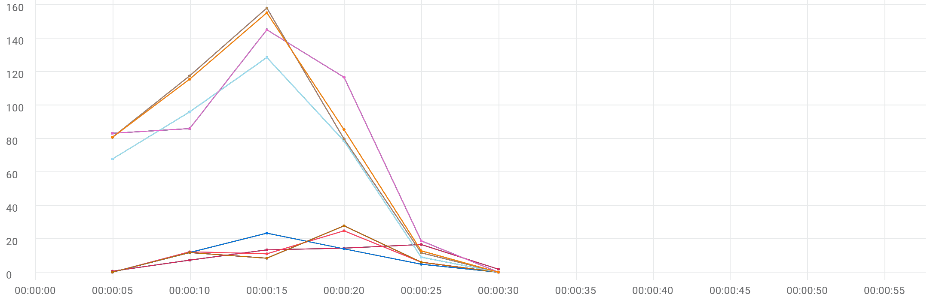

|  |  |  |  |  |  |  |  |  |  |  |
| --- | --- | --- | --- | --- | --- | --- | --- | --- | --- | --- |
|  | Metric | Script | Location | Emulation | Max | Min | Graph max | Graph avg | Graph min | Med |
| |  | | --- | |  | | Hits per second | 97_eShowBizz_CWS_Book_Buy183 (2) | All | All | 24.8 | 0 | 24.8 | 9 | 0 | 11 |
| |  | | --- | |  | | Hits per second | 98_eShowBizz_CWS_Book_Buy202 (2) | All | All | 23.4 | 0 | 23.4 | 9 | 0 | 11.8 |
| |  | | --- | |  | | Hits per second | 99_eShowBizz_CWS_Book_Buy232 (2) | All | All | 27.8 | 0 | 27.8 | 9 | 0 | 8.4 |
| |  | | --- | |  | | Hits per second | 100_eShowBizz_CWS_Book_Buy251 (2) | All | All | 16.6 | 0.6 | 16.6 | 9 | 0.6 | 13.4 |
| |  | | --- | |  | | Hits per second | 93_eShowBizz_ShowSeats_AllClassOpen183 | All | All | 128.6 | 0 | 128.6 | 63.333 | 0 | 78.6 |
| |  | | --- | |  | | Hits per second | 94_eShowBizz_ShowSeats_AllClassOpen251 | All | All | 145.2 | 0 | 145.2 | 75 | 0 | 86 |
| |  | | --- | |  | | Hits per second | 95_eShowBizz_ShowSeats_AllClassOpen232 | All | All | 158.2 | 0 | 158.2 | 74.667 | 0 | 80.8 |
| |  | | --- | |  | | Hits per second | 96_eShowBizz_ShowSeats_AllClassOpen202 | All | All | 155.4 | 0 | 155.4 | 75 | 0 | 85.4 |
| |  | | --- | |  | | Hits per second | 97_eShowBizz_CWS_Book_Buy183 (2) | On-Premise | All | 24.8 | 0 | 24.8 | 9 | 0 | 11 |
| |  | | --- | |  | | Hits per second | 98_eShowBizz_CWS_Book_Buy202 (2) | On-Premise | All | 23.4 | 0 | 23.4 | 9 | 0 | 11.8 |
| |  | | --- | |  | | Hits per second | 99_eShowBizz_CWS_Book_Buy232 (2) | On-Premise | All | 27.8 | 0 | 27.8 | 9 | 0 | 8.4 |
| |  | | --- | |  | | Hits per second | 100_eShowBizz_CWS_Book_Buy251 (2) | On-Premise | All | 16.6 | 0.6 | 16.6 | 9 | 0.6 | 13.4 |
| |  | | --- | |  | | Hits per second | 93_eShowBizz_ShowSeats_AllClassOpen183 | On-Premise | All | 128.6 | 0 | 128.6 | 63.333 | 0 | 78.6 |
| |  | | --- | |  | | Hits per second | 94_eShowBizz_ShowSeats_AllClassOpen251 | On-Premise | All | 145.2 | 0 | 145.2 | 75 | 0 | 86 |
| |  | | --- | |  | | Hits per second | 95_eShowBizz_ShowSeats_AllClassOpen232 | On-Premise | All | 158.2 | 0 | 158.2 | 74.667 | 0 | 80.8 |
| |  | | --- | |  | | Hits per second | 96_eShowBizz_ShowSeats_AllClassOpen202 | On-Premise | All | 155.4 | 0 | 155.4 | 75 | 0 | 85.4 |
| |  | | --- | |  | | Hits per second | 100_eShowBizz_CWS_Book_Buy251 (2) | On-Premise | No Emulation | 16.6 | 0.6 | 16.6 | 9 | 0.6 | 13.4 |
| |  | | --- | |  | | Hits per second | 97_eShowBizz_CWS_Book_Buy183 (2) | On-Premise | No Emulation | 24.8 | 0 | 24.8 | 9 | 0 | 11 |
| |  | | --- | |  | | Hits per second | 98_eShowBizz_CWS_Book_Buy202 (2) | On-Premise | No Emulation | 23.4 | 0 | 23.4 | 9 | 0 | 11.8 |
| |  | | --- | |  | | Hits per second | 99_eShowBizz_CWS_Book_Buy232 (2) | On-Premise | No Emulation | 27.8 | 0 | 27.8 | 9 | 0 | 8.4 |
| |  | | --- | |  | | Hits per second | 94_eShowBizz_ShowSeats_AllClassOpen251 | On-Premise | No Emulation | 145.2 | 0 | 145.2 | 75 | 0 | 86 |
| |  | | --- | |  | | Hits per second | 95_eShowBizz_ShowSeats_AllClassOpen232 | On-Premise | No Emulation | 158.2 | 0 | 158.2 | 74.667 | 0 | 80.8 |
| |  | | --- | |  | | Hits per second | 96_eShowBizz_ShowSeats_AllClassOpen202 | On-Premise | No Emulation | 155.4 | 0 | 155.4 | 75 | 0 | 85.4 |
| |  | | --- | |  | | Hits per second | 93_eShowBizz_ShowSeats_AllClassOpen183 | On-Premise | No Emulation | 128.6 | 0 | 128.6 | 63.333 | 0 | 78.6 |
| |  | | --- | |  | | HTTP_200 | 100_eShowBizz_CWS_Book_Buy251 (2) | On-Premise | No Emulation | 16.6 | 0.6 | 16.6 | 9 | 0.6 | 13.4 |
| |  | | --- | |  | | HTTP_200 | 97_eShowBizz_CWS_Book_Buy183 (2) | On-Premise | No Emulation | 24.8 | 0 | 24.8 | 9 | 0 | 11 |
| |  | | --- | |  | | HTTP_200 | 98_eShowBizz_CWS_Book_Buy202 (2) | On-Premise | No Emulation | 23.4 | 0 | 23.4 | 9 | 0 | 11.8 |
| |  | | --- | |  | | HTTP_200 | 99_eShowBizz_CWS_Book_Buy232 (2) | On-Premise | No Emulation | 27.8 | 0 | 27.8 | 9 | 0 | 8.4 |
| |  | | --- | |  | | HTTP_200 | 93_eShowBizz_ShowSeats_AllClassOpen183 | On-Premise | No Emulation | 128.6 | 0 | 128.6 | 63.333 | 0 | 78.6 |
| |  | | --- | |  | | HTTP_200 | 94_eShowBizz_ShowSeats_AllClassOpen251 | On-Premise | No Emulation | 145.2 | 0 | 145.2 | 75 | 0 | 86 |
| |  | | --- | |  | | HTTP_200 | 95_eShowBizz_ShowSeats_AllClassOpen232 | On-Premise | No Emulation | 158.2 | 0 | 158.2 | 74.667 | 0 | 80.8 |
| |  | | --- | |  | | HTTP_200 | 96_eShowBizz_ShowSeats_AllClassOpen202 | On-Premise | No Emulation | 155.4 | 0 | 155.4 | 75 | 0 | 85.4 |

# Throughput



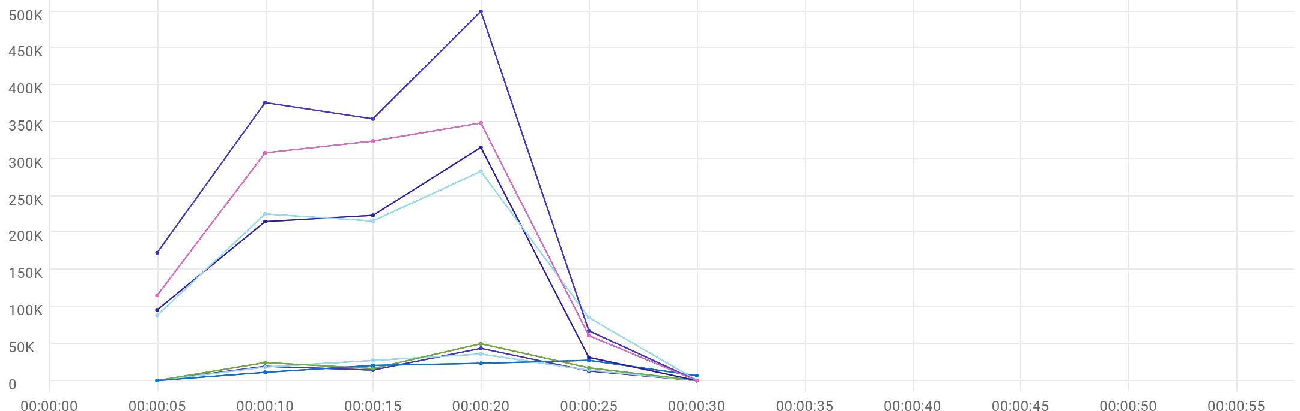

|  |  |  |  |  |  |  |  |  |  |  |
| --- | --- | --- | --- | --- | --- | --- | --- | --- | --- | --- |
|  | Metric | Script | Location | Emulation | Max | Min | Graph max | Graph avg | Graph min | Med |
| |  | | --- | |  | | Throughput | 100_eShowBizz_CWS_Book_Buy251 (2) | All | All | 26.67 KB/s | 0 Byte/s | 26.67 KB/s | 14.469 KB/s | 0 Byte/s | 20.028 KB/s |
| |  | | --- | |  | | Throughput | 97_eShowBizz_CWS_Book_Buy183 (2) | All | All | 42.577 KB/s | 0 Byte/s | 42.577 KB/s | 14.607 KB/s | 0 Byte/s | 13.798 KB/s |
| |  | | --- | |  | | Throughput | 98_eShowBizz_CWS_Book_Buy202 (2) | All | All | 34.99 KB/s | 0 Byte/s | 34.99 KB/s | 15.472 KB/s | 0 Byte/s | 17.679 KB/s |
| |  | | --- | |  | | Throughput | 99_eShowBizz_CWS_Book_Buy232 (2) | All | All | 48.618 KB/s | 0 Byte/s | 48.618 KB/s | 17.468 KB/s | 0 Byte/s | 16.742 KB/s |
| |  | | --- | |  | | Throughput | 94_eShowBizz_ShowSeats_AllClassOpen251 | All | All | 276.803 KB/s | 353.2 B/s | 276.803 KB/s | 146.315 KB/s | 353.2 B/s | 211.028 KB/s |
| |  | | --- | |  | | Throughput | 95_eShowBizz_ShowSeats_AllClassOpen232 | All | All | 488.528 KB/s | 0 Byte/s | 488.528 KB/s | 239.557 KB/s | 0 Byte/s | 346.124 KB/s |
| |  | | --- | |  | | Throughput | 96_eShowBizz_ShowSeats_AllClassOpen202 | All | All | 340.771 KB/s | 0 Byte/s | 340.771 KB/s | 188.466 KB/s | 0 Byte/s | 301.267 KB/s |
| |  | | --- | |  | | Throughput | 93_eShowBizz_ShowSeats_AllClassOpen183 | All | All | 308.507 KB/s | 0 Byte/s | 308.507 KB/s | 143.535 KB/s | 0 Byte/s | 210.275 KB/s |
| |  | | --- | |  | | Throughput | 97_eShowBizz_CWS_Book_Buy183 (2) | On-Premise | All | 42.577 KB/s | 0 Byte/s | 42.577 KB/s | 14.607 KB/s | 0 Byte/s | 13.798 KB/s |
| |  | | --- | |  | | Throughput | 98_eShowBizz_CWS_Book_Buy202 (2) | On-Premise | All | 34.99 KB/s | 0 Byte/s | 34.99 KB/s | 15.472 KB/s | 0 Byte/s | 17.679 KB/s |
| |  | | --- | |  | | Throughput | 99_eShowBizz_CWS_Book_Buy232 (2) | On-Premise | All | 48.618 KB/s | 0 Byte/s | 48.618 KB/s | 17.468 KB/s | 0 Byte/s | 16.742 KB/s |
| |  | | --- | |  | | Throughput | 100_eShowBizz_CWS_Book_Buy251 (2) | On-Premise | All | 26.67 KB/s | 0 Byte/s | 26.67 KB/s | 14.469 KB/s | 0 Byte/s | 20.028 KB/s |
| |  | | --- | |  | | Throughput | 94_eShowBizz_ShowSeats_AllClassOpen251 | On-Premise | All | 276.803 KB/s | 353.2 B/s | 276.803 KB/s | 146.315 KB/s | 353.2 B/s | 211.028 KB/s |
| |  | | --- | |  | | Throughput | 95_eShowBizz_ShowSeats_AllClassOpen232 | On-Premise | All | 488.528 KB/s | 0 Byte/s | 488.528 KB/s | 239.557 KB/s | 0 Byte/s | 346.124 KB/s |
| |  | | --- | |  | | Throughput | 96_eShowBizz_ShowSeats_AllClassOpen202 | On-Premise | All | 340.771 KB/s | 0 Byte/s | 340.771 KB/s | 188.466 KB/s | 0 Byte/s | 301.267 KB/s |
| |  | | --- | |  | | Throughput | 93_eShowBizz_ShowSeats_AllClassOpen183 | On-Premise | All | 308.507 KB/s | 0 Byte/s | 308.507 KB/s | 143.535 KB/s | 0 Byte/s | 210.275 KB/s |
| |  | | --- | |  | | Throughput | 97_eShowBizz_CWS_Book_Buy183 (2) | On-Premise | No Emulation | 42.577 KB/s | 0 Byte/s | 42.577 KB/s | 14.607 KB/s | 0 Byte/s | 13.798 KB/s |
| |  | | --- | |  | | Throughput | 98_eShowBizz_CWS_Book_Buy202 (2) | On-Premise | No Emulation | 34.99 KB/s | 0 Byte/s | 34.99 KB/s | 15.472 KB/s | 0 Byte/s | 17.679 KB/s |
| |  | | --- | |  | | Throughput | 99_eShowBizz_CWS_Book_Buy232 (2) | On-Premise | No Emulation | 48.618 KB/s | 0 Byte/s | 48.618 KB/s | 17.468 KB/s | 0 Byte/s | 16.742 KB/s |
| |  | | --- | |  | | Throughput | 100_eShowBizz_CWS_Book_Buy251 (2) | On-Premise | No Emulation | 26.67 KB/s | 0 Byte/s | 26.67 KB/s | 14.469 KB/s | 0 Byte/s | 20.028 KB/s |
| |  | | --- | |  | | Throughput | 93_eShowBizz_ShowSeats_AllClassOpen183 | On-Premise | No Emulation | 308.507 KB/s | 0 Byte/s | 308.507 KB/s | 143.535 KB/s | 0 Byte/s | 210.275 KB/s |
| |  | | --- | |  | | Throughput | 94_eShowBizz_ShowSeats_AllClassOpen251 | On-Premise | No Emulation | 276.803 KB/s | 353.2 B/s | 276.803 KB/s | 146.315 KB/s | 353.2 B/s | 211.028 KB/s |
| |  | | --- | |  | | Throughput | 95_eShowBizz_ShowSeats_AllClassOpen232 | On-Premise | No Emulation | 488.528 KB/s | 0 Byte/s | 488.528 KB/s | 239.557 KB/s | 0 Byte/s | 346.124 KB/s |
| |  | | --- | |  | | Throughput | 96_eShowBizz_ShowSeats_AllClassOpen202 | On-Premise | No Emulation | 340.771 KB/s | 0 Byte/s | 340.771 KB/s | 188.466 KB/s | 0 Byte/s | 301.267 KB/s |

# Errors



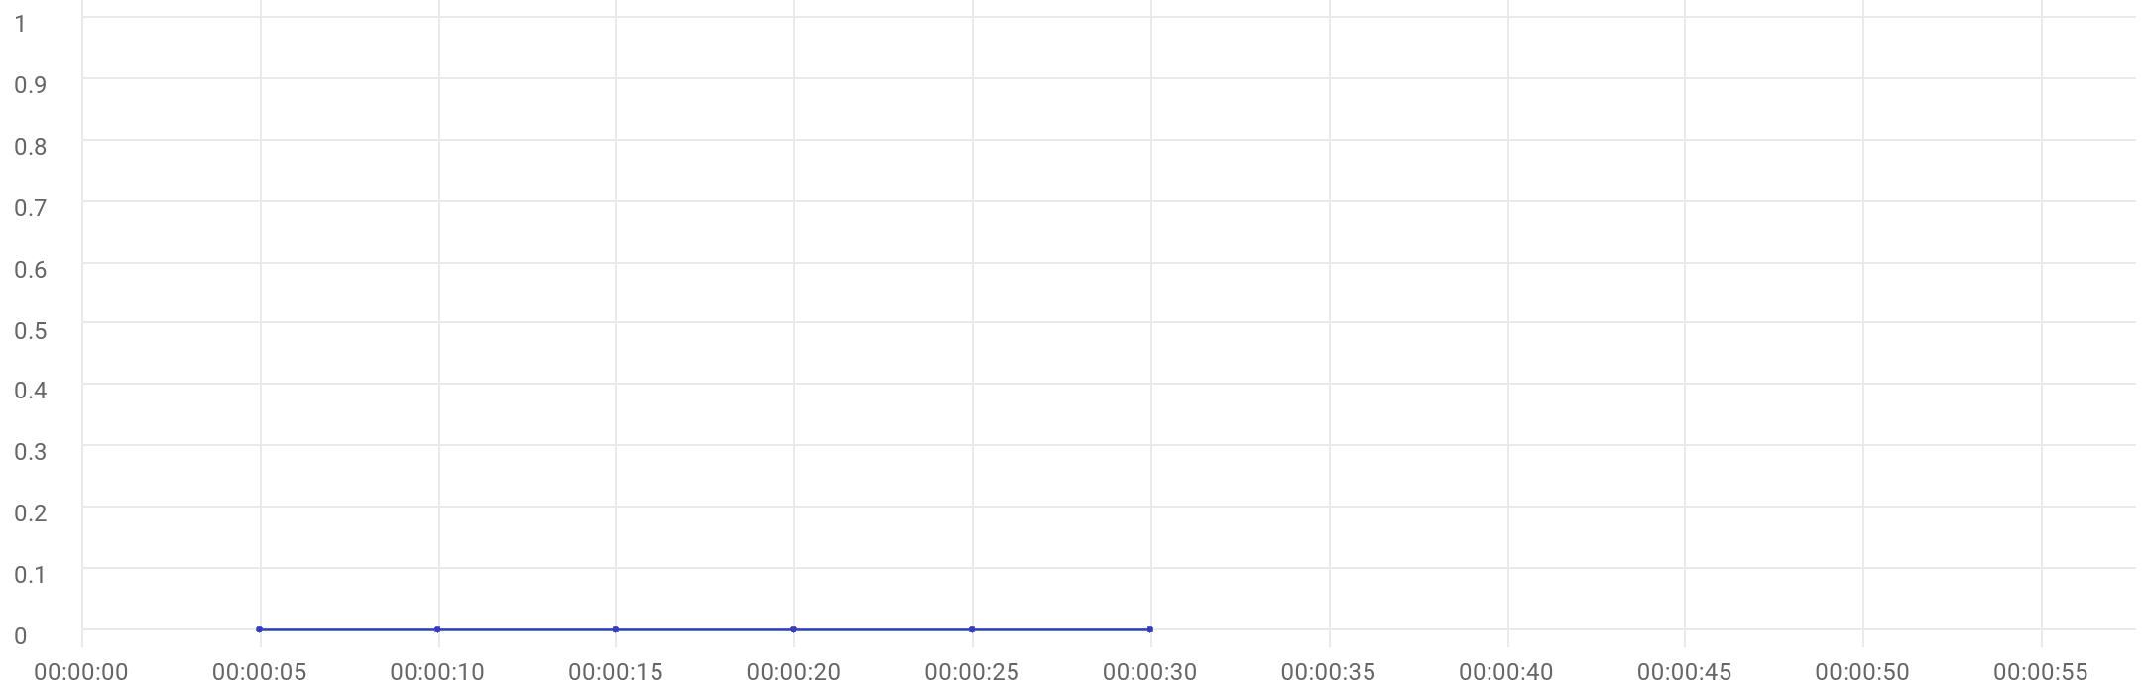

|  |  |  |  |  |  |  |  |  |  |  |
| --- | --- | --- | --- | --- | --- | --- | --- | --- | --- | --- |
|  | Metric | Script | Location | Emulation | Max | Min | Graph max | Graph avg | Graph min | Med |
| |  | | --- | |  | | Errors | 97_eShowBizz_CWS_Book_Buy183 (2) | All | All | N/A | N/A | 0 | 0 | 0 | 0 |
| |  | | --- | |  | | Errors | 98_eShowBizz_CWS_Book_Buy202 (2) | All | All | N/A | N/A | 0 | 0 | 0 | 0 |
| |  | | --- | |  | | Errors | 99_eShowBizz_CWS_Book_Buy232 (2) | All | All | N/A | N/A | 0 | 0 | 0 | 0 |
| |  | | --- | |  | | Errors | 100_eShowBizz_CWS_Book_Buy251 (2) | All | All | N/A | N/A | 0 | 0 | 0 | 0 |
| |  | | --- | |  | | Errors | 93_eShowBizz_ShowSeats_AllClassOpen183 | All | All | N/A | N/A | 0 | 0 | 0 | 0 |
| |  | | --- | |  | | Errors | 94_eShowBizz_ShowSeats_AllClassOpen251 | All | All | N/A | N/A | 0 | 0 | 0 | 0 |
| |  | | --- | |  | | Errors | 95_eShowBizz_ShowSeats_AllClassOpen232 | All | All | N/A | N/A | 0 | 0 | 0 | 0 |
| |  | | --- | |  | | Errors | 96_eShowBizz_ShowSeats_AllClassOpen202 | All | All | N/A | N/A | 0 | 0 | 0 | 0 |
| |  | | --- | |  | | Errors | 97_eShowBizz_CWS_Book_Buy183 (2) | On-Premise | All | N/A | N/A | 0 | 0 | 0 | 0 |
| |  | | --- | |  | | Errors | 98_eShowBizz_CWS_Book_Buy202 (2) | On-Premise | All | N/A | N/A | 0 | 0 | 0 | 0 |
| |  | | --- | |  | | Errors | 99_eShowBizz_CWS_Book_Buy232 (2) | On-Premise | All | N/A | N/A | 0 | 0 | 0 | 0 |
| |  | | --- | |  | | Errors | 100_eShowBizz_CWS_Book_Buy251 (2) | On-Premise | All | N/A | N/A | 0 | 0 | 0 | 0 |
| |  | | --- | |  | | Errors | 93_eShowBizz_ShowSeats_AllClassOpen183 | On-Premise | All | N/A | N/A | 0 | 0 | 0 | 0 |
| |  | | --- | |  | | Errors | 94_eShowBizz_ShowSeats_AllClassOpen251 | On-Premise | All | N/A | N/A | 0 | 0 | 0 | 0 |
| |  | | --- | |  | | Errors | 95_eShowBizz_ShowSeats_AllClassOpen232 | On-Premise | All | N/A | N/A | 0 | 0 | 0 | 0 |
| |  | | --- | |  | | Errors | 96_eShowBizz_ShowSeats_AllClassOpen202 | On-Premise | All | N/A | N/A | 0 | 0 | 0 | 0 |
| |  | | --- | |  | | Errors | 100_eShowBizz_CWS_Book_Buy251 (2) | On-Premise | No Emulation | N/A | N/A | 0 | 0 | 0 | 0 |
| |  | | --- | |  | | Errors | 97_eShowBizz_CWS_Book_Buy183 (2) | On-Premise | No Emulation | N/A | N/A | 0 | 0 | 0 | 0 |
| |  | | --- | |  | | Errors | 98_eShowBizz_CWS_Book_Buy202 (2) | On-Premise | No Emulation | N/A | N/A | 0 | 0 | 0 | 0 |
| |  | | --- | |  | | Errors | 99_eShowBizz_CWS_Book_Buy232 (2) | On-Premise | No Emulation | N/A | N/A | 0 | 0 | 0 | 0 |
| |  | | --- | |  | | Errors | 94_eShowBizz_ShowSeats_AllClassOpen251 | On-Premise | No Emulation | N/A | N/A | 0 | 0 | 0 | 0 |
| |  | | --- | |  | | Errors | 95_eShowBizz_ShowSeats_AllClassOpen232 | On-Premise | No Emulation | N/A | N/A | 0 | 0 | 0 | 0 |
| |  | | --- | |  | | Errors | 96_eShowBizz_ShowSeats_AllClassOpen202 | On-Premise | No Emulation | N/A | N/A | 0 | 0 | 0 | 0 |
| |  | | --- | |  | | Errors | 93_eShowBizz_ShowSeats_AllClassOpen183 | On-Premise | No Emulation | N/A | N/A | 0 | 0 | 0 | 0 |

# TRT [90th]



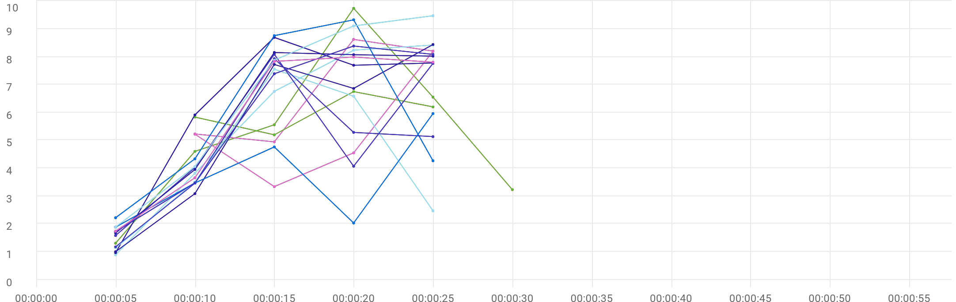

|  |  |  |  |  |  |  |  |  |  |  |  |
| --- | --- | --- | --- | --- | --- | --- | --- | --- | --- | --- | --- |
|  | Metric | Transaction | Script | Location | Emulation | Max | Min | Graph max | Graph avg | Graph min | Med |
| |  | | --- | |  | | TRT [90 th percentile] | Eshowbizz_04_Buy_251 | 100_eShowBizz_CWS_Book_Buy251 (2) | All | All | N/A | N/A | 9.744 sec | 5.167 sec | 1.307 sec | 5.56 sec |
| |  | | --- | |  | | TRT [90 th percentile] | Eshowbizz_04_Buy_183 | 97_eShowBizz_CWS_Book_Buy183 (2) | All | All | N/A | N/A | 8.628 sec | 6.753 sec | 4.947 sec | 8.208 sec |
| |  | | --- | |  | | TRT [90 th percentile] | Eshowbizz_04_Buy_202 | 98_eShowBizz_CWS_Book_Buy202 (2) | All | All | N/A | N/A | 6.754 sec | 5.998 sec | 5.199 sec | 6.202 sec |
| |  | | --- | |  | | TRT [90 th percentile] | Eshowbizz_04_Buy_232 | 99_eShowBizz_CWS_Book_Buy232 (2) | All | All | N/A | N/A | 8.201 sec | 5.329 sec | 3.34 sec | 5.223 sec |
| |  | | --- | |  | | TRT [90 th percentile] | Eshowbizz_03_BookSeats_251 | 100_eShowBizz_CWS_Book_Buy251 (2) | All | All | N/A | N/A | 8.424 sec | 5.627 sec | 891.133 ms | 8.238 sec |
| |  | | --- | |  | | TRT [90 th percentile] | Eshowbizz_03_BookSeats_183 | 97_eShowBizz_CWS_Book_Buy183 (2) | All | All | N/A | N/A | 8.698 sec | 6.211 sec | 964.301 ms | 7.781 sec |
| |  | | --- | |  | | TRT [90 th percentile] | Eshowbizz_03_BookSeats_202 | 98_eShowBizz_CWS_Book_Buy202 (2) | All | All | N/A | N/A | 7.558 sec | 4.252 sec | 1.139 sec | 6.587 sec |
| |  | | --- | |  | | TRT [90 th percentile] | Eshowbizz_03_BookSeats_232 | 99_eShowBizz_CWS_Book_Buy232 (2) | All | All | N/A | N/A | 8.442 sec | 5.425 sec | 1.003 sec | 7.728 sec |
| |  | | --- | |  | | TRT [90 th percentile] | ShowSeats_AllClasses_Open_251 | 100_eShowBizz_CWS_Book_Buy251 (2) | All | All | N/A | N/A | 9.33 sec | 5.784 sec | 2.222 sec | 8.762 sec |
| |  | | --- | |  | | TRT [90 th percentile] | ShowSeats_AllClasses_Open_183 | 97_eShowBizz_CWS_Book_Buy183 (2) | All | All | N/A | N/A | 7.933 sec | 4.599 sec | 1.175 sec | 5.288 sec |
| |  | | --- | |  | | TRT [90 th percentile] | ShowSeats_AllClasses_Open_202 | 98_eShowBizz_CWS_Book_Buy202 (2) | All | All | N/A | N/A | 5.962 sec | 3.624 sec | 1.887 sec | 4.765 sec |
| |  | | --- | |  | | TRT [90 th percentile] | ShowSeats_AllClasses_Open_232 | 99_eShowBizz_CWS_Book_Buy232 (2) | All | All | N/A | N/A | 8.093 sec | 5.109 sec | 1.584 sec | 7.765 sec |
| |  | | --- | |  | | TRT [90 th percentile] | ShowSeats_AllClasses_Open_251 | 94_eShowBizz_ShowSeats_AllClassOpen251 | All | All | N/A | N/A | 9.477 sec | 6.483 sec | 1.887 sec | 9.11 sec |
| |  | | --- | |  | | TRT [90 th percentile] | ShowSeats_AllClasses_Open_232 | 95_eShowBizz_ShowSeats_AllClassOpen232 | All | All | N/A | N/A | 8.389 sec | 5.813 sec | 1.719 sec | 8.088 sec |
| |  | | --- | |  | | TRT [90 th percentile] | ShowSeats_AllClasses_Open_202 | 96_eShowBizz_ShowSeats_AllClassOpen202 | All | All | N/A | N/A | 7.994 sec | 5.807 sec | 1.739 sec | 7.836 sec |
| |  | | --- | |  | | TRT [90 th percentile] | ShowSeats_AllClasses_Open_183 | 93_eShowBizz_ShowSeats_AllClassOpen183 | All | All | N/A | N/A | 8.158 sec | 5.978 sec | 1.675 sec | 8.078 sec |
| |  | | --- | |  | | TRT [90 th percentile] | Eshowbizz_04_Buy_251 | 100_eShowBizz_CWS_Book_Buy251 (2) | On-Premise | All | N/A | N/A | 9.744 sec | 5.167 sec | 1.307 sec | 5.56 sec |
| |  | | --- | |  | | TRT [90 th percentile] | Eshowbizz_04_Buy_183 | 97_eShowBizz_CWS_Book_Buy183 (2) | On-Premise | All | N/A | N/A | 8.628 sec | 6.753 sec | 4.947 sec | 8.208 sec |
| |  | | --- | |  | | TRT [90 th percentile] | Eshowbizz_04_Buy_202 | 98_eShowBizz_CWS_Book_Buy202 (2) | On-Premise | All | N/A | N/A | 6.754 sec | 5.998 sec | 5.199 sec | 6.202 sec |
| |  | | --- | |  | | TRT [90 th percentile] | Eshowbizz_04_Buy_232 | 99_eShowBizz_CWS_Book_Buy232 (2) | On-Premise | All | N/A | N/A | 8.201 sec | 5.329 sec | 3.34 sec | 5.223 sec |
| |  | | --- | |  | | TRT [90 th percentile] | Eshowbizz_03_BookSeats_251 | 100_eShowBizz_CWS_Book_Buy251 (2) | On-Premise | All | N/A | N/A | 8.424 sec | 5.627 sec | 891.133 ms | 8.238 sec |
| |  | | --- | |  | | TRT [90 th percentile] | Eshowbizz_03_BookSeats_183 | 97_eShowBizz_CWS_Book_Buy183 (2) | On-Premise | All | N/A | N/A | 8.698 sec | 6.211 sec | 964.301 ms | 7.781 sec |
| |  | | --- | |  | | TRT [90 th percentile] | Eshowbizz_03_BookSeats_202 | 98_eShowBizz_CWS_Book_Buy202 (2) | On-Premise | All | N/A | N/A | 7.558 sec | 4.252 sec | 1.139 sec | 6.587 sec |
| |  | | --- | |  | | TRT [90 th percentile] | Eshowbizz_03_BookSeats_232 | 99_eShowBizz_CWS_Book_Buy232 (2) | On-Premise | All | N/A | N/A | 8.442 sec | 5.425 sec | 1.003 sec | 7.728 sec |
| |  | | --- | |  | | TRT [90 th percentile] | ShowSeats_AllClasses_Open_251 | 100_eShowBizz_CWS_Book_Buy251 (2) | On-Premise | All | N/A | N/A | 9.33 sec | 5.784 sec | 2.222 sec | 8.762 sec |
| |  | | --- | |  | | TRT [90 th percentile] | ShowSeats_AllClasses_Open_183 | 97_eShowBizz_CWS_Book_Buy183 (2) | On-Premise | All | N/A | N/A | 7.933 sec | 4.599 sec | 1.175 sec | 5.288 sec |
| |  | | --- | |  | | TRT [90 th percentile] | ShowSeats_AllClasses_Open_202 | 98_eShowBizz_CWS_Book_Buy202 (2) | On-Premise | All | N/A | N/A | 5.962 sec | 3.624 sec | 1.887 sec | 4.765 sec |
| |  | | --- | |  | | TRT [90 th percentile] | ShowSeats_AllClasses_Open_232 | 99_eShowBizz_CWS_Book_Buy232 (2) | On-Premise | All | N/A | N/A | 8.093 sec | 5.109 sec | 1.584 sec | 7.765 sec |
| |  | | --- | |  | | TRT [90 th percentile] | ShowSeats_AllClasses_Open_251 | 94_eShowBizz_ShowSeats_AllClassOpen251 | On-Premise | All | N/A | N/A | 9.477 sec | 6.483 sec | 1.887 sec | 9.11 sec |
| |  | | --- | |  | | TRT [90 th percentile] | ShowSeats_AllClasses_Open_232 | 95_eShowBizz_ShowSeats_AllClassOpen232 | On-Premise | All | N/A | N/A | 8.389 sec | 5.813 sec | 1.719 sec | 8.088 sec |
| |  | | --- | |  | | TRT [90 th percentile] | ShowSeats_AllClasses_Open_202 | 96_eShowBizz_ShowSeats_AllClassOpen202 | On-Premise | All | N/A | N/A | 7.994 sec | 5.807 sec | 1.739 sec | 7.836 sec |
| |  | | --- | |  | | TRT [90 th percentile] | ShowSeats_AllClasses_Open_183 | 93_eShowBizz_ShowSeats_AllClassOpen183 | On-Premise | All | N/A | N/A | 8.158 sec | 5.978 sec | 1.675 sec | 8.078 sec |
| |  | | --- | |  | | TRT [90 th percentile] | Eshowbizz_04_Buy_251 | 100_eShowBizz_CWS_Book_Buy251 (2) | On-Premise | No Emulation | N/A | N/A | 9.744 sec | 5.167 sec | 1.307 sec | 5.56 sec |
| |  | | --- | |  | | TRT [90 th percentile] | Eshowbizz_04_Buy_183 | 97_eShowBizz_CWS_Book_Buy183 (2) | On-Premise | No Emulation | N/A | N/A | 8.628 sec | 6.753 sec | 4.947 sec | 8.208 sec |
| |  | | --- | |  | | TRT [90 th percentile] | Eshowbizz_04_Buy_202 | 98_eShowBizz_CWS_Book_Buy202 (2) | On-Premise | No Emulation | N/A | N/A | 6.754 sec | 5.998 sec | 5.199 sec | 6.202 sec |
| |  | | --- | |  | | TRT [90 th percentile] | Eshowbizz_04_Buy_232 | 99_eShowBizz_CWS_Book_Buy232 (2) | On-Premise | No Emulation | N/A | N/A | 8.201 sec | 5.329 sec | 3.34 sec | 5.223 sec |
| |  | | --- | |  | | TRT [90 th percentile] | Eshowbizz_03_BookSeats_251 | 100_eShowBizz_CWS_Book_Buy251 (2) | On-Premise | No Emulation | N/A | N/A | 8.424 sec | 5.627 sec | 891.133 ms | 8.238 sec |
| |  | | --- | |  | | TRT [90 th percentile] | Eshowbizz_03_BookSeats_183 | 97_eShowBizz_CWS_Book_Buy183 (2) | On-Premise | No Emulation | N/A | N/A | 8.698 sec | 6.211 sec | 964.301 ms | 7.781 sec |
| |  | | --- | |  | | TRT [90 th percentile] | Eshowbizz_03_BookSeats_202 | 98_eShowBizz_CWS_Book_Buy202 (2) | On-Premise | No Emulation | N/A | N/A | 7.558 sec | 4.252 sec | 1.139 sec | 6.587 sec |
| |  | | --- | |  | | TRT [90 th percentile] | Eshowbizz_03_BookSeats_232 | 99_eShowBizz_CWS_Book_Buy232 (2) | On-Premise | No Emulation | N/A | N/A | 8.442 sec | 5.425 sec | 1.003 sec | 7.728 sec |
| |  | | --- | |  | | TRT [90 th percentile] | ShowSeats_AllClasses_Open_251 | 100_eShowBizz_CWS_Book_Buy251 (2) | On-Premise | No Emulation | N/A | N/A | 9.33 sec | 5.784 sec | 2.222 sec | 8.762 sec |
| |  | | --- | |  | | TRT [90 th percentile] | ShowSeats_AllClasses_Open_183 | 97_eShowBizz_CWS_Book_Buy183 (2) | On-Premise | No Emulation | N/A | N/A | 7.933 sec | 4.599 sec | 1.175 sec | 5.288 sec |
| |  | | --- | |  | | TRT [90 th percentile] | ShowSeats_AllClasses_Open_202 | 98_eShowBizz_CWS_Book_Buy202 (2) | On-Premise | No Emulation | N/A | N/A | 5.962 sec | 3.624 sec | 1.887 sec | 4.765 sec |
| |  | | --- | |  | | TRT [90 th percentile] | ShowSeats_AllClasses_Open_232 | 99_eShowBizz_CWS_Book_Buy232 (2) | On-Premise | No Emulation | N/A | N/A | 8.093 sec | 5.109 sec | 1.584 sec | 7.765 sec |
| |  | | --- | |  | | TRT [90 th percentile] | ShowSeats_AllClasses_Open_183 | 93_eShowBizz_ShowSeats_AllClassOpen183 | On-Premise | No Emulation | N/A | N/A | 8.158 sec | 5.978 sec | 1.675 sec | 8.078 sec |
| |  | | --- | |  | | TRT [90 th percentile] | ShowSeats_AllClasses_Open_251 | 94_eShowBizz_ShowSeats_AllClassOpen251 | On-Premise | No Emulation | N/A | N/A | 9.477 sec | 6.483 sec | 1.887 sec | 9.11 sec |
| |  | | --- | |  | | TRT [90 th percentile] | ShowSeats_AllClasses_Open_232 | 95_eShowBizz_ShowSeats_AllClassOpen232 | On-Premise | No Emulation | N/A | N/A | 8.389 sec | 5.813 sec | 1.719 sec | 8.088 sec |
| |  | | --- | |  | | TRT [90 th percentile] | ShowSeats_AllClasses_Open_202 | 96_eShowBizz_ShowSeats_AllClassOpen202 | On-Premise | No Emulation | N/A | N/A | 7.994 sec | 5.807 sec | 1.739 sec | 7.836 sec |

# TRT [AVG]



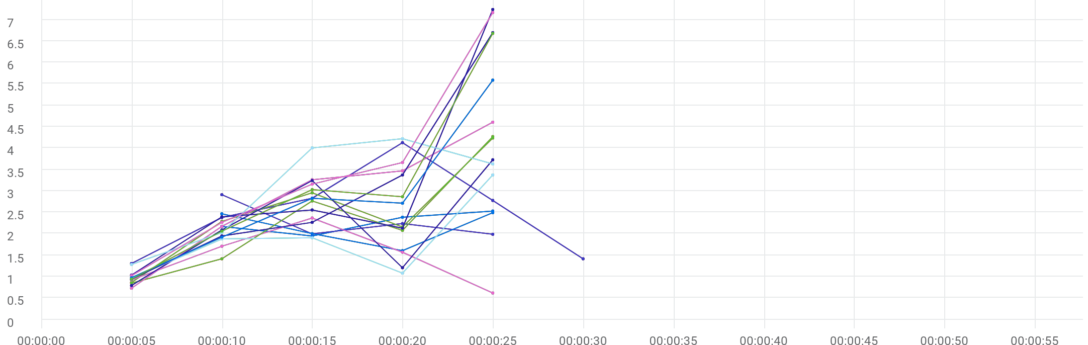

|  |  |  |  |  |  |  |  |  |  |  |  |
| --- | --- | --- | --- | --- | --- | --- | --- | --- | --- | --- | --- |
|  | Metric | Transaction | Script | Location | Emulation | Max | Min | Graph max | Graph avg | Graph min | Med |
| |  | | --- | |  | | TRT [AVG] | Eshowbizz_04_Buy_183 | 97_eShowBizz_CWS_Book_Buy183 (2) | All | All | N/A | N/A | 2.531 sec | 2.259 sec | 1.948 sec | 2.387 sec |
| |  | | --- | |  | | TRT [AVG] | Eshowbizz_04_Buy_202 | 98_eShowBizz_CWS_Book_Buy202 (2) | All | All | N/A | N/A | 2.914 sec | 2.285 sec | 1.989 sec | 2.238 sec |
| |  | | --- | |  | | TRT [AVG] | Eshowbizz_04_Buy_232 | 99_eShowBizz_CWS_Book_Buy232 (2) | All | All | N/A | N/A | 2.494 sec | 2.143 sec | 1.606 sec | 2.467 sec |
| |  | | --- | |  | | TRT [AVG] | Eshowbizz_04_Buy_251 | 100_eShowBizz_CWS_Book_Buy251 (2) | All | All | N/A | N/A | 4.13 sec | 2.474 sec | 1.307 sec | 2.779 sec |
| |  | | --- | |  | | TRT [AVG] | Eshowbizz_03_BookSeats_183 | 97_eShowBizz_CWS_Book_Buy183 (2) | All | All | N/A | N/A | 4.237 sec | 2.501 sec | 863.911 ms | 2.957 sec |
| |  | | --- | |  | | TRT [AVG] | Eshowbizz_03_BookSeats_202 | 98_eShowBizz_CWS_Book_Buy202 (2) | All | All | N/A | N/A | 2.369 sec | 1.438 sec | 617.171 ms | 1.71 sec |
| |  | | --- | |  | | TRT [AVG] | Eshowbizz_03_BookSeats_232 | 99_eShowBizz_CWS_Book_Buy232 (2) | All | All | N/A | N/A | 4.27 sec | 2.276 sec | 848.052 ms | 2.766 sec |
| |  | | --- | |  | | TRT [AVG] | ShowSeats_AllClasses_Open_183 | 97_eShowBizz_CWS_Book_Buy183 (2) | All | All | N/A | N/A | 3.728 sec | 2.213 sec | 792.171 ms | 3.245 sec |
| |  | | --- | |  | | TRT [AVG] | ShowSeats_AllClasses_Open_202 | 98_eShowBizz_CWS_Book_Buy202 (2) | All | All | N/A | N/A | 3.375 sec | 1.841 sec | 960.057 ms | 1.908 sec |
| |  | | --- | |  | | TRT [AVG] | ShowSeats_AllClasses_Open_232 | 99_eShowBizz_CWS_Book_Buy232 (2) | All | All | N/A | N/A | 7.24 sec | 3.072 sec | 1.036 sec | 2.557 sec |
| |  | | --- | |  | | TRT [AVG] | Eshowbizz_03_BookSeats_251 | 100_eShowBizz_CWS_Book_Buy251 (2) | All | All | N/A | N/A | 4.607 sec | 2.849 sec | 730.344 ms | 3.47 sec |
| |  | | --- | |  | | TRT [AVG] | ShowSeats_AllClasses_Open_251 | 100_eShowBizz_CWS_Book_Buy251 (2) | All | All | N/A | N/A | 4.221 sec | 3.034 sec | 1.284 sec | 4.006 sec |
| |  | | --- | |  | | TRT [AVG] | ShowSeats_AllClasses_Open_183 | 93_eShowBizz_ShowSeats_AllClassOpen183 | All | All | N/A | N/A | 6.682 sec | 3.116 sec | 940.477 ms | 3.032 sec |
| |  | | --- | |  | | TRT [AVG] | ShowSeats_AllClasses_Open_251 | 94_eShowBizz_ShowSeats_AllClassOpen251 | All | All | N/A | N/A | 7.168 sec | 3.457 sec | 1.023 sec | 3.665 sec |
| |  | | --- | |  | | TRT [AVG] | ShowSeats_AllClasses_Open_232 | 95_eShowBizz_ShowSeats_AllClassOpen232 | All | All | N/A | N/A | 6.699 sec | 3.045 sec | 937.092 ms | 3.375 sec |
| |  | | --- | |  | | TRT [AVG] | ShowSeats_AllClasses_Open_202 | 96_eShowBizz_ShowSeats_AllClassOpen202 | All | All | N/A | N/A | 5.589 sec | 2.806 sec | 975.507 ms | 2.83 sec |
| |  | | --- | |  | | TRT [AVG] | Eshowbizz_04_Buy_183 | 97_eShowBizz_CWS_Book_Buy183 (2) | On-Premise | All | N/A | N/A | 2.531 sec | 2.259 sec | 1.948 sec | 2.387 sec |
| |  | | --- | |  | | TRT [AVG] | Eshowbizz_04_Buy_202 | 98_eShowBizz_CWS_Book_Buy202 (2) | On-Premise | All | N/A | N/A | 2.914 sec | 2.285 sec | 1.989 sec | 2.238 sec |
| |  | | --- | |  | | TRT [AVG] | Eshowbizz_04_Buy_232 | 99_eShowBizz_CWS_Book_Buy232 (2) | On-Premise | All | N/A | N/A | 2.494 sec | 2.143 sec | 1.606 sec | 2.467 sec |
| |  | | --- | |  | | TRT [AVG] | Eshowbizz_04_Buy_251 | 100_eShowBizz_CWS_Book_Buy251 (2) | On-Premise | All | N/A | N/A | 4.13 sec | 2.474 sec | 1.307 sec | 2.779 sec |
| |  | | --- | |  | | TRT [AVG] | Eshowbizz_03_BookSeats_183 | 97_eShowBizz_CWS_Book_Buy183 (2) | On-Premise | All | N/A | N/A | 4.237 sec | 2.501 sec | 863.911 ms | 2.957 sec |
| |  | | --- | |  | | TRT [AVG] | Eshowbizz_03_BookSeats_202 | 98_eShowBizz_CWS_Book_Buy202 (2) | On-Premise | All | N/A | N/A | 2.369 sec | 1.438 sec | 617.171 ms | 1.71 sec |
| |  | | --- | |  | | TRT [AVG] | Eshowbizz_03_BookSeats_232 | 99_eShowBizz_CWS_Book_Buy232 (2) | On-Premise | All | N/A | N/A | 4.27 sec | 2.276 sec | 848.052 ms | 2.766 sec |
| |  | | --- | |  | | TRT [AVG] | ShowSeats_AllClasses_Open_183 | 97_eShowBizz_CWS_Book_Buy183 (2) | On-Premise | All | N/A | N/A | 3.728 sec | 2.213 sec | 792.171 ms | 3.245 sec |
| |  | | --- | |  | | TRT [AVG] | ShowSeats_AllClasses_Open_202 | 98_eShowBizz_CWS_Book_Buy202 (2) | On-Premise | All | N/A | N/A | 3.375 sec | 1.841 sec | 960.057 ms | 1.908 sec |
| |  | | --- | |  | | TRT [AVG] | ShowSeats_AllClasses_Open_232 | 99_eShowBizz_CWS_Book_Buy232 (2) | On-Premise | All | N/A | N/A | 7.24 sec | 3.072 sec | 1.036 sec | 2.557 sec |
| |  | | --- | |  | | TRT [AVG] | Eshowbizz_03_BookSeats_251 | 100_eShowBizz_CWS_Book_Buy251 (2) | On-Premise | All | N/A | N/A | 4.607 sec | 2.849 sec | 730.344 ms | 3.47 sec |
| |  | | --- | |  | | TRT [AVG] | ShowSeats_AllClasses_Open_251 | 100_eShowBizz_CWS_Book_Buy251 (2) | On-Premise | All | N/A | N/A | 4.221 sec | 3.034 sec | 1.284 sec | 4.006 sec |
| |  | | --- | |  | | TRT [AVG] | ShowSeats_AllClasses_Open_183 | 93_eShowBizz_ShowSeats_AllClassOpen183 | On-Premise | All | N/A | N/A | 6.682 sec | 3.116 sec | 940.477 ms | 3.032 sec |
| |  | | --- | |  | | TRT [AVG] | ShowSeats_AllClasses_Open_251 | 94_eShowBizz_ShowSeats_AllClassOpen251 | On-Premise | All | N/A | N/A | 7.168 sec | 3.457 sec | 1.023 sec | 3.665 sec |
| |  | | --- | |  | | TRT [AVG] | ShowSeats_AllClasses_Open_232 | 95_eShowBizz_ShowSeats_AllClassOpen232 | On-Premise | All | N/A | N/A | 6.699 sec | 3.045 sec | 937.092 ms | 3.375 sec |
| |  | | --- | |  | | TRT [AVG] | ShowSeats_AllClasses_Open_202 | 96_eShowBizz_ShowSeats_AllClassOpen202 | On-Premise | All | N/A | N/A | 5.589 sec | 2.806 sec | 975.507 ms | 2.83 sec |
| |  | | --- | |  | | TRT [AVG] | Eshowbizz_04_Buy_183 | 97_eShowBizz_CWS_Book_Buy183 (2) | On-Premise | No Emulation | N/A | N/A | 2.531 sec | 2.259 sec | 1.948 sec | 2.387 sec |
| |  | | --- | |  | | TRT [AVG] | Eshowbizz_04_Buy_202 | 98_eShowBizz_CWS_Book_Buy202 (2) | On-Premise | No Emulation | N/A | N/A | 2.914 sec | 2.285 sec | 1.989 sec | 2.238 sec |
| |  | | --- | |  | | TRT [AVG] | Eshowbizz_04_Buy_232 | 99_eShowBizz_CWS_Book_Buy232 (2) | On-Premise | No Emulation | N/A | N/A | 2.494 sec | 2.143 sec | 1.606 sec | 2.467 sec |
| |  | | --- | |  | | TRT [AVG] | Eshowbizz_04_Buy_251 | 100_eShowBizz_CWS_Book_Buy251 (2) | On-Premise | No Emulation | N/A | N/A | 4.13 sec | 2.474 sec | 1.307 sec | 2.779 sec |
| |  | | --- | |  | | TRT [AVG] | Eshowbizz_03_BookSeats_183 | 97_eShowBizz_CWS_Book_Buy183 (2) | On-Premise | No Emulation | N/A | N/A | 4.237 sec | 2.501 sec | 863.911 ms | 2.957 sec |
| |  | | --- | |  | | TRT [AVG] | Eshowbizz_03_BookSeats_202 | 98_eShowBizz_CWS_Book_Buy202 (2) | On-Premise | No Emulation | N/A | N/A | 2.369 sec | 1.438 sec | 617.171 ms | 1.71 sec |
| |  | | --- | |  | | TRT [AVG] | Eshowbizz_03_BookSeats_232 | 99_eShowBizz_CWS_Book_Buy232 (2) | On-Premise | No Emulation | N/A | N/A | 4.27 sec | 2.276 sec | 848.052 ms | 2.766 sec |
| |  | | --- | |  | | TRT [AVG] | Eshowbizz_03_BookSeats_251 | 100_eShowBizz_CWS_Book_Buy251 (2) | On-Premise | No Emulation | N/A | N/A | 4.607 sec | 2.849 sec | 730.344 ms | 3.47 sec |
| |  | | --- | |  | | TRT [AVG] | ShowSeats_AllClasses_Open_183 | 97_eShowBizz_CWS_Book_Buy183 (2) | On-Premise | No Emulation | N/A | N/A | 3.728 sec | 2.213 sec | 792.171 ms | 3.245 sec |
| |  | | --- | |  | | TRT [AVG] | ShowSeats_AllClasses_Open_202 | 98_eShowBizz_CWS_Book_Buy202 (2) | On-Premise | No Emulation | N/A | N/A | 3.375 sec | 1.841 sec | 960.057 ms | 1.908 sec |
| |  | | --- | |  | | TRT [AVG] | ShowSeats_AllClasses_Open_232 | 99_eShowBizz_CWS_Book_Buy232 (2) | On-Premise | No Emulation | N/A | N/A | 7.24 sec | 3.072 sec | 1.036 sec | 2.557 sec |
| |  | | --- | |  | | TRT [AVG] | ShowSeats_AllClasses_Open_251 | 100_eShowBizz_CWS_Book_Buy251 (2) | On-Premise | No Emulation | N/A | N/A | 4.221 sec | 3.034 sec | 1.284 sec | 4.006 sec |
| |  | | --- | |  | | TRT [AVG] | ShowSeats_AllClasses_Open_251 | 94_eShowBizz_ShowSeats_AllClassOpen251 | On-Premise | No Emulation | N/A | N/A | 7.168 sec | 3.457 sec | 1.023 sec | 3.665 sec |
| |  | | --- | |  | | TRT [AVG] | ShowSeats_AllClasses_Open_232 | 95_eShowBizz_ShowSeats_AllClassOpen232 | On-Premise | No Emulation | N/A | N/A | 6.699 sec | 3.045 sec | 937.092 ms | 3.375 sec |
| |  | | --- | |  | | TRT [AVG] | ShowSeats_AllClasses_Open_202 | 96_eShowBizz_ShowSeats_AllClassOpen202 | On-Premise | No Emulation | N/A | N/A | 5.589 sec | 2.806 sec | 975.507 ms | 2.83 sec |
| |  | | --- | |  | | TRT [AVG] | ShowSeats_AllClasses_Open_183 | 93_eShowBizz_ShowSeats_AllClassOpen183 | On-Premise | No Emulation | N/A | N/A | 6.682 sec | 3.116 sec | 940.477 ms | 3.032 sec |

# TRT [MIN]



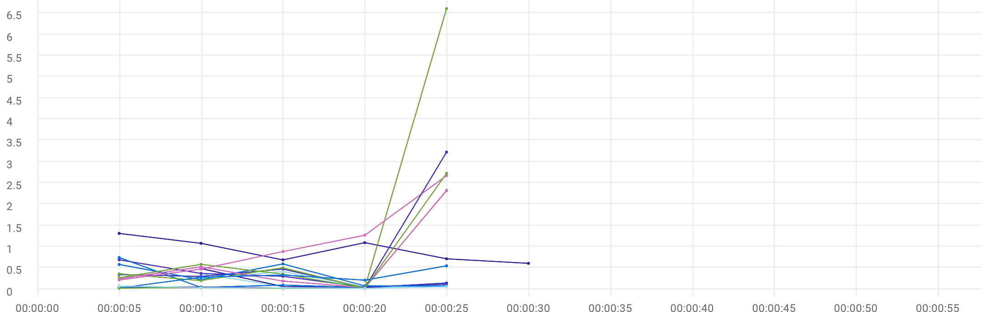

|  |  |  |  |  |  |  |  |  |  |  |  |
| --- | --- | --- | --- | --- | --- | --- | --- | --- | --- | --- | --- |
|  | Metric | Transaction | Script | Location | Emulation | Max | Min | Graph max | Graph avg | Graph min | Med |
| |  | | --- | |  | | TRT [MIN] | Eshowbizz_04_Buy_251 | 100_eShowBizz_CWS_Book_Buy251 (2) | All | All | N/A | N/A | 1.307 sec | 910.675 ms | 601.225 ms | 1.074 sec |
| |  | | --- | |  | | TRT [MIN] | Eshowbizz_04_Buy_183 | 97_eShowBizz_CWS_Book_Buy183 (2) | All | All | N/A | N/A | 355.226 ms | 129.431 ms | 46.311 ms | 59.872 ms |
| |  | | --- | |  | | TRT [MIN] | Eshowbizz_04_Buy_202 | 98_eShowBizz_CWS_Book_Buy202 (2) | All | All | N/A | N/A | 479.197 ms | 169.242 ms | 49.185 ms | 92.521 ms |
| |  | | --- | |  | | TRT [MIN] | Eshowbizz_04_Buy_232 | 99_eShowBizz_CWS_Book_Buy232 (2) | All | All | N/A | N/A | 409.86 ms | 191.091 ms | 42.268 ms | 234.743 ms |
| |  | | --- | |  | | TRT [MIN] | Eshowbizz_03_BookSeats_251 | 100_eShowBizz_CWS_Book_Buy251 (2) | All | All | N/A | N/A | 588.487 ms | 302.629 ms | 59.955 ms | 574.972 ms |
| |  | | --- | |  | | TRT [MIN] | Eshowbizz_03_BookSeats_183 | 97_eShowBizz_CWS_Book_Buy183 (2) | All | All | N/A | N/A | 685.613 ms | 301.648 ms | 39.088 ms | 363.007 ms |
| |  | | --- | |  | | TRT [MIN] | Eshowbizz_03_BookSeats_202 | 98_eShowBizz_CWS_Book_Buy202 (2) | All | All | N/A | N/A | 738.754 ms | 205.232 ms | 29.796 ms | 134.453 ms |
| |  | | --- | |  | | TRT [MIN] | Eshowbizz_03_BookSeats_232 | 99_eShowBizz_CWS_Book_Buy232 (2) | All | All | N/A | N/A | 468.109 ms | 253.249 ms | 28.33 ms | 336.647 ms |
| |  | | --- | |  | | TRT [MIN] | ShowSeats_AllClasses_Open_251 | 100_eShowBizz_CWS_Book_Buy251 (2) | All | All | N/A | N/A | 2.67 sec | 1.098 sec | 211.822 ms | 1.265 sec |
| |  | | --- | |  | | TRT [MIN] | ShowSeats_AllClasses_Open_183 | 97_eShowBizz_CWS_Book_Buy183 (2) | All | All | N/A | N/A | 2.322 sec | 677.384 ms | 19.944 ms | 496.23 ms |
| |  | | --- | |  | | TRT [MIN] | ShowSeats_AllClasses_Open_202 | 98_eShowBizz_CWS_Book_Buy202 (2) | All | All | N/A | N/A | 2.313 sec | 656.567 ms | 27.554 ms | 518.657 ms |
| |  | | --- | |  | | TRT [MIN] | ShowSeats_AllClasses_Open_232 | 99_eShowBizz_CWS_Book_Buy232 (2) | All | All | N/A | N/A | 6.607 sec | 1.562 sec | 16.321 ms | 576.681 ms |
| |  | | --- | |  | | TRT [MIN] | ShowSeats_AllClasses_Open_183 | 93_eShowBizz_ShowSeats_AllClassOpen183 | All | All | N/A | N/A | 3.225 sec | 668.015 ms | 18.056 ms | 44.458 ms |
| |  | | --- | |  | | TRT [MIN] | ShowSeats_AllClasses_Open_251 | 94_eShowBizz_ShowSeats_AllClassOpen251 | All | All | N/A | N/A | 542.641 ms | 273.505 ms | 19.08 ms | 325.302 ms |
| |  | | --- | |  | | TRT [MIN] | ShowSeats_AllClasses_Open_232 | 95_eShowBizz_ShowSeats_AllClassOpen232 | All | All | N/A | N/A | 2.724 sec | 559.675 ms | 12.226 ms | 30.78 ms |
| |  | | --- | |  | | TRT [MIN] | ShowSeats_AllClasses_Open_202 | 96_eShowBizz_ShowSeats_AllClassOpen202 | All | All | N/A | N/A | 65.083 ms | 34.977 ms | 12.098 ms | 50.509 ms |
| |  | | --- | |  | | TRT [MIN] | Eshowbizz_04_Buy_251 | 100_eShowBizz_CWS_Book_Buy251 (2) | On-Premise | All | N/A | N/A | 1.307 sec | 910.675 ms | 601.225 ms | 1.074 sec |
| |  | | --- | |  | | TRT [MIN] | Eshowbizz_04_Buy_183 | 97_eShowBizz_CWS_Book_Buy183 (2) | On-Premise | All | N/A | N/A | 355.226 ms | 129.431 ms | 46.311 ms | 59.872 ms |
| |  | | --- | |  | | TRT [MIN] | Eshowbizz_04_Buy_202 | 98_eShowBizz_CWS_Book_Buy202 (2) | On-Premise | All | N/A | N/A | 479.197 ms | 169.242 ms | 49.185 ms | 92.521 ms |
| |  | | --- | |  | | TRT [MIN] | Eshowbizz_04_Buy_232 | 99_eShowBizz_CWS_Book_Buy232 (2) | On-Premise | All | N/A | N/A | 409.86 ms | 191.091 ms | 42.268 ms | 234.743 ms |
| |  | | --- | |  | | TRT [MIN] | Eshowbizz_03_BookSeats_251 | 100_eShowBizz_CWS_Book_Buy251 (2) | On-Premise | All | N/A | N/A | 588.487 ms | 302.629 ms | 59.955 ms | 574.972 ms |
| |  | | --- | |  | | TRT [MIN] | Eshowbizz_03_BookSeats_183 | 97_eShowBizz_CWS_Book_Buy183 (2) | On-Premise | All | N/A | N/A | 685.613 ms | 301.648 ms | 39.088 ms | 363.007 ms |
| |  | | --- | |  | | TRT [MIN] | Eshowbizz_03_BookSeats_202 | 98_eShowBizz_CWS_Book_Buy202 (2) | On-Premise | All | N/A | N/A | 738.754 ms | 205.232 ms | 29.796 ms | 134.453 ms |
| |  | | --- | |  | | TRT [MIN] | Eshowbizz_03_BookSeats_232 | 99_eShowBizz_CWS_Book_Buy232 (2) | On-Premise | All | N/A | N/A | 468.109 ms | 253.249 ms | 28.33 ms | 336.647 ms |
| |  | | --- | |  | | TRT [MIN] | ShowSeats_AllClasses_Open_251 | 100_eShowBizz_CWS_Book_Buy251 (2) | On-Premise | All | N/A | N/A | 2.67 sec | 1.098 sec | 211.822 ms | 1.265 sec |
| |  | | --- | |  | | TRT [MIN] | ShowSeats_AllClasses_Open_183 | 97_eShowBizz_CWS_Book_Buy183 (2) | On-Premise | All | N/A | N/A | 2.322 sec | 677.384 ms | 19.944 ms | 496.23 ms |
| |  | | --- | |  | | TRT [MIN] | ShowSeats_AllClasses_Open_202 | 98_eShowBizz_CWS_Book_Buy202 (2) | On-Premise | All | N/A | N/A | 2.313 sec | 656.567 ms | 27.554 ms | 518.657 ms |
| |  | | --- | |  | | TRT [MIN] | ShowSeats_AllClasses_Open_232 | 99_eShowBizz_CWS_Book_Buy232 (2) | On-Premise | All | N/A | N/A | 6.607 sec | 1.562 sec | 16.321 ms | 576.681 ms |
| |  | | --- | |  | | TRT [MIN] | ShowSeats_AllClasses_Open_183 | 93_eShowBizz_ShowSeats_AllClassOpen183 | On-Premise | All | N/A | N/A | 3.225 sec | 668.015 ms | 18.056 ms | 44.458 ms |
| |  | | --- | |  | | TRT [MIN] | ShowSeats_AllClasses_Open_251 | 94_eShowBizz_ShowSeats_AllClassOpen251 | On-Premise | All | N/A | N/A | 542.641 ms | 273.505 ms | 19.08 ms | 325.302 ms |
| |  | | --- | |  | | TRT [MIN] | ShowSeats_AllClasses_Open_232 | 95_eShowBizz_ShowSeats_AllClassOpen232 | On-Premise | All | N/A | N/A | 2.724 sec | 559.675 ms | 12.226 ms | 30.78 ms |
| |  | | --- | |  | | TRT [MIN] | ShowSeats_AllClasses_Open_202 | 96_eShowBizz_ShowSeats_AllClassOpen202 | On-Premise | All | N/A | N/A | 65.083 ms | 34.977 ms | 12.098 ms | 50.509 ms |
| |  | | --- | |  | | TRT [MIN] | Eshowbizz_04_Buy_183 | 97_eShowBizz_CWS_Book_Buy183 (2) | On-Premise | No Emulation | N/A | N/A | 355.226 ms | 129.431 ms | 46.311 ms | 59.872 ms |
| |  | | --- | |  | | TRT [MIN] | Eshowbizz_04_Buy_202 | 98_eShowBizz_CWS_Book_Buy202 (2) | On-Premise | No Emulation | N/A | N/A | 479.197 ms | 169.242 ms | 49.185 ms | 92.521 ms |
| |  | | --- | |  | | TRT [MIN] | Eshowbizz_04_Buy_232 | 99_eShowBizz_CWS_Book_Buy232 (2) | On-Premise | No Emulation | N/A | N/A | 409.86 ms | 191.091 ms | 42.268 ms | 234.743 ms |
| |  | | --- | |  | | TRT [MIN] | Eshowbizz_04_Buy_251 | 100_eShowBizz_CWS_Book_Buy251 (2) | On-Premise | No Emulation | N/A | N/A | 1.307 sec | 910.675 ms | 601.225 ms | 1.074 sec |
| |  | | --- | |  | | TRT [MIN] | Eshowbizz_03_BookSeats_183 | 97_eShowBizz_CWS_Book_Buy183 (2) | On-Premise | No Emulation | N/A | N/A | 685.613 ms | 301.648 ms | 39.088 ms | 363.007 ms |
| |  | | --- | |  | | TRT [MIN] | Eshowbizz_03_BookSeats_202 | 98_eShowBizz_CWS_Book_Buy202 (2) | On-Premise | No Emulation | N/A | N/A | 738.754 ms | 205.232 ms | 29.796 ms | 134.453 ms |
| |  | | --- | |  | | TRT [MIN] | Eshowbizz_03_BookSeats_232 | 99_eShowBizz_CWS_Book_Buy232 (2) | On-Premise | No Emulation | N/A | N/A | 468.109 ms | 253.249 ms | 28.33 ms | 336.647 ms |
| |  | | --- | |  | | TRT [MIN] | Eshowbizz_03_BookSeats_251 | 100_eShowBizz_CWS_Book_Buy251 (2) | On-Premise | No Emulation | N/A | N/A | 588.487 ms | 302.629 ms | 59.955 ms | 574.972 ms |
| |  | | --- | |  | | TRT [MIN] | ShowSeats_AllClasses_Open_183 | 97_eShowBizz_CWS_Book_Buy183 (2) | On-Premise | No Emulation | N/A | N/A | 2.322 sec | 677.384 ms | 19.944 ms | 496.23 ms |
| |  | | --- | |  | | TRT [MIN] | ShowSeats_AllClasses_Open_202 | 98_eShowBizz_CWS_Book_Buy202 (2) | On-Premise | No Emulation | N/A | N/A | 2.313 sec | 656.567 ms | 27.554 ms | 518.657 ms |
| |  | | --- | |  | | TRT [MIN] | ShowSeats_AllClasses_Open_232 | 99_eShowBizz_CWS_Book_Buy232 (2) | On-Premise | No Emulation | N/A | N/A | 6.607 sec | 1.562 sec | 16.321 ms | 576.681 ms |
| |  | | --- | |  | | TRT [MIN] | ShowSeats_AllClasses_Open_251 | 100_eShowBizz_CWS_Book_Buy251 (2) | On-Premise | No Emulation | N/A | N/A | 2.67 sec | 1.098 sec | 211.822 ms | 1.265 sec |
| |  | | --- | |  | | TRT [MIN] | ShowSeats_AllClasses_Open_183 | 93_eShowBizz_ShowSeats_AllClassOpen183 | On-Premise | No Emulation | N/A | N/A | 3.225 sec | 668.015 ms | 18.056 ms | 44.458 ms |
| |  | | --- | |  | | TRT [MIN] | ShowSeats_AllClasses_Open_251 | 94_eShowBizz_ShowSeats_AllClassOpen251 | On-Premise | No Emulation | N/A | N/A | 542.641 ms | 273.505 ms | 19.08 ms | 325.302 ms |
| |  | | --- | |  | | TRT [MIN] | ShowSeats_AllClasses_Open_232 | 95_eShowBizz_ShowSeats_AllClassOpen232 | On-Premise | No Emulation | N/A | N/A | 2.724 sec | 559.675 ms | 12.226 ms | 30.78 ms |
| |  | | --- | |  | | TRT [MIN] | ShowSeats_AllClasses_Open_202 | 96_eShowBizz_ShowSeats_AllClassOpen202 | On-Premise | No Emulation | N/A | N/A | 65.083 ms | 34.977 ms | 12.098 ms | 50.509 ms |

# TRT [MAX]



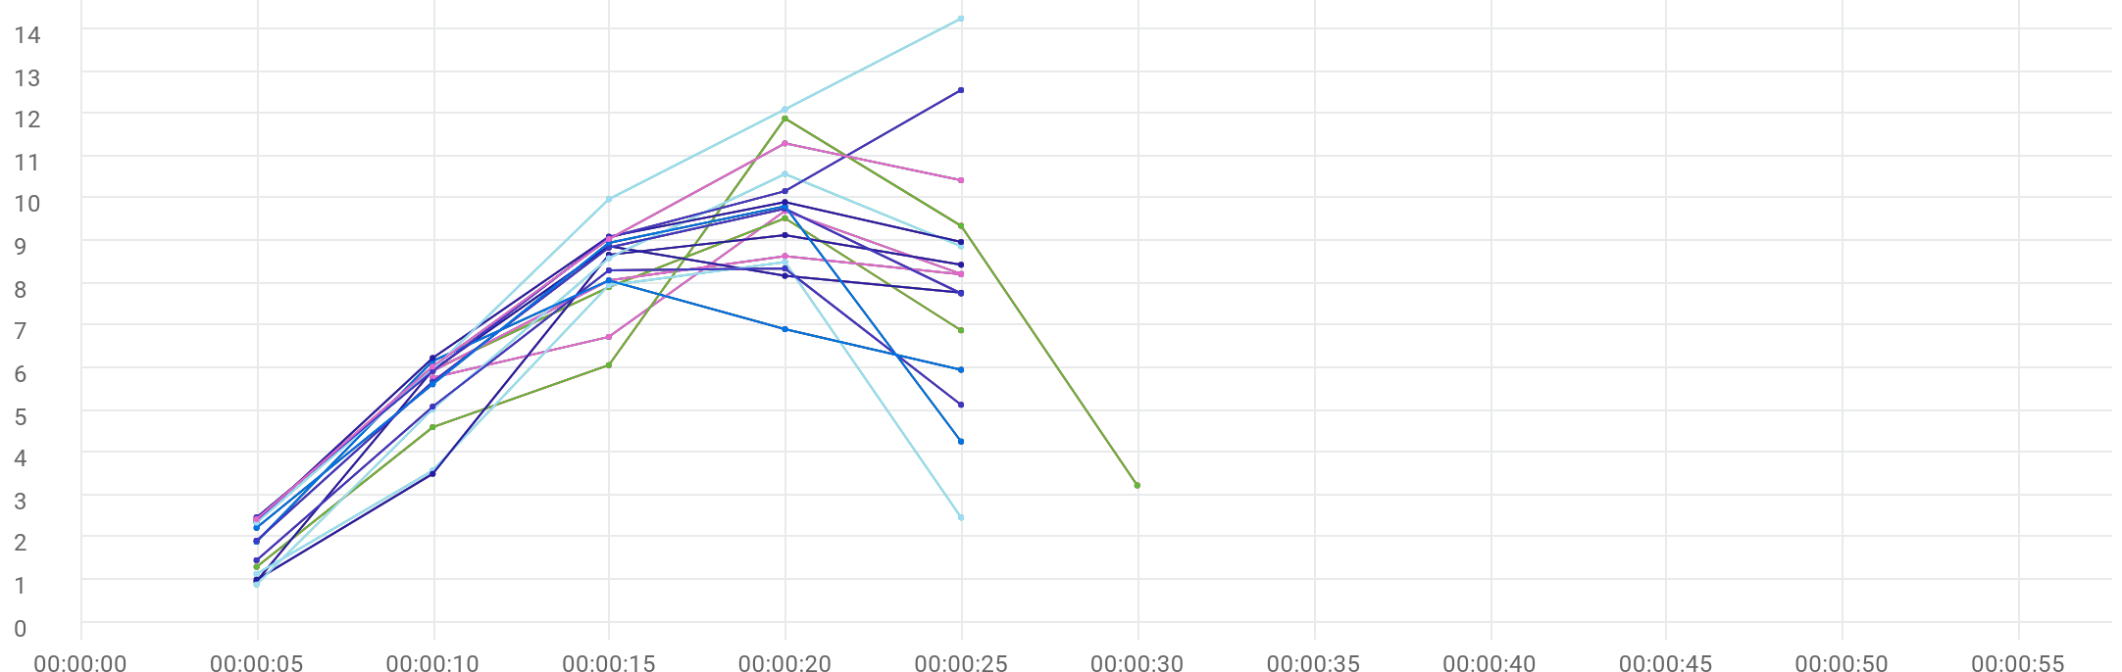

|  |  |  |  |  |  |  |  |  |  |  |  |
| --- | --- | --- | --- | --- | --- | --- | --- | --- | --- | --- | --- |
|  | Metric | Transaction | Script | Location | Emulation | Max | Min | Graph max | Graph avg | Graph min | Med |
| |  | | --- | |  | | TRT [MAX] | Eshowbizz_04_Buy_251 | 100_eShowBizz_CWS_Book_Buy251 (2) | All | All | N/A | N/A | 11.898 sec | 6.079 sec | 1.307 sec | 6.071 sec |
| |  | | --- | |  | | TRT [MAX] | Eshowbizz_04_Buy_183 | 97_eShowBizz_CWS_Book_Buy183 (2) | All | All | N/A | N/A | 9.715 sec | 7.614 sec | 5.778 sec | 8.227 sec |
| |  | | --- | |  | | TRT [MAX] | Eshowbizz_04_Buy_202 | 98_eShowBizz_CWS_Book_Buy202 (2) | All | All | N/A | N/A | 9.541 sec | 7.576 sec | 5.954 sec | 7.915 sec |
| |  | | --- | |  | | TRT [MAX] | Eshowbizz_04_Buy_232 | 99_eShowBizz_CWS_Book_Buy232 (2) | All | All | N/A | N/A | 8.648 sec | 7.716 sec | 5.927 sec | 8.218 sec |
| |  | | --- | |  | | TRT [MAX] | Eshowbizz_03_BookSeats_251 | 100_eShowBizz_CWS_Book_Buy251 (2) | All | All | N/A | N/A | 10.586 sec | 6.798 sec | 891.133 ms | 8.881 sec |
| |  | | --- | |  | | TRT [MAX] | Eshowbizz_03_BookSeats_183 | 97_eShowBizz_CWS_Book_Buy183 (2) | All | All | N/A | N/A | 8.879 sec | 6.351 sec | 964.301 ms | 8.18 sec |
| |  | | --- | |  | | TRT [MAX] | Eshowbizz_03_BookSeats_202 | 98_eShowBizz_CWS_Book_Buy202 (2) | All | All | N/A | N/A | 8.507 sec | 4.731 sec | 1.139 sec | 7.959 sec |
| |  | | --- | |  | | TRT [MAX] | Eshowbizz_03_BookSeats_232 | 99_eShowBizz_CWS_Book_Buy232 (2) | All | All | N/A | N/A | 9.143 sec | 6.154 sec | 1.003 sec | 8.677 sec |
| |  | | --- | |  | | TRT [MAX] | ShowSeats_AllClasses_Open_251 | 100_eShowBizz_CWS_Book_Buy251 (2) | All | All | N/A | N/A | 9.823 sec | 6.18 sec | 2.23 sec | 8.958 sec |
| |  | | --- | |  | | TRT [MAX] | ShowSeats_AllClasses_Open_183 | 97_eShowBizz_CWS_Book_Buy183 (2) | All | All | N/A | N/A | 8.354 sec | 5.67 sec | 1.463 sec | 8.308 sec |
| |  | | --- | |  | | TRT [MAX] | ShowSeats_AllClasses_Open_202 | 98_eShowBizz_CWS_Book_Buy202 (2) | All | All | N/A | N/A | 8.072 sec | 5.805 sec | 1.9 sec | 6.921 sec |
| |  | | --- | |  | | TRT [MAX] | ShowSeats_AllClasses_Open_232 | 99_eShowBizz_CWS_Book_Buy232 (2) | All | All | N/A | N/A | 9.766 sec | 6.797 sec | 1.926 sec | 8.848 sec |
| |  | | --- | |  | | TRT [MAX] | ShowSeats_AllClasses_Open_183 | 93_eShowBizz_ShowSeats_AllClassOpen183 | All | All | N/A | N/A | 9.922 sec | 7.326 sec | 2.386 sec | 9.105 sec |
| |  | | --- | |  | | TRT [MAX] | ShowSeats_AllClasses_Open_251 | 94_eShowBizz_ShowSeats_AllClassOpen251 | All | All | N/A | N/A | 14.26 sec | 8.936 sec | 2.349 sec | 12.113 sec |
| |  | | --- | |  | | TRT [MAX] | ShowSeats_AllClasses_Open_232 | 95_eShowBizz_ShowSeats_AllClassOpen232 | All | All | N/A | N/A | 12.567 sec | 8.048 sec | 2.476 sec | 10.181 sec |
| |  | | --- | |  | | TRT [MAX] | ShowSeats_AllClasses_Open_202 | 96_eShowBizz_ShowSeats_AllClassOpen202 | All | All | N/A | N/A | 11.311 sec | 7.854 sec | 2.434 sec | 10.437 sec |
| |  | | --- | |  | | TRT [MAX] | Eshowbizz_04_Buy_251 | 100_eShowBizz_CWS_Book_Buy251 (2) | On-Premise | All | N/A | N/A | 11.898 sec | 6.079 sec | 1.307 sec | 6.071 sec |
| |  | | --- | |  | | TRT [MAX] | Eshowbizz_04_Buy_183 | 97_eShowBizz_CWS_Book_Buy183 (2) | On-Premise | All | N/A | N/A | 9.715 sec | 7.614 sec | 5.778 sec | 8.227 sec |
| |  | | --- | |  | | TRT [MAX] | Eshowbizz_04_Buy_202 | 98_eShowBizz_CWS_Book_Buy202 (2) | On-Premise | All | N/A | N/A | 9.541 sec | 7.576 sec | 5.954 sec | 7.915 sec |
| |  | | --- | |  | | TRT [MAX] | Eshowbizz_04_Buy_232 | 99_eShowBizz_CWS_Book_Buy232 (2) | On-Premise | All | N/A | N/A | 8.648 sec | 7.716 sec | 5.927 sec | 8.218 sec |
| |  | | --- | |  | | TRT [MAX] | Eshowbizz_03_BookSeats_251 | 100_eShowBizz_CWS_Book_Buy251 (2) | On-Premise | All | N/A | N/A | 10.586 sec | 6.798 sec | 891.133 ms | 8.881 sec |
| |  | | --- | |  | | TRT [MAX] | Eshowbizz_03_BookSeats_183 | 97_eShowBizz_CWS_Book_Buy183 (2) | On-Premise | All | N/A | N/A | 8.879 sec | 6.351 sec | 964.301 ms | 8.18 sec |
| |  | | --- | |  | | TRT [MAX] | Eshowbizz_03_BookSeats_202 | 98_eShowBizz_CWS_Book_Buy202 (2) | On-Premise | All | N/A | N/A | 8.507 sec | 4.731 sec | 1.139 sec | 7.959 sec |
| |  | | --- | |  | | TRT [MAX] | Eshowbizz_03_BookSeats_232 | 99_eShowBizz_CWS_Book_Buy232 (2) | On-Premise | All | N/A | N/A | 9.143 sec | 6.154 sec | 1.003 sec | 8.677 sec |
| |  | | --- | |  | | TRT [MAX] | ShowSeats_AllClasses_Open_251 | 100_eShowBizz_CWS_Book_Buy251 (2) | On-Premise | All | N/A | N/A | 9.823 sec | 6.18 sec | 2.23 sec | 8.958 sec |
| |  | | --- | |  | | TRT [MAX] | ShowSeats_AllClasses_Open_183 | 97_eShowBizz_CWS_Book_Buy183 (2) | On-Premise | All | N/A | N/A | 8.354 sec | 5.67 sec | 1.463 sec | 8.308 sec |
| |  | | --- | |  | | TRT [MAX] | ShowSeats_AllClasses_Open_202 | 98_eShowBizz_CWS_Book_Buy202 (2) | On-Premise | All | N/A | N/A | 8.072 sec | 5.805 sec | 1.9 sec | 6.921 sec |
| |  | | --- | |  | | TRT [MAX] | ShowSeats_AllClasses_Open_232 | 99_eShowBizz_CWS_Book_Buy232 (2) | On-Premise | All | N/A | N/A | 9.766 sec | 6.797 sec | 1.926 sec | 8.848 sec |
| |  | | --- | |  | | TRT [MAX] | ShowSeats_AllClasses_Open_183 | 93_eShowBizz_ShowSeats_AllClassOpen183 | On-Premise | All | N/A | N/A | 9.922 sec | 7.326 sec | 2.386 sec | 9.105 sec |
| |  | | --- | |  | | TRT [MAX] | ShowSeats_AllClasses_Open_251 | 94_eShowBizz_ShowSeats_AllClassOpen251 | On-Premise | All | N/A | N/A | 14.26 sec | 8.936 sec | 2.349 sec | 12.113 sec |
| |  | | --- | |  | | TRT [MAX] | ShowSeats_AllClasses_Open_232 | 95_eShowBizz_ShowSeats_AllClassOpen232 | On-Premise | All | N/A | N/A | 12.567 sec | 8.048 sec | 2.476 sec | 10.181 sec |
| |  | | --- | |  | | TRT [MAX] | ShowSeats_AllClasses_Open_202 | 96_eShowBizz_ShowSeats_AllClassOpen202 | On-Premise | All | N/A | N/A | 11.311 sec | 7.854 sec | 2.434 sec | 10.437 sec |
| |  | | --- | |  | | TRT [MAX] | Eshowbizz_04_Buy_183 | 97_eShowBizz_CWS_Book_Buy183 (2) | On-Premise | No Emulation | N/A | N/A | 9.715 sec | 7.614 sec | 5.778 sec | 8.227 sec |
| |  | | --- | |  | | TRT [MAX] | Eshowbizz_04_Buy_202 | 98_eShowBizz_CWS_Book_Buy202 (2) | On-Premise | No Emulation | N/A | N/A | 9.541 sec | 7.576 sec | 5.954 sec | 7.915 sec |
| |  | | --- | |  | | TRT [MAX] | Eshowbizz_04_Buy_232 | 99_eShowBizz_CWS_Book_Buy232 (2) | On-Premise | No Emulation | N/A | N/A | 8.648 sec | 7.716 sec | 5.927 sec | 8.218 sec |
| |  | | --- | |  | | TRT [MAX] | Eshowbizz_04_Buy_251 | 100_eShowBizz_CWS_Book_Buy251 (2) | On-Premise | No Emulation | N/A | N/A | 11.898 sec | 6.079 sec | 1.307 sec | 6.071 sec |
| |  | | --- | |  | | TRT [MAX] | Eshowbizz_03_BookSeats_183 | 97_eShowBizz_CWS_Book_Buy183 (2) | On-Premise | No Emulation | N/A | N/A | 8.879 sec | 6.351 sec | 964.301 ms | 8.18 sec |
| |  | | --- | |  | | TRT [MAX] | Eshowbizz_03_BookSeats_202 | 98_eShowBizz_CWS_Book_Buy202 (2) | On-Premise | No Emulation | N/A | N/A | 8.507 sec | 4.731 sec | 1.139 sec | 7.959 sec |
| |  | | --- | |  | | TRT [MAX] | Eshowbizz_03_BookSeats_232 | 99_eShowBizz_CWS_Book_Buy232 (2) | On-Premise | No Emulation | N/A | N/A | 9.143 sec | 6.154 sec | 1.003 sec | 8.677 sec |
| |  | | --- | |  | | TRT [MAX] | Eshowbizz_03_BookSeats_251 | 100_eShowBizz_CWS_Book_Buy251 (2) | On-Premise | No Emulation | N/A | N/A | 10.586 sec | 6.798 sec | 891.133 ms | 8.881 sec |
| |  | | --- | |  | | TRT [MAX] | ShowSeats_AllClasses_Open_183 | 97_eShowBizz_CWS_Book_Buy183 (2) | On-Premise | No Emulation | N/A | N/A | 8.354 sec | 5.67 sec | 1.463 sec | 8.308 sec |
| |  | | --- | |  | | TRT [MAX] | ShowSeats_AllClasses_Open_202 | 98_eShowBizz_CWS_Book_Buy202 (2) | On-Premise | No Emulation | N/A | N/A | 8.072 sec | 5.805 sec | 1.9 sec | 6.921 sec |
| |  | | --- | |  | | TRT [MAX] | ShowSeats_AllClasses_Open_232 | 99_eShowBizz_CWS_Book_Buy232 (2) | On-Premise | No Emulation | N/A | N/A | 9.766 sec | 6.797 sec | 1.926 sec | 8.848 sec |
| |  | | --- | |  | | TRT [MAX] | ShowSeats_AllClasses_Open_251 | 100_eShowBizz_CWS_Book_Buy251 (2) | On-Premise | No Emulation | N/A | N/A | 9.823 sec | 6.18 sec | 2.23 sec | 8.958 sec |
| |  | | --- | |  | | TRT [MAX] | ShowSeats_AllClasses_Open_183 | 93_eShowBizz_ShowSeats_AllClassOpen183 | On-Premise | No Emulation | N/A | N/A | 9.922 sec | 7.326 sec | 2.386 sec | 9.105 sec |
| |  | | --- | |  | | TRT [MAX] | ShowSeats_AllClasses_Open_251 | 94_eShowBizz_ShowSeats_AllClassOpen251 | On-Premise | No Emulation | N/A | N/A | 14.26 sec | 8.936 sec | 2.349 sec | 12.113 sec |
| |  | | --- | |  | | TRT [MAX] | ShowSeats_AllClasses_Open_232 | 95_eShowBizz_ShowSeats_AllClassOpen232 | On-Premise | No Emulation | N/A | N/A | 12.567 sec | 8.048 sec | 2.476 sec | 10.181 sec |
| |  | | --- | |  | | TRT [MAX] | ShowSeats_AllClasses_Open_202 | 96_eShowBizz_ShowSeats_AllClassOpen202 | On-Premise | No Emulation | N/A | N/A | 11.311 sec | 7.854 sec | 2.434 sec | 10.437 sec |

# Total transactions



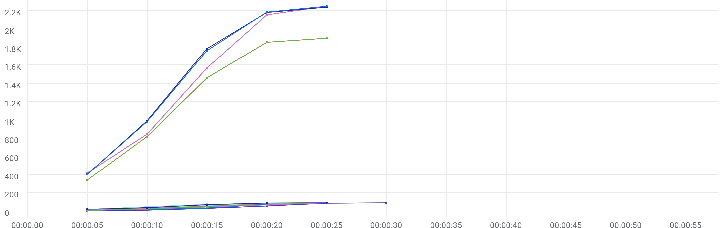

|  |  |  |  |  |  |  |  |  |  |  |  |
| --- | --- | --- | --- | --- | --- | --- | --- | --- | --- | --- | --- |
|  | Metric | Transaction | Script | Location | Emulation | Max | Min | Graph max | Graph avg | Graph min | Med |
| |  | | --- | |  | | Total transactions | Eshowbizz_04_Buy_251 | 100_eShowBizz_CWS_Book_Buy251 (2) | All | All | N/A | N/A | 90 | 45.167 | 1 | 55 |
| |  | | --- | |  | | Total transactions | Eshowbizz_04_Buy_183 | 97_eShowBizz_CWS_Book_Buy183 (2) | All | All | N/A | N/A | 90 | 53 | 16 | 75 |
| |  | | --- | |  | | Total transactions | Eshowbizz_04_Buy_202 | 98_eShowBizz_CWS_Book_Buy202 (2) | All | All | N/A | N/A | 90 | 60.5 | 17 | 80 |
| |  | | --- | |  | | Total transactions | Eshowbizz_04_Buy_232 | 99_eShowBizz_CWS_Book_Buy232 (2) | All | All | N/A | N/A | 90 | 54 | 17 | 76 |
| |  | | --- | |  | | Total transactions | Eshowbizz_03_BookSeats_251 | 100_eShowBizz_CWS_Book_Buy251 (2) | All | All | N/A | N/A | 90 | 46 | 6 | 68 |
| |  | | --- | |  | | Total transactions | Eshowbizz_03_BookSeats_183 | 97_eShowBizz_CWS_Book_Buy183 (2) | All | All | N/A | N/A | 90 | 52 | 4 | 83 |
| |  | | --- | |  | | Total transactions | Eshowbizz_03_BookSeats_202 | 98_eShowBizz_CWS_Book_Buy202 (2) | All | All | N/A | N/A | 90 | 56 | 8 | 84 |
| |  | | --- | |  | | Total transactions | Eshowbizz_03_BookSeats_232 | 99_eShowBizz_CWS_Book_Buy232 (2) | All | All | N/A | N/A | 90 | 50.4 | 9 | 82 |
| |  | | --- | |  | | Total transactions | ShowSeats_AllClasses_Open_251 | 100_eShowBizz_CWS_Book_Buy251 (2) | All | All | N/A | N/A | 90 | 58.2 | 15 | 87 |
| |  | | --- | |  | | Total transactions | ShowSeats_AllClasses_Open_183 | 97_eShowBizz_CWS_Book_Buy183 (2) | All | All | N/A | N/A | 90 | 60.6 | 17 | 88 |
| |  | | --- | |  | | Total transactions | ShowSeats_AllClasses_Open_202 | 98_eShowBizz_CWS_Book_Buy202 (2) | All | All | N/A | N/A | 90 | 62.2 | 17 | 85 |
| |  | | --- | |  | | Total transactions | ShowSeats_AllClasses_Open_232 | 99_eShowBizz_CWS_Book_Buy232 (2) | All | All | N/A | N/A | 90 | 60.6 | 20 | 87 |
| |  | | --- | |  | | Total transactions | ShowSeats_AllClasses_Open_251 | 94_eShowBizz_ShowSeats_AllClassOpen251 | All | All | N/A | N/A | 2250 | 1448.4 | 418 | 2156 |
| |  | | --- | |  | | Total transactions | ShowSeats_AllClasses_Open_232 | 95_eShowBizz_ShowSeats_AllClassOpen232 | All | All | N/A | N/A | 2240 | 1520.6 | 404 | 2182 |
| |  | | --- | |  | | Total transactions | ShowSeats_AllClasses_Open_202 | 96_eShowBizz_ShowSeats_AllClassOpen202 | All | All | N/A | N/A | 2250 | 1517.2 | 404 | 2186 |
| |  | | --- | |  | | Total transactions | ShowSeats_AllClasses_Open_183 | 93_eShowBizz_ShowSeats_AllClassOpen183 | All | All | N/A | N/A | 1900 | 1275.4 | 340 | 1855 |
| |  | | --- | |  | | Total transactions | Eshowbizz_04_Buy_251 | 100_eShowBizz_CWS_Book_Buy251 (2) | On-Premise | All | N/A | N/A | 90 | 45.167 | 1 | 55 |
| |  | | --- | |  | | Total transactions | Eshowbizz_04_Buy_183 | 97_eShowBizz_CWS_Book_Buy183 (2) | On-Premise | All | N/A | N/A | 90 | 53 | 16 | 75 |
| |  | | --- | |  | | Total transactions | Eshowbizz_04_Buy_202 | 98_eShowBizz_CWS_Book_Buy202 (2) | On-Premise | All | N/A | N/A | 90 | 60.5 | 17 | 80 |
| |  | | --- | |  | | Total transactions | Eshowbizz_04_Buy_232 | 99_eShowBizz_CWS_Book_Buy232 (2) | On-Premise | All | N/A | N/A | 90 | 54 | 17 | 76 |
| |  | | --- | |  | | Total transactions | Eshowbizz_03_BookSeats_251 | 100_eShowBizz_CWS_Book_Buy251 (2) | On-Premise | All | N/A | N/A | 90 | 46 | 6 | 68 |
| |  | | --- | |  | | Total transactions | Eshowbizz_03_BookSeats_183 | 97_eShowBizz_CWS_Book_Buy183 (2) | On-Premise | All | N/A | N/A | 90 | 52 | 4 | 83 |
| |  | | --- | |  | | Total transactions | Eshowbizz_03_BookSeats_202 | 98_eShowBizz_CWS_Book_Buy202 (2) | On-Premise | All | N/A | N/A | 90 | 56 | 8 | 84 |
| |  | | --- | |  | | Total transactions | Eshowbizz_03_BookSeats_232 | 99_eShowBizz_CWS_Book_Buy232 (2) | On-Premise | All | N/A | N/A | 90 | 50.4 | 9 | 82 |
| |  | | --- | |  | | Total transactions | ShowSeats_AllClasses_Open_251 | 100_eShowBizz_CWS_Book_Buy251 (2) | On-Premise | All | N/A | N/A | 90 | 58.2 | 15 | 87 |
| |  | | --- | |  | | Total transactions | ShowSeats_AllClasses_Open_183 | 97_eShowBizz_CWS_Book_Buy183 (2) | On-Premise | All | N/A | N/A | 90 | 60.6 | 17 | 88 |
| |  | | --- | |  | | Total transactions | ShowSeats_AllClasses_Open_202 | 98_eShowBizz_CWS_Book_Buy202 (2) | On-Premise | All | N/A | N/A | 90 | 62.2 | 17 | 85 |
| |  | | --- | |  | | Total transactions | ShowSeats_AllClasses_Open_232 | 99_eShowBizz_CWS_Book_Buy232 (2) | On-Premise | All | N/A | N/A | 90 | 60.6 | 20 | 87 |
| |  | | --- | |  | | Total transactions | ShowSeats_AllClasses_Open_251 | 94_eShowBizz_ShowSeats_AllClassOpen251 | On-Premise | All | N/A | N/A | 2250 | 1448.4 | 418 | 2156 |
| |  | | --- | |  | | Total transactions | ShowSeats_AllClasses_Open_232 | 95_eShowBizz_ShowSeats_AllClassOpen232 | On-Premise | All | N/A | N/A | 2240 | 1520.6 | 404 | 2182 |
| |  | | --- | |  | | Total transactions | ShowSeats_AllClasses_Open_202 | 96_eShowBizz_ShowSeats_AllClassOpen202 | On-Premise | All | N/A | N/A | 2250 | 1517.2 | 404 | 2186 |
| |  | | --- | |  | | Total transactions | ShowSeats_AllClasses_Open_183 | 93_eShowBizz_ShowSeats_AllClassOpen183 | On-Premise | All | N/A | N/A | 1900 | 1275.4 | 340 | 1855 |
| |  | | --- | |  | | Total transactions | Eshowbizz_04_Buy_251 | 100_eShowBizz_CWS_Book_Buy251 (2) | On-Premise | No Emulation | N/A | N/A | 90 | 45.167 | 1 | 55 |
| |  | | --- | |  | | Total transactions | Eshowbizz_04_Buy_183 | 97_eShowBizz_CWS_Book_Buy183 (2) | On-Premise | No Emulation | N/A | N/A | 90 | 53 | 16 | 75 |
| |  | | --- | |  | | Total transactions | Eshowbizz_04_Buy_202 | 98_eShowBizz_CWS_Book_Buy202 (2) | On-Premise | No Emulation | N/A | N/A | 90 | 60.5 | 17 | 80 |
| |  | | --- | |  | | Total transactions | Eshowbizz_04_Buy_232 | 99_eShowBizz_CWS_Book_Buy232 (2) | On-Premise | No Emulation | N/A | N/A | 90 | 54 | 17 | 76 |
| |  | | --- | |  | | Total transactions | Eshowbizz_03_BookSeats_251 | 100_eShowBizz_CWS_Book_Buy251 (2) | On-Premise | No Emulation | N/A | N/A | 90 | 46 | 6 | 68 |
| |  | | --- | |  | | Total transactions | Eshowbizz_03_BookSeats_183 | 97_eShowBizz_CWS_Book_Buy183 (2) | On-Premise | No Emulation | N/A | N/A | 90 | 52 | 4 | 83 |
| |  | | --- | |  | | Total transactions | Eshowbizz_03_BookSeats_202 | 98_eShowBizz_CWS_Book_Buy202 (2) | On-Premise | No Emulation | N/A | N/A | 90 | 56 | 8 | 84 |
| |  | | --- | |  | | Total transactions | Eshowbizz_03_BookSeats_232 | 99_eShowBizz_CWS_Book_Buy232 (2) | On-Premise | No Emulation | N/A | N/A | 90 | 50.4 | 9 | 82 |
| |  | | --- | |  | | Total transactions | ShowSeats_AllClasses_Open_251 | 100_eShowBizz_CWS_Book_Buy251 (2) | On-Premise | No Emulation | N/A | N/A | 90 | 58.2 | 15 | 87 |
| |  | | --- | |  | | Total transactions | ShowSeats_AllClasses_Open_183 | 97_eShowBizz_CWS_Book_Buy183 (2) | On-Premise | No Emulation | N/A | N/A | 90 | 60.6 | 17 | 88 |
| |  | | --- | |  | | Total transactions | ShowSeats_AllClasses_Open_202 | 98_eShowBizz_CWS_Book_Buy202 (2) | On-Premise | No Emulation | N/A | N/A | 90 | 62.2 | 17 | 85 |
| |  | | --- | |  | | Total transactions | ShowSeats_AllClasses_Open_232 | 99_eShowBizz_CWS_Book_Buy232 (2) | On-Premise | No Emulation | N/A | N/A | 90 | 60.6 | 20 | 87 |
| |  | | --- | |  | | Total transactions | ShowSeats_AllClasses_Open_183 | 93_eShowBizz_ShowSeats_AllClassOpen183 | On-Premise | No Emulation | N/A | N/A | 1900 | 1275.4 | 340 | 1855 |
| |  | | --- | |  | | Total transactions | ShowSeats_AllClasses_Open_251 | 94_eShowBizz_ShowSeats_AllClassOpen251 | On-Premise | No Emulation | N/A | N/A | 2250 | 1448.4 | 418 | 2156 |
| |  | | --- | |  | | Total transactions | ShowSeats_AllClasses_Open_232 | 95_eShowBizz_ShowSeats_AllClassOpen232 | On-Premise | No Emulation | N/A | N/A | 2240 | 1520.6 | 404 | 2182 |
| |  | | --- | |  | | Total transactions | ShowSeats_AllClasses_Open_202 | 96_eShowBizz_ShowSeats_AllClassOpen202 | On-Premise | No Emulation | N/A | N/A | 2250 | 1517.2 | 404 | 2186 |