[1]

Puzzle Alarm

Abha Marathe, Gayatri Munde

Department of Computer Engineering (COMP)

*Abstract* — PuzzleAlarm is an upgraded version of normal Alarm Clock designed for Android users. It is basically, for users who struggle to get out of bed in the morning, PuzzleAlarm has challenges that the user has to complete, such as solving a math puzzle, in order to turn off the alarm. The app includes other modes too. To disable the alarm, users might have to solve a calculation, enter the CAPTCHA text, or even shake the phone vigorously. The main idea behind being actively waking-up the mind and body before the user hits the snooze

***Keywords*** *—* ***alarm, heavy sleep, analysis, activity, Captcha***

# INTRODUCTION

Effective time management is important for every individual’s personal life and career success. A lot of time is experimentally proven to be wasted unproductively each day, which can be put to better uses. Waking up at the correct point of time in the morning not only helps in waking up less tired and less stressed but also saves time during commute if the delay caused by traffic is already taken into consideration to set the alarm time. Adequate sleep optimally impacts mental functioning and therefore impacts a student’s performance during examinations or otherwise. In a 24-hour period, the pattern of sleep one experiences directly correlates with their physical health, mood, and mental functioning.

Puzzle Alarm is a mobile application which is an upgraded version of simple alarm clock applications. Mostly everyone schedules the alarm but when it starts ringing, they simply snooze it; which results in delay in the decided routine. So, to avoid this, one can use a puzzle alarm clock. In this application, the scheduled alarm will snooze only when the user solves some kind of puzzle, like completing the sentence, or solving a simple mathematical equation. This will activate the brain cells and the person will realize that ze has to wake up.

# Literature Review

Alarm applications are common on almost all stores available for getting applications, both for Android and iOS, in free and paid versions also. There are few existing android applications which traces sleeping activity of user using mobile sensors. Also, few alarm apps support functionality like mind-activities for heavy sleepers, sleep tracking using mobile sensors.

# Methodology/Experimental

## Materials/Components/Flowchart/Block Diagram/Theory

For developing PuzzleAlarm, mainly Flutter framework is used and Firebase for database purpose.

1. Flutter: Flutter is an open-source UI software development kit created by Google. It is used to develop applications for Android, iOS, Linux, Mac, Windows, Google Fuchsia, and the web from a single codebase.
2. Firebase: Firebase is a Backend-as-a-Service — BaaS — that started as a [YC11 startup](http://blog.ycombinator.com/firebase-yc-s11-raises-5-dollars-dot-6m-series-a-from-union-square-ventures-and-flybridge) and grew up into a next-generation app-development platform on Google Cloud Platform.
3. Firestore: Cloud Firestore is a NoSQL document database that lets you easily store, sync, and query data for your mobile and web apps - at global scale.
4. Figma: Figma is a vector graphics editor and prototyping tool which is primarily web-based, with additional offline features enabled by desktop applications for macOS and Windows.

## Status till date

* The raw app designing and wireframing of a complete mobile application is done using Figma.
* The main HomePage which displays an analog clock, along with time in digital form, current day and date is implemented.
* Also, the timer and stopwatch part is done.
* Different puzzles are added to the database, now the main part of integrating them with the app is in progress.
* Almost 40-45% of the project is done.

## Characterization/Pseudo Code/ Screenshots of implementation

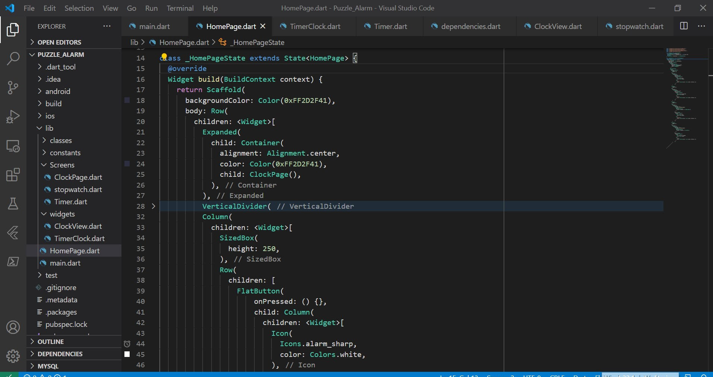

Fig.1 Code for HomePage

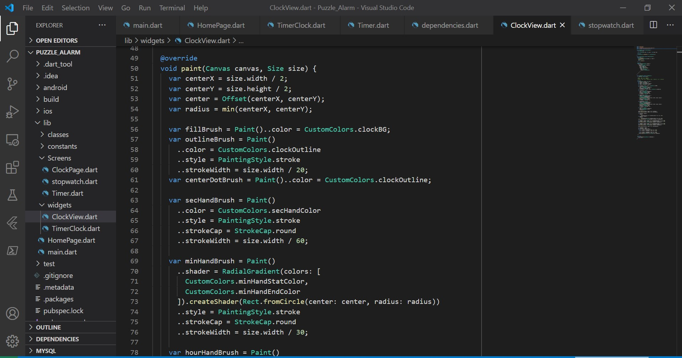

Fig. 2 Code for Analog Clock

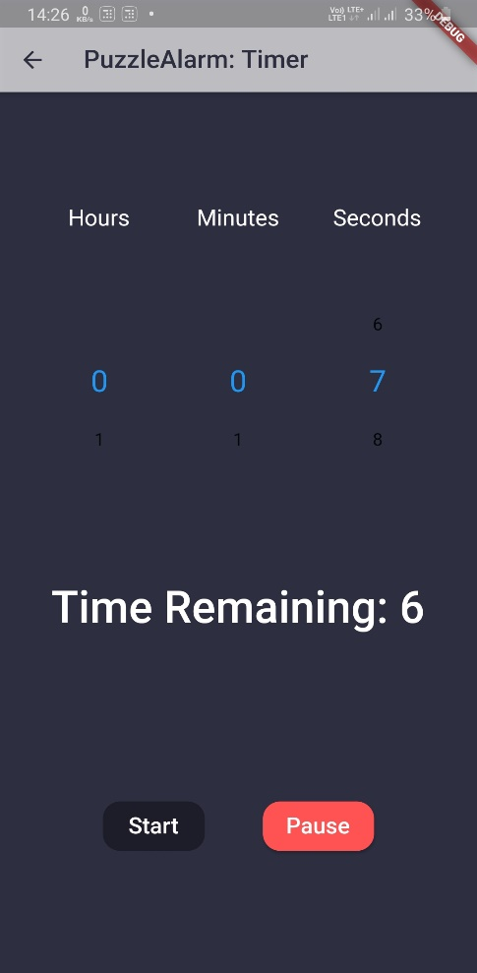

Fig. 3. Timer Screen

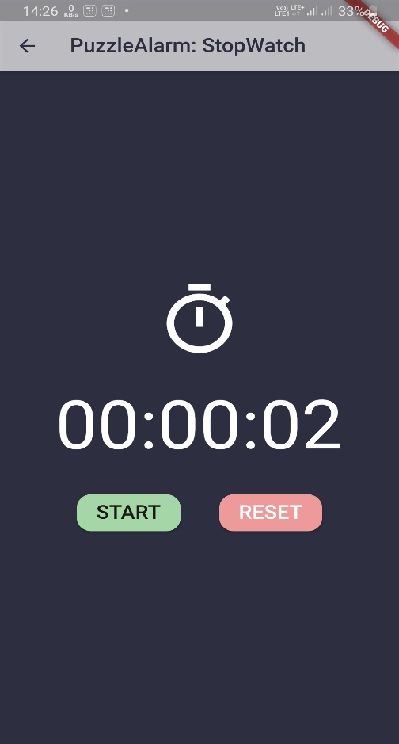

Fig. 4. Stopwatch screen

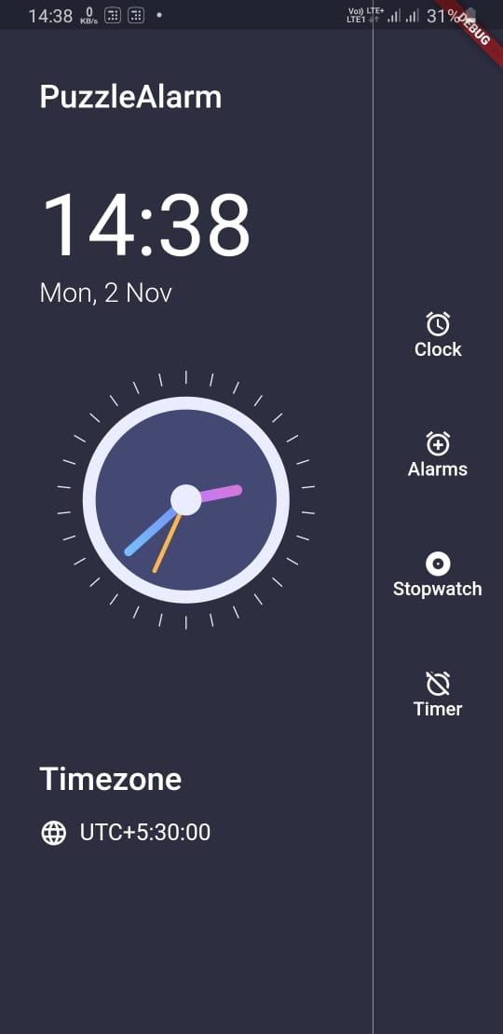

Fig. 5 Homepage Screen

# Results and Discussions

Advantages:

* User will wake up on scheduled time
* User will be able to use Stopwatch and Timer facility also

# Limitations

* It requires a lot of dataset of quizzes else it will repeat daily
* As a result, user will be easily able to solve and snooze again

References

1. Dabholkar, Amruta, Bhavana Choudhary, and Rushikesh Gajmal. *"EarlyBuddy: Smart alarm app for commuters."*
2. JULIANTO TJAKRA, I. N. D. R. A. *PERANCANGAN DAN PENGEMBANGAN KONSEP" PAC" PUZZLE ALARM CLOCK*. Diss. BINUS, 2007.
3. Flutter Documentation
4. Articles from Medium

1.