**Exercise on GitHub and Git**

**Part 3:**

What is GitHub? When was it created? Why? By who? What similar platforms exist? Why would you use such a platform?

Ans:

GitHub is a version control repository, which allows developers to store their projects. It was launched on 10th April, 2008 developed by Chris Wanstrath, PJ Hyett, Tom Preston-Werner and Scott Chacon using Ruby on Rails. Linus Torvalds who has developed Linux Kernel is the original author of the Git system, it was his idea to develop such system. Some of other similar platforms are: Gitlab, Bitbucket, Beanstalk, GitBucket, SourceForge, GitKraken, LaunchPad, Phabricator, Gogs, Gitea, Apache Allura. This kind of platform is useful when there are multiple developers working on a single project. With the help of this kind of system everyone’s code changes are tracked and can be reverted back in case some error occurs with one of the developer’s codes.

**Part 4:**

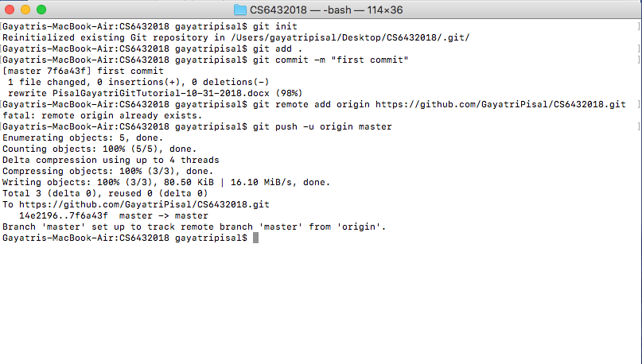

**Part 5:**

1. Repository:

A repository is a location where all the files for a particular project are stored. Each project has its own repository and one can access it with a unique URL. Individual project folder is referenced as a git repository.

2.Commit:

Recording the changes that the developer made in the local git log, and the changes are not reflected in the git repository.

3. Push:

Adding the locally made changes to the git repository, i.e. adding the commits to the global repository.

4. Branch:

A copy of the main repository, and the changes of the branch doesn’t affect the original branch code.

5. Fork:

A copy of the main repo which is used to experiment on the original code or suggest some changes in someone else’s project

6. Merge:

Combining the changes made in a child branch to the parent branch

7. Clone:

Getting a local copy of the main repository from the git

8. Pull:

Getting new changes pushed by other developers on a certain branch in to the local copy of the code.

9. Pull request:

Asking permission to the repository owner to propose and collaborate changes to the repository.