Game Design Document

Fill up the Following document

1. Write the title of your project.

Escape through orange boxes

1. What is the goal of the game?

To reach the destination without hitting or touching the NP characters

1. Write a brief story of your game?

Escape from the obstacles and reach your destination.

1. Which are the playing characters of this game?

* Playing characters are the ones which respond to the user based on the input from the user
* Cars, monkeys, dinos, wizards etc, are the playing characters in the game.

|  |  |  |
| --- | --- | --- |
| Number | Character Name | What can this character do? |
| 1 | Green Square box | Escape from the obstacles and move all 4 directions |
| 2 |  |  |
| 3 |  |  |
| 4 |  |  |
| 5 |  |  |
| 6 |  |  |
| 7 |  |  |
| 8 |  |  |

1. Which are the Non Playing Characters of this game?

* Non Playing characters are the ones which don't have an action or a behaviour when the user interacts with the game.
* Hurdles, stones, bananas, coins, etc are non playing characters in the game.

|  |  |  |
| --- | --- | --- |
| Number | Character Name | What can this character do? |
| 1 | Orange square box 1 | Move up and down blocking the way of the PC |
| 2 | Orange square box 2 | Move up and down opposite direction of 1 orange box blocking the way of the PC |
| 3 | Orange square box 3 | Move up and down opposite direction of 2 blocking the way of the PC |
| 4 | Orange square box 4 | Move up and down opposite direction of 3 blocking the way of the PC |
| 5 |  |  |
| 6 |  |  |
| 7 |  |  |
| 8 |  |  |

Draw your imagination of this game. What does this game look like?

* Draw the game either on your computer or on paper,
* Add images of scenes of the game to show each of the playing and non-playing characters at least once.

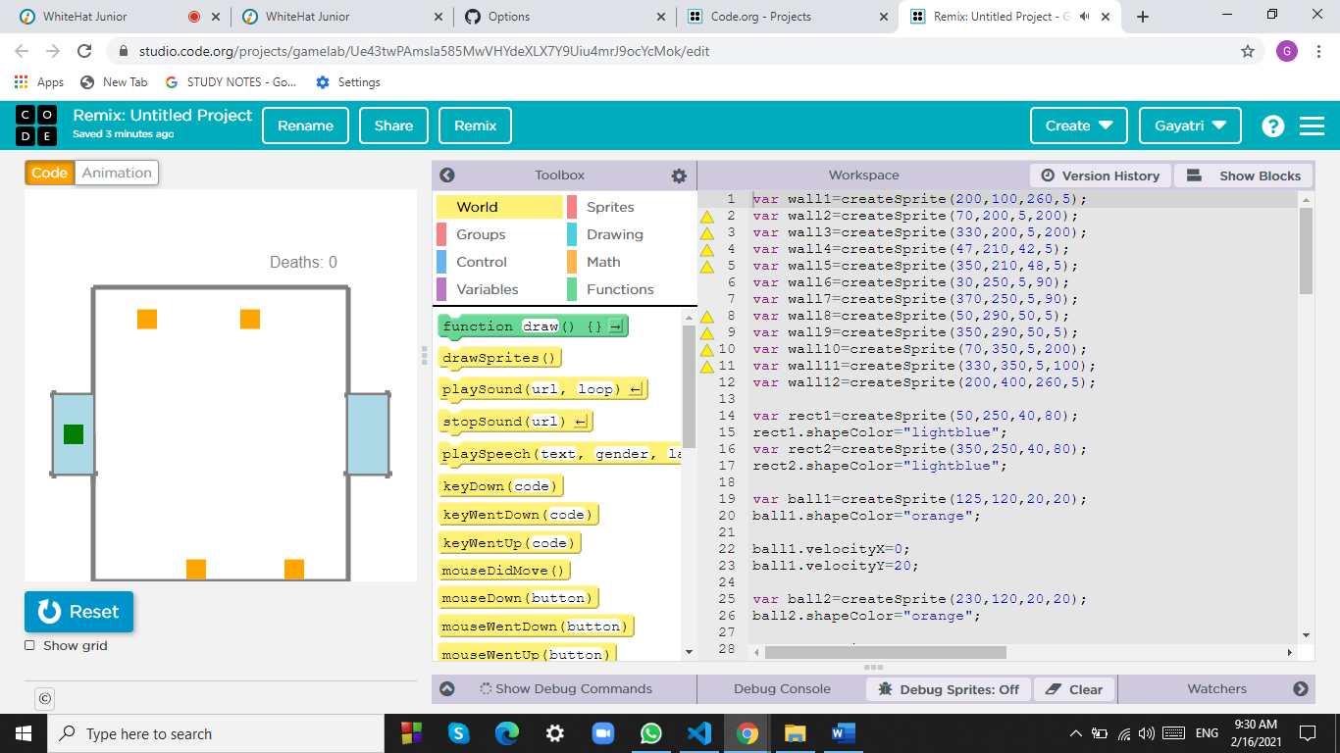

How do you plan to make your game engaging?

It has a background music which encourages you to reach the destination crossing the obstacles.