**Propose a Conceptual Design using ER features using tools like ERD plus, ER Win etc. Convert the ER diagram into tables on paper and propose a normalize Relational data model.**

**LIBRARY MANAGEMENT SYSTEM**

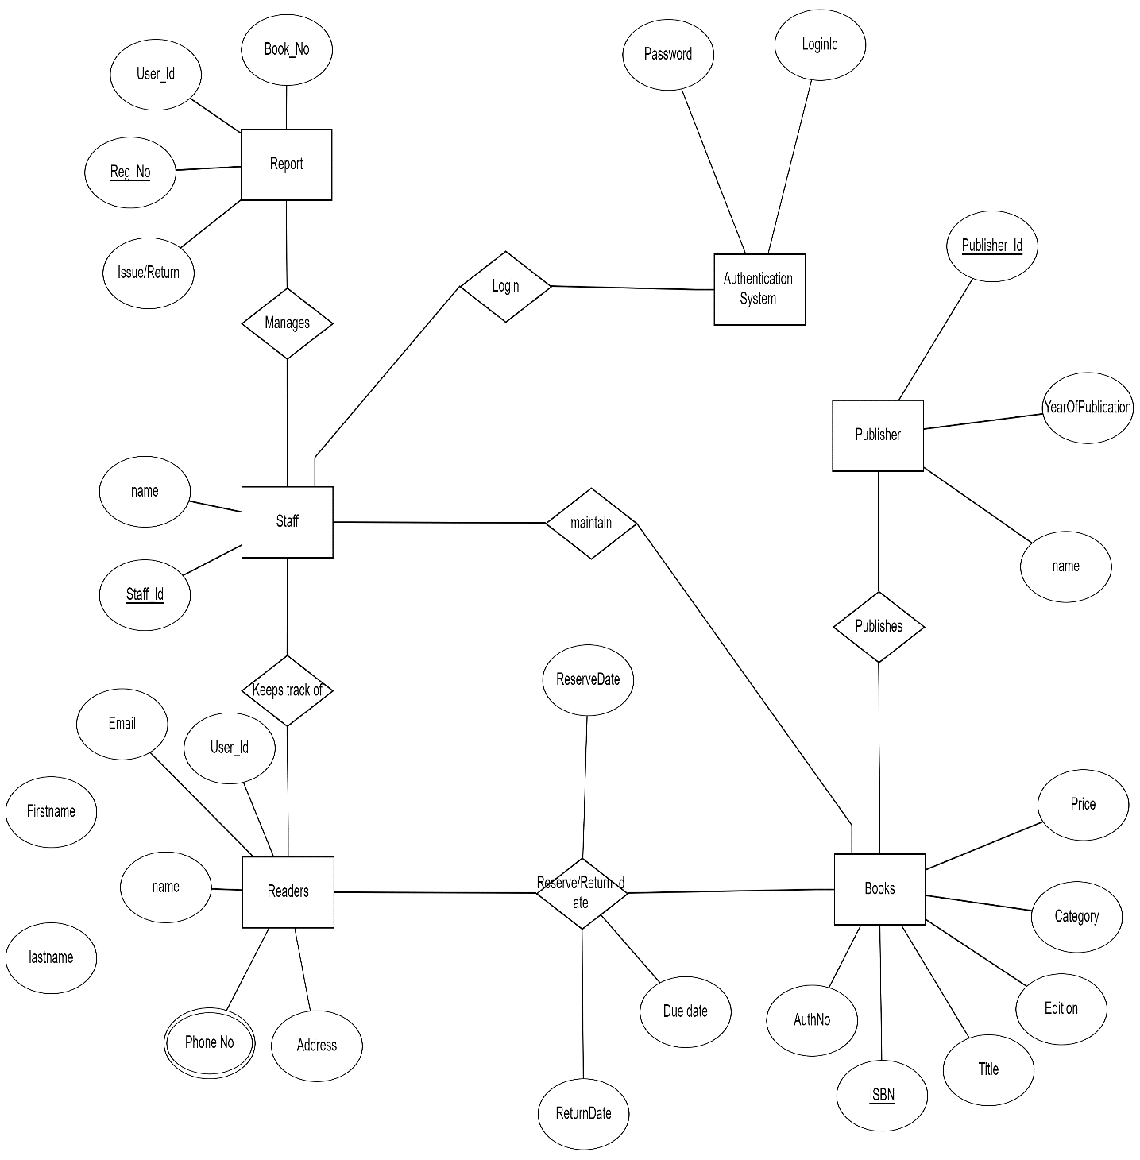

This Library ER diagram illustrates key information about the Library,including entities such as staff, readers, books, publishers, reports, and authentication system. It allows for understanding the relationships between entities.

**Entities and their Attributes –**

* **Book Entity:**

It has authno, isbn number, title, edition, category, price.

**ISBN** is the **Primary Key** for Book Entity.

* **Reader Entity:**

It has UserId, Email, address, phone no, name.

Name is **composite** attribute of firstname and lastname.

**Phone** no is **multi valued** attribute.

**UserId** is the **Primary Key** for Readers entity.

* **Publisher Entity :**

It has PublisherId, Year of publication, name.

**PublisherID** is the **Primary Key**.

* **Authentication System Entity :**

It has **LoginId** and password with **LoginID** as **Primary Key**.

* **Reports Entity :**

It has UserId, Reg_no, Book_no, Issue/Return date.

**Reg_no** is the **Primary Key** of reports entity.

* **Staff Entity :**

It has name and staff_id with **staff_id** as **Primary Key.**

* **Reserve/Return Relationship Set :**

It has three attributes: Reserve date, Due date, Return date.

[**Relationships**](https://www.geeksforgeeks.org/attributes-to-relationships-in-er-model/)**between Entities :**

* A reader can reserve N books but one book can be reserved by only one reader. The relationship 1:N.
* A publisher can publish many books but a book is published by only one publisher. The relationship 1:N.
* Staff keeps track of readers. The relationship is M:N.
* Staff maintains multiple reports. The relationship 1:N.
* Staff maintains multiple Books. The relationship 1:N.
* Authentication system provides login to multiple staffs. The relation is 1:N.

**Notes**

* **Primary Keys (PK) uniquely identify each record in a table.**
* **Foreign Keys (FK) are used to establish relationships between tables.**
* **Many-to-Many relationships are handled using junction tables (e.g., Enrollment).**