Title The title should be short and informative

Firstname Lastname 1, Firstname Lastname 2 & Firstname Lastname 3

1Author Affiliation 1; institution, (department), city, state, country, Email-ID

2Author Affiliation 2; institution, (department), city, state, country, Email-ID

**Abstract**

160 to 260 words. Max 460 words. No abbreviations. {Text: Times New Roman (10 font), Line spacing (1.15)}

**Keywords:** 5 to 7 keywords may be used for Indexing purpose

**A well-structured article** **should follow a standard pattern as given below. This comprises of:**

* **Introduction & Literature Survey**
* **Proposed Methods**
* **Results & Discussion**
* **Conclusions**
* **Acknowledgement (funding Organization etc.)**

**1. Introduction**

Background/Contextual/Related data/statistics required to recognize Research work/study, and the motives why you conducted your experiments/trials etc.

It should answer the question: what problem is defined and what homework is done for the Research work?

References to be cited in Paper: numbers/numerals in square brackets like- [1] or [3,4], or [5–9].

**2. Proposed Methods**

Details of how you conducted your study/work includes:

* Use separate subheadings for different methodologies/procedures/practices
* Use past tense to Explain/Describe the work done
* Explain novel/innovative methods so that new investigator can reproduce your research experiment results
* Describe recognized/established approaches briefly and simply with correct citation process.
* Show all statistical parameters, performance evaluation parameters and related test results

**3. Results & Discussion**

Simply describe the findings in logical order.

Avoid duplication or matching data between figures, tables, and text.

**3.1 Subsection**

3.1.1 Sub-subsection

Bulleted:

• 1st bullet;

• 2nd bullet;

• 3rd bullet.

**3.2** **Equations**

Insert the equation from insert menu, which will be centered. To insert the equation number, press Tab again. Number the equations consecutively. For example,

$D=\max{(}\sum_{i=1}^{n}{Y_{i}X_{i}})$**(1)**

**3.3 Tables and Figures**

All tables and figures are to be numbered in consecutive numerical order.

**Table 1 T**able caption (title) explaining the components of the table.

|  |  |
| --- | --- |
| **Parameters** | **Value** |
| Parameter A | 0.7 |
| Parameter B | 0.8 |
| Parameter C | 0.6 |
| Parameter D | 0.2 |

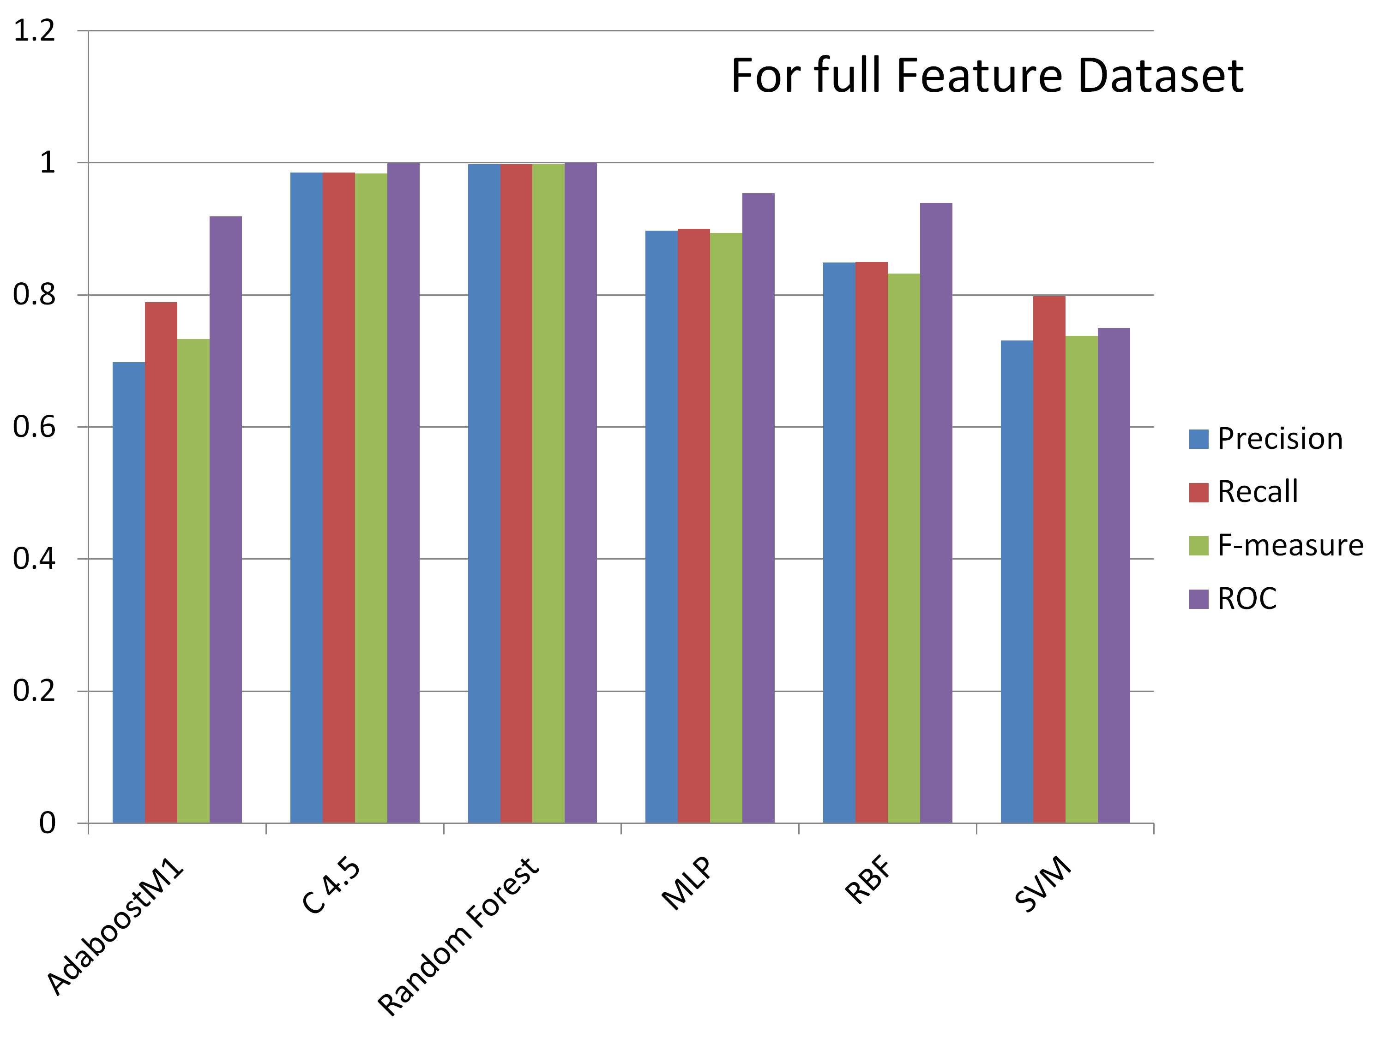

**Fig. 1 F**igure with concise/short caption telling accurately what the figure describes.

Figure in parts should be represented by lowercase letters (a, b, c, etc.). Images should be self-drawn and with 300 dpi resolution. Strictly avoid any type of copy paste from Internet or other sources.

For previously published figures, take the permission from the owner(s) for both the print and online format. PIJET publisher will not be responsible for any refund or any costs for the same.

When preparing your figures, the figures should be 85 mm wide and not higher than 235 mm.

**4. Conclusion**

Conclusions sections should answer the question: What do your results/outcomes mean?

It should be interpretation/ Clarification of experimental results, Also:

* Discussing the conclusions.
* Comparing results with respect to consistency and any possible explanations for the variance if any.
* Indicate any unsatisfying/questionable results and clarify them as best you can. Also, advise additional experiments needed to clarify the experimental results.
* Briefly explain the restrictions of your research work, methodology etc.
* Briefly explain extension of results related to previous findings of related studies.
* For primary findings, suggest further future studies/revisions that need to be carried out extensively.

**Acknowledgements**

Here, you can acknowledge any support given by the author/funding organization etc.

**References**

Books:

1. Behrouz A. Forouzan, *Data Communications and Networking*, 4nd Edition; The McGraw-Hill Companies, Inc. New York, 2007, pp29-38.

Transaction/Journals:

1. Thuy, Nguyen, Grenville Armitage, “A survey of techniques for Internet traffic classification using Machine Learning”*, IEEE communications surveys & tutorials,* vol. 10, no. 4, fourth quarter*,* 2008.

International/National Conference Proceedings:

1. M. Roughan, S. Sen, O. Spatscheck and N. Duffield, “Class-of-service mapping for QoS: A statistical signature-based approach to IP traffic classification”, in Proc. ACM/SIGCOMM Internet Measurement Conference (IMC), October 2004.

Standards/Patents:

1. G.Brandli and M. Dick, “Alternating current fed power supply,” U.S.Patent 4 084 217, Nov.4,1978

Technical Reports:

1. E. E. Reber, R. L. Mitchell, and C. J. Carter, “Oxygen absorption in the Earth’s atmosphere,” Aerospace Corp., Los Angeles, CA, Tech. Rep. TR-0200 (4230-46)-3, Nov. 1968

Website:

1. M. Duncan. “Engineering Concepts on Ice. Internet: www.iceengg.edu/staff.html, Oct. 25, 2000 [Nov. 29, 2003].

Note: Above Red colored titles should not be included in the paper. Only references are to be included.