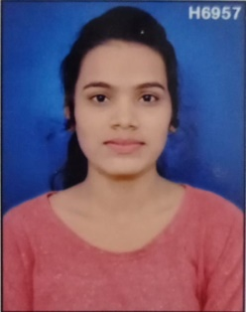Gaytri Lonarkar

 gaytrilonarkar@gmail.com

+ 91- 8830007894/8698036669

# Objective

ASP.NET Developer with experience developing web,batch and business intelligence solution using ASP.NET,C#,MS SQL.skilled in architecting and executing customized,data- driven solution,hosted both on-premise and on the cloud.Expertise in requirement analysis,design,development,testing,maintenance,enhancement and production support of business applications,Web Hosting,VPS Hosting.

# Educational Qualification:

* Completed Full Time **B.Sc(Computer Science)** from J.M Patel Collage, Bhandara with **58%**  in 2021.
* Completed **HSC(Science)** from Nagpur Board with **65.40%** in 2017.
* Completed **SSC** from Nagpur Board with **64.40%** in March 2015.

# Professional Experience:

* 1. Develop and maintain custom data-centric web applications using ASP.NET, C# .NET, and SQL Database.
  2. Created 2 .NET websites with 100% client satisfaction and on-time completion.
  3. Completed 2 SQL database design projects, optimizing queries and developing stored-procedures, triggers, tables, views, and functions.
  4. Designed and developed C# components for implementing business logic in 3-tier application interacting with SQL Server database using managed provider.
  5. Developed customized data-centric web applications using ASP.NET, C#.NET, HTML and MS SQL.

# Certifications:

* C#, ASP.NET, SQL, WEB DESIGNING, MS OFFICE
* MS VISUAL STUDIO, SQL SERVER
* MS-CIT
* Tally, Data Entry.

# Skills and Abilities:

Initiative Hard Working and friendly Team Work

# Language Proficiency:

English Hindi Marathi

# Personal Details:

**Date of Birth:** 18 Sept 1999

**Gender:** FEMALE **Marital Status:** Unmarried **Nationality: -** Indian

**Permanent Address:** Vivekanad Nagar, Near Malviya School Sihora Road, Tal. Tumsar, Dist Bhandara, Maharashtra, 441912

# Declaration:

I solemnly declare that all the above information is correct to the best of my knowledge and belief.

Date: Place: Signature: