MACHINE HEALTH MONITOR
A small sensor that notices when a machine starts to go wrong
Three week build plan · STM32 + Raspberry Pi · about 12 hours a week

In one sentence
A cheap chip watches a fan all the time and, the moment the shaking looks wrong, it wakes up a bigger computer that works out what is actually wrong and keeps a record of it.

1. What we are building
Machines wobble. A healthy fan wobbles in one steady way. A fan with a bent blade, a blocked grille or a loose screw wobbles differently.
We are building something that spots that change on its own and tells you about it — before the machine actually breaks.
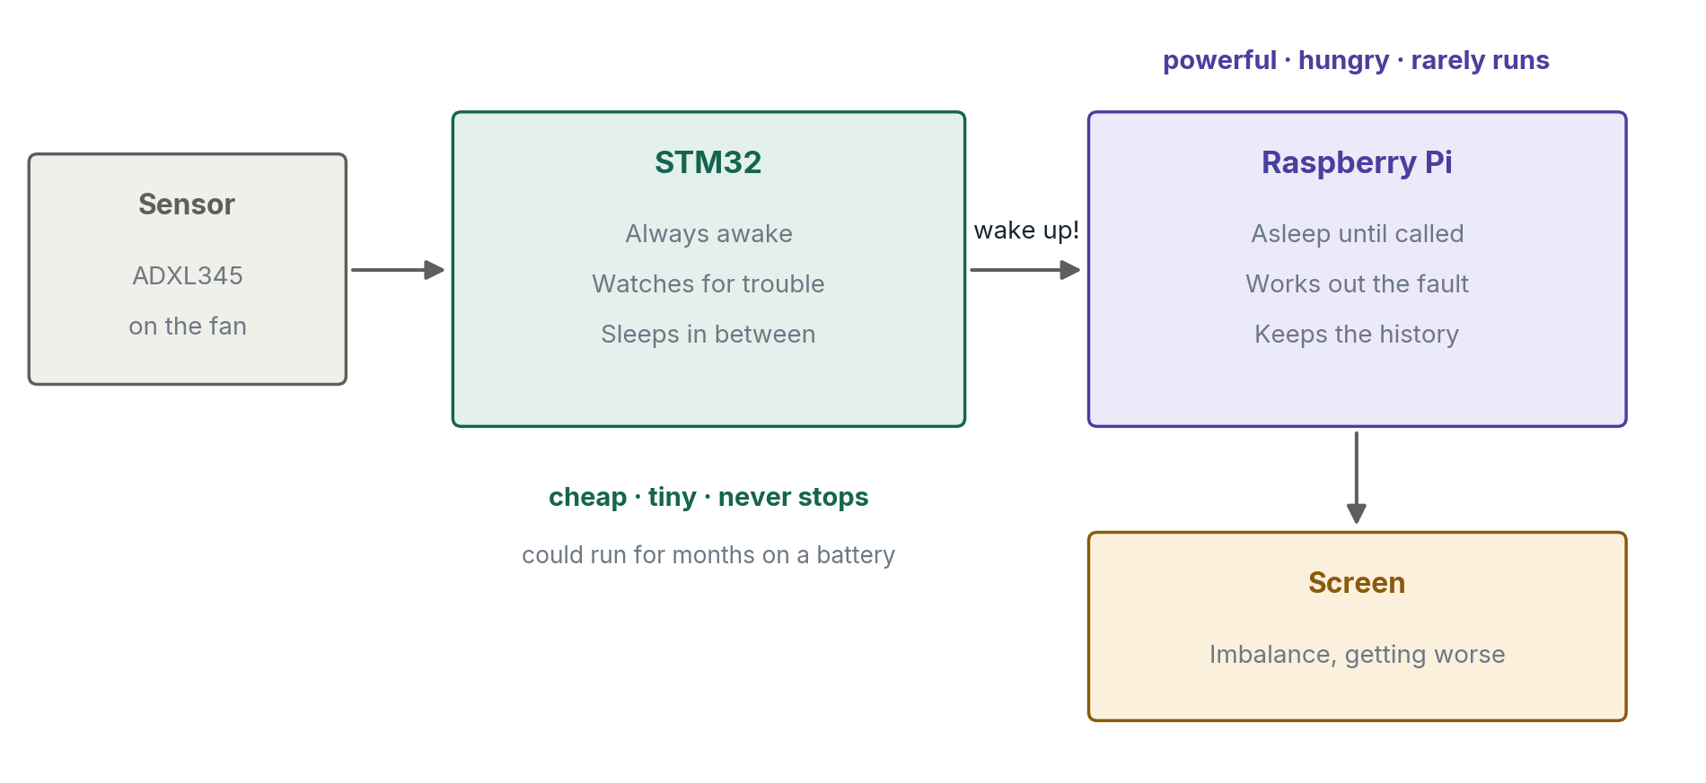
There are two boards because they do two different jobs.
- The STM32 is small and cheap. It never sleeps properly and it never stops watching. But it can only manage simple thinking.
- The Raspberry Pi is clever but hungry. It uses about a hundred times more power, so it cannot stay awake forever. It only wakes when the STM32 calls it.

Why not just use the Pi for everything?
Because a real sensor has to sit on a machine for months, often on a battery. A Pi would flatten that battery in hours. This is the whole reason the system has two halves — and it is the first thing an interviewer will ask you.

2. The three rounds
The interesting part of this project is that we solve the same problem three times, each in a smarter way, and then compare them honestly.
All three do exactly the same job: decide whether to wake the Pi. What changes is how they decide.
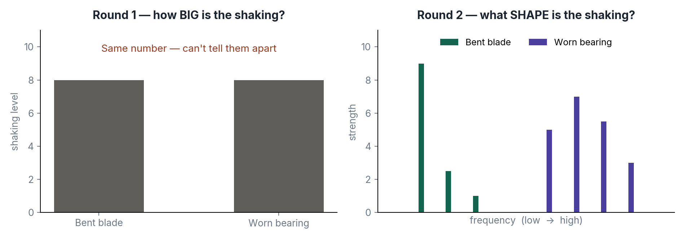

Round 1 — how big is the shaking?
Plain C code. Add up how much the sensor is moving, compare it to a limit. If it is over the limit, wake the Pi.
Simple and fast. But it only gives you one number, so two completely different faults can look identical.

Round 2 — what shape is the shaking?
We use maths called an FFT to split the shaking into its different frequencies. Now instead of one number we get a shape.
A bent blade shakes slowly. A worn bearing shakes fast. Same overall size, totally different shape — so now we can tell them apart.

Round 3 — let the computer learn the shape
Same information as round 2. The difference is who writes the rules.
In round 2 you write them yourself: "if the slow peak is twice as big as normal, call it imbalance." In round 3 you write no rules at all. You show it examples of normal and of each fault, and it works out the pattern itself.

The honest result is the point
Round 3 might not win. With one fan and a few faults, hand written rules may well beat the learned model — and they are smaller and easier to explain. If that happens, write it down. Being able to say "I tried machine learning and the simple version was better, here is the data" is rarer and more impressive than any model.

3. What you have and what is coming
Item | Status | What it is for
STM32 Nucleo F446RE | have | The small always awake chip
Raspberry Pi 5 | have | The clever one that sleeps
ADXL345 sensor (3 pack) | arriving | Feels the shaking
120 mm fan + speed controller | arriving | The machine we are watching
Jumper wires | check | Nine wires in total
Hot glue or strong tape | check | Fixing the sensor down

Total spent: under twenty five euros. Nothing else is needed.

4. How it all connects
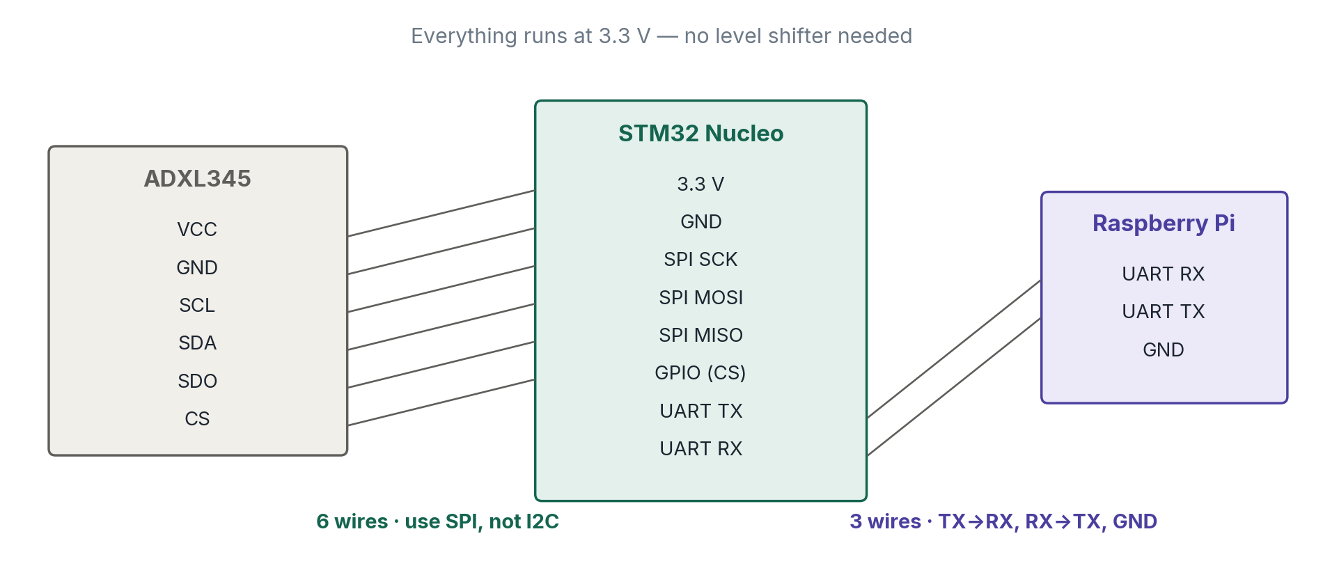
Two small things that save hours later:
- Use SPI for the sensor, not I2C. We need to read it very fast and I2C struggles.
- TX connects to RX and RX connects to TX. Crossed over, not straight across. Everyone gets this wrong once.

5. Where to stick the sensor
This sounds trivial. It is actually the easiest way to ruin the whole project.
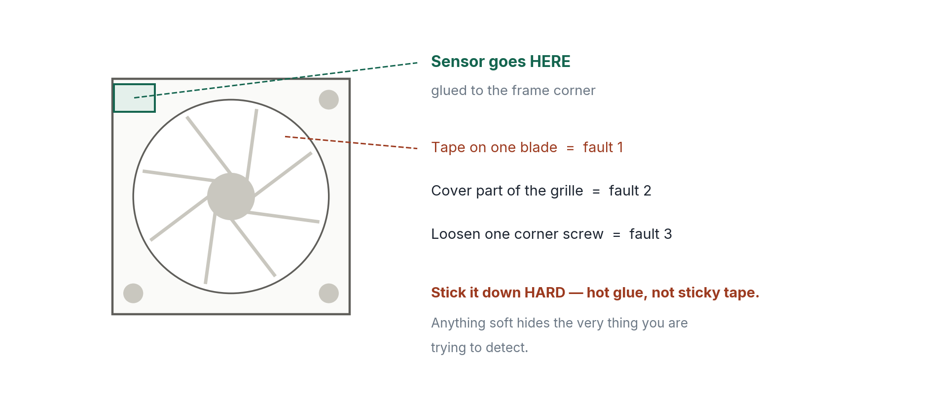
Pick one corner, mark it with a pen, and always use that exact spot. If the sensor moves between recordings, you are measuring where the sensor is, not what the fan is doing.
Also screw the fan to something solid, like a piece of wood. A fan sitting loose on a desk rattles against the desk, and you end up measuring the desk.

6. Today, before anything arrives
Everything here can be done with no hardware. Doing it now means tomorrow you can go straight to the interesting part instead of fighting installers.

Set up the tools (about 1 hour)
- Install STM32CubeIDE on your laptop. It is free from ST.
- Make a new project for the Nucleo F446RE and blink the green LED. This proves the whole chain works before a sensor is involved.
- On the Pi, check you can log in over SSH, and install pyserial and numpy.

Make the folder (15 minutes)
Create the project folder and a Git repository now, so every day's work goes somewhere from day one.
Folder | What goes in it
stm32/ | All the C code for the small board
pi/ | All the Python for the Pi
data/ | The sensor recordings
results/ | Charts and comparison tables
docs/ | Your notes and what went wrong

Read four things (30 minutes)
Open the ADXL345 datasheet and find these four registers. You do not need the rest of it.
Register | What it does
DEVID | Says hello. Should always read 0xE5
BW_RATE | Sets how fast it samples. We want 1600 Hz
DATA_FORMAT | Sets the range. We want plus or minus 2g or 4g
DATAX0 to DATAZ1 | The actual readings, six bytes

Optional, if you have an evening spare
Watch MIT 6.5940 Lecture 2 on YouTube. It explains where the work actually happens inside these models. Free, and it makes weeks two and three much easier.

7. The three weeks
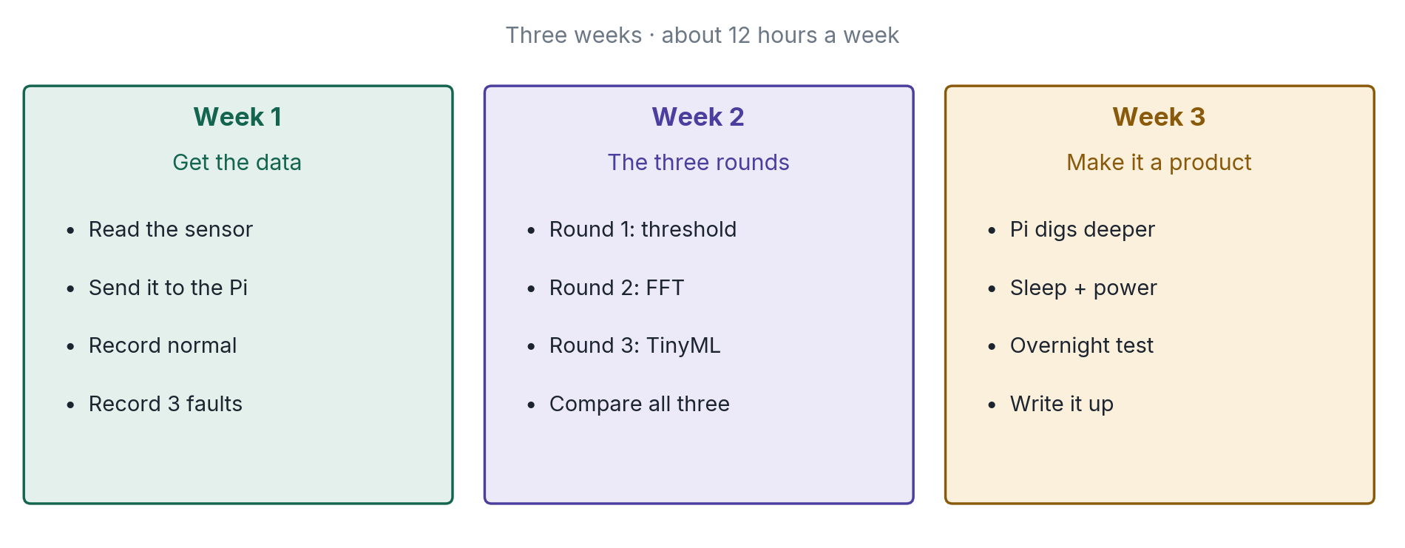

Week 1 — get the data
You cannot compare three methods without recordings to compare them on. This week is about getting good data, and nothing else.
- Day 1: wire the sensor, read DEVID, get 0xE5 back. Do not go further until you do.
- Day 2: read the sensor on a timer so the samples come at an exact steady rate.
- Day 3: send those readings to the Pi and save them into a file.
- Day 4: mount the fan and the sensor properly. Record normal running at three different speeds.
- Day 5: record each of the three faults, at the same three speeds. Also record yourself banging the desk, so you know what a false alarm looks like.
- Weekend: plot everything in Python. Can you see the difference with your own eyes?

If you can see the faults in the plots, the project is safe
If you cannot see any difference, something is wrong with the sampling rate or the mounting. Fix that now. Everything in weeks two and three sits on top of this data.

Week 2 — the three rounds
Now you write the three detectors and test all of them against the same recordings from week one. Same data for all three, so the comparison is fair.
- Round 1: the simple threshold in C. Maybe half a day.
- Round 2: add the FFT using CMSIS-DSP, which is free and already in CubeIDE. Then write rules on the shape.
- Round 3: feed those same FFT numbers into a small learned model using Edge Impulse or X-CUBE-AI.
- Then score all three: how often did each one miss a real fault, and how often did it cry wolf?

Round 3 sits on top of round 2, not instead of it. The FFT work is not thrown away — the model eats the FFT output. So the last round is lighter than it sounds.

Week 3 — make it a real product
So far you have a detector. This week turns it into something a person would actually use.
- The Pi side: when woken, do a much finer analysis than the small chip can, name the fault, and score how bad it is.
- Save every event, so the Pi can say "this has been getting worse since Tuesday". That sentence is the actual product.
- A small web page on the Pi showing the current state and the trend.
- Put the STM32 to sleep between readings and measure how little power it uses. Borrow a meter from the lab.
- Leave the whole thing running overnight and count how many times it woke up for nothing.
- Write the README, record a short video, update your CV.

8. The five things that go wrong
Every one of these has eaten somebody's week. None of them announce themselves.
The trap | What to do
Sampling too slowly | The faults simply will not be in your data, and nothing warns you. Set 1600 Hz, not the default 100 Hz.
Soft mounting | Sticky tape acts like a cushion and hides the fast shaking. Use hot glue.
Moving the sensor | Mark one spot. Same spot every single time, for every recording.
Only one fault | All three rounds will score perfectly and you learn nothing. You need three faults.
Testing live instead of on saved data | The room, the fan and the mounting all change. Record once, then test all three rounds on those same files.

9. What you can say at the end
Two different kinds of job, one project.

For a firmware job
You wrote bare metal C. You used timers, interrupts, SPI and UART. You built a message format with a checksum so a corrupted message gets thrown away instead of believed. You put a chip to sleep and measured the current. You ran it overnight and counted the failures.

For an edge AI job
You built a system where a tiny model runs all the time and a big one only wakes when needed, and you can explain exactly why. Better still, you tried three approaches and can say which parts genuinely needed machine learning and which did not.

The sentence worth aiming for
"I built all three versions and measured them on the same data. The simple one was good enough for one fault. Once I had three faults at three speeds, the FFT version pulled ahead. Here are the numbers."

