PROJECT DOCUMENTATION
Password-Vault

1. Objective
The objective of this project is to design and implement a secure, offline password management application using Python. The application enables users to store, retrieve, and manage credentials locally, with all data protected through industry-standard cryptographic primitives. The project demonstrates the practical application of concepts covered in Secure Software Engineering, including authenticated encryption, key derivation, and secure session management.

2. Problem Statement
Users today manage dozens of online accounts, often resorting to weak, reused passwords or insecure plaintext storage methods such as spreadsheets or notes. Cloud-based password managers, while convenient, introduce a dependency on third-party servers and present an attractive target for attackers. There is a clear need for a self-contained, offline password vault that:
- Stores credentials in an encrypted format on the user's local machine.
- Uses cryptographically sound algorithms that resist brute-force and tampering attacks.
- Provides a simple graphical interface accessible to non-technical users.
- Does not transmit any data over a network.

3. Research Findings
Prior to implementation, the following key findings from security literature and best practices guided design decisions:

3.1 Password Storage
Plaintext and reversibly-encoded storage (e.g., Base64) are categorically insecure. Symmetric encryption with a key derived from the master password is the standard approach used by tools such as KeePass and BitWarden's local export feature.

3.2 Key Derivation
PBKDF2-HMAC-SHA256 is a NIST-recommended key derivation function that deliberately slows brute-force attacks by applying a configurable number of hash iterations. With 100,000 iterations and a 32-byte random salt, the cost of an offline dictionary attack rises to a computationally prohibitive level for an average adversary.

3.3 Authenticated Encryption
AES in GCM (Galois/Counter Mode) provides both confidentiality and integrity. Unlike plain AES-CBC, GCM appends a 16-byte authentication tag that detects any tampering with the ciphertext. An attacker who modifies vault.enc will trigger an InvalidTag exception on decryption, rejecting the corrupted data.

3.4 Cryptographically Secure Randomness
Python's secrets module wraps os.urandom, which reads from the OS-level CSPRNG (/dev/urandom on Linux/macOS, BCryptGenRandom on Windows). This is suitable for generating salts, nonces, and random passwords — unlike the random module, which is pseudo-random and predictable.

4. Methodology
The project followed a modular, layered design approach with clear separation of concerns:
- Cryptographic layer (crypto_utils.py) isolated from UI and persistence.
- Persistence layer (data_manager.py) responsible solely for disk I/O.
- UI layer (ui_screens.py) containing all Tkinter components.
- Controller (main.py) orchestrating navigation and shared state.
Development proceeded iteratively: the core crypto functions were built and tested first, followed by file persistence, then the GUI was layered on top. This ensured that each layer could be verified independently before integration.

5. Tools Used

Tool / Library | Purpose
Python 3.x | Core programming language
tkinter | Standard library GUI framework for all screens and dialogs
cryptography (PyPI) | AES-256-GCM encryption and PBKDF2-HMAC-SHA256 key derivation
secrets | CSPRNG for generating salts, nonces, and random passwords
json | Serialization of the entry list before encryption
os / string | File path resolution and character set definitions

6. Implementation

6.1 Architecture Overview
The application consists of four Python modules and one encrypted binary file (vault.enc). Global constants (salt size, nonce size, iteration count, key size) are centralised in config.py, ensuring that a single-line change propagates across the entire application.

6.2 Vault File Structure
vault.enc is a binary file with the following byte layout on disk:
[ Salt (32 bytes) ] [ Nonce (12 bytes) ] [ Ciphertext (variable) ] [ GCM Tag (16 bytes) ]
On load, the first 32 bytes are extracted as the salt. The remainder is passed to decrypt_data(), which parses the nonce from its first 12 bytes and hands the rest to AESGCM.decrypt().

6.3 Encryption & Decryption Flow
Save (encrypt):
- Serialize entries list to JSON string.
- Generate a fresh 12-byte nonce using secrets.token_bytes().
- Encrypt with AESGCM(key).encrypt(nonce, plaintext, None) — returns nonce || ciphertext || tag.
- Write salt + encrypted blob to vault.enc.
Load (decrypt):
- Read vault.enc; split salt (bytes 0–31) and encrypted blob (bytes 32+).
- Re-derive the AES key via PBKDF2(password, salt, 100k iterations).
- Pass blob to decrypt_data(); on tag mismatch, InvalidTag is raised and login is rejected.
- JSON-parse the plaintext to recover the entries list.

6.4 Key Derivation
derive_key(password, salt) uses PBKDF2HMAC with SHA-256, 100,000 iterations, and a 32-byte output. The salt is stored in plaintext alongside the ciphertext — this is correct and expected; the salt's purpose is uniqueness, not secrecy.

6.5 Random Password Generator
make_random_password() generates a 16-character string from the full printable ASCII set using secrets.choice(). A validation loop ensures at least one character from each class (lowercase, uppercase, digit, punctuation) is present, preventing structurally weak outputs.

6.6 Session Management
The derived AES key and salt are held only in memory as attributes of the PasswordVaultApp controller. The logout() method explicitly sets them to None and clears the entries list before returning to the login screen, minimising the window of exposure in memory.

7. Results
The completed application successfully delivers the following outcomes:
- Master password setup creates a salted, encrypted vault file on first run.
- Subsequent logins verify the password via AES-GCM tag authentication — wrong passwords are rejected with a generic error message to prevent oracle attacks.
- Credentials (Site, Username, Password) can be created, listed, and deleted through the GUI.
- The random password generator produces high-entropy, structurally diverse 16-character passwords.
- Logout wipes the in-memory key, making the vault inaccessible without re-authentication.
- Master password reset wipes vault.enc and prompts the user to create a new password.
All cryptographic operations are handled exclusively through the cryptography library's hazmat primitives, with no home-grown crypto. The vault file is opaque binary and cannot be read or tampered with without the correct master password.

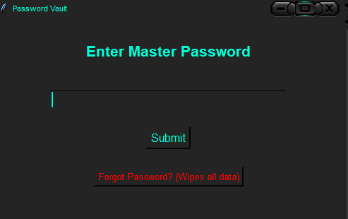
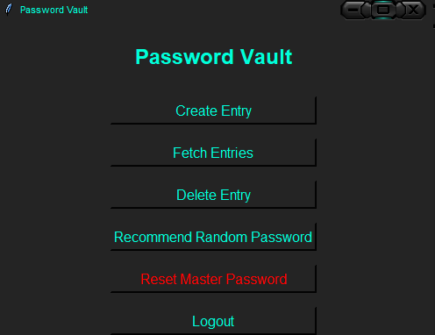
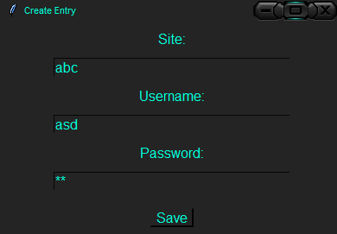

8. Challenges
- Nonce handling: The AESGCM.encrypt() call in the cryptography library prepends the nonce to the returned blob. This required careful slicing logic in decrypt_data() to correctly separate the nonce from the ciphertext.
- Error messaging: Distinguishing between a wrong password (InvalidTag) and genuinely corrupted data without leaking information to an attacker required intentionally vague error messages.
- In-memory state sharing: Multiple Toplevel windows (Create, Delete, Fetch) needed access to the shared entries list and save callback. This was resolved by passing references through constructors rather than using global state.
- Refactoring from monolith to modules: The initial single-file version (password_vault.py) was refactored into four separate modules to achieve clean separation of concerns and improve testability.

9. Future Scope
- Upgrade key derivation to Argon2id, the current Password Hashing Competition winner, for better memory-hardness.
- Add an entry search / filter feature for vaults with large numbers of credentials.
- Implement auto-lock: automatically log out after a configurable period of inactivity.
- Support vault export to an encrypted backup file and import from backup.
- Add password strength scoring on entry creation to warn users against weak inputs.
- Integrate clipboard auto-clear after a fixed timeout to prevent credential leakage.
- Provide optional biometric or TOTP-based second factor for local authentication.

10. Conclusion
This project demonstrates the practical implementation of a secure, offline password vault using Python. By combining AES-256-GCM authenticated encryption with PBKDF2-SHA256 key derivation and cryptographically secure randomness, the application achieves a security posture comparable to production-grade password managers for local use cases.
The modular architecture cleanly separates cryptographic logic, persistence, and UI concerns, making the codebase maintainable and independently testable. The project reinforced core Secure Software Engineering principles: defence in depth, minimal exposure of sensitive data, and the use of established cryptographic standards over custom implementations.
The identified future enhancements — particularly Argon2id and auto-lock — would further strengthen the application for real-world deployment. As a virtual internship deliverable, this project successfully bridges theoretical knowledge of secure design with hands-on implementation.

