1.Adding Two numbers
public class Intern {
public static void main(String[] args) {
//Add two numbers
int a=4;
int b=33;
int result=a+b;
System.out.println("Result = "+result);
}
}

Output:
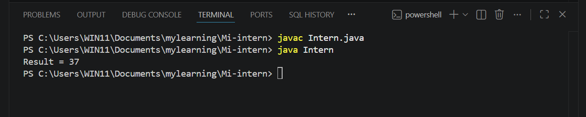

2.Multiplying two numbers
public class Intern {
public static void main(String[] args) {
//mulitiplication
int a=45;
int b=25;
int result=a*b;
System.out.println("Result = "+result);
}
}

Output:
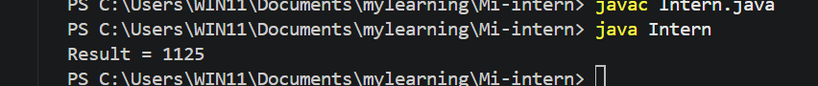

3.Division and Modulus Division
public class Intern {
public static void main(String[] args) {
//Division and Modulo division
//Division
int a=55;
int b=5;
float result=a/b;
System.out.println("Division = "+result);
//Modulo Division
int x=55;
int y=5;
int ans=x%y;
System.out.println("Modulo Division = "+ans);
}
}

Output
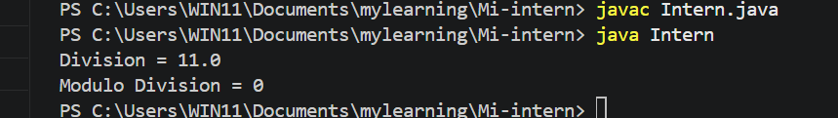

4.Getting input and using Conditionals
import java.util.Scanner;
public class Intern {
public static void main(String[] args) {
// Getting input
Scanner obj=new Scanner(System.in);
System.out.println("Enter a number:");
int num=obj.nextInt();
//Conditionals
if (num>10){
System.out.println("Hello");
}
else{
System.out.println("Hai");
}

}
}

Output:
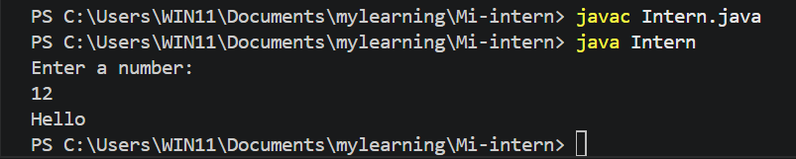

5. Using For Loop
import java.util.Scanner;
public class Intern {
public static void main(String[] args) {
// Getting input
Scanner obj=new Scanner(System.in);
System.out.println("Enter a number:");
int num=obj.nextInt();
//Looping
for (int i=0;i<=num;i++)
System.out.println("Hello World");
}

}

Output:
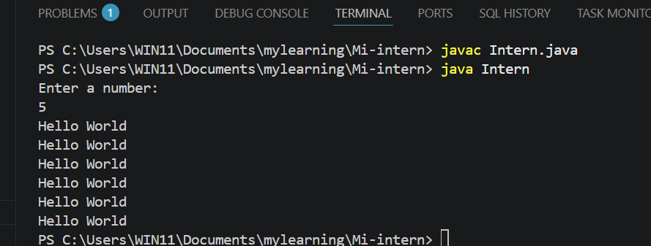

6.While
import java.util.Scanner;
public class Intern {
public static void main(String[] args) {
// Getting input
Scanner obj=new Scanner(System.in);
System.out.println("Enter a number:");
int num=obj.nextInt();
//Looping - While
while (num>0)
{
System.out.println("Welcome to java");
num--;
}
}
}

Output:
PS C:\Users\WIN11\Documents\mylearning\Mi-intern> java Intern
Enter a number:
7
Welcome to java
Welcome to java
Welcome to java
Welcome to java
Welcome to java
Welcome to java
Welcome to java

7. Do while
import java.util.Scanner;
public class Intern {
public static void main(String[] args) {
// Getting input
Scanner obj=new Scanner(System.in);
System.out.println("Enter a number:");
int num=obj.nextInt();
//Looping - Do While
do{
System.out.println("Good programmer");
num--;
}while (num>0);

}
}

Output:
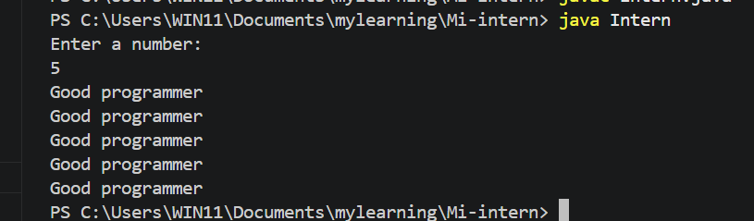

8. Find odd or even
import java.util.Scanner;
public class Intern {
public static void main(String[] args) {
// Getting input
Scanner obj=new Scanner(System.in);
System.out.println("Enter a number:");
int num=obj.nextInt();
//Find odd or even
if(num%2==0)
System.out.println("Even");
else
System.out.println("Odd");

}
}

Output:
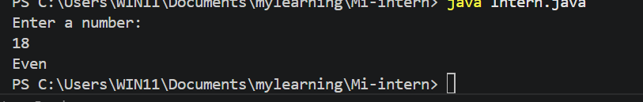
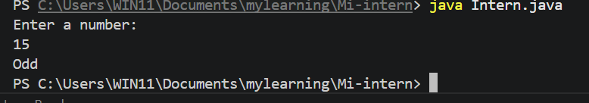

9. Factorial of a number
import java.util.Scanner;
public class Intern {
public static void main(String[] args) {
// Getting input
Scanner obj=new Scanner(System.in);
System.out.println("Enter a number:");
int num=obj.nextInt();
// Factorial
int fact=1;
for(int i=num;i>0;i--){
fact*=i;
}
System.out.println("The factorial of " + num +"is " + fact);

}
}

Output;
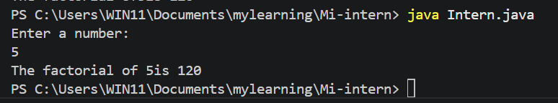

10. Prime Numbers or Not
import java.util.Scanner;
public class Intern {
public static void main(String[] args) {
// Getting input
Scanner obj=new Scanner(System.in);
System.out.println("Enter a number:");
int num=obj.nextInt();
int result=0;
//Prime Numbers or Not
for(int i=2;i<=num/2;i++){
result=num%i;
}
if(result!=0){
System.out.println("Prime Number");
}
else{
System.out.println("Not Prime Number");
}
}
}

Output:
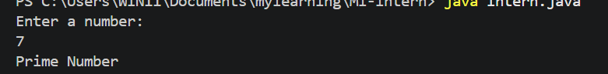
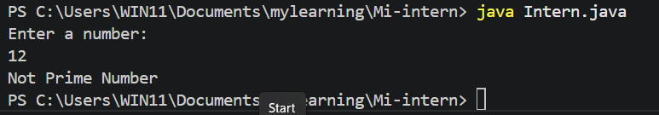

11. Fibonacci Series
import java.util.Scanner;
public class Intern {
public static void main(String[] args) {
// Getting input
Scanner obj=new Scanner(System.in);
System.out.println("Enter a number:");
int num=obj.nextInt();
int first_term=0;
int sec_term=1;
//Fibonacci Se=ries
for(int i=0;i<=num;i++){
System.out.println(first_term + " ");
int nextTerm = first_term +sec_term;
first_term=sec_term;
sec_term=nextTerm;

}
}
}
Output:
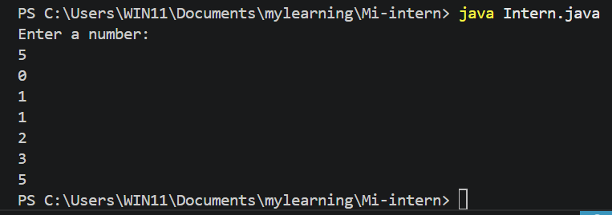

12. Armstrong Number
import java.util.Scanner;
public class Intern {
public static void main(String[] args) {
// Getting input
Scanner obj=new Scanner(System.in);
System.out.println("Enter a number:");
int num=obj.nextInt();
//Armstrong number
int temp=num;
int sum=0;
while(num>0){
int n=num%10;
int cube=n*n*n;
sum+=cube;
num=num/10;
}
if(temp==sum)
System.out.println("Armstrong Number");
else
System.out.println("Not Armstrong Number");

}
}

Output:
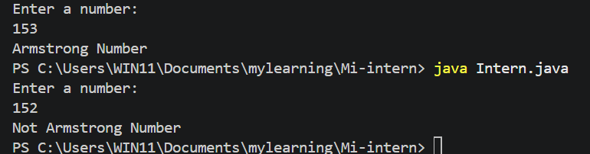

13. Largest Number
import java.util.Scanner;
public class Intern {
public static void main(String[] args) {
// Getting input
Scanner obj=new Scanner(System.in);
System.out.println("Enter A:");
int a=obj.nextInt();
System.out.println("Enter B:");
int b=obj.nextInt();
System.out.println("Enter C:");
int c=obj.nextInt();
//Finding largest Number
if ((a>b)&&(a>c))
System.out.println("A is Largest");
else if((b>a)&&(b>c))
System.out.println("B is the Largest");
else
System.out.println("C is the Largest");
}
}

Output:
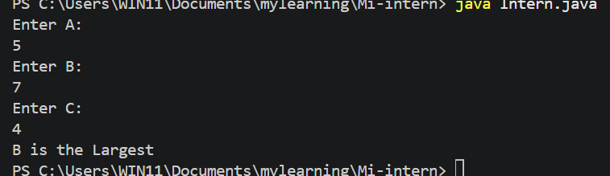

14. Palindrome number
import java.util.Scanner;
public class Intern {
public static void main(String[] args) {
// Getting input
Scanner obj=new Scanner(System.in);
System.out.println("Enter the Number:");
int num=obj.nextInt();
//Pallindrome Number
int temp=num;
int rev_no=0;
while(num>0){
int n=num%10;
rev_no=(rev_no*10)+n;
num/=10;
}
if(temp==rev_no)
System.out.println("Pallindrome Number");
else
System.out.println("Not pallindrome number");
}
}

Output:
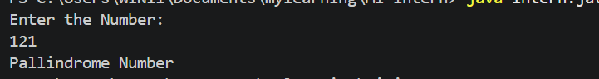
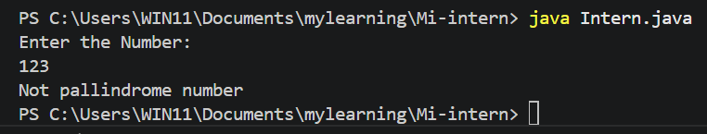

15. Perfect Number
import java.util.Scanner;
public class Intern {
public static void main(String[] args) {
// Getting input
Scanner obj=new Scanner(System.in);
System.out.println("Enter the Number:");
int num=obj.nextInt();
//Perfect Number
int temp=num;
int sum=0;
for(int i=1;i<=num/2;i++){
if(num%i==0){
sum+=i;
}
}
if(temp==sum)
System.out.println("Perfect Number");
else
System.out.println("Not perfect Number");
}
}

Output:
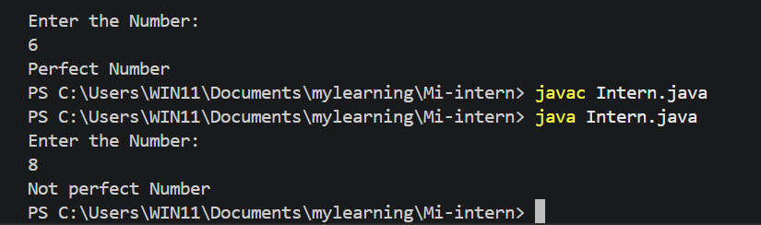

16. Strong Number
import java.util.Scanner;
public class Intern {
public static void main(String[] args) {
// Getting input
Scanner obj=new Scanner(System.in);
System.out.println("Enter the Number:");
int num=obj.nextInt();
//Strong Number
int sum=0;
int temp=num;
while(num>0){
int rem=num%10;
int fact=1;
for (int i=1;i<=rem;i++){
fact=fact*i;
}
sum=sum+fact;
num=num/10;
}
System.out.println((sum==temp)?"Strong Number":"Not strong Number");
}
}

Output:
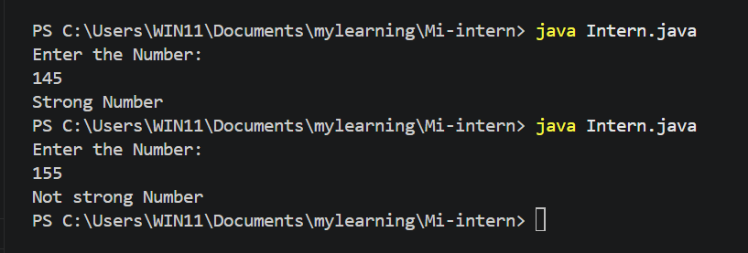

17. Amicable number
import java.util.Scanner;
public class Intern {
public static void main(String[] args) {
// Getting input
Scanner obj=new Scanner(System.in);
System.out.println("Enter the 1stNumber:");
int num1=obj.nextInt();
System.out.println("Enter the 2ndNumber:");
int num2=obj.nextInt();
//Amicable Number
int sum1=0;
int sum2=0;
for(int i=1;i<=(num1/2);i++){
if(num1%i==0){
sum1+=i;
}
}
for(int i=1;i<=(num2/2);i++){
if(num2%i==0){
sum2+=i;
}
}
if(sum1==num2 && sum2==num1)
System.out.println("Amicable Number");
else
System.out.println(" NotAmicable Number");
}
}

Output:
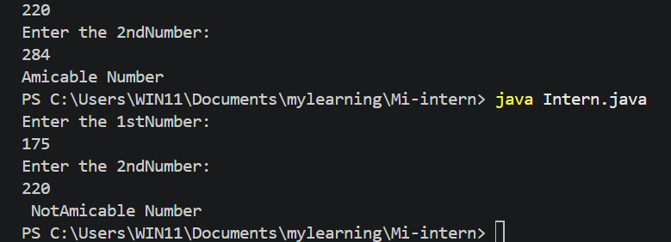

18. Odd or even without using Modulo division
import java.util.Scanner;
public class Intern {
public static void main(String[] args) {
// Getting input
Scanner obj=new Scanner(System.in);
System.out.println("Enter the Number:");
int num=obj.nextInt();
//Odd or even without using Modulo Division
if((num&1)==0)
System.out.println("even");
else
System.out.println("Odd");
}
}

Output:
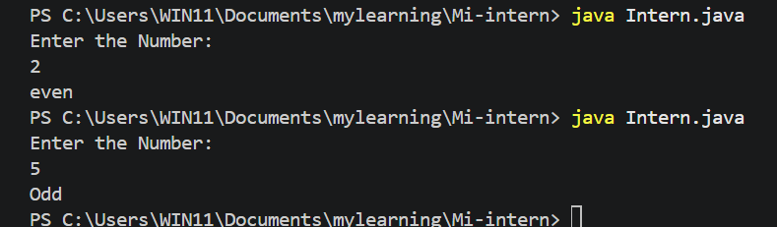

19. Upper case and Lower case by using ASCII value
import java.util.Scanner;
public class Intern {
public static void main(String[] args) {
// Getting input
Scanner obj=new Scanner(System.in);
System.out.println("Enter a letter:");
char ch=obj.next().charAt(0);
//Upper Case and Lower case by using ASCII value
if (ch>=65 && ch<=90)
System.out.println("Lower case");
else
System.out.println("Upper case");

}
}

Output:
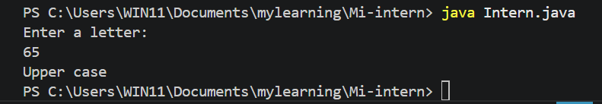

20.Number of days in a month
import java.util.Scanner;
public class Intern {
public static void main(String[] args) {
// Getting input
Scanner obj=new Scanner(System.in);
System.out.println("Enter a month:");
int m=obj.nextInt();
//No of days in a month
if(m==1||m==3||m==5||m==7||m==8||m==10||m==12)
System.out.println("31 days");
else if(m==4||m==6||m==9||m==11)
System.out.println("30 days");
else if(m==2)
System.out.println("28 or 29 days");
else
System.out.println("invalid month");
}
}

Output:
