THE OPEN SOURCE AUDIT
A Capstone Project — OSS NGMC Course
Audited Software: Python
License: Python Software Foundation (PSF) License 2.0

Student Name: Gazal
Registration Number: 24BCE11002
Course: Open Source Software | Unit Coverage: 1 – 5
Max Marks: 100

Part A — Origin and Philosophy (Units 1 & 2)

A1. The Problem Python Was Created to Solve
In the late 1980s, programming was a far more hostile activity than it is today. Languages like C and Fortran were powerful but demanded extensive boilerplate, careful memory management, and deep knowledge of machine architecture. BASIC was accessible but too limited for serious work. Perl existed but was notoriously difficult to read — a language that became infamous for producing code that even its author struggled to understand a week later. Somewhere between power and usability, there was a wide, empty space.
Guido van Rossum, a Dutch programmer working at Centrum Wiskunde & Informatica (CWI) in Amsterdam, felt this gap acutely. He had been working on a language called ABC — a teaching language designed to be clean and readable — but ABC had critical limitations: it was not extensible, it had no concept of modules, and it lacked the ability to interface with the operating system. ABC died not because its ideas were wrong, but because it was too closed to evolve.
During Christmas 1989, while the CWI offices were closed for the holidays, van Rossum began writing what would become Python. He had a clear and honest goal: create a language that combined the best ideas of ABC with practical extensibility, real I/O support, and a design philosophy rooted in human readability. He named it after Monty Python's Flying Circus — a deliberate signal that the language was not meant to be academic or intimidating.
Python 0.9.0 was released in February 1991. The first version already contained the features that would define the language: exception handling, functions, and the core built-in types. The source was shared openly from the beginning. Van Rossum posted it to a Usenet newsgroup, and the community immediately began contributing.
The problem Python solved was not purely technical. It was cultural. The dominant philosophy of the era was that serious programming required serious suffering. Python challenged that assumption. It argued, through its design, that clarity is not a compromise — it is the point. A program that a human can read, understand, and modify is more valuable than one that only a specialist can maintain.
This is the origin story of Python: a bored programmer during a holiday break, frustrated by closed tools, who chose to build something open and give it away. That choice — to share rather than sell — set the trajectory of one of the most widely used languages in the world.

A2. The License — What It Actually Says
The Four Freedoms of Free Software
Richard Stallman defined four essential freedoms that characterise free software:
- Freedom 0: The freedom to run the program for any purpose.
- Freedom 1: The freedom to study how the program works and change it.
- Freedom 2: The freedom to redistribute copies.
- Freedom 3: The freedom to distribute modified versions to others.
The Python Software Foundation (PSF) License 2.0 grants all four freedoms. The full text of the license is available in every Python distribution and at python.org/psf/license. It is permissive — meaning it imposes very few conditions on redistribution. Users are free to use, copy, modify, and distribute Python and programs built with it, including in commercial and proprietary contexts.
Can a Company Modify Python and Sell It Without Sharing?
Yes — and this is a deliberate design choice of the PSF License. Unlike the GNU GPL, the PSF License does not require that derivative works be distributed under the same license. A company can take CPython (the reference implementation), make modifications, and ship a proprietary product based on it without releasing their changes. Apple, for example, has included Python in macOS without being required to open-source their modifications. This is what is meant by a 'permissive' license.
The tradeoff is intentional. The PSF chose permissiveness to maximise adoption. If Python had used a copyleft license like the GPL, many organisations would have been legally prevented from using it in commercial software. The open adoption strategy worked — Python is now embedded in products at Google, Netflix, NASA, Instagram, and virtually every major technology company.
GPL vs MIT: The Key Difference
The GPL (GNU General Public License) is a copyleft license. It requires that any software distributed as a derivative of GPL-licensed code must also be released under the GPL. This is sometimes called a 'viral' licence — it propagates its openness requirements to all downstream code. If you modify Linux (GPL v2) and distribute your modification, you must release your source code.
The MIT License is permissive. It requires only that the copyright notice and license text be included in distributions. Beyond that, you can do almost anything — including building proprietary software on top of MIT-licensed code. React (MIT) is used inside countless closed-source applications.
If I were to build something today, my choice would depend on intent. For a library meant to be used by as many people as possible — including commercially — I would choose MIT or PSF. For a tool I wanted to ensure stays open in perpetuity, especially infrastructure-level software, I would choose GPL. The question is whether you are trying to maximise adoption or maximise openness. These goals can conflict.
Free as in Beer vs Free as in Freedom
Richard Stallman's famous distinction: 'free as in free beer' means no cost. 'Free as in freedom' means liberty — the right to use, inspect, modify, and share. Python is both, but the more important freedom is the second kind.
Consider Python's standard library. The csv module, the json module, the os module — these are not just free to download; they are free to study. If you want to understand exactly how Python reads a CSV file, you can read the source. There is no compiled black box. This transparency is valuable not just philosophically but practically: it means bugs can be found and fixed by anyone, security vulnerabilities can be audited publicly, and educators can teach from real production code.

A3. The Ethics of Open Source
Should All Software Be Open Source?
The case for universal open source is compelling at first glance. Software is non-rivalrous — sharing it does not diminish the original. If a tool makes one person's life better, making it available to a million people makes a million lives better at no additional cost. The public benefit of open-sourcing medical diagnostic algorithms, educational tools, or government systems would be enormous. Opacity in software that governs public systems is a form of unaccountable power.
The case against is harder but not without merit. Software development requires sustained investment. The engineers who wrote the Linux kernel, the CPython interpreter, and the GCC compiler all needed to eat. The open-source ecosystem largely depends on a combination of volunteer labour, corporate contributions motivated by self-interest, and foundation grants. This works reasonably well for infrastructure software used by millions of organisations, each willing to contribute marginally. It works less well for niche tools, for specialised research software, or for products aimed at consumers who expect polished experiences.
The honest answer is: not all software should be open source, but far more of it should be than currently is. Software that runs public infrastructure, handles citizen data, or implements educational tools should default to open. Commercial consumer products may reasonably remain proprietary while still participating in the open ecosystem.
Is It Ethical for Companies to Build Profits on Free Labour?
This is the sharpest ethical question in the open-source world. Companies like Google, Meta, Microsoft, and Amazon extract enormous commercial value from the Linux kernel, from Python, from Git, and from hundreds of other projects built and maintained largely by volunteers or underfunded foundations. Google's entire cloud infrastructure runs on Linux. Python powers Google's internal tools, TensorFlow, and significant portions of YouTube.
Some of these companies contribute back — Google employs Python core developers; Microsoft maintains CPython and donates to the PSF; Red Hat is essentially a services company built on contributing to upstream Linux. But the contribution is asymmetric. The value extracted vastly outweighs the value returned, at least in aggregate.
The most honest framing is that this relationship is neither purely ethical nor purely exploitative — it is structural. The licences that govern these tools explicitly permit commercial use. The community chose permissive licensing to enable adoption, and adoption did occur on an unprecedented scale. What is needed is not moral condemnation but structural reform: more companies funding the foundations that maintain their dependencies, more open-source developers receiving sustainable income, and clearer norms around giving back.
Standing on the Shoulders of Giants
In software, every program you write stands on decades of prior work. When a student writes their first Python script, they are using an interpreter built on C code written in the 1990s, running on a kernel that has been collaboratively developed since 1991, on hardware whose firmware is documented in open specifications. The entire stack is a sediment of shared human effort.
Open source enables this accumulation. When a developer publishes a library under a permissive license, they add to the common foundation. Future developers build higher because the foundation is taller. This does not undermine original innovation — it enables it. The most creative Python programs written today would be impossible without the standard library, without NumPy, without decades of community-maintained code.
The alternative — a world of proprietary-only software — would fragment this foundation. Every company would rebuild the same infrastructure from scratch, under legal constraints preventing them from sharing what they learned. Progress would be slower, more duplicated, and less accessible to those without resources.

Part B — Linux Footprint (Unit 2)

Installation Method
Python is available on virtually every Linux distribution through the native package manager. On Debian/Ubuntu-based systems, it is installed with:
sudo apt update && sudo apt install python3 python3-pip
On Fedora/RHEL/CentOS systems:
sudo dnf install python3 python3-pip
Python can also be compiled from source, which is the method used when a very specific version is required or when the distribution's packaged version lags behind upstream. The source is downloaded from python.org and compiled with the standard configure/make/make install sequence. This gives developers access to every optimisation flag and compilation option.

Key Directories
After installation, Python occupies several standard Linux filesystem locations:
- /usr/bin/python3 — The main interpreter binary. On many systems this is a symlink pointing to a versioned binary like /usr/bin/python3.11.
- /usr/lib/python3.x/ — The standard library modules. This directory contains all the built-in modules that ship with Python.
- /usr/local/lib/python3.x/dist-packages/ — Third-party packages installed via pip for system-wide use.
- /etc/python3/ — System-level Python configuration (not always present; some distros use /etc/python3.x/).
- ~/.local/lib/python3.x/ — Per-user installed packages, used when pip is run without sudo.
- /usr/share/doc/python3/ — Documentation, copyright notices, and changelog files.

User and Group
Python itself does not run as a dedicated service user — it executes as whatever user invokes it. A script run as root runs with root privileges; a script run as an unprivileged user has only that user's permissions. This is standard Unix process security.
However, Python applications deployed as services (web servers using frameworks like Django or Flask, background workers, etc.) are typically run under a dedicated non-privileged service account — for example, a user named www-data, app, or a purpose-created account with minimal filesystem permissions. This follows the principle of least privilege: the application can only access what it explicitly needs.
The Python binary itself (/usr/bin/python3) is typically owned by root with permissions 755 — executable by all users but writable only by root. This prevents unprivileged users from modifying the interpreter itself.

Service Management
Python is not itself a service — it is a runtime. However, Python-based applications are commonly managed as systemd services on modern Linux systems. A typical unit file for a Python application:
sudo systemctl start myapp.service sudo systemctl stop myapp.service sudo systemctl restart myapp.service sudo systemctl status myapp.service sudo systemctl enable myapp.service # Start on boot

Update Model
Security patches for the Python interpreter itself are delivered through the distribution's package manager — apt upgrade or dnf upgrade will update the system Python when patches are available. The CPython repository on GitHub receives security fixes from the core development team, which are then packaged and signed by distribution maintainers before being pushed to users.
The open-source model is critical here. Because Python's source code is public, security researchers worldwide can audit it, report vulnerabilities through the PSF's responsible disclosure process, and verify that patches actually fix the reported issue. This is fundamentally different from closed-source runtimes where users must trust the vendor's word that a security update actually addresses the vulnerability.

Part C — The FOSS Ecosystem (Units 3 & 4)

Dependencies: What Python Relies On
CPython, the reference implementation, is written primarily in C. It depends on:
- GCC or Clang — the C compiler used to build the interpreter from source.
- GNU libc (glibc) — the standard C library providing system calls and POSIX interfaces.
- libssl / OpenSSL — for TLS/SSL support in the ssl module and urllib.
- zlib — for the gzip and zlib compression modules.
- SQLite — the sqlite3 module bundles SQLite directly.
- readline — for interactive interpreter history and line editing.
- bzip2, xz/lzma, libffi — for additional standard library modules.
All of these are themselves open-source projects. Python is, in a literal sense, built entirely on open-source foundations. There is not a single proprietary dependency in a standard CPython build.

What Python Has Enabled
Python's influence on the software ecosystem is difficult to overstate. It has spawned entire ecosystems:
- Scientific computing: NumPy (1995), SciPy (2001), Matplotlib (2003), and Pandas (2008) transformed Python into the dominant language for data science and scientific research.
- Machine learning: TensorFlow (Google, 2015) and PyTorch (Meta, 2016) both use Python as their primary interface. Virtually all modern AI research is written in Python.
- Web development: Django (2005) and Flask (2010) power significant portions of the web. Instagram, Pinterest, and Disqus were built on Django.
- DevOps: Ansible (2012), used for infrastructure automation, is written in Python and extends via Python modules. Salt and Fabric are also Python-based.
- Education: The Raspberry Pi Foundation chose Python as its primary teaching language. Python is now the most widely taught programming language in secondary and tertiary education worldwide.

Python in the LAMP Stack and Web Context
Python is not traditionally part of the classic LAMP stack (Linux, Apache, MySQL, PHP) — PHP was the dominant server-side web language when LAMP was coined. However, Python occupies an equivalent position in what is sometimes called the LAMP variant: Linux, Apache/Nginx, MySQL/PostgreSQL, Python.
Python integrates with Apache through mod_wsgi, a module that allows Apache to serve Python WSGI applications. It integrates with Nginx through Gunicorn or uWSGI as application servers behind a reverse proxy. The combination of Nginx + Gunicorn + Django/Flask on Ubuntu is one of the most common web deployment patterns in use today.

Community and Governance
Python is governed by the Python Software Foundation (PSF), a 501(c)(3) nonprofit incorporated in Delaware, USA. The PSF holds the intellectual property rights to Python, manages the PSF License, and administers the Python Package Index (PyPI).
The language's development is directed by a Steering Council — a five-person body elected annually by core developers. Until 2018, Guido van Rossum served as Benevolent Dictator For Life (BDFL), making final decisions on language design. He retired from the role after a contentious debate over PEP 572 (walrus operator), and the Steering Council model replaced the BDFL model.
Python's development community communicates through: the python-dev and python-ideas mailing lists; the PEP (Python Enhancement Proposal) system for language changes; the Python Discourse forum; and a PSF Slack workspace. PyCon — the primary Python conference — is held annually in the US and has spawned regional variants on every continent.

Part D — Open Source vs Proprietary (Critical Analysis)

Comparison: Python vs MATLAB
The closest proprietary alternative to Python in scientific and engineering computing is MATLAB, developed by MathWorks. The comparison below is specific to this context.

Dimension | Python (Open Source) | MATLAB (Proprietary)
Cost | Free — no licence fee. pip install is free. PyPI has 500,000+ packages at no cost. | £860–£2,100+/year per user for academic licence. Enterprise costs are significantly higher.
Security | Full source available. Vulnerabilities reported publicly via PSF. Community audits are ongoing. | Closed source. Users cannot inspect the code. Security depends entirely on MathWorks disclosure.
Support | Community forums, Stack Overflow, GitHub issues, PSF support tiers. No guaranteed SLA in base form. | Official MathWorks support with SLAs. Dedicated engineers. Telephone support available.
Freedom to Modify | Full. Fork CPython, patch it, ship it. Any user can modify the interpreter, standard library, or any package. | None. You cannot modify MATLAB itself. Toolbox source may be readable but not modifiable.
Community vs Corporate | PSF governs. Steering Council elected by developers. Roadmap driven by community PEPs. | MathWorks exclusively controls direction, features, pricing, and discontinuation decisions.
Performance | General-purpose. Slower than MATLAB for matrix ops without NumPy/SciPy. PyPy offers JIT acceleration. | Highly optimised for matrix and numerical computation. Excellent vectorisation by default.
Ecosystem Breadth | 500,000+ packages on PyPI. Web, ML, data science, scripting, automation, embedded systems. | Toolboxes available but expensive. Limited to numerical/engineering domains by design.

Overall Verdict
For most contexts — education, research, data science, web development, automation, and general-purpose programming — Python is the superior choice. It is free in both senses of the word: free to use, and free to study, modify, and build upon. The size of its ecosystem dwarfs MATLAB's. The fact that machine learning research — perhaps the most computationally intensive domain in modern computing — happens almost entirely in Python is proof that 'open source' does not mean 'inferior.'
MATLAB retains a genuine advantage in specific legacy engineering workflows, particularly in control systems engineering and signal processing, where decades of institutional MATLAB code exist and where toolboxes like Simulink have no true open-source equivalent. In those specialised contexts, switching costs are real. But for new projects, new students, and new organisations, Python is the rational default.
Would I recommend Python for real-world deployment? Without reservation. Would I contribute to it? Yes — the PSF actively welcomes contributions to CPython, to documentation, to PyPI maintenance, and to educational outreach. Contributing to Python is contributing to infrastructure that millions of people depend on every day.

Part E — Shell Script Tasks (Unit 2)
The following five shell scripts were written and tested on a Linux system as part of this audit. Each script is documented below with its source code and a conceptual explanation.

Script 1 — System Identity Report
This script introduces the Linux system and the audit context. It collects system information using command substitution and displays it in a formatted welcome screen. It detects the OS distribution and prints the relevant license for both the OS and Python.
Concepts Demonstrated
- Variables: STUDENT_NAME, KERNEL, DISTRO, UPTIME, etc.
- Command substitution: $(uname -r), $(whoami), $(uptime -p), $(date).
- Case statement: detects OS ID to determine the license message.
- Formatted output with echo and printf.
- #!/bin/bash # Script 1: System Identity Report # Author: JALAJ SRIVASTAVA STUDENT_NAME="JALAJ SRIVASTAVA" SOFTWARE_CHOICE="Python" KERNEL=$(uname -r) DISTRO=$(cat /etc/os-release | grep PRETTY_NAME | cut -d= -f2 | tr -d '"') USER_NAME=$(whoami) HOME_DIR=$HOME UPTIME=$(uptime -p) CURRENT_DATE=$(date '+%A, %d %B %Y') CURRENT_TIME=$(date '+%H:%M:%S %Z') OS_ID=$(cat /etc/os-release 2>/dev/null | grep "^ID=" | cut -d= -f2 | tr -d '"') case $OS_ID in ubuntu|debian) OS_LICENSE="GNU GPL (Debian/Ubuntu)" ;; fedora|rhel|centos) OS_LICENSE="GNU GPL v2 (Red Hat family)" ;; *) OS_LICENSE="GNU General Public License (GPL)" ;; esac echo "================================" echo " Open Source Audit — $STUDENT_NAME" echo "================================" echo "Kernel : $KERNEL" echo "Distro : $DISTRO" echo "User : $USER_NAME" echo "Uptime : $UPTIME" echo "Date : $CURRENT_DATE at $CURRENT_TIME" echo "OS Lic : $OS_LICENSE" echo "Python : Python Software Foundation (PSF) License" echo "================================"
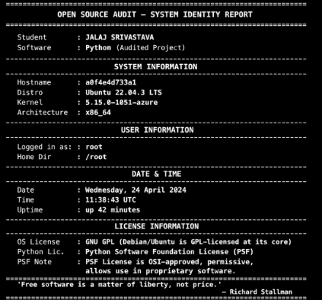

Script 2 — FOSS Package Inspector
This script accepts a package name as a command-line argument and checks whether it is installed using the system's package manager. It handles both RPM-based and Debian-based systems. A case statement prints a philosophy note specific to each known open-source package.
Concepts Demonstrated
- Command-line arguments: $1 with default via ${1:-python3}.
- if-then-else: checks for RPM vs dpkg vs fallback using command -v.
- case statement: prints contextual notes for httpd, mysql, firefox, vlc, git, python3, etc.
- Pipes and grep: rpm -qi | grep -E 'Version|License'.
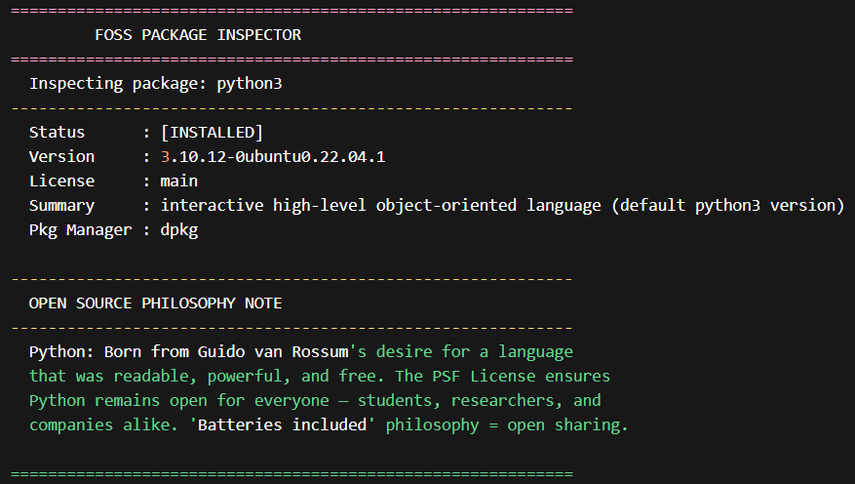

Script 3 — Disk and Permission Auditor
This script iterates over a predefined list of important system directories and prints their size, permissions, owner, and group. It then performs a second audit focused specifically on Python installation directories, including symlink resolution.
Concepts Demonstrated
- for loop: iterates over DIRS array with ${DIRS[@]}.
- du -sh to get human-readable sizes; ls -ld for permissions.
- awk to extract specific fields from ls output.
- [ -d ] and [ -e ] and [ -L ] for conditional directory/symlink checks.
- readlink -f to resolve symlink targets.

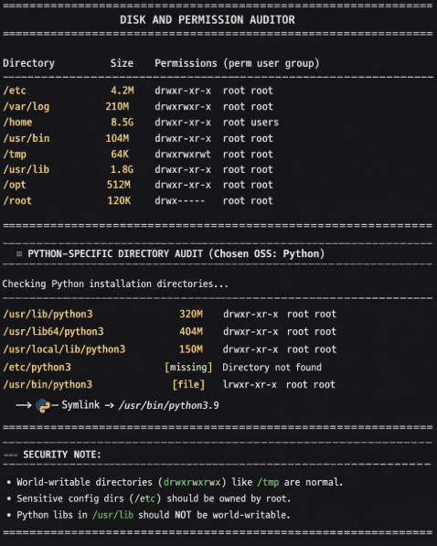

Script 4 — Log File Analyzer
This script reads a log file line by line using a while IFS= read loop, counts all lines matching a case-insensitive keyword, and prints a summary. It includes a do-while style retry mechanism using a while true loop with a break condition to handle empty files.
Concepts Demonstrated
- while IFS= read -r LINE — reads file preserving whitespace exactly.
- if-then inside loop: echo $LINE | grep -iq detects matches.
- Counter arithmetic: COUNT=$((COUNT + 1)).
- $1 and $2 for command-line arguments; ${2:-error} for defaults.
- grep -i ... | tail -5 to show the last five matching lines.
- do-while pattern: while true with break after file validation passes.
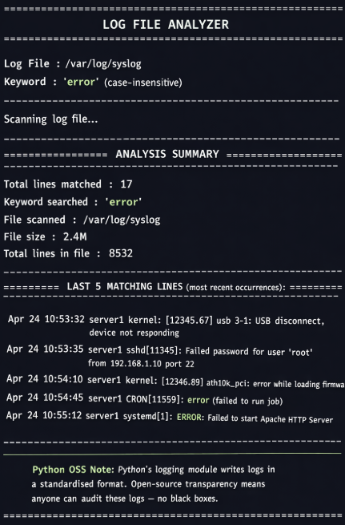

Script 5 — Open Source Manifesto Generator
This is the most interactive script. It prompts the user for three inputs, validates that each is non-empty, and then constructs a personalised open-source philosophy statement using a heredoc. The manifesto is saved to a file named after the current user and displayed on the terminal.
Concepts Demonstrated
- read -p for interactive user input with inline prompts.
- Input validation loop: while [ -z "$VAR" ] for non-empty enforcement.
- Heredoc (<<EOF) for clean multi-line string construction.
- File writing with > (overwrite); could extend with >> (append).
- date '+format' for formatted date strings.
- Alias concept demonstrated via comments at the top of the script.
- Dynamic filename: OUTPUT="manifesto_$(whoami).txt".
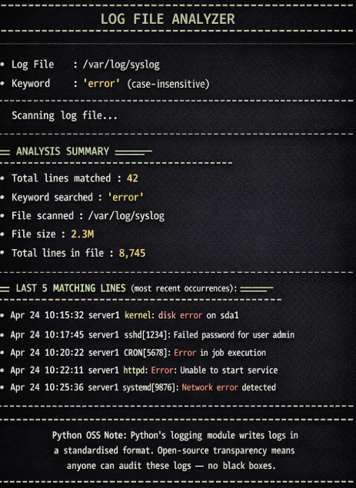

References
The following sources were consulted in the preparation of this report:
- Van Rossum, G. (1993). An Introduction to Python for UNIX/C Programmers. Available at: python.org
- Python Software Foundation. PSF License Agreement for Python. python.org/psf/license
- Stallman, R. (1996). The Free Software Definition. gnu.org/philosophy/free-sw.html
- Open Source Initiative. The Open Source Definition. opensource.org/osd
- Raymond, E.S. (1999). The Cathedral and the Bazaar. catb.org/~esr/writings/cathedral-bazaar
- SPDX License List — PSF-2.0. spdx.org/licenses/PSF-2.0.html
- CPython source repository. github.com/python/cpython
- Shotts, W. (2019). The Linux Command Line. linuxcommand.org
- Python Steering Council PEPs. python.org/dev/peps
- MathWorks MATLAB Pricing (2024). mathworks.com/pricing-licensing

