1. What is the IP address and TCP port number used by the client computer (source) that is transferring the file to gaia.cs.umass.edu? To answer this question, it’s probably easiest to select an HTTP message and explore the details of the TCP packet used to carry this HTTP message, using the “details of the selected packet header window” (refer to Figure 2 in the “Getting Started with Wireshark” Lab if you’re uncertain about the Wireshark windows.

The IP address used by the client computer is 192.168.1.102, and the TCP port number used by the client computer is 1161.



1. What is the IP address of gaia.cs.umass.edu? On what port number is it sending and receiving TCP segments for this connection?

The IP address of gaia.cs.umass.edu is 128.119.245.12, and its port number is 80.

1. What is the IP address and TCP port number used by your client computer (source) to transfer the file to gaia.cs.umass.edu?

The IP address of my client computer is 10.41.89.176, and the TCP port number of my client computer is 7729.



1. What is the sequence number of the TCP SYN segment that is used to initiate the TCP connection between the client computer and gaia.cs.umass.edu? What is it in the segment that identifies the segment as a SYN segment?

The sequence number is 0.

It uses flag to identifies the segment as a SYN segment in TCP segment.

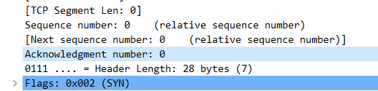

1. What is the sequence number of the SYNACK segment sent by gaia.cs.umass.edu to the client computer in reply to the SYN? What is the value of the Acknowledgement field in the SYNACK segment? How did gaia.cs.umass.edu determine that value? What is it in the segment that identifies the segment as a

SYNACK segment?

The sequence number is 0, and the value of the Acknowledgement field is 1.

The value of flag shows that it is a SYNACK segment.

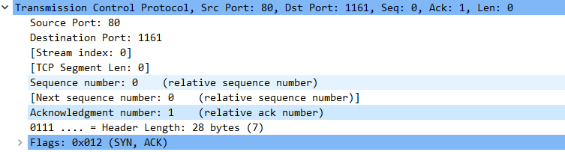

1. What is the sequence number of the TCP segment containing the HTTP POST command? Note that in order to find the POST command, you’ll need to dig into the packet content field at the bottom of the Wireshark window, looking for a segment with a “POST” within its DATA field.

The sequence number of the TCP segment containing the HTTP POST command is 1.

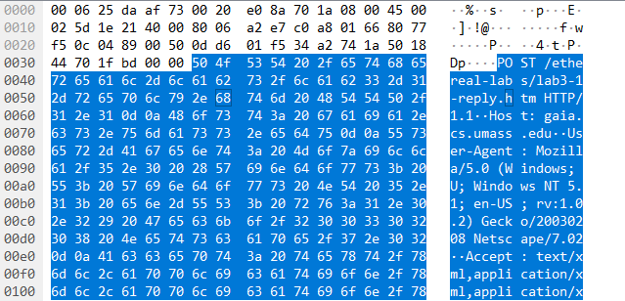



1. Consider the TCP segment containing the HTTP POST as the first segment in the

TCP connection. What are the sequence numbers of the first six segments in the

TCP connection (including the segment containing the HTTP POST)? At what time was each segment sent? When was the ACK for each segment received? Given the difference between when each TCP segment was sent, and when its acknowledgement was received, what is the RTT value for each of the six segments? What is the EstimatedRTT value (see Section 3.5.3, page 242 in text) after the receipt of each ACK? Assume that the value of the

EstimatedRTT is equal to the measured RTT for the first segment, and then is computed using the EstimatedRTT equation on page 242 for all subsequent segments.

The segment numbers of the first six segments containing the HTTP POST in the TCP are 1, 566, 2026, 3486, 4946, 6406.

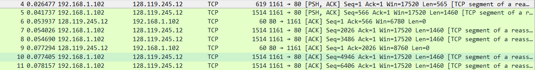

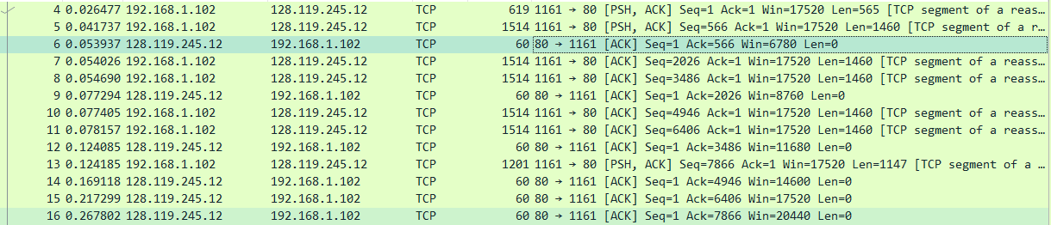

The RTT value for each of the six segments are 0.02746s, 0.035557s, 0.070059s, 0.114428s, 0.139894s, 0.189645s.

The EstimatedRTT value after the receipt of each ACK are 0.02746s, 0.028472125s, 0.033670484375s, 0.043765173828125s, 0.05578127709960937s, 0.07251424246215821s.

1. What is the length of each of the first six TCP segments?[1]

The length of each of the first six TCP segments are 565, 1460, 1460, 1460, 1460, 1460.













1. What is the minimum amount of available buffer space advertised at the received for the entire trace? Does the lack of receiver buffer space ever throttle the sender?

The minimum amount of available buffer space advertised at the received for the entire trace is 5840.



No, it doesn’t.

1. Are there any retransmitted segments in the trace file? What did you check for (in the trace) in order to answer this question?

There are no retransmitted segments in the trace file.

I used the graph provided by wireshark.

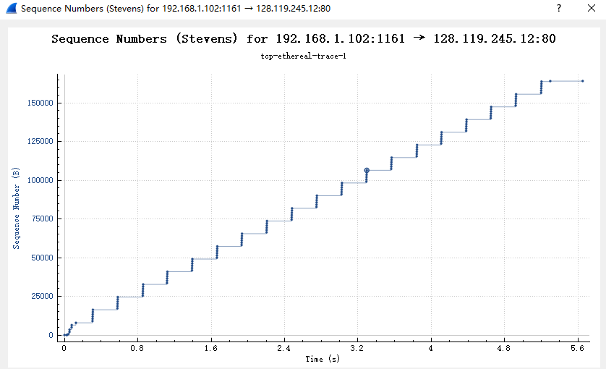

1. How much data does the receiver typically acknowledge in an ACK? Can you identify cases where the receiver is ACKing every other received segment (see Table 3.2 on page 250 in the text).

Solution: The acknowledged sequence numbers of the ACKs are listed as follows.

acknowledged sequence number acknowledged data

ACK 1 566 566

ACK 2 2026 1460

ACK 3 3486 1460

ACK 4 4946 1460

ACK 5 6406 1460

ACK 6 7866 1460

ACK 7 9013 1147

ACK 8 10473 1460

ACK 9 11933 1460

ACK 10 13393 1460

ACK 11 14853 1460

ACK 12 16313 1460

The difference between the acknowledged sequence numbers of two consecutive ACKs indicates the data received by the server between these two ACKs. By inspecting the amount of acknowledged data by each ACK, there are cases where the receiver is ACKing every other segment. For example, segment of No. 80 acknowledged data with 2920 bytes = 1460*2 bytes.

1. What is the throughput (bytes transferred per unit time) for the TCP connection? Explain how you calculated this value.

The throughput for the TCP connection is 164090/(5.455830-0.026477) = 30222.49 bytes per second.

Use the total amount data divides the total transmission time.





1.