
GAZEBO CLOUD · MANAGEMENT PACK
Buyer Category, Global Stocks, and Purchase Order Follow-up
Simple English pack for management. Diagrams use numbered steps. Evidence boxes are blank so you can paste a screen recording after the developer finishes.
- For: Management
- Date: 17 September 2026
- Status: Proposed — not built yet
- How to use: read each page, look at the numbered picture, leave the evidence table empty until you record the screen
1. Why we are doing this
Buyers and planners need a simple label on raw materials: Key product, Other product, or Planner monitor. Admin sets that label on the product. It can be changed later. Every change is kept in the product timeline.
Global Stocks should filter like the Products page (category, sub-category, sub-sub category), plus this new buyer label. The Location filter we already have stays. People should also be able to tick which columns they see. If they hide Trace or Supplier, quantities add up — but Unit 2 and Low Risk never mix.
Open purchase orders sit on the right of that report. When warehouse finishes goods-in for a PO, that PO leaves the report and the next one moves up. Each night at 00:10 we email the list of POs still Ordered or Partial. Planning Excel can optionally add one sheet that totals the same raw material across recipe levels.
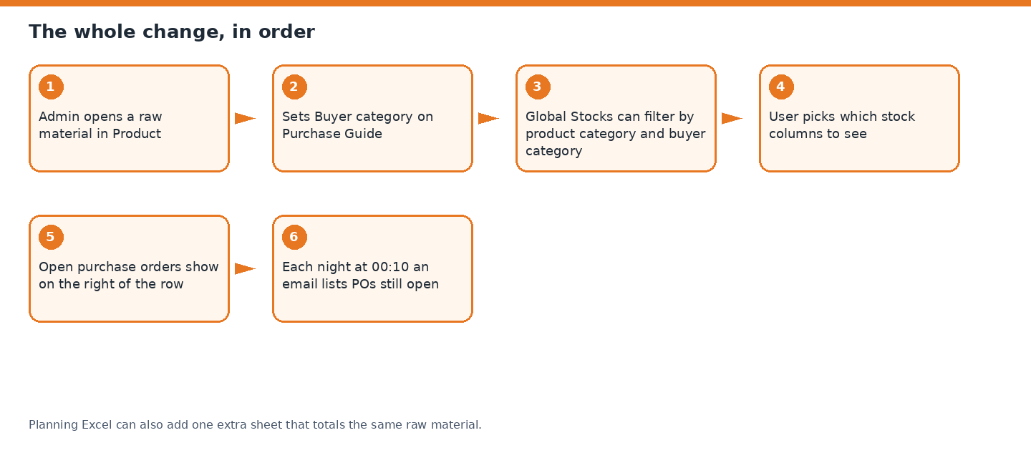
Picture 1. The whole change, step by step.
2. Who does what
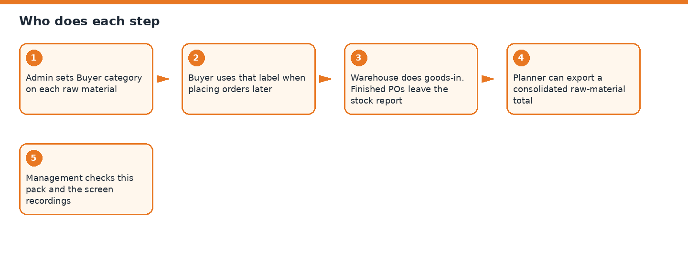
Picture 2. Admin, buyer, warehouse, planner, management.
3. Req 1 — Buyer category
What it is. Three labels on a raw material.
- Key product — used a lot, important every day
- Other product — not a key product
- Planner monitor — the production planner watches it and orders when needed
Where it lives. Product → Purchase → Guide. New row: Buyer category.
Who uses it. Admin sets it. Buyers use it later when placing orders.
It can be edited any time. The timeline records the old value, the new value, who, and when.
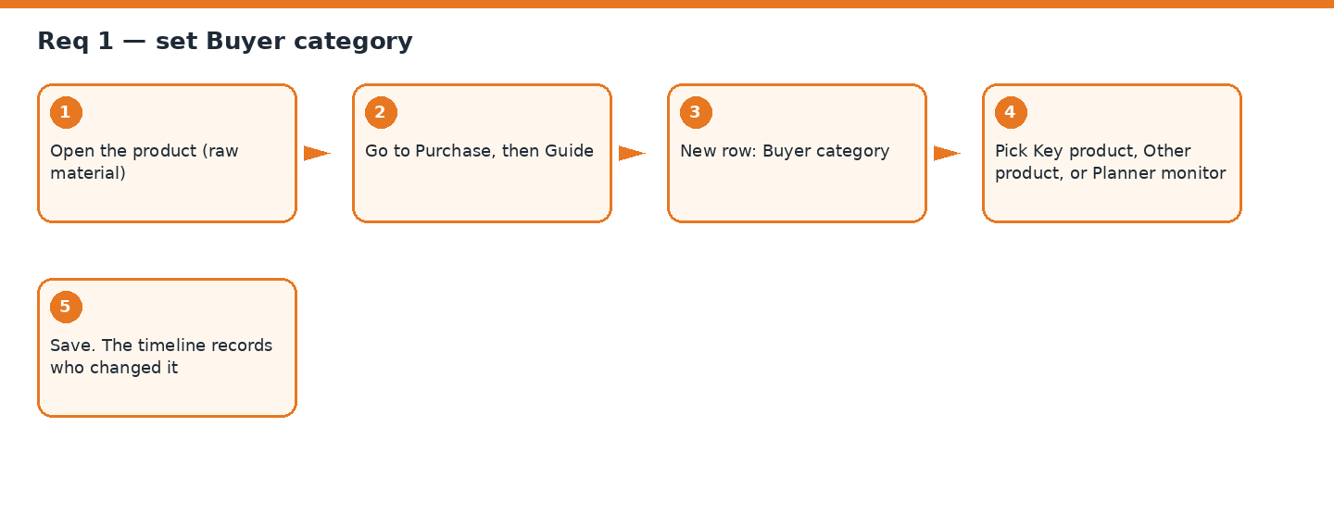
Picture 3. How admin sets Buyer category.
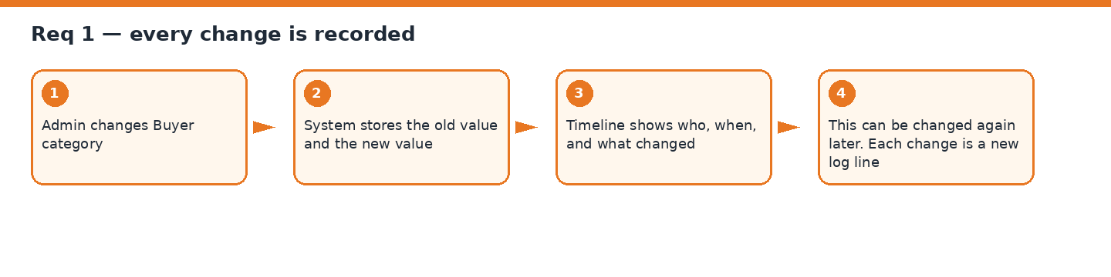
Picture 4. How the audit log stores each change.
What “done” looks like. The dropdown saves. The timeline shows the change. Old Purchase Guide fields still work.
Evidence of outcome (after developer)
Leave this blank for now. After the developer finishes, record your screen and paste the file or a link in the row below.
Field | Fill in after the work is done
Date recorded | ________________________________
Recorded by | ________________________________
Screen recording / screenshot | ________________________________
Pass / Fail | ________________________________
Notes | ________________________________

4. Req 2 — Filters on Global Stocks
Add the same category menus as the Products page, plus Buyer category. Keep Location.
- Category → Sub-category → Sub-sub category
- Buyer category (the three labels from Req 1)
- Location stays (Unit 2, Low Risk, and other warehouse names)
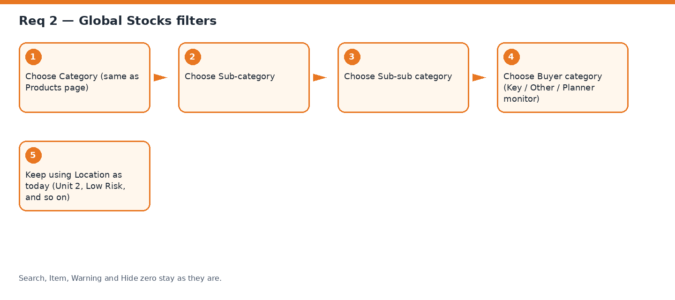
Picture 5. Filter order on Global Stocks.
What “done” looks like. You can narrow the list by product tree, buyer label, and location, without losing search, item, warning, or hide-zero.
Evidence of outcome (after developer)
Leave this blank for now. After the developer finishes, record your screen and paste the file or a link in the row below.
Field | Fill in after the work is done
Date recorded | ________________________________
Recorded by | ________________________________
Screen recording / screenshot | ________________________________
Pass / Fail | ________________________________
Notes | ________________________________

5. Req 3 — Column chooser
The table can show many columns. You choose which ones are visible.
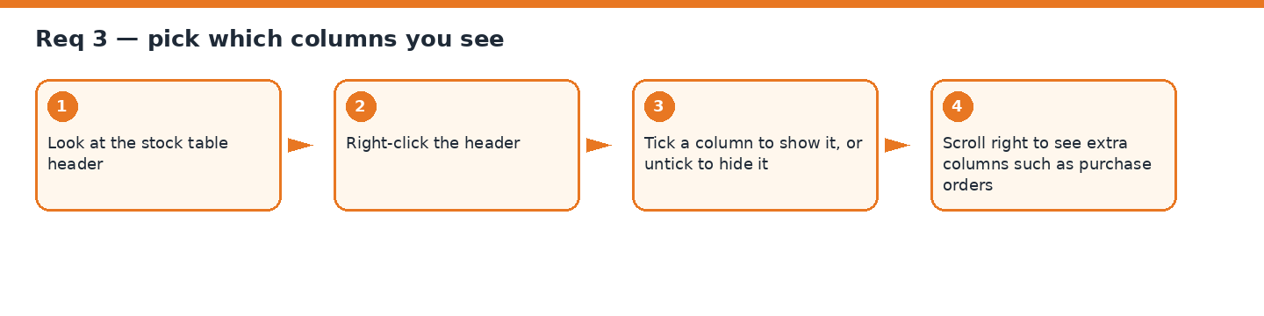
Picture 6. Right-click the header. Tick or untick a column.
What “done” looks like. Right-click works. Hidden columns come back when you tick them again. The page scrolls sideways for extra columns.
Evidence of outcome (after developer)
Leave this blank for now. After the developer finishes, record your screen and paste the file or a link in the row below.
Field | Fill in after the work is done
Date recorded | ________________________________
Recorded by | ________________________________
Screen recording / screenshot | ________________________________
Pass / Fail | ________________________________
Notes | ________________________________

6. Req 3.1 — Add qty when a split column is hidden
Product code is the identity. Product name stays with it.
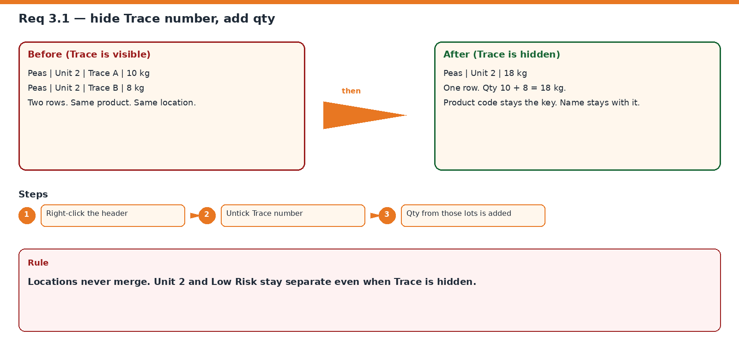
Picture 7. Peas, two traces, same location → one row.
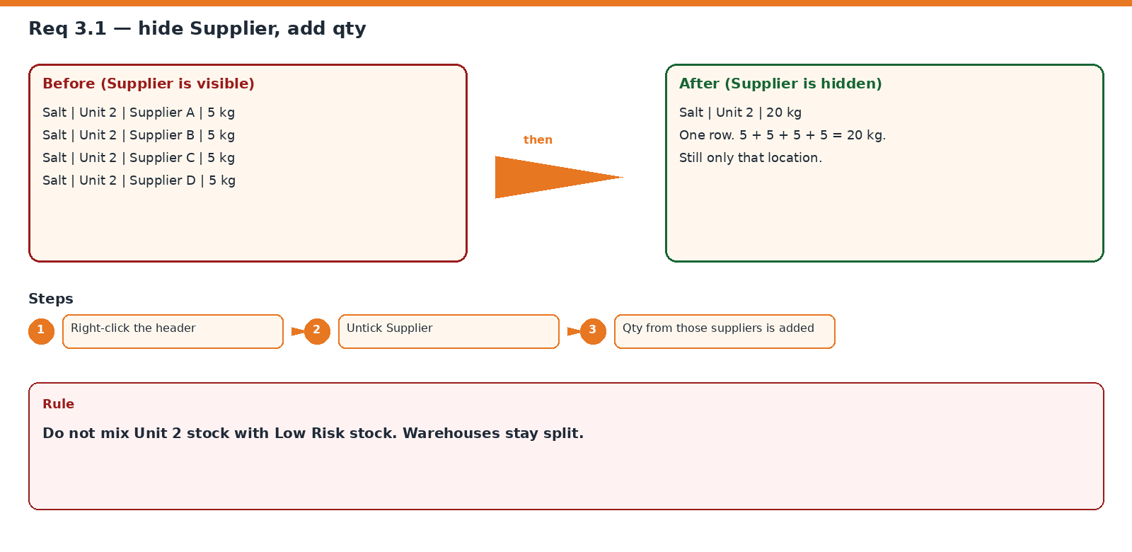
Picture 8. Salt, four suppliers, 5 kg each → 20 kg.
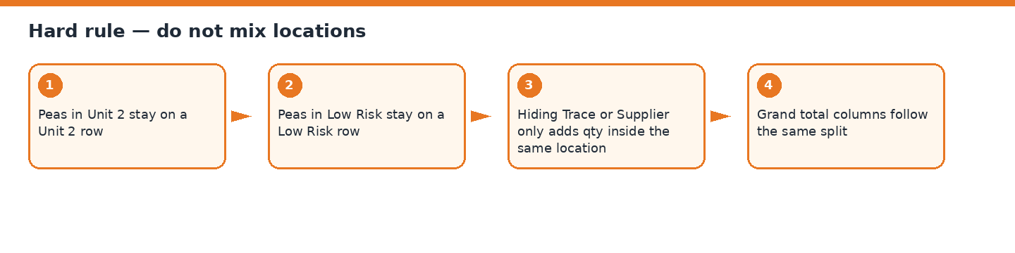
Picture 9. Unit 2 and Low Risk never become one row.
What “done” looks like. Hide Trace or Supplier and qty adds inside the same location. Two warehouses stay two rows.
Evidence of outcome (after developer)
Leave this blank for now. After the developer finishes, record your screen and paste the file or a link in the row below.
Field | Fill in after the work is done
Date recorded | ________________________________
Recorded by | ________________________________
Screen recording / screenshot | ________________________________
Pass / Fail | ________________________________
Notes | ________________________________

7. Req 4 — Future purchase orders on the report
On the right of Global Stocks, each product row can show open POs. Soonest delivery first.
- Each PO slot: remaining qty, delivery date, PO number
- PO 1, then PO 2, then PO 3, as needed
- Only Ordered and Partial POs. Not draft, not cancelled, not fully received
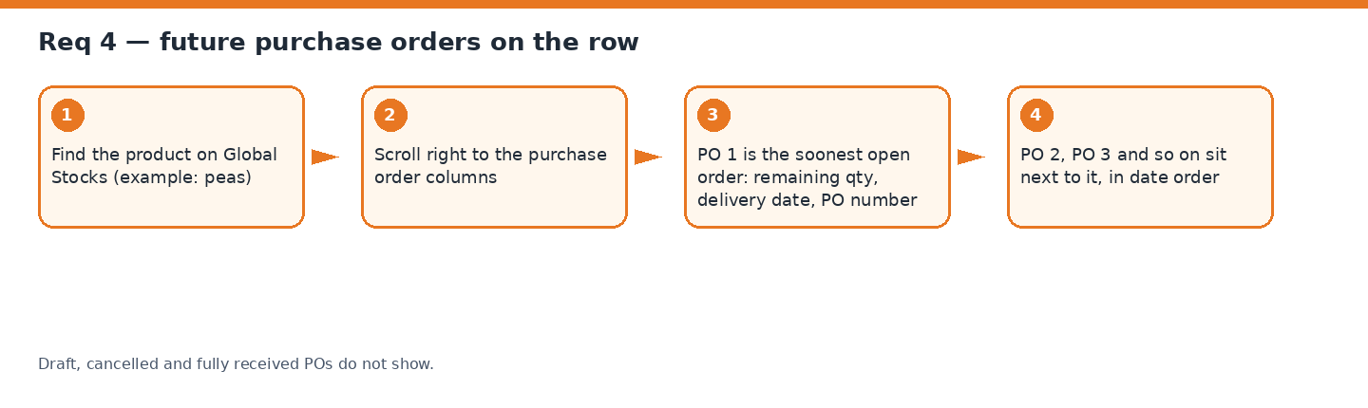
Picture 10. How future POs appear on the row.
Goods-in rule. If PO 43123 ordered 90 kg and warehouse received 40 kg, the row still shows that PO with 50 kg left. When the last 50 kg is received, that PO disappears and the next future PO moves into first place.
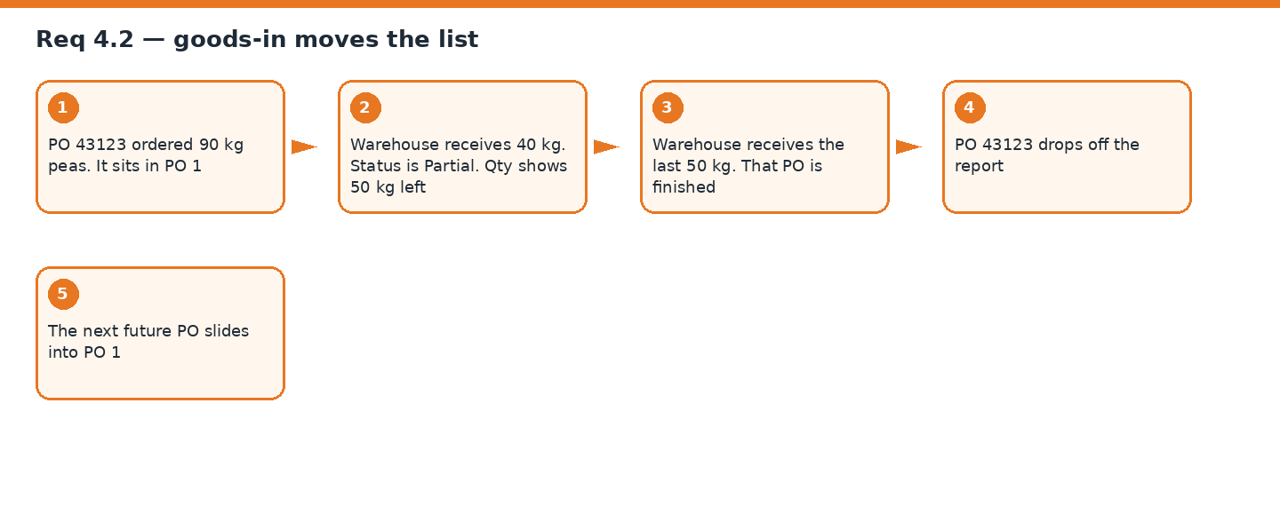
Picture 11. Partial receive keeps the PO. Full receive slides the next PO in.
What “done” looks like. Open POs show. Remaining qty is correct. Finished POs leave. The next PO takes their place.
Evidence of outcome (after developer)
Leave this blank for now. After the developer finishes, record your screen and paste the file or a link in the row below.
Field | Fill in after the work is done
Date recorded | ________________________________
Recorded by | ________________________________
Screen recording / screenshot | ________________________________
Pass / Fail | ________________________________
Notes | ________________________________

8. Req 5 — Three quantity columns
- Current stock qty — already on the page
- Future order stock qty — total remaining qty on open POs for that row
- Grand total — current + future
Example. Peas: 100 kg in stock. 50 kg still on open POs. Grand total 150 kg.
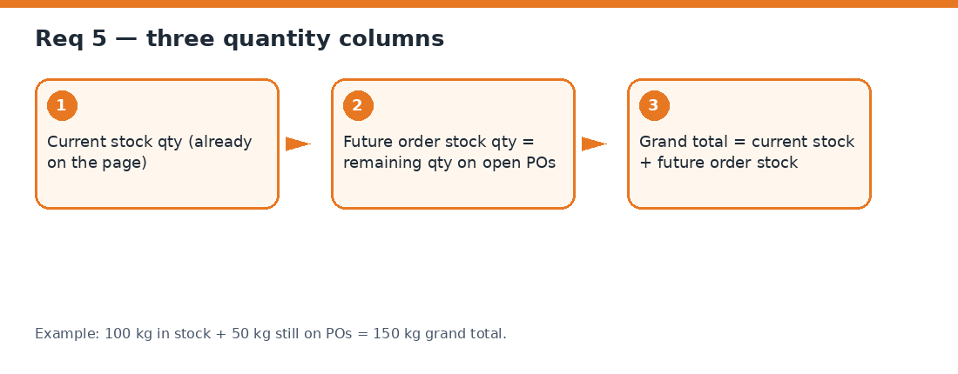
Picture 12. How the three qty columns are built.
What “done” looks like. The three numbers match stock plus remaining PO qty, and they follow the same location split as Req 3.1.
Evidence of outcome (after developer)
Leave this blank for now. After the developer finishes, record your screen and paste the file or a link in the row below.
Field | Fill in after the work is done
Date recorded | ________________________________
Recorded by | ________________________________
Screen recording / screenshot | ________________________________
Pass / Fail | ________________________________
Notes | ________________________________

9. Req 6 — Reminder email at 00:10
Same idea as the closing stock email: a short branded message and a file attached. Addresses are set in the app.
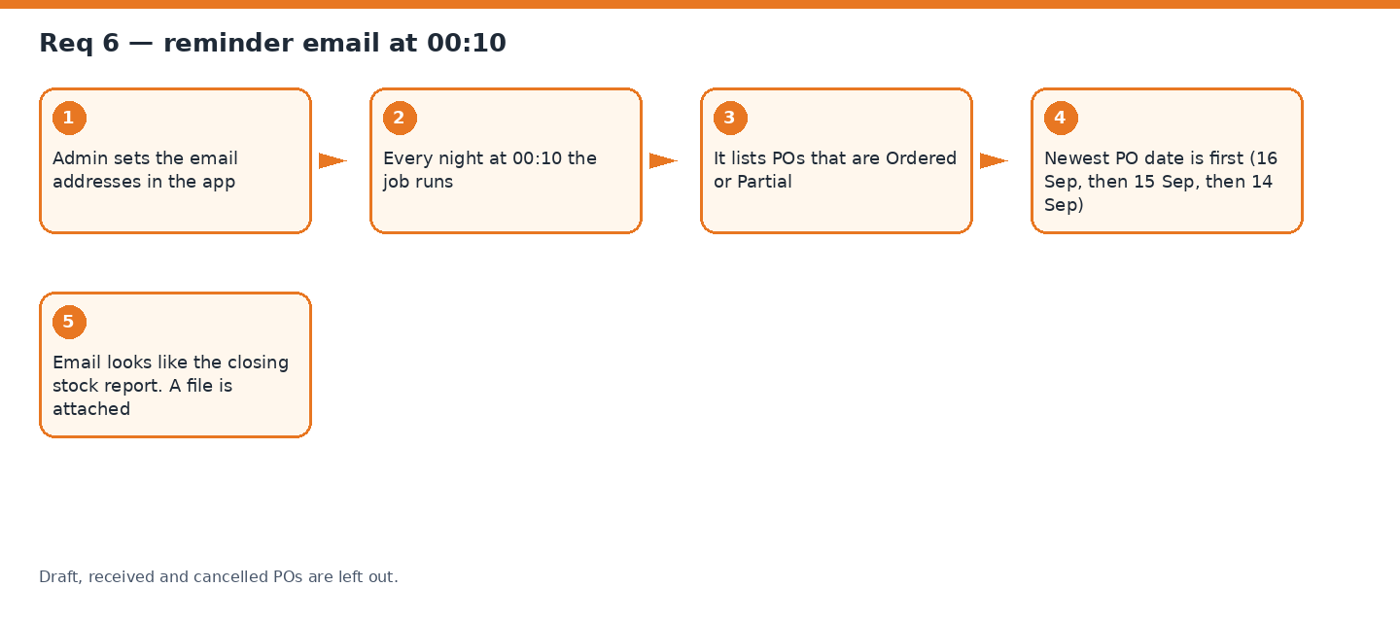
Picture 13. Night job, newest PO date first.
- Include: Ordered (nothing received yet) and Partial (some received, not finished)
- Exclude: Draft, Received, Cancelled
- Sort: newest PO date first, so recent orders sit at the top
- This is the full open list each night, not a “only new since yesterday” list
What “done” looks like. At 00:10 the named inboxes get the email. The list matches open POs in the system, newest first.
Evidence of outcome (after developer)
Leave this blank for now. After the developer finishes, record your screen and paste the file or a link in the row below.
Field | Fill in after the work is done
Date recorded | ________________________________
Recorded by | ________________________________
Screen recording / screenshot | ________________________________
Pass / Fail | ________________________________
Notes | ________________________________

10. Req 7 — Planning Excel, consolidated raw material
Today the plan Excel lists each requirement on its own row. Peas at one level and peas at another level are two rows.
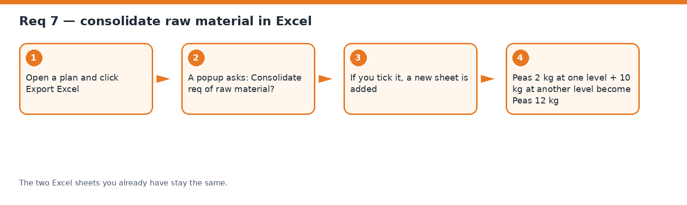
Picture 14. Optional extra sheet. Old sheets stay.
What “done” looks like. A popup asks if you want the consolidated sheet. If yes, peas 2 kg + 10 kg become 12 kg. Plan Requirements and Working do not change.
Evidence of outcome (after developer)
Leave this blank for now. After the developer finishes, record your screen and paste the file or a link in the row below.
Field | Fill in after the work is done
Date recorded | ________________________________
Recorded by | ________________________________
Screen recording / screenshot | ________________________________
Pass / Fail | ________________________________
Notes | ________________________________

11. What we will not break
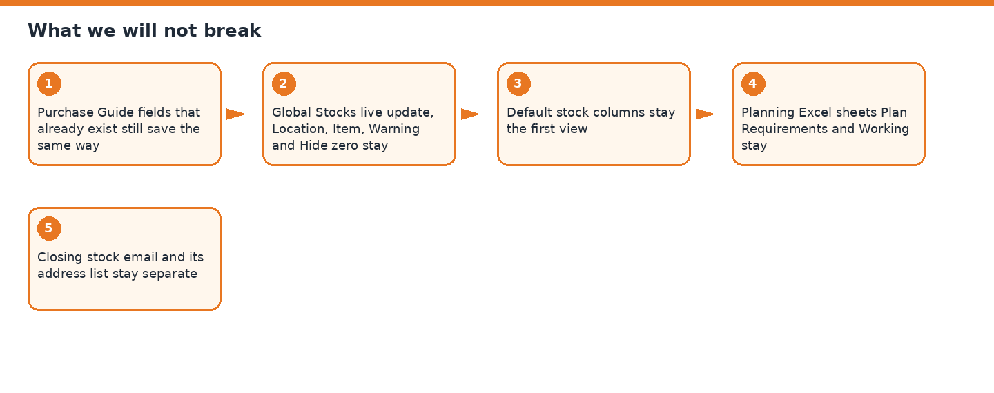
Picture 15. Existing working parts stay.
- Purchase unit, format and version on Guide
- Product timeline (we only add the new field into it)
- Global Stocks live feed and current filters
- The nine columns you see today remain the default view
- Planning Excel sheets Plan Requirements and Working
- Closing stock email and its own address list
12. Sign-off
This pack describes the work. It is not built yet. Sign when the understanding is accepted. After build, fill the evidence tables with screen recordings.
Prepared for management | Date: 17 Sep 2026
Approved by (name / signature) | Date: ________
Ready for developers to build | Yes / No: ________
Evidence pack complete (after build) | Yes / No: ________

Editable diagram files (open in excalidraw.com): docs/management/excalidraw/
Pictures used in this Word file: docs/management/diagrams/

