# Introduction

In industries, machine breakdowns can cause big problems like money loss, safety issues, and delays in work. The old ways of maintenance are not always good enough. Reactive maintenance means fixing machines only after they break, which causes sudden downtime. Preventive maintenance means checking machines at fixed times, but sometimes it wastes time and money if the machine does not really need repair.

To solve this, a better idea called Predictive Maintenance (PdM) is used. In this method, machines are monitored all the time using sensors that collect data such as temperature, vibration, pressure, and electricity flow. This data is sent to the cloud, where data analysis and machine learning help to find if something is going wrong. In this way, we can predict failures before they actually happen.

With the help of the Internet of Things (IoT), predictive maintenance becomes more powerful. IoT devices can continuously watch the condition of machines and give alerts when needed. This helps industries to reduce downtime, save costs, and increase machine life.

An IoT-Based Predictive Maintenance System provides:

* Live monitoring of machines.
* Early warning of problems using sensor data.
* Better decisions for repair and service.
* Lower cost and more reliable machines.

This system can be used in many areas like factories, energy plants, transport, and healthcare. It helps companies move from a reactive (after breakdown) method to a proactive (before breakdown) method, making work more efficient, safe, and profitable.

**ER Diagram**

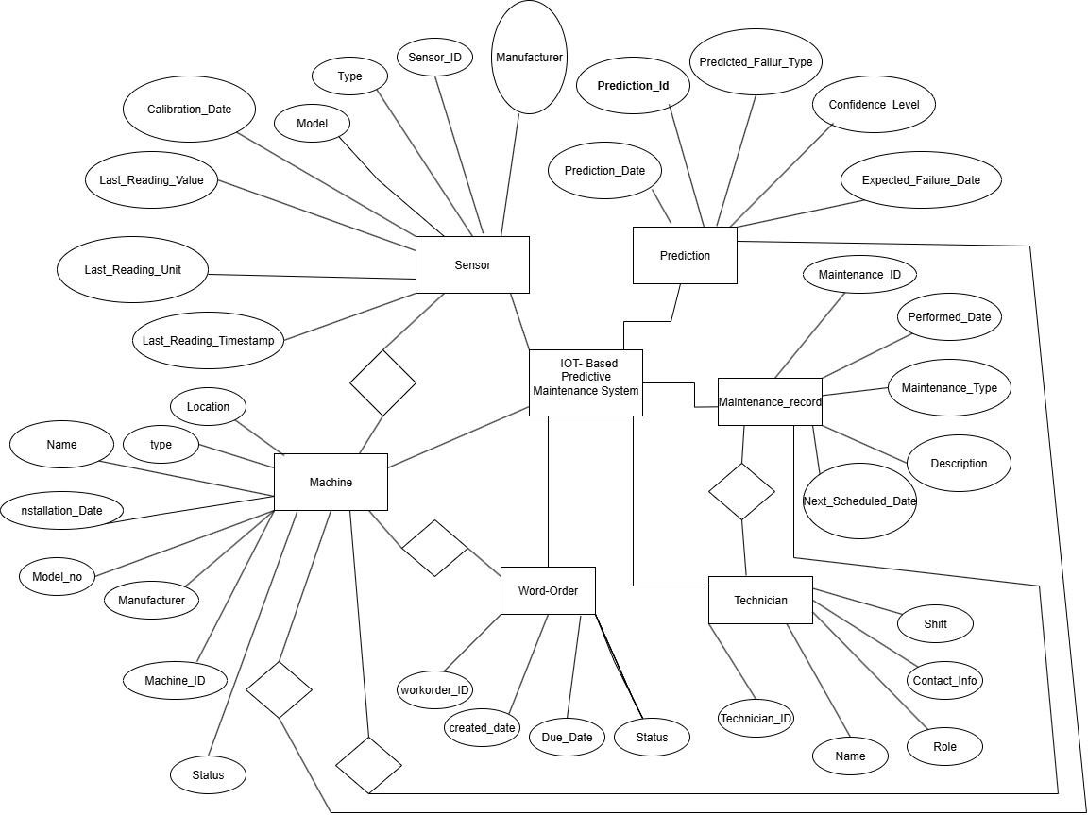

**Finalization**

**Machine**

* Attributes: Machine_ID, Name, Type, Location, Installation_Date, Model_No, Manufacturer_ID, Status
* Primary Key: Machine_ID
* Foreign Key: Manufacturer_ID → Manufacturer

**Manufacturer**

* Attributes: Manufacturer_ID, Name
* Primary Key: Manufacturer_ID
* Foreign Key: –

**Sensor**

* Attributes: Sensor_ID, Type, Model, Manufacturer_ID, Calibration_Date, Last_Reading_Value, Last_Reading_Unit, Last_Reading_Timestamp, Machine_ID
* Primary Key: Sensor_ID
* Foreign Key: Manufacturer_ID → Manufacturer, Machine_ID → Machine

**Prediction**

* Attributes: Prediction_ID, Prediction_Date, Predicted_Failure_Type, Confidence_Level, Expected_Failure_Date, Sensor_ID
* Primary Key: Prediction_ID
* Foreign Key: Sensor_ID → Sensor

**Maintenance_Record**

* Attributes: Maintenance_ID, Performed_Date, Maintenance_Type, Description, Next_Scheduled_Date, Machine_ID
* Primary Key: Maintenance_ID
* Foreign Key: Machine_ID → Machine

**WorkOrder**

* Attributes: WorkOrder_ID, Created_Date, Due_Date, Status, Machine_ID, Technician_ID
* Primary Key: WorkOrder_ID
* Foreign Key: Machine_ID → Machine, Technician_ID → Technician

**Technician**

* Attributes: Technician_ID, Name, Role, Contact_Info, Shift
* Primary Key: Technician_ID
* Foreign Key

**Features or User define**

## Main Features

1. **Real-time Monitoring**
   * Sensors (temperature, vibration, pressure, etc.) continuously monitor machine health.

## Data Collection & Storage

* + IoT devices send data to a cloud/database for processing.

## Predictive Analytics

* + Machine learning models predict possible failures before they happen.

## Alert & Notification System

* + Sends SMS, email, or app notifications when abnormal behavior is detected.

## Dashboard & Visualization

* + User-friendly dashboard showing machine status, graphs, and reports.

## Maintenance Scheduling

* + Suggests optimal maintenance time to avoid unexpected breakdowns.

## Historical Data & Reports

* + Stores past performance and maintenance logs for analysis.

## User-defined Features (Custom Ideas)

* 1. **User Roles & Access Control**
     + Admin, Engineer, Operator with different permissions.

## Cost Estimation Module

* + - Estimates maintenance cost vs. breakdown cost.

## Remote Control

* + - Start/stop or reset machine remotely via IoT.

## Integration with ERP/SCADA

* + - Sync data with existing enterprise systems.

## Energy Efficiency Tracking

* + - Monitors energy usage to reduce costs.

## Failure Cause Prediction

Not just alerts, but also suggests possible reasons (e.g., overheating, imbalance)

**Forms**

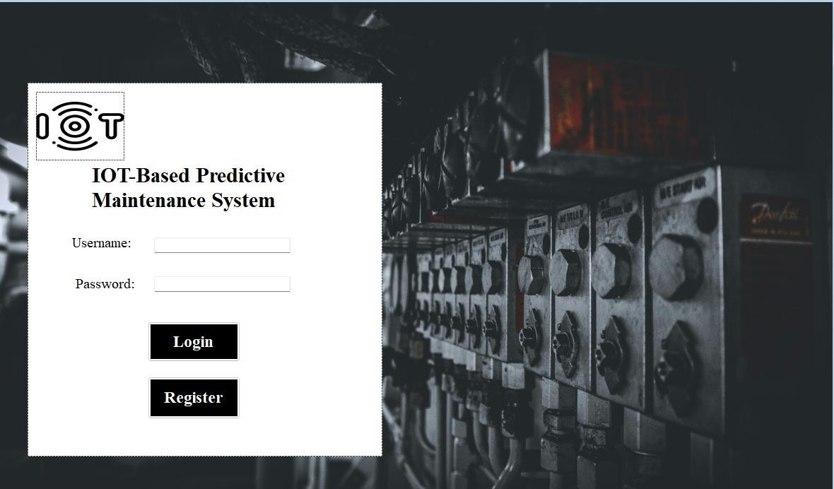

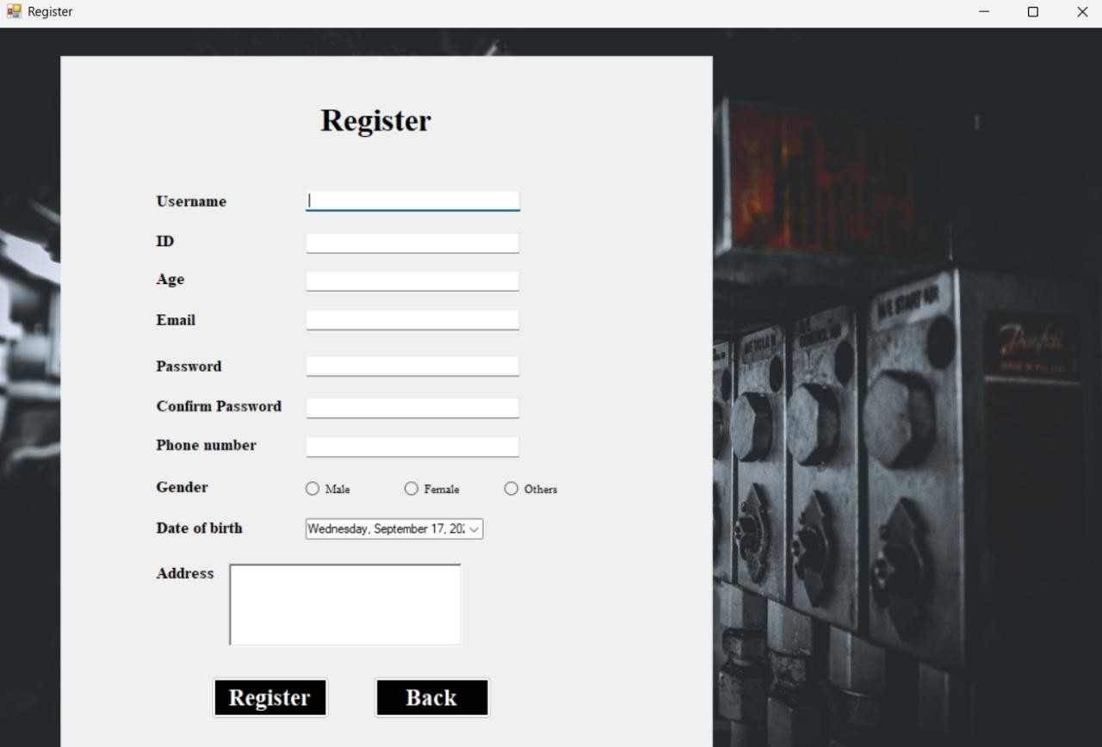

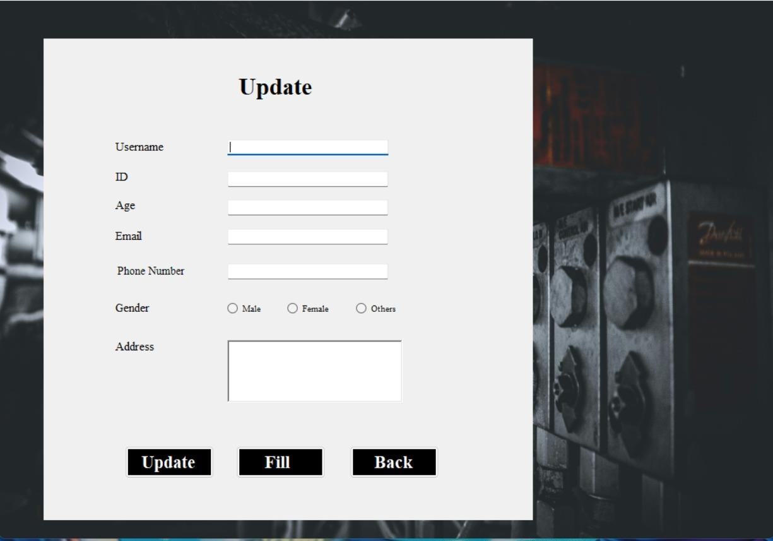

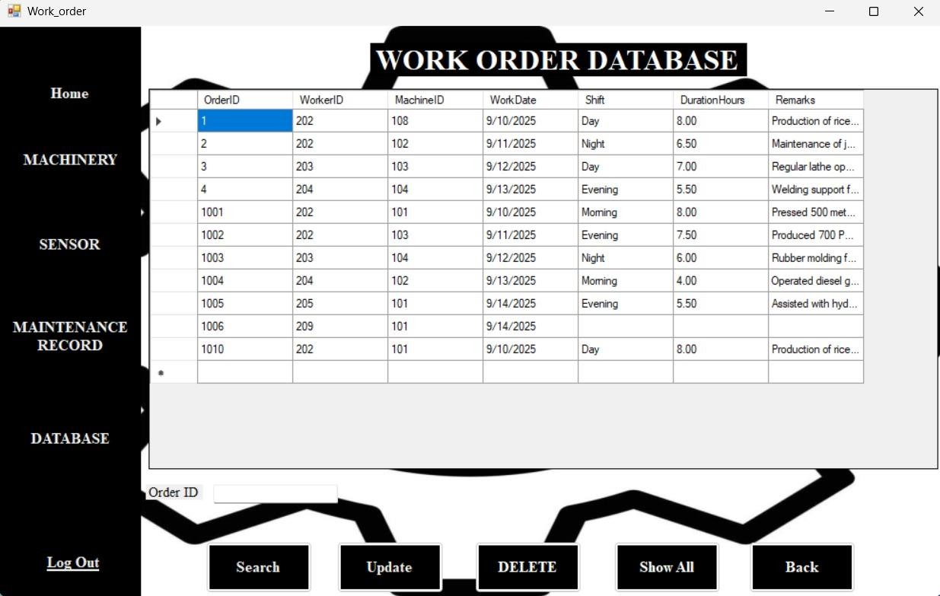

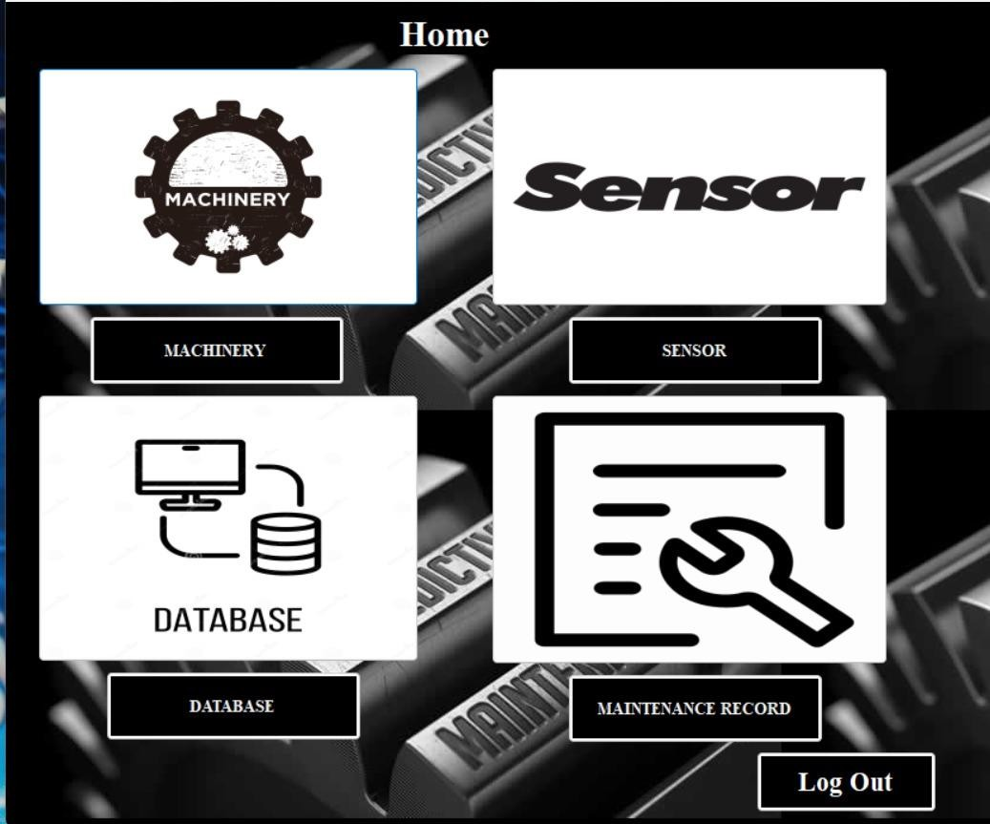

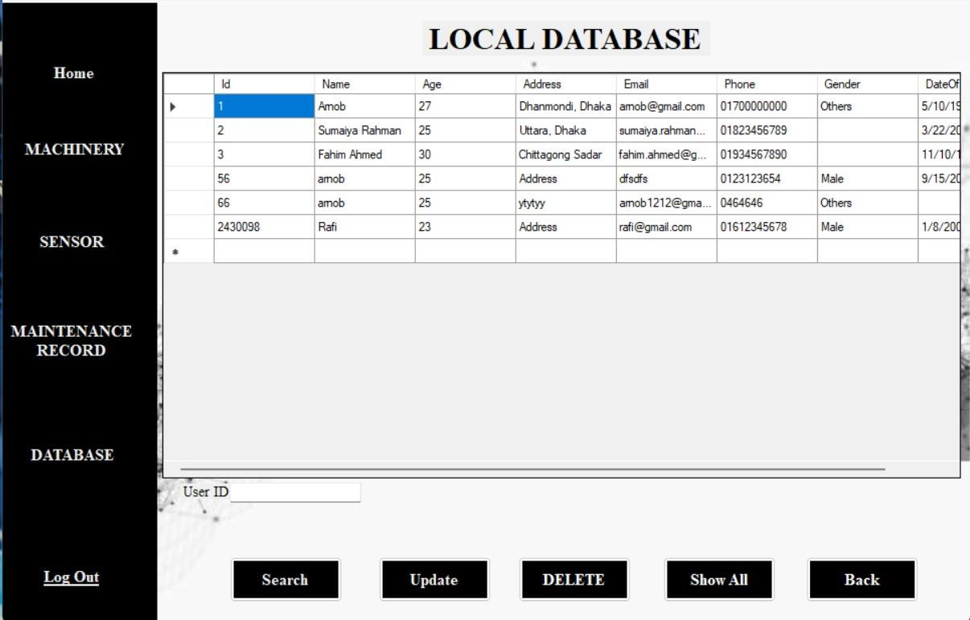

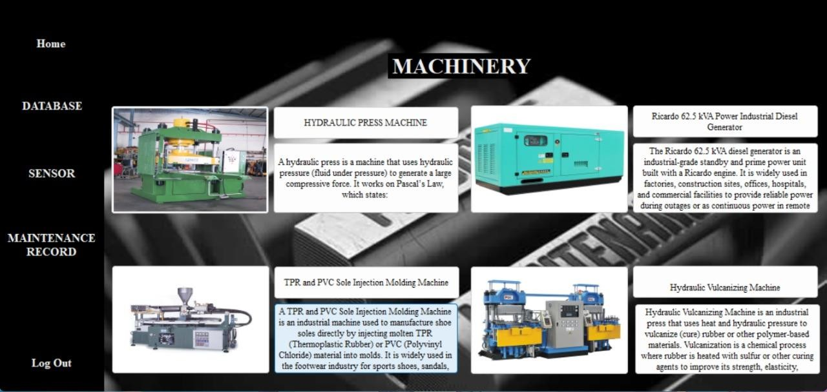

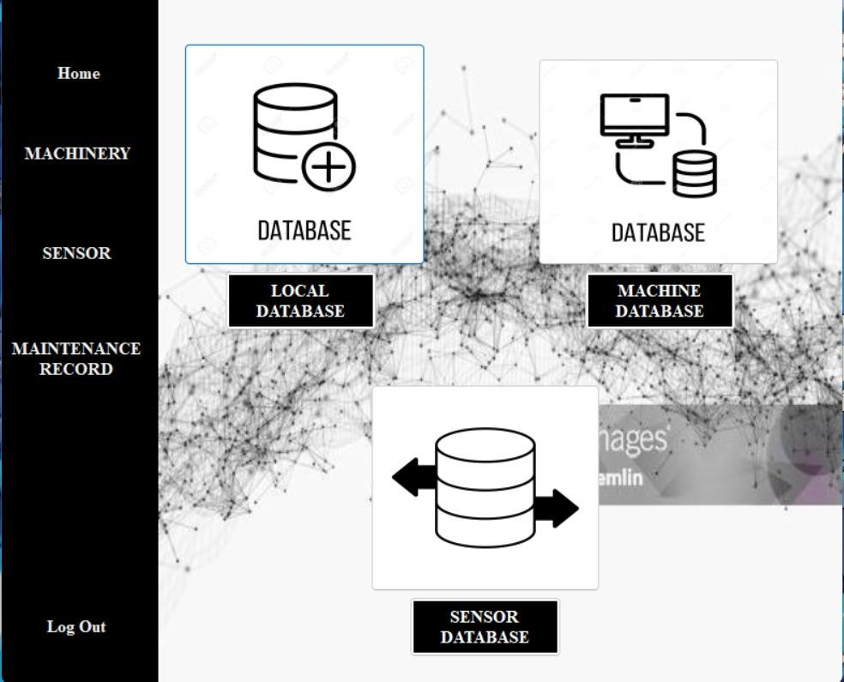

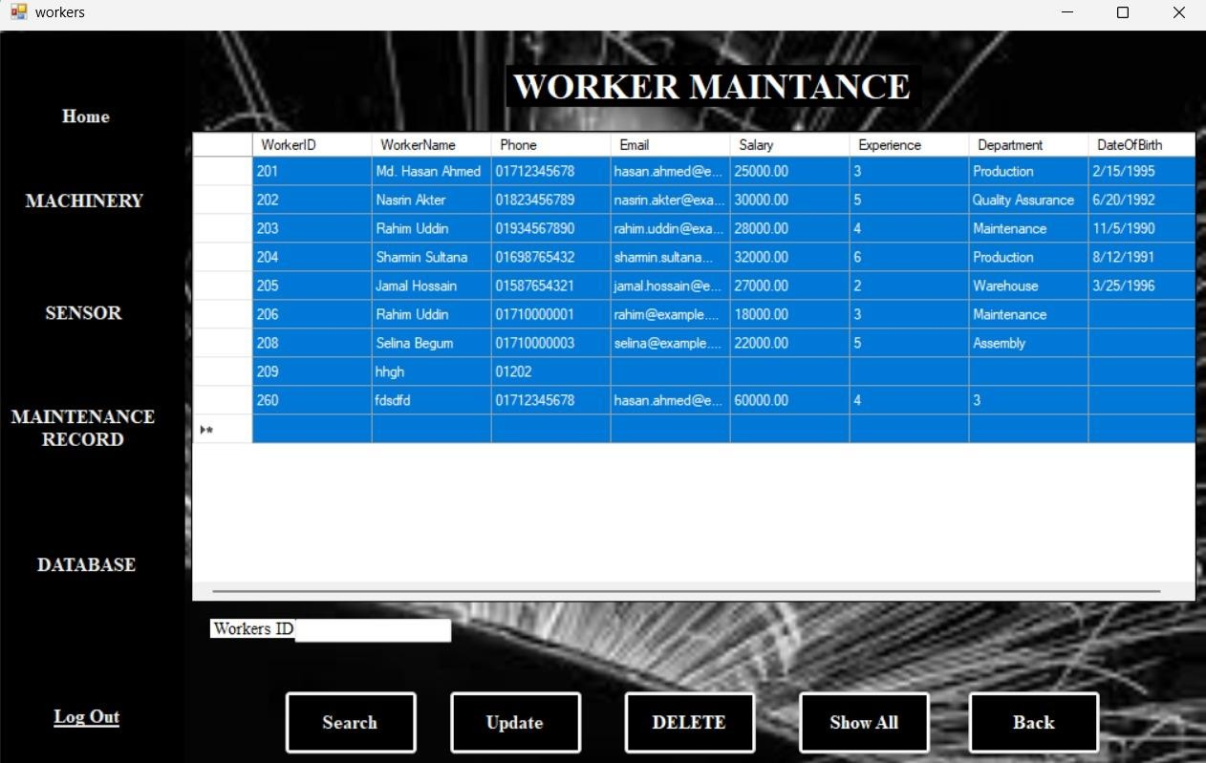

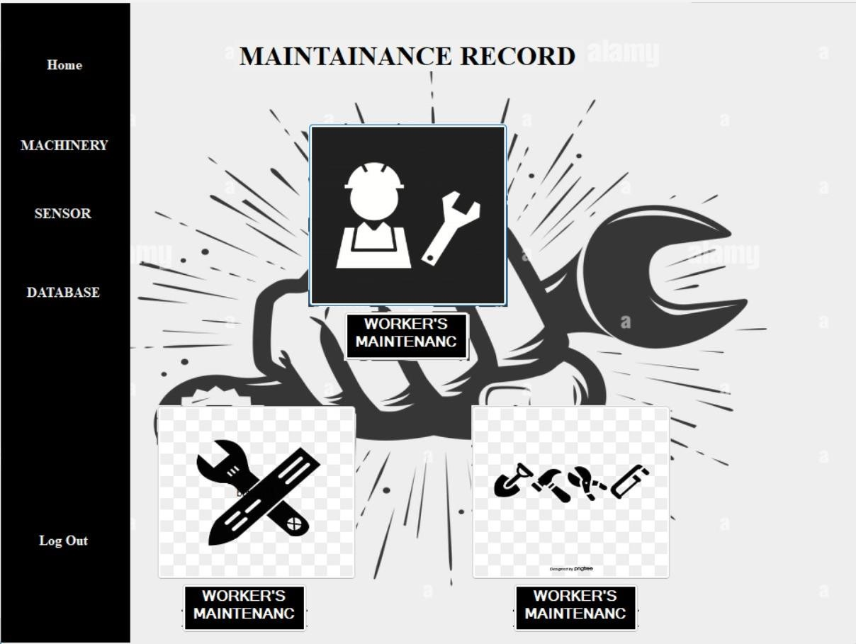

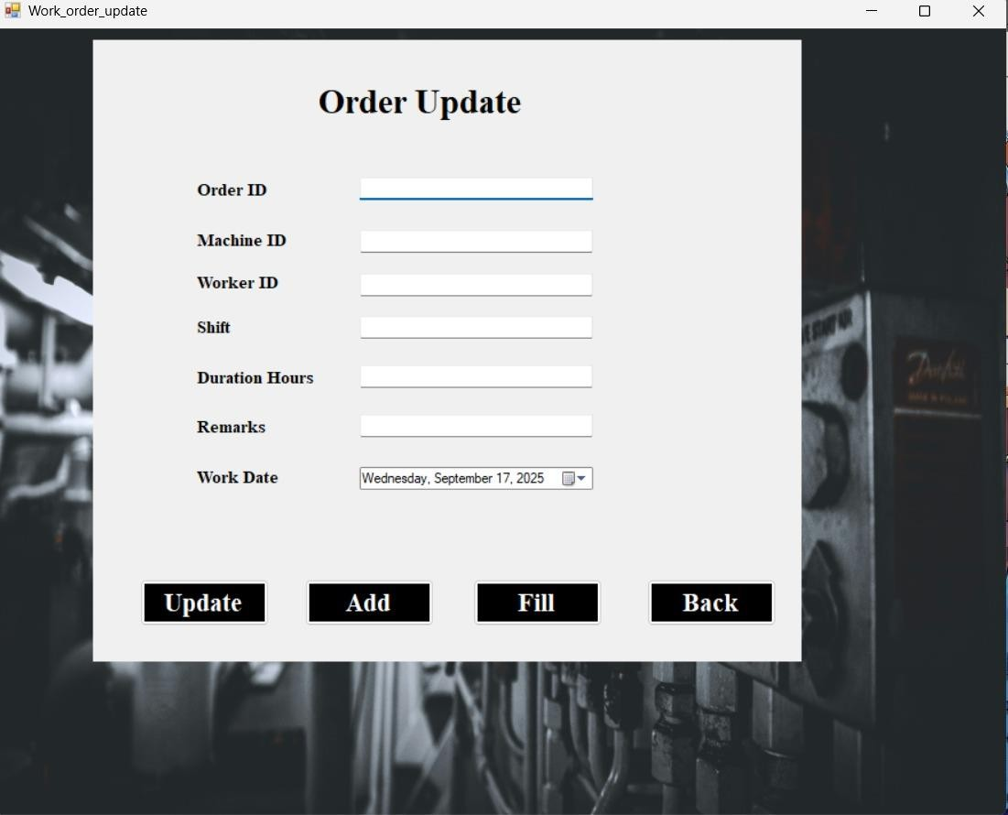

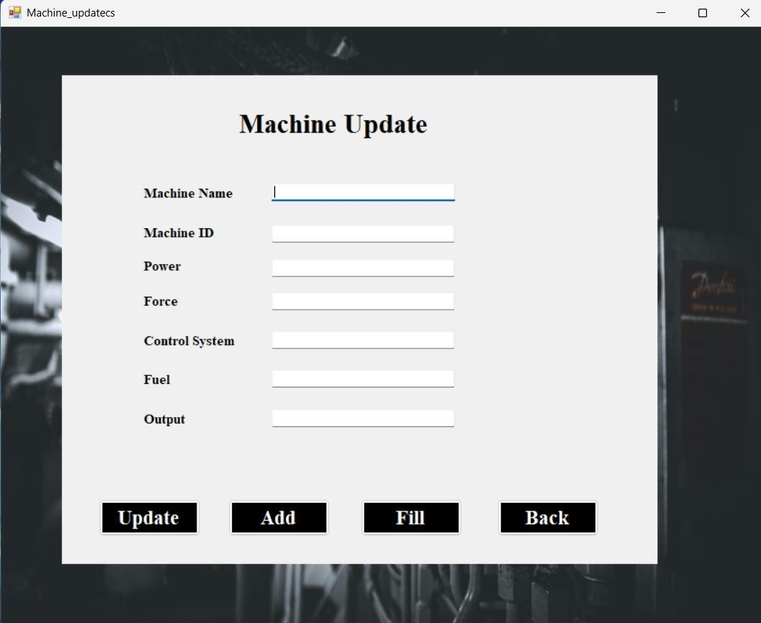

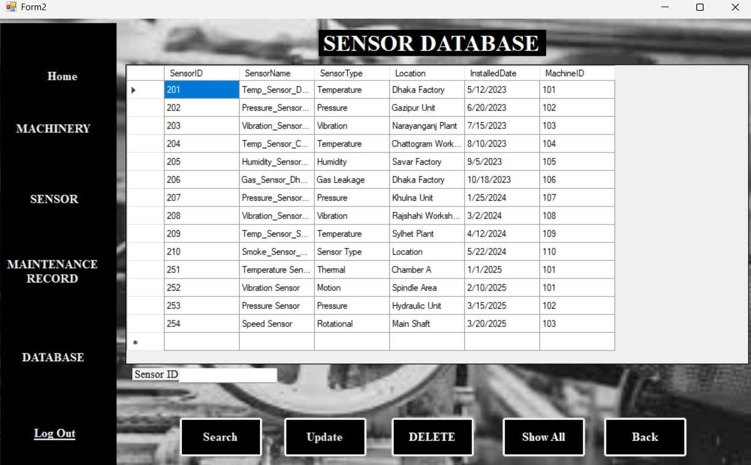

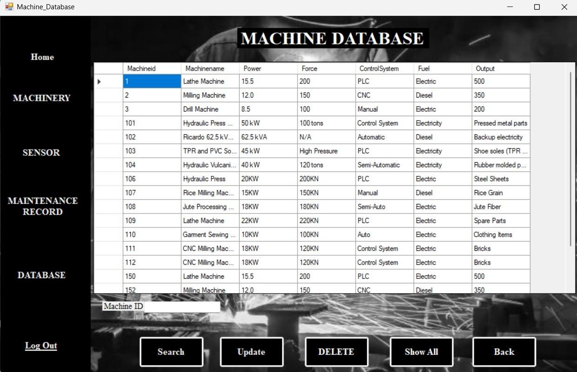

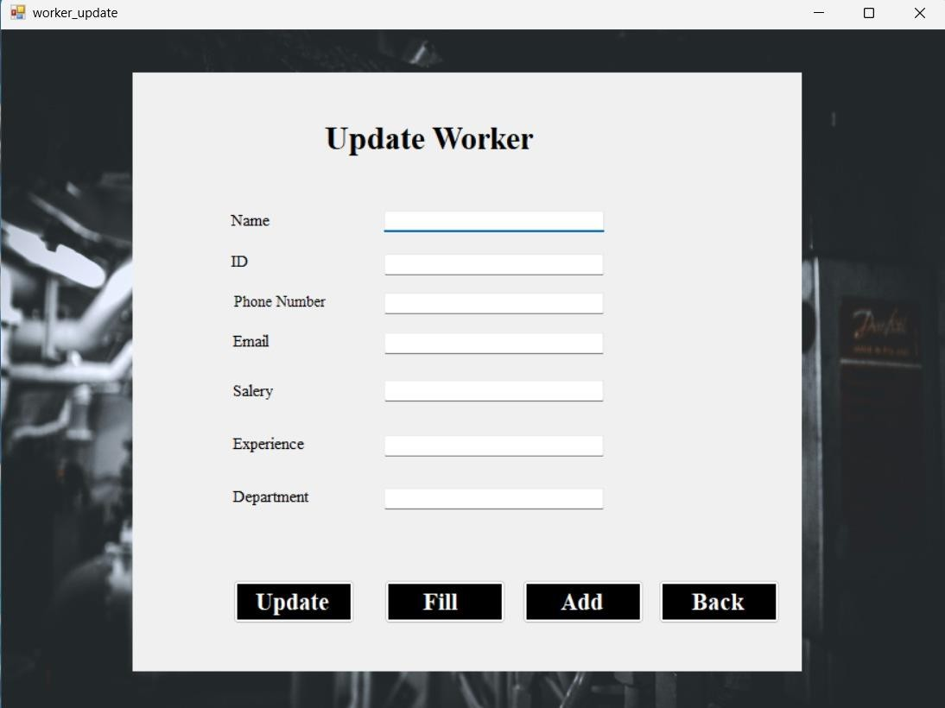

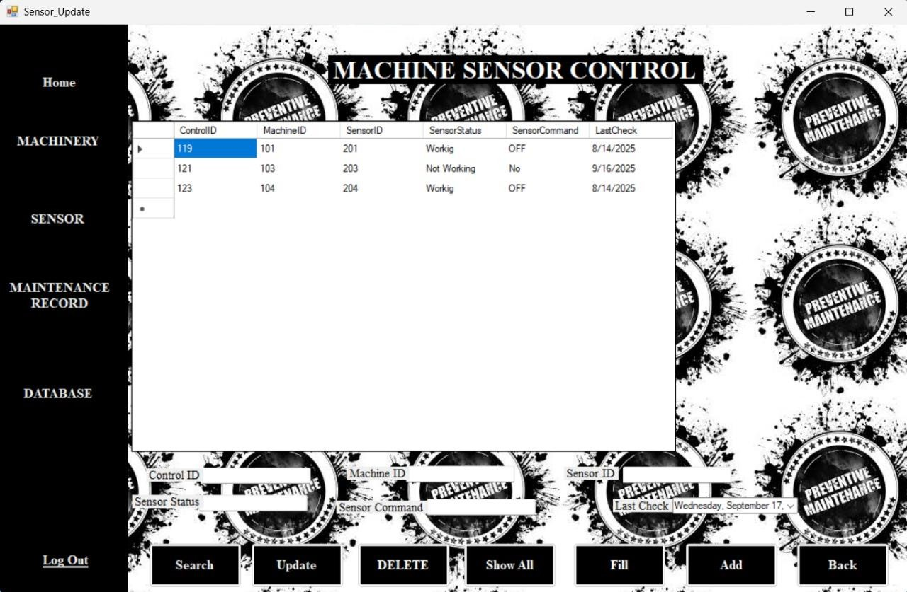

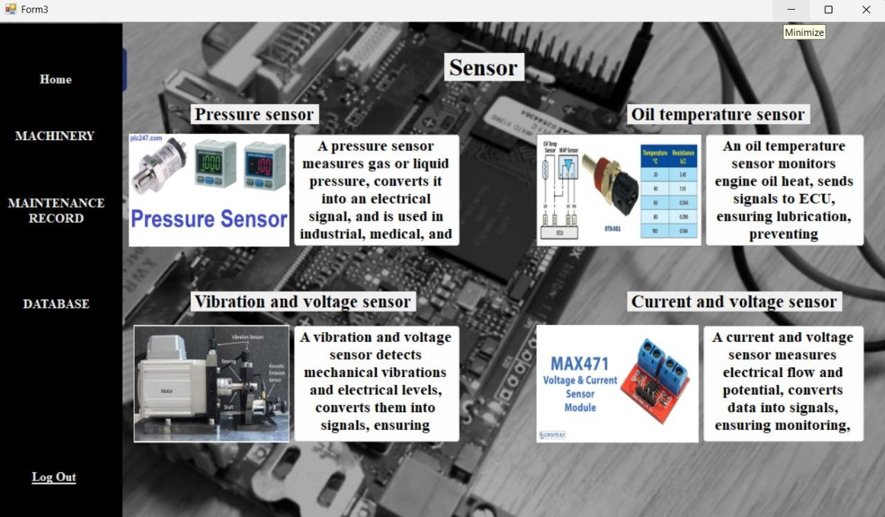

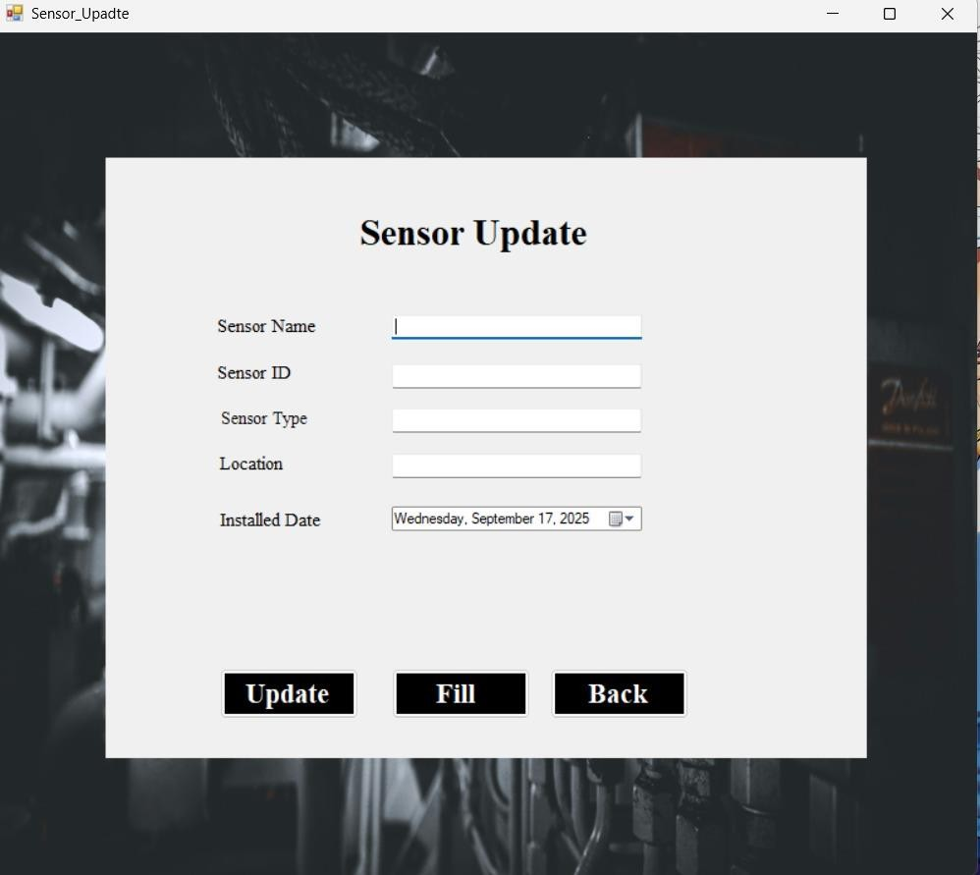

**Table**

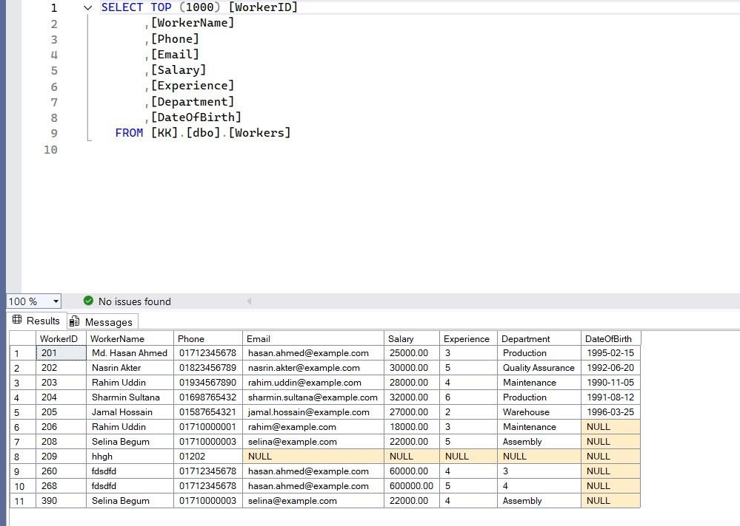

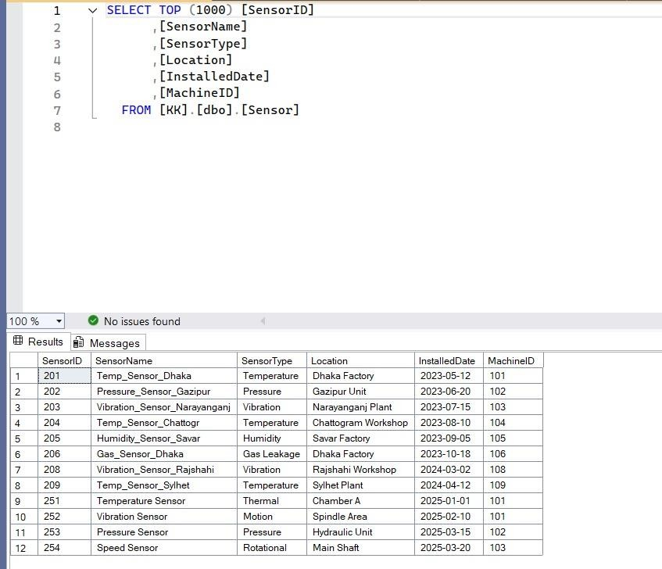

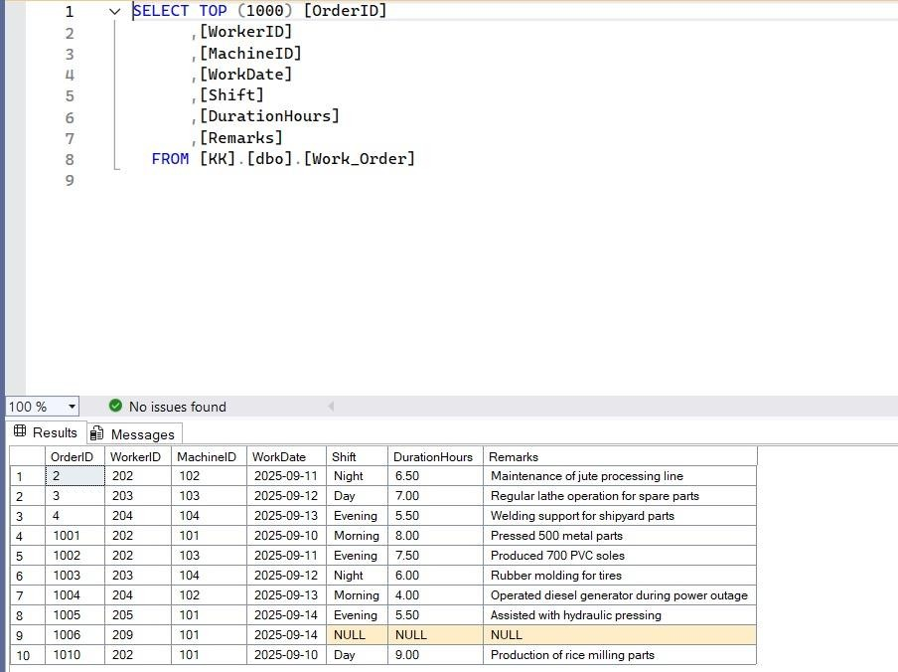

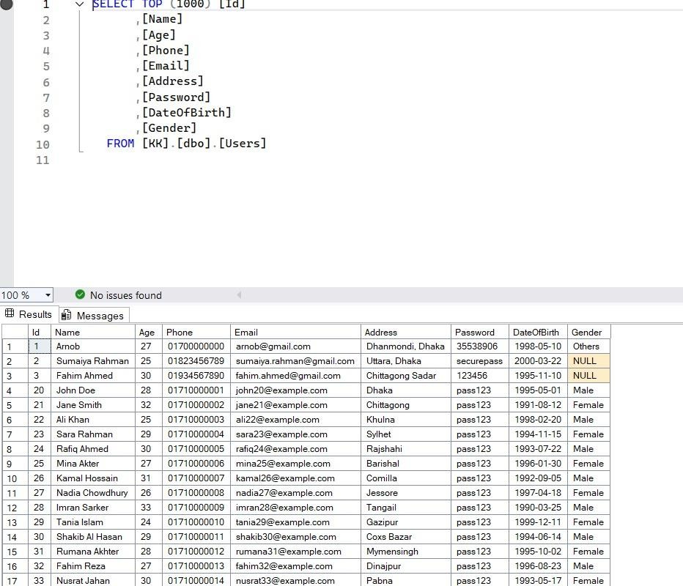

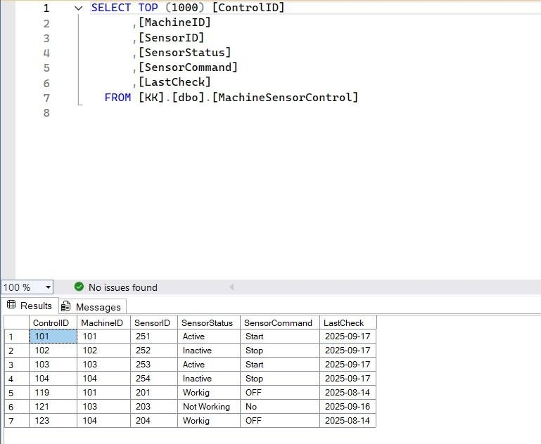

**Schema Diagram**

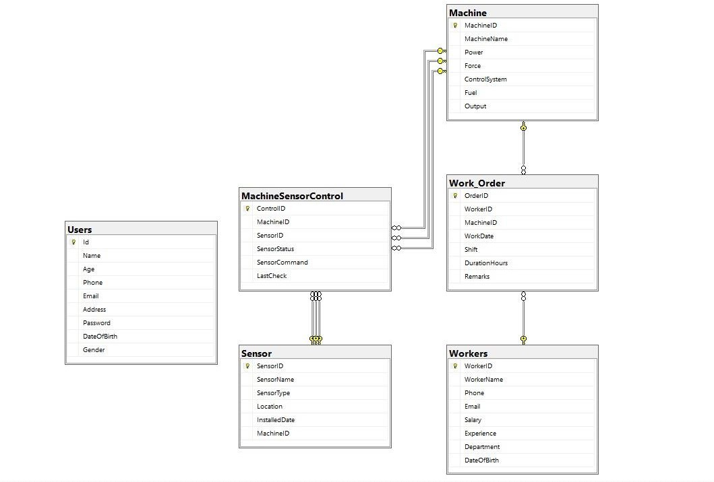

**Activity Diagram**

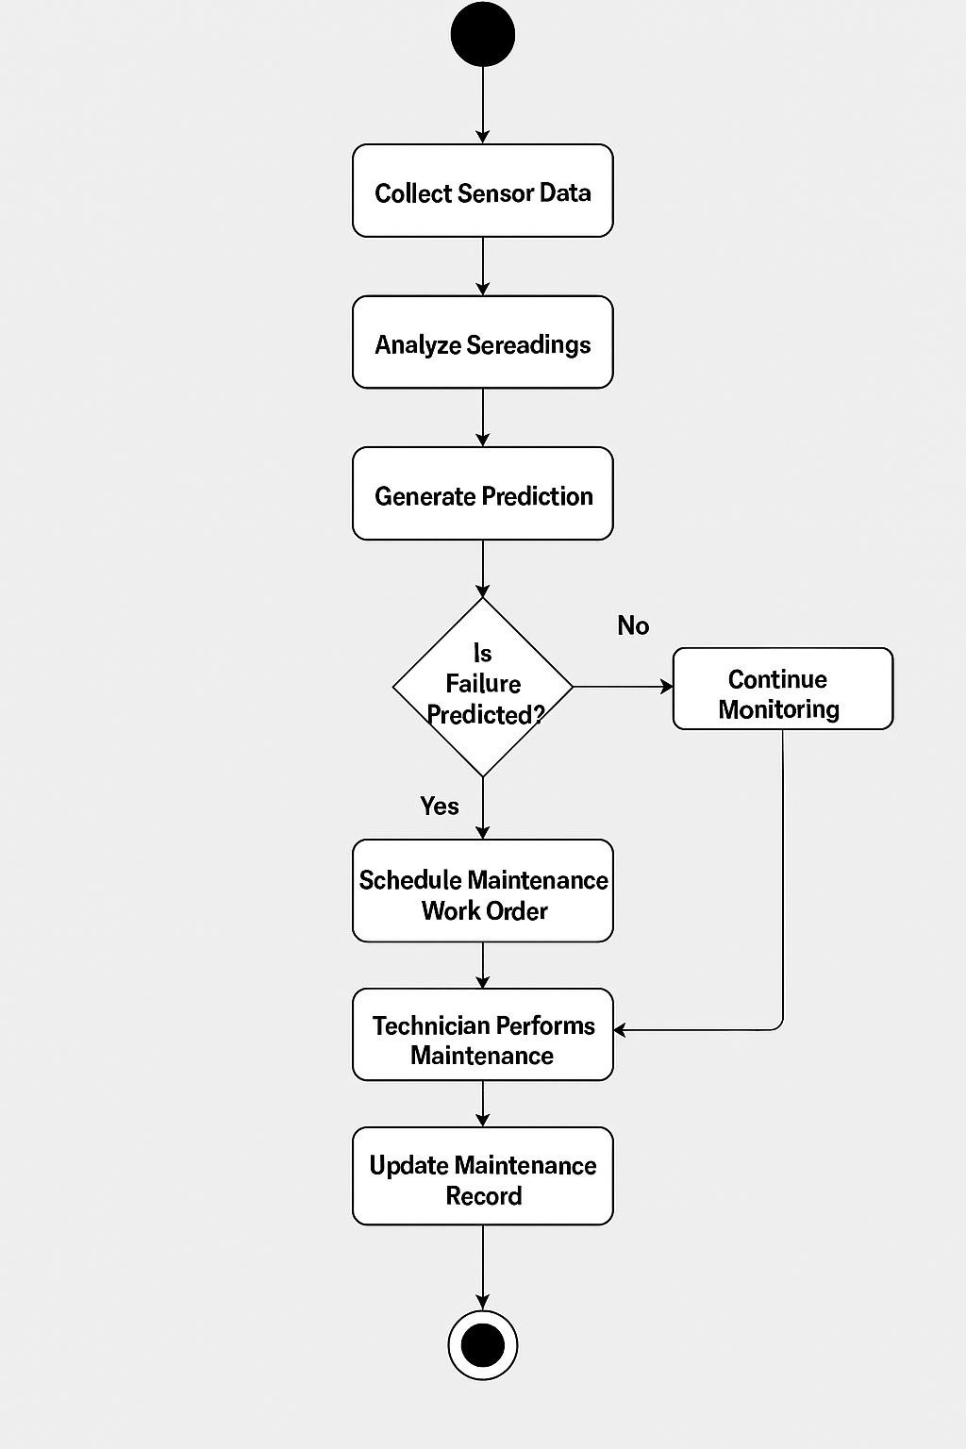

**Conclusion**

The IoT-based Predictive Maintenance System is a smart way to check the health of machines in real time. Using IoT sensors and data analysis, it can find early signs of problems, reduce machine downtime, and plan maintenance at the right time. This makes machines more reliable, improves performance, and lowers costs. With features like live monitoring, alerts, and clear reports, the system helps industries work better and make good decisions. In the future, adding AI and big data will make it even more accurate and useful, making it an important part of modern industry.

**GitHub**

[**https://github.com/ablaha22**](https://github.com/ablaha22) **https://github.com/GaziArnob**

**Reference**

**Zhu, T., Ran, Y., Zhou, X., Wen, Y. *A Survey of Predictive Maintenance: Systems, Purposes and Approaches*. arXiv, 2019. [arXiv](https://arxiv.org/abs/1912.07383?utm_source=chatgpt.com) *Use this as a basis for the “Background / Literature Review” section: definitions, different maintenance paradigms (reactive, preventive, predictive), architectures used, challenges identified.*

 Machine Learning and IoT – Based Predictive Maintenance Approach for Industrial Applications. *Alexandria Engineering Journal*, 2024. [ScienceDirect](https://www.sciencedirect.com/science/article/pii/S1110016823011572?utm_source=chatgpt.com) *Use this for a case/application example: how ML + IoT can be integrated, what sensors, what ML algorithms are effective, etc.*