Software Development Project II
CSE 3200

Project Name: Thief Finder

Developed By
Nazimuddin Gazi Roll: 1107036
Md.Awon-Uz-Zaman Roll: 1107057

Supervised by
Md. Abdul Awal
Lecturer,
Dept. of Computer Science and Engineering
KUET, Khulna-9203



Acknowledgement

The authors express their profound gratitude and heartiest thanks to their honorable thesis supervisor, Md. Abdul Awal for his helpful contribution giving by valuable guidance, suggestions, and encouragement throughout this research work. Md. Abdul Awal is an intellectual person. He has been appropriate source of valuable and effective ideas, understanding knowledge about this work.

The authors would like to thank all the teachers of CSE Department, Khulna University of Engineering and Technology, Bangladesh who helped the authors in various ways throughout this research work.

Authors

Abstract

Thief Finder is a software to catch or detect Smartphone thief. We use android operating system to prepare this project. If someone gives wrong password or pattern a photo will be taken and send to an email set by the user and will pass the GPS location. It will be helpful for the Smartphone users to detect the thief. We will be grateful if it fulfills its purpose.

Table of Contents

Chapter Title Page No.
Title Page | ............................i
Acknowledgement | ...........................ii
Abstract | ..........................iii
Table of Contents | ..........................iv
List of Figures | ...........................v

Chapter 1 Introduction
1.1 | Background | ...........................vi
1.2 | Statement of the Problem | ............................vi
1.3  1.4 | Motivation  Project Platform | ............................vi  ………………….vi

Chapter 2 Working Procedure …....…………..vii
Chapter 3 Project and Architectural Design
3.1 | UML Diagram | ...........................vii
3.2 | First time User Interface | ............................ix
3.3  3.4 | Normal User Interface  Default lock screen view | ..............................x  ..……………….xi

Chapter 4 Implementation …………………xi

Chapter 5 Drawbacks and Future Plans .......……………xii

References .....................................................................................................................xii

List of Figures

Fig No. | Figure Name |  | Page No.
3.1 |  | UML Diagram | viii
3.2 |  | First time user Interface | ix
3.3 |  | Normal user Interface | x
3.4 |  | Default lock screen view | xi
4.1 |  | Implementation Procedure Flowchart | xii

Chapter 1
Introduction

  - Background
Now a day’s almost everybody has a Smartphone. We need security for this phone. Some of us has lost their phone by pick pocketer or someone else.

  - Statement of the Problem
We need a software that will give us the information of the thief, so that we can identify the thief and recover our Smartphone.

  - Motivation
We got our motivation from our supervisor, Md. Abdul Awal sir to make a software that is not a complete new thing but a useful software for the user. The software may be the combination of some existing features.

  - Project Platform
The project is on android platform. The background code is JAVA. We choose this for various reasons. Applications can be easily developed in the Java programming language using the Android Software Development Kit and other development tools are available.

Chapter 2
Working Procedure

This software works on the lock of the Smartphone. When the phone is locked few wrong password triggers the application. The app temporarily unlocks the phone and gives a fake view. It’s just a picture button. If any place at the screen is touched the front camera takes a photo secretly and sends it to desired email previously set by the user. It needs internet turn on to send a email. That’s how we can see the phone taker.

Chapter 3
Project and Architectural Design

3.1 UML Diagram

A UML diagram of our project-
On/Off
Lock the Device
Go to Lock Screen View
Update User Email
For Enable/ disable Admin Power
Lock Button
Very small surface for camera

Image Button
Set Receiving Email
Save

Fig-3.1: UML diagram of Thief detector

3.2 First time User Interface

After installing the software the user will get the interface wanting the Email in which he/she wants the picture to be sent. The sending Email is auto set by the developer.

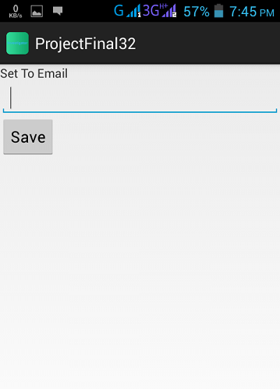

Fig-3.2: First time User Interface

3.3 Normal User Interface

When we has installed the software and given the “sending” Email, then we will get the view with 4 buttons. Their function is to give admin power, lock the device instantly, see how the face lock screen looks like and update the Email.

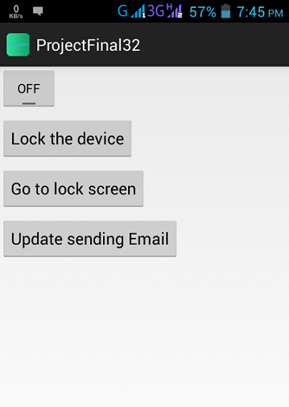

Fig-3.3: User Interface

3.4 Default Lock Screen View

We have given a fixed fake lock screen view.

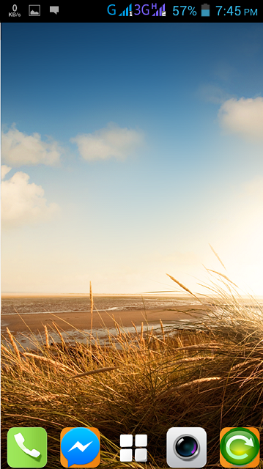

Fig-3.4: Lock Screen View

Chapter 4
Implementation

Implementation Procedure:

We have created few classes to organize the whole application. They work step by step. The flowchart is given below-

Admin Receiver
OnPasswordFailed method
Camera Class
Take Picture & Send Email and GPS location
Go to Locked Screen

Intent Filter

If 3 times failed

By pressing picture button/
On backpress

Fig-4.1: Flowchart of implementation

Chapter 5
Drawbacks and Future Plans

5.1 Drawbacks

- Need high speed Internet.
- Needs to press the picture button.

5.2 Recommendations for Future Work

- Make more efficient by not opening the lock for anytime.
- Auto trigger the app, don’t need to press any picture button.
- Send mms using phone network.
- User can select after how many time of wrong password will trigger the app and how many times it will send GPS location.

References:

- http://developer.android.com/guide/index.html
- http://stackoverflow.com/
- http://www.chupamobile.com/android
- http://www.vogella.com/tutorials/AndroidDialogs/article.html
- http://www.mkyong.com/android/android-alert-dialog-example/

