Equipment Selection Questionnaire
Customer __________________________________ Well number _________________________________
Complete all seven well parameters. The numbers match the sketch. Water chemistry is optional.
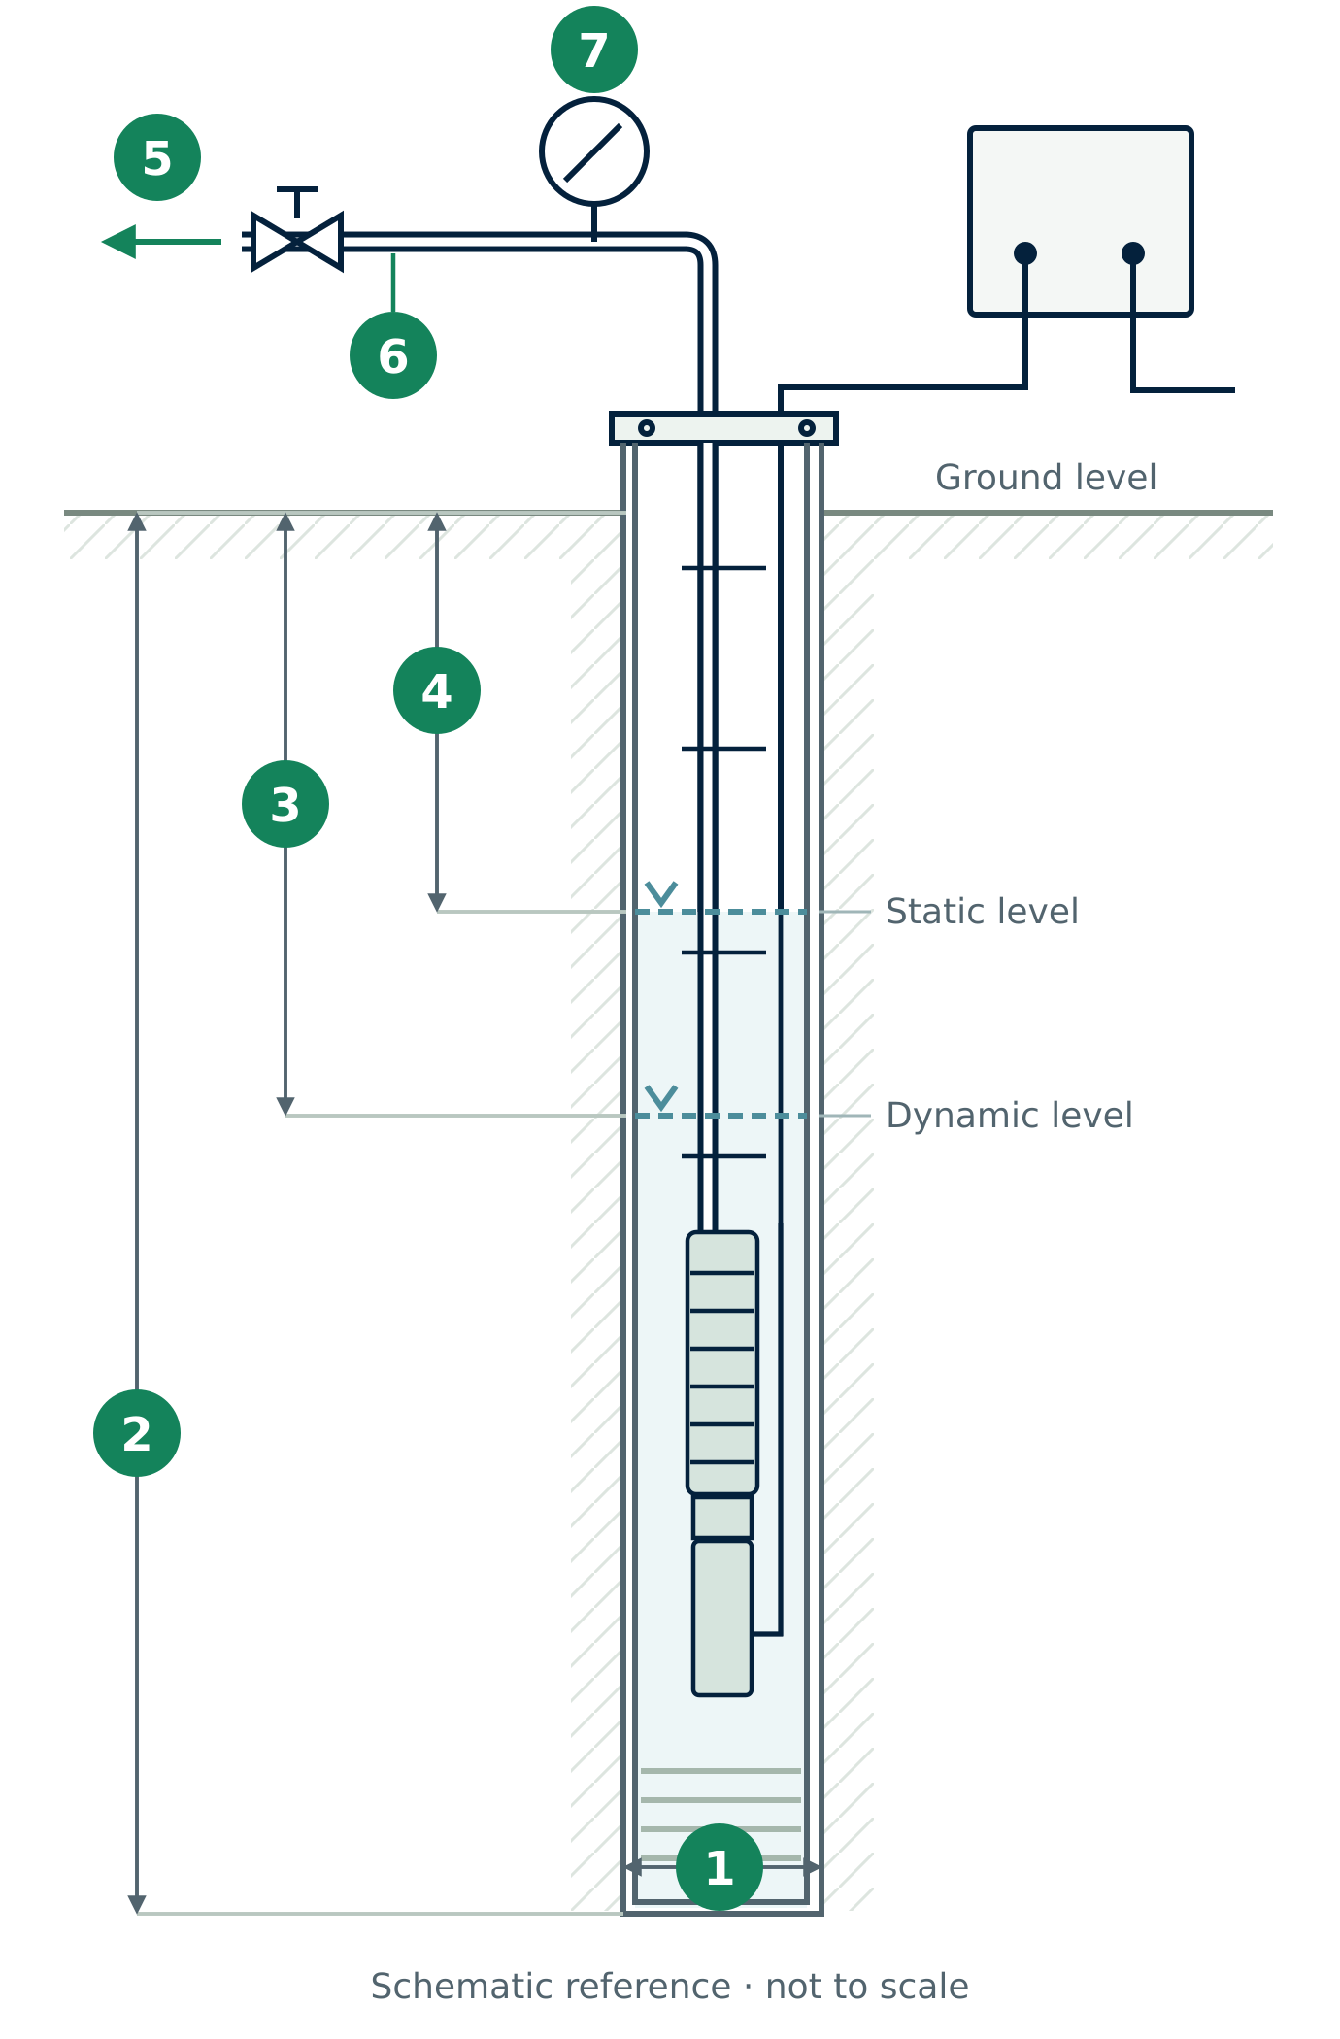 | Minimum well parameters  Depth references  2 Well depth is measured from ground level to the bottom of the well.  3 Dynamic level is measured below ground level while pumping.  4 Static level is measured below ground level when the well is at rest.  For 1, state whether the diameter is in mm or inch. The drawing is schematic and is not to scale.
  No. | Parameter | Value | Unit
  1 | Borehole diameter | ________________ | mm / inch
  2 | Well depth | ________________ | m
  3 | Dynamic water level | ________________ | m
  4 | Static water level | ________________ | m
  5 | Well flow rate | ________________ | m³/h
  6 | Water temperature | ________________ | °C
  7 | Design pressure at wellhead | ________________ | bar

Additional information
Provide water chemistry and inhibitor details only if available. Equipment selection is completed by REPN-FZCO.
Water chemistry Optional  pH is dimensionless.  Chemical composition of the injected inhibitor  _________________________________________________  _________________________________________________  _________________________________________________ | Equipment selection REPN-FZCO  Project notes  _________________________________________________  _________________________________________________  _________________________________________________
  Parameter | Value | Unit
  pH | ________________ | —
  HCO3 | ________________ | mg/L
  CO3 | ________________ | mg/L
  Cl | ________________ | mg/L
  SO4 | ________________ | mg/L
  H2S | ________________ | mg/L
  Equipment | Type | Note
  Pump | ________________ | ________________
  Motor | ________________ | ________________
  Protector | ________________ | ________________
  Cable line | ________________ | ________________
  Bolt on head | ________________ | ________________
  Intake module | ________________ | ________________

Project and operating information
The numbers match the optional fields in the website form. Leave unknown operating values blank.
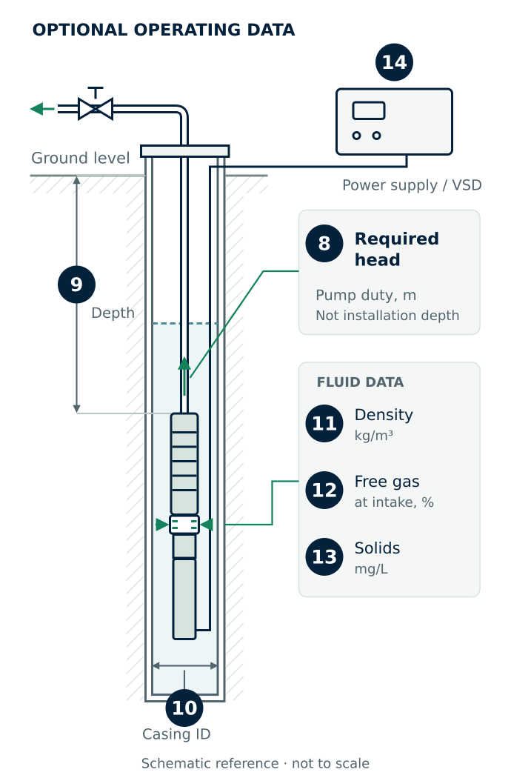 | Project and contact details  Additional operating information Optional  8 Required head is not installation depth.  9 State the installation-depth reference point in your project notes.  10 Enter the casing inside diameter.
  Field | Value
  Application | ________________
  Equipment / service | ________________
  Project location | ________________
  Contact name | ________________
  Email | ________________
  No. | Parameter | Value | Unit
  8 | Required head | ________________ | m
  9 | Pump installation depth | ________________ | m
  10 | Casing inside diameter | ________________ | mm
  11 | Fluid density | ________________ | kg/m³
  12 | Free gas at pump intake | ________________ | %
  13 | Suspended solids | ________________ | mg/L
  14 | Existing power supply / VSD | ________________ | —

