**Dokumentacija za izradu sajta**

[**https://gazz7.github.io/**](https://gazz7.github.io/)

**PLANTEX**

**Student: Nikola Vujetić 17/20**

**Predmet: Web programiranje 1**

**Visoka škola za internet i komunikacione tehnologije**



Sadržaj

Student: Nikola Vujetić 17/20 0

Predmet: Web programiranje 1 0

Visoka škola za internet i komunikacione tehnologije 0

Uvod 2

Jezici korišćeni za izradu sajta: 2

Opis funkcionalnosti: 2

Template: index.html 3

Organizacija - Organizaciona šema: 6

Sajt sadrži: 6

Mapa sajta 6

Stranice sajta 7

Kod stranice 14

Html: index.html 14

Html: author.html 19

Css: styles.css 22

CSS za društvene mreže: jquery.floating-social-share.css 48

Javascript kod: main.js 52

Scroll reveal 76

Jquery kod za društvene mreže 80

REZIME 89

**Uvod**

**Jezici korišćeni za izradu sajta:**

CSS2, CSS3, HTML4, HTML5, native JavaScript, Jquery.

**Opis funkcionalnosti:**

* Sajt sadrži dinamički ispisane sadržaje putem JavaScript-a
* Formu(validaciju) sa regularnim izrazima
* Dugme koje služi za skrol na vrh strane
* Korpu za kupovinu
* Jquery plugin za socialne mreže

nav__container

home section

Template: index.html

<https://github.com/bedimcode/responsive-plants-website>

nav__btns

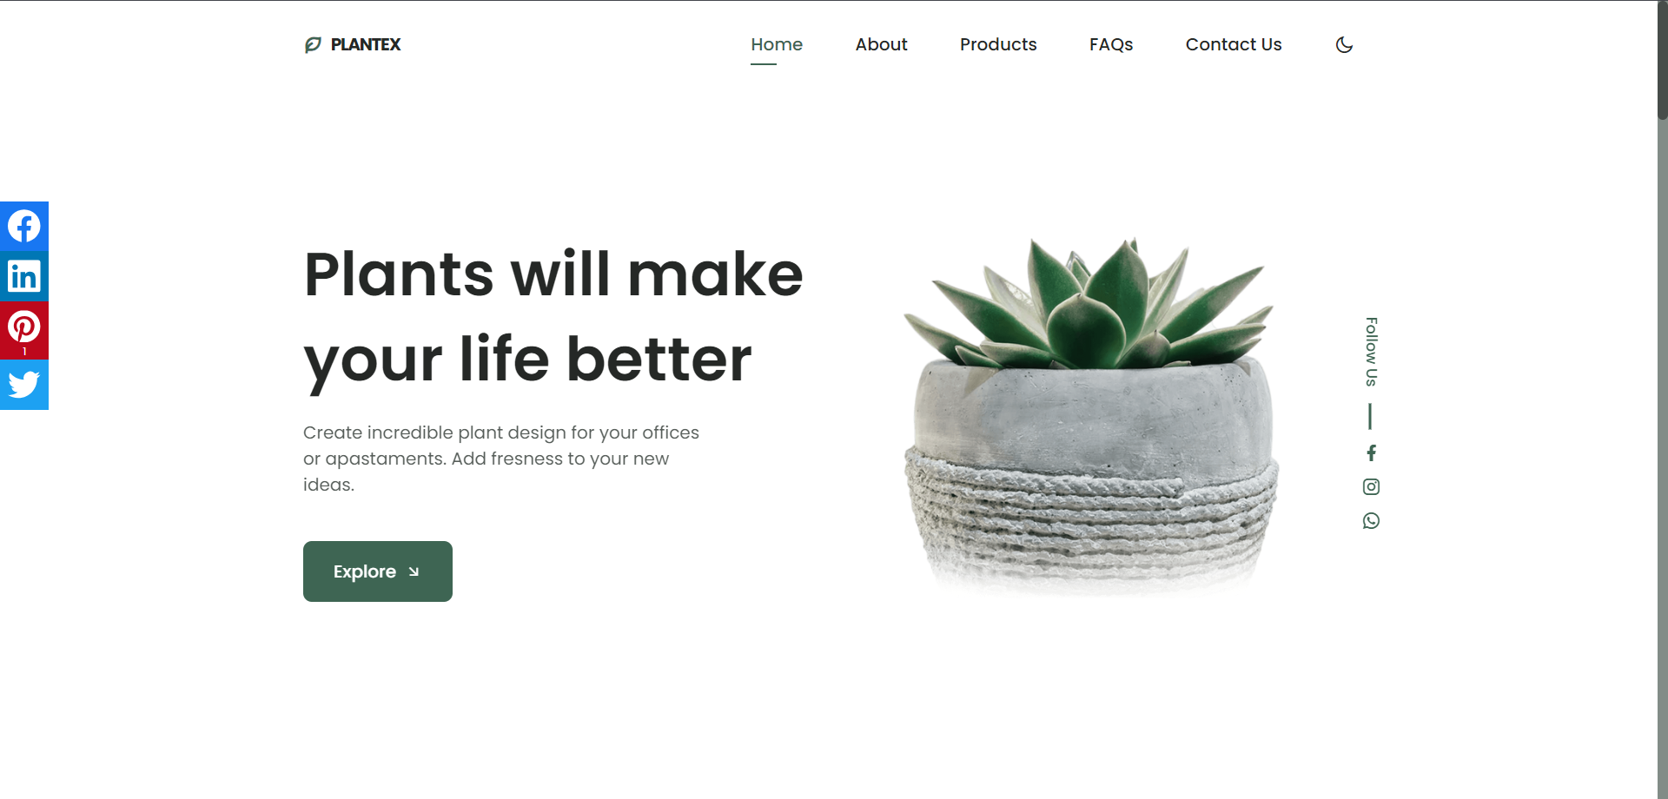

nav__menu

nav__logo

home__data

home__social

home__data

home__img

home__container

about section

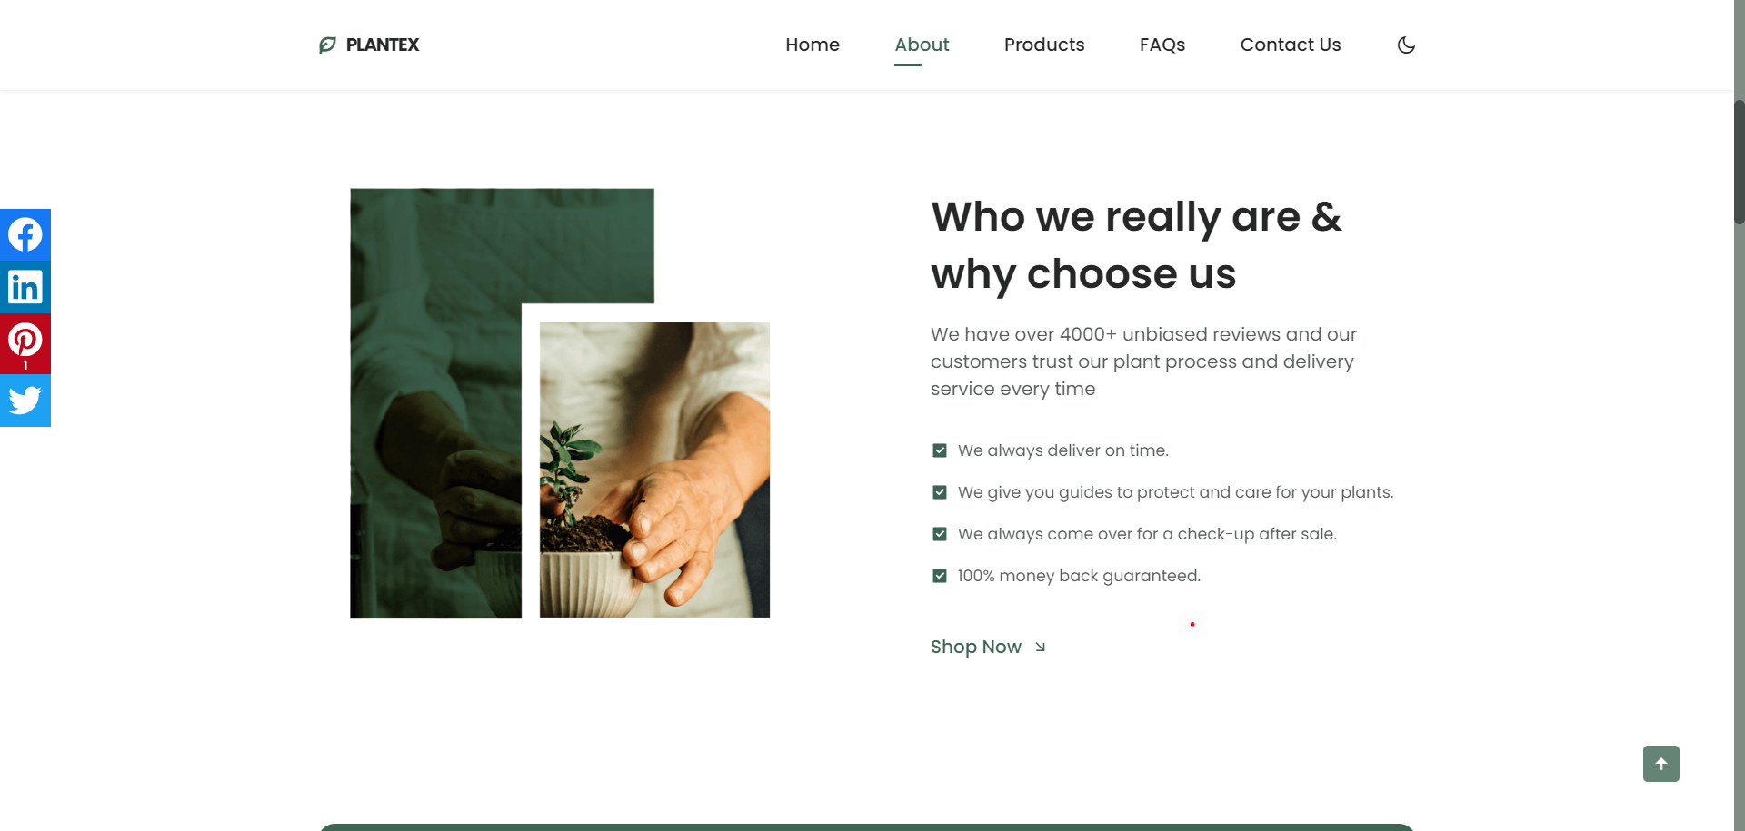

about­__data

about­__img

about­__container

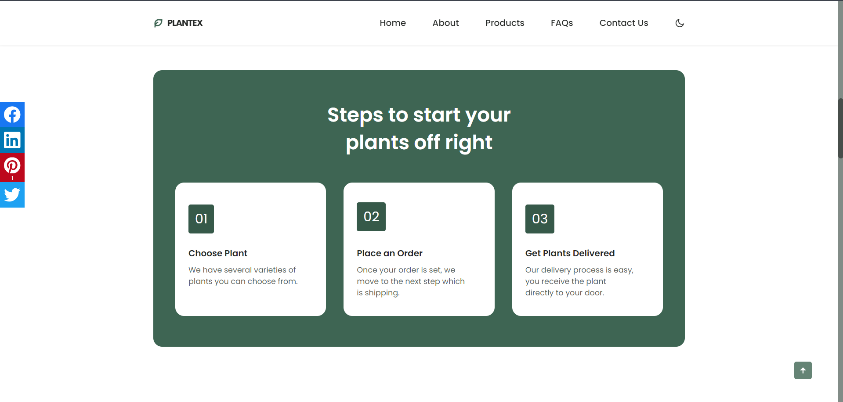

product section

steps__container

steps__card

steps section

steps__bg

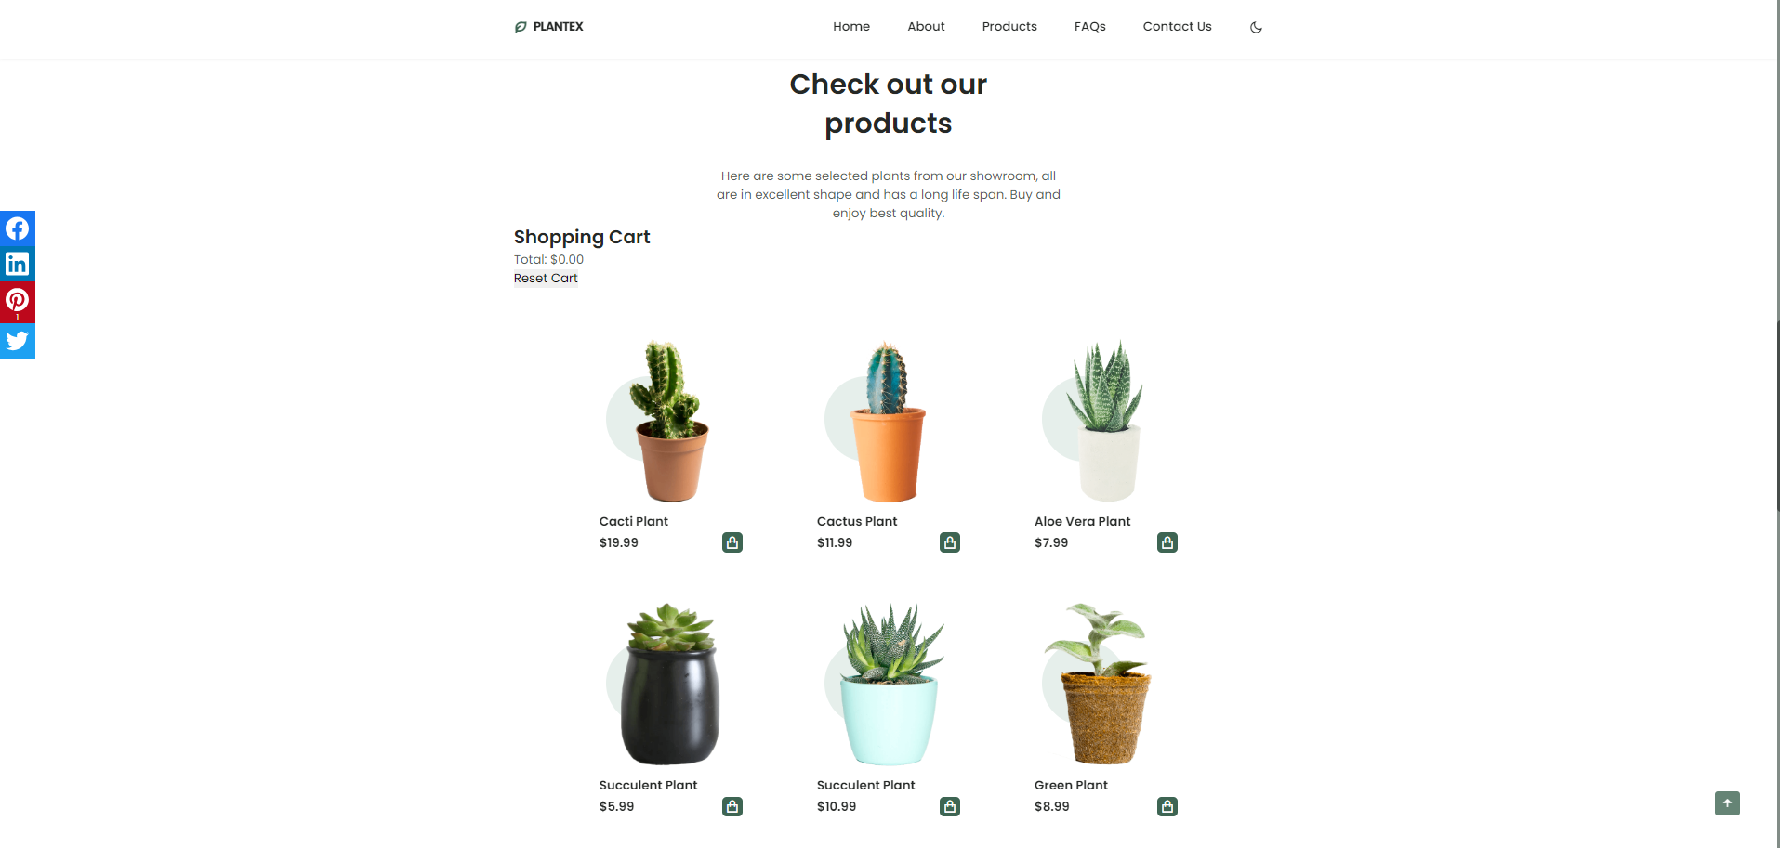

produc­t__card

product__container

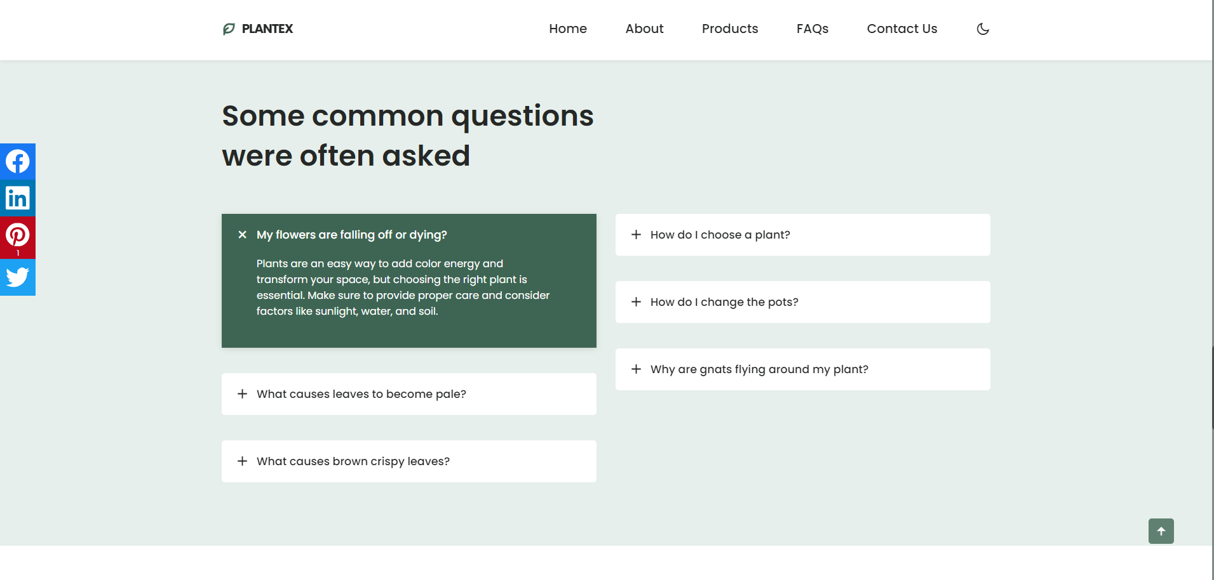

questions__item

contact section

questions__group

questions__container

questions section

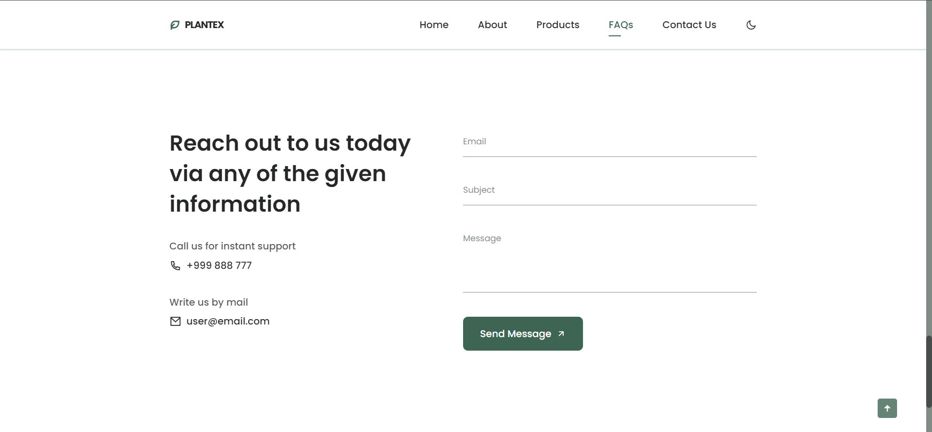

footer section

contact__inputs

contact__information

contact__data

contact__form

contact__box

contact__container

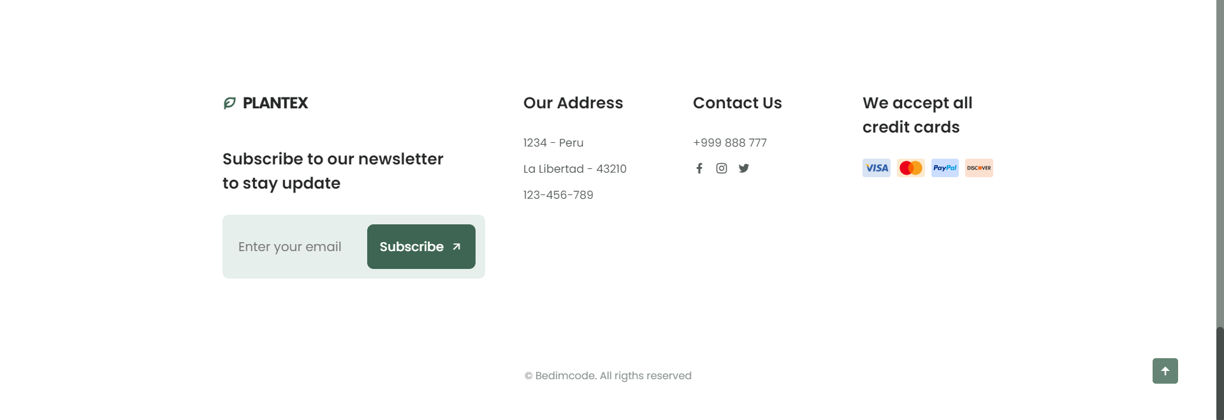

footer__subscribe

footer__cards

footer__content

footer__container

# Organizacija - Organizaciona šema:

## Sajt sadrži:

* “index.html”
* “author.html

Na index.html stranici se preko linkova može pristupiti svakom delu stranice, kao i stranici do author.html. Na author.html stranici se preko logoa(linka) može pristupiti index.html stranici.

author.html

index.html

## Mapa sajta

<?xml version="1.0" encoding="UTF-8"?>

<urlset

xmlns="http://www.sitemaps.org/schemas/sitemap/0.9"

xmlns:xsi="http://www.w3.org/2001/XMLSchema-instance"

xsi:schemaLocation="http://www.sitemaps.org/schemas/sitemap/0.9

http://www.sitemaps.org/schemas/sitemap/0.9/sitemap.xsd">

<!-- created with Free Online Sitemap Generator www.xml-sitemaps.com -->

<url>

<loc>https://gazz7.github.io/index.html</loc>

<lastmod>2023-12-12</lastmod>

<priority>1.00</priority>

</url>

<url>

<loc>https://gazz7.github.io/author.html</loc>

<lastmod>2020-12-11</lastmod>

<priority>0.80</priority>

</url>

</urlset>

## Stranice sajta

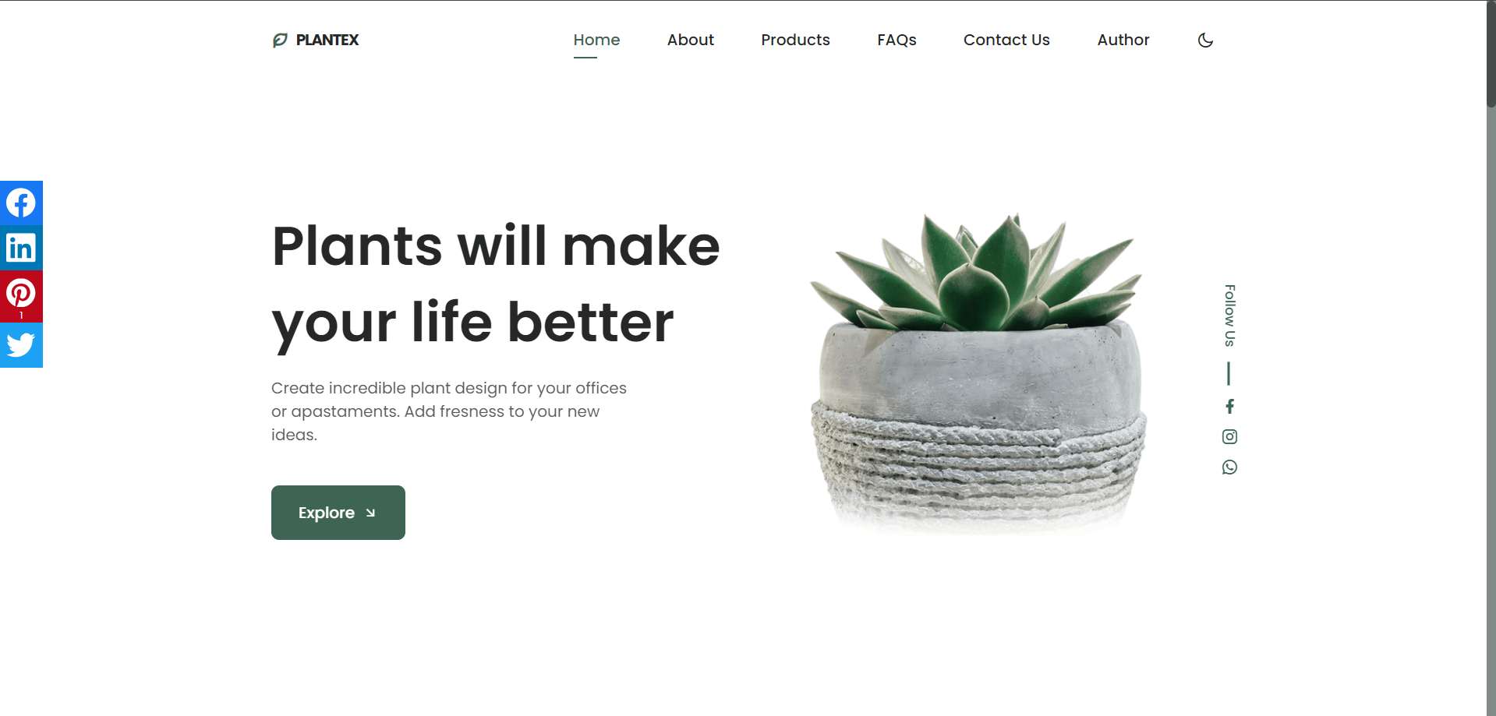

Sa leve strane se nalazi tab sa socijalnim mrežama koji je fiksiran i pri skrolovanju. Takođe “header” je fiksiran pri skrolovanju stranice I osim linkova do različitih delova stranice nalazi se I dugme u obliku polumeseca koje prebacuje stranicu u “dark mod”. Ponovni klik vraća stranicu u “light mod”. Ta funkcionalnost je preuzeta sa template-a. U home sekciji se, pored linkova do društvenih mreža, nalazi i dugme “Explore” koje prebacuje korisnika do “About” dela stranice. Skrolovanjem stranice u donjem desnom uglu se pojavljuje strelica kojom se korisnik vraća na početak stranice.

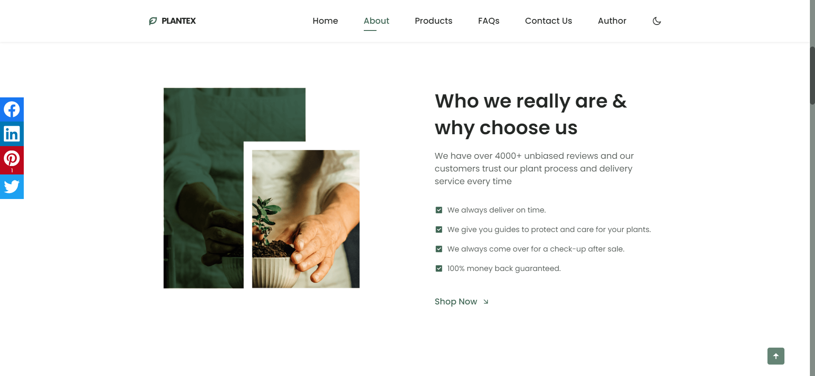

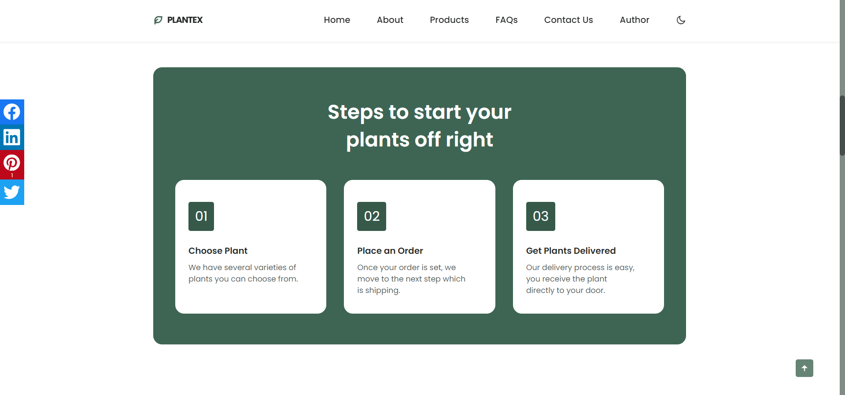

U “About” sekciji se nalazi div sa koracima kako naručiti biljke koji je takođe dinamički ispisan. U gornjem screenshot-u se nalazi I dugme sa strelicom“Shop Now” koje prebacuje korisnika na “Products” deo stranice, tj. sledeći deo stranice.

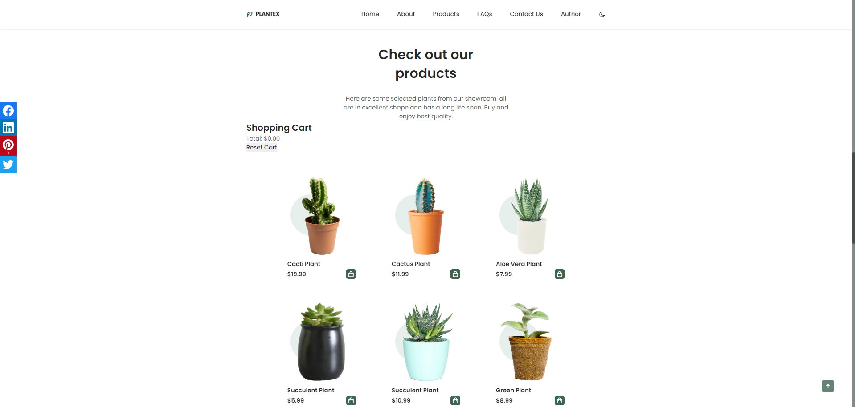

“Products” sekcija sadrži dinamički ispisane artikle sa biljkama ispod kojih se nalazi vrsta biljke, cena i dugme čijim se klikom može dotati odgovarajući artikal u korpu(cart). Dodavanjem artikla ispisuje se koji artikal je dodat, njegova cena, kao I ukupna suma dodatih artikala. Odmah ispod ukupne cene nalazi se dugme “Reset cart” koje briše sve artikle koji su dodati u korpu I vraća korpu u početno stanje.

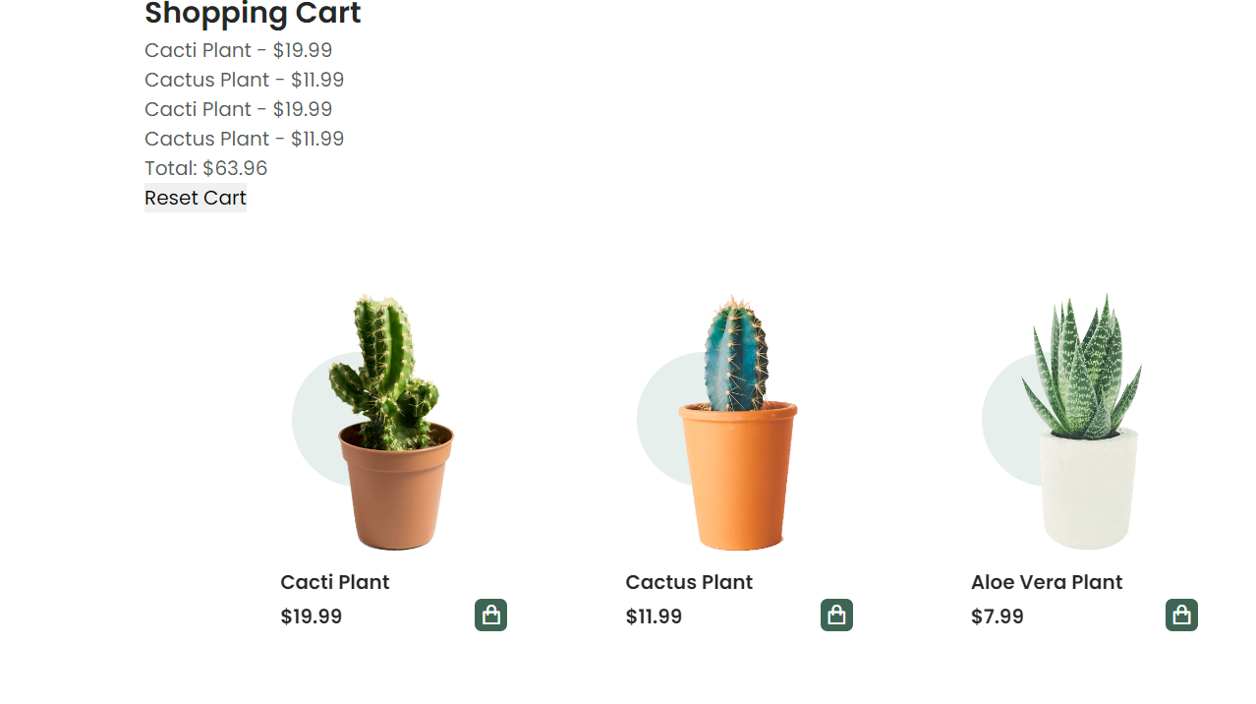

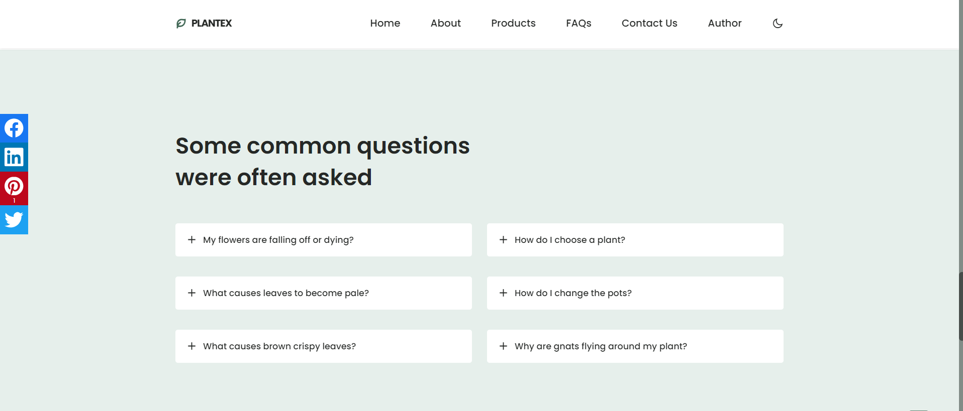

“Questions” sekcija sastoji se od najčešće postavljenih pitanja koji su dinamički ispisani. U ovom slučaju po 3 item-a sa pitanjima su raspoređeni u 2 diva koji ih grupišu, a oni su obuhvaćeni posebnim kontejnerom. Klikom na željeno pitanje primenjuje se “accordion” efekat sa sažetim odgovorom na odogvarajuće pitanje. Taj efekat se briše za prethodno selektovano pitanje u slučaju da kliknete I ”proširite” neko drugo pitanje.

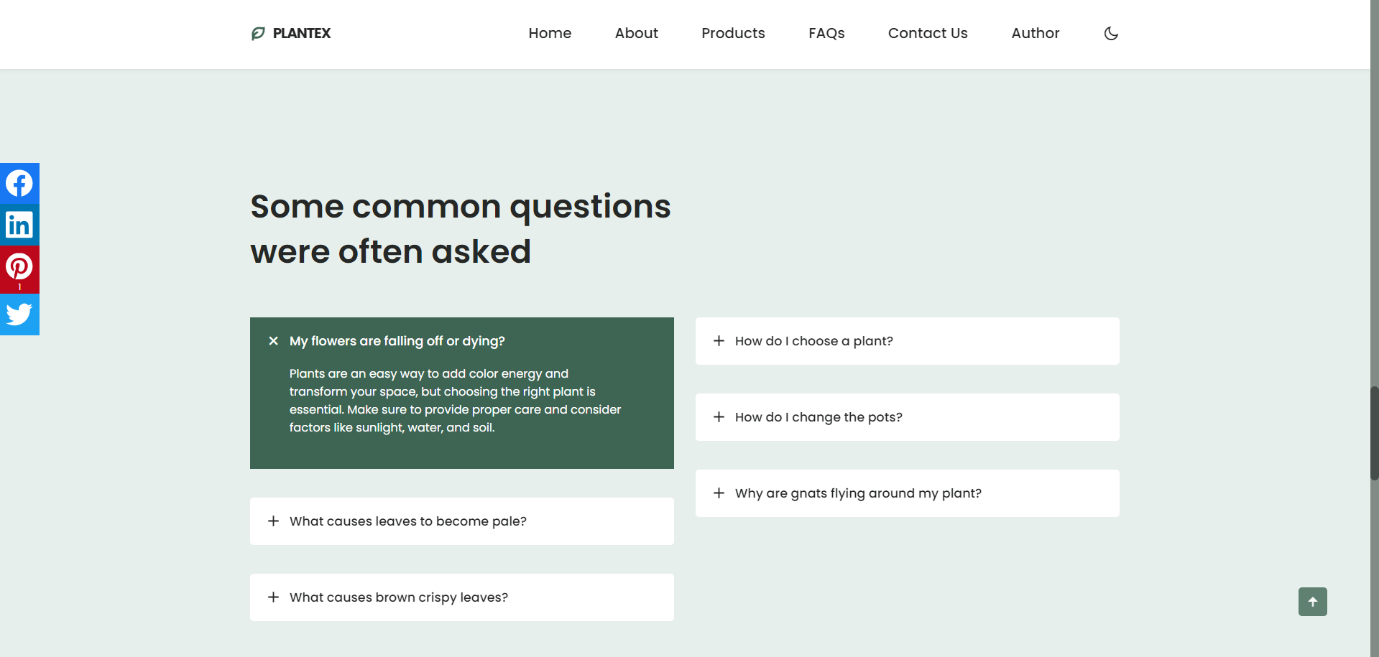

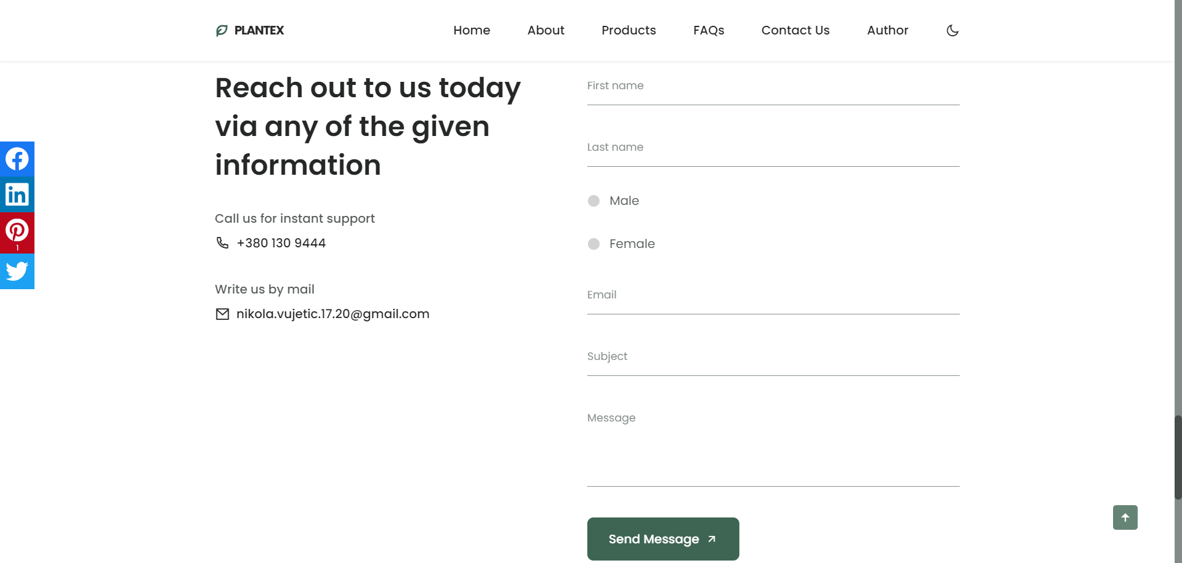

U “Contact” sekciji nalazi se forma koju korisnik popunjava da bi došao u kontakt sa prodavcem. Forma je dinamički ispisana i sarži polja za: ime, prezime, pol, e-mail adresu, temu poruke, poruku i dugme kojim se šalje uspešno popunjena forma. Validacija forme je napisana tako da bi zabranila slanje poruke u nekom od sledećih slučajeva: ako korisnik ne bi uneo ime, prezime ili e-mail u ispravnom formatu ili ako ne bi izabrao pol. Klikom na dugme “Send Message”, u nekom od navedenih slučajeva ili kombinacijom više njih, ispisaće se poruka da forma nije ispravno popunjena I da treba proveriti format za popunjavanje koji je dat za svaki neispravno unet element forme. U slučaju uspešne popunjene forme, klikom na dugme obaveštava se korisnik da je poruka uspešno poslata. Takođe proverava se input korisnika prilikom popunjavanja forme, odnosno onog trenutka kada je polje za ime, prezime ili e-mail ispravno popunjeno, iznad unetog teksta dobija se poruka da je polje ispravno popunjeno.

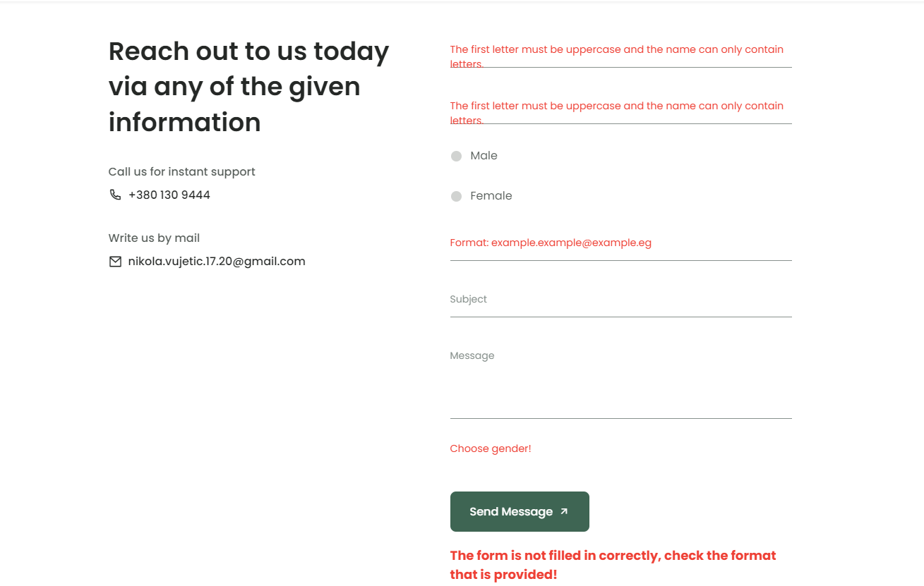

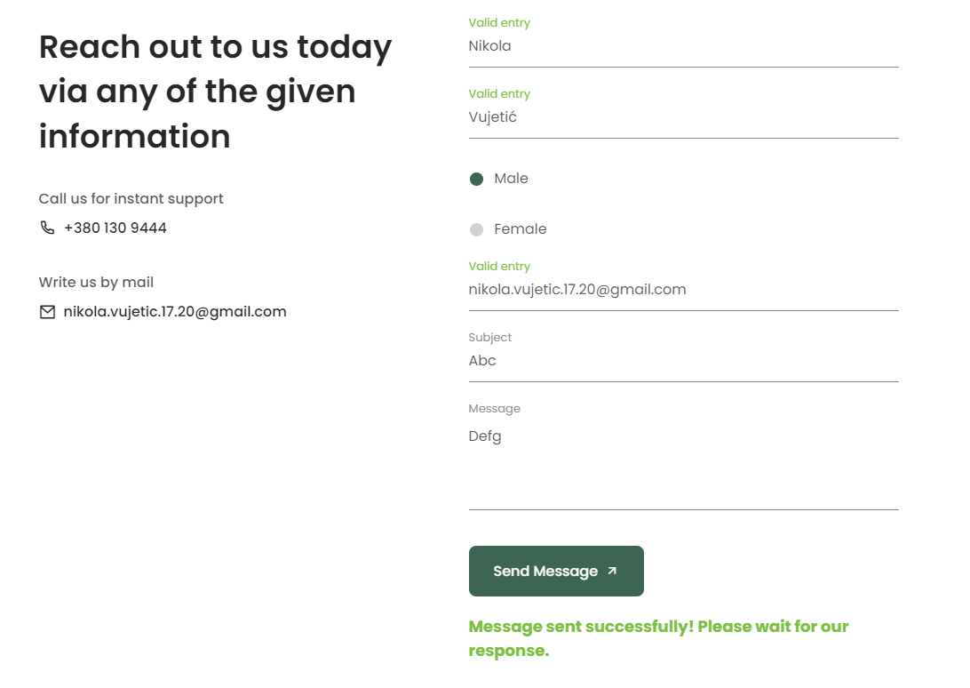

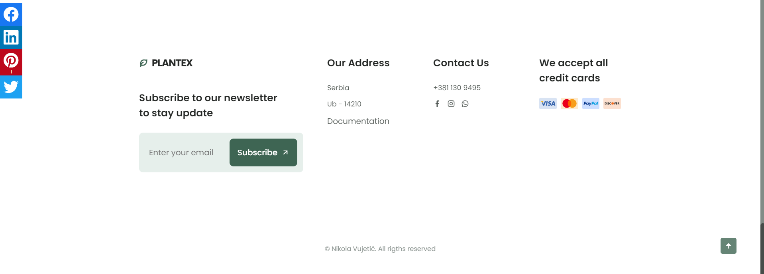

U footeru se nalazi tekstualno polje za e-mail adrese za supskripciju i dugme za istu. Takođe neispravnim unosom i klikom na dugme dobija se format na koji način treba ispravno popuniti polje. Poruka o uspešnoj supskripciji se dobija nakon pravilnog unosa e-mail adrese





# Kod stranice

## Html: index.html

!DOCTYPE html>

    <html lang="en">

    <head>

        <meta charset="UTF-8">

        <meta name="viewport" content="width=device-width, initial-scale=1.0">

        <meta name="description" content="Explore a variety of plants and gardening tips on Plantex - Your Ultimate Plant Companion.">

        <meta name="keywords" content="plants, gardening, flowers, indoor plants, outdoor plants, plant care">

        <meta name="author" content="Nikola Vujetic">

        <!--=============== FAVICON ===============-->

        <link rel="shortcut icon" href="assets/img/favicon.png" type="image/x-icon">

        <!--=============== REMIX ICONS ===============-->

        <link href="https://cdn.jsdelivr.net/npm/remixicon@2.5.0/fonts/remixicon.css" rel="stylesheet">

        <!--=============== CSS ===============-->

        <link rel="stylesheet" href="assets/css/styles.css">

        <!--=============== JQUERY CSS ===============-->

        <link rel="stylesheet" href="assets/css/jquery.floating-social-share.css">

        <title>Plantex - Plants will make your life better</title>

    </head>

    <body>

        <!--==================== HEADER ====================-->

        <header class="header" id="header">

            <nav class="nav container" id="navM">

                <a href="#" class="nav__logo">

                    <i class="ri-leaf-line nav__logo-icon"></i> Plantex

                </a>

                <div class="nav__menu" id="nav-menu">

                    <div class="nav__close" id="nav-close">

                        <i class="ri-close-line"></i>

                    </div>

                </div>

                <div class="nav__btns">

                    <!-- Theme change button -->

                    <i class="ri-moon-line change-theme" id="theme-button"></i>

                    <div class="nav__toggle" id="nav-toggle">

                        <i class="ri-menu-line"></i>

                    </div>

                </div>

            </nav>

        </header>

        <main class="main">

            <!--==================== HOME ====================-->

            <section class="home" id="home">

                <div class="home__container container grid">

                    <img src="assets/img/home.png" alt="" class="home__img">

                    <div class="home__data">

                        <h1 class="home__title">

                            Plants will make <br> your life better

                        </h1>

                        <p class="home__description">

                            Create incredible plant design for your offices or apastaments.

                            Add fresness to your new ideas.

                        </p>

                        <a href="#about" class="button button--flex">

                            Explore <i class="ri-arrow-right-down-line button__icon"></i>

                        </a>

                    </div>

                    <div class="home__social">

                    </div>

                </div>

            </section>

            <!--==================== ABOUT ====================-->

            <section class="about section container" id="about">

                <div class="about__container grid">

                    <img src="assets/img/about.png" alt="" class="about__img">

                    <div class="about__data">

                        <h2 class="section__title about__title">

                            Who we really are & <br> why choose us

                        </h2>

                        <p class="about__description">

                            We have over 4000+ unbiased reviews and our customers

                            trust our plant process and delivery service every time

                        </p>

                        <div class="about__details">

                            <p class="about__details-description">

                                <i class="ri-checkbox-fill about__details-icon"></i>

                                We always deliver on time.

                            </p>

                            <p class="about__details-description">

                                <i class="ri-checkbox-fill about__details-icon"></i>

                                We give you guides to protect and care for your plants.

                            </p>

                            <p class="about__details-description">

                                <i class="ri-checkbox-fill about__details-icon"></i>

                                We always come over for a check-up after sale.

                            </p>

                            <p class="about__details-description">

                                <i class="ri-checkbox-fill about__details-icon"></i>

                                100% money back guaranteed.

                            </p>

                        </div>

                        <a href="#products" class="button--link button--flex">

                            Shop Now <i class="ri-arrow-right-down-line button__icon"></i>

                        </a>

                    </div>

                </div>

            </section>

            <!--==================== STEPS ====================-->

            <section id="steps">

            </section>

            <!--==================== PRODUCTS ====================-->

            <section id="products">

                <h2 class="section__title-center">

                    Check out our <br> products

                </h2>

                <p class="product__description">

                    Here are some selected plants from our showroom, all are in excellent

                    shape and has a long life span. Buy and enjoy best quality.

                </p>

                <div class="cart">

                    <h2>Shopping Cart</h2>

                    <ul id="cartList"></ul>

                    <p>Total: $<span id="totalPrice">0.00</span></p>

                    <button id="resetCartButton">Reset Cart</button>

                </div>

            </section>

            <!--==================== QUESTIONS ====================-->

            <section id="faqs">

                <h2 class="section__title-center questions__title container">

                    Some common questions <br> were often asked

                </h2>

            </section>

            <!--==================== CONTACT ====================-->

            <section id="contact">

            </section>

        </main>

        <!--==================== FOOTER ====================-->

        <footer class="footer section" id="htmlFooter">

            <div class="footer__container container grid">

                <div class="footer__content">

                    <a href="#" class="footer__logo">

                        <i class="ri-leaf-line footer__logo-icon"></i> Plantex

                    </a>

                    <h3 class="footer__title">

                        Subscribe to our newsletter <br> to stay update

                    </h3>

                    <div class="footer__subscribe">

                        <input type="email" id="emailInput" placeholder="Enter your email" class="footer__input">

                        <button id="subscribeButton" class="button button--flex footer__button">

                            Subscribe

                            <i class="ri-arrow-right-up-line button__icon"></i>

                        </button>

                    </div>

                    <div id="message"></div>

                </div>

                <div class="footer__content">

                    <h3 class="footer__title">Our Address</h3>

                    <ul class="footer__data">

                        <li class="footer__information">Serbia</li>

                        <li class="footer__information">Ub - 14210</li>

                        <li class="footer__information"><a href="#" class="footer__social-link">Documentation</a></li>

                    </ul>

                </div>

                <div class="footer__content">

                    <h3 class="footer__title">Contact Us</h3>

                    <ul class="footer__data">

                        <li class="footer__information">+381 130 9495</li>

                        <div class="footer__social">

                            <a href="https://www.facebook.com/profile.php?id=100017969461650" class="footer__social-link">

                                <i class="ri-facebook-fill"></i>

                            </a>

                            <a href="https://www.instagram.com/nikola_vujetic_/" class="footer__social-link">

                                <i class="ri-instagram-line"></i>

                            </a>

                            <a href="https://wa.me/0601309495" class="footer__social-link">

                                <i class="ri-whatsapp-line"></i>

                            </a>

                        </div>

                    </ul>

                </div>

                <div class="footer__content">

                    <h3 class="footer__title">

                        We accept all credit cards

                    </h3>

                    <div class="footer__cards">

                        <img src="assets/img/card1.png" alt="" class="footer__card">

                        <img src="assets/img/card2.png" alt="" class="footer__card">

                        <img src="assets/img/card3.png" alt="" class="footer__card">

                        <img src="assets/img/card4.png" alt="" class="footer__card">

                    </div>

                </div>

            </div>

            <p class="footer__copy">&#169; Nikola Vujetić. All rigths reserved</p>

        </footer>

        <!--=============== SCROLL UP ===============   -->

        <a href="#" class="scrollup" id="scroll-up">

            <i class="ri-arrow-up-fill scrollup__icon"></i>

        </a>

        <!--=============== SCROLL REVEAL ===============-->

        <script src="assets/js/scrollreveal.min.js"></script>

        <script src="assets/js/jquery.min.js"></script>

    <script src="assets/js/jquery.floating-social-share.js"></script>

        <!--=============== MAIN JS ===============-->

        <script src="assets/js/main.js"></script>

    </body>

</html>

## Html: author.html

<!DOCTYPE html>

    <html lang="en">

    <head>

        <meta charset="UTF-8">

        <meta name="viewport" content="width=device-width, initial-scale=1.0">

        <meta name="description" content="Explore a variety of plants and gardening tips on Plantex - Your Ultimate Plant Companion.">

        <meta name="keywords" content="plants, gardening, flowers, indoor plants, outdoor plants, plant care">

        <meta name="author" content="Nikola Vujetic">

        <!--=============== FAVICON ===============-->

        <link rel="shortcut icon" href="assets/img/favicon.png" type="image/x-icon">

        <!--=============== REMIX ICONS ===============-->

        <link href="https://cdn.jsdelivr.net/npm/remixicon@2.5.0/fonts/remixicon.css" rel="stylesheet">

        <!--=============== CSS ===============-->

        <link rel="stylesheet" href="assets/css/styles.css">

        <!--=============== JQUERY CSS ===============-->

        <link rel="stylesheet" href="assets/css/jquery.floating-social-share.css">

        <title>Plantex - Plants will make your life better</title>

    </head>

    <body>

        <!--==================== HEADER ====================-->

        <header class="header" id="header">

            <nav class="nav container">

                <a href="index.html" class="nav__logo">

                    <i class="ri-leaf-line nav__logo-icon"></i> Plantex

                </a>

            </nav>

        </header>

        <main class="main">

            <div id="wrapper-aboutus">

                <h1>About me</h1>

                <div id="border">

                </div>

                <div id="profile-picture">

                    <img src="assets/img/profile-picture.jpg" alt="Profile picture" />

                </div>

                <div id="description">

                    <p>Motivated and aspiring programming student with a hunger for learning and a keen interest in software development.</p>

                    <p>I thrive on tackling complex problems and enjoy the logical and creative aspects of coding. My coursework has equipped me with a strong understanding of data structures, algorithms, and software development methodologies. I am adept at translating ideas into functional and efficient code, and I constantly seek opportunities to expand my knowledge in emerging technologies.</p>

                    <p>I am actively seeking opportunities to collaborate on projects, contribute to coding challenges, and engage with the programming community to enhance my skills. I am a quick learner, adaptable, and committed to self-improvement.</p>

                </div>

        </main>

        <!--==================== FOOTER ====================-->

        <footer class="footer section" id="htmlFooter">

            <div class="footer__container container grid">

                <div class="footer__content">

                    <a href="#" class="footer__logo">

                        <i class="ri-leaf-line footer__logo-icon"></i> Plantex

                    </a>

                    <h3 class="footer__title">

                        Subscribe to our newsletter <br> to stay update

                    </h3>

                    <div class="footer__subscribe">

                        <input type="email" id="emailInput" placeholder="Enter your email" class="footer__input">

                        <button id="subscribeButton" class="button button--flex footer__button">

                            Subscribe

                            <i class="ri-arrow-right-up-line button__icon"></i>

                        </button>

                    </div>

                    <div id="message"></div>

                </div>

                <div class="footer__content">

                    <h3 class="footer__title">Our Address</h3>

                    <ul class="footer__data">

                        <li class="footer__information">Serbia</li>

                        <li class="footer__information">Ub - 14210</li>

                        <li class="footer__information"><a href="#" class="footer__social-link">Documentation</a></li>

                    </ul>

                </div>

                <div class="footer__content">

                    <h3 class="footer__title">Contact Us</h3>

                    <ul class="footer__data">

                        <li class="footer__information">+381 130 9495</li>

                        <div class="footer__social">

                            <a href="https://www.facebook.com/profile.php?id=100017969461650" class="footer__social-link">

                                <i class="ri-facebook-fill"></i>

                            </a>

                            <a href="https://www.instagram.com/nikola_vujetic_/" class="footer__social-link">

                                <i class="ri-instagram-line"></i>

                            </a>

                            <a href="https://wa.me/0601309495" class="footer__social-link">

                                <i class="ri-whatsapp-line"></i>

                            </a>

                        </div>

                    </ul>

                </div>

                <div class="footer__content">

                    <h3 class="footer__title">

                        We accept all credit cards

                    </h3>

                    <div class="footer__cards">

                        <img src="assets/img/card1.png" alt="" class="footer__card">

                        <img src="assets/img/card2.png" alt="" class="footer__card">

                        <img src="assets/img/card3.png" alt="" class="footer__card">

                        <img src="assets/img/card4.png" alt="" class="footer__card">

                    </div>

                </div>

            </div>

            <p class="footer__copy">&#169; Nikola Vujetić. All rigths reserved</p>

        </footer>

        <!--=============== SCROLL UP ===============-->

        <a href="#" class="scrollup" id="scroll-up">

            <i class="ri-arrow-up-fill scrollup__icon"></i>

        </a>

        <!--=============== SCROLL REVEAL ===============-->

        <script src="assets/js/scrollreveal.min.js"></script>

        <script src="assets/js/jquery.min.js"></script>

    <script src="assets/js/jquery.floating-social-share.js"></script>

        <!--=============== MAIN JS ===============-->

        <script src="assets/js/main.js"></script>

    </body>

</html>

## Css: styles.css - template

/*=============== GOOGLE FONTS ===============*/

@import url('https://fonts.googleapis.com/css2?family=Poppins:wght@400;500;600;700&display=swap');

/*=============== VARIABLES CSS ===============*/

:root {

  --header-height: 3.5rem; /*56px*/

  /*========== Colors ==========*/

  /*Color mode HSL(hue, saturation, lightness)*/

  --hue: 152;

  --first-color: hsl(var(--hue), 24%, 32%);

  --first-color-alt: hsl(var(--hue), 24%, 28%);

  --first-color-light: hsl(var(--hue), 24%, 66%);

  --first-color-lighten: hsl(var(--hue), 24%, 92%);

  --title-color: hsl(var(--hue), 4%, 15%);

  --text-color: hsl(var(--hue), 4%, 35%);

  --text-color-light: hsl(var(--hue), 4%, 55%);

  --body-color: hsl(var(--hue), 0%, 100%);

  --container-color: #FFF;

  /*========== Font and typography ==========*/

  /*.5rem = 8px | 1rem = 16px ...*/

  --body-font: 'Poppins', sans-serif;

  --big-font-size: 2rem;

  --h1-font-size: 1.5rem;

  --h2-font-size: 1.25rem;

  --h3-font-size: 1rem;

  --normal-font-size: .938rem;

  --small-font-size: .813rem;

  --smaller-font-size: .75rem;

  /*========== Font weight ==========*/

  --font-medium: 500;

  --font-semi-bold: 600;

  /*========== Margenes Bottom ==========*/

  /*.5rem = 8px | 1rem = 16px ...*/

  --mb-0-5: .5rem;

  --mb-0-75: .75rem;

  --mb-1: 1rem;

  --mb-1-5: 1.5rem;

  --mb-2: 2rem;

  --mb-2-5: 2.5rem;

  /*========== z index ==========*/

  --z-tooltip: 10;

  --z-fixed: 100;

}

/* Responsive typography */

@media screen and (min-width: 968px) {

  :root {

    --big-font-size: 3.5rem;

    --h1-font-size: 2.25rem;

    --h2-font-size: 1.5rem;

    --h3-font-size: 1.25rem;

    --normal-font-size: 1rem;

    --small-font-size: .875rem;

    --smaller-font-size: .813rem;

  }

}

/*=============== BASE ===============*/

*{

  box-sizing: border-box;

  padding: 0;

  margin: 0;

}

html{

  scroll-behavior: smooth;

}

body,

button,

input,

textarea{

  font-family: var(--body-font);

  font-size: var(--normal-font-size);

}

body{

  margin: var(--header-height) 0 0 0;

  background-color: var(--body-color);

  color: var(--text-color);

  transition: .4s; /*For animation dark mode*/

}

button{

  cursor: pointer;

  border: none;

  outline: none;

}

h1,h2,h3{

  color: var(--title-color);

  font-weight: var(--font-semi-bold);

}

ul{

  list-style: none;

}

a{

  text-decoration: none;

}

img{

  max-width: 100%;

  height: auto;

}

/*=============== THEME ===============*/

/*========== Variables Dark theme ==========*/

body.dark-theme{

  --first-color-dark: hsl(var(--hue), 8%, 20%);

  --title-color: hsl(var(--hue), 4%, 95%);

  --text-color: hsl(var(--hue), 4%, 75%);

  --body-color: hsl(var(--hue), 8%, 12%);

  --container-color: hsl(var(--hue), 8%, 16%);

}

/*========== Button Dark/Light ==========*/

.change-theme{

  color: var(--title-color);

  font-size: 1.15rem;

  cursor: pointer;

}

.nav__btns{

  display: inline-flex;

  align-items: center;

  column-gap: 1rem;

}

/*==========

Color changes in some parts of

the website, in dark theme

==========*/

.dark-theme .steps__bg,

.dark-theme .questions{

  background-color: var(--first-color-dark);

}

.dark-theme .product__circle,

.dark-theme .footer__subscribe{

  background-color: var(--container-color);

}

.dark-theme .scroll-header{

  box-shadow: 0 1px 4px hsla(var(--hue), 4%, 4%, .3);

}

/*=============== REUSABLE CSS CLASSES ===============*/

.section{

  padding: 5.5rem 0 1rem;

}

.section__title,

.section__title-center{

  font-size: var(--h2-font-size);

  margin-bottom: var(--mb-2);

  line-height: 140%;

}

.section__title-center{

  text-align: center;

}

.container{

  max-width: 968px;

  margin-left: var(--mb-1-5);

  margin-right: var(--mb-1-5);

}

.grid{

  display: grid;

}

.main{

  overflow: hidden; /*For animation*/

}

/*=============== HEADER ===============*/

.header{

  width: 100%;

  background-color: var(--body-color);

  position: fixed;

  top: 0;

  left: 0;

  z-index: var(--z-fixed);

  transition: .4s; /*For animation dark mode*/

}

/*=============== NAV ===============*/

.nav{

  height: var(--header-height);

  display: flex;

  justify-content: space-between;

  align-items: center;

}

.nav__logo,

.nav__toggle,

.nav__close{

  color: var(--title-color);

}

.nav__logo{

  text-transform: uppercase;

  font-weight: 700;

  letter-spacing: -1px;

  display: inline-flex;

  align-items: center;

  column-gap: .5rem;

  transition: .3s;

}

.nav__logo-icon{

  font-size: 1.15rem;

  color: var(--first-color);

}

.nav__logo:hover{

  color: var(--first-color);

}

.nav__toggle{

  display: inline-flex;

  font-size: 1.25rem;

  cursor: pointer;

}

@media screen and (max-width: 767px){

  .nav__menu{

    position: fixed;

    background-color: var(--container-color);

    width: 80%;

    height: 100%;

    top: 0;

    right: -100%;

    box-shadow: -2px 0 4px hsla(var(--hue), 24%, 15%, .1);

    padding: 4rem 0 0 3rem;

    border-radius: 1rem 0 0 1rem;

    transition: .3s;

    z-index: var(--z-fixed);

  }

}

.nav__close{

  font-size: 1.5rem;

  position: absolute;

  top: 1rem;

  right: 1.25rem;

  cursor: pointer;

}

.nav__list{

  display: flex;

  flex-direction: column;

  row-gap: 1.5rem;

}

.nav__link{

  color: var(--title-color);

  font-weight: var(--font-medium);

  transition: .3s;

}

.nav__link:hover{

  color: var(--first-color);

}

/* Show menu */

.show-menu{

  right: 0;

}

/* Change background header */

.scroll-header{

  box-shadow: 0 1px 4px hsla(var(--hue), 4%, 15%, .1);

}

/* Active link */

.active-link{

  position: relative;

  color: var(--first-color);

}

.active-link::after{

  content: '';

  position: absolute;

  bottom: -.5rem;

  left: 0;

  width: 50%;

  height: 2px;

  background-color: var(--first-color);

}

/*=============== HOME ===============*/

.home{

  padding: 3.5rem 0 2rem;

}

.home__container{

  position: relative;

  row-gap: 2rem;

}

.home__img{

  width: 200px;

  justify-self: center;

}

.home__title{

  font-size: var(--big-font-size);

  line-height: 140%;

  margin-bottom: var(--mb-1);

}

.home__description{

  margin-bottom: var(--mb-2-5);

}

.home__social{

  position: absolute;

  top: 2rem;

  right: -1rem;

  display: grid;

  justify-items: center;

  row-gap: 3.5rem;

}

.home__social-follow{

  font-weight: var(--font-medium);

  font-size: var(--smaller-font-size);

  color: var(--first-color);

  position: relative;

  transform: rotate(90deg);

}

.home__social-follow::after{

  content: '';

  position: absolute;

  width: 1rem;

  height: 2px;

  background-color: var(--first-color);

  right: -45%;

  top: 50%;

}

.home__social-links{

  display: inline-flex;

  flex-direction: column;

  row-gap: .25rem;

}

.home__social-link{

  font-size: 1rem;

  color: var(--first-color);

  transition: .3s;

}

.home__social-link:hover{

  transform: translateX(.25rem);

}

/*=============== BUTTONS ===============*/

.button{

  display: inline-block;

  background-color: var(--first-color);

  color: #FFF;

  padding: 1rem 1.75rem;

  border-radius: .5rem;

  font-weight: var(--font-medium);

  transition: .3s;

}

.button:hover{

  background-color: var(--first-color-alt);

}

.button__icon{

  transition: .3s;

}

.button:hover .button__icon{

  transform: translateX(.25rem);

}

.button--flex{

  display: inline-flex;

  align-items: center;

  column-gap: .5rem;

}

.button--link{

  color: var(--first-color);

  font-weight: var(--font-medium);

}

.button--link:hover .button__icon{

  transform: translateX(.25rem);

}

/*=============== ABOUT ===============*/

.about__container{

  row-gap: 2rem;

}

.about__img{

  width: 280px;

  justify-self: center;

}

.about__title{

  margin-bottom: var(--mb-1);

}

.about__description{

  margin-bottom: var(--mb-2);

}

.about__details{

  display: grid;

  row-gap: 1rem;

  margin-bottom: var(--mb-2-5);

}

.about__details-description{

  display: inline-flex;

  column-gap: .5rem;

  font-size: var(--small-font-size);

}

.about__details-icon{

  font-size: 1rem;

  color: var(--first-color);

  margin-top: .15rem;

}

/*=============== STEPS ===============*/

.steps__bg{

  background-color: var(--first-color);

  padding: 3rem 2rem 2rem;

  border-radius: 1rem;

}

.steps__container{

  gap: 2rem;

  padding-top: 1rem;

}

.steps__title{

  color: #FFF;

}

.steps__card{

  background-color: var(--container-color);

  padding: 2.5rem 3rem 2rem 1.5rem;

  border-radius: 1rem;

}

.steps__card-number{

  display: inline-block;

  background-color: var(--first-color-alt);

  color: #FFF;

  padding: .5rem .75rem;

  border-radius: .25rem;

  font-size: var(--h2-font-size);

  margin-bottom: var(--mb-1-5);

  transition: .3s;

}

.steps__card-title{

  font-size: var(--h3-font-size);

  margin-bottom: var(--mb-0-5);

}

.steps__card-description{

  font-size: var(--small-font-size);

}

.steps__card:hover .steps__card-number{

  transform: translateY(-.25rem);

}

/*=============== PRODUCTS ===============*/

.product__description{

  text-align: center;

}

.product__container{

  padding: 3rem 0;

  grid-template-columns: repeat(2, 1fr);

  gap: 2.5rem 3rem;

}

.product__card{

  display: grid;

  position: relative;

}

.product__img{

  position: relative;

  width: 120px;

  justify-self: center;

  margin-bottom: var(--mb-0-75);

  transition: .3s;

}

.product__title,

.product__price{

  font-size: var(--small-font-size);

  font-weight: var(--font-semi-bold);

  color: var(--title-color);

}

.product__title{

  margin-bottom: .25rem;

}

.product__button{

  position: absolute;

  right: 0;

  bottom: 0;

  background-color: var(--first-color);

  color: #FFF;

  padding: .25rem;

  border-radius: .35rem;

  font-size: 1.15rem;

}

.product__button:hover{

  background-color: var(--first-color-alt);

}

.product__circle{

  width: 90px;

  height: 90px;

  background-color: var(--first-color-lighten);

  border-radius: 50%;

  position: absolute;

  top: 18%;

  left: 5%;

}

.product__card:hover .product__img{

  transform: translateY(-.5rem);

}

/*=============== QUESTIONS ===============*/

.questions{

  background-color: var(--first-color-lighten);

}

.questions__container{

  gap: 1.5rem;

  padding: 1.5rem 0;

}

.questions__group{

  display: grid;

  row-gap: 1.5rem;

}

.questions__item{

  background-color: var(--container-color);

  border-radius: .25rem;

}

.questions__item-title{

  font-size: var(--small-font-size);

  font-weight: var(--font-medium);

}

.questions__icon{

  font-size: 1.25rem;

  color: var(--title-color);

}

.questions__description{

  font-size: var(--smaller-font-size);

  padding: 0 1.25rem 1.25rem 2.5rem;

}

.questions__header{

  display: flex;

  align-items: center;

  column-gap: .5rem;

  padding: .75rem .5rem;

  cursor: pointer;

}

.questions__content{

  overflow: hidden;

  height: 0;

}

.questions__item,

.questions__header,

.questions__item-title,

.questions__icon,

.questions__description,

.questions__content{

  transition: .3s;

}

.questions__item:hover{

  box-shadow: 0 2px 8px hsla(var(--hue), 4%, 15%, .15);

}

/*Rotate icon, change color of titles and background*/

.accordion-open .questions__header,

.accordion-open .questions__content{

  background-color: var(--first-color);

}

.accordion-open .questions__item-title,

.accordion-open .questions__description,

.accordion-open .questions__icon{

  color: #FFF;

}

.accordion-open .questions__icon{

  transform: rotate(45deg);

}

/*=============== CONTACT ===============*/

.contact__container{

  row-gap: 3.5rem;

}

.contact__data{

  display: grid;

  row-gap: 2rem;

}

.contact__subtitle{

  font-size: var(--normal-font-size);

  font-weight: var(--font-medium);

  color: var(--text-color);

  margin-bottom: var(--mb-0-5);

}

.contact__description{

  display: inline-flex;

  align-items: center;

  column-gap: .5rem;

  color: var(--title-color);

  font-weight: var(--font-medium);

}

.contact__icon{

  font-size: 1.25rem;

}

.contact__inputs{

  display: grid;

  row-gap: 2rem;

  margin-bottom: var(--mb-2-5);

}

.contact__content{

  position: relative;

  height: 3rem;

  border-bottom: 1px solid var(--text-color-light);

}

.contact__input{

  position: absolute;

  top: 0;

  left: 0;

  width: 100%;

  height: 100%;

  padding: 1rem 1rem 1rem 0;

  background: none;

  color: var(--text-color);

  border: none;

  outline: none;

  z-index: 1;

}

.contact__label{

  position: absolute;

  top: .75rem;

  width: 100%;

  font-size: var(--small-font-size);

  color: var(--text-color-light);

  transition: .3s;

}

.contact__area{

  height: 7rem;

}

.contact__area textarea{

  resize: none;

}

/*Input focus move up label*/

.contact__input:focus + .contact__label{

  top: -.75rem;

  left: 0;

  font-size: var(--smaller-font-size);

  z-index: 10;

}

/*Input focus sticky top label*/

.contact__input:not(:placeholder-shown).contact__input:not(:focus) + .contact__label{

  top: -.75rem;

  font-size: var(--smaller-font-size);

  z-index: 10;

}

.radioB{

  width: 4%;

}

.radioLabel{

  margin-left: 2%;

}

.rDiv{

  display:inline-flex;

  align-items: center;

}

/*=============== FOOTER ===============*/

.footer__container{

  row-gap: 3rem;

}

.footer__logo{

  display: inline-flex;

  align-items: center;

  column-gap: .5rem;

  color: var(--title-color);

  text-transform: uppercase;

  font-weight: 700;

  letter-spacing: -1px;

  margin-bottom: var(--mb-2-5);

  transition: .3s;

}

.footer__logo-icon{

  font-size: 1.15rem;

  color: var(--first-color);

}

.footer__logo:hover{

  color: var(--first-color);

}

.footer__title{

  font-size: var(--h3-font-size);

  margin-bottom: var(--mb-1-5);

}

.footer__subscribe{

  background-color: var(--first-color-lighten);

  padding: .75rem;

  display: flex;

  justify-content: space-between;

  border-radius: .5rem;

}

.footer__input{

  width: 70%;

  padding: 0 .5rem;

  background: none;

  color: var(--text-color);

  border: none;

  outline: none;

}

.footer__button{

  padding: 1rem;

}

.footer__data{

  display: grid;

  row-gap: .75rem;

}

.footer__information{

  font-size: var(--small-font-size);

}

.footer__social{

  display: inline-flex;

  column-gap: .75rem;

}

.footer__social-link{

  font-size: 1rem;

  color: var(--text-color);

  transition: .3s;

}

.footer__social-link:hover{

  transform: translateY(-.25rem);

}

.footer__cards{

  display: inline-flex;

  align-items: center;

  column-gap: .5rem;

}

.footer__card{

  width: 35px;

}

.footer__copy{

  text-align: center;

  font-size: var(--smaller-font-size);

  color: var(--text-color-light);

  margin: 5rem 0 1rem;

}

/*=============== SCROLL UP ===============*/

.scrollup{

  position: fixed;

  background-color: var(--first-color);

  right: 1rem;

  bottom: -30%;

  display: inline-flex;

  padding: .5rem;

  border-radius: .25rem;

  z-index: var(--z-tooltip);

  opacity: .8;

  transition: .4s;

}

.scrollup__icon{

  font-size: 1rem;

  color: #FFF;

}

.scrollup:hover{

  background-color: var(--first-color-alt);

  opacity: 1;

}

/* Show Scroll Up*/

.show-scroll{

  bottom: 3rem;

}

/*=============== SCROLL BAR ===============*/

::-webkit-scrollbar{

  width: .6rem;

  background: hsl(var(--hue), 4%, 53%);

}

::-webkit-scrollbar-thumb{

  background: hsl(var(--hue), 4%, 29%);

  border-radius: .5rem;

}

/*=============== BREAKPOINTS ===============*/

/* For small devices */

@media screen and (max-width: 320px){

  .container{

    margin-left: var(--mb-1);

    margin-right: var(--mb-1);

  }

  .home__img{

    width: 180px;

  }

  .home__title{

    font-size: var(--h1-font-size);

  }

  .steps__bg{

    padding: 2rem 1rem;

  }

  .steps__card{

    padding: 1.5rem;

  }

  .product__container{

    grid-template-columns: .6fr;

    justify-content: center;

  }

}

/* For medium devices */

@media screen and (min-width: 576px){

  .steps__container{

    grid-template-columns: repeat(2, 1fr);

  }

  .product__description{

    padding: 0 4rem;

  }

  .product__container{

    grid-template-columns: repeat(2, 170px);

    justify-content: center;

    column-gap: 5rem;

  }

  .footer__subscribe{

    width: 400px;

  }

}

@media screen and (min-width: 767px){

  body{

    margin: 0;

  }

  .nav{

    height: calc(var(--header-height) + 1.5rem);

    column-gap: 3rem;

  }

  .nav__toggle,

  .nav__close{

    display: none;

  }

  .nav__list{

    flex-direction: row;

    column-gap: 3rem;

  }

  .nav__menu{

    margin-left: auto;

  }

  .home__container,

  .about__container,

  .questions__container,

  .contact__container,

  .footer__container{

    grid-template-columns: repeat(2, 1fr);

  }

  .home{

    padding: 10rem 0 5rem;

  }

  .home__container{

    align-items: center;

  }

  .home__img{

    width: 280px;

    order: 1;

  }

  .home__social{

    top: 30%;

  }

  .questions__container{

    align-items: flex-start;

  }

  .footer__container{

    column-gap: 3rem;

  }

  .footer__subscribe{

    width: initial;

  }

}

/* For large devices */

@media screen and (min-width: 992px){

  .container{

    margin-left: auto;

    margin-right: auto;

  }

  .section{

    padding: 8rem 0 1rem;

  }

  .section__title,

  .section__title-center{

    font-size: var(--h1-font-size);

  }

  .home{

    padding: 13rem 0 5rem;

  }

  .home__img{

    width: 350px;

  }

  .home__description{

    padding-right: 7rem;

  }

  .about__img{

    width: 380px;

  }

  .steps__container{

    grid-template-columns: repeat(3, 1fr);

  }

  .steps__bg{

    padding: 3.5rem 2.5rem;

  }

  .steps__card-title{

    font-size: var(--normal-font-size);

  }

  .product__description{

    padding: 0 16rem;

  }

  .product__container{

    padding: 4rem 0;

    grid-template-columns: repeat(3, 185px);

    gap: 4rem 6rem;

  }

  .product__img{

    width: 160px;

  }

  .product__circle{

    width: 110px;

    height: 110px;

  }

  .product__title,

  .product__price{

    font-size: var(--normal-font-size);

  }

  .questions__container{

    padding: 1rem 0 4rem;

  }

  .questions__title{

    text-align: initial;

  }

  .questions__group{

    row-gap: 2rem;

  }

  .questions__header{

    padding: 1rem;

  }

  .questions__description{

    padding: 0 3.5rem 2.25rem 2.75rem;

  }

  .footer__logo{

    font-size: var(--h3-font-size);

  }

  .footer__container{

    grid-template-columns: 1fr .5fr .5fr .5fr;

  }

  .footer__copy{

    margin: 7rem 0 2rem;

  }

}

@media screen and (min-width: 1200px){

  .home__social{

    right: -3rem;

    row-gap: 4.5rem;

  }

  .home__social-follow{

    font-size: var(--small-font-size);

  }

  .home__social-follow::after{

    width: 1.5rem;

    right: -60%;

  }

  .home__social-link{

    font-size: 1.15rem;

  }

  .about__container{

    column-gap: 7rem;

  }

  .scrollup{

    right: 3rem;

  }

}

/* author */

#wrapper-aboutus{

  text-align: center;

  height: 800px;

  width: 80%;

  margin: 0 auto;

  color: #1a1a1d;

  padding-top: 9%;

}

#profile-picture{

  width: 24%;

  height: 400px;

  margin-left: 15%;

  margin-top: 5%;

  background-color: #1a1a1d;

  border: 2px solid #191919;

  box-shadow: 0 5px 15px rgba(0,0,0,0.5);

}

#description{

  width: 35%;

  position: relative;

  font-size: 18px;

  text-align: justify;

  top: -400px;

  right: -55%;

}

.white{

  background-color: #dfe2db;

}

#profile-picture img{

  width: 100%;

  height: 100%;

}

#border{

  width: 100px;

  height: 10px;

  margin: 30px auto;

  background-color: hsl(var(--hue), 24%, 32%);

}

.correct{

  margin-bottom: 10px;

    color: #7bc043;

}

.mistake{

  margin-bottom: 10px;

    color: #ee4035;

    font-size: .9em;

}

#rDiv{

  display: flex;

  align-items: center;

  justify-content: center;

  display: inline-flex;

}

input[type='radio']:after {

  width: 15px;

  height: 15px;

  border-radius: 15px;

  top: -2px;

  left: -1px;

  position: relative;

  background-color: #d1d3d1;

  content: '';

  display: inline-block;

  visibility: visible;

  border: 2px solid white;

}

input[type='radio']:checked:after {

  width: 15px;

  height: 15px;

  border-radius: 15px;

  top: -2px;

  left: -1px;

  position: relative;

  background-color: hsl(var(--hue), 24%, 32%);

  content: '';

  display: inline-block;

  visibility: visible;

  border: 2px solid white;

}

#message {

  padding-bottom: 2rem;

  opacity: 1;

  transition: opacity 0.5s ease-out;

}

## CSS za društvene mreže: jquery.floating-social-share.css

#floatingSocialShare {

  position: relative;

}

#floatingSocialShare *,

#floatingSocialShare *:before,

#floatingSocialShare *:after {

  -webkit-box-sizing: content-box !important;

  -moz-box-sizing: content-box !important;

  box-sizing: content-box !important;

}

#floatingSocialShare a {

  position: relative;

  width: 45px;

  height: 30px;

  line-height: 20px;

  padding: 8px 0;

  display: list-item;

  list-style-type: none;

  text-align: center;

  color: #FFFFFF;

  outline: 0 none !important;

}

#floatingSocialShare a:focus,

#floatingSocialShare a:hover {

  color: #FFFFFF;

  width: 52px;

  opacity: 0.8;

  transition-duration: 0.3s;

  transition-property: right;

  transition-timing-function: ease-out;

}

#floatingSocialShare a:focus,

#floatingSocialShare a:hover,

#floatingSocialShare a:visited,

#floatingSocialShare a:active {

  outline: 0 none !important;

}

#floatingSocialShare svg {

  fill: #FFFFFF;

  height: 30px;

}

#floatingSocialShare a.without-counter svg {

  position: absolute;

  top: 50%;

  -webkit-transform: translateY(-50%);

  -ms-transform: translateY(-50%);

  transform: translateY(-50%);

  left: 0;

  right: 0;

  margin: auto;

  text-align: center;

}

#floatingSocialShare a.with-counter-desktop {

  height: 38px;

}

#floatingSocialShare .shareCount {

  position: absolute;

  top: 36px;

  bottom: 0;

  right: 0;

  left: 0;

  margin: auto;

  color: #FFFFFF;

  font-size: 10px;

}

#floatingSocialShare .top-left,

#floatingSocialShare .top-right,

#floatingSocialShare .content-left,

#floatingSocialShare .content-right {

  position: fixed;

  top: 25%;

  transform: translateZ(0);

  -webkit-transform: translateZ(0);

}

#floatingSocialShare .top-left {

  left: 0;

}

#floatingSocialShare .top-right {

  right: 0;

  direction: rtl;

}

#floatingSocialShare .content-left {

  margin: 0;

}

#floatingSocialShare .content-right {

  margin: 0;

}

#floatingSocialShare .mail {

  background-color: #D14836;

}

#floatingSocialShare .facebook {

  background-color: #1877F2;

}

#floatingSocialShare .linkedin {

  background-color: #0077B5;

}

#floatingSocialShare .odnoklassniki {

  background-color: #EE8208;

}

#floatingSocialShare .pinterest {

  background-color: #BD081C;

}

#floatingSocialShare .reddit {

  background-color: #FF4500;

}

#floatingSocialShare .telegram {

  background-color: #2CA5E0;

}

#floatingSocialShare .tumblr {

  background-color: #36465D;

}

#floatingSocialShare .twitter {

  background-color: #1DA1F2;

}

#floatingSocialShare .viber {

  background-color: #665CAC;

}

#floatingSocialShare .vk {

  background-color: #4680C2;

}

#floatingSocialShare .whatsapp {

  background-color: #25D366;

}

@media only screen and (max-width: 961px) {

  #floatingSocialShare {

    margin-top: 50px;

  }

  #floatingSocialShare .top-left,

  #floatingSocialShare .top-right,

  #floatingSocialShare .content-left,

  #floatingSocialShare .content-right {

    top: auto;

    bottom: 0;

    margin: 0;

    right: 0;

    left: 0;

    width: 100%;

    z-index: 999;

  }

  #floatingSocialShare a {

    position: relative;

    float: left;

    display: list-item;

    list-style-type: none;

  }

  #floatingSocialShare a:focus,

  #floatingSocialShare a:hover {

    -moz-transition-property: none;

    -webkit-transition-property: none;

    -o-transition-property: none;

    transition-property: none;

  }

  #floatingSocialShare svg {

    height: 24px;

  }

  #floatingSocialShare .shareCount {

    top: 30px;

  }

}

## Javascript kod: main.js

    // Data for navigation items

    const navData = [

      { text: "Home", id: "homeH", link: "#home", active: true },

      { text: "About", id: "aboutA", link: "#about", active: false },

      { text: "Products", id: "productsP", link: "#products", active: false },

      { text: "FAQs", id: "faqsF", link: "#faqs", active: false },

      { text: "Contact Us", id: "contactC", link: "#contact", active: false },

      { text: "Author", id: "authorA", link: "author.html", active: false }

  ];

  // Create the navigation list dynamically

  const navList = document.createElement("ul");

  navList.classList.add("nav__list");

  navData.forEach(item => {

      const navItem = document.createElement("li");

      navItem.classList.add("nav__item");

      let navLink = document.createElement("a");

      navLink.href = item.link;

      navLink.id = item.id;

      navLink.classList.add("nav__link");

      if (item.active) {

          navLink.classList.add("active-link");

      }

      navLink.textContent = item.text;

      navItem.appendChild(navLink);

      navList.appendChild(navItem);

  });

  // Append the generated navigation to the container

  const navContainer = document.getElementById("nav-menu");

  navContainer.appendChild(navList);

  // nav author

// Home - social network

// Data for social links

const socialLinksData = [

  { platform: 'Facebook', url: 'https://www.facebook.com/profile.php?id=100017969461650', iconClass: 'ri-facebook-fill' },

  { platform: 'Instagram', url: 'https://www.instagram.com/nikola_vujetic_/', iconClass: 'ri-instagram-line' },

  { platform: 'Whatsapp', url: 'https://wa.me/381601309495', iconClass: 'ri-whatsapp-line' }

];

// Create the social links dynamically

const homeSocialContainer = document.querySelector('.home__social');

const socialContainer = document.createElement('div');

socialContainer.classList.add('home__social-links');

socialLinksData.forEach(link => {

  const socialLink = document.createElement('a');

  socialLink.href = link.url;

  socialLink.target = '_blank';

  socialLink.classList.add('home__social-link');

  const icon = document.createElement('i');

  icon.classList.add(link.iconClass);

  socialLink.appendChild(icon);

  socialContainer.appendChild(socialLink);

});

// Create the "Follow Us" span element

const followUsSpan = document.createElement('span');

followUsSpan.classList.add('home__social-follow');

followUsSpan.textContent = 'Follow Us';

// Append the "Follow Us" span and social links to the container

homeSocialContainer.appendChild(followUsSpan);

homeSocialContainer.appendChild(socialContainer);

// STEPS

// Create the steps dynamically

const stepsData = [

  { number: '01', title: 'Choose Plant', description: 'We have several varieties of plants you can choose from.' },

  { number: '02', title: 'Place an Order', description: 'Once your order is set, we move to the next step which is shipping.' },

  { number: '03', title: 'Get Plants Delivered', description: 'Our delivery process is easy, you receive the plant directly to your door.' }

];

// Create the steps dynamically

const stepsSection = document.getElementById('steps');

stepsSection.classList.add('steps', 'section', 'container');

const stepsBg = document.createElement('div');

stepsBg.classList.add('steps__bg');

const stepsTitle = document.createElement('h2');

stepsTitle.classList.add('section__title-center', 'steps__title');

stepsTitle.innerHTML = 'Steps to start your <br> plants off right';

const stepsCardsContainer = document.createElement('div');

stepsCardsContainer.classList.add('steps__container', 'grid');

stepsData.forEach(step => {

  const stepsCard = document.createElement('div');

  stepsCard.classList.add('steps__card');

  const stepsCardNumber = document.createElement('div');

  stepsCardNumber.classList.add('steps__card-number');

  stepsCardNumber.textContent = step.number;

  const stepsCardTitle = document.createElement('h3');

  stepsCardTitle.classList.add('steps__card-title');

  stepsCardTitle.textContent = step.title;

  const stepsCardDescription = document.createElement('p');

  stepsCardDescription.classList.add('steps__card-description');

  stepsCardDescription.textContent = step.description;

  stepsCard.appendChild(stepsCardNumber);

  stepsCard.appendChild(stepsCardTitle);

  stepsCard.appendChild(stepsCardDescription);

  stepsCardsContainer.appendChild(stepsCard);

});

// Append elements to the body

stepsSection.appendChild(stepsBg);

stepsBg.appendChild(stepsTitle);

stepsBg.appendChild(stepsCardsContainer);

// PRODUCTS

const productsData = [

  { imgSrc: 'assets/img/product1.png', title: 'Cacti Plant', price: '$19.99' },

  { imgSrc: 'assets/img/product2.png', title: 'Cactus Plant', price: '$11.99' },

  { imgSrc: 'assets/img/product3.png', title: 'Aloe Vera Plant', price: '$7.99' },

  { imgSrc: 'assets/img/product4.png', title: 'Succulent Plant', price: '$5.99' },

  { imgSrc: 'assets/img/product5.png', title: 'Succulent Plant', price: '$10.99' },

  { imgSrc: 'assets/img/product6.png', title: 'Green Plant', price: '$8.99' },

];

// Create the product section dynamically

const productSection = document.getElementById('products');

productSection.classList.add('product', 'section', 'container');

const productContainer = document.createElement('div');

productContainer.classList.add('product__container', 'grid');

productsData.forEach(product => {

  const productCard = document.createElement('article');

  productCard.classList.add('product__card');

  const productCircle = document.createElement('div');

  productCircle.classList.add('product__circle');

  const productImg = document.createElement('img');

  productImg.src = product.imgSrc;

  productImg.alt = '';

  productImg.classList.add('product__img');

  const productTitle = document.createElement('h3');

  productTitle.classList.add('product__title');

  productTitle.textContent = product.title;

  const productPrice = document.createElement('span');

  productPrice.classList.add('product__price');

  productPrice.textContent = product.price;

  const productButton = document.createElement('button');

  productButton.classList.add('button--flex', 'product__button');

  const productIcon = document.createElement('i');

  productIcon.classList.add('ri-shopping-bag-line');

  // Append elements to the product card

  productButton.appendChild(productIcon);

  productCard.appendChild(productCircle);

  productCard.appendChild(productImg);

  productCard.appendChild(productTitle);

  productCard.appendChild(productPrice);

  productCard.appendChild(productButton);

  // Append the product card to the container

  productContainer.appendChild(productCard);

});

// Append elements to the body

productSection.appendChild(productContainer);

// FAQ

const faqsData = [

  { title: 'My flowers are falling off or dying?', description: 'Plants are an easy way to add color energy and transform your space, but choosing the right plant is essential. Make sure to provide proper care and consider factors like sunlight, water, and soil.' },

  { title: 'What causes leaves to become pale?', description: 'Plants can have pale leaves due to various factors such as nutrient deficiencies, insufficient light, or improper watering. Identify the specific needs of your plant and adjust care accordingly.' },

  { title: 'What causes brown crispy leaves?', description: 'Brown crispy leaves can be a sign of underwatering, overwatering, or environmental stress. Check the soil moisture, adjust watering, and ensure the plant is in suitable conditions.' },

  { title: 'How do I choose a plant?', description: 'Choosing a plant depends on factors like your location, available sunlight, and the level of care you can provide. Research different plant species and consider their specific requirements before making a selection.' },

  { title: 'How do I change the pots?', description: 'When changing pots, choose a container with drainage holes, use well-draining soil, and carefully transplant the plant. Be gentle to avoid damaging the roots, and water the plant after repotting.' },

  { title: 'Why are gnats flying around my plant?', description: 'Gnats around plants may indicate overwatering or damp soil. Allow the soil to dry out between waterings, and consider using sticky traps to capture the gnats. Maintain good hygiene to prevent infestations.' },

];

// Create the FAQ section dynamically

const faqSection = document.getElementById('faqs');

faqSection.classList.add('questions', 'section');

const faqContainer = document.createElement('div');

faqContainer.classList.add('questions__container', 'container', 'grid');

// Create FAQ groups dynamically

const faqGroups = faqsData.reduce((groups, faq, index) => {

  const groupIndex = Math.floor(index / 3);

  if (!groups[groupIndex]) {

      groups[groupIndex] = document.createElement('div');

      groups[groupIndex].classList.add('questions__group');

  }

  const faqItem = document.createElement('div');

  faqItem.classList.add('questions__item');

  const faqHeader = document.createElement('header');

  faqHeader.classList.add('questions__header');

  const faqIcon = document.createElement('i');

  faqIcon.classList.add('ri-add-line', 'questions__icon');

  const faqTitle = document.createElement('h3');

  faqTitle.classList.add('questions__item-title');

  faqTitle.textContent = faq.title;

  const faqContent = document.createElement('div');

  faqContent.classList.add('questions__content');

  const faqDescription = document.createElement('p');

  faqDescription.classList.add('questions__description');

  faqDescription.textContent = faq.description;

  // Append elements to the FAQ item

  faqHeader.appendChild(faqIcon);

  faqHeader.appendChild(faqTitle);

  faqContent.appendChild(faqDescription);

  faqItem.appendChild(faqHeader);

  faqItem.appendChild(faqContent);

  // Append the FAQ item to the group

  groups[groupIndex].appendChild(faqItem);

  return groups;

}, []);

// Append FAQ groups to the container

faqGroups.forEach(group => {

  faqContainer.appendChild(group);

});

// Append elements to the body

faqSection.appendChild(faqContainer);

// CONTACT

// Create the contact section dynamically

const contactSection = document.getElementById('contact');

contactSection.classList.add('contact', 'section', 'container');

// Create the contact container dynamically

const contactContainer = document.createElement('div');

contactContainer.classList.add('contact__container', 'grid');

// Create the contact box dynamically

const contactBox = document.createElement('div');

contactBox.classList.add('contact__box');

// Create the contact title dynamically

const contactTitle = document.createElement('h2');

contactTitle.classList.add('section__title');

contactTitle.innerHTML = 'Reach out to us today <br> via any of the given <br> information';

// Create the contact data dynamically

const contactData = document.createElement('div');

contactData.classList.add('contact__data');

// Create the contact information dynamically

const contactInformation1 = createContactInformation('Call us for instant support', '+380 130 9444', 'ri-phone-line');

const contactInformation2 = createContactInformation('Write us by mail', 'nikola.vujetic.17.20@gmail.com', 'ri-mail-line');

// Append the contact information to the contact data

contactData.appendChild(contactInformation1);

contactData.appendChild(contactInformation2);

// Append the contact title and data to the contact box

contactBox.appendChild(contactTitle);

contactBox.appendChild(contactData);

// Create the contact form dynamically

const contactForm = document.createElement('form');

contactForm.action = '';

contactForm.classList.add('contact__form');

// Create the contact inputs dynamically

const contactInputs = document.createElement('div');

contactInputs.classList.add('contact__inputs');

// Create contact input fields dynamically

createContactInput('text', ' ', 'First name', 'fname');

createContactInput('text', ' ', 'Last name', 'lname');

createRadioButton('male', 'Male', 'male');

createRadioButton('female', 'Female', 'female');

createContactInput('email', ' ', 'Email', 'email');

createContactInput('text', ' ', 'Subject');

// Create the contact area dynamically

const contactArea = document.createElement('div');

contactArea.classList.add('contact__content', 'contact__area');

const contactTextarea = document.createElement('textarea');

contactTextarea.name = 'message';

contactTextarea.placeholder = ' ';

contactTextarea.classList.add('contact__input');

const contactLabelTextarea = document.createElement('label');

contactLabelTextarea.for = '';

contactLabelTextarea.classList.add('contact__label');

contactLabelTextarea.textContent = 'Message';

// Append textarea elements to the contact area

contactArea.appendChild(contactTextarea);

contactArea.appendChild(contactLabelTextarea);

// Append the contact area to the inputs container

contactInputs.appendChild(contactArea);

// Create the send button dynamically

const sendButton = document.createElement('button');

sendButton.classList.add('button', 'button--flex',);

sendButton.id = "buttonS";

const sendButtonText = document.createTextNode('Send Message');

const sendButtonIcon = document.createElement('i');

sendButtonIcon.classList.add('ri-arrow-right-up-line', 'button__icon');

// Append text and icon to the send button

sendButton.appendChild(sendButtonText);

sendButton.appendChild(sendButtonIcon);

// Append elements to the form

contactForm.appendChild(contactInputs);

contactForm.appendChild(sendButton);

// Append contact box and form to the contact container

contactContainer.appendChild(contactBox);

contactContainer.appendChild(contactForm);

// Append contact container to the contact section

contactSection.appendChild(contactContainer);

// Append section to the body

// Function to create contact information dynamically

function createContactInformation(subtitle, description, iconClass) {

  const contactInformation = document.createElement('div');

  contactInformation.classList.add('contact__information');

  const contactSubtitle = document.createElement('h3');

  contactSubtitle.classList.add('contact__subtitle');

  contactSubtitle.textContent = subtitle;

  const contactDescription = document.createElement('span');

  contactDescription.classList.add('contact__description');

  const icon = document.createElement('i');

  icon.classList.add(iconClass, 'contact__icon');

  contactDescription.appendChild(icon);

  contactDescription.innerHTML += description;

  // Append elements to the contact information

  contactInformation.appendChild(contactSubtitle);

  contactInformation.appendChild(contactDescription);

  return contactInformation;

}

// Function to create contact input field

function createContactInput(type, placeholder, labelText, id) {

  const contactContent = document.createElement('div');

  contactContent.classList.add('contact__content');

  const contactInput = document.createElement('input');

  contactInput.type = type;

  contactInput.placeholder = ' ';

  contactInput.setAttribute('id', id);

  contactInput.classList.add('contact__input');

  const contactLabel = document.createElement('label');

  contactLabel.for = '';

  contactLabel.classList.add('contact__label');

  contactLabel.textContent = labelText;

if(labelText === "First name" || labelText === "Last name" || labelText === "Email" || labelText == "Female"){

  const divMessage = document.createElement('div');

  divMessage.classList.add('vMessage')

}

  // Append elements to the contact content

  contactContent.appendChild(contactInput);

  contactContent.appendChild(contactLabel);

  // Append the contact content to the inputs container

  contactInputs.appendChild(contactContent);

}

// Function to create radio button dynamically

function createRadioButton(id, label, value) {

  const radioDiv = document.createElement('div');

  radioDiv.classList.add("rDiv");

  const radioInput = document.createElement('input');

  radioInput.type = 'radio';

  radioInput.id = id;

  radioInput.classList.add('radioB');

  radioInput.name = 'gender';

  radioInput.value = value;

  const radioLabel = document.createElement('label');

  radioLabel.classList.add('radioLabel');

  radioLabel.for = id;

  radioLabel.textContent = label;

  // Append radio elements to the inputs container

  radioDiv.appendChild(radioInput);

  radioDiv.appendChild(radioLabel);

  contactInputs.appendChild(radioDiv);

}

//send

let isMessageDisplayed = false;

sendButton.addEventListener('click', function() {

  let firstName = document.querySelector("#fname");

  let regFirstName = /^[A-ZČĆŽŠĐ][a-zčćžšđ]{2,14}(\s[A-ZČĆŽŠĐ][a-zčćžšđ]{2,14})*$/;

  let lastName = document.querySelector("#lname");

  let regLastName = /^[A-ZČĆŽŠĐ][a-zčćžšđ]{2,14}(\s[A-ZČĆŽŠĐ][a-zčćžšđ]{2,14})*$/;

  let email = document.querySelector("#email");

  let regEmail = /^[a-z][\d\w\.]*\@[a-z]{3,}(\.[a-z]{2,4}){1,3}$/;

  const maleRadioButton = document.querySelector('input[name="gender"][value="male"]');

  const femaleRadioButton = document.querySelector('input[name="gender"][value="female"]');

  // Check if a message is already displayed

    if(!isMessageDisplayed){

      // Perform any necessary actions here, such as sending a message

      if ((regEmail.test(email.value))&&(regFirstName.test(firstName.value))&&(regLastName.test(lastName.value))&&(maleRadioButton.checked || femaleRadioButton.checked)){

      // Display the success message with a delay

      setTimeout(function() {

          // Display the success message

          const successMessage = document.createElement('p');

          successMessage.textContent = 'Message sent successfully! Please wait for our response.';

          successMessage.classList.add("correct");

          successMessage.style.fontWeight = 'bold';

          successMessage.style.fontSize = '18px';

          successMessage.style.transition = 'opacity 1s ease-in-out'; // CSS transition for fade effect

          successMessage.style.marginTop = '20px';

          // Append the success message to the document body (or any other desired element)

          contactForm.appendChild(successMessage);

          // Triggering a reflow to apply the initial opacity setting

          void successMessage.offsetWidth;

          // Set opacity to 1 to trigger the fade-in effect

          successMessage.style.opacity = '1';

          // You can remove the success message after a certain duration if needed

          setTimeout(function() {

              // Set opacity to 0 to trigger the fade-out effect

              successMessage.style.opacity = '0';

              // Remove the success message after the fade-out effect completes

              setTimeout(function() {

                  successMessage.remove();

                  isMessageDisplayed = false; // Reset the flag after removing the message

              }, 1000);

          }, 3000);

          isMessageDisplayed = true; // Set the flag to true when the message is displayed

      }, 500); // Display after 1 second (adjust as needed)

    } else setTimeout(function() {

      // Display the success message

      const successMessage = document.createElement('p');

      successMessage.textContent = 'The form is not filled in correctly, check the format that is provided!';

      successMessage.classList.add("mistake");

      successMessage.style.fontWeight = 'bold';

      successMessage.style.fontSize = '18px';

      successMessage.style.transition = 'opacity 1s ease-in-out'; // CSS transition for fade effect

      successMessage.style.marginTop = '20px';

      // Append the success message to the document body (or any other desired element)

      contactForm.appendChild(successMessage);

      // Triggering a reflow to apply the initial opacity setting

      void successMessage.offsetWidth;

      // Set opacity to 1 to trigger the fade-in effect

      successMessage.style.opacity = '1';

      // You can remove the success message after a certain duration if needed

      setTimeout(function() {

          // Set opacity to 0 to trigger the fade-out effect

          successMessage.style.opacity = '0';

          // Remove the success message after the fade-out effect completes

          setTimeout(function() {

              successMessage.remove();

              isMessageDisplayed = false; // Reset the flag after removing the message

          }, 1000);

      }, 3000);

      isMessageDisplayed = true; // Set the flag to true when the message is displayed

  }, 500); // Display after 1 second (adjust as needed)

}

});

// SUBSCRIBE BUTTON validation

function validateSubscribe() {

  const emailInput = document.getElementById('emailInput');

  const messageDiv = document.getElementById('message');

  const sub = document.querySelector('.footer__subscribe');

  const email = emailInput.value;

  if (isValidEmail(email)) {

    sub.nextElementSibling.innerHTML = "Successfully subscribed!";

    sub.nextElementSibling.classList.remove("mistake");

    sub.nextElementSibling.classList.add("correct");

  } else {

      sub.nextElementSibling.classList.remove("correct");

      sub.nextElementSibling.classList.add("mistake");

      sub.nextElementSibling.innerHTML = `Invalid address!<br/>Format: example.example@example.eg`;

  }

  setTimeout(() => {

    messageDiv.style.opacity = 0;

    setTimeout(() => {

      sub.nextElementSibling.innerHTML = '';

      sub.nextElementSibling.innerHTML = '';

      messageDiv.style.opacity = 1;

    }, 500);

  }, 3000);

}

// Function to validate email format

function isValidEmail(email) {

  // Simple email validation regex

  const emailRegex = /^[a-z][\d\w\.]*\@[a-z]{3,}(\.[a-z]{2,4}){1,3}$/;

  return emailRegex.test(email);

}

// Add event listener to the "Subscribe" button

const subscribeButton = document.getElementById('subscribeButton');

subscribeButton.addEventListener('click', validateSubscribe);

document.getElementById('buttonS').addEventListener('click', function(event) {

  event.preventDefault();

  document.getElementById('fname').scrollIntoView({

    behavior: 'smooth'

  });

});

// FOOTER

/*document.addEventListener('DOMContentLoaded', function () {

  // Data for dynamic content

  const footerData = [

      {

          title: 'Subscribe',

          logoIcon: 'ri-leaf-line',

          logoText: 'Plantex',

          subtitle: 'Subscribe to our newsletter <br> to stay updated',

          inputId: 'emailInput',

          inputPlaceholder: 'Enter your email',

          buttonId: 'subscribeButton',

          buttonText: 'Subscribe',

          buttonIcon: 'ri-arrow-right-up-line',

          messageId: 'message'

      },

      {

          title: 'Our Address',

          information: ['Serbia', 'Ub - 14210', { text: 'Documentation', url: '#' }]

      },

      {

          title: 'Contact Us',

          information: ['+380 130 9444'],

          socialLinks: [

              { url: 'https://www.facebook.com/profile.php?id=100017969461650', iconClass: 'ri-facebook-fill' },

              { url: 'https://www.instagram.com/nikola_vujetic_/', iconClass: 'ri-instagram-line' }

          ]

      },

      {

          title: 'We accept all credit cards',

          cardImages: ['assets/img/card1.png', 'assets/img/card2.png', 'assets/img/card3.png', 'assets/img/card4.png']

      }

  ];

  // Create footer container

  const footerContainer = document.createElement('div');

  footerContainer.className = 'footer__container container grid';

  // Create Subscribe section first

  const subscribeItem = footerData.shift();

  const subscribeContent = document.createElement('div');

  subscribeContent.className = 'footer__content';

  const logoLink = document.createElement('a');

  logoLink.href = '#';

  logoLink.className = 'footer__logo';

  const logoIcon = document.createElement('i');

  logoIcon.className = `ri-leaf-line ${subscribeItem.logoIcon} footer__logo-icon`;

  logoLink.appendChild(logoIcon);

  logoLink.innerHTML += ` ${subscribeItem.logoText}`;

  subscribeContent.appendChild(logoLink);

  const title = document.createElement('h3');

  title.className = 'footer__title';

  title.innerHTML = subscribeItem.subtitle;

  subscribeContent.appendChild(title);

  const subscribeDiv = document.createElement('div');

  subscribeDiv.className = 'footer__subscribe';

  const emailInput = document.createElement('input');

  emailInput.type = 'email';

  emailInput.id = subscribeItem.inputId;

  emailInput.placeholder = subscribeItem.inputPlaceholder;

  emailInput.className = 'footer__input';

  const subscribeButton = document.createElement('button');

  subscribeButton.id = subscribeItem.buttonId;

  subscribeButton.className = 'button button--flex footer__button';

  subscribeButton.innerHTML = `${subscribeItem.buttonText} <i class="${subscribeItem.buttonIcon} button__icon"></i>`;

  subscribeDiv.appendChild(emailInput);

  subscribeDiv.appendChild(subscribeButton);

  subscribeContent.appendChild(subscribeDiv);

  const messageDiv = document.createElement('div');

  messageDiv.id = subscribeItem.messageId;

  subscribeContent.appendChild(messageDiv);

  footerContainer.appendChild(subscribeContent);

  // Loop through the rest of the data array and create elements dynamically

  footerData.forEach(item => {

      const content = document.createElement('div');

      content.className = 'footer__content';

      const title = document.createElement('h3');

      title.className = 'footer__title';

      title.textContent = item.title;

      content.appendChild(title);

      if (item.information) {

          const dataList = document.createElement('ul');

          dataList.className = 'footer__data';

          item.information.forEach(info => {

              const listItem = document.createElement('li');

              listItem.className = 'footer__information';

              if (typeof info === 'object' && info.text && info.url) {

                  const socialLink = document.createElement('a');

                  socialLink.href = info.url;

                  socialLink.className = 'footer__social-link';

                  socialLink.textContent = info.text;

                  listItem.appendChild(socialLink);

              } else {

                  listItem.textContent = info;

              }

              dataList.appendChild(listItem);

          });

          content.appendChild(dataList);

      }

      if (item.socialLinks) {

          const socialContainer = document.createElement('div');

          socialContainer.className = 'footer__social';

          item.socialLinks.forEach(link => {

              const socialLink = document.createElement('a');

              socialLink.href = link.url;

              socialLink.className = 'footer__social-link';

              const icon = document.createElement('i');

              icon.className = link.iconClass;

              socialLink.appendChild(icon);

              socialContainer.appendChild(socialLink);

          });

          content.appendChild(socialContainer);

      }

      if (item.cardImages) {

          const cardContainer = document.createElement('div');

          cardContainer.className = 'footer__cards';

          item.cardImages.forEach(src => {

              const cardImage = document.createElement('img');

              cardImage.src = src;

              cardImage.alt = '';

              cardImage.className = 'footer__card';

              cardContainer.appendChild(cardImage);

          });

          content.appendChild(cardContainer);

      }

      footerContainer.appendChild(content);

  });

  footer = document.createElement('footer');

  footer.appendChild(footerContainer);

});

*/

// FORM VALIDATION

try {

  // FORM REG EX

  let provera = document.querySelector("#buttonS");

  provera.addEventListener("click", proveri);

  function proveri(event) {

    event.preventDefault();

    // RegEx Ime

    let firstName = document.querySelector("#fname");

    let regFirstName = /^[A-ZČĆŽŠĐ][a-zčćžšđ]{2,14}(\s[A-ZČĆŽŠĐ][a-zčćžšđ]{2,14})*$/;

    if (regFirstName.test(firstName.value)) {

      firstName.nextElementSibling.classList.remove("mistake");

      firstName.nextElementSibling.classList.add("correct");

      firstName.nextElementSibling.innerHTML = "Valid entry";

    } else {

      firstName.nextElementSibling.classList.remove("correct");

      firstName.nextElementSibling.classList.add("mistake");

      firstName.nextElementSibling.innerHTML =

        "The first letter must be uppercase and the name can only contain letters.";

    }

    firstName.addEventListener("input", () => {

      if (regFirstName.test(firstName.value)) {

        firstName.nextElementSibling.style.opacity = 0;

        setTimeout(() => {

          firstName.nextElementSibling.innerHTML = "Valid entry";

          firstName.nextElementSibling.classList.remove("mistake"); // Remove the mistake class

          firstName.nextElementSibling.classList.add("correct");

          firstName.nextElementSibling.style.opacity = 1;

        }, 2000);

      }

    });

    // RegEx Prezime

    let lastName = document.querySelector("#lname");

    let regLastName = /^[A-ZČĆŽŠĐ][a-zčćžšđ]{2,14}(\s[A-ZČĆŽŠĐ][a-zčćžšđ]{2,14})*$/;

    if (regLastName.test(lastName.value)) {

      lastName.nextElementSibling.classList.remove("mistake");

      lastName.nextElementSibling.classList.add("correct");

      lastName.nextElementSibling.innerHTML = "Valid entry";

    } else {

      lastName.nextElementSibling.classList.remove("correct");

      lastName.nextElementSibling.classList.add("mistake");

      lastName.nextElementSibling.innerHTML =

        "The first letter must be uppercase and the name can only contain letters.";

    }

    lastName.addEventListener("input", () => {

      if (regLastName.test(lastName.value)) {

        lastName.nextElementSibling.style.opacity = 0;

        setTimeout(() => {

          lastName.nextElementSibling.innerHTML = "Valid entry";

          lastName.nextElementSibling.classList.remove("mistake"); // Remove the mistake class

          lastName.nextElementSibling.classList.add("correct");

          lastName.nextElementSibling.style.opacity = 1;

        }, 2000);

      }

    });

    // RegEx Email

    let email = document.querySelector("#email");

    let regEmail = /^[a-z][\d\w\.]*\@[a-z]{3,}(\.[a-z]{2,4}){1,3}$/;

    if (regEmail.test(email.value)) {

      email.nextElementSibling.classList.remove("mistake");

      email.nextElementSibling.classList.add("correct");

      email.nextElementSibling.innerHTML = "Valid entry";

    } else {

      email.nextElementSibling.classList.remove("correct");

      email.nextElementSibling.classList.add("mistake");

      email.nextElementSibling.innerHTML = `Format: example.example@example.eg`;

    }

    email.addEventListener("input", () => {

      const emailCorrect = email.value;

      if (regEmail.test(emailCorrect)) {

        email.nextElementSibling.style.opacity = 0;

        setTimeout(() => {

          email.nextElementSibling.innerHTML = "Valid entry";

          email.nextElementSibling.classList.remove("mistake"); // Remove the mistake class

          email.nextElementSibling.classList.add("correct");

          email.nextElementSibling.style.opacity = 1;

        }, 2000);

      }

    });

  }

  //Radio

  let falseMessageRadioDisplayed = false;

  sendButton.addEventListener('click', function() {

    const maleRadioButton = document.querySelector('input[name="gender"][value="male"]');

  const femaleRadioButton = document.querySelector('input[name="gender"][value="female"]');

  if (!(maleRadioButton.checked || femaleRadioButton.checked)&& !falseMessageRadioDisplayed){

    const falseMessageRadio = document.createElement('p');

      falseMessageRadio.textContent = 'Choose gender!';

      falseMessageRadio.classList.add("mistake");

      contactInputs.appendChild(falseMessageRadio);

      falseMessageRadioDisplayed = true;

      setTimeout(function() {

        falseMessageRadio.remove();

        falseMessageRadioDisplayed = false;

    }, 3000); // Remove after 3 seconds (adjust as needed)

  }

  });

} catch (e) {}

$("body").floatingSocialShare({

  buttons: [

    "facebook", "linkedin", "pinterest", "twitter"

  ],

  text: "share with: ",

  url: "https://github.com/ozdemirburak/jquery-floating-social-share"

});

// CART

document.addEventListener('DOMContentLoaded', function () {

  // Cart object to store selected items

  let cart = [];

  const cartList = document.getElementById('cartList');

  const totalPriceElement = document.getElementById('totalPrice');

  const resetCartButton = document.getElementById('resetCartButton');

  // Function to update the cart and UI

  function updateCart(product) {

      cart.push(product);

      renderCart();

  }

  // Function to reset the cart

  function resetCart() {

      cart = [];

      renderCart();

  }

  // Function to render the cart

  function renderCart() {

      // Clear the existing cart

      cartList.innerHTML = '';

      // Calculate and update the total price

      const totalPrice = cart.reduce((total, product) => total + product.price, 0);

      totalPriceElement.textContent = totalPrice.toFixed(2);

      // Render each item in the cart

      cart.forEach(product => {

          const listItem = document.createElement('li');

          listItem.textContent = `${product.title} - $${product.price.toFixed(2)}`;

          cartList.appendChild(listItem);

      });

  }

  // Function to handle button click

  function handleButtonClick(product) {

      updateCart(product);

  }

  // Attach click event listeners to each "Add to Cart" button

  const addToCartButtons = document.querySelectorAll('.product__button');

  addToCartButtons.forEach((button, index) => {

      const product = {

          title: document.querySelectorAll('.product__title')[index].textContent,

          price: parseFloat(document.querySelectorAll('.product__price')[index].textContent.slice(1))

      };

      button.addEventListener('click', () => handleButtonClick(product));

  });

  // Attach click event listener to the "Reset Cart" button

  resetCartButton.addEventListener('click', resetCart);

});

/*=============== SHOW MENU ===============*/

const navMenu = document.getElementById('nav-menu'),

    navToggle = document.getElementById('nav-toggle'),

    navClose = document.getElementById('nav-close')

/*===== MENU SHOW =====*/

/* Validate if constant exists */

if(navToggle){

  navToggle.addEventListener('click', () =>{

      navMenu.classList.add('show-menu')

  })

}

/*===== MENU HIDDEN =====*/

/* Validate if constant exists */

if(navClose){

  navClose.addEventListener('click', () =>{

      navMenu.classList.remove('show-menu')

  })

}

/*=============== REMOVE MENU MOBILE ===============*/

const navLink = document.querySelectorAll('.nav__link')

function linkAction(){

  const navMenu = document.getElementById('nav-menu')

  // When we click on each nav__link, we remove the show-menu class

  navMenu.classList.remove('show-menu')

}

navLink.forEach(n => n.addEventListener('click', linkAction))

/*=============== CHANGE BACKGROUND HEADER ===============*/

function scrollHeader(){

  const header = document.getElementById('header')

  // When the scroll is greater than 80 viewport height, add the scroll-header class to the header tag

  if(this.scrollY >= 80) header.classList.add('scroll-header'); else header.classList.remove('scroll-header')

}

window.addEventListener('scroll', scrollHeader)

/*=============== QUESTIONS ACCORDION ===============*/

const accordionItems = document.querySelectorAll('.questions__item')

accordionItems.forEach((item) =>{

  const accordionHeader = item.querySelector('.questions__header')

  accordionHeader.addEventListener('click', () =>{

      const openItem = document.querySelector('.accordion-open')

      toggleItem(item)

      if(openItem && openItem!== item){

          toggleItem(openItem)

      }

  })

})

const toggleItem = (item) =>{

  const accordionContent = item.querySelector('.questions__content')

  if(item.classList.contains('accordion-open')){

      accordionContent.removeAttribute('style')

      item.classList.remove('accordion-open')

  }else{

      accordionContent.style.height = accordionContent.scrollHeight + 'px'

      item.classList.add('accordion-open')

  }

}

/*=============== SCROLL SECTIONS ACTIVE LINK ===============*/

const sections = document.querySelectorAll('section[id]');

window.addEventListener('scroll', scrollActive);

function scrollActive() {

  const scrollY = window.scrollY;

  sections.forEach((current) => {

    const sectionHeight = current.offsetHeight,

      sectionTop = current.offsetTop - 58,

      sectionId = current.getAttribute('id');

    if (scrollY > sectionTop && scrollY <= sectionTop + sectionHeight) {

      document.querySelector('.nav__list a[href*=' + sectionId + ']').classList.add('active-link');

    } else {

      document.querySelector('.nav__list a[href*=' + sectionId + ']').classList.remove('active-link');

    }

  });

}

/*=============== SHOW SCROLL UP ===============*/

function scrollUp(){

  const scrollUp = document.getElementById('scroll-up');

  // When the scroll is higher than 400 viewport height, add the show-scroll class to the a tag with the scroll-top class

  if(this.scrollY >= 400) scrollUp.classList.add('show-scroll'); else scrollUp.classList.remove('show-scroll')

}

window.addEventListener('scroll', scrollUp)

/*=============== DARK LIGHT THEME ===============*/

const themeButton = document.getElementById('theme-button')

const darkTheme = 'dark-theme'

const iconTheme = 'ri-sun-line'

// Previously selected topic (if user selected)

const selectedTheme = localStorage.getItem('selected-theme')

const selectedIcon = localStorage.getItem('selected-icon')

// We obtain the current theme that the interface has by validating the dark-theme class

const getCurrentTheme = () => document.body.classList.contains(darkTheme) ? 'dark' : 'light'

const getCurrentIcon = () => themeButton.classList.contains(iconTheme) ? 'ri-moon-line' : 'ri-sun-line'

// We validate if the user previously chose a topic

if (selectedTheme) {

// If the validation is fulfilled, we ask what the issue was to know if we activated or deactivated the dark

document.body.classList[selectedTheme === 'dark' ? 'add' : 'remove'](darkTheme)

themeButton.classList[selectedIcon === 'ri-moon-line' ? 'add' : 'remove'](iconTheme)

}

// Activate / deactivate the theme manually with the button

themeButton.addEventListener('click', () => {

  // Add or remove the dark / icon theme

  document.body.classList.toggle(darkTheme)

  themeButton.classList.toggle(iconTheme)

  // We save the theme and the current icon that the user chosef

  localStorage.setItem('selected-theme', getCurrentTheme())

  localStorage.setItem('selected-icon', getCurrentIcon())

})

/*=============== SCROLL REVEAL ANIMATION ===============*/

const sr = ScrollReveal({

  origin: 'top',

  distance: '60px',

  duration: 2500,

  delay: 400,

  // reset: true

})

sr.reveal(`.home__data`)

sr.reveal(`.home__img`, {delay: 500})

sr.reveal(`.home__social`, {delay: 600})

sr.reveal(`.about__img, .contact__box`,{origin: 'left'})

sr.reveal(`.about__data, .contact__form`,{origin: 'right'})

sr.reveal(`.steps__card, .product__card, .questions__group, .footer`,{interval: 100})

## Scroll reveal

/*! @license ScrollReveal v4.0.9

    Copyright 2021 Fisssion LLC.

    Licensed under the GNU General Public License 3.0 for

    compatible open source projects and non-commercial use.

    For commercial sites, themes, projects, and applications,

    keep your source code private/proprietary by purchasing

    a commercial license from https://scrollrevealjs.org/

*/

var ScrollReveal=function(){"use strict";var r={delay:0,distance:"0",duration:600,easing:"cubic-bezier(0.5, 0, 0, 1)",interval:0,opacity:0,origin:"bottom",rotate:{x:0,y:0,z:0},scale:1,cleanup:!1,container:document.documentElement,desktop:!0,mobile:!0,reset:!1,useDelay:"always",viewFactor:0,viewOffset:{top:0,right:0,bottom:0,left:0},afterReset:function(){},afterReveal:function(){},beforeReset:function(){},beforeReveal:function(){}};var n={success:function(){document.documentElement.classList.add("sr"),document.body?document.body.style.height="100%":document.addEventListener("DOMContentLoaded",function(){document.body.style.height="100%"})},failure:function(){return document.documentElement.classList.remove("sr"),{clean:function(){},destroy:function(){},reveal:function(){},sync:function(){},get noop(){return!0}}}};function o(e){return"object"==typeof window.Node?e instanceof window.Node:null!==e&&"object"==typeof e&&"number"==typeof e.nodeType&&"string"==typeof e.nodeName}function u(e,t){if(void 0===t&&(t=document),e instanceof Array)return e.filter(o);if(o(e))return[e];if(n=e,i=Object.prototype.toString.call(n),"object"==typeof window.NodeList?n instanceof window.NodeList:null!==n&&"object"==typeof n&&"number"==typeof n.length&&/^\[object (HTMLCollection|NodeList|Object)\]$/.test(i)&&(0===n.length||o(n[0])))return Array.prototype.slice.call(e);var n,i;if("string"==typeof e)try{var r=t.querySelectorAll(e);return Array.prototype.slice.call(r)}catch(e){return[]}return[]}function s(e){return null!==e&&e instanceof Object&&(e.constructor===Object||"[object Object]"===Object.prototype.toString.call(e))}function f(n,i){if(s(n))return Object.keys(n).forEach(function(e){return i(n[e],e,n)});if(n instanceof Array)return n.forEach(function(e,t){return i(e,t,n)});throw new TypeError("Expected either an array or object literal.")}function h(e){for(var t=[],n=arguments.length-1;0<n--;)t[n]=arguments[n+1];if(this.constructor.debug&&console){var i="%cScrollReveal: "+e;t.forEach(function(e){return i+="\n — "+e}),console.log(i,"color: #ea654b;")}}function t(){var n=this,i={active:[],stale:[]},t={active:[],stale:[]},r={active:[],stale:[]};try{f(u("[data-sr-id]"),function(e){var t=parseInt(e.getAttribute("data-sr-id"));i.active.push(t)})}catch(e){throw e}f(this.store.elements,function(e){-1===i.active.indexOf(e.id)&&i.stale.push(e.id)}),f(i.stale,function(e){return delete n.store.elements[e]}),f(this.store.elements,function(e){-1===r.active.indexOf(e.containerId)&&r.active.push(e.containerId),e.hasOwnProperty("sequence")&&-1===t.active.indexOf(e.sequence.id)&&t.active.push(e.sequence.id)}),f(this.store.containers,function(e){-1===r.active.indexOf(e.id)&&r.stale.push(e.id)}),f(r.stale,function(e){var t=n.store.containers[e].node;t.removeEventListener("scroll",n.delegate),t.removeEventListener("resize",n.delegate),delete n.store.containers[e]}),f(this.store.sequences,function(e){-1===t.active.indexOf(e.id)&&t.stale.push(e.id)}),f(t.stale,function(e){return delete n.store.sequences[e]})}function N(e){if(e.constructor!==Array)throw new TypeError("Expected array.");if(16===e.length)return e;if(6!==e.length)throw new RangeError("Expected array with either 6 or 16 values.");var t=z();return t[0]=e[0],t[1]=e[1],t[4]=e[2],t[5]=e[3],t[12]=e[4],t[13]=e[5],t}function z(){for(var e=[],t=0;t<16;t++)t%5==0?e.push(1):e.push(0);return e}function F(e,t){for(var n=N(e),i=N(t),r=[],o=0;o<4;o++)for(var s=[n[o],n[o+4],n[o+8],n[o+12]],a=0;a<4;a++){var c=4*a,l=[i[c],i[c+1],i[c+2],i[c+3]],d=s[0]*l[0]+s[1]*l[1]+s[2]*l[2]+s[3]*l[3];r[o+c]=d}return r}function D(e,t){var n=z();return n[0]=e,n[5]="number"==typeof t?t:e,n}var S=function(){var n={},i=document.documentElement.style;function e(e,t){if(void 0===t&&(t=i),e&&"string"==typeof e){if(n[e])return n[e];if("string"==typeof t[e])return n[e]=e;if("string"==typeof t["-webkit-"+e])return n[e]="-webkit-"+e;throw new RangeError('Unable to find "'+e+'" style property.')}throw new TypeError("Expected a string.")}return e.clearCache=function(){return n={}},e}();function p(e){var t=window.getComputedStyle(e.node),n=t.position,i=e.config,r={},o=(e.node.getAttribute("style")||"").match(/[\w-]+\s*:\s*[^;]+\s*/gi)||[];r.computed=o?o.map(function(e){return e.trim()}).join("; ")+";":"",r.generated=o.some(function(e){return e.match(/visibility\s?:\s?visible/i)})?r.computed:o.concat(["visibility: visible"]).map(function(e){return e.trim()}).join("; ")+";";var s,a,c,l,d,u,f,h,p,m,y,v,g,b=parseFloat(t.opacity),w=isNaN(parseFloat(i.opacity))?parseFloat(t.opacity):parseFloat(i.opacity),E={computed:b!==w?"opacity: "+b+";":"",generated:b!==w?"opacity: "+w+";":""},j=[];if(parseFloat(i.distance)){var T="top"===i.origin||"bottom"===i.origin?"Y":"X",k=i.distance;"top"!==i.origin&&"left"!==i.origin||(k=/^-/.test(k)?k.substr(1):"-"+k);var O=k.match(/(^-?\d+\.?\d?)|(em$|px$|%$)/g),x=O[0];switch(O[1]){case"em":k=parseInt(t.fontSize)*x;break;case"px":k=x;break;case"%":k="Y"===T?e.node.getBoundingClientRect().height*x/100:e.node.getBoundingClientRect().width*x/100;break;default:throw new RangeError("Unrecognized or missing distance unit.")}"Y"===T?j.push((c=k,(l=z())[13]=c,l)):j.push((s=k,(a=z())[12]=s,a))}i.rotate.x&&j.push((d=i.rotate.x,u=Math.PI/180*d,(f=z())[5]=f[10]=Math.cos(u),f[6]=f[9]=Math.sin(u),f[9]*=-1,f)),i.rotate.y&&j.push((h=i.rotate.y,p=Math.PI/180*h,(m=z())[0]=m[10]=Math.cos(p),m[2]=m[8]=Math.sin(p),m[2]*=-1,m)),i.rotate.z&&j.push((y=i.rotate.z,v=Math.PI/180*y,(g=z())[0]=g[5]=Math.cos(v),g[1]=g[4]=Math.sin(v),g[4]*=-1,g)),1!==i.scale&&(0===i.scale?j.push(D(2e-4)):j.push(D(i.scale)));var R={};if(j.length){R.property=S("transform"),R.computed={raw:t[R.property],matrix:function(e){if("string"==typeof e){var t=e.match(/matrix(3d)?\(([^)]+)\)/);if(t)return N(t[2].split(", ").map(parseFloat))}return z()}(t[R.property])},j.unshift(R.computed.matrix);var q=j.reduce(F);R.generated={initial:R.property+": matrix3d("+q.join(", ")+");",final:R.property+": matrix3d("+R.computed.matrix.join(", ")+");"}}else R.generated={initial:"",final:""};var A={};if(E.generated||R.generated.initial){A.property=S("transition"),A.computed=t[A.property],A.fragments=[];var P=i.delay,L=i.duration,M=i.easing;E.generated&&A.fragments.push({delayed:"opacity "+L/1e3+"s "+M+" "+P/1e3+"s",instant:"opacity "+L/1e3+"s "+M+" 0s"}),R.generated.initial&&A.fragments.push({delayed:R.property+" "+L/1e3+"s "+M+" "+P/1e3+"s",instant:R.property+" "+L/1e3+"s "+M+" 0s"}),A.computed&&!A.computed.match(/all 0s|none 0s/)&&A.fragments.unshift({delayed:A.computed,instant:A.computed});var I=A.fragments.reduce(function(e,t,n){return e.delayed+=0===n?t.delayed:", "+t.delayed,e.instant+=0===n?t.instant:", "+t.instant,e},{delayed:"",instant:""});A.generated={delayed:A.property+": "+I.delayed+";",instant:A.property+": "+I.instant+";"}}else A.generated={delayed:"",instant:""};return{inline:r,opacity:E,position:n,transform:R,transition:A}}function m(r,e){e.split(";").forEach(function(e){var t=e.split(":"),n=t[0],i=t.slice(1);n&&i&&(r.style[n.trim()]=i.join(":"))})}function y(e){var i,r=this;try{f(u(e),function(e){var t=e.getAttribute("data-sr-id");if(null!==t){i=!0;var n=r.store.elements[t];n.callbackTimer&&window.clearTimeout(n.callbackTimer.clock),m(n.node,n.styles.inline.generated),e.removeAttribute("data-sr-id"),delete r.store.elements[t]}})}catch(e){return h.call(this,"Clean failed.",e.message)}if(i)try{t.call(this)}catch(e){return h.call(this,"Clean failed.",e.message)}}function v(n){for(var e=[],t=arguments.length-1;0<t--;)e[t]=arguments[t+1];if(s(n))return f(e,function(e){f(e,function(e,t){s(e)?(n[t]&&s(n[t])||(n[t]={}),v(n[t],e)):n[t]=e})}),n;throw new TypeError("Target must be an object literal.")}function g(e){return void 0===e&&(e=navigator.userAgent),/Android|iPhone|iPad|iPod/i.test(e)}var e,b=(e=0,function(){return e++});function w(){var n=this;t.call(this),f(this.store.elements,function(e){var t=[e.styles.inline.generated];e.visible?(t.push(e.styles.opacity.computed),t.push(e.styles.transform.generated.final),e.revealed=!0):(t.push(e.styles.opacity.generated),t.push(e.styles.transform.generated.initial),e.revealed=!1),m(e.node,t.filter(function(e){return""!==e}).join(" "))}),f(this.store.containers,function(e){var t=e.node===document.documentElement?window:e.node;t.addEventListener("scroll",n.delegate),t.addEventListener("resize",n.delegate)}),this.delegate(),this.initTimeout=null}function c(e,t){void 0===t&&(t={});var n=t.pristine||this.pristine,i="always"===e.config.useDelay||"onload"===e.config.useDelay&&n||"once"===e.config.useDelay&&!e.seen,r=e.visible&&!e.revealed,o=!e.visible&&e.revealed&&e.config.reset;return t.reveal||r?function(e,t){var n=[e.styles.inline.generated,e.styles.opacity.computed,e.styles.transform.generated.final];t?n.push(e.styles.transition.generated.delayed):n.push(e.styles.transition.generated.instant);e.revealed=e.seen=!0,m(e.node,n.filter(function(e){return""!==e}).join(" ")),a.call(this,e,t)}.call(this,e,i):t.reset||o?function(e){var t=[e.styles.inline.generated,e.styles.opacity.generated,e.styles.transform.generated.initial,e.styles.transition.generated.instant];e.revealed=!1,m(e.node,t.filter(function(e){return""!==e}).join(" ")),a.call(this,e)}.call(this,e):void 0}function a(e,t){var n=this,i=t?e.config.duration+e.config.delay:e.config.duration,r=e.revealed?e.config.beforeReveal:e.config.beforeReset,o=e.revealed?e.config.afterReveal:e.config.afterReset,s=0;e.callbackTimer&&(s=Date.now()-e.callbackTimer.start,window.clearTimeout(e.callbackTimer.clock)),r(e.node),e.callbackTimer={start:Date.now(),clock:window.setTimeout(function(){o(e.node),e.callbackTimer=null,e.revealed&&!e.config.reset&&e.config.cleanup&&y.call(n,e.node)},i-s)}}function l(e,t){if(void 0===t&&(t=this.pristine),!e.visible&&e.revealed&&e.config.reset)return c.call(this,e,{reset:!0});var n=this.store.sequences[e.sequence.id],i=e.sequence.index;if(n){var r=new d(n,"visible",this.store),o=new d(n,"revealed",this.store);if(n.models={visible:r,revealed:o},!o.body.length){var s=n.members[r.body[0]],a=this.store.elements[s];if(a)return j.call(this,n,r.body[0],-1,t),j.call(this,n,r.body[0],1,t),c.call(this,a,{reveal:!0,pristine:t})}if(!n.blocked.head&&i===[].concat(o.head).pop()&&i>=[].concat(r.body).shift())return j.call(this,n,i,-1,t),c.call(this,e,{reveal:!0,pristine:t});if(!n.blocked.foot&&i===[].concat(o.foot).shift()&&i<=[].concat(r.body).pop())return j.call(this,n,i,1,t),c.call(this,e,{reveal:!0,pristine:t})}}function E(e){var t=Math.abs(e);if(isNaN(t))throw new RangeError("Invalid sequence interval.");this.id=b(),this.interval=Math.max(t,16),this.members=[],this.models={},this.blocked={head:!1,foot:!1}}function d(e,i,r){var o=this;this.head=[],this.body=[],this.foot=[],f(e.members,function(e,t){var n=r.elements[e];n&&n[i]&&o.body.push(t)}),this.body.length&&f(e.members,function(e,t){var n=r.elements[e];n&&!n[i]&&(t<o.body[0]?o.head.push(t):o.foot.push(t))})}function j(e,t,n,i){var r=this,o=["head",null,"foot"][1+n],s=e.members[t+n],a=this.store.elements[s];e.blocked[o]=!0,setTimeout(function(){e.blocked[o]=!1,a&&l.call(r,a,i)},e.interval)}function i(e,a,t){var c=this;void 0===a&&(a={}),void 0===t&&(t=!1);var l,d=[],n=a.interval||r.interval;try{n&&(l=new E(n));var i=u(e);if(!i.length)throw new Error("Invalid reveal target.");f(i.reduce(function(e,t){var n={},i=t.getAttribute("data-sr-id");i?(v(n,c.store.elements[i]),m(n.node,n.styles.inline.computed)):(n.id=b(),n.node=t,n.seen=!1,n.revealed=!1,n.visible=!1);var r=v({},n.config||c.defaults,a);if(!r.mobile&&g()||!r.desktop&&!g())return i&&y.call(c,n),e;var o,s=u(r.container)[0];if(!s)throw new Error("Invalid container.");return s.contains(t)&&(null===(o=function(t){var e=[],n=arguments.length-1;for(;0<n--;)e[n]=arguments[n+1];var i=null;return f(e,function(e){f(e,function(e){null===i&&e.node===t&&(i=e.id)})}),i}(s,d,c.store.containers))&&(o=b(),d.push({id:o,node:s})),n.config=r,n.containerId=o,n.styles=p(n),l&&(n.sequence={id:l.id,index:l.members.length},l.members.push(n.id)),e.push(n)),e},[]),function(e){(c.store.elements[e.id]=e).node.setAttribute("data-sr-id",e.id)})}catch(e){return h.call(this,"Reveal failed.",e.message)}f(d,function(e){c.store.containers[e.id]={id:e.id,node:e.node}}),l&&(this.store.sequences[l.id]=l),!0!==t&&(this.store.history.push({target:e,options:a}),this.initTimeout&&window.clearTimeout(this.initTimeout),this.initTimeout=window.setTimeout(w.bind(this),0))}var T,k=Math.sign||function(e){return(0<e)-(e<0)||+e},O=(T=Date.now(),function(e){var t=Date.now();16<t-T?e(T=t):setTimeout(function(){return O(e)},0)}),x=window.requestAnimationFrame||window.webkitRequestAnimationFrame||window.mozRequestAnimationFrame||O;function R(e,t){for(var n=t?e.node.clientHeight:e.node.offsetHeight,i=t?e.node.clientWidth:e.node.offsetWidth,r=0,o=0,s=e.node;isNaN(s.offsetTop)||(r+=s.offsetTop),isNaN(s.offsetLeft)||(o+=s.offsetLeft),s=s.offsetParent;);return{bounds:{top:r,right:o+i,bottom:r+n,left:o},height:n,width:i}}function q(e,t){var i=this;void 0===e&&(e={type:"init"}),void 0===t&&(t=this.store.elements),x(function(){var n="init"===e.type||"resize"===e.type;f(i.store.containers,function(e){n&&(e.geometry=R.call(i,e,!0));var t=function(e){var t,n;return n=e.node===document.documentElement?(t=window.pageYOffset,window.pageXOffset):(t=e.node.scrollTop,e.node.scrollLeft),{top:t,left:n}}.call(i,e);e.scroll&&(e.direction={x:k(t.left-e.scroll.left),y:k(t.top-e.scroll.top)}),e.scroll=t}),f(t,function(e){(n||void 0===e.geometry)&&(e.geometry=R.call(i,e)),e.visible=function(e){void 0===e&&(e={});var t=this.store.containers[e.containerId];if(t){var n=Math.max(0,Math.min(1,e.config.viewFactor)),i=e.config.viewOffset,r=e.geometry.bounds.top+e.geometry.height*n,o=e.geometry.bounds.right-e.geometry.width*n,s=e.geometry.bounds.bottom-e.geometry.height*n,a=e.geometry.bounds.left+e.geometry.width*n,c=t.geometry.bounds.top+t.scroll.top+i.top,l=t.geometry.bounds.right+t.scroll.left-i.right,d=t.geometry.bounds.bottom+t.scroll.top-i.bottom,u=t.geometry.bounds.left+t.scroll.left+i.left;return r<d&&u<o&&c<s&&a<l||"fixed"===e.styles.position}}.call(i,e)}),f(t,function(e){e.sequence?l.call(i,e):c.call(i,e)}),i.pristine=!1})}var A,P,L,M,I,C,W,Y,$="4.0.9";function H(e){var t;if(void 0===e&&(e={}),void 0===this||Object.getPrototypeOf(this)!==H.prototype)return new H(e);if(!H.isSupported())return h.call(this,"Instantiation failed.","This browser is not supported."),n.failure();try{t=v({},C||r,e)}catch(e){return h.call(this,"Invalid configuration.",e.message),n.failure()}try{if(!u(t.container)[0])throw new Error("Invalid container.")}catch(e){return h.call(this,e.message),n.failure()}return!(C=t).mobile&&g()||!C.desktop&&!g()?(h.call(this,"This device is disabled.","desktop: "+C.desktop,"mobile: "+C.mobile),n.failure()):(n.success(),this.store={containers:{},elements:{},history:[],sequences:{}},this.pristine=!0,A=A||q.bind(this),P=P||function(){var n=this;f(this.store.elements,function(e){m(e.node,e.styles.inline.generated),e.node.removeAttribute("data-sr-id")}),f(this.store.containers,function(e){var t=e.node===document.documentElement?window:e.node;t.removeEventListener("scroll",n.delegate),t.removeEventListener("resize",n.delegate)}),this.store={containers:{},elements:{},history:[],sequences:{}}}.bind(this),L=L||i.bind(this),M=M||y.bind(this),I=I||function(){var t=this;f(this.store.history,function(e){i.call(t,e.target,e.options,!0)}),w.call(this)}.bind(this),Object.defineProperty(this,"delegate",{get:function(){return A}}),Object.defineProperty(this,"destroy",{get:function(){return P}}),Object.defineProperty(this,"reveal",{get:function(){return L}}),Object.defineProperty(this,"clean",{get:function(){return M}}),Object.defineProperty(this,"sync",{get:function(){return I}}),Object.defineProperty(this,"defaults",{get:function(){return C}}),Object.defineProperty(this,"version",{get:function(){return $}}),Object.defineProperty(this,"noop",{get:function(){return!1}}),Y||(Y=this))}return H.isSupported=function(){return("transform"in(t=document.documentElement.style)||"WebkitTransform"in t)&&("transition"in(e=document.documentElement.style)||"WebkitTransition"in e);var e,t},Object.defineProperty(H,"debug",{get:function(){return W||!1},set:function(e){return W="boolean"==typeof e?e:W}}),H(),H}();

## Jquery kod za društvene mreže

;(function($, window, document, undefined) {

  "use strict";

  var pluginName = "floatingSocialShare",

    defaults = {

      place: "top-left",

      counter: true,

      target: true,

      facebook_token: null,

      buttons: ["facebook", "twitter"],

      title: document.title,

      url: window.location.href,

      description: $('meta[name="description"]').attr("content") || "",

      media: $('meta[property="og:image"]').attr("content") || "",

      text: {'default': 'share with:'},

      text_title_case: false,

      popup: true,

      popup_width: 400,

      popup_height: 300,

      extra_offset: 15

    }, isMobile = updateIsMobile();

  function Plugin (element, options) {

    this.element = element;

    this.settings = $.extend({}, defaults, options);

    this._defaults = defaults;

    this._name = pluginName;

    this.init();

  }

  $.extend(Plugin.prototype, {

    init: function() {

      if ($.inArray(this.settings.place, places) == -1) {

        this.settings.place = this._defaults.place;

      }

      var base = this,

        $template = $("<div>", { id: "floatingSocialShare" }),

        $child = $("<div>", { class: this.settings.place }).appendTo($template),

        _text_default = base.settings.text['default'] || base.settings.text;

      $.each(this.settings.buttons, function(index, value) {

        var v = networks[value],

          $icon = $(v["icon"]),

          _href = v["url"].replace("{url}", encodeURIComponent(base.settings.url))

            .replace("{title}", encodeURIComponent(base.settings.title))

            .replace("{description}", encodeURIComponent(base.settings.description))

            .replace("{media}", encodeURIComponent(base.settings.media)),

          _text_value = base.settings.text[value] || _text_default + value,

          _text_output = base.settings.text_title_case ? title_case(_text_value) : _text_value,

          $component = $("<a>", { title: base.settings.title, class: value + " pop-upper"}).attr("href", _href).attr("title", _text_output).append($icon).addClass("without-counter");

        if (base.settings.target === true) {

          $component.attr("target", "_blank").attr("rel", "noopener noreferrer");

        }

        if (base.settings.counter === true) {

          setShareCount(value, encodeURI(base.settings.url), $component, base.settings.facebook_token);

        }

        $child.append($component);

      });

      $template.appendTo(this.element);

      var links = $(this.element).find(".pop-upper");

      if (this.settings.popup === true) {

        links.on("click", function(event) {

          event.preventDefault();

          openPopUp($(this).attr("href"), $(this).attr("title"), base.settings.popup_width, base.settings.popup_height);

        });

      }

      setMobileCss(links);

      checkPlacePosition($child, base.settings.place, base.element, base.settings.extra_offset);

      $(window).resize(function() {

        setMobileCss(links);

        checkPlacePosition($child, base.settings.place, base.element, base.settings.extra_offset);

        updateIsMobile();

      });

    }

  });

  var places = ["content-left", "content-right", "top-left", "top-right"],

    networks = { // Icons: https://github.com/simple-icons/simple-icons

      "mail":  {

        icon: "<svg aria-label='Mail' role='img' viewBox='0 0 24 24' xmlns='http://www.w3.org/2000/svg'><path d='M24 4.5v15c0 .85-.65 1.5-1.5 1.5H21V7.387l-9 6.463-9-6.463V21H1.5C.649 21 0 20.35 0 19.5v-15c0-.425.162-.8.431-1.068C.7 3.16 1.076 3 1.5 3H2l10 7.25L22 3h.5c.425 0 .8.162 1.069.432.27.268.431.643.431 1.068z'/></svg>",

        url: "mailto:?subject={url}"

      },

      "facebook" : {

        icon: "<svg aria-label='Facebook' role='img' xmlns='http://www.w3.org/2000/svg' viewBox='0 0 24 24'><path d='M24 12.073c0-6.627-5.373-12-12-12s-12 5.373-12 12c0 5.99 4.388 10.954 10.125 11.854v-8.385H7.078v-3.47h3.047V9.43c0-3.007 1.792-4.669 4.533-4.669 1.312 0 2.686.235 2.686.235v2.953H15.83c-1.491 0-1.956.925-1.956 1.874v2.25h3.328l-.532 3.47h-2.796v8.385C19.612 23.027 24 18.062 24 12.073z'/></svg>",

        url:"https://www.facebook.com/sharer/sharer.php?u={url}&t={title}"

      },

      "linkedin": {

        icon: "<svg aria-label='Linkedin' role='img' viewBox='0 0 24 24' xmlns='http://www.w3.org/2000/svg'><path d='M20.447 20.452h-3.554v-5.569c0-1.328-.027-3.037-1.852-3.037-1.853 0-2.136 1.445-2.136 2.939v5.667H9.351V9h3.414v1.561h.046c.477-.9 1.637-1.85 3.37-1.85 3.601 0 4.267 2.37 4.267 5.455v6.286zM5.337 7.433c-1.144 0-2.063-.926-2.063-2.065 0-1.138.92-2.063 2.063-2.063 1.14 0 2.064.925 2.064 2.063 0 1.139-.925 2.065-2.064 2.065zm1.782 13.019H3.555V9h3.564v11.452zM22.225 0H1.771C.792 0 0 .774 0 1.729v20.542C0 23.227.792 24 1.771 24h20.451C23.2 24 24 23.227 24 22.271V1.729C24 .774 23.2 0 22.222 0h.003z'/></svg>",

        url: "https://www.linkedin.com/shareArticle?mini=true&url={url}&title={title}&summary={description}&source="

      },

      "odnoklassniki": {

        icon: "<svg aria-label='Odnoklassniki' role='img' viewBox='0 0 24 24' xmlns='http://www.w3.org/2000/svg'><path d='M14.505 17.44c1.275-.29 2.493-.794 3.6-1.49.834-.558 1.058-1.686.5-2.52-.536-.802-1.604-1.044-2.435-.553-2.55 1.595-5.79 1.595-8.34 0-.847-.534-1.965-.28-2.5.565 0 .002 0 .004-.002.005-.534.847-.28 1.966.567 2.5l.002.002c1.105.695 2.322 1.2 3.596 1.488l-3.465 3.465c-.707.695-.72 1.83-.028 2.537l.03.03c.344.354.81.53 1.274.53.465 0 .93-.176 1.275-.53L12 20.065l3.404 3.406c.72.695 1.87.676 2.566-.045.678-.703.678-1.818 0-2.52l-3.465-3.466zM12 12.388c3.42-.004 6.19-2.774 6.195-6.193C18.195 2.78 15.415 0 12 0S5.805 2.78 5.805 6.197c.005 3.42 2.776 6.19 6.195 6.192zm0-8.757c1.416.002 2.563 1.15 2.564 2.565 0 1.416-1.148 2.563-2.564 2.565-1.415-.002-2.562-1.148-2.565-2.564C9.437 4.78 10.585 3.633 12 3.63z'/></svg>",

        url: "https://connect.ok.ru/dk?st.cmd=WidgetSharePreview&st.shareUrl={url}"

      },

      "pinterest":  {

        icon: "<svg aria-label='Pinterest' role='img' viewBox='0 0 24 24' xmlns='http://www.w3.org/2000/svg'><path d='M12.017 0C5.396 0 .029 5.367.029 11.987c0 5.079 3.158 9.417 7.618 11.162-.105-.949-.199-2.403.041-3.439.219-.937 1.406-5.957 1.406-5.957s-.359-.72-.359-1.781c0-1.663.967-2.911 2.168-2.911 1.024 0 1.518.769 1.518 1.688 0 1.029-.653 2.567-.992 3.992-.285 1.193.6 2.165 1.775 2.165 2.128 0 3.768-2.245 3.768-5.487 0-2.861-2.063-4.869-5.008-4.869-3.41 0-5.409 2.562-5.409 5.199 0 1.033.394 2.143.889 2.741.099.12.112.225.085.345-.09.375-.293 1.199-.334 1.363-.053.225-.172.271-.401.165-1.495-.69-2.433-2.878-2.433-4.646 0-3.776 2.748-7.252 7.92-7.252 4.158 0 7.392 2.967 7.392 6.923 0 4.135-2.607 7.462-6.233 7.462-1.214 0-2.354-.629-2.758-1.379l-.749 2.848c-.269 1.045-1.004 2.352-1.498 3.146 1.123.345 2.306.535 3.55.535 6.607 0 11.985-5.365 11.985-11.987C23.97 5.39 18.592.026 11.985.026L12.017 0z'/></svg>",

        url: "https://www.pinterest.com/pin/create/button/?url={url}&description={description}&media={media}"

      },

      "reddit": {

        icon: "<svg aria-label='Reddit' role='img' viewBox='0 0 24 24' xmlns='http://www.w3.org/2000/svg'><path d='M12 0A12 12 0 0 0 0 12a12 12 0 0 0 12 12 12 12 0 0 0 12-12A12 12 0 0 0 12 0zm5.01 4.744c.688 0 1.25.561 1.25 1.249a1.25 1.25 0 0 1-2.498.056l-2.597-.547-.8 3.747c1.824.07 3.48.632 4.674 1.488.308-.309.73-.491 1.207-.491.968 0 1.754.786 1.754 1.754 0 .716-.435 1.333-1.01 1.614a3.111 3.111 0 0 1 .042.52c0 2.694-3.13 4.87-7.004 4.87-3.874 0-7.004-2.176-7.004-4.87 0-.183.015-.366.043-.534A1.748 1.748 0 0 1 4.028 12c0-.968.786-1.754 1.754-1.754.463 0 .898.196 1.207.49 1.207-.883 2.878-1.43 4.744-1.487l.885-4.182a.342.342 0 0 1 .14-.197.35.35 0 0 1 .238-.042l2.906.617a1.214 1.214 0 0 1 1.108-.701zM9.25 12C8.561 12 8 12.562 8 13.25c0 .687.561 1.248 1.25 1.248.687 0 1.248-.561 1.248-1.249 0-.688-.561-1.249-1.249-1.249zm5.5 0c-.687 0-1.248.561-1.248 1.25 0 .687.561 1.248 1.249 1.248.688 0 1.249-.561 1.249-1.249 0-.687-.562-1.249-1.25-1.249zm-5.466 3.99a.327.327 0 0 0-.231.094.33.33 0 0 0 0 .463c.842.842 2.484.913 2.961.913.477 0 2.105-.056 2.961-.913a.361.361 0 0 0 .029-.463.33.33 0 0 0-.464 0c-.547.533-1.684.73-2.512.73-.828 0-1.979-.196-2.512-.73a.326.326 0 0 0-.232-.095z'/></svg>",

        url: "https://www.reddit.com/submit?url={url}&title={title}"

      },

      "telegram": {

        icon: "<svg aria-label='Telegram' role='img' xmlns='http://www.w3.org/2000/svg' viewBox='0 0 24 24'><path d='M23.91 3.79L20.3 20.84c-.25 1.21-.98 1.5-2 .94l-5.5-4.07-2.66 2.57c-.3.3-.55.56-1.1.56-.72 0-.6-.27-.84-.95L6.3 13.7l-5.45-1.7c-1.18-.35-1.19-1.16.26-1.75l21.26-8.2c.97-.43 1.9.24 1.53 1.73z'/></svg>",

        url: "https://telegram.me/share/url?text={title}&url={url}"

      },

      "tumblr": {

        icon: "<svg aria-label='Tumblr' role='img' viewBox='0 0 24 24' xmlns='http://www.w3.org/2000/svg'><path d='M14.563 24c-5.093 0-7.031-3.756-7.031-6.411V9.747H5.116V6.648c3.63-1.313 4.512-4.596 4.71-6.469C9.84.051 9.941 0 9.999 0h3.517v6.114h4.801v3.633h-4.82v7.47c.016 1.001.375 2.371 2.207 2.371h.09c.631-.02 1.486-.205 1.936-.419l1.156 3.425c-.436.636-2.4 1.374-4.156 1.404h-.178l.011.002z'/></svg>",

        url: "https://www.tumblr.com/share/link?url={url}&name={title}&description={description}"

      },

      "twitter": {

        icon: "<svg aria-label='Twitter' role='img' xmlns='http://www.w3.org/2000/svg' viewBox='0 0 24 24'><path d='M23.953 4.57a10 10 0 01-2.825.775 4.958 4.958 0 002.163-2.723c-.951.555-2.005.959-3.127 1.184a4.92 4.92 0 00-8.384 4.482C7.69 8.095 4.067 6.13 1.64 3.162a4.822 4.822 0 00-.666 2.475c0 1.71.87 3.213 2.188 4.096a4.904 4.904 0 01-2.228-.616v.06a4.923 4.923 0 003.946 4.827 4.996 4.996 0 01-2.212.085 4.936 4.936 0 004.604 3.417 9.867 9.867 0 01-6.102 2.105c-.39 0-.779-.023-1.17-.067a13.995 13.995 0 007.557 2.209c9.053 0 13.998-7.496 13.998-13.985 0-.21 0-.42-.015-.63A9.935 9.935 0 0024 4.59z'/></svg>",

        url:"https://twitter.com/intent/tweet?text={title}%20{url}"

      },

      "vk": {

        icon: "<svg aria-label='VK' role='img' viewBox='0 0 24 24' xmlns='http://www.w3.org/2000/svg'><path d='M15.684 0H8.316C1.592 0 0 1.592 0 8.316v7.368C0 22.408 1.592 24 8.316 24h7.368C22.408 24 24 22.408 24 15.684V8.316C24 1.592 22.391 0 15.684 0zm3.692 17.123h-1.744c-.66 0-.864-.525-2.05-1.727-1.033-1-1.49-1.135-1.744-1.135-.356 0-.458.102-.458.593v1.575c0 .424-.135.678-1.253.678-1.846 0-3.896-1.118-5.335-3.202C4.624 10.857 4.03 8.57 4.03 8.096c0-.254.102-.491.593-.491h1.744c.44 0 .61.203.78.677.863 2.49 2.303 4.675 2.896 4.675.22 0 .322-.102.322-.66V9.721c-.068-1.186-.695-1.287-.695-1.71 0-.204.17-.407.44-.407h2.744c.373 0 .508.203.508.643v3.473c0 .372.17.508.271.508.22 0 .407-.136.813-.542 1.254-1.406 2.151-3.574 2.151-3.574.119-.254.322-.491.763-.491h1.744c.525 0 .644.27.525.643-.22 1.017-2.354 4.031-2.354 4.031-.186.305-.254.44 0 .78.186.254.796.779 1.203 1.253.745.847 1.32 1.558 1.473 2.05.17.49-.085.744-.576.744z'/></svg>",

        url: "https://vk.com/share.php?url={url}&title={title}&description={description}"

      },

      "whatsapp": {

        icon: "<svg aria-label='WhatsApp' role='img' viewBox='0 0 24 24' xmlns='http://www.w3.org/2000/svg'><path d='M17.472 14.382c-.297-.149-1.758-.867-2.03-.967-.273-.099-.471-.148-.67.15-.197.297-.767.966-.94 1.164-.173.199-.347.223-.644.075-.297-.15-1.255-.463-2.39-1.475-.883-.788-1.48-1.761-1.653-2.059-.173-.297-.018-.458.13-.606.134-.133.298-.347.446-.52.149-.174.198-.298.298-.497.099-.198.05-.371-.025-.52-.075-.149-.669-1.612-.916-2.207-.242-.579-.487-.5-.669-.51-.173-.008-.371-.01-.57-.01-.198 0-.52.074-.792.372-.272.297-1.04 1.016-1.04 2.479 0 1.462 1.065 2.875 1.213 3.074.149.198 2.096 3.2 5.077 4.487.709.306 1.262.489 1.694.625.712.227 1.36.195 1.871.118.571-.085 1.758-.719 2.006-1.413.248-.694.248-1.289.173-1.413-.074-.124-.272-.198-.57-.347m-5.421 7.403h-.004a9.87 9.87 0 01-5.031-1.378l-.361-.214-3.741.982.998-3.648-.235-.374a9.86 9.86 0 01-1.51-5.26c.001-5.45 4.436-9.884 9.888-9.884 2.64 0 5.122 1.03 6.988 2.898a9.825 9.825 0 012.893 6.994c-.003 5.45-4.437 9.884-9.885 9.884m8.413-18.297A11.815 11.815 0 0012.05 0C5.495 0 .16 5.335.157 11.892c0 2.096.547 4.142 1.588 5.945L.057 24l6.305-1.654a11.882 11.882 0 005.683 1.448h.005c6.554 0 11.89-5.335 11.893-11.893a11.821 11.821 0 00-3.48-8.413Z'/></svg>",

        url: "whatsapp://send?text={title}%20{url}"

      },

      "viber": {

        icon: "<svg aria-label='Viber' role='img' viewBox='0 0 24 24' xmlns='http://www.w3.org/2000/svg'><path d='M11.398.002C9.473.028 5.331.344 3.014 2.467 1.294 4.177.693 6.698.623 9.82c-.06 3.11-.13 8.95 5.5 10.541v2.42s-.038.97.602 1.17c.79.25 1.24-.499 1.99-1.299l1.4-1.58c3.85.32 6.8-.419 7.14-.529.78-.25 5.181-.811 5.901-6.652.74-6.031-.36-9.831-2.34-11.551l-.01-.002c-.6-.55-3-2.3-8.37-2.32 0 0-.396-.025-1.038-.016zm.067 1.697c.545-.003.88.02.88.02 4.54.01 6.711 1.38 7.221 1.84 1.67 1.429 2.528 4.856 1.9 9.892-.6 4.88-4.17 5.19-4.83 5.4-.28.09-2.88.73-6.152.52 0 0-2.439 2.941-3.199 3.701-.12.13-.26.17-.35.15-.13-.03-.17-.19-.16-.41l.02-4.019c-4.771-1.32-4.491-6.302-4.441-8.902.06-2.6.55-4.732 2-6.172 1.957-1.77 5.475-2.01 7.11-2.02zm.36 2.6a.299.299 0 0 0-.3.299.3.3 0 0 0 .3.3 5.631 5.631 0 0 1 4.03 1.59c1.09 1.06 1.621 2.48 1.641 4.34a.3.3 0 0 0 .3.3v-.009a.3.3 0 0 0 .3-.3 6.451 6.451 0 0 0-1.81-4.76c-1.19-1.16-2.692-1.76-4.462-1.76zm-3.954.69a.955.955 0 0 0-.615.12h-.012c-.41.24-.788.54-1.148.94-.27.32-.421.639-.461.949a1.24 1.24 0 0 0 .05.541l.02.01a13.722 13.722 0 0 0 1.2 2.6 15.383 15.383 0 0 0 2.32 3.171l.03.04.04.03.03.03.03.03a15.603 15.603 0 0 0 3.18 2.33c1.32.72 2.122 1.06 2.602 1.2v.01c.14.04.268.06.398.06a1.84 1.84 0 0 0 1.102-.472c.39-.35.7-.738.93-1.148v-.01c.23-.43.15-.841-.18-1.121a13.632 13.632 0 0 0-2.15-1.54c-.51-.28-1.03-.11-1.24.17l-.45.569c-.23.28-.65.24-.65.24l-.012.01c-3.12-.8-3.95-3.959-3.95-3.959s-.04-.43.25-.65l.56-.45c.27-.22.46-.74.17-1.25a13.522 13.522 0 0 0-1.54-2.15.843.843 0 0 0-.504-.3zm4.473.89a.3.3 0 0 0 .002.6 3.78 3.78 0 0 1 2.65 1.15 3.5 3.5 0 0 1 .9 2.57.3.3 0 0 0 .3.299l.01.012a.3.3 0 0 0 .3-.301c.03-1.19-.34-2.19-1.07-2.99-.73-.8-1.75-1.25-3.05-1.34a.3.3 0 0 0-.042 0zm.49 1.619a.305.305 0 0 0-.018.611c.99.05 1.47.55 1.53 1.58a.3.3 0 0 0 .3.29h.01a.3.3 0 0 0 .29-.32c-.07-1.34-.8-2.091-2.1-2.161a.305.305 0 0 0-.012 0z'/></svg>",

        url: "viber://forward?text={title}%20{url}"

      }

    };

  /*

  * Inspired by the answer from Tony M @ Stack Overflow

  * https://stackoverflow.com/a/16861050

  */

  function openPopUp(url, title, width, height) {

    var w = window.innerWidth ? window.innerWidth : document.documentElement.clientWidth ? document.documentElement.clientWidth : screen.width,

      h = window.innerHeight ? window.innerHeight : document.documentElement.clientHeight ? document.documentElement.clientHeight : screen.height,

      left = (w / 2) - (width / 2) +  10,

      top  = (h / 2) - (height / 2) +  50;

    window.open(url, title, "scrollbars=yes, width=" + width + ", height=" + height + ", top=" + top + ", left=" + left).focus();

  }

  /*

  * Function by Greg Dean @ Stack Overflow

  * https://stackoverflow.com/a/196991

  */

  function title_case(str) {

    return str.replace(/\w\S*/g, function (txt) {

      return txt.charAt(0).toUpperCase() + txt.substr(1).toLowerCase();

    });

  }

  /*

  * Function by Yash @ Stack Overflow

  * https://stackoverflow.com/a/14994860

  */

  function shorten(num) {

    if (num >= 1000000000) {

      return (num / 1000000000).toFixed(1).replace(/\.0$/, "") + "G";

    } else if (num >= 1000000) {

      return (num / 1000000).toFixed(1).replace(/\.0$/, "") + "M";

    } else if (num >= 1000) {

      return (num / 1000).toFixed(1).replace(/\.0$/, "") + "K";

    } else {

      return num;

    }

  }

  function setMobileCss(objects) {

    $.each(objects, function() {

      if (isMobile) {

        $(this).css("width", 100 / objects.length + "%");

        $(this).removeClass('with-counter-desktop');

      } else {

        $(this).removeAttr("style");

        if ($(this).find("span.shareCount").length > 0) {

          $(this).addClass("with-counter-desktop");

        }

      }

    });

  }

  function checkPlacePosition($child, position, element, extraOffset) {

    if (isMobile === false && $.inArray(position, ["content-right", "content-left"]) != -1) {

      var initialOffset = position === "content-right" ? element.offsetWidth : -75;

      $child.css("margin-left", initialOffset + extraOffset);

    } else {

      $child.css("margin-left", 0);

    }

  }

  function getWidth() {

    return window.innerWidth ? window.innerWidth : document.documentElement.clientWidth ? document.documentElement.clientWidth : screen.width;

  }

  function updateIsMobile() {

    var mobile = getWidth() < 961;

    if (typeof isMobile !== "undefined") {

      isMobile = mobile;

    }

    return mobile;

  }

  function appendButtons(count, $component) {

    if (count && count > 0) {

      $component.append($("<span>", { class: "shareCount" }).append(shorten(count))).removeClass("without-counter");

      if (isMobile === false) {

        $component.addClass("with-counter-desktop");

      }

    }

  }

  function issetOrZero(fn) {

    var value;

    try {

      value = fn();

    } catch (e) {

      value = 0;

    }

    return value;

  }

  function setShareCount(network, url, $component, facebookToken) {

    switch(network) {

      case "facebook":

        if (facebookToken) {

          $.getJSON("https://graph.facebook.com/?id=" + url + "&fields=engagement&access_token=" + facebookToken + "&callback=?", function(data) {

            appendButtons(issetOrZero(function () { return data.engagement.share_count; }), $component);

          });

        }

        break;

      case "odnoklassniki":

        $.getJSON("https://connect.ok.ru/dk?st.cmd=extLike&ref=" + url + "&callback=?", function() {});

        window.ODKL = window.ODKL || {};

        window.ODKL.updateCount = function(index, count) {

          appendButtons(count, $component);

        }

        break;

      case "pinterest":

        $.getJSON("https://api.pinterest.com/v1/urls/count.json?url=" + url.replace(/\/+$/, '/') + "&callback=?", function(data) {

          appendButtons(issetOrZero(function () { return data.count; }), $component);

        });

        break;

      case "reddit":

        $.getJSON("https://www.reddit.com/api/info.json?url=" + url + "&jsonp=?", function(response) {

          appendButtons(issetOrZero(function () { return response.data.children[0].data.score; }), $component);

        });

        break;

      case "tumblr":

        $.getJSON("https://api.tumblr.com/v2/share/stats?url=" + url + "&callback=?", function(data) {

          appendButtons(issetOrZero(function () { return data.response.note_count; }), $component);

        });

        break;

      case "vk":

        $.getJSON("https://vk.com/share.php?act=count&index=1&url=" + url + "&callback=?", function() {});

        window.VK = window.VK || {};

        window.VK.Share = window.VK.Share || {};

        window.VK.Share.count = function(index, count) {

          appendButtons(count, $component);

        }

        break;

      default:

        return -1;

    }

  }

  $.fn[pluginName] = function(options) {

    return this.each(function() {

      if (!$.data(this, "plugin_" + pluginName)) {

        $.data(this, "plugin_" + pluginName, new Plugin(this, options));

      }

    });

  };

})(jQuery, window, document);

# REZIME

Dinamički ispis je korišćen za ispis proizvoda, slika, menija, forme.

Forma koristi regularne izraze, kako bi ogranicila I odredila tačnost podataka.

Jquery je korišćen za socialne mreže.