# Dokumentacija za izradu sajta:

**https://gazz7.github.io/**

**Student: Nikola Vujetić 17/20**

**Predmet: Web programiranje 1**

**Visoka škola za internet i komunikacione tehnologije**



**Uvod**

**Jezici korišćeni za izradu sajta:**

CSS2, CSS3, HTML4, HTML5, native JavaScript, Jquery.

**Opis funkcionalnosti:**

* Sajt sadrži dinamički ispisane sadržaje putem JavaScript-a
* Formu sa regularnim izrazima
* Dugme koje služi za skrol na vrh strane
* Jquery plugin za socialne mreže
* Efekte radjene putem Jquery-ja

**Template:index.html**

**header**

<https://github.com/bedimcode/responsive-plants-website>

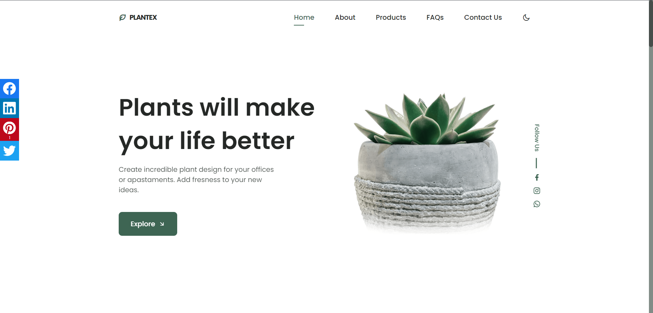

**home**

**menu**

**Kod stranice**

**Html: index.html**

!DOCTYPE html>

    <html lang="en">

    <head>

        <meta charset="UTF-8">

        <meta name="viewport" content="width=device-width, initial-scale=1.0">

        <meta name="description" content="Explore a variety of plants and gardening tips on Plantex - Your Ultimate Plant Companion.">

        <meta name="keywords" content="plants, gardening, flowers, indoor plants, outdoor plants, plant care">

        <meta name="author" content="Nikola Vujetic">

        <!--=============== FAVICON ===============-->

        <link rel="shortcut icon" href="assets/img/favicon.png" type="image/x-icon">

        <!--=============== REMIX ICONS ===============-->

        <link href="https://cdn.jsdelivr.net/npm/remixicon@2.5.0/fonts/remixicon.css" rel="stylesheet">

        <!--=============== CSS ===============-->

        <link rel="stylesheet" href="assets/css/styles.css">

        <!--=============== JQUERY CSS ===============-->

        <link rel="stylesheet" href="assets/css/jquery.floating-social-share.css">

        <title>Plantex - Plants will make your life better</title>

    </head>

    <body>

        <!--==================== HEADER ====================-->

        <header class="header" id="header">

            <nav class="nav container" id="navM">

                <a href="#" class="nav__logo">

                    <i class="ri-leaf-line nav__logo-icon"></i> Plantex

                </a>

                <div class="nav__menu" id="nav-menu">

                    <div class="nav__close" id="nav-close">

                        <i class="ri-close-line"></i>

                    </div>

                </div>

                <div class="nav__btns">

                    <!-- Theme change button -->

                    <i class="ri-moon-line change-theme" id="theme-button"></i>

                    <div class="nav__toggle" id="nav-toggle">

                        <i class="ri-menu-line"></i>

                    </div>

                </div>

            </nav>

        </header>

        <main class="main">

            <!--==================== HOME ====================-->

            <section class="home" id="home">

                <div class="home__container container grid">

                    <img src="assets/img/home.png" alt="" class="home__img">

                    <div class="home__data">

                        <h1 class="home__title">

                            Plants will make <br> your life better

                        </h1>

                        <p class="home__description">

                            Create incredible plant design for your offices or apastaments.

                            Add fresness to your new ideas.

                        </p>

                        <a href="#about" class="button button--flex">

                            Explore <i class="ri-arrow-right-down-line button__icon"></i>

                        </a>

                    </div>

                    <div class="home__social">

                    </div>

                </div>

            </section>

            <!--==================== ABOUT ====================-->

            <section class="about section container" id="about">

                <div class="about__container grid">

                    <img src="assets/img/about.png" alt="" class="about__img">

                    <div class="about__data">

                        <h2 class="section__title about__title">

                            Who we really are & <br> why choose us

                        </h2>

                        <p class="about__description">

                            We have over 4000+ unbiased reviews and our customers

                            trust our plant process and delivery service every time

                        </p>

                        <div class="about__details">

                            <p class="about__details-description">

                                <i class="ri-checkbox-fill about__details-icon"></i>

                                We always deliver on time.

                            </p>

                            <p class="about__details-description">

                                <i class="ri-checkbox-fill about__details-icon"></i>

                                We give you guides to protect and care for your plants.

                            </p>

                            <p class="about__details-description">

                                <i class="ri-checkbox-fill about__details-icon"></i>

                                We always come over for a check-up after sale.

                            </p>

                            <p class="about__details-description">

                                <i class="ri-checkbox-fill about__details-icon"></i>

                                100% money back guaranteed.

                            </p>

                        </div>

                        <a href="#products" class="button--link button--flex">

                            Shop Now <i class="ri-arrow-right-down-line button__icon"></i>

                        </a>

                    </div>

                </div>

            </section>

            <!--==================== STEPS ====================-->

            <section id="steps">

            </section>

            <!--==================== PRODUCTS ====================-->

            <section id="products">

                <h2 class="section__title-center">

                    Check out our <br> products

                </h2>

                <p class="product__description">

                    Here are some selected plants from our showroom, all are in excellent

                    shape and has a long life span. Buy and enjoy best quality.

                </p>

                <div class="cart">

                    <h2>Shopping Cart</h2>

                    <ul id="cartList"></ul>

                    <p>Total: $<span id="totalPrice">0.00</span></p>

                    <button id="resetCartButton">Reset Cart</button>

                </div>

            </section>

            <!--==================== QUESTIONS ====================-->

            <section id="faqs">

                <h2 class="section__title-center questions__title container">

                    Some common questions <br> were often asked

                </h2>

            </section>

            <!--==================== CONTACT ====================-->

            <section id="contact">

            </section>

        </main>

        <!--==================== FOOTER ====================-->

        <footer class="footer section" id="htmlFooter">

            <div class="footer__container container grid">

                <div class="footer__content">

                    <a href="#" class="footer__logo">

                        <i class="ri-leaf-line footer__logo-icon"></i> Plantex

                    </a>

                    <h3 class="footer__title">

                        Subscribe to our newsletter <br> to stay update

                    </h3>

                    <div class="footer__subscribe">

                        <input type="email" id="emailInput" placeholder="Enter your email" class="footer__input">

                        <button id="subscribeButton" class="button button--flex footer__button">

                            Subscribe

                            <i class="ri-arrow-right-up-line button__icon"></i>

                        </button>

                    </div>

                    <div id="message"></div>

                </div>

                <div class="footer__content">

                    <h3 class="footer__title">Our Address</h3>

                    <ul class="footer__data">

                        <li class="footer__information">Serbia</li>

                        <li class="footer__information">Ub - 14210</li>

                        <li class="footer__information"><a href="#" class="footer__social-link">Documentation</a></li>

                    </ul>

                </div>

                <div class="footer__content">

                    <h3 class="footer__title">Contact Us</h3>

                    <ul class="footer__data">

                        <li class="footer__information">+381 130 9495</li>

                        <div class="footer__social">

                            <a href="https://www.facebook.com/profile.php?id=100017969461650" class="footer__social-link">

                                <i class="ri-facebook-fill"></i>

                            </a>

                            <a href="https://www.instagram.com/nikola_vujetic_/" class="footer__social-link">

                                <i class="ri-instagram-line"></i>

                            </a>

                            <a href="https://wa.me/0601309495" class="footer__social-link">

                                <i class="ri-whatsapp-line"></i>

                            </a>

                        </div>

                    </ul>

                </div>

                <div class="footer__content">

                    <h3 class="footer__title">

                        We accept all credit cards

                    </h3>

                    <div class="footer__cards">

                        <img src="assets/img/card1.png" alt="" class="footer__card">

                        <img src="assets/img/card2.png" alt="" class="footer__card">

                        <img src="assets/img/card3.png" alt="" class="footer__card">

                        <img src="assets/img/card4.png" alt="" class="footer__card">

                    </div>

                </div>

            </div>

            <p class="footer__copy">&#169; Nikola Vujetić. All rigths reserved</p>

        </footer>

        <!--=============== SCROLL UP ===============   -->

        <a href="#" class="scrollup" id="scroll-up">

            <i class="ri-arrow-up-fill scrollup__icon"></i>

        </a>

        <!--=============== SCROLL REVEAL ===============-->

        <script src="assets/js/scrollreveal.min.js"></script>

        <script src="assets/js/jquery.min.js"></script>

    <script src="assets/js/jquery.floating-social-share.js"></script>

        <!--=============== MAIN JS ===============-->

        <script src="assets/js/main.js"></script>

    </body>

</html>

**Html: author.html**

<!DOCTYPE html>

    <html lang="en">

    <head>

        <meta charset="UTF-8">

        <meta name="viewport" content="width=device-width, initial-scale=1.0">

        <meta name="description" content="Explore a variety of plants and gardening tips on Plantex - Your Ultimate Plant Companion.">

        <meta name="keywords" content="plants, gardening, flowers, indoor plants, outdoor plants, plant care">

        <meta name="author" content="Nikola Vujetic">

        <!--=============== FAVICON ===============-->

        <link rel="shortcut icon" href="assets/img/favicon.png" type="image/x-icon">

        <!--=============== REMIX ICONS ===============-->

        <link href="https://cdn.jsdelivr.net/npm/remixicon@2.5.0/fonts/remixicon.css" rel="stylesheet">

        <!--=============== CSS ===============-->

        <link rel="stylesheet" href="assets/css/styles.css">

        <!--=============== JQUERY CSS ===============-->

        <link rel="stylesheet" href="assets/css/jquery.floating-social-share.css">

        <title>Plantex - Plants will make your life better</title>

    </head>

    <body>

        <!--==================== HEADER ====================-->

        <header class="header" id="header">

            <nav class="nav container">

                <a href="index.html" class="nav__logo">

                    <i class="ri-leaf-line nav__logo-icon"></i> Plantex

                </a>

            </nav>

        </header>

        <main class="main">

            <div id="wrapper-aboutus">

                <h1>About me</h1>

                <div id="border">

                </div>

                <div id="profile-picture">

                    <img src="assets/img/profile-picture.jpg" alt="Profile picture" />

                </div>

                <div id="description">

                    <p>Motivated and aspiring programming student with a hunger for learning and a keen interest in software development.</p>

                    <p>I thrive on tackling complex problems and enjoy the logical and creative aspects of coding. My coursework has equipped me with a strong understanding of data structures, algorithms, and software development methodologies. I am adept at translating ideas into functional and efficient code, and I constantly seek opportunities to expand my knowledge in emerging technologies.</p>

                    <p>I am actively seeking opportunities to collaborate on projects, contribute to coding challenges, and engage with the programming community to enhance my skills. I am a quick learner, adaptable, and committed to self-improvement.</p>

                </div>

        </main>

        <!--==================== FOOTER ====================-->

        <footer class="footer section" id="htmlFooter">

            <div class="footer__container container grid">

                <div class="footer__content">

                    <a href="#" class="footer__logo">

                        <i class="ri-leaf-line footer__logo-icon"></i> Plantex

                    </a>

                    <h3 class="footer__title">

                        Subscribe to our newsletter <br> to stay update

                    </h3>

                    <div class="footer__subscribe">

                        <input type="email" id="emailInput" placeholder="Enter your email" class="footer__input">

                        <button id="subscribeButton" class="button button--flex footer__button">

                            Subscribe

                            <i class="ri-arrow-right-up-line button__icon"></i>

                        </button>

                    </div>

                    <div id="message"></div>

                </div>

                <div class="footer__content">

                    <h3 class="footer__title">Our Address</h3>

                    <ul class="footer__data">

                        <li class="footer__information">Serbia</li>

                        <li class="footer__information">Ub - 14210</li>

                        <li class="footer__information"><a href="#" class="footer__social-link">Documentation</a></li>

                    </ul>

                </div>

                <div class="footer__content">

                    <h3 class="footer__title">Contact Us</h3>

                    <ul class="footer__data">

                        <li class="footer__information">+381 130 9495</li>

                        <div class="footer__social">

                            <a href="https://www.facebook.com/profile.php?id=100017969461650" class="footer__social-link">

                                <i class="ri-facebook-fill"></i>

                            </a>

                            <a href="https://www.instagram.com/nikola_vujetic_/" class="footer__social-link">

                                <i class="ri-instagram-line"></i>

                            </a>

                            <a href="https://wa.me/0601309495" class="footer__social-link">

                                <i class="ri-whatsapp-line"></i>

                            </a>

                        </div>

                    </ul>

                </div>

                <div class="footer__content">

                    <h3 class="footer__title">

                        We accept all credit cards

                    </h3>

                    <div class="footer__cards">

                        <img src="assets/img/card1.png" alt="" class="footer__card">

                        <img src="assets/img/card2.png" alt="" class="footer__card">

                        <img src="assets/img/card3.png" alt="" class="footer__card">

                        <img src="assets/img/card4.png" alt="" class="footer__card">

                    </div>

                </div>

            </div>

            <p class="footer__copy">&#169; Nikola Vujetić. All rigths reserved</p>

        </footer>

        <!--=============== SCROLL UP ===============-->

        <a href="#" class="scrollup" id="scroll-up">

            <i class="ri-arrow-up-fill scrollup__icon"></i>

        </a>

        <!--=============== SCROLL REVEAL ===============-->

        <script src="assets/js/scrollreveal.min.js"></script>

        <script src="assets/js/jquery.min.js"></script>

    <script src="assets/js/jquery.floating-social-share.js"></script>

        <!--=============== MAIN JS ===============-->

        <script src="assets/js/main.js"></script>

    </body>

</html>

### Css:

/*=============== GOOGLE FONTS ===============*/

@import url('https://fonts.googleapis.com/css2?family=Poppins:wght@400;500;600;700&display=swap');

/*=============== VARIABLES CSS ===============*/

:root {

  --header-height: 3.5rem; /*56px*/

  /*========== Colors ==========*/

  /*Color mode HSL(hue, saturation, lightness)*/

  --hue: 152;

  --first-color: hsl(var(--hue), 24%, 32%);

  --first-color-alt: hsl(var(--hue), 24%, 28%);

  --first-color-light: hsl(var(--hue), 24%, 66%);

  --first-color-lighten: hsl(var(--hue), 24%, 92%);

  --title-color: hsl(var(--hue), 4%, 15%);

  --text-color: hsl(var(--hue), 4%, 35%);

  --text-color-light: hsl(var(--hue), 4%, 55%);

  --body-color: hsl(var(--hue), 0%, 100%);

  --container-color: #FFF;

  /*========== Font and typography ==========*/

  /*.5rem = 8px | 1rem = 16px ...*/

  --body-font: 'Poppins', sans-serif;

  --big-font-size: 2rem;

  --h1-font-size: 1.5rem;

  --h2-font-size: 1.25rem;

  --h3-font-size: 1rem;

  --normal-font-size: .938rem;

  --small-font-size: .813rem;

  --smaller-font-size: .75rem;

  /*========== Font weight ==========*/

  --font-medium: 500;

  --font-semi-bold: 600;

  /*========== Margenes Bottom ==========*/

  /*.5rem = 8px | 1rem = 16px ...*/

  --mb-0-5: .5rem;

  --mb-0-75: .75rem;

  --mb-1: 1rem;

  --mb-1-5: 1.5rem;

  --mb-2: 2rem;

  --mb-2-5: 2.5rem;

  /*========== z index ==========*/

  --z-tooltip: 10;

  --z-fixed: 100;

}

/* Responsive typography */

@media screen and (min-width: 968px) {

  :root {

    --big-font-size: 3.5rem;

    --h1-font-size: 2.25rem;

    --h2-font-size: 1.5rem;

    --h3-font-size: 1.25rem;

    --normal-font-size: 1rem;

    --small-font-size: .875rem;

    --smaller-font-size: .813rem;

  }

}

/*=============== BASE ===============*/

*{

  box-sizing: border-box;

  padding: 0;

  margin: 0;

}

html{

  scroll-behavior: smooth;

}

body,

button,

input,

textarea{

  font-family: var(--body-font);

  font-size: var(--normal-font-size);

}

body{

  margin: var(--header-height) 0 0 0;

  background-color: var(--body-color);

  color: var(--text-color);

  transition: .4s; /*For animation dark mode*/

}

button{

  cursor: pointer;

  border: none;

  outline: none;

}

h1,h2,h3{

  color: var(--title-color);

  font-weight: var(--font-semi-bold);

}

ul{

  list-style: none;

}

a{

  text-decoration: none;

}

img{

  max-width: 100%;

  height: auto;

}

/*=============== THEME ===============*/

/*========== Variables Dark theme ==========*/

body.dark-theme{

  --first-color-dark: hsl(var(--hue), 8%, 20%);

  --title-color: hsl(var(--hue), 4%, 95%);

  --text-color: hsl(var(--hue), 4%, 75%);

  --body-color: hsl(var(--hue), 8%, 12%);

  --container-color: hsl(var(--hue), 8%, 16%);

}

/*========== Button Dark/Light ==========*/

.change-theme{

  color: var(--title-color);

  font-size: 1.15rem;

  cursor: pointer;

}

.nav__btns{

  display: inline-flex;

  align-items: center;

  column-gap: 1rem;

}

/*==========

Color changes in some parts of

the website, in dark theme

==========*/

.dark-theme .steps__bg,

.dark-theme .questions{

  background-color: var(--first-color-dark);

}

.dark-theme .product__circle,

.dark-theme .footer__subscribe{

  background-color: var(--container-color);

}

.dark-theme .scroll-header{

  box-shadow: 0 1px 4px hsla(var(--hue), 4%, 4%, .3);

}

/*=============== REUSABLE CSS CLASSES ===============*/

.section{

  padding: 5.5rem 0 1rem;

}

.section__title,

.section__title-center{

  font-size: var(--h2-font-size);

  margin-bottom: var(--mb-2);

  line-height: 140%;

}

.section__title-center{

  text-align: center;

}

.container{

  max-width: 968px;

  margin-left: var(--mb-1-5);

  margin-right: var(--mb-1-5);

}

.grid{

  display: grid;

}

.main{

  overflow: hidden; /*For animation*/

}

/*=============== HEADER ===============*/

.header{

  width: 100%;

  background-color: var(--body-color);

  position: fixed;

  top: 0;

  left: 0;

  z-index: var(--z-fixed);

  transition: .4s; /*For animation dark mode*/

}

/*=============== NAV ===============*/

.nav{

  height: var(--header-height);

  display: flex;

  justify-content: space-between;

  align-items: center;

}

.nav__logo,

.nav__toggle,

.nav__close{

  color: var(--title-color);

}

.nav__logo{

  text-transform: uppercase;

  font-weight: 700;

  letter-spacing: -1px;

  display: inline-flex;

  align-items: center;

  column-gap: .5rem;

  transition: .3s;

}

.nav__logo-icon{

  font-size: 1.15rem;

  color: var(--first-color);

}

.nav__logo:hover{

  color: var(--first-color);

}

.nav__toggle{

  display: inline-flex;

  font-size: 1.25rem;

  cursor: pointer;

}

@media screen and (max-width: 767px){

  .nav__menu{

    position: fixed;

    background-color: var(--container-color);

    width: 80%;

    height: 100%;

    top: 0;

    right: -100%;

    box-shadow: -2px 0 4px hsla(var(--hue), 24%, 15%, .1);

    padding: 4rem 0 0 3rem;

    border-radius: 1rem 0 0 1rem;

    transition: .3s;

    z-index: var(--z-fixed);

  }

}

.nav__close{

  font-size: 1.5rem;

  position: absolute;

  top: 1rem;

  right: 1.25rem;

  cursor: pointer;

}

.nav__list{

  display: flex;

  flex-direction: column;

  row-gap: 1.5rem;

}

.nav__link{

  color: var(--title-color);

  font-weight: var(--font-medium);

  transition: .3s;

}

.nav__link:hover{

  color: var(--first-color);

}

/* Show menu */

.show-menu{

  right: 0;

}

/* Change background header */

.scroll-header{

  box-shadow: 0 1px 4px hsla(var(--hue), 4%, 15%, .1);

}

/* Active link */

.active-link{

  position: relative;

  color: var(--first-color);

}

.active-link::after{

  content: '';

  position: absolute;

  bottom: -.5rem;

  left: 0;

  width: 50%;

  height: 2px;

  background-color: var(--first-color);

}

/*=============== HOME ===============*/

.home{

  padding: 3.5rem 0 2rem;

}

.home__container{

  position: relative;

  row-gap: 2rem;

}

.home__img{

  width: 200px;

  justify-self: center;

}

.home__title{

  font-size: var(--big-font-size);

  line-height: 140%;

  margin-bottom: var(--mb-1);

}

.home__description{

  margin-bottom: var(--mb-2-5);

}

.home__social{

  position: absolute;

  top: 2rem;

  right: -1rem;

  display: grid;

  justify-items: center;

  row-gap: 3.5rem;

}

.home__social-follow{

  font-weight: var(--font-medium);

  font-size: var(--smaller-font-size);

  color: var(--first-color);

  position: relative;

  transform: rotate(90deg);

}

.home__social-follow::after{

  content: '';

  position: absolute;

  width: 1rem;

  height: 2px;

  background-color: var(--first-color);

  right: -45%;

  top: 50%;

}

.home__social-links{

  display: inline-flex;

  flex-direction: column;

  row-gap: .25rem;

}

.home__social-link{

  font-size: 1rem;

  color: var(--first-color);

  transition: .3s;

}

.home__social-link:hover{

  transform: translateX(.25rem);

}

/*=============== BUTTONS ===============*/

.button{

  display: inline-block;

  background-color: var(--first-color);

  color: #FFF;

  padding: 1rem 1.75rem;

  border-radius: .5rem;

  font-weight: var(--font-medium);

  transition: .3s;

}

.button:hover{

  background-color: var(--first-color-alt);

}

.button__icon{

  transition: .3s;

}

.button:hover .button__icon{

  transform: translateX(.25rem);

}

.button--flex{

  display: inline-flex;

  align-items: center;

  column-gap: .5rem;

}

.button--link{

  color: var(--first-color);

  font-weight: var(--font-medium);

}

.button--link:hover .button__icon{

  transform: translateX(.25rem);

}

/*=============== ABOUT ===============*/

.about__container{

  row-gap: 2rem;

}

.about__img{

  width: 280px;

  justify-self: center;

}

.about__title{

  margin-bottom: var(--mb-1);

}

.about__description{

  margin-bottom: var(--mb-2);

}

.about__details{

  display: grid;

  row-gap: 1rem;

  margin-bottom: var(--mb-2-5);

}

.about__details-description{

  display: inline-flex;

  column-gap: .5rem;

  font-size: var(--small-font-size);

}

.about__details-icon{

  font-size: 1rem;

  color: var(--first-color);

  margin-top: .15rem;

}

/*=============== STEPS ===============*/

.steps__bg{

  background-color: var(--first-color);

  padding: 3rem 2rem 2rem;

  border-radius: 1rem;

}

.steps__container{

  gap: 2rem;

  padding-top: 1rem;

}

.steps__title{

  color: #FFF;

}

.steps__card{

  background-color: var(--container-color);

  padding: 2.5rem 3rem 2rem 1.5rem;

  border-radius: 1rem;

}

.steps__card-number{

  display: inline-block;

  background-color: var(--first-color-alt);

  color: #FFF;

  padding: .5rem .75rem;

  border-radius: .25rem;

  font-size: var(--h2-font-size);

  margin-bottom: var(--mb-1-5);

  transition: .3s;

}

.steps__card-title{

  font-size: var(--h3-font-size);

  margin-bottom: var(--mb-0-5);

}

.steps__card-description{

  font-size: var(--small-font-size);

}

.steps__card:hover .steps__card-number{

  transform: translateY(-.25rem);

}

/*=============== PRODUCTS ===============*/

.product__description{

  text-align: center;

}

.product__container{

  padding: 3rem 0;

  grid-template-columns: repeat(2, 1fr);

  gap: 2.5rem 3rem;

}

.product__card{

  display: grid;

  position: relative;

}

.product__img{

  position: relative;

  width: 120px;

  justify-self: center;

  margin-bottom: var(--mb-0-75);

  transition: .3s;

}

.product__title,

.product__price{

  font-size: var(--small-font-size);

  font-weight: var(--font-semi-bold);

  color: var(--title-color);

}

.product__title{

  margin-bottom: .25rem;

}

.product__button{

  position: absolute;

  right: 0;

  bottom: 0;

  background-color: var(--first-color);

  color: #FFF;

  padding: .25rem;

  border-radius: .35rem;

  font-size: 1.15rem;

}

.product__button:hover{

  background-color: var(--first-color-alt);

}

.product__circle{

  width: 90px;

  height: 90px;

  background-color: var(--first-color-lighten);

  border-radius: 50%;

  position: absolute;

  top: 18%;

  left: 5%;

}

.product__card:hover .product__img{

  transform: translateY(-.5rem);

}

/*=============== QUESTIONS ===============*/

.questions{

  background-color: var(--first-color-lighten);

}

.questions__container{

  gap: 1.5rem;

  padding: 1.5rem 0;

}

.questions__group{

  display: grid;

  row-gap: 1.5rem;

}

.questions__item{

  background-color: var(--container-color);

  border-radius: .25rem;

}

.questions__item-title{

  font-size: var(--small-font-size);

  font-weight: var(--font-medium);

}

.questions__icon{

  font-size: 1.25rem;

  color: var(--title-color);

}

.questions__description{

  font-size: var(--smaller-font-size);

  padding: 0 1.25rem 1.25rem 2.5rem;

}

.questions__header{

  display: flex;

  align-items: center;

  column-gap: .5rem;

  padding: .75rem .5rem;

  cursor: pointer;

}

.questions__content{

  overflow: hidden;

  height: 0;

}

.questions__item,

.questions__header,

.questions__item-title,

.questions__icon,

.questions__description,

.questions__content{

  transition: .3s;

}

.questions__item:hover{

  box-shadow: 0 2px 8px hsla(var(--hue), 4%, 15%, .15);

}

/*Rotate icon, change color of titles and background*/

.accordion-open .questions__header,

.accordion-open .questions__content{

  background-color: var(--first-color);

}

.accordion-open .questions__item-title,

.accordion-open .questions__description,

.accordion-open .questions__icon{

  color: #FFF;

}

.accordion-open .questions__icon{

  transform: rotate(45deg);

}

/*=============== CONTACT ===============*/

.contact__container{

  row-gap: 3.5rem;

}

.contact__data{

  display: grid;

  row-gap: 2rem;

}

.contact__subtitle{

  font-size: var(--normal-font-size);

  font-weight: var(--font-medium);

  color: var(--text-color);

  margin-bottom: var(--mb-0-5);

}

.contact__description{

  display: inline-flex;

  align-items: center;

  column-gap: .5rem;

  color: var(--title-color);

  font-weight: var(--font-medium);

}

.contact__icon{

  font-size: 1.25rem;

}

.contact__inputs{

  display: grid;

  row-gap: 2rem;

  margin-bottom: var(--mb-2-5);

}

.contact__content{

  position: relative;

  height: 3rem;

  border-bottom: 1px solid var(--text-color-light);

}

.contact__input{

  position: absolute;

  top: 0;

  left: 0;

  width: 100%;

  height: 100%;

  padding: 1rem 1rem 1rem 0;

  background: none;

  color: var(--text-color);

  border: none;

  outline: none;

  z-index: 1;

}

.contact__label{

  position: absolute;

  top: .75rem;

  width: 100%;

  font-size: var(--small-font-size);

  color: var(--text-color-light);

  transition: .3s;

}

.contact__area{

  height: 7rem;

}

.contact__area textarea{

  resize: none;

}

/*Input focus move up label*/

.contact__input:focus + .contact__label{

  top: -.75rem;

  left: 0;

  font-size: var(--smaller-font-size);

  z-index: 10;

}

/*Input focus sticky top label*/

.contact__input:not(:placeholder-shown).contact__input:not(:focus) + .contact__label{

  top: -.75rem;

  font-size: var(--smaller-font-size);

  z-index: 10;

}

.radioB{

  width: 4%;

}

.radioLabel{

  margin-left: 2%;

}

.rDiv{

  display:inline-flex;

  align-items: center;

}

/*=============== FOOTER ===============*/

.footer__container{

  row-gap: 3rem;

}

.footer__logo{

  display: inline-flex;

  align-items: center;

  column-gap: .5rem;

  color: var(--title-color);

  text-transform: uppercase;

  font-weight: 700;

  letter-spacing: -1px;

  margin-bottom: var(--mb-2-5);

  transition: .3s;

}

.footer__logo-icon{

  font-size: 1.15rem;

  color: var(--first-color);

}

.footer__logo:hover{

  color: var(--first-color);

}

.footer__title{

  font-size: var(--h3-font-size);

  margin-bottom: var(--mb-1-5);

}

.footer__subscribe{

  background-color: var(--first-color-lighten);

  padding: .75rem;

  display: flex;

  justify-content: space-between;

  border-radius: .5rem;

}

.footer__input{

  width: 70%;

  padding: 0 .5rem;

  background: none;

  color: var(--text-color);

  border: none;

  outline: none;

}

.footer__button{

  padding: 1rem;

}

.footer__data{

  display: grid;

  row-gap: .75rem;

}

.footer__information{

  font-size: var(--small-font-size);

}

.footer__social{

  display: inline-flex;

  column-gap: .75rem;

}

.footer__social-link{

  font-size: 1rem;

  color: var(--text-color);

  transition: .3s;

}

.footer__social-link:hover{

  transform: translateY(-.25rem);

}

.footer__cards{

  display: inline-flex;

  align-items: center;

  column-gap: .5rem;

}

.footer__card{

  width: 35px;

}

.footer__copy{

  text-align: center;

  font-size: var(--smaller-font-size);

  color: var(--text-color-light);

  margin: 5rem 0 1rem;

}

/*=============== SCROLL UP ===============*/

.scrollup{

  position: fixed;

  background-color: var(--first-color);

  right: 1rem;

  bottom: -30%;

  display: inline-flex;

  padding: .5rem;

  border-radius: .25rem;

  z-index: var(--z-tooltip);

  opacity: .8;

  transition: .4s;

}

.scrollup__icon{

  font-size: 1rem;

  color: #FFF;

}

.scrollup:hover{

  background-color: var(--first-color-alt);

  opacity: 1;

}

/* Show Scroll Up*/

.show-scroll{

  bottom: 3rem;

}

/*=============== SCROLL BAR ===============*/

::-webkit-scrollbar{

  width: .6rem;

  background: hsl(var(--hue), 4%, 53%);

}

::-webkit-scrollbar-thumb{

  background: hsl(var(--hue), 4%, 29%);

  border-radius: .5rem;

}

/*=============== BREAKPOINTS ===============*/

/* For small devices */

@media screen and (max-width: 320px){

  .container{

    margin-left: var(--mb-1);

    margin-right: var(--mb-1);

  }

  .home__img{

    width: 180px;

  }

  .home__title{

    font-size: var(--h1-font-size);

  }

  .steps__bg{

    padding: 2rem 1rem;

  }

  .steps__card{

    padding: 1.5rem;

  }

  .product__container{

    grid-template-columns: .6fr;

    justify-content: center;

  }

}

/* For medium devices */

@media screen and (min-width: 576px){

  .steps__container{

    grid-template-columns: repeat(2, 1fr);

  }

  .product__description{

    padding: 0 4rem;

  }

  .product__container{

    grid-template-columns: repeat(2, 170px);

    justify-content: center;

    column-gap: 5rem;

  }

  .footer__subscribe{

    width: 400px;

  }

}

@media screen and (min-width: 767px){

  body{

    margin: 0;

  }

  .nav{

    height: calc(var(--header-height) + 1.5rem);

    column-gap: 3rem;

  }

  .nav__toggle,

  .nav__close{

    display: none;

  }

  .nav__list{

    flex-direction: row;

    column-gap: 3rem;

  }

  .nav__menu{

    margin-left: auto;

  }

  .home__container,

  .about__container,

  .questions__container,

  .contact__container,

  .footer__container{

    grid-template-columns: repeat(2, 1fr);

  }

  .home{

    padding: 10rem 0 5rem;

  }

  .home__container{

    align-items: center;

  }

  .home__img{

    width: 280px;

    order: 1;

  }

  .home__social{

    top: 30%;

  }

  .questions__container{

    align-items: flex-start;

  }

  .footer__container{

    column-gap: 3rem;

  }

  .footer__subscribe{

    width: initial;

  }

}

/* For large devices */

@media screen and (min-width: 992px){

  .container{

    margin-left: auto;

    margin-right: auto;

  }

  .section{

    padding: 8rem 0 1rem;

  }

  .section__title,

  .section__title-center{

    font-size: var(--h1-font-size);

  }

  .home{

    padding: 13rem 0 5rem;

  }

  .home__img{

    width: 350px;

  }

  .home__description{

    padding-right: 7rem;

  }

  .about__img{

    width: 380px;

  }

  .steps__container{

    grid-template-columns: repeat(3, 1fr);

  }

  .steps__bg{

    padding: 3.5rem 2.5rem;

  }

  .steps__card-title{

    font-size: var(--normal-font-size);

  }

  .product__description{

    padding: 0 16rem;

  }

  .product__container{

    padding: 4rem 0;

    grid-template-columns: repeat(3, 185px);

    gap: 4rem 6rem;

  }

  .product__img{

    width: 160px;

  }

  .product__circle{

    width: 110px;

    height: 110px;

  }

  .product__title,

  .product__price{

    font-size: var(--normal-font-size);

  }

  .questions__container{

    padding: 1rem 0 4rem;

  }

  .questions__title{

    text-align: initial;

  }

  .questions__group{

    row-gap: 2rem;

  }

  .questions__header{

    padding: 1rem;

  }

  .questions__description{

    padding: 0 3.5rem 2.25rem 2.75rem;

  }

  .footer__logo{

    font-size: var(--h3-font-size);

  }

  .footer__container{

    grid-template-columns: 1fr .5fr .5fr .5fr;

  }

  .footer__copy{

    margin: 7rem 0 2rem;

  }

}

@media screen and (min-width: 1200px){

  .home__social{

    right: -3rem;

    row-gap: 4.5rem;

  }

  .home__social-follow{

    font-size: var(--small-font-size);

  }

  .home__social-follow::after{

    width: 1.5rem;

    right: -60%;

  }

  .home__social-link{

    font-size: 1.15rem;

  }

  .about__container{

    column-gap: 7rem;

  }

  .scrollup{

    right: 3rem;

  }

}

/* author */

#wrapper-aboutus{

  text-align: center;

  height: 800px;

  width: 80%;

  margin: 0 auto;

  color: #1a1a1d;

  padding-top: 9%;

}

#profile-picture{

  width: 24%;

  height: 400px;

  margin-left: 15%;

  margin-top: 5%;

  background-color: #1a1a1d;

  border: 2px solid #191919;

  box-shadow: 0 5px 15px rgba(0,0,0,0.5);

}

#description{

  width: 35%;

  position: relative;

  font-size: 18px;

  text-align: justify;

  top: -400px;

  right: -55%;

}

.white{

  background-color: #dfe2db;

}

#profile-picture img{

  width: 100%;

  height: 100%;

}

#border{

  width: 100px;

  height: 10px;

  margin: 30px auto;

  background-color: hsl(var(--hue), 24%, 32%);

}

.correct{

  margin-bottom: 10px;

    color: #7bc043;

}

.mistake{

  margin-bottom: 10px;

    color: #ee4035;

    font-size: .9em;

}

#rDiv{

  display: flex;

  align-items: center;

  justify-content: center;

  display: inline-flex;

}

input[type='radio']:after {

  width: 15px;

  height: 15px;

  border-radius: 15px;

  top: -2px;

  left: -1px;

  position: relative;

  background-color: #d1d3d1;

  content: '';

  display: inline-block;

  visibility: visible;

  border: 2px solid white;

}

input[type='radio']:checked:after {

  width: 15px;

  height: 15px;

  border-radius: 15px;

  top: -2px;

  left: -1px;

  position: relative;

  background-color: hsl(var(--hue), 24%, 32%);

  content: '';

  display: inline-block;

  visibility: visible;

  border: 2px solid white;

}

#message {

  padding-bottom: 2rem;

  opacity: 1;

  transition: opacity 0.5s ease-out;

}

## Organizacija

### Organizaciona šema:

## Sajt sadrži:

* “index.html”
* “author.html

Na index.html stranici se preko linkova može pristupiti svakom delu stranice, kao i stranici do author.html. Na author.html stranici se preko logoa(linka) može pristupiti index.html stranici.

Mapa sajta

<?xml version="1.0" encoding="UTF-8"?>

<urlset

xmlns="http://www.sitemaps.org/schemas/sitemap/0.9"

xmlns:xsi="http://www.w3.org/2001/XMLSchema-instance"

xsi:schemaLocation="http://www.sitemaps.org/schemas/sitemap/0.9

http://www.sitemaps.org/schemas/sitemap/0.9/sitemap.xsd">

<!-- created with Free Online Sitemap Generator www.xml-sitemaps.com -->

<url>

<loc>https://gazz7.github.io/index.html</loc>

<lastmod>2023-12-12</lastmod>

<priority>1.00</priority>

</url>

<url>

<loc>https://gazz7.github.io/author.html</loc>

<lastmod>2020-12-11</lastmod>

<priority>0.80</priority>

</url>

</urlset>

**Index.html:**

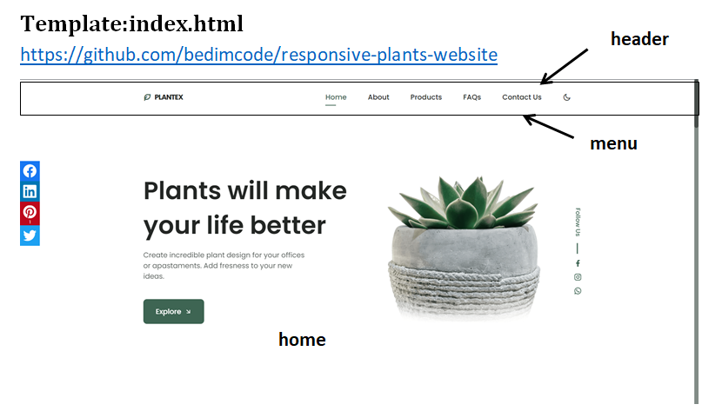

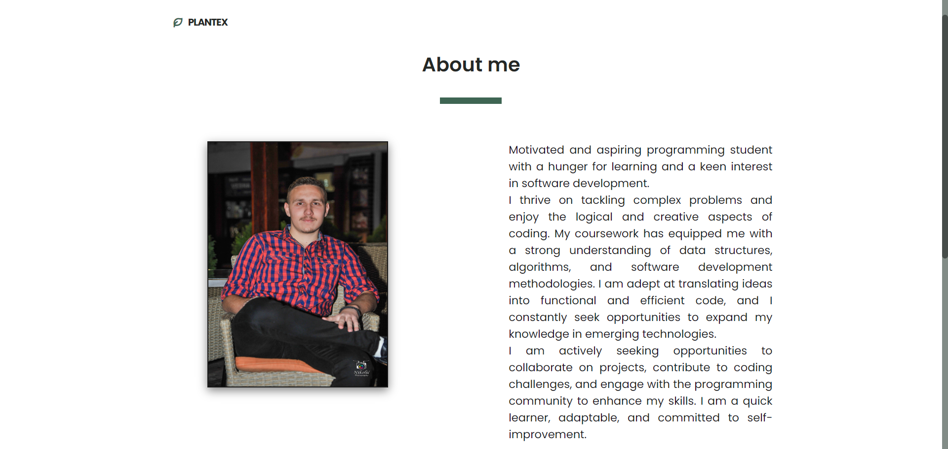

**description**

**Profile-picture**

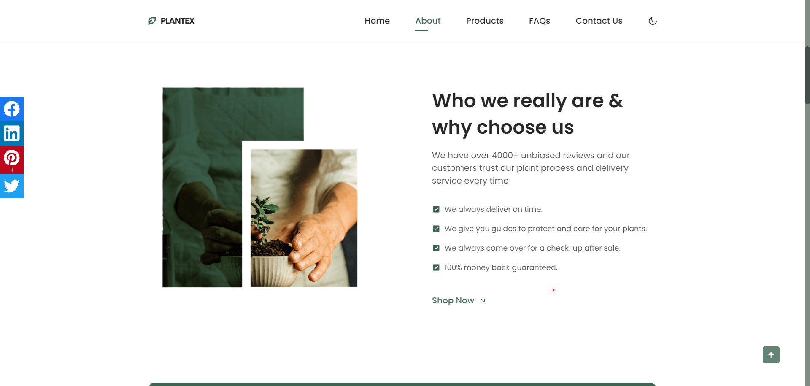

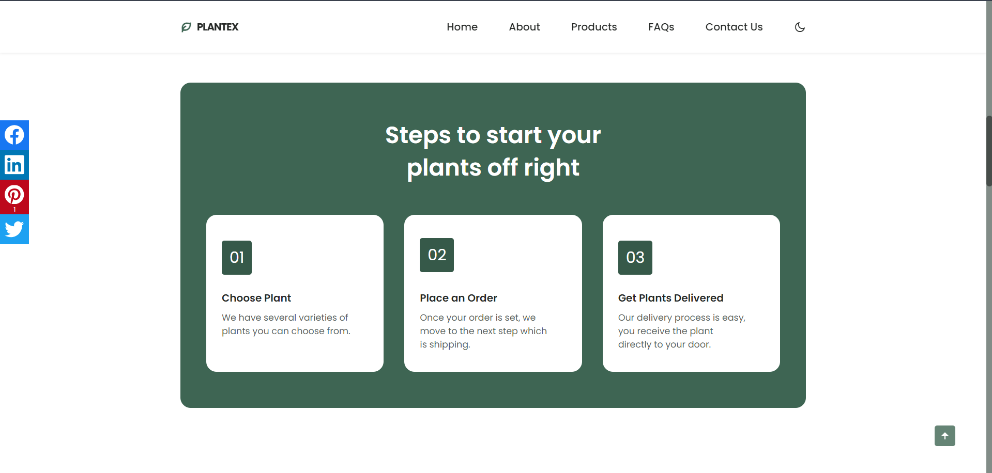

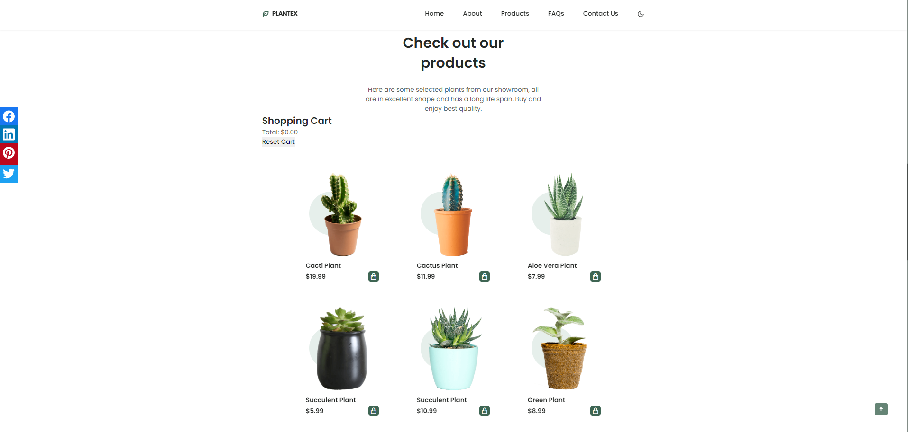

**cart**

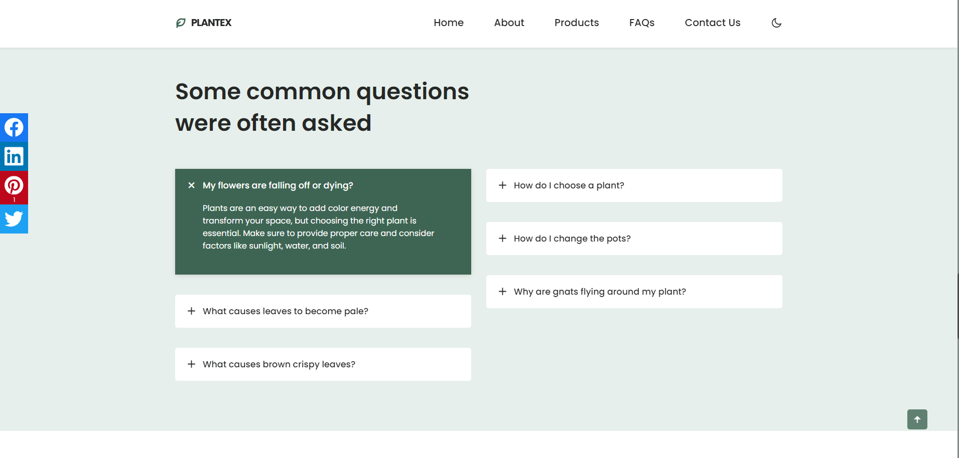

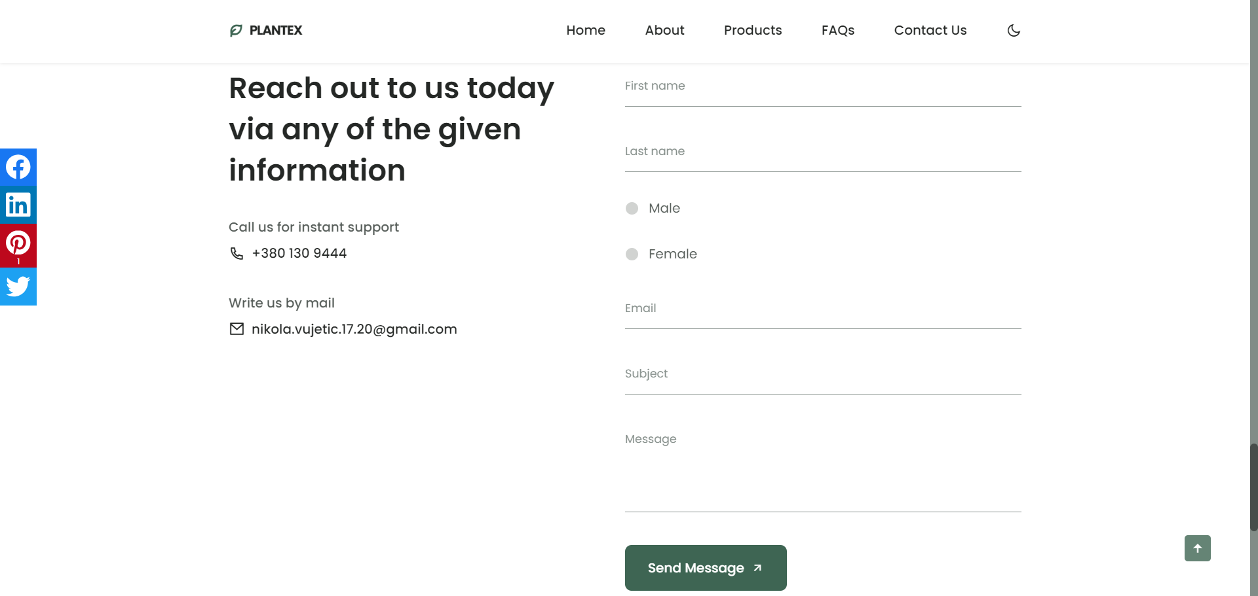

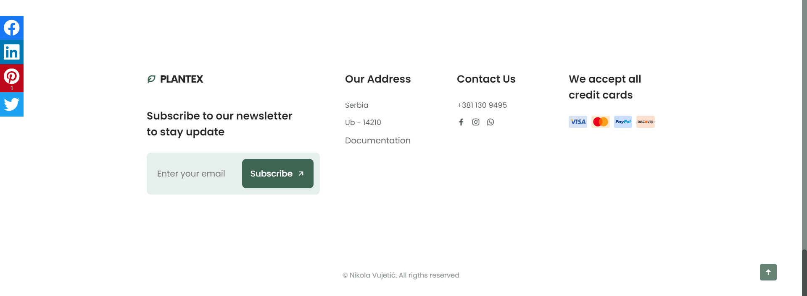

**footer**

**Kodovi:**

**Javascript kod za ceo sajt:**

    // Data for navigation items

    const navData = [

      { text: "Home", link: "#home", active: true },

      { text: "About", link: "#about", active: false },

      { text: "Products", link: "#products", active: false },

      { text: "FAQs", link: "#faqs", active: false },

      { text: "Contact Us", link: "#contact", active: false },

      { text: "Author", link: "author.html", active: false }

  ];

  // Create the navigation list dynamically

  const navList = document.createElement("ul");

  navList.classList.add("nav__list");

  navData.forEach(item => {

      const navItem = document.createElement("li");

      navItem.classList.add("nav__item");

      const navLink = document.createElement("a");

      navLink.href = item.link;

      navLink.classList.add("nav__link");

      if (item.active) {

          navLink.classList.add("active-link");

      }

      navLink.textContent = item.text;

      navItem.appendChild(navLink);

      navList.appendChild(navItem);

  });

  // Append the generated navigation to the container

  const navContainer = document.getElementById("nav-menu");

  navContainer.appendChild(navList);

  // nav author

// Home - social network

// Data for social links

const socialLinksData = [

  { platform: 'Facebook', url: 'https://www.facebook.com/profile.php?id=100017969461650', iconClass: 'ri-facebook-fill' },

  { platform: 'Instagram', url: 'https://www.instagram.com/nikola_vujetic_/', iconClass: 'ri-instagram-line' },

  { platform: 'Whatsapp', url: 'https://wa.me/381601309495', iconClass: 'ri-whatsapp-line' }

];

// Create the social links dynamically

const homeSocialContainer = document.querySelector('.home__social');

const socialContainer = document.createElement('div');

socialContainer.classList.add('home__social-links');

socialLinksData.forEach(link => {

  const socialLink = document.createElement('a');

  socialLink.href = link.url;

  socialLink.target = '_blank';

  socialLink.classList.add('home__social-link');

  const icon = document.createElement('i');

  icon.classList.add(link.iconClass);

  socialLink.appendChild(icon);

  socialContainer.appendChild(socialLink);

});

// Create the "Follow Us" span element

const followUsSpan = document.createElement('span');

followUsSpan.classList.add('home__social-follow');

followUsSpan.textContent = 'Follow Us';

// Append the "Follow Us" span and social links to the container

homeSocialContainer.appendChild(followUsSpan);

homeSocialContainer.appendChild(socialContainer);

// STEPS

// Create the steps dynamically

const stepsData = [

  { number: '01', title: 'Choose Plant', description: 'We have several varieties of plants you can choose from.' },

  { number: '02', title: 'Place an Order', description: 'Once your order is set, we move to the next step which is shipping.' },

  { number: '03', title: 'Get Plants Delivered', description: 'Our delivery process is easy, you receive the plant directly to your door.' }

];

// Create the steps dynamically

const stepsSection = document.getElementById('steps');

stepsSection.classList.add('steps', 'section', 'container');

const stepsBg = document.createElement('div');

stepsBg.classList.add('steps__bg');

const stepsTitle = document.createElement('h2');

stepsTitle.classList.add('section__title-center', 'steps__title');

stepsTitle.innerHTML = 'Steps to start your <br> plants off right';

const stepsCardsContainer = document.createElement('div');

stepsCardsContainer.classList.add('steps__container', 'grid');

stepsData.forEach(step => {

  const stepsCard = document.createElement('div');

  stepsCard.classList.add('steps__card');

  const stepsCardNumber = document.createElement('div');

  stepsCardNumber.classList.add('steps__card-number');

  stepsCardNumber.textContent = step.number;

  const stepsCardTitle = document.createElement('h3');

  stepsCardTitle.classList.add('steps__card-title');

  stepsCardTitle.textContent = step.title;

  const stepsCardDescription = document.createElement('p');

  stepsCardDescription.classList.add('steps__card-description');

  stepsCardDescription.textContent = step.description;

  stepsCard.appendChild(stepsCardNumber);

  stepsCard.appendChild(stepsCardTitle);

  stepsCard.appendChild(stepsCardDescription);

  stepsCardsContainer.appendChild(stepsCard);

});

// Append elements to the body

stepsSection.appendChild(stepsBg);

stepsBg.appendChild(stepsTitle);

stepsBg.appendChild(stepsCardsContainer);

// PRODUCTS

const productsData = [

  { imgSrc: 'assets/img/product1.png', title: 'Cacti Plant', price: '$19.99' },

  { imgSrc: 'assets/img/product2.png', title: 'Cactus Plant', price: '$11.99' },

  { imgSrc: 'assets/img/product3.png', title: 'Aloe Vera Plant', price: '$7.99' },

  { imgSrc: 'assets/img/product4.png', title: 'Succulent Plant', price: '$5.99' },

  { imgSrc: 'assets/img/product5.png', title: 'Succulent Plant', price: '$10.99' },

  { imgSrc: 'assets/img/product6.png', title: 'Green Plant', price: '$8.99' },

];

// Create the product section dynamically

const productSection = document.getElementById('products');

productSection.classList.add('product', 'section', 'container');

const productContainer = document.createElement('div');

productContainer.classList.add('product__container', 'grid');

productsData.forEach(product => {

  const productCard = document.createElement('article');

  productCard.classList.add('product__card');

  const productCircle = document.createElement('div');

  productCircle.classList.add('product__circle');

  const productImg = document.createElement('img');

  productImg.src = product.imgSrc;

  productImg.alt = '';

  productImg.classList.add('product__img');

  const productTitle = document.createElement('h3');

  productTitle.classList.add('product__title');

  productTitle.textContent = product.title;

  const productPrice = document.createElement('span');

  productPrice.classList.add('product__price');

  productPrice.textContent = product.price;

  const productButton = document.createElement('button');

  productButton.classList.add('button--flex', 'product__button');

  const productIcon = document.createElement('i');

  productIcon.classList.add('ri-shopping-bag-line');

  // Append elements to the product card

  productButton.appendChild(productIcon);

  productCard.appendChild(productCircle);

  productCard.appendChild(productImg);

  productCard.appendChild(productTitle);

  productCard.appendChild(productPrice);

  productCard.appendChild(productButton);

  // Append the product card to the container

  productContainer.appendChild(productCard);

});

// Append elements to the body

productSection.appendChild(productContainer);

// FAQ

const faqsData = [

  { title: 'My flowers are falling off or dying?', description: 'Plants are an easy way to add color energy and transform your space, but choosing the right plant is essential. Make sure to provide proper care and consider factors like sunlight, water, and soil.' },

  { title: 'What causes leaves to become pale?', description: 'Plants can have pale leaves due to various factors such as nutrient deficiencies, insufficient light, or improper watering. Identify the specific needs of your plant and adjust care accordingly.' },

  { title: 'What causes brown crispy leaves?', description: 'Brown crispy leaves can be a sign of underwatering, overwatering, or environmental stress. Check the soil moisture, adjust watering, and ensure the plant is in suitable conditions.' },

  { title: 'How do I choose a plant?', description: 'Choosing a plant depends on factors like your location, available sunlight, and the level of care you can provide. Research different plant species and consider their specific requirements before making a selection.' },

  { title: 'How do I change the pots?', description: 'When changing pots, choose a container with drainage holes, use well-draining soil, and carefully transplant the plant. Be gentle to avoid damaging the roots, and water the plant after repotting.' },

  { title: 'Why are gnats flying around my plant?', description: 'Gnats around plants may indicate overwatering or damp soil. Allow the soil to dry out between waterings, and consider using sticky traps to capture the gnats. Maintain good hygiene to prevent infestations.' },

];

// Create the FAQ section dynamically

const faqSection = document.getElementById('faqs');

faqSection.classList.add('questions', 'section');

const faqContainer = document.createElement('div');

faqContainer.classList.add('questions__container', 'container', 'grid');

// Create FAQ groups dynamically

const faqGroups = faqsData.reduce((groups, faq, index) => {

  const groupIndex = Math.floor(index / 3);

  if (!groups[groupIndex]) {

      groups[groupIndex] = document.createElement('div');

      groups[groupIndex].classList.add('questions__group');

  }

  const faqItem = document.createElement('div');

  faqItem.classList.add('questions__item');

  const faqHeader = document.createElement('header');

  faqHeader.classList.add('questions__header');

  const faqIcon = document.createElement('i');

  faqIcon.classList.add('ri-add-line', 'questions__icon');

  const faqTitle = document.createElement('h3');

  faqTitle.classList.add('questions__item-title');

  faqTitle.textContent = faq.title;

  const faqContent = document.createElement('div');

  faqContent.classList.add('questions__content');

  const faqDescription = document.createElement('p');

  faqDescription.classList.add('questions__description');

  faqDescription.textContent = faq.description;

  // Append elements to the FAQ item

  faqHeader.appendChild(faqIcon);

  faqHeader.appendChild(faqTitle);

  faqContent.appendChild(faqDescription);

  faqItem.appendChild(faqHeader);

  faqItem.appendChild(faqContent);

  // Append the FAQ item to the group

  groups[groupIndex].appendChild(faqItem);

  return groups;

}, []);

// Append FAQ groups to the container

faqGroups.forEach(group => {

  faqContainer.appendChild(group);

});

// Append elements to the body

faqSection.appendChild(faqContainer);

// CONTACT

// Create the contact section dynamically

const contactSection = document.getElementById('contact');

contactSection.classList.add('contact', 'section', 'container');

// Create the contact container dynamically

const contactContainer = document.createElement('div');

contactContainer.classList.add('contact__container', 'grid');

// Create the contact box dynamically

const contactBox = document.createElement('div');

contactBox.classList.add('contact__box');

// Create the contact title dynamically

const contactTitle = document.createElement('h2');

contactTitle.classList.add('section__title');

contactTitle.innerHTML = 'Reach out to us today <br> via any of the given <br> information';

// Create the contact data dynamically

const contactData = document.createElement('div');

contactData.classList.add('contact__data');

// Create the contact information dynamically

const contactInformation1 = createContactInformation('Call us for instant support', '+380 130 9444', 'ri-phone-line');

const contactInformation2 = createContactInformation('Write us by mail', 'nikola.vujetic.17.20@gmail.com', 'ri-mail-line');

// Append the contact information to the contact data

contactData.appendChild(contactInformation1);

contactData.appendChild(contactInformation2);

// Append the contact title and data to the contact box

contactBox.appendChild(contactTitle);

contactBox.appendChild(contactData);

// Create the contact form dynamically

const contactForm = document.createElement('form');

contactForm.action = '';

contactForm.classList.add('contact__form');

// Create the contact inputs dynamically

const contactInputs = document.createElement('div');

contactInputs.classList.add('contact__inputs');

// Create contact input fields dynamically

createContactInput('text', ' ', 'First name', 'fname');

createContactInput('text', ' ', 'Last name', 'lname');

createRadioButton('male', 'Male', 'male');

createRadioButton('female', 'Female', 'female');

createContactInput('email', ' ', 'Email', 'email');

createContactInput('text', ' ', 'Subject');

// Create the contact area dynamically

const contactArea = document.createElement('div');

contactArea.classList.add('contact__content', 'contact__area');

const contactTextarea = document.createElement('textarea');

contactTextarea.name = 'message';

contactTextarea.placeholder = ' ';

contactTextarea.classList.add('contact__input');

const contactLabelTextarea = document.createElement('label');

contactLabelTextarea.for = '';

contactLabelTextarea.classList.add('contact__label');

contactLabelTextarea.textContent = 'Message';

// Append textarea elements to the contact area

contactArea.appendChild(contactTextarea);

contactArea.appendChild(contactLabelTextarea);

// Append the contact area to the inputs container

contactInputs.appendChild(contactArea);

// Create the send button dynamically

const sendButton = document.createElement('button');

sendButton.classList.add('button', 'button--flex',);

sendButton.id = "buttonS";

const sendButtonText = document.createTextNode('Send Message');

const sendButtonIcon = document.createElement('i');

sendButtonIcon.classList.add('ri-arrow-right-up-line', 'button__icon');

// Append text and icon to the send button

sendButton.appendChild(sendButtonText);

sendButton.appendChild(sendButtonIcon);

// Append elements to the form

contactForm.appendChild(contactInputs);

contactForm.appendChild(sendButton);

// Append contact box and form to the contact container

contactContainer.appendChild(contactBox);

contactContainer.appendChild(contactForm);

// Append contact container to the contact section

contactSection.appendChild(contactContainer);

// Append section to the body

// Function to create contact information dynamically

function createContactInformation(subtitle, description, iconClass) {

  const contactInformation = document.createElement('div');

  contactInformation.classList.add('contact__information');

  const contactSubtitle = document.createElement('h3');

  contactSubtitle.classList.add('contact__subtitle');

  contactSubtitle.textContent = subtitle;

  const contactDescription = document.createElement('span');

  contactDescription.classList.add('contact__description');

  const icon = document.createElement('i');

  icon.classList.add(iconClass, 'contact__icon');

  contactDescription.appendChild(icon);

  contactDescription.innerHTML += description;

  // Append elements to the contact information

  contactInformation.appendChild(contactSubtitle);

  contactInformation.appendChild(contactDescription);

  return contactInformation;

}

// Function to create contact input field

function createContactInput(type, placeholder, labelText, id) {

  const contactContent = document.createElement('div');

  contactContent.classList.add('contact__content');

  const contactInput = document.createElement('input');

  contactInput.type = type;

  contactInput.placeholder = ' ';

  contactInput.setAttribute('id', id);

  contactInput.classList.add('contact__input');

  const contactLabel = document.createElement('label');

  contactLabel.for = '';

  contactLabel.classList.add('contact__label');

  contactLabel.textContent = labelText;

if(labelText === "First name" || labelText === "Last name" || labelText === "Email"){

  const divMessage = document.createElement('div');

}

  // Append elements to the contact content

  contactContent.appendChild(contactInput);

  contactContent.appendChild(contactLabel);

  // Append the contact content to the inputs container

  contactInputs.appendChild(contactContent);

}

// Function to create radio button dynamically

function createRadioButton(id, label, value) {

  const radioDiv = document.createElement('div');

  radioDiv.classList.add("rDiv");

  const radioInput = document.createElement('input');

  radioInput.type = 'radio';

  radioInput.id = id;

  radioInput.classList.add('radioB');

  radioInput.name = 'gender';

  radioInput.value = value;

  const radioLabel = document.createElement('label');

  radioLabel.classList.add('radioLabel');

  radioLabel.for = id;

  radioLabel.textContent = label;

  // Append radio elements to the inputs container

  radioDiv.appendChild(radioInput);

  radioDiv.appendChild(radioLabel);

  contactInputs.appendChild(radioDiv);

}

// SUBSCRIBE BUTTON validation

function validateSubscribe() {

  const emailInput = document.getElementById('emailInput');

  const messageDiv = document.getElementById('message');

  const sub = document.querySelector('.footer__subscribe');

  const email = emailInput.value;

  if (isValidEmail(email)) {

    sub.nextElementSibling.innerHTML = "Successfully subscribed!";

    sub.nextElementSibling.classList.remove("mistake");

    sub.nextElementSibling.classList.add("correct");

  } else {

      sub.nextElementSibling.classList.remove("correct");

      sub.nextElementSibling.classList.add("mistake");

      sub.nextElementSibling.innerHTML = `Invalid address!<br/>Format: example.example@example.eg`;

  }

  setTimeout(() => {

    messageDiv.style.opacity = 0;

    setTimeout(() => {

      sub.nextElementSibling.innerHTML = '';

      sub.nextElementSibling.innerHTML = '';

      messageDiv.style.opacity = 1;

    }, 500);

  }, 3000);

}

// Function to validate email format

function isValidEmail(email) {

  // Simple email validation regex

  const emailRegex = /^[a-z][\d\w\.]*\@[a-z]{3,}(\.[a-z]{2,4}){1,3}$/;

  return emailRegex.test(email);

}

// Add event listener to the "Subscribe" button

const subscribeButton = document.getElementById('subscribeButton');

subscribeButton.addEventListener('click', validateSubscribe);

document.getElementById('buttonS').addEventListener('click', function(event) {

  // Prevent the default form submission

  event.preventDefault();

  document.getElementById('fname').scrollIntoView({

    behavior: 'smooth'

  });

});

// FOOTER

/*document.addEventListener('DOMContentLoaded', function () {

  // Data for dynamic content

  const footerData = [

      {

          title: 'Subscribe',

          logoIcon: 'ri-leaf-line',

          logoText: 'Plantex',

          subtitle: 'Subscribe to our newsletter <br> to stay updated',

          inputId: 'emailInput',

          inputPlaceholder: 'Enter your email',

          buttonId: 'subscribeButton',

          buttonText: 'Subscribe',

          buttonIcon: 'ri-arrow-right-up-line',

          messageId: 'message'

      },

      {

          title: 'Our Address',

          information: ['Serbia', 'Ub - 14210', { text: 'Documentation', url: '#' }]

      },

      {

          title: 'Contact Us',

          information: ['+380 130 9444'],

          socialLinks: [

              { url: 'https://www.facebook.com/profile.php?id=100017969461650', iconClass: 'ri-facebook-fill' },

              { url: 'https://www.instagram.com/nikola_vujetic_/', iconClass: 'ri-instagram-line' }

          ]

      },

      {

          title: 'We accept all credit cards',

          cardImages: ['assets/img/card1.png', 'assets/img/card2.png', 'assets/img/card3.png', 'assets/img/card4.png']

      }

  ];

  // Create footer container

  const footerContainer = document.createElement('div');

  footerContainer.className = 'footer__container container grid';

  // Create Subscribe section first

  const subscribeItem = footerData.shift();

  const subscribeContent = document.createElement('div');

  subscribeContent.className = 'footer__content';

  const logoLink = document.createElement('a');

  logoLink.href = '#';

  logoLink.className = 'footer__logo';

  const logoIcon = document.createElement('i');

  logoIcon.className = `ri-leaf-line ${subscribeItem.logoIcon} footer__logo-icon`;

  logoLink.appendChild(logoIcon);

  logoLink.innerHTML += ` ${subscribeItem.logoText}`;

  subscribeContent.appendChild(logoLink);

  const title = document.createElement('h3');

  title.className = 'footer__title';

  title.innerHTML = subscribeItem.subtitle;

  subscribeContent.appendChild(title);

  const subscribeDiv = document.createElement('div');

  subscribeDiv.className = 'footer__subscribe';

  const emailInput = document.createElement('input');

  emailInput.type = 'email';

  emailInput.id = subscribeItem.inputId;

  emailInput.placeholder = subscribeItem.inputPlaceholder;

  emailInput.className = 'footer__input';

  const subscribeButton = document.createElement('button');

  subscribeButton.id = subscribeItem.buttonId;

  subscribeButton.className = 'button button--flex footer__button';

  subscribeButton.innerHTML = `${subscribeItem.buttonText} <i class="${subscribeItem.buttonIcon} button__icon"></i>`;

  subscribeDiv.appendChild(emailInput);

  subscribeDiv.appendChild(subscribeButton);

  subscribeContent.appendChild(subscribeDiv);

  const messageDiv = document.createElement('div');

  messageDiv.id = subscribeItem.messageId;

  subscribeContent.appendChild(messageDiv);

  footerContainer.appendChild(subscribeContent);

  // Loop through the rest of the data array and create elements dynamically

  footerData.forEach(item => {

      const content = document.createElement('div');

      content.className = 'footer__content';

      const title = document.createElement('h3');

      title.className = 'footer__title';

      title.textContent = item.title;

      content.appendChild(title);

      if (item.information) {

          const dataList = document.createElement('ul');

          dataList.className = 'footer__data';

          item.information.forEach(info => {

              const listItem = document.createElement('li');

              listItem.className = 'footer__information';

              if (typeof info === 'object' && info.text && info.url) {

                  const socialLink = document.createElement('a');

                  socialLink.href = info.url;

                  socialLink.className = 'footer__social-link';

                  socialLink.textContent = info.text;

                  listItem.appendChild(socialLink);

              } else {

                  listItem.textContent = info;

              }

              dataList.appendChild(listItem);

          });

          content.appendChild(dataList);

      }

      if (item.socialLinks) {

          const socialContainer = document.createElement('div');

          socialContainer.className = 'footer__social';

          item.socialLinks.forEach(link => {

              const socialLink = document.createElement('a');

              socialLink.href = link.url;

              socialLink.className = 'footer__social-link';

              const icon = document.createElement('i');

              icon.className = link.iconClass;

              socialLink.appendChild(icon);

              socialContainer.appendChild(socialLink);

          });

          content.appendChild(socialContainer);

      }

      if (item.cardImages) {

          const cardContainer = document.createElement('div');

          cardContainer.className = 'footer__cards';

          item.cardImages.forEach(src => {

              const cardImage = document.createElement('img');

              cardImage.src = src;

              cardImage.alt = '';

              cardImage.className = 'footer__card';

              cardContainer.appendChild(cardImage);

          });

          content.appendChild(cardContainer);

      }

      footerContainer.appendChild(content);

  });

  footer = document.createElement('footer');

  footer.appendChild(footerContainer);

});

*/

// FORM VALIDATION

try {

  //FORME REG EX

  let provera = document.querySelector("#buttonS");

  provera.addEventListener("click", proveri);

  event.preventDefault();

  function proveri() {

    //RegEx Ime

    let firstName = document.querySelector("#fname");

    let regFirstName = /^[A-ZČĆŽŠĐ][a-zčćžšđ]{2,14}(\s[A-ZČĆŽŠĐ][a-zčćžšđ]{2,14})*$/;

    if (regFirstName.test(firstName.value)) {

      email.nextElementSibling.classList.remove("mistake");

      firstName.nextElementSibling.classList.add("correct");

      firstName.nextElementSibling.innerHTML = "Valid entry";

    } else {

      firstName.nextElementSibling.classList.remove("correct");

      firstName.nextElementSibling.classList.add("mistake");

      firstName.nextElementSibling.innerHTML =

        "The first letter must be uppercase and the name can only contain letters.";

    }

    firstName.addEventListener('input', () => {

      if (regFirstName.test(firstName.value)) {

        firstName.nextElementSibling.style.opacity = 0;

      setTimeout(() => {

        firstName.nextElementSibling.innerHTML = '';

        firstName.nextElementSibling.style.opacity = 1;

      }, 2000);

      }

    });

    //RegEx Prezime

    let lastName = document.querySelector("#lname");

    let regLastName = /^[A-ZČĆŽŠĐ][a-zčćžšđ]{2,14}(\s[A-ZČĆŽŠĐ][a-zčćžšđ]{2,14})*$/;

    if (regLastName.test(lastName.value)) {

      email.nextElementSibling.classList.remove("mistake");

      lastName.nextElementSibling.classList.add("correct");

      lastName.nextElementSibling.innerHTML = "Valid entry";

    } else {

      lastName.nextElementSibling.classList.remove("correct");

      lastName.nextElementSibling.classList.add("mistake");

      lastName.nextElementSibling.innerHTML =

        "The first letter must be uppercase and the name can only contain letters.";

    }

    lastName.addEventListener('input', () => {

      if (regLastName.test(lastName.value)) {

        lastName.nextElementSibling.style.opacity = 0;

      setTimeout(() => {

        lastName.nextElementSibling.innerHTML = '';

        lastName.nextElementSibling.style.opacity = 1;

      }, 2000);

      }

    });

    // Radio

    //RegEx Email

    let email = document.querySelector("#email");

    let regEmail = /^[a-z][\d\w\.]*\@[a-z]{3,}(\.[a-z]{2,4}){1,3}$/;

    if (regEmail.test(email.value)) {

      email.nextElementSibling.classList.add("correct");

      email.nextElementSibling.innerHTML = "Valid entry";

    } else {

      email.nextElementSibling.classList.remove("correct");

      email.nextElementSibling.classList.add("mistake");

      email.nextElementSibling.innerHTML = `Format: example.example@example.eg`;

    }

    email.addEventListener('input', () => {

      const emailCorrect = email.value;

      if (isValidEmail(emailCorrect)) {

        email.nextElementSibling.style.opacity = 0;

      setTimeout(() => {

        email.nextElementSibling.innerHTML = '';

        email.nextElementSibling.style.opacity = 1;

      }, 2000);

      }

    });

  }

}

catch (e) { }

$("body").floatingSocialShare({

  buttons: [

    "facebook", "linkedin", "pinterest", "twitter"

  ],

  text: "share with: ",

  url: "https://github.com/ozdemirburak/jquery-floating-social-share"

});

// CART

document.addEventListener('DOMContentLoaded', function () {

  // Cart object to store selected items

  let cart = [];

  const cartList = document.getElementById('cartList');

  const totalPriceElement = document.getElementById('totalPrice');

  const resetCartButton = document.getElementById('resetCartButton');

  // Function to update the cart and UI

  function updateCart(product) {

      cart.push(product);

      renderCart();

  }

  // Function to reset the cart

  function resetCart() {

      cart = [];

      renderCart();

  }

  // Function to render the cart

  function renderCart() {

      // Clear the existing cart

      cartList.innerHTML = '';

      // Calculate and update the total price

      const totalPrice = cart.reduce((total, product) => total + product.price, 0);

      totalPriceElement.textContent = totalPrice.toFixed(2);

      // Render each item in the cart

      cart.forEach(product => {

          const listItem = document.createElement('li');

          listItem.textContent = `${product.title} - $${product.price.toFixed(2)}`;

          cartList.appendChild(listItem);

      });

  }

  // Function to handle button click

  function handleButtonClick(product) {

      updateCart(product);

  }

  // Attach click event listeners to each "Add to Cart" button

  const addToCartButtons = document.querySelectorAll('.product__button');

  addToCartButtons.forEach((button, index) => {

      const product = {

          title: document.querySelectorAll('.product__title')[index].textContent,

          price: parseFloat(document.querySelectorAll('.product__price')[index].textContent.slice(1))

      };

      button.addEventListener('click', () => handleButtonClick(product));

  });

  // Attach click event listener to the "Reset Cart" button

  resetCartButton.addEventListener('click', resetCart);

});

/*=============== SHOW MENU ===============*/

const navMenu = document.getElementById('nav-menu'),

    navToggle = document.getElementById('nav-toggle'),

    navClose = document.getElementById('nav-close')

/*===== MENU SHOW =====*/

/* Validate if constant exists */

if(navToggle){

  navToggle.addEventListener('click', () =>{

      navMenu.classList.add('show-menu')

  })

}

/*===== MENU HIDDEN =====*/

/* Validate if constant exists */

if(navClose){

  navClose.addEventListener('click', () =>{

      navMenu.classList.remove('show-menu')

  })

}

/*=============== REMOVE MENU MOBILE ===============*/

const navLink = document.querySelectorAll('.nav__link')

function linkAction(){

  const navMenu = document.getElementById('nav-menu')

  // When we click on each nav__link, we remove the show-menu class

  navMenu.classList.remove('show-menu')

}

navLink.forEach(n => n.addEventListener('click', linkAction))

/*=============== CHANGE BACKGROUND HEADER ===============*/

function scrollHeader(){

  const header = document.getElementById('header')

  // When the scroll is greater than 80 viewport height, add the scroll-header class to the header tag

  if(this.scrollY >= 80) header.classList.add('scroll-header'); else header.classList.remove('scroll-header')

}

window.addEventListener('scroll', scrollHeader)

/*=============== QUESTIONS ACCORDION ===============*/

const accordionItems = document.querySelectorAll('.questions__item')

accordionItems.forEach((item) =>{

  const accordionHeader = item.querySelector('.questions__header')

  accordionHeader.addEventListener('click', () =>{

      const openItem = document.querySelector('.accordion-open')

      toggleItem(item)

      if(openItem && openItem!== item){

          toggleItem(openItem)

      }

  })

})

const toggleItem = (item) =>{

  const accordionContent = item.querySelector('.questions__content')

  if(item.classList.contains('accordion-open')){

      accordionContent.removeAttribute('style')

      item.classList.remove('accordion-open')

  }else{

      accordionContent.style.height = accordionContent.scrollHeight + 'px'

      item.classList.add('accordion-open')

  }

}

/*=============== SCROLL SECTIONS ACTIVE LINK ===============*/

const sections = document.querySelectorAll('section[id]')

function scrollActive(){

  const scrollY = window.pageYOffset;

  sections.forEach(current =>{

      const sectionHeight = current.offsetHeight,

            sectionTop = current.offsetTop - 58,

            sectionId = current.getAttribute('id')

      if(scrollY > sectionTop && scrollY <= sectionTop + sectionHeight){

          document.querySelector('.nav__menu a[href*=' + sectionId + ']').classList.add('active-link')

      }else{

          document.querySelector('.nav__menu a[href*=' + sectionId + ']').classList.remove('active-link')

      }

  })

}

window.addEventListener('scroll', scrollActive)

/*=============== SHOW SCROLL UP ===============*/

function scrollUp(){

  const scrollUp = document.getElementById('scroll-up');

  // When the scroll is higher than 400 viewport height, add the show-scroll class to the a tag with the scroll-top class

  if(this.scrollY >= 400) scrollUp.classList.add('show-scroll'); else scrollUp.classList.remove('show-scroll')

}

window.addEventListener('scroll', scrollUp)

/*=============== DARK LIGHT THEME ===============*/

const themeButton = document.getElementById('theme-button')

const darkTheme = 'dark-theme'

const iconTheme = 'ri-sun-line'

// Previously selected topic (if user selected)

const selectedTheme = localStorage.getItem('selected-theme')

const selectedIcon = localStorage.getItem('selected-icon')

// We obtain the current theme that the interface has by validating the dark-theme class

const getCurrentTheme = () => document.body.classList.contains(darkTheme) ? 'dark' : 'light'

const getCurrentIcon = () => themeButton.classList.contains(iconTheme) ? 'ri-moon-line' : 'ri-sun-line'

// We validate if the user previously chose a topic

if (selectedTheme) {

// If the validation is fulfilled, we ask what the issue was to know if we activated or deactivated the dark

document.body.classList[selectedTheme === 'dark' ? 'add' : 'remove'](darkTheme)

themeButton.classList[selectedIcon === 'ri-moon-line' ? 'add' : 'remove'](iconTheme)

}

// Activate / deactivate the theme manually with the button

themeButton.addEventListener('click', () => {

  // Add or remove the dark / icon theme

  document.body.classList.toggle(darkTheme)

  themeButton.classList.toggle(iconTheme)

  // We save the theme and the current icon that the user chosef

  localStorage.setItem('selected-theme', getCurrentTheme())

  localStorage.setItem('selected-icon', getCurrentIcon())

})

/*=============== SCROLL REVEAL ANIMATION ===============*/

const sr = ScrollReveal({

  origin: 'top',

  distance: '60px',

  duration: 2500,

  delay: 400,

  // reset: true

})

sr.reveal(`.home__data`)

sr.reveal(`.home__img`, {delay: 500})

sr.reveal(`.home__social`, {delay: 600})

sr.reveal(`.about__img, .contact__box`,{origin: 'left'})

sr.reveal(`.about__data, .contact__form`,{origin: 'right'})

sr.reveal(`.steps__card, .product__card, .questions__group, .footer`,{interval: 100})

**REZIME**

Dinamički ispis je korišćen za ispis proizvoda, slika, menija.

Forma koristi regularne izraze , kako bi ogranicila I oderio tačnost podataka.

Jquery je korišćen za socialne mreže.